Measuring THE
density of a gas
LAB 10
TECHNIQUE
STUDENT BOOK | Chapter 1, page 23
toolbox | Page 37

Goal
Measure the density of a gas.
Materials
• 140-mL syringe with perforated plunger and stopper
• 4-in nail
• balance (accurate to 0.01 g)
• cylinder of gas (e.g. oxygen, carbon dioxide, nitrogen)
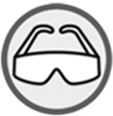
Procedure
1. Empty the syringe.
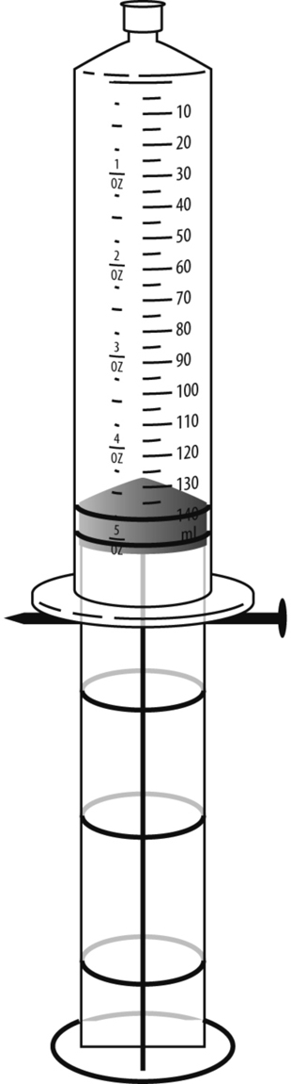
a) Push the plunger down fully into the syringe.
b) Stopper the syringe.
c) Pull the plunger to the mark of 140 mL.
d) Insert the nail into the hole of the plunger.
2. Weigh the syringe (with plunger, stopper and nail).
Record the result.
3. Fill the syringe with gas.
a) Remove the stopper and the nail from the syringe.
b) Push the plunger down fully into the syringe.
c) Connect the rubber tip of the gas cylinder to the tip of the syringe.
d) Carefully open the valve of the gas cylinder.
e) Quickly close the valve of the gas cylinder when the plunger
reaches the mark of 140 mL.
f) Disconnect and quickly close the syringe.
g) Insert the nail into the hole of the plunger.
4. Note the density of gas contained in the syringe as exactly
as possible.
5. Weigh the syringe (with gas). Record the result.
6. Calculate the density of the gas.
7. Clean up and put away materials.

Results
Record your results in the table below. Give the table a title.

Title:
Gas | Mass of empty syringe (g) | Mass of syringe and gas (g) | Density (g/mL)
Calculations
Write down your calculations below.
Calculation of gas mass
Calculation of gas density
Reflecting on the lab technique
1. What is the density of each gas chosen for this lab?
2. Compare the density obtained with data provided in tables of characteristic properties. Are they
similar? If not, explain why.

