- Series Slide

- Vincent van Gogh sold 1 painting in his lifetime. Before he killed himself at age 37.

- But van Gogh didn’t commit suicide because he thought he was an artistic failure.

- No, he reached that level of despair for different reasons.

- Did you know Vincent van Gogh tried to be a minister?

- The Dutch Reformed Church supported him on a 6 month trial as an evangelist to a poor region of Belgium that consisted mostly of miners.

- Van Gogh’s unorthodox style got him in trouble with church officials. Things like cutting up his bed sheets to make bandages for workers who were burned in the mines, or refusing to bathe because he didn’t want to live a more privileged life than the people he served.

- After his 6-month trial was over, the church decided he was unfit to be a minister. Not respectable enough.

- Van Gogh went on to experience more and more rejection.
- His best friend left him….admittedly, after van Gogh threatened him with a razor…and subsequently cut his own ear off.

- And eventually, his brother Theo wrote him a letter telling him he was no longer able to fund his art career.

- On top of all of this, van Gogh suffered from psychotic delusions. He would go through periods of terrible mental instability…like that time cut off one of his ears.

- But all through van Gogh’s life, through all his mental illness, and all the rejection… he had a deep desire to know and worship God and to love others. (Well, except for that time he tried to cut his best friend with a razor blade).

- After his death, his paintings have become some of the most recognized and duplicated in the world.

- I love his art because he has so many pieces that say beautiful and challenging things.

- 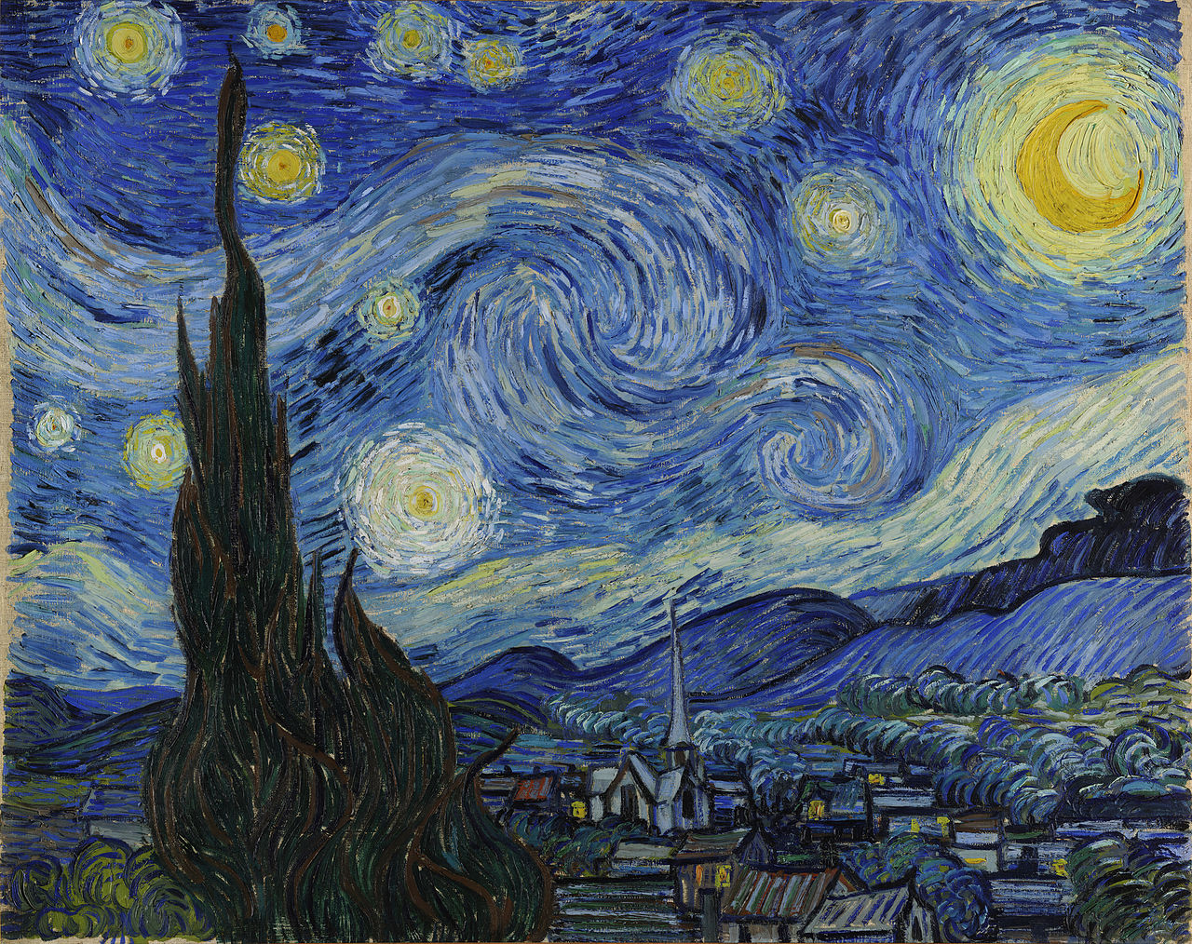
- You’ve probably seen his work “Starry Night” a couple thousand times. He actually painted this picture from inside his room in a mental institution.

- Here’s something you may not have ever noticed about van Gogh’s most famous painting.
- Did you know that he used the color yellow to represent the divine love of God?
  - “The Divine Commodity”, Skye Jethani

- Of course, when you look at “Starry Night” you see it all over the sky. No doubt, van Gogh wants you to recognize the absolute transcendence of God. His bigness. His otherworldliness.

- But maybe you never noticed the little town below. Take a look in the windows. Most of the windows of the little houses are lit up. Touched by the same yellow paint that lit up the sky.

- In other words, in van Gogh is not just showing you God’s transcendence…he’s also showing you his immanence.

- He’s not just saying “Look to the Heavens” to see God.

- He’s also telling you, look inside your home to find God.

- God is huge…a million miles away in the heavens…. at the same time, he’s sitting right next to you.

- But don’t miss van Gogh’s subtle critique in this painting.
- Do you notice what building is dark in the town underneath this expansive sky lit up by God’s divine love?

- Do you see what isn’t showing this heavenly light?
  - The church building.
  - Black as night.
  - Dark and cold.

- I want to show you one more van Gogh painting…the painting that shows what is going on in those houses under the Starry Night sky. And van Gogh didn’t see happening in the church.

- Here’s a peek in one of the windows.

- 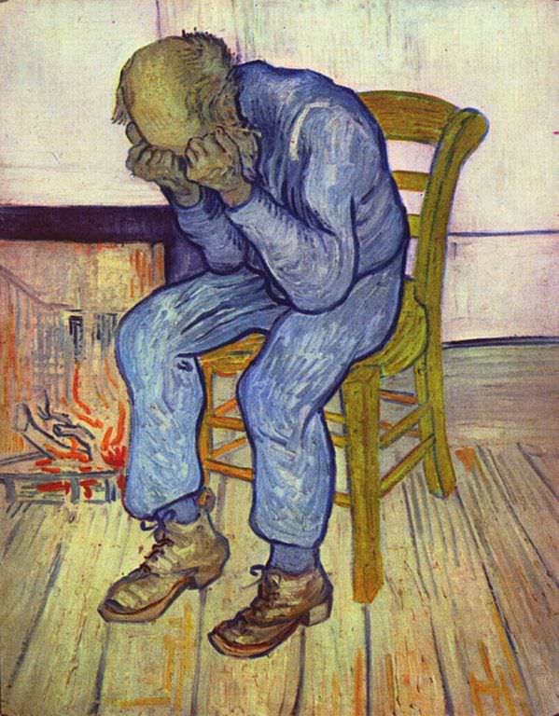

We’re not sure if this peasant man is exhausted, or crying, or if he just bought a Samsung Galaxy Note 7…and that’ the reason for the fire behind him…

But, we do know what he he’s doing.

He’s praying.

Van Gogh titled this painting “At Eternity’s Gate”.

And through it he is showing how the most common, ordinary people…not priests, not rich, not distinguished…can have direct access to God in prayer.

Listen to van Gogh in his own words-

“This is far from theology, simply the fact the poorest little wood-cutter or peasant on the heath or miner can have moments of emotion and inspiration which give him a feeling of an eternal home to which he is near.”

Today, we’re going to start a series of messages on Prayer, that I hope will do 2 things.

Back to picture “Eternity’s Gate”

First, I hope this series helps you realize van Gogh’s statement is true. That no matter what your status is in society, no matter how “unworthy” you think you might be…that Eternity’s Gate is as close as a bowed head in your hands.

And…

Back to picture of “Starry Night”

Second, for this church, I hope that through what we do together over the next 6 weeks, that prayer becomes foundational for us as we grow together…so that all the people in our community that don’t have the divine glow in their windows will see one coming from 313B S. Church St…and from every single one of our homes.

In short, I want this series to put our heads back in our hands, and the light back in our window.

To do this, we’re going to go through what’s historically known as the Lord’s prayer. What Jesus taught his disciples to pray. So every week, we’ll read it together.

Here we go.

Matt 6:5-13
- “And when you pray, you must not be like the hypocrites. For they love to stand and pray in the synagogues and at the street corners, that they may be seen by others. Truly, I say to you, they have received their reward. But when you pray, go into your room and shut the door and pray to your Father who is in secret. And your Father who sees in secret will reward you.

- “And when you pray, do not heap up empty phrases as the Gentiles do, for they think that they will be heard for their many words. Do not be like them, for your Father knows what you need before you ask him. Pray then like this:

- “Our Father in heaven,
- hallowed be your name.
- Your kingdom come,
- your will be done,
- on earth as it is in heaven.
- Give us this day our daily bread,
- and forgive us our debts,
- as we also have forgiven our debtors.
- And lead us not into temptation,

but deliver us from evil.

TRANSITION: Every week, for the next 6 weeks, I’m going to go through a part of the Lord’s Prayer to show you God intends prayer to be.

See, when we let Jesus set our agenda for prayer, we’re letting him start the conversation.

So often, we think of prayer as God just kind of “up there” in the starry sky, waiting for me to say, “Dear God, if you’re up there…its little old me way down here…”

Like we always have to start the conversation.

- Title Slide “Our Father In The Starry Night: Why You Have To Put Your Head In Your Hands to Get Heaven in Your House”- Matthew 6:5-9

That’s why I’ve entitled this series “Call & Response”. Because I want to show you how to let God start the conversation in prayer… Instead of thinking of prayer as MAINLY, you calling and God responding…what if it was more of God calling…and you responding?

What if there was more Starry Night inside your house than you ever thought there could be?

What if there was more Starry Night in the windows of the church than van Gogh ever thought possible?

If we prayed the Lord’s Prayer…and really believed God was listening…what would that do to our lives, our relationships, our city, what that do to the world?

That’s what I hope to show in the next 6 weeks, but for now, we need to start right where Jesus does…how NOT to pray.

1) Prayer is about God’s presence, not his presents.
  - Please excuse the cheesiness of that statement for a minute and let me show you how true it is. And how much better prayer will be when you realize it.
  - When van Gogh talked about the subject of his “Eternity’s Gate” painting of the peasant man praying by the fire, did you notice how he described it?

  - BACK TO van Gogh quote
  - He doesn’t say, “the poorest little wood-cutter or peasant can have whatever he thinks he needs. Or “all his problems solved.”

  - He says, that they can know in prayer that the eternal is near.
  - That the transcendent is immanent.
  - That the Starry Night is in their living room.

  - Van Gogh was onto something.

  - Look how Jesus puts it.
  - V 5
  - Jesus tells his disciples not to pray like a hypocrite.
  - They pray to receive a reward.
  - See, they get up in front of people to gain people’s honor and respect.
  - They are using God as a means to a different end. That end is the praise of men.

  - V 6
  - Then he counters that by telling his disciples to go into their room and shut the door and pray to their Father who is in secret, and they will be rewarded in secret.

  - Now, I used to read this verse and think, “Ohhhh, if I pray where only God can see me do it…he’ll put an envelope of money in my mailbox, because he’ll be like ‘Look at that boy…not caring what other people think…I’m gonna reward him in secret with a wad of cash.”

  - But that still has me using God as a means to an end. Right, my end is the money in the mailbox.

  - So what is this reward in secret?

  - Well, its exactly what van Gogh painted.
  - It's the presence of God with my head in my hands.
  - It's the divine love from the Starry Night in my living room.

  - See, God is the reward in secret. You go in a closet…he’s the only other one in there. Unless you find Mr. Tumnus’ house in that closet…its just you and God in there.

- Back to 1)
  - The chief reward of prayer is to better know God.
  - Its to make the transcendent immanent.
  - The reward of prayer…well…its that you’re praying.

  - Please, for just a minute, think about this.
  - When you pray…if prayer is real…if its really what the Bible says it is…you are talking to the sovereign God of the universe.
  - Not only are you talking to the one who made the guy who painted Starry Night…you are talking to the one who ACTUALLY painted the real starry night. Like…the actual stars.

  - If Prayer is anything…it is making the transcendent immanent.
  - There’s an old book by the 17th century monk, “Brother Lawrence” called “Practicing the Presence of God”

  - Brother Lawrence converted to Xianity when he was 18 years old, and became a monk at age 24.
  - He changed his name Nicholas Herman to “Lawrence of the Resurrection”
    - …which can we just stop and say, “AWESOME”
    - Can we start addressing each other like that?
    - Call me “Trevor of the Resurrection!”

  - Anyway, Brother Lawrence writes this little book to instruct Xians how to “practice the presence of God”

  - Look what he says- (same slide)
  - “There is not in the world a kind of life more sweet and delightful, than that of a continual conversation with God; those only can comprehend it who practice and experience it.”

  - “Above all, get in the habit of thinking of God, and forget him the least you can.”
  - - Brother Lawrence of the Resurrection

  - The reward for Brother Lawrence is knowing that God is near. Knowing that he’s present, even in the ordinary things of life…like cooking and cleaning…

  - Think about that. If you are aware someone is riding in the car with you, you talk to them.
  - If you aren’t aware they are there…you don’t. (and you call the police when you finally see them in the back seat)

  - See,If you simply practice God’s presence…mentally acknowledging that wherever you go, and whatever you do, that he is with you…I bet you’ll start talking to him more. Cuz its kind of awkward to just sit there.

- Back to 1)
  - Look, here’s the question you gotta ask.
  - Do you see God as beautiful…or useful?
  - Do you love God because he’s God…or do you love something you think he can get for you if you ask in just the right way?
  - If he’s only useful, you really don’t care if he’s present with you or not…you just care if he answers your prayers in the way you think they should be answered.

  - But if you actually begin to appreciate God for God’s sake…it will be hard to shut yourself up.

TRANSITION: Now, I know what some of you are thinking… “Ummmm, I have never even remotely had a beautiful thought about God. Just the thought of having some transcendent moment with God seems foreign to me.” Well, Jesus is going to help you get started…and so is this church today. See..you’ve got to

2) Talk to God as your Father, not your Landlord.

  - Did you notice something strange in Jesus’ instructions?
  - Look at v 7
  - He says, “Do not heap up empty phrases as the Gentiles do…

  - That word “Gentiles” means “other nations”
  - In other words, Jesus is telling his Jewish audience, who has this unique covenant relationship with God…that there is a kind of distinct way they should pray to God because of his promises to them.
  - He’s also acknowledging that pagans pray.
  - Right?
  - He doesn’t say, your prayers make you distinct from other religions…he says the WAY you pray makes you distinctive.
  - Other nations, committed to worshipping other gods…they pray, but they do it very differently.

  - Jesus tells them that when people worship other Gods they think there is a formula.
  - Like if they say the right words, in the right pattern, at the right volume, with enough gusto, that their God will hear and be compelled to answer them.

  - When Jesus says they “heap up empty phrases” that's the greek word for “babbling”.
  - Anybody else’s prayers ever sound like that?
  - You get in the middle of a prayer and start thinking…I haven’t really said anything yet. I’ve said the word “Just” about 67 times…I’ve told God what I’m praying for….
“Lord, I pray for Aunt Sally”
  - But actually talking to God….I don’t think I’ve done much of that at all.

  - And you know,..Most religions seem to teach some sort of formulaic babbling that is sort of the magic key to being heard by their deity... Catholics think if you repeat enough Hail Mary’s, God will be inclined to forgive you;
  - Many Muslims don’t really care that you understand the verses from the Koran, as long as you can mindlessly recall them in the original Arabic, Allah will bless you.
  - Hindus will chant from the Bhagavad Gita to win the favor of their gods;
  - In those religions, the problem is not that people forget God’s presence…they acknowledge that God is wherever they are…they believe their living with God, they just talk to him like he’s a landlord.

- Back to 2)
  - Here’s what I mean.
  - 7 people live in my house right now. My wife, my 3 sons, 2 college students.
  - There are 2 major differences between how I treat my sons and how I treat our 2 housemates.

  - The first one is rent.
  - On the first of month, I expect a check on my kitchen counter…from our renters.
  - But I have never gone looking for rent money from my kids.

  - Do you know why?
  - Because the relationship a landlord has to tenants is always dependent on that rent money.
  - In other words, the way you keep staying in this house is you keep paying me.
    - (Now, I love both our housemates and our relationship is a little different than that, but still, at best, if they can’t pay rent its going to put a strain on the relationship.)

  - But my kids are safe. There is zero expectation for them to pay rent. They are my kids. Giving them a home is one of the privileges of being their father. I’m not expecting them to pay for their spot.

  - I certainly ask them to contribute to the household, but I ask them to do chores, make beds, clean bathrooms…BECAUSE they already have a permanent spot in my home. When chores go undone, there are consequences, but I never threaten to kick them out.

  - The other way my kids are different from our housemates is access.
  - At 2 am, my kids can come in my room and ask for a drink of water.
  - They can tell me they’re scared or can’t sleep and ask me to scoot over so they can get in.

  - No offense to our college student roomates, but if I catch one of you standing over my bed in the middle of the night, you’re gonna catch a Louisville Slugger to the teeth.

  - See, the relationship is different. We all live in a house together, but my kids don’t pay me and they have a more intimate access to me.

  - If you talk to God like he’s a landlord, you are going to spend time stacking up empty phrases to try and buy God’s ear, almost like you are paying rent. If you get the words right, God will give you what you need.

  - Look what Jesus says.

  - V 8
  - What makes Xianity unique is that we pray to God as a Father.
  - Jesus says “Don’t be like the gentiles, don’t be like the pagans, Don’t use your words to pay rent…instead, realize the kind of access you have to God.
  - He’s a Father that knows what you need…so talk to him.

  - Listen, Jesus is telling us that you have Access like a kid walking into his parents bedroom at 2 am.

  - Are you anxious? Afraid? …tap him on the shoulder and say, “Can I climb in, Dad?…There’s monsters in my room”
  - He’s a good Father. He’s not going to ask you to pay rent first.

  - He’s not going to say, “Oh, you didn’t phrase that right.”

  - See, Jesus doesn’t give us the Lord’s Prayer as the only prayer we are supposed to pray. He gives it as a model. A pattern for the way we pray.

  - V 9a
  - That’s why he starts it with “Our Father in heaven”

  - See, the Lord’s prayer is Jesus saying “Let what you know about God start your prayer. Let him start the conversation.”
  - “Don’t start your prayers with who you believe you are…tired, lonely, forsaken, beat up,”
  - ….he says, “Start the conversation with God says he is…
  - Our Father, in Heaven”

  - Do you see what that phrase is?
  - Its van Gogh’s Starry Night.
  - Our Father…that’s the immanence. The intimacy. That’s the light in the windows. He’s close. He lives with you. He’s right there.

  - In heaven…that’s the transcendence. That’s the huge swirls of stars in the sky. Your Father is that powerful. He’s the one who created everything. There is nothing he can’t do.

  - Did you ever wonder why Jesus didn’t just double down on God’s transcendence?
  - Why doesn’t he just focus on God’s power?
  - Why doesn’t he start with “Our Creator in Heaven”

  - Well, remember, Jesus is setting this God apart from other gods.
  - There were plenty of pagans who prayed to a god they thought created them.

  - But Jesus is showing you this God is intimate. He’s close.
  - …and he’s showing you the real God loves you. He’s your father.

  - Another reason he starts with “Our Father” is because being a Father is more central to God’s character than being a creator is.

  - God, for all of eternity, has been a Father.
  - See, the Bible teaches that God is ONE God in 3 persons…Father, Son, and Holy Spirit.
  - And they have eternally existed in a relationship.

  - So there is no time…ever…even before the world began, where the Father was not loving the Son.
  - BUT…God had to BECOME a Creator. He wasn’t a creator before he created.
  - But he was a Father.
  - That’s why you’ll find the Scripture tells us GOD IS LOVE…but it doesn’t say God is POWER.

  - See, God is fundamentally, at his very core…in the depth of his character…a Father who’s throwing back the covers for his kids to come close…even in the middle of a night when there aren’t any stars shining. When its dark…and scary…He’s still able to light up your house.

  - He always has been and always will be a Father who wants you close.

- Back to 2)
  - Listen, the Gentiles just kind of assumed that God was naturally hostile to them. That he had to won over with slick words.
  - But that’s not how Fathers work. Fathers know you before you can ever speak a word. Fathers love you when all you can do is make messes in diapers.
  - Fathers aren’t looking for their babies to talk to them first…they teach them how to do it by starting the conversation.

  - You want revolutionize your prayer life.
  - Stop thinking about God as a Landlord and your prayers as Rent.
  - Start believing what he says about himself, that he’s a Good Father that loves you and wants to teach you to pray.

  - He knows what you need…and wants to give it to you.
  - “If you want to judge how well a person understands Christianity, find out how much he makes of the thought of being God’s child, and having God as his Father. If this is not the thought that prompts and controls his worship and prayers and his whole outlook on life, it means that he does not understand Christianity very well at all.”- JI PACKER

  - Let me get real practical with you for a second.
  - A few months ago, when we decided that this church was here to Multiply Gospel Change. For Broken People. On Purpose. I realized something.

  - If we were going to multiply gospel change…we’ve got to teach people to pray to Our Father in Heaven.
  - We’ve got to get our heads out of the Starry Night and into our hands at Eternity’s Gate.
  - Not only that, to multiply something, you have to have something that can be replicated….and you have to have a starting point that anyone can get on board with.

  - So, here’s what we’re gonna do.
  - For the next 30 days, we’re going to help you establish a discipline in your life that help you listen to God’s call…and respond to it.
  - It will help you begin reading the Bible, and responding to God in prayer.
  - The idea, is that you don’t start your prayers with your list…you start by letting Our Father in Heaven describe himself to you.

  - The only way to do that, is by reading the Bible.
  - And turning it into a prayer.

  - This is something our staff and elder teams have been doing for about 3 months now. And now we’ve all gone and gotten 2 other people and we’re doing it with them. My hope is that eventually, everyone is doing this with 2 other people.

  - We call it a HEAR Journal.
  - HEAR is a an acronym that just helps you read through a passage of Scripture

  - H- Highlight
  - E- Explain
  - A- Apply
  - R- Respond in Prayer

  - Prayer guide on App going up this week.
  - Buy Journals for $2
  - One passage per week.
  - Share it in your community group, with a friend.

  - Personal: Listen, I’m going to tell you, I’ve been reading the Bible and praying for A LONG time. And doing this 5 times a week for the last several months has been changing my prayer life. I’ve never journaled this much in my life. It is bringing me a renewed intimacy with the Lord that I’m loving…and I’m starting my prayers with the Bible…who God says HE is and what he says about me,…instead of starting them with me and my problems and who I say I am.

- TRANSITION: Now, its one thing for me to tell you God is your Father…its another thing for you to understand how he did it.

3) We can pray the Lord’s Prayer, because Jesus prayed our prayer on the cross.
  - You know, its kind of strange that we call the prayer Jesus taught his disciples to pray “The LORD’S Prayer”
  - After all, its not really a prayer Jesus would need to pray.
  - One of the lines is “forgive us our trespasses, or debts, or sins”

  - But Jesus never sinned.
  - He doesn’t need this prayer. Its not really a prayer for him, it's a prayer for us.

  - You want to read the true Lord’s Prayer?
  - On the night before Jesus died he went into an Olive Garden to pray….(not the restaurant…if he did THAT he REALLY would have descended into our depravity…we shouldn’t do that to Italian food…”Father forgive us”)

  - Anyway, he goes into this grove of Olive Trees, the Garden of Gethsemane to pray.
  - And while he’s praying, he asks his disciples to pray with him…but they all fall asleep.

  - They may have had their heads in their hands, but they were snoozing.
  - But Jesus prays anyway.
  - And in John 17:22-23 we get this wonderful privilege of listening in to the REAL LORD’S PRAYER

  - Jesus says that he is giving everyone who trusts in him his glory. John would describe it later as the “Right to be the children of God.”
  - Do you see what Jesus prays in v 23?
  - He says, “Father, because of what I’m about to do, I want you to look at them with the eyes of a Father…I want you to love them EVEN as you love me.”
  - The real LORDS prayer was for you. That you would become a loved son or daughter.

  - For a good portion of his life, van Gogh wanted to paint this scene.
  - He would look at a lot of his contemporaries work, they painted this scene over and over. This Garden of Gethsemane prayer.

  - But van Gogh could never do it.
  - He thought it was too dark. Too scary. To paint the night before Jesus died.

  - So, he painted an olive garden….but it wasn’t dark.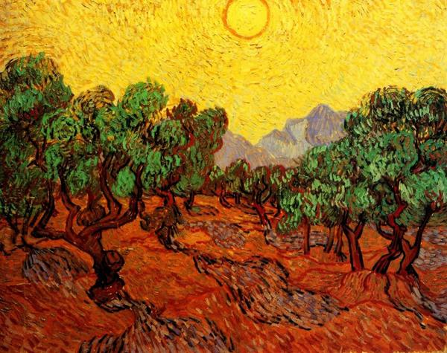
  - In fact, it was one of the brightest pictures van Gogh ever painted.
  - How could he represent the night before Jesus died…in excrutiating pain in a garden, asking if the Father would somehow save the world in another way….how could he paint it so …well…bright?

  - Well, remember, the color Yellow for van Gogh represents Divine Love. This is the brightness in the Starry Night sky and house windows.
  - See, van Gogh knew Jesus prayer in the garden. His request that the Father would love us like he loved his only son.

  - It was a prayer for adoption.
  - And on the cross, the next day, on a different tree, Jesus would pay for that adoption.

  - See, our sin, our rejection of God as our Father separated us from our loving father. And the price to pay was death.
  - But on the cross, Jesus hung on a cross, a different kind of tree, and he prayed, “My God, why have you forsaken me?”
  - That’s not a prayer our Lord should have prayed. That’s the prayer WE deserved to pray.

  - But Jesus died on that tree, and he prayed that prayer in our place.
  - When Jesus prayed it…he breathed his last breath and died.
  - And the sky went black.
  - No sun. No Starry night. No lights in the windows.

  - But 3 days later, on a Sunday Morning, the Sun rose on the Garden of Gethsemane….and Jesus rose out of the grave.

  - The bright divine love of the Father was now shining on the ones that betrayed Jesus.

  - Indeed, Jesus didn’t ask for his own forgiveness, on the cross he said “Father, forgive them…they don’t know what they are doing”

- Back to 3)
  - Because Jesus prayed a prayer on the cross we should have been praying…now we can pray a prayer everyday that only he deserves to pray “Our Father in Heaven”

  - You remember Brother Lawrence of the Resurrection?
  - The Monk that taught people how to Practice the Presence of God?
  - Do you know how he became a Xian?

  - He was converted when he saw a dead tree in the winter and realized that in the spring…it would come back to life.
  - At that moment he realized that Resurrection was real.

  - Likewise, we are changed by Jesus when we look at a tree of death…a cross…and realize that the God who hung their in our place came back to life.

  - Because Jesus’ day went dark on the cross for us, now even in our most desperate Gethsemane prayers…we are bathed in the divine love of our father…and he’s throwing back the covers saying “Come on in”

- Eternity’s gate pic
  - City Church…if we want to get the Starry Night of heaven in our houses…its time to put our heads in our hands…and pray…”Our Father in Heaven”
  - Lets do it together.

