- All In
- Big Give Sunday next week

- Series Slide
- Ali Bati is a creative director primarily known for his work in advertising around the world.

- In 2017, he was hired to lead an ad campaign for a art school that was offering accelerated drawing classes.

- So he came up with 3 pieces that were circulated online and in print.

- Here’s the first one.

- 

- Here’s the second one

- 

- Those were great- but likely its this third one you are going to recognize

- 
- In March of 2018, this picture took off as Meme. And as much as I can tell, it all started with the following post on Reddit.

- 

- From that it developed into sectioning off the horse with descriptions of waning time, interest and ability.

- Like this: (Teaching in 2020)

- 

- Here’s another good one. (When your client asks for cheaper)

- 

- Or, you can go to a meme generator and do your own. Like I did! (Sermon Writing)

- 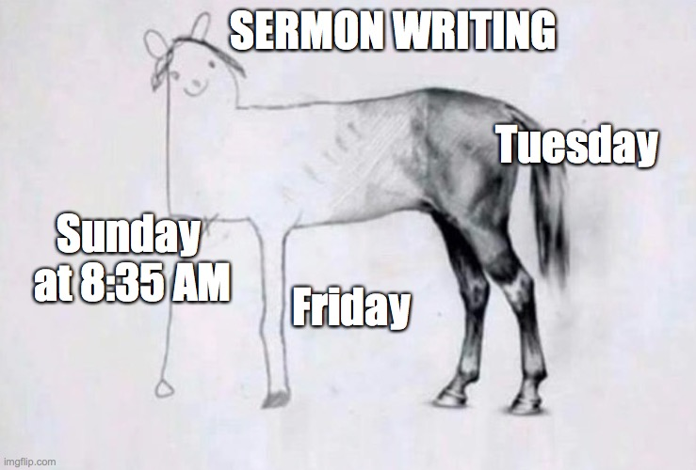

- Or this one…. (Sermon Jokes)

- 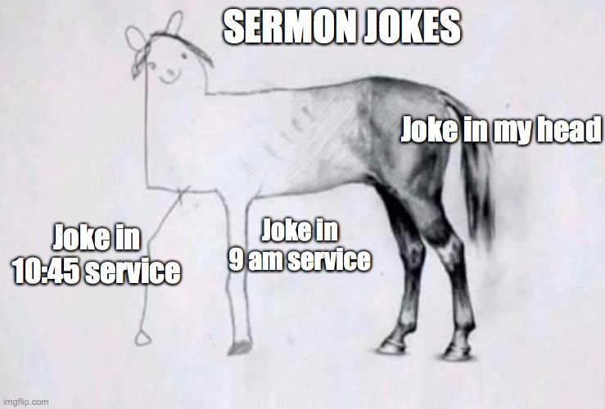
- Title Slide: “Finish the Horse: What You Need to Keep Believing”- Hebrews 3

- The people to whom the book of Hebrews is written are tired. They are worn out. They have been persecuted and suffered because they decided to follow Jesus. They don’t fit in with the Jews, because they have embraced Jesus as their Messiah, and they don’t fit in with the Gentiles- for the same reason. So many of them are ready to quit. Questioning whether it was a mistake to follow Jesus. It just seems easier to go back to one side or the other. But especially the temptation- is just to reject Jesus and go back to their seminal Hebrew faith in YHWH.

- In other words, they started strong in their faith. They made difficult decisions in Jesus’ name and were trusting God. But now- they’re to the middle of the horse…and they are starting to lose steam. So the writer of Hebrews is encouraging…and warning them….as they finish the head and front leg of the horse…go back to the way they drew the tail.

- Hebrews 3

- Therefore, holy brothers and sisters, who share in a heavenly calling, consider Jesus, the apostle and high priest of our confession.
- 2 He was faithful to the one who appointed him, just as Moses was in all God’s household. 3 For Jesus is considered worthy of more glory than Moses, just as the builder has more honor than the house. 4 Now every house is built by someone, but the one who built everything is God. 5 Moses was faithful as a servant in all God’s household, as a testimony to what would be said in the future. 6 But Christ was faithful as a Son over his household. And we are that household if we hold on to our confidence and the hope in which we boast.

- 7 Therefore, as the Holy Spirit says:

- Today, if you hear his voice,

- 8 do not harden your hearts as in the rebellion,

- on the day of testing in the wilderness,

- 9 where your ancestors tested me, tried me,

- and saw my works 10 for forty years.

- Therefore I was provoked to anger with that generation

- and said, “They always go astray in their hearts,

- and they have not known my ways.”

- 11 So I swore in my anger,

- “They will not enter my rest.”

- 12 Watch out, brothers and sisters, so that there won’t be in any of you an evil, unbelieving heart that turns away from the living God. 13 But encourage each other daily, while it is still called today, so that none of you is hardened by sin’s deception. 14 For we have become participants in Christ if we hold firmly until the end the reality that we had at the start. 15 As it is said:

- Today, if you hear his voice,

- do not harden your hearts as in the rebellion.

- 16 For who heard and rebelled? Wasn’t it all who came out of Egypt under Moses? 17 With whom was God angry for forty years? Wasn’t it with those who sinned, whose bodies fell in the wilderness? 18 And to whom did he swear that they would not enter his rest, if not to those who disobeyed? 19 So we see that they were unable to enter because of unbelief.

- Transition: Deconstructing one’s faith is a pretty popular way to handle adversity today. In other words, some pain or suffering happens to you or to someone you love and you can’t really find a way to reconcile that with what you believe about a loving and powerful God. So you take apart your faith a piece at a time, until you have something that can explain the suffering you’ve witnessed or been through yourself. Perhaps that describes you today, you’re struggling to believe that Jesus is real…and that he is who he says he is. Hebrews 3 is going to tell you why deciding today to stick with Jesus is extremely important….and show you how to do it.

- The first advice we get from Hebrews 3 is…
- 1) Don’t stop at the sign, go where it points.

  - Imagine you were taking a trip to the Grand Canyon. And you got to Flagstaff Arizona and saw a sign to exit the highway to head to the Grand Canyon. So you pull off the road, unload all your camping gear, and your kayaks, and you and your family pitch a tent at the exit sign to the Grand Canyon.

  - To say the least, you’d be missing the point. You wouldn’t be honoring the purpose of the sign, and you certainy would miss the grandeur of the GRAND CANYON.
  - It doesn’t bring any glory to the sign for you to camp there, when the whole point of the sign is to get you to finish your journey.
  - You don’t stop and the sign…you go where it points. Anything else is like the unfinished horse meme---it starts well, but ends up very lackluster.

  - So lets take a look at the problem this chapter is addressing.
  - Remember, the pattern of this letter is these little sections where the author says, “Jesus is better than…X”….and then he gives a warning, “and if you forget that, this is the bad thing that is coming your way.”

  - V 12

  - The concern is unbelief. That because of the pressure to fit in, these Christians will just say, you know what….its easier to just go back to our old way of life…particularly where we just reject Jesus, and we can just be Hebrews again.

  - V 14
  - His encouragement is “We gotta finish the Horse like we started it. And that all rests on how we go on believing.”

- Back to 1)
  - So the line of reasoning for those tempted to deconstruct their faith in Jesus is “Well- Moses- who is so important to us…and of course- the TORAH says that he was super important to YHWH… Its just kind of insulting TO MOSES that we are worshipping Jesus. Aren’t we making Jesus more important than Moses? Moses would be offended. So we need to get back to what we know for sure…that Moses knew God, walked with God, received the Covenant Law from God, and God endorsed his teaching. Whatever Moses said is what we need to do.”

  - This would allow them to fit right back in with all the people that were rejecting them. They’d have a team again. They’d be true Jews again. They wouldn’t feel so isolated and alone.

  - V1
  - That’s why the chapter starts with all these reminders that they DO HAVE a family…they do have a team.

  - He calls them HOLY BROTHERS AND SISTERS…(Guys we are a family set apart by God!)_
  - They share in a heavenly calling.
  - This is not just a calling TO HEAVEN- like “You’ll go to heaven when you die…its also about receiving a call FROM heaven.”
  - When you decided to follow Jesus- you were also given a mission FROM HEAVEN. A calling…a vocation. To make Jesus known through your love and perseverance in the faith.

  - He calls Jesus the Aposte and High Priest of our confession.
  - Confession here doesn’t mean admitting sins. It means what you say you believe. Its what we do every week when we recite the Apostles Creed. That is a CONFESSION of our Faith.

  - He reminds them that Jesus was SENT by GOD- that's what Apostle means…and that he is the only one who could really make atonement for their sin….so that they could be called BROTHERS and SISTERS- that’s what it means that Jesus is a high priest.

  - V 2
  - That sets up the 2nd verse where he points out how Jesus was faithful to God’s family, just like Moses was.
  - IN other words- Moses didn’t quit on God’s people, and neither did Jesus. They both did what they were called to do, despite very painful and difficult circumstances.

  - V 3-4
  - Then He takes it a step further, by saying “Actually, Jesus was better than Moses. But not because they represent 2 different truths…No. They are all apart of the same family, the same house.

  - Its just that Jesus built the house, Moses was just in charge of opening the door.

  - V 5-6
  - Then, he says, “And the whole point of Moses…and all he did…was to point you to Jesus. The real builder of God’s family. Moses was a servant of God’s Household. Jesus is the SON of God that built the whole house. All Moses was trying to do is point to Jesus in the future.

  - In other words- JESUS is better than MOSES…and Moses is not mad about you following Jesus. IN fact- it honors Moses when you follow Jesus!
  - So don’t give up the confession of Jesus as Lord and Savior.
  - You don’t go BACK into God’s family when you do that- YOU LEAVE IT! You abandon your calling! And you are nothing like Moses.

- Back to 1)
  - I doubt that anybody today is struggling with whether you should be a Christian or a Jew, because your life is so filled with suffering.
  - But there are a couple of larger applications here about finishing the Horse.

  - That is, often, when we deconstruct our faith because of suffering or difficulty, we go back to loving and even worshipping signs that are pointing us to the Jesus we just rejected.

  - Something I hear often in deconstruction stories, is that people will often leave their faith in Jesus…but very rarely do people decide to walk away from their faith in Love or Justice or Beauty.

  - In fact, it is a very secular creed that says “Love is Love”. Or “Justice for ALL”

  - But Love and Justice are both standards. How do you know LOVE is good? How do we know what is just and right?

  - There are really only 2 ways. Either both of those things are objective. They are realities that transcend time and culture…or they are completely arbitrary and self-defined.
  - Whatever you say Love is…that’s what love is. Or whatever you think is Just and right- so it is.

  - The truth is, nobody can live by that second definition.
  - See Like Moses, Love and Justice are pointers to God. In other words, a God, who is a person- defines Love and Justice for us…and when he created us…put a desire for Love and Justice inside of us…as his image bearers.

  - To make us LIKE him.

  - SO, when you reject Jesus in favor of LOVE and Justice….its like rejecting Jesus in favor of Moses. LOVE and JUSTICE and MOSES are all signs POINTING to JESUS. You dishonor them when you reject Jesus. You have to follow love and Justice ALL THE WAY to the person they come from…the builder of the house. LOVE and JUSTICE are just servants.

  - There’s another take away from this concept.
  - And that’s the nature of signs.
  - We have to remember, that in our journey with Jesus, we aren’t finished yet. Jesus has not returned to make all things new. Which means- we still need signs. We still need reminders and pointers to Jesus, because the suffering and difficulty, the brokenness of creation is still happening.

  - 2 of those signs that we are given by Jesus are baptism and the Lord’s Supper. I’ll talk about the Lords Supper at the end.
  - But baptism is a sign that marks the truth that you belong to Jesus. It is a marker of the confession that you are holding to. That Jesus died, was buried and resurrected to bring you into God’s family.
  - There are some of you who may, even in recent weeks, started your journey with following Jesus. And you haven’t marked that with Baptism.
  - Let me invite you to do that…soon.
  - ON THE APP- ELDERS @Borocitychurch.com

  - There also may be some of you who are struggling with that decision, because you were baptized as an infant, and you are afraid that being baptized again will dishonor your parents…like what they did wasn’t good enough.
  - I’d invite you to look at it the way the writer of Hebrews has his audience looking at Moses. That Baptism was not your faith…it was a pointer to the hope your parents had that you would believe. Now, baptism after belief in Jesus is a ratification of that early sign. It is a fulfillment of your parents’ prayer…and it was what that early baptism pointed to…but now- you can make that choice freely based on your own confession that Jesus is your Savior.

- Transition: Don’t stop at the sign- follow all the way through to where it points. That's the only thing that honors the sign AND the destination.

- 2) Deciding to follow Jesus is urgent.

  - In the next section of this passage, the author begins to quote thee old testament passages about Israel following YHWH through the wilderness after he rescued them from 400 years of slavery in Egypt.

  - V 15
  - 3 times in chapter 3 and 4- He will quote Psalm 95, particularly this portion about TODAY, if you hear his voice, don't harden your hearts.

  - Do you hear the urgency?
  - RIGHT NOW- if you hear him speaking….follow him. Listen to him.

  - See Israel was in slavery, they cried out to God for deliverance…and God heard them. He sent Moses to lead them out. He sent miraculous plagues of judgment on Egypt until they finally relented. He took a weak and unarmed people…and brought them through the Red Sea safely…where he drowned the strong and heavily armed Egyptians. Then- he promised to give them a home. A place to rest after 400 years of slavery.

  - He even stayed with them in a pillar of fire and cloud. He spoke to them through Moses and from Mt. Sinai.
  - He fed them manna and quail and gave them water from a Rock.
  - And yet, year after year- for 40 years- they complained- about God, about Moses- they remembered their old slavery fondly- saying things like “Lets go back to Egypt, we had meat to eat back there!”

  - In other words, in all the ways God was speaking to them through his loving provision and his law…they hardened their hearts, worshipped idols, and many of them never entered the Promised land, where they would finally have the rest they had been longing for.

  - So this Psalm, that is quoted looks backward to their poor example, and points forward as a warning- “You will hear God’s voice again. DO NOT TAKE IT FOR GRANTED. DO WHAT HE SAYS.”

  - Its urgent. Do it TODAY. You may not have tomorrow.
  - V 12
  - Because, like Israel, if you ignore him speaking to you, your heart will become callous and unbelieving. And you will walk away from God...and never find the rest you are looking for.

  - V 13
  - He says that the danger of taking God’s voice for granted…that calls you out of the slavery of sin and TO the freedom of walking with him in the light…
  - The danger is you will be HARDENED by Sins deception.

  - You know what Sins deception is.
  - It's a cheeky little promise that goes like this.
  - “If only I… then I’d have rest”
  - “If only I… could get revenge. Then I’d have rest.”
  - “If only I… could make 6 figures…then I could rest.”
  - If only I … could get married…then I could rest.”
  - If only I… could get my weight down….then I could rest.”
  - If only I… could get control of my kids… then I could rest.
  - If only I… could get into the popular group….then I could rest.
  - If only I…could get people to see that I’m talented…then I could rest.”

  - Sin’s deception is not merely “I think I will do evil today”
  - No, sins deception, at its root, is this little voice that whispers that rest comes apart from God.

  - Ever seen people that chase revenge, or money, or marriage or a certain body image, or control, or popularity, or recognition…do they seem like well rested people?

  - No. Because that chase is endless. There will never be enough money or recognition….never the right number on the scale or right person sleeping in the bed next to you….so you will keep that chase up for your life.

  - Most of that is camping at signs to the Grand Canyon.
  - ALL of it ends you up with a very SORRY picture of a horse…that started so well.

- Back to 2)

  - That's why making a decision to follow Jesus is so urgent.
  - Because the more you chase that stuff…the more you replace God… the harder and more cynical your heart gets…until you can’t even hear Jesus saying stuff like this.

  - Matthew 11:28-30
  - “Come to me, all of you who are weary and burdened, and I will give you rest. 29 Take up my yoke and learn from me, because I am lowly and humble in heart, and you will find rest for your souls. 30 For my yoke is easy and my burden is light.”

  - Your longing for rest…is pointing you to Jesus…who came to give it to you.
  - So if you are looking for that rest…TODAY, if you hear his voice…don’t harden your heart… instead follow him…and KEEP FOLLOWING him…all the way to your death…and resurrection.

  - And here is how the author of Hebrews says to hold on to your confession-

- 3) Focus on Jesus and be a part of the church…anything else is an unfinished horse.

  - Take a look at the 2 things we are instructed to do in this passage to combat unbelief and hardening hearts.
  - V 1
  - Consider Jesus.
  - The word Consider here is more like CONTEMPLATE.
  - Think deeply about.

  - And he tells us about 2 ways to think about Jesus
  - First as an apostle.
  - An apostle is a person sent by God with a message.
  - To Consider Jesus as an apostle, means to consider that he was sent by God with a message.

  - IN other words…listen to what Jesus said.
  - You already heard one beautiful thing.
  - COME TO ME AND FIND REST. ALL THE SIGNS you have been camping underneath that have been unable to satisfy you..they have been pointing to me. SO COME and FIND THE REST you’ve been looking for.

  - Another way he put it was like this.
  - Mark 1:14-15
  - Jesus went to Galilee, proclaiming the good news of God: 15 “The time is fulfilled, and the kingdom of God has come near. Repent and believe the good news! ”

  - This is Jesus’ primary message. REPENT- or turn from trying to find rest in pointers to God…and turn to the God to whom they point. WHICH IS ME. I'm HERE. THE TIME IS FULFILLED. The one to whom Moses and John the Baptist have been telling you about is here. WHO HAS 2 THUMBS AND WILL BRING THE KINGDOM OF GOD TO YOU…THIS GUY!

  - That was his message.

  - V 1
  - The second thing we are supposed to consider is Jesus as a High Priest.

  - An apostle represented God to the people. He had a message from God.

  - A high priest went the other direction. He had a message from the people to God.

  - A high priest made sacrifices, that responded to the message and instructions Israel received from God. You have sinned…and you need to be reconciled to me. So God gave instructions in the law to kill a bull or lamb…as representative of the death that sin brings.

  - Sacrifices were a kind of confession. We have sinned. We are sorry. And we want to be your people again, God.

  - Jesus though as the High Priest is better than the law.
  - He himself is the spotless lamb, who on a cross, was slain. He was pierced for our transgressions.

  - And when he died, he took all the evil and punishment that our hard unbelieving hearts brought on ourselves…so that we could receive his standing….as God’s righteous and accepted children.

  - READ BIBLE!
  - PRAY!
  - THINK daily about that sacrifice…Jesus’ message and his action!

  - 3:13
  - The other thing we are told to do hear is encourage each other.
  - Literally, encourage here is Paraclete- it means to come alongside and comfort and exhort and be a pointer yourself. It means to help each other follow Jesus.

  - It is a description of what the HOLY SPIRIT DOES WITHIN US.
  - …and what he does through us together as a people.

- Back to 3)
- That's why I said the encouragement is to be a part of a church.
- Because you can’t even obey this command…or receive this comfort and counsel and help…if you don’t have one anothers to practice it with.

- Notice- the frequency- DAILY.
- That means that DAILY there is opportunity to do this. Notice it doesn’t say SUNDAYS.

- OFFER CHANCE TO BELIEVE…
- Be Baptized….
- AND BE A CHURCH MEMBER/ Community Group.

LORDS SUPPER Slide

