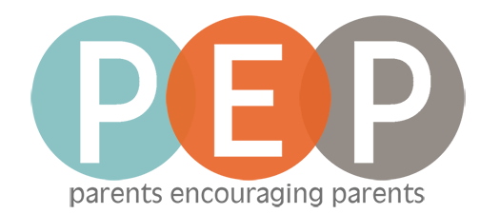

Youth Parent Ministry
January-May 2022

At Prince of Peace we believe in training, equipping, and resourcing parents to be the faith leaders for their teenagers. We would like to give you an opportunity to grow in your faith, learn how to teach your teen about important truths about Jesus, and connect with other parents in the same season of life. We will meet on the 3rd floor of the main building, room 305, on Sundays 9:15-10:15am.

January 2 Parent Learning Time: Ten Commandments
January 9 PEP Topic: Faith & Science
January 16 Being Challenge Kick-off
January 23 Being Challenge: Keystone Habits
January 30 Being Challenge: Commit to Community

February 6 Being Challenge: Study Scripture
February 13 Being Challenge: Prioritize Prayer
February 20 Being Challenge: Seek Solitude
February 27 Being Challenge: Choose Church

March 6 Parent Learning Time: Baptism
March 13 PEP Topic: Married People
March 20 Bible Study
March 27 Mentor Moments: God’s Best for You

April 3 Parent Learning Time: Holy Communion
April 10 PEP Topic: Teen Suicide
April 17 Easter No Class
April 24 Mentor Moments: Blessing

May 1 Parent Learning Time: Statement of Faith
May 8 PEP Topic: Where Bored Teens Spend Their Time on the Internet
May 15 Bible Study
May 22 Mentor Moments: Sticky Faith
May 29 Serve Sunday

Hear, O Israel: The Lord our God, the Lord is one. Love the Lord your God with all your heart and with all your soul and with all your strength. These commandments that I give you today are to be on your hearts. Impress them on your children. Talk about them when you sit at home and when you walk along the road, when you lie down and when you get up. Tie them as symbols on your hands and bind them on your foreheads. Write them on the doorframes of your houses and on your gates. Deuteronomy 6:4-9

