Accelerating KMGBF Implementation through the CBD’s Technical and Scientific Cooperation Mechanism
Connecting Partners through an Interactive Marketplace

- Date: XX October 2026 (First week of COP17)
- Time: TBD (90 minutes)
- Location: TBD
- Speakers:
  - CBD Secretariat
  - 4 TSCC Representatives from each region – Asia and the Pacific, Africa, Europe, Americas
- Expected number of participants: 50 people

Background
The implementation of the Kunming-Montreal Global Biodiversity Framework (KMGBF) requires strengthened technical and scientific cooperation across regions, sectors, and stakeholders. In this context, at the COP 15, the Parties have established the Technical and Scientific Cooperation (TSC) Mechanism at COP15, coordinated by the Global Coordination Entity hosted by the SCBD.
18 Technical and Scientific Cooperation Centres (TSCCs) were selected across the 4 regions – Asia and the Pacific, Africa, Americas, and Europe. These Centres play a critical role in facilitating knowledge exchange, capacity-building, and collaboration among Parties and relevant actors to accelerate biodiversity action to implement the KMGBF. With a growing need for more interactive space that actively connects stakeholders, the event enables participants to engage directly with each other and identify concrete collaboration opportunities more quickly.

Objectives
- Introduce the CBD TSC Mechanism and the role of TSCCs in accelerating the implementation of the KMGBF by highlighting regional progress, priorities, ongoing initiatives, and key challenges – Asia and the Pacific, Africa, Americas, Europe
- Facilitate direct engagement between participants and TSCC representatives and enable participants to rapidly identify shared interests and collaboration opportunities
- Foster partnerships that support technical and scientific cooperation for KMGBF implementation

Structure and Format
This side event will adopt an interactive collaboration marketplace format, designed to create a dynamic platform to match cooperation needs with offers among TSCCs and participants.
The session will begin with a brief and focused overview of the progress of the TSC Mechanism, followed by short, targeted interventions from TSCC representatives across regions. These introductory segments will be concise, setting the stage for a highly interactive session.
Following this, regional collaboration marketplace will open for engagement. The venue will be organized into four regional stations – Asia and the Pacific, Africa, Americas, and Europe – hosted by 18 TSCCs. Participants will be invited to move freely across these stations, engaging directly with TSCC representatives and other partners to further explore regional priorities, ongoing work, and concrete opportunities for collaboration. Participants who found their match will be asked to put their cards on the “we found our match!” partnership wall. TSCCs and participants will then be asked to share their reflection and any promising connections that emerged at the end of the event.
More about the Regional collaboration marketplace:

Upon arrival, each participant will receive an “opportunity card” (sticky note). Cards will be color-coded according to stakeholder group (Government, international/non-governmental organizations, research institutions, donors, and private sector). Participants will be asked to write three keywords that best describe their profile:

- What they can offer
- What they are looking for
- Field of expertise
These visible identifiers will facilitate rapid matchmaking by allowing participants to quickly identify potential collaborators.

Participants who do not identify a match during the session will have the option to leave their opportunity cards with the TSCCs. These will be used to support follow-up engagement and identify potential cooperation opportunities beyond the event. This approach will lower barriers to interaction, encourage active participation, and shift the focus from information-sharing to concrete partnership-building.

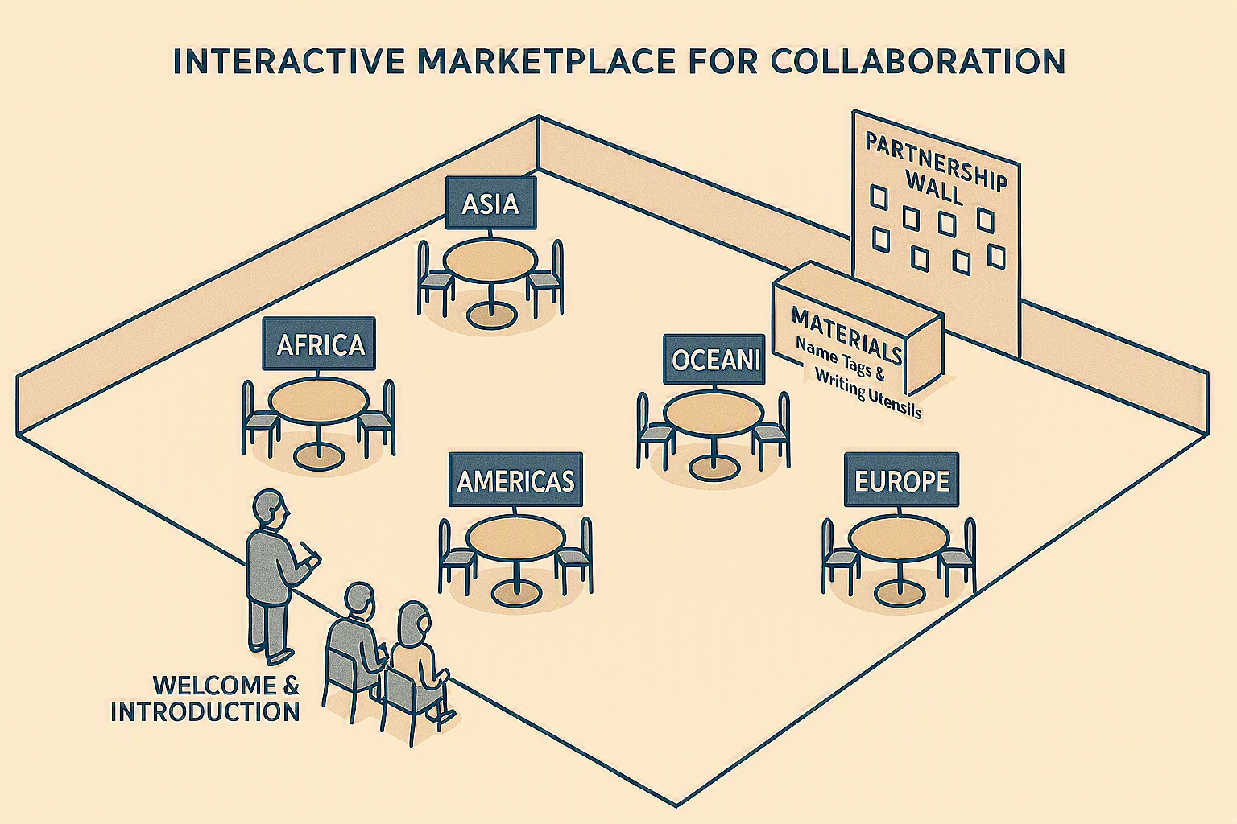
Agenda
Time | Session | Speaker
5 min | Welcome remark | SCBD
5 min | Overview of the TSC Mechanism | GCE
20 min | TSCC interventions (4 regions, ~5 min each) | 4 Reps from TSCCs
5 min | Instructions for interactive session | GCE
40 min | TSC Marketplace: Open networking & identify cooperation opportunities | GCE to facilitate
10 min | Share reflections and any promising connections emerged per region (4 regions, ~2.5min each) | TSCCs/Participants
5 min | Wrap-up and closing remarks | GCE

Logistics
- Venue setup: Five clearly marked regional stations with 4 partnership walls “We found our match!”
- Limited seats to encourage movement and interaction
- A table at the entrance for opportunity cards (sticky-notes) and writing tools
- Materials required: Sticky notes (5 different colors, template cards will be better), markers, region labels, 4 paper flip charts/boards
- Support staff needed to assist participants in creating opportunity cards and support smooth running of the side event
- Instruction to be visually presented to minimize confusion

