Accelerating KMGBF Implementation through the CBD’s Technical and Scientific Cooperation Mechanism
Unlocking New Partnerships through Interactive Networking

- Date: 22 October 2026
- Time: 13:15-14:45 (90 minutes)
- Location: Jermuk - African States meeting room
- Speakers:
  - CBD Secretariat
  - TSCC Representatives from 5 regions – Asia, Oceania, Africa, Europe, Americas
- Expected number of participants: 100 people

Background
The implementation of the Kunming-Montreal Global Biodiversity Framework (KMGBF) requires strengthened technical and scientific cooperation across regions, sectors, and stakeholders. In this context, at the COP 15, the Parties have established the Technical and Scientific Cooperation (TSC) Mechanism coordinated by the Global Coordination Entity, which is hosted by the SCBD.
A total of 18 Technical and Scientific Cooperation Centres (TSCCs) were selected across the 5 regions – Asia, Oceania, Africa, Americas, and Europe. These Centres play a critical role in providing technical support to Parties upon request and in facilitating exchange of knowledge and expertise, capacity-building, catalyzing TSC programmes and partnerships, and fostering collaboration among Parties and relevant actors to accelerate biodiversity action to implement the KMGBF. With a growing need for more interactive space that actively connects stakeholders, the event enables participants to engage directly with each other and identify concrete collaboration opportunities more quickly.
Objectives
- Increase awareness of the TSC Mechanism and the role of TSCCs in accelerating the implementation of the KMGBF
- Provide updates on the regional priorities, ongoing initiatives, the progress made and key challenges encountered
- Facilitate direct engagement between participants and TSCC representatives and enable participants to identify shared interests and collaboration opportunities
- Foster partnerships to support technical and scientific cooperation for KMGBF implementation
Structure and Format
The side event will adopt an interactive networking format designed to facilitate open matchmaking and collaboration among all participants. The event will provide a platform where Parties, donor agencies, partner organizations, technical experts, and other participants can meet TSCCs and identify potential cooperation opportunities with them.
The session will begin with a brief overview of the TSC Mechanism, followed by short, targeted interventions from one TSCC representative per region (5 regions in total). These introductory segments will be concise, setting the stage for a highly interactive session.
Following this, regional breakout groups will be created. The venue will be organized into five regional groups – Asia, Oceania, Africa, Americas, and Europe – and participants will be invited to join the groups they are interested in. TSCCs will facilitate group discussion and engage directly with participants to further explore regional TSC needs, identify partners and areas they have expertise, and potential opportunities for collaboration. TSCCs and participants will then be asked to share their reflection and any promising connections that emerged at the end of the event.
More about the Interactive Networking Space:

During the breakout group session, participants will receive a color-coded cards (sticky notes) to write down technical and scientific “needs” for implementing NBSAPs at the national level, as well as areas where they have expertise or know of technologies that can support Parties in achieving the KMGBF targets. The TSCC representatives will collect the cards and put them on the flip chart. These will be used to have a discussion with the participants and identify potential cooperation opportunities.
What are your TSC needs:
e.g. Monitoring Technology, Training on biodiversity finance, Assessment tools, Restoration technology…

Name of your Organization:
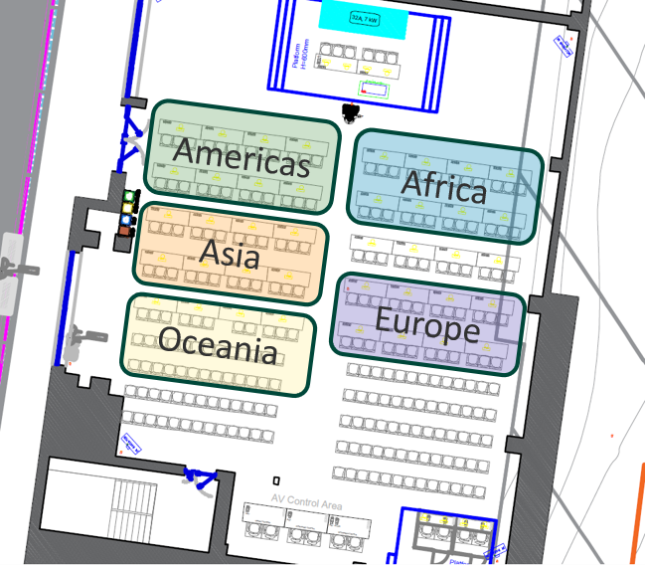
Areas where you have expertise or technologies that can support others:
e.g. Wildlife monitoring tools, Experience in developing biodiversity finance plans, Remote sensing and GIS tech…
Name of Organization:

Agenda and Facilitation Guidance
Time | Session | Speaker
5 min | Welcome remarks | GCE?
Facilitation Guidance | GCE invites the Executive Secretary of SCBD to give a welcome remark.  Speaking note for ES will be prepared by GCE
5 min | Overview of the TSC Mechanism | GCE
Facilitation Guidance | GCE presents the background, mandate, current stage - achievements and challenges – of the mechanism
15 min | TSCC regional interventions (5 regions, ~3 min each) | 5 Reps from TSCCs
Facilitation Guidance | One representative from each region will deliver brief presentation (max. 3 slides) on:  - Which TSCCs are in the region  - Countries covered by each TSCC  - Key-Highlights: Current regional priorities, challenges and ongoing work, building on what was discussed during the Kunming Dialogue TSCC session.  TSCC representative for their region  - Africa:  - Americas:  - Asia:  - Oceania:  - Europe:
50 min | Regional breakout groups session:  Open networking & identify cooperation opportunities | GCE to facilitate the whole room,  TSCCs to facilitate breakout groups
Facilitation Guidance | - Setup & Orientation (5 min):  - GCE to ask participants to join one of the regional breakout groups they are interested in getting to know more/directly engaging with them. Present the instruction slide and instruct participants to fill out the sticky note for the breakout group activity.  - TSCCs welcome participants to the regional station.  - TSCC-led group discussion & Pitching (20 min)  - TSCCs to introduce themselves to the participants.  - Brief Q&A session with participants on TSCC work.  - TSCC facilitator to facilitate group discussion with the following guiding questions. Ask participants to fill out the sticky notes. Invite 3-4 participants to deliver 1-min quick pitches.  - What are your technical and scientific cooperation needs?  - Which areas of expertise do you have? What kind of support or technologies can you provide or know of, if possible, relevant to the needs shared?  - What do you see as opportunities for collaboration?  - Matchmaking (25 min):  - TSCC facilitator clusters cards by theme (e.g., Capacity building, Finance, Tech transfer). Place the cards on a flip chart.  - TSCCs actively match needs and expertise/technologies related to the countries they cover.  - Identify regional spokesperson to report back to Plenary and share the key highlights of their region.
10 min | Share reflections and any promising connections emerged per region (5 regions, ~2 min each) and Wrap-up | TSCCs/Participants  GCE to wrap-up
Facilitation Guidance | GCE to pass the mic to each regional group to share reflections, insights, and any promising matches emerged.
5 min | Closing remarks | Astrid Schomaker

Logistics
- Venue setup: Five regional stations with flip charts attached to walls
- A table at the entrance for opportunity cards (sticky-notes) and writing tools
- Materials required: Sticky notes (5 different colors, template cards will be better), markers, region labels, 5 paper flip charts
- Support staff needed to assist participants in creating opportunity cards and support smooth running of the side event
- Instruction to be visually presented to minimize confusion

