[Type the company name]
Mobile Marketing
[Type the document subtitle]

Table Of Contents
S.No. | Topic |  | Page
1 | Executive Summary |  | 3
2 | Mobile Industry Statistics |  | 3
3 | Smartphones: The Current State of the Market |  | 5
3.1 | Smartphone penetration |  | 5
3.2 | Internet usage on smartphones |  | 6
3.3 | Future expected internet usage on smartphones |  | 7
3.4 | Browsing satisfaction on smartphones |  | 8
3.5 | Has ever purchased on a smartphone |  | 9
4.0 | A survey by web.com |  | 10
5.0 | Increasing Share of Mobile Devices in Web Traffic |  | 13
6.0 | What is a Mobile Website? |  | 15
6.1 | Reasons to have a mobile friendly website |  | 16
6.2 | Desirable Qualities of a Mobile Website |  | 17
7.0 | Mobile Marketing Case Studies |  | 21
1.0 Executive Summary
The mobile industry is innovating in a big way. The adoption of mobile devices is multiplying year on year. People are making use of their mobile devices for different activities ranging from general web search to buying products. A share of the web traffic can now be attributed to mobile devices. And this share is growing day by day.
Keeping in view these trends in the favor of mobile devices, it has become a lot more important for the businesses to invest into a mobile marketing strategy. The strategy basically starts from having a mobile website or an app that is much more user friendly and easy to use depeding on the smaller screen size when compared to the computer screens.
This report discusses some important statistics from research reports, trends in usage of mobile devices and a few case studies on leveraging mobile marketing to drive sales.
2.0 Mobile Industry Statistics
A number of research firms have come up with latest statistics related to the usage patterns of mobile devices. These statistics highly support the fact that mobile marketing is a must as per the current scenario.
According to a new study from Deloitte, the “mobile influence factor” (or effect of smartphones on in-store sales) on retail purchases will increase to $689 billion (or 19% of total store sales) by 2016, up from the current influence factor of $159 billion (or 5.1% of sales). (Mobile sales, meanwhile, are only expected to be $30 billion at that time.) Further evidence suggests smartphone shoppers are 14% more likely to make a purchase in the store than non-smartphone users.
Another research report from the Pew Research Center says that more than half (55%) of mobile owners go online through their phones. This figure is up from 47% last year. This is a clear indication of increasing share of mobile devices in internet usage. Microsoft Tag even predicts that by 2014 mobile internet may take over the desktop internet usage.
Comscore reported that 43 percent of smarpthone owners have used their mobile device while in a store for a shopping purpose. On the other hand a report by eDigitalResearch states that 64% of smartphone owners are now using their mobile devices to shop online.
More and more retailers are now planning to invest into a mobile strategy. A research by the eretailing group says that 85 percent of merchants say mobile commerce is a focus in 2012, up from 68 percent in 2011.
A complete list of all such interesting statistics is available at: http://www.digby.com/mobile-industry-resources/mobile-industry-statistics/

3.0 Smartphones: The Current State of the Market
3.1 Smartphone penetration
Australia, UK, Sweden, Norway, Saudi Arabia and UAE all have more than 50% of their population on smartphones. An additional seven countries - the US, New Zealand, Denmark, Ireland, Netherlands, Spain and Switzerland - now have more than 40% smartphone penetration. This is a clear indicator of the high rates and interest in smartphones. Mobile devices have drastically affected people’s lives and hence are responsible for massive changes in consumer behavior.
The graph below shows the penetration of smartphones in some countries of the world. Other countries of the world are following the same pattern as well.
In the U.S., 80 percent of smartphone owners say they don’t leave home without their device—and one in three would even give up their TV before their mobile devices!
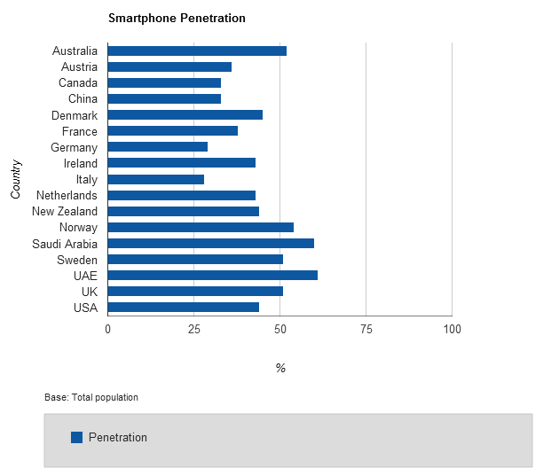
3.2 Internet usage on smartphones
It’s interesting to see that how frequently do people access internet on their smartphones. Even these numbers are quite amazing. In countries like Denmark, UAE and Sweden more than 60% of the smartphone users access internet multiple times a day on their smartphones. Whereas in Australia, Austria, Canada, Ireland, Netherlands, Saudi Arabia, UK and US more than 50% smartphone users access internet multiple times a day. On an average more than 40% of the users can be considered to be accessing internet through their smartphones multiple times a day.
The graph below shows these statistics for some major countries.
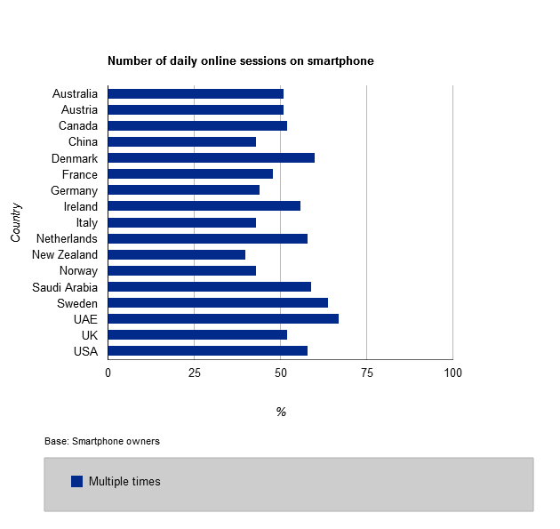
3.3 Future expected internet usage on smartphones
In most of the countries more than 25% users expect to increase their online time on the smartphones whereas less than 10% users expect to reduce their online time. And more than 50% users on an average expect to keep the online time the same. Clearly 25% figure indicates that the usage of smartphones is going to increase as far as accessing the internet is concerned.
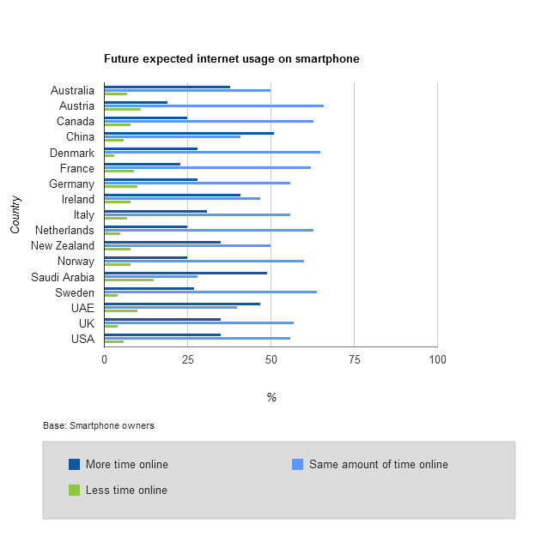

3.4 Browsing satisfaction on smartphones
As far as browsing satisfaction on smartphones is concerned, most of the people are satisfied with the smaller screens of their mobile devices. Around 30 – 45% of people are satisfied with their browsing experience on their smartphones. 15 – 30% people in different countries are completely satisfied. On the other hand less than 10% people are dissatisfied and less than 5%.
High satisfaction rates obviously point towards increasing share of mobile devices in web traffic.

3.5 Has ever purchased on a smartphone
Product search and purchasing on smartphone is one of the most popular activities. Whereas more than 50% of the users do product search on their smartphones, 20 – 39% of users have made a purchase on a smartphone. Most of these countries have already crossed the 25% mark. In general, overall 35% of users now make purchases on smartphones.

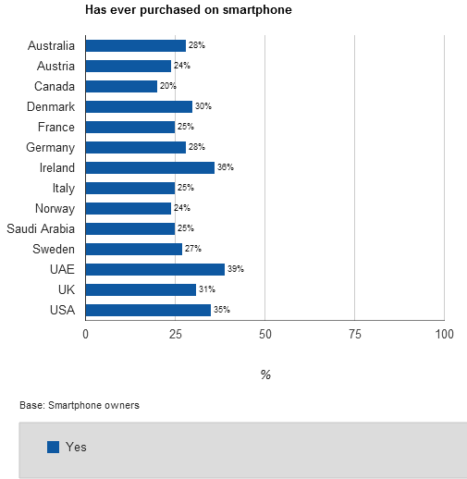

4.0 A Survey by Web.com:

84% of U.S. Small Businesses Using Mobile Marketing See Increase in New Business Activity
Source: Web.com
The Web.com survey reveals the current state of U.S. small businesses using mobile technology, including key motivations and challenges in integrating mobile into their marketing mix and their plans for future investment in mobile marketing.
This survey was conducted online via social networks from April 5 - April 12, 2012 among 500 small business owners (defined as <100 employees).
Seven Key Findings from the Web.com Small Business Mobile Survey Include:
- 69% of U.S. Small Businesses Consider Mobile Marketing Key to Growth in Next Five Years: There has been a significant increase over the past year in overall awareness and acceptance that having a mobile presence is critical to small business growth. About 69% of the small businesses surveyed agreed that mobile marketing is key to their growth in the next five years and will consider increasing their mobile spend this year.
- U.S. Small Businesses Maintain Good Web-Presence But Still Lack Mobile Presence: While 60% of small businesses surveyed have a website, only 26% have a mobile-friendly website (same layout/content as standard site adjusted to suit your smartphone screen) while an even smaller percentage (14% of small business owners have a stand-alone mobile website (content/layout designed specifically for mobile purposes).
- 84% of Small Businesses Currently with Mobile Presence See Increase in New Business Activity: Out of the 500 small business owners surveyed, 14% have a stand-alone mobile website, of which 84% indicated that they have seen an increase in new business activity due to their mobile marketing efforts. This alone serves as validation to make the move into mobile for the majority of small businesses that are skeptical to invest in mobile efforts.
- While Mobile Search Becomes Mainstream, Small Businesses Still Not Ready to be Found Via Smartphones: There is a large gap between the rapidly increasing mobile search volumes and the majority of small businesses lagging behind in mobile search strategy. Over 61% of small businesses currently do not have a mobile search strategy and are missing out on consumers trying to find them via a smartphone device.
- Biggest Motivation to Embrace Mobile is to Provide Better Service to Existing Customers: When asked to rank their top motivations to invest in mobile marketing, small business owners indicated the following as their top three motivations:
  - Provide better service to existing customers (38%)
  - Attract more local customers (36%)
  - Gain competitive advantage (34%)
- Biggest Hurdle to Embrace Mobile is Limited Time and Resources: It's not surprising that time and resource limitations prevent small businesses from entertaining new solutions to market themselves. The survey revealed that 64% of small business owners are also acting as their one-person marketing team. This puts pressure on the small business owner to wear multiple hats and find the time to build a mobile presence besides running other aspects of their business.
- 64% of Small Businesses Will Spend More on Mobile Marketing This Year - 2012 might be the year when mobile-savvy small businesses increase their spend on mobile marketing initiatives. 64% of small business owners surveyed expressed an intention to increase their mobile investments this year, with only 33% indicating that their mobile spend this year will remain the same as last year.

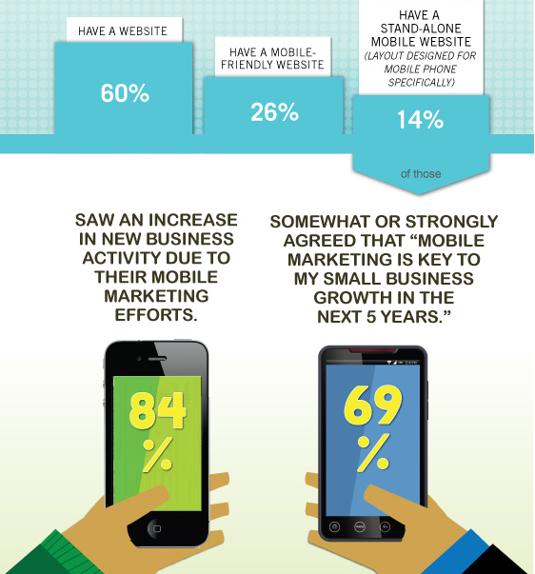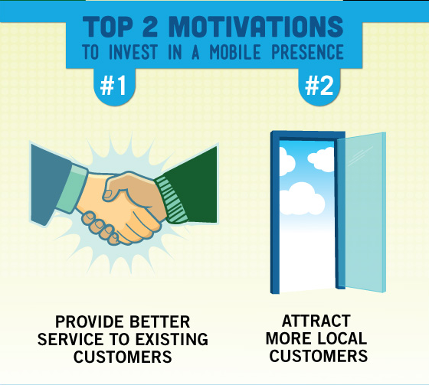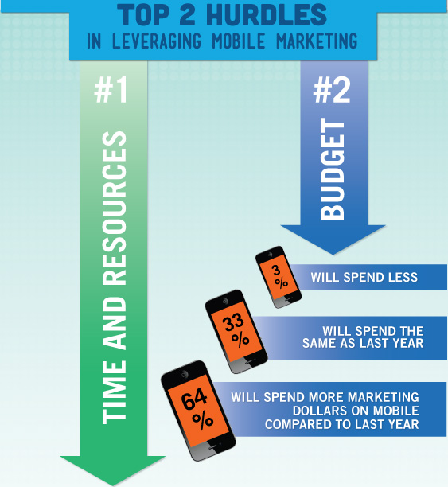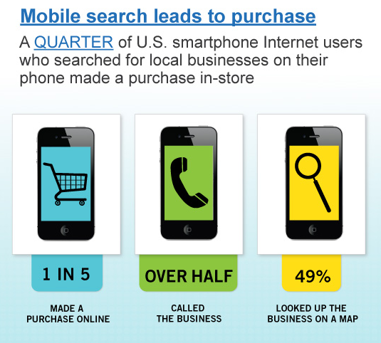

5.0 Increasing Share of Mobile Devices in Web Traffic
In May 2012, Pingdom.com conducted a research regarding what part of all web usage across the world was mobile. Ranking by the number of mobile phones China is the number one, followed by India, United States, Brazil, and Indonesia. However, when the countries were ranked according to internet usage on mobile phones, the list changed. The following table published by Pingdom shows the change in web traffic from mobile devices in various parts of the world. Africa leads the way with the highest increase in traffic from mobile devices followed by Asia and Europe.
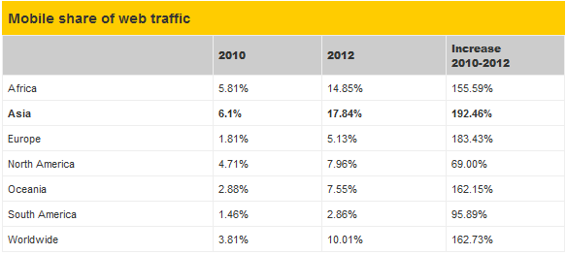
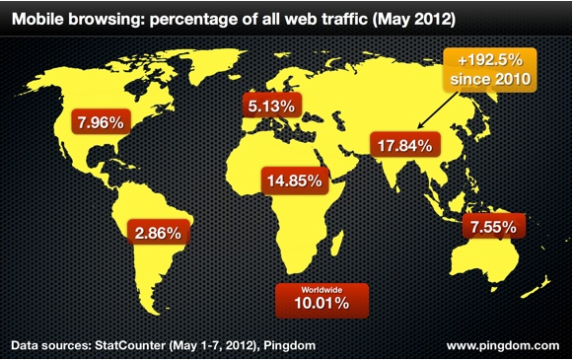
This is a clear indicator of the growing use of mobile devices to access the internet. In just over two years, the share of web traffic in Asia that comes from mobile devices has almost tripled. In fact, in some countries, close to half of all web traffic comes from mobile devices. India is very close to mobile traffic breaking 50% of all web traffic, and several other countries have already passed that benchmark.
A complete list of percentage of mobile v/s traffic from computer for different countries has been published by Pingdom.
It is available here: https://docs.google.com/spreadsheet/pub?key=0AsDrQsdrVZikdFBnR1dyamdfa1ZEc1N2ZjhLWHNYRVE&gid=0
According to this list the countries with highest mobile share of web traffic are:
- 58.06% – Zimbabwe
- 57.89% – Nigeria
- 48.24% – India
- 45.32% – Sudan
Worldwide, mobiles only account for about 10% of web access, but it’s a figure that is growing fast. With some countries already passed 50% of web traffic coming from mobiles – with Zimbabwe in the lead – it’s safe to assume this development will only continue.

6.0 What is a Mobile Website?
Source: support.google.com
A mobile or mobile-optimized site, is a website designed to be viewed on a mobile device. As mobile devices have considerably smaller screen sizes than standard desktop computers, it’s important to deliver an experience with mobile users in mind. A mobile-friendly site can help you engage your users and even open your content up to a whole new audience.
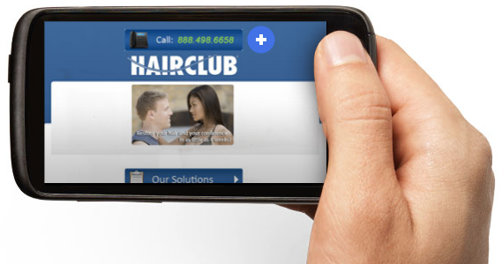
While some older phones and certain regions require websites to be written in a specific language and cannot handle JavaScript, most smartphones now have browsers similar to desktop computers. For this reason, older mobile websites are considerably different from more modern mobile sites.
If you are considering building a mobile website, it is recommended that you focus on building a site for users of high-end devices.
What is a high end device?
Many older phones required (and still require) certain protocols to access the Internet. At the time, most mobile websites were designed using specific mobile markup languages, and most browsers could not render standard HTML or JavaScript.
Now phones like iPhones and Android phones have more sophisticated browsers that can access the Internet in the same way as a standard desktop browser. Phones with this capability are considered to be high-end devices.
6.1 Reasons to have a mobile friendly website
According to a research 80% of the customers abandon a mobile site if they have a bad user experience. And they don’t even recommend it to others. Due to the difference in the screen size and input types in desktop computers and mobile devices there is a huge difference in the elements of user friendliness. The same website created for the desktop computers can’t be optimal for the mobile devices as well. This definitely affects the conversion rates through the mobile devices.
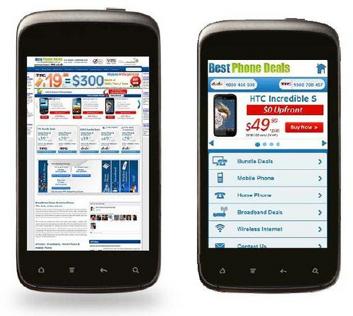
Traffic from mobile devices is growing year on year. Moreover, less than 40% of businesses have a mobile optimized site. So this is the right time to tap into the market, create a mobile optimized site and hence increase conversion rates.
6.2 Desirable Qualities of a Mobile Website
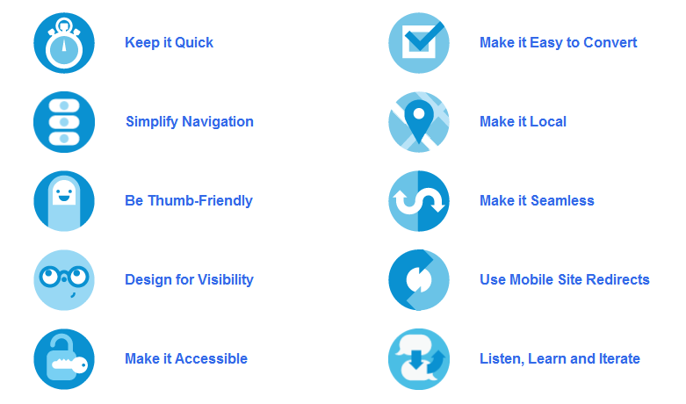

Keep it quick
Mobile users are often short on time, squeezing in online tasks as they go about their day. To help them, design your site to load fast and make copy easy to read.
- Prioritise the content and features that mobile users need most. Use your desktop site analytics to see what mobile users are doing.
- Reduce large blocks of text and use bullet points for easy reading.
- Compress images to keep them small for faster site loading.

Make it easy to convert
No matter what your site’s objective is, your customers need to be able to do it with a virtual keyboard and no mouse. Make it easy to buy something or contact you!
- Focus on information that will aid conversion (i.e., product details).
- Reduce the number of steps needed to complete a transaction.
- Keep forms short and use the fewest number of fields possible.
- Use check boxes, lists and scroll menus to make data entry easier.
- Use click-to-call functionality for all phone numbers.
- Implement conversion tracking to monitor how users are converting on the site.

Simplify Navigation
No one likes to be confused. Clear navigation and, on large or complex sites, search functionality, will help your customers easily find what they need.
- Minimise scrolling and keep it vertical only.
- Use a clear hierarchy in menus and avoid rollovers.
- Help users navigate between levels with clear back and home buttons.
- Use seven links or fewer per page of navigation.
- Have a search box prominently available on complex sites.
Make it local
Consumers look for local info on their phones all the time—from locating the nearest gas station to finding an open pizza place. Include functionality that helps people find and get to you.
- Have your address or store locator on the landing page.
- Include maps and directions. Use GPS to personalise when possible.
- Allow users to check stock at nearby stores.
Be thumb friendly
People use their fingers to operate mobile devices – especially their thumbs. Design your site so even large hands can easily interact with it.
- Use large, centred buttons and give them breathing room to reduce accidental clicks.
- Pad smaller buttons to increase the clickable area.
- Pad check boxes by making the text clickable.
Make it seamless
People now use multiple screens throughout the day. Convert as much of the functionality of your desktop site to mobile as you can to create a seamless experience.
- Allow users to save popular searches and shopping cart contents.
- Maintain key features of your site across all channels as much as possible.
- Display the same information for products/services.

Design for visibility
A mobile-friendly site gets its message across without causing eyestrain. Make it easy for your customers to read – remember they may be in a place with low light.
- Create contrast between background and text.
- Make sure content fits on screen and can be read without pinching and zooming.
- Use plenty of negative space.
- Use size and colour to indicate link/button priority.
- Use 3D effects and shadowing for buttons.

Use mobile site redirects
A mobile site redirect is code that can automatically tell if visitors are using a mobile device and send them to the mobile-friendly version of your site. Have your site developer implement this redirect code so your customers get the best version of your site for their needs.
- Give users a choice to go back to the desktop site, but make it easy to return to the mobile site.
- Let users choose which version they prefer to see for later visits.
- Include key information, such as your address or a store locator, on the redirect page.
Make it accessible
Ideally, your mobile site should work across all mobile devices and all handset orientations.
- Find alternatives to Flash – it does not work on some devices.
- Use HTML5 for interactivity and animation.
- Adapt your site for both vertical and horizontal orientations.
- Keep users in the same place when they change orientation.
Listen, learn and iterate
Good mobile sites are user-centric, which means they’re built with input from your audience. Ask your desktop site users what they want in a mobile website and make testing and optimisation an ongoing process.
- Use analytics and conversion tracking to understand how people use your site.
- If possible, especially for complex sites, do user testing before implementation and collect user feedback after launch.
- Iterate often and continuously improve your site based on your research.

7.0 Mobile Marketing Case Studies
TicketsNow
A subsidiary of Ticketmaster, TicketsNow is a resale marketplace where fans buy and sell event tickets. When research revealed that more than 25% of ticketing-related web searches occur on mobile devices, they knew they needed to transform www.ticketsnow.com into a better experience for their mobile users.
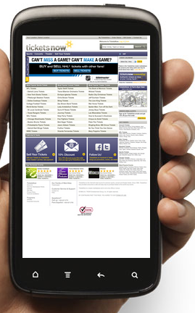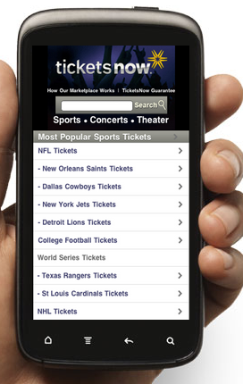
Before After
App or Site – Which comes first?
This led the team to the inevitable question: which should we build first – a mobile site or an app?
Given that search is one of the company’s biggest channels for customer acquisition, it made the most sense to lead with a mobile site and provide a streamlined user experience. A mobile site would also reach the broadest audience rather than having to develop apps one by one for the most popular platforms.
Cost was another factor. TicketsNow had enough technical expertise, curiosity and specific knowledge about the ticketing industry to create a mobile site faster at less cost in-house. A tiny group of innovators – initially comprised of just one person – had a demo ready in no time. According to Gadhvi, creating a mobile site wasn’t a massive undertaking.
To make informed decisions about optimizing the mobile site, marketers analyzed traffic by device to the original desktop site. Based on the insight that 97% of mobile traffic came from Android, iPhone and Blackberry smartphones, developers keyed in on these three devices when determining the mobile site’s design parameters and functionality.
“At the very least we wanted to cover the cost of building the mobile site using the margin generated by incremental sales from Google mobile paid search as a result of conversion and efficiency improvements. We are right on track to achieve that.”
—Sachin Gadhvi, Director of Search and Mobile Marketing, TicketsNow
Results: Even better than expected
After creating the mobile site, TicketsNow monitored trends: average order values, conversions, sales and more. While the team already knew that ticketing and mobile were a natural match, the power of mobile marketing exceeded their expectations. In the first month after launching the mobile site, average order values from mobile devices increased 8%, conversion rate grew by a sustained 50%, sales grew by an impressive 100% and overall return on ad spend from paid search saw a 30% boost.

Insurance Auto Auctions Inc. (IAAI)

The Opportunity
Headquartered near Chicago, Insurance Auto Auctions, Inc., (IAAI) is one of North America’s largest vehicle buyers / auctioneers, reselling insurance-salvaged and donated vehicles, and purchasing vehicles from the general public. The company auctions more than 1.3 million vehicles per year. The company uses its cars.iaai.com site to connect with vehicle owners who want to sell their cars to IAAI.
Says Joe Sieger, IAAI’s Vice President of Product Development, “When someone wants to sell their car, that person is probably sitting in their car or near their car, so if we can catch them on their mobile device, we can close the deal then and there.”

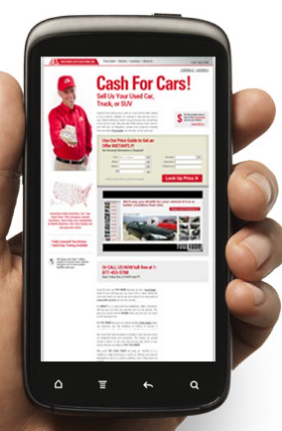

Before After

Mobile Site Highlights
The IAAI mobile site concentrates on content that drives fast conversions: location info, the online price guide, and strong calls to action. Anonymous price quotes and a photo guide to vehicle conditions have increased conversion rates dramatically. Simplified navigation and forms make it easy for customers to get in touch. “The mobile site is about contacting us quickly. We know we only have a few minutes of their time,” Sieger notes.

The Results
The new site launched along with a mobile-targeted AdWords campaign. Both site and campaign have undergone constant optimization since, as the team learned and refined accordingly. The results have been amazing — less than a year in, mobile generates about 20% of all conversions. Now, the team is considering location-specific mobile landing pages for a geo-targeted mobile campaign.

Take advantage of the Mobile Markting boom
If you want your business to take advantage of this huge growth sector, we can help. Our company offers a full range of Mobile Marketing solutions with everything from App building through to mobile websites and marketing campaign management.
Call us at: 123-456-789 or email: you@yoursite.com to get started

References
Industry statistics
http://www.digby.com/mobile-industry-resources/mobile-industry-statistics/
Detailed statistics and graphs
http://www.thinkwithgoogle.com/mobileplanet/en/
http://www.thinkwithgoogle.com/insights/library/infographics/mobile-movement/
Web.com survey
http://ir.web.com/releasedetail.cfm?ReleaseID=670104
http://www.networksolutions.com/smallbusiness/smbmobileinfographic/?channelid=P99C425S627N0B142A1D38E0000V100
Increasing share of mobile devices
http://royal.pingdom.com/2012/05/08/mobile-web-traffic-asia-tripled/
Desirable qualities of a mobile website
http://www.howtogomo.com/en/d/why-go-mo/#reasons-mobile-matters
Case Studies
http://www.howtogomo.com/en/d/why-go-mo/#case-studies

