**YI LIU**

Phone: +1 *817-678-8116*

Email: *yiliu@my.unt.edu*

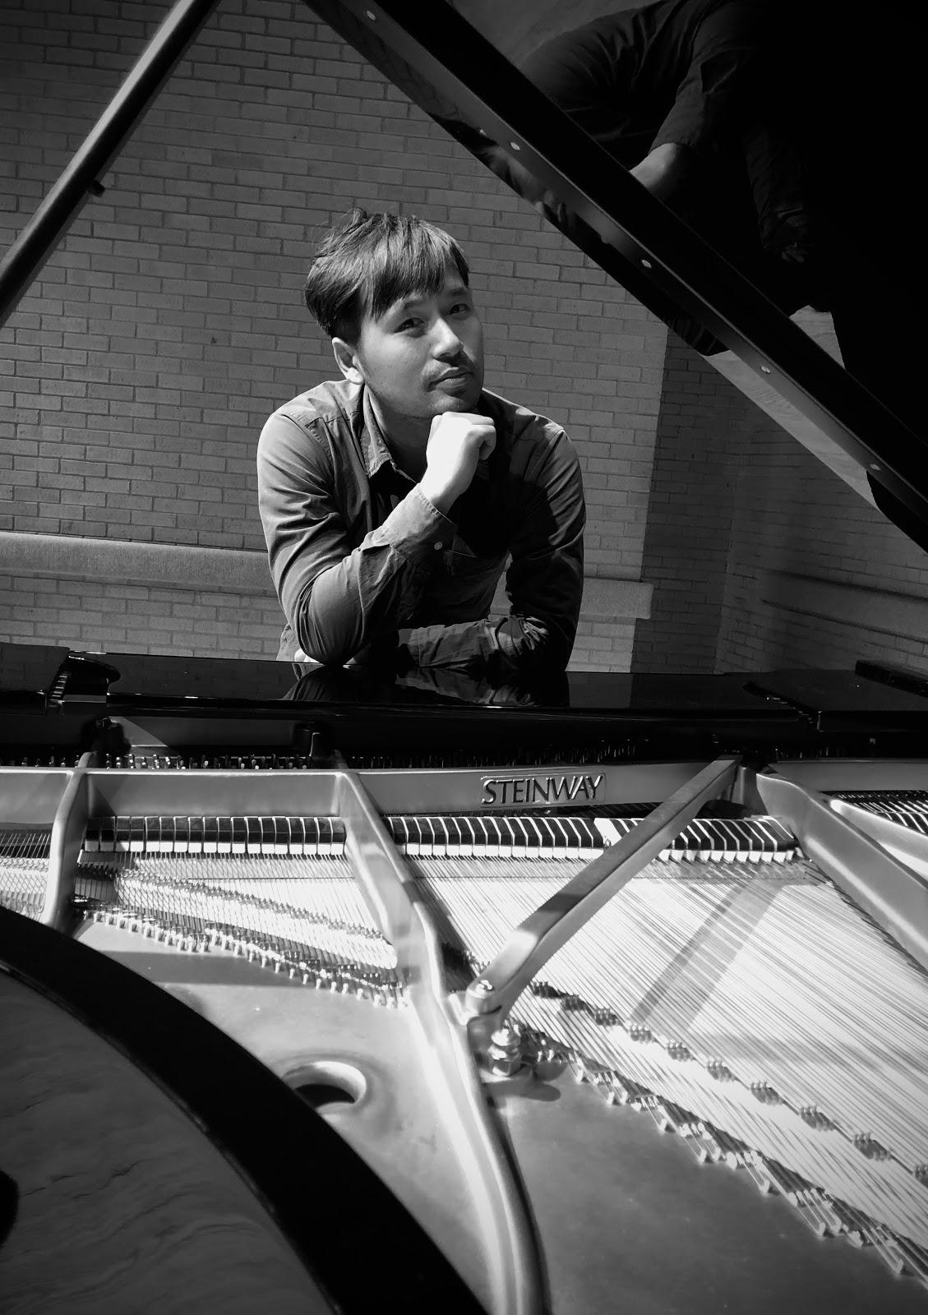

**EDUCATION**

**The University of North Texas** | Denton, TX | All but dissertation (ABD) status, anticipated graduation in May 2023

Doctor of Musical Arts in Piano Performance and Collaborative Piano. Under tutoring by Adam Wodnicki(Piano Private Lesson), Dr. Steven Harlos and Dr. Elvia L. Puccinelli(Collaborative Piano), Dr. Brad Backman(Piano Pedagogy), Dr. Pamela Mia Paul(Center Piano Trio), Dr. Timothy Jackson(Music Analysis), Joseph Banowetz(Piano Literature).

**Boston Conservatory at Berklee** | Boston, MA | graduated in December 2017

Graduate Performance Degree in Piano performance. Under tutoring by Ya-fei Chuang (Piano Private Lesson), Lynn Chang and Andrew Mark (Chamber Music), Mischa Salkind-Pearl and Rebecca Marchand (Music Theory and Musicology).

**Mozarteum International Summer Academy |** Salzburg, Austria | August 2016

Summer Institute at Mozarteum University Salzburg Wolfgang Holzmair, director. Lessons with Ya-fei Chuang and Robert Levin.

**Shanghai Conservatory** | Shanghai, China | graduated in June 2015

Master of Music in Piano Performance. Under tutoring by Dr. Cheung-Yu Mo (Piano Private Lesson), Dr. Chen Jiang and Dr. Wei-cong Zhang(Chamber Music).

**Shanghai Normal University College of Music |** Shanghai, China | graduated in 2009 Bachelor of Arts in Piano Performance. Studied with professor Qiao-Yun Yang (2004-2006) and professor Yi-Qiang Sun (2006-2010).

**Shanghai** | China | Studied Piano with Dr. Kang-wei Hou (1991-1993) and Zhen-yu Dong (1993-2004).

**AWARDS**

* Gershwin International Music Competition Chamber Division Final Round, June 2022 <http://www.gershwincompetition.org/Winners2022.html>
* Isabel Scionti Scholarship Piano Competition Winner, Nov. 2021
* University of North Texas College of Music Concerto Competition Winner, Oct. 2020
* Gold Medal Winner in the Solo Division of the Piano Competition of International Keyboard Odyssiad & Festival, August 2019 <http://odyssiad.com/winners>
* Second Prize in the Chamber Music Division of 4th ENKOR International Music Competition,2018 <http://www.enkorcompetition.com/2018/02/fenway-quartet-2nd-prize-chamber-music.html>
* Piano Honors Competition Winner, The Boston Conservatory, 2016
* Third Prize in the competition of the 30th Shanghai Spring International Music Festival, 2013 <http://www.pianoun.com/detail.asp?id=552>
* Shanghai-Osaka Chinese & Japanese Friendship Youth Piano Competition, New Comer’s Prize, Shanghai, 2000

**SCHOLARSHIP**

* UNT College of Music Competitive Graduate Chamber Music Award (Verdehr Trio), 2022
* Isabel Scionti Piano Competition Winner Scholarship, 2022
* Teaching Fellowship, University of North Texas College of Music, 2021 - 2022
* Competitive Graduate Chamber Music Performance Scholarship from Murchison Foundation, 2021 - 2022
* Competitive Graduate Chamber Music Performance Scholarship from Murchison Foundation, 2020 - 2021
* Teaching Fellowship, University of North Texas College of Music, 2020 - 2021
* Teaching Fellowship, University of North Texas College of Music, 2019 - 2020
* Academic Scholarship in Graduate Studies, The Boston Conservatory at Berklee, 2017 - 2018
* Academic Scholarship in Graduate Studies, The Boston Conservatory at Berklee, 2016 - 2017
* Academic Scholarship, Mozarteum International Summer Music Festival, Salzburg, 2016

**SELECTED PERFORMANCE EXPERIENCE**

* Gershwin International Music Competition Chamber Division Semi Final and Final Round, New York, June 2022
* Ashley Beyer’s Horn Recital at Music Institute of North Texas, Frisco, TX May 2022
* UNT Center for Chamber Music Concert, the program including the US premeire of composer Joseph Jongen’s deux pièces en trio pour piano, violon et violoncelle, op. 95 Voertman Hall, TX, April 2022
* Piano Recital at Voertman Hall, TX, April 2022
* A concert featuring all contemporary compositions including Gian Cario Menotti, Alexander Arutunian, and Joan Tower’s works written for the Clarinet, Violin, and Piano Trio, Voertman Hall, TX, April 2022
* Temeraire Piano Trio Recital at Brookhaven College of Music, Farmer Branch, TX, April 2022
* Performance with double bass at the Christian Stronghold Church, Dallas, April 2022
* Piano Recital at Brookhaven College of Music, featuring Handel, Brahms, Richard Wagner, Leopold Godowsky, and Ignaz Friedman’s works, Farmer Branch, TX, April 2022
* Temeraire Piano outreach concert at the Carriage House Assisted Living of Denton, April 2022
* Mckinney Philharmonic Orchestra Recital Concert Series III — the Temeraire Piano Trio, March 2022
* Temeraire Piano outreach concert at the Good Samaritan Lake Forest, March 2022
* Isabel Scionti Scholarship Piano Competition Winner’s Recital, March 2022
* Jin Wang’s DMA Cello Recital, performed Brahms Sonata No. 2 in F major, Op.99 for Cello and Piano, Choir Hall at UNT, TX, March 2022
* Accompanied for Samuel Garcia who won the 2nd prize in the senior division of the 2022 Vernell Gregg Young Artists Competition, January 2022
* UNT Center for Chamber Music Concert, Temeraire Piano Trio performed Brahms Piano Trio No. 3 in C minor, Op. 101, Voertman Hall, TX, Nov. 2021
* Recording project of the Schubert Piano Trio in E flat major No. 2, Op. 100, posted on the UNT Chamber Studies website, TX, 2021
* Piano Recital at Brookhaven College of Music, featuring Rameau, Schubert, Liszt, and Scriabin’s works, Farmer Branch, TX, April 2021
* Piano Recital, Voertman Hall, TX, April 2021
* Isaac Kim’s Graduate Artist Certificate Cello Recital, performed Rachmaninoff Sonata in G minor, Op.19 for Cello and Piano at Voertman Hall, TX, 2021
* Collaborative Piano Recital, featuring Schubert and Debussy’s Art songs and Rachmaninoff Sonata in G minor, Op.19 for Cello and Piano at Voertman Hall, TX, 2021
* Lecture Recital of Chopin’s etudes on the online platform VIP Peilian, 2020
* UNT Center for Chamber Music Concert, the Center Piano Trio performed Shostakovich Piano Trio No.1 at Voertman Hall, TX, 2020
* Yuhong Sun’s DMA Violin Recital featuring Grieg’s Sonata for violin and piano No.2 in G major, Op. 13, and Prokofiev Sonata for Violin and Piano No. 2 in D Major, Op. 94a, Voertman Hall, TX, Nov. 2020
* UNT 2020 Concerto Competition Winner’s Concert, Murchison Performing Arts Center Winspear Performance Hall, TX, 2020.
* Beethoven 250th Celebration Series Concerts, performed Beethoven Piano Sonata No.30 in E Op.109 Murchison Performing Arts Center Winspear Performance Hall, TX, 2020.
* Artist Interview and Piano Recital of the Chopin Etudes Op. 25 (Whole) posted on the Facebook Classic Music Channel “Le Salon de la Music”, September 2020.
* Recording project of composer kory reeder’s Piano Trio “Adjacent Spaces”( Premiere), 2020
* Recording project of the Beethoven Piano Trio Op.70 No. 2 posted on the Facebook Classic Music Channel “Le Salon de la Music”, 2020
* CollabFest 2019 masterclass performance of Brahms Sonata for Violin and Piano No. 3 in D minor, Op. 108 at Recital Hall, UNT, TX, 2019
* UNT Center Trio Chamber Music Recital performed Shostakovich Piano Trio No.2 Op.67 at Voertman Hall, TX, 2019
* Piano Recital, featuring Beethoven Piano Sonata No.12 in A-flat major, Op. 26, and Chopin Etudes Op. 25 (Whole) at Recital Hall of UNT, TX, 2019
* Winner concert of the Piano Competition of International Keyboard Odyssiad & Festival, Colorado State University, Fort Collins, CO, Aug. 2019
* UNT Summer Opera festival performed the whole of Mozart’s Opera Don Giovanni, Voertman Hall, University of North Texas College of Music, Denton, TX, 2019
* Sunset Recital Series Vocal Concert, Corinth, TX, 2019
* North Texas Collaborative Pianist Concert, UNT on the Square, Denton, TX, 2018
* China and Turkey Exchange Concert - International Musicians Concert Series, performed Mozart Sonata in G major for Violin and Piano K.301 and Brahms Violin Sonata No. 2 in A major, Op. 100 at Suzhou University of Science and Technology, Suzhou, China, 2018
* Chamber Music Lecture Concert, with Violinist Jin Zhou, performed Mozart Sonata in G major for Violin and Piano K.301 and Brahms Violin Sonata No. 2 in A major, Op. 100 at Shanghai Concert Hall, Shanghai, 2018
* Chamber Series Concert, Performed Robert Schumann’s Piano Quintet in E-flat major, Op. 44 with Boston Conservatory Faculties Violinist Katie Lansdale, Violist Lila Brown, and Cellist Rhonda Rider, Seully Hall, Boston Conservatory at Berklee, MA, 2017
* Competitor in the 18th San Jose International Piano Competition, Trianon Theater, San Jose, CA, 2017
* Millennial Chamber Music Concert, Seully Hall, The Boston Conservatory at Berklee, MA, 2017
* Recital, Seully Hall, The Boston Conservatory at Berklee, Boston, MA, 2016, 2017
* Mozarteum International Summer Music Festival Recital, Kleines Studio Hall, Salzburg, 2016
* Winners Chamber Music Concert, Seully Hall, The Boston Conservatory at Berklee, MA, 2016
* Chamber Music Concert Series, Shanghai Concert Hall, 2015
* Chamber Music Concert Series, Hangzhou Grand Theater, 2015
* Piano Recital, The Music Hall at TV Tower of Zhengzhou City, Henan, 2014
* Piano Recital, Shanghai Concert Hall, 2014
* Piano Duo Recital at Shanghai Concert Hall featuring Bach Chopin and Liszt (had media reviewed)
* Piano Recital, North Building Lecture Hall, The Shanghai Conservatory, 2013
* Piano Recital featuring Mozart, Chopin, Liszt, Faure, and Horowitz works, at Beethoven Hall, Shanghai, 2012 (had media reviewed)
* Chamber Music Concert Series, Shanghai Conservatory, 2012
* Master Class of the International SHNU Music Week, performed Ravel Gaspard de la Nuit, and has been given instructions by renowned American Pianist Joseph Banowetz, 2008
* Piano Degree Recital, Shanghai Normal University College of Music, Shanghai, 2007
* SSO Weekend Chamber Music Concert, Piano Solo Performed Beethoven Piano Sonata No. 21 in C major, Op. 53, “Waldstein”, Rachmaninoff Tableau in c minor, Op.39 No.7, and Liszt Hungarian Rhapsody No.12 in c sharp minor, S.244, Shanghai Symphony Ochestra Hall, Aug. 2007
* SSO Weekend Chamber Music Concert, with Shanghai Normal University College of Music professor flutist Qi Wang, performed Mozart Flute Concerto No.2 in D Major, and Burton Flute Sonatina, Shanghai Symphony Ochestra Hall, May. 2006
* SSO Weekend Chamber Music Concert —— Mozart 250 Birthday Memorial Concert Series, with Shanghai Normal University College of Music professor flutist Qi Wang, performed Mozart A Major, K. 12 and F Major, K.13 Flute Sonatas, Shanghai Symphony Ochestra Hall, Jan. 2006
* Shanghai-Osaka Chinese & Japanese Friendship Youth Piano Competition, performd Liszt Hungarian Rhapsody No.12 in c sharp minor, S.244, Shanghai, Aug. 2000

**MASTERCLASS EXPERIENCE**

* Chamber Performance and Masterclass with Hermitage Trio (Misha Keylin, Sergey Antonov, and Ilya Kazantsev), 2021
* Chamber Performance and Masterclass with Jean Barr, 2021
* Chamber Performance and Masterclass with Dover Quartet (Joel Link, Bryan Lee, Milena Pajaro-Van de Stadt, Camden Shaw), 2021
* Chamber Performance and Masterclass with Seth Knopp, 2020
* Chamber Performance and Masterclass with New Zealand String Quartet (Helene Pohl, Monique Lapins, Gillian Ansell, Rolf Gjelsten), 2020
* Chamber Performance and Masterclass with Alan L. Smith, 2019
* Chamber Performance and Masterclass with Andrew Harley, 2019
* Solo Performance and Masterclass with Kemal Gekic, 2019
* Solo Performance and Masterclass with Oleg Marshev, 2019
* Solo Performance and Masterclass with Arnaldo Cohen, 2018
* Chamber Performance and Masterclass with Jonathan Bass, 2017
* Chamber Performance and Masterclass with Rhonda Rider, 2017
* Chamber Performance and Masterclass with Judith Gordon, 2017
* Chamber Performance and Masterclass with Sarah Bob, 2016
* Solo Performance and Masterclass with Michael Chertock, 2016
* Solo Performance and Masterclass with Joseph Banowetz, 2008

**WORKING EXPERIENCE**

* Adjunct instructor, Collaborative Pianist, Texas Woman's University, 2022
* Teaching Fellow, Piano instructor, Piano Group Class teacher, University of North Texas College of Music, directed under Dr. Brad Beckman, 2019- present
* Center Trio Pianist, University of North Texas College of Music, directed under Dr. Pamela Mia Paul, 2019 - present <https://chambermusic.music.unt.edu/>
* Pianist and Organist, Buckingham United Methodist Church, Garland, TX, 2020-2021
* Pianist, First United Methodist Church, Alvord, Texas, 2019 -2020
* Piano​ instructor, 7-notes Yamaha music school, Frisco, Texas, 2018 - 2019
* Instructor of ABRSM​ ​Piano​, Music​ ​Theory​ ​and​ ​Ear​ ​Training, ​ABRSM​ ​Exam Accompanist, ​IP​ ​Piano​ School​, ​Boston​, 2017
* Piano Instructor at Yinhua Riverside Music School, Shanghai, Pudong, 2014-2015
* Piano Instructor at Yamaha Music School, Shanghai, 2013-2015
* Piano instructor ABRSM​ ​Piano​, Music​ ​Theory​ ​and​ ​Ear​ ​Training at Zhiyin Music School, Shanghai, 2008-2015
* Piano instructor, ABRSM​ ​Piano​, Music​ ​Theory​ ​and​ ​Ear​ ​Training at Haiyin Music School, Shanghai, 2006-2013

**Group Piano Classes and Studio Piano Classes at UNT**

* MUAS 1501 Section 710 - Lower-Level Applied Music, Private Lessons (Fall 2019 1)
* MUAC 3501 Section 710 - Upper-Level Applied Music, Private Lessons (Fall 2019 1)
* MUAG 1011 Section 504 - Keyboard Skills for Music Majors (Fall 2019 1)
* MUAS 1501 Section 710 - Lower-Level Applied Music, Private Lessons (Spring 2020 1)
* MUAC 1501 Section 710 - Upper-Level Applied Music, Private Lessons (Spring 2020 1)
* MUAG 1012 Section 503 - Keyboard Skills for Music Majors (Spring 2020 1)
* MUAG 1002 Section 500 - Piano Class for Non-Music Majors (Fall 2020 1)
* MUAG 1012 Section 503 - Keyboard Skills for Music Majors (Fall 2020 1)
* MUAG 1012 Section 511 - Keyboard Skills for Music Majors (Spring 2021 1)
* MUAG 1012 Section 507 - Keyboard Skills for Music Majors (Spring 2021 1)
* MUAG 1013 Section 500 - Keyboard Skills for Music Majors (Fall 2021 1)
* MUAG 1013 Section 503 - Keyboard Skills for Music Majors (Fall 2021 1)
* MUAG 1001 Section 502 - Piano Class for Non-Music Majors (Spring 2022 1)
* MUAG 1002 Section 500 - Piano Class for Non-Music Majors (Spring 2022 1)
* MUAG 1011 Section 505 - Keyboard Skills for Music Majors (Fall 2022 1)
* MUAG 1011 Section 509 - Keyboard Skills for Music Majors (Fall 2022 1)

**STUDENTS ACHIEVEMENT**

* Juner Zhang was admitted to the San Francisco Conservatory of Music for MM in Collaborative Piano Major with half scholarship, San Francisco, 2022
* Xi-Jian Jiang was admitted on a full scholarship to the Berklee College of Music for a BA in Composition Major, Boston, 2019
* Yu-Jie Cai was admitted to the Monash University Sir Zelman Cowen School of Music for BM in Music Performance and Music Education double major, Melbourne, 2019
* Xin Tong was admitted to the École Normale de Musique de Paris "Alfred Cortot" for BA with scholarship in Piano Major, Paris, 2016