CSCE 5290/4290

Course Information:
Instructor: Weishi Shi ( Weishi.Shi@unt.edu)
Office: Discovery Park F227
Office Hours: 3:00 pm - 4:00 pm Wed.
Office Hours (TA/IAs):
CSCE 5290 section 1: Rahul Sai Challa Thursday from 4 pm - 5 pm at E Wing Cubicle E
CSCE 5290 section 2: Arefa Patwary Wednesday from 3 pm - 4 pm at F254
Lecture Time: 5:30pm-8:20pm Wed.
Lecture Location: NTDP E266

Course Description:
This course provides an introduction to the fundamental ideas and methods of natural language processing (NLP), with a focus on how modern language and multimodal models represent, learn from, and reason over text and language-related data. Topics include text preprocessing and tokenization, classical language models, text classification, word embeddings, neural networks for NLP, large language models, Transformer architectures, and information retrieval. The course emphasizes conceptual understanding of modeling assumptions and design choices, rather than exhaustive theoretical derivations. In addition to lectures, students will complete a team-based project involving the annotation of vision–language data, gaining hands-on experience with data collection and labeling practices that underpin contemporary multimodal language models. The course is intended for advanced undergraduate and graduate students seeking a broad and coherent view of NLP and modern language modeling.

Course Requirements:
- Basic familiarity with Python programming, including core syntax, control flow, and simple data structures.
- Prior exposure to undergraduate level mathematics, including calculus, linear algebra, and probability, with emphasis on conceptual understanding rather than advanced proofs.
- Willingness to read the course textbook and assigned materials in parallel with the lecture schedule.

Course Outcomes:
After taking this course, the student will:
- Understand core concepts in natural language processing, including words, tokens, sequences, and semantic representations, and distinguish symbolic representations from learned semantic models.
- Apply classical text processing techniques such as edit distance and n-gram representations and explain their roles and limitations in language modeling and text analysis.
- Explain the principles behind statistical language models, including probability estimation, independence assumptions, and data sparsity issues.
- Formulate text classification problems as supervised learning tasks and implement basic classifiers using logistic regression.
- Understand the motivation behind distributed word representations and word embeddings and analyze what linguistic information they capture and fail to capture.
- Describe how neural networks are used in NLP, including the role of feedforward models in text representation and classification.
- Develop a high-level understanding of large language models, including the pretraining and fine-tuning paradigm and its implications for downstream tasks.
- Explain the core components of the Transformer architecture, including attention mechanisms and encoder–decoder structures, and why Transformers dominate modern NLP systems.
- Compare autoregressive and masked language modeling objectives and explain their suitability for different NLP tasks.
- Understand recurrent neural networks and LSTMs at a conceptual level, including their historical significance and limitations relative to Transformers.
- Explain fundamental ideas in information retrieval, including text representation, similarity matching, and ranking objectives.
- Critically read NLP research papers and technical reports, identifying modeling assumptions, scope of applicability, and practical limitations beyond reported performance metrics.
- Gain hands-on experience in collecting and annotating vision–language data through a team-based project, developing a practical understanding of how training data for modern multimodal language models is created, structured, and curated.

Course Textbooks:

Main textbook:
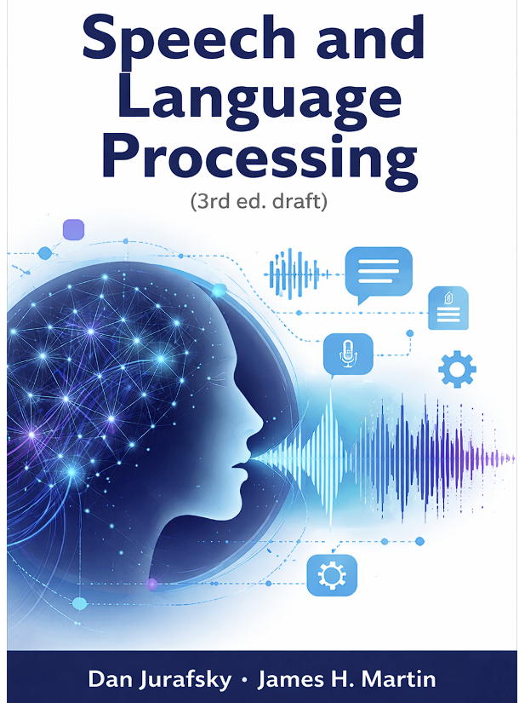 | NAME: Speech and Language Processing  Author: Dan Jurafsky and James H. Martin  Availability: Full PDF online  https://web.stanford.edu/~jurafsky/slp3/  Scope: Volume I: Large Language Models

Course Schedule:

Calendar | Major Topic(s) | Content Covered in Textbook | Activities
Week1 (1.14) | Introduction | - | Project Team formation
Week2 (1.21) | Words and Tokens (1)  [Edit Distance] | Ch2 | Team-Up due. Project1 publish
Week3 (1.28) | Words and Tokens (2)  [Edit Distance] | Ch2 | Assignment 1 publish.
Week4 (2. 4) | N - Gram Language Model | Ch3
Week5 (2.11) | Text Classification (1)  [Logistic Regression] | Ch4 | Assignment 1 due.
Week6 (2.18) | Text Classification (2)  [Logistic Regression] | Ch4 | Assignment 2 publish
Week7 (2.25) | Word Embedding | Ch5 | Project 1 due.  Project 2 publish.
Week8 (3.4) | Mid-Term Exam |  | Mid-Term Exam
Week9 (3.11) | Spring Break No Class
Week10 (3.18) | Neural Networks | Ch6
Week11 (3.25) | Large Language Models | Ch7 | Assignment 2 due
Week12 (4.1) | Transformers | Ch8 | Assignment 3 publish.
Week13 (4.8) | Masked Language Models | Ch10
Week14 (4.15) | RNN & LSTM | Ch13
Week15 (4.22) | Information Retrieval | Ch11 | Assignment 3 Due.  Project 2 Due
Week16(4.29) | Class Summary & Review
 | Final Exam

Grade & Evaluation:

Component | Weight
Assignments | 3 * 10 = 30%
Team Project | 1Mordern Language Data Annotation 20%.  2.Mordern Language Data Annotation with AI assistance. 20%  Total: 40%
Mid Term | 15%
Final | 15%
Extra Credits for Participating in the Class Discussion & Class Evaluation | 10%

Percentage | Grade
A | >=90%
B | [80%,90%)
C | [70%,80%)
D | [60%,70)
F | [0%,60)

AI Use Policy
This course allows the use of AI tools, including large language models, for learning, exploration, and brainstorming purposes. However, all submitted work must reflect the student’s own understanding and effort. Direct copying of AI-generated content, or submitting AI-generated work as one’s own without proper acknowledgment, is not permitted. Specific assignments may include additional guidance on acceptable and unacceptable uses of AI tools. Violations will be treated as academic misconduct under UNT’s Academic Integrity Policy.

SPOT & ABET Evaluation Notice
Student feedback is an important component of course and program improvement. Students are encouraged to participate in the Student Perception of Teaching (SPOT) evaluation at the end of the semester. Results from SPOT and other assessment instruments may also be used for ABET accreditation and continuous improvement of the program.

ODA Notification
The University of North Texas makes reasonable academic accommodations for students with disabilities. Students seeking accommodations must first register with the Office of Disability Access (ODA). Once approved, students should notify the instructor as early as possible to arrange accommodations.

Course Rules:
- Emails will be answered as promptly as possible. Emails outside normal working hours (8 am to 5 pm) will be answered on the next working day.
- Work handed in for grade (homework, project report, etc.) MUST BE YOUR OWN effort only. Students are NOT allowed to use online solutions from previous course offerings, websites, etc. This will be strictly checked and enforced. The students should adhere to the UNT policies and procedures on the Code of Academic Integrity. 06.003 Student Academic Integrity https://policy.unt.edu/policy/06-003. Plagiarism WILL result in a score of 0 for the assessment in which it occurs.
- Any appeals on assessment grading must be made online in Canvas (not by email) no later than one week after the grading is complete. This applies to examinations as well. Appeals should be as specific as possible and must contain a valid reason. Appeal such as “I think I deserve more for this assessment, or my overall grade has reduced as a result of this assessment” are NOT valid reasons and such appeals will not be processed. Grading is done carefully, and, in most cases, appeals will not result in a change of mark. Do not share your submission, do not ask for others’ submission. This is an introduction course, we are very kind to honest submissions but extremely harsh on misconduct and dishonest behaviors. The first time misconduct results in 0 for the corresponding assignment and the second time violation will be reported to academy integrity office with recommendation of F for final grade.
- Student behavior that interferes with an instructor’s ability to conduct a class or other students’ opportunity to learn is unacceptable and disruptive and will not be tolerated in any instructional forum at UNT. Students engaging in unacceptable behavior will be directed to leave the classroom and the instructor may refer the student to the Center for Student Rights and Responsibilities to consider whether the student’s conduct violated the Code of Student Conduct. The university’s expectations for student conduct apply to all instructional forums, including university and electronic classrooms, labs, discussion groups, field trips, etc. The Code of Student Conduct can be found at https://policy.unt.edu/policy/07-012
- Usage of cell phones, earphones, and other electronic devices, or recording of lectures is restricted. Usage of laptops and tablets is permitted for class purposes, only after obtaining permission from the instructor. Usage of classrooms computers, if any, are not allowed, while the class is in session.

