CSCE 5215 Machine Learning

Course Information:
Instructor: Weishi Shi ( Weishi.Shi@unt.edu)
Office: Discovery Park F227
Office Hours: 3:30 pm - 5:00 pm Fri.
Office Hours (IAs): 3:00 PM to 5:00 PM Mon
Lecture Time: 13:00 pm– 15:00pm Fri.
Lecture Location: online. https://unt.zoom.us/j/84248102496

Course Description:
Machine learning algorithms are able to learn directly from data to make predictions and decisions without being explicitly programmed. Topics include a wide variety of supervised learning methods, both regression and classification, with an emphasis on those that perform well on large feature sets. Ensemble methods are used to combine independent approaches efficiently. Unsupervised and semi-supervised methods will demonstrate the power of learning from data without an explicit training target or goal.

Learning outcomes: Students in this course will learn how to apply sophisticated algorithms to large data sets, focusing on practical application. The goal will be to create models that can make automated predictions or classifications on new data, or make inferences on unlabelled data to aid in understanding and future prediction models.

Online Course Delivery & Format:
This course is delivered fully online. All course activities, materials, and grades are managed through Canvas.
- Weekly Lecture (optional): A live lecture is held each week at the meeting time listed above, via the Zoom link listed above. Attendance is not mandatory — this session is offered for students who want real-time interaction with the instructor and classmates. Each session is recorded and posted to Canvas after class, so all students can review the full lecture content on their own schedule.
- Weekly Quiz: A quiz covering that week’s material is posted to Canvas each week and remains open for one week. Students must log into Canvas and complete the quiz within that window. Quizzes generally cannot be made up after the window closes, except in cases of a documented emergency, at the instructor’s discretion.
- Exams: The Mid-Term Exam and Final Exam are administered online through Canvas. Each exam is open from 9:00 AM to 9:00 PM Central Time on the scheduled exam day (see the Course Schedule for exact dates); students may start the exam at any time within that window, and the 90-minute time limit is counted from the moment each individual student starts the exam, not from a fixed clock time. Exams are open-book/open-note. Only one attempt is allowed, and questions may be shuffled or drawn from a question bank so that students do not all receive the exact same version.
- Technical Requirements: A reliable, high-speed internet connection and a computer capable of running Canvas and Zoom (a current version of Chrome, Firefox, or Edge is recommended). A webcam and microphone are optional and only needed if a student chooses to participate live in the Zoom session.
- Technical Support: For Canvas issues, contact the UNT Student Help Desk at ithelp@unt.edu / 940-565-2324, or visit helpdesk.unt.edu. For Zoom issues, see UNT’s Zoom support resources at zoom.unt.edu.
- Time Zone: All deadlines (quiz windows, exam windows, assignment due dates) are in Central Time (America/Chicago) unless otherwise noted on Canvas.
- Course Communication: The primary communication channel is UNT email and the Canvas Inbox. See Course Rules below for the expected email response time.

Course Requirements:
- Comfortable with python programming.
- Good understanding of data structures and scientific computing operations on computer(dot product, inverse, pseudo inverse, determinant, expectation, etc.)
- Undergraduate level calculus, linear algebra, and statistics.
- Attendance: Attendance is not mandatory.

Course Outcomes:
After taking this course, the student will:
- Learn the essentials of linear models. (Linear regression, Logistic Regression)
- Learn the advanced kernel models. (Gaussian Processes, SVM)
- Understand the fundamental theorems behind machine learning algorithms.
- Learn unsupervised learning techniques.(PCA,KMEANs)
- Be able to implement classical machine learning models and deep neural networks with open source libraries.

Course Textbooks:

Highly Recommended:
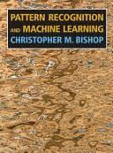 | NAME: Pattern Recognition and Machine Learning  Author: C. Bishop  Availability: Full PDF online

Recommended:

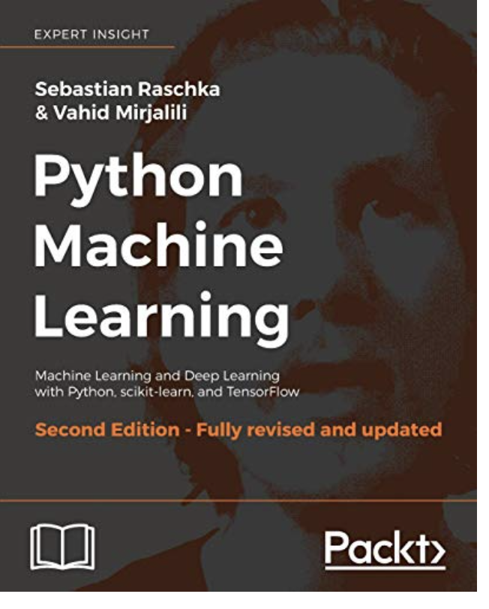 | NAME:Python Machine Learning  - Second Edition: Machine Learning and Deep Learning with Python, scikit-learn, and TensorFlow  (2th Edition)  Author: Raschka, Sebastian; Mirjalili, Vahid  Availability: Full PDF online

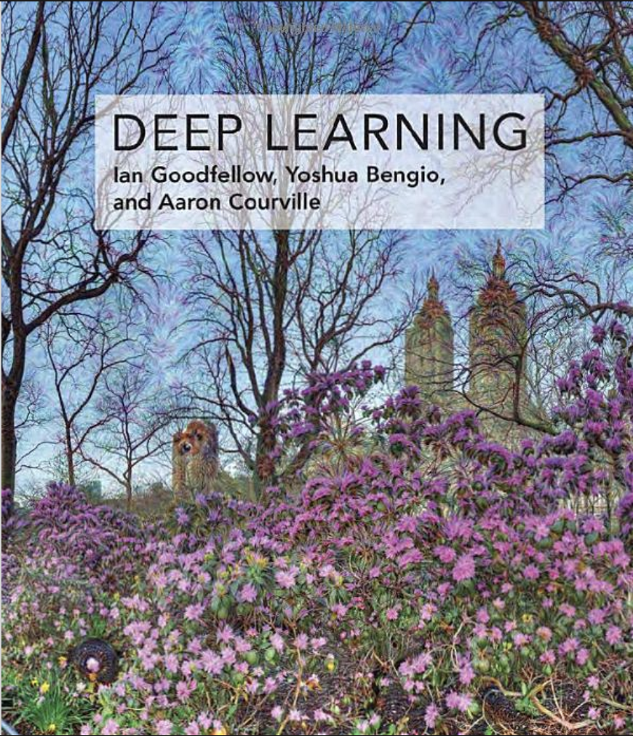 | NAME: Deep Learning  Author: Ian Goodfellow et al.  Availability: Full PDF online

Course Schedule:

Calendar | Major Topic(s) | Content Covered in Textbook | Activities
Week1 (8.21) | Introduction (1) | Ch1 | Quiz 1
Week2 (8.28) | Introduction (2) | Ch1 | Quiz 2
Week3 (9.4) | Probability Theory(1) | Ch2 | Quiz 3
Week4 (9.11) | Probability Theory(2) |  | Quiz 4
Week5 (9.18) | Linear Model for Regression(1) | Ch3 | Quiz 5  Assignment1 publish
Week6 (9.25) | Linear Model for Regression(2) | Ch3 | Quiz 6
Week7 (10.2) | Introduction to learning theorem & Mid-Term review.
Week8 (10.9)  9:00 AM – 9:00 PM | Mid-Term Exam |  | Mid-Term Exam
Week10 (10.16) | Linear Model for Classification | Ch4 | Quiz 7  Assignment 1 due  Assignment 2 publish
Week11 (10.23) | Neural Nets | Ch5 | Quiz 8
Week12 (10.30) | Kernel Methods | Ch6 | Quiz 9
Week13 (11.6) | Sparse Kernel Methods | Ch7 | Quiz 10  Assignment 2 due.  Assignment 3 publish
Week14 (11.13) | Mixture Models and EM | Ch9
Week15 (11.20) | Transformers |  | Assignment 3 due.  Assignment 4 publish
Week16 (11.27) | Summary Class
12.4 | Last assignment due |  | Assignment 4 due
12.9  9:00 AM – 9:00 PM | Final Exam |  | Final Exam

Grade & Evaluation:

Component | Weight
Assignments | 4 * 10% = 40%  Bonus 2*5% = 10% (From Assignment 3 and 4)
In-class Quiz | 10*2%=20%
Mid Term | 20%
Final | 20%
Extra Credits for Participating in the Class Discussion | 0% ~ 10%

Percentage | Grade
A | [90%+]
B | [80%,90%)
C | [70%,80%)
D | [60%,70)
F | 60%-

Canvas Grading Display Note: The Canvas Gradebook for this course is configured using Points, not Percentage. The grading components above sum to 100 points, with up to 20 additional bonus points available (10 points from the Assignment 3/4 bonuses, and up to 10 points from class participation), for a maximum possible total of 120 points. A score of 90 points or above (out of the 100-point base) corresponds to an A, and so on per the grading scale above. If your personal Canvas Grades view defaults to showing a percentage instead, use the gear/settings icon on the Grades page to switch the display to Points, so your running total matches the scale above.

AI Use Policy:
This course allows the use of AI tools, including large language models, for learning, exploration, and brainstorming purposes. However, all submitted work must reflect the student’s own understanding and effort. Direct copying of AI-generated content, or submitting AI-generated work as one’s own without proper acknowledgment, is not permitted. Specific assignments may include additional guidance on acceptable and unacceptable uses of AI tools. Violations will be treated as academic misconduct under UNT’s Academic Integrity Policy.

SPOT & ABET Evaluation Notice:
Student feedback is an important component of course and program improvement. Students are encouraged to participate in the Student Perception of Teaching (SPOT) evaluation at the end of the semester. Results from SPOT and other assessment instruments may also be used for ABET accreditation and continuous improvement of the program.

ODA Notification:
The University of North Texas makes reasonable academic accommodations for students with disabilities. Students seeking accommodations must first register with the Office of Disability Access (ODA). Once approved, students should notify the instructor as early as possible to arrange accommodations.

Emergency Notification:
UNT uses a system called Eagle Alert to quickly notify students with critical information in the event of an emergency (e.g., severe weather, campus closing, health hazard). Students should ensure their contact information is current with the university; more information is available at unt.edu/eaglealert.html.

Religious Holy Days:
Per UNT Policy 06.039 (Student Attendance and Authorized Absences), students should notify the instructor of anticipated absences to observe religious holy days as early in the semester as possible. Students will not be penalized for these excused absences and will be given a reasonable opportunity to make up missed work.

Title IX & Sexual Misconduct:
UNT is committed to providing a safe learning environment free of all forms of sexual misconduct, including sexual harassment, sexual assault, domestic violence, dating violence, and stalking. Students who have experienced or witnessed any of these issues may find resources at titleixeo.unt.edu, or may contact Survivor Advocates at SurvivorAdvocate@unt.edu or the Dean of Students Office at 940-565-2648.

Student Support & Wellness:
UNT’s Counseling and Testing Services offers free and confidential mental health support to enrolled students, including individual and group counseling and crisis support. Students experiencing distress can contact Counseling and Testing Services at (940) 565-2741 (option 2), or visit Chestnut Hall, Suite 313. Crisis support is available 24/7 at the same number (option 1).

Syllabus Subject to Change:
This syllabus, including the course schedule, is subject to change at the instructor’s discretion. Any changes will be announced on Canvas.

Course Rules:
- Emails will be answered as promptly as possible. Emails outside normal working hours (8 am to 5 pm) will be answered on the next working day.
- Work handed in for grade (homework, project report, etc.) MUST BE YOUR OWN effort only. Students are NOT allowed to use online solutions from previous course offerings, websites, etc. This will be strictly checked and enforced. The students should adhere to the UNT policies and procedures on the Code of Academic Integrity. 06.003 Student Academic Integrity https://policy.unt.edu/policy/06-003First-time misconduct WILL result in a score of 0 for the assessment in which it occurs.
Second-time misconduct will be reported to the provost office with the final grade deduction.
Any appeals on assessment grading (including quizzes and exams) must be made online in Canvas (not by email) no later than one week after the grading is complete. Appeals should be as specific as possible and must contain a valid reason; grading is done carefully, and in most cases appeals will not result in a change of grade. Do not share your submission, and do not request another student’s submission.

- Student behavior that interferes with an instructor’s ability to conduct a class or other students’ opportunity to learn is unacceptable and disruptive and will not be tolerated in any instructional forum at UNT. Students engaging in unacceptable behavior may be removed from the Zoom session and/or have their Canvas access restricted for the relevant activity and the instructor may refer the student to the Center for Student Rights and Responsibilities to consider whether the student’s conduct violated the Code of Student Conduct. The university’s expectations for student conduct apply to all instructional forums, including university and electronic classrooms, labs, discussion groups, field trips, etc. The Code of Student Conduct can be found at https://policy.unt.edu/policy/07-012

- This course includes live Zoom sessions and recorded lectures posted to Canvas for the personal educational use of students enrolled in this course only. Students may not record, download, reproduce, or redistribute Zoom sessions, Canvas recordings, or any other course materials to anyone outside the class, or post them to any public platform, without the instructor’s written permission. During live Zoom sessions, students are expected to mute their microphone when not speaking and to maintain respectful, appropriate conduct; use of camera/video is optional. Any student who violates this policy may lose access to course recordings and/or be referred to the Center for Student Rights and Responsibilities.

