|  |  |
| --- | --- |
| **University of North Texas logo and name** | University of North Texas  College of Science  Mathematics Department |

# INSTRUCTOR INFORMATION

|  |
| --- |
| Instructor: Dr. Walter Bridges  Email: Walter.Bridges@unt.edu  Office: GAB 434  Office Hours: TR, 2-4 (or by appointment)  Mode of communication: Email; responses within 1 business day. |

**COURSE INFORMATION**

Course Name: Advanced Study of the Secondary Mathematics Curriculum

Course number/section: Math 4050.001

Class meetings: LANG 315, TR 12:30-1:50

**Required Text**: *Mathematics for Secondary School Teachers*, by E. G. Bremigan, R. J. Bremigan, and J. D. Lorch.

Course topics are chosen to ensure all TNT math majors are exposed to the topics listed in the [program standards](https://www.nctm.org/uploadedFiles/Standards_and_Positions/NCTM%20Standards%202020%20-%20Secondary.pdf) for initial preparation of secondary mathematics published by the [National Council of Teachers of Mathematics](http://www.nctm.org/). Course topics are also chosen to ensure that your future students are prepared for the mathematics portion of the [Texas College and Career Readiness Standards](https://www.esc17.net/upload/page/0104/docs/hb.College%20and%20Career%20Readiness%20Standards.pdf).

**Catalog Course Description**

Study of mathematical topics in the secondary curriculum from an advanced viewpoint. Discussion of the relationship between secondary and collegiate curricula. Combinatorics. The Euclidean algorithm, congruence classes, and prime factorization. Modeling with differential equations. Conic sections. Pedagogical techniques.  
*Prerequisite(s)*: MATH 2100 and MATH 3000. See <http://meangreenmath.com/2013/10/27/all-i-want-to-be-is-a-high-school-math-teacher-why-do-i-have-to-take-real-analysis/>

**Grading Policies**

|  |  |
| --- | --- |
| **Category** | **Percentage** |
| In-class exams (3) | 35% |
| Final Exam (1) | 20% |
| Course Project | 15% |
| Homework/in-class participation | 10% |
| Certificate Exam Preparations | 10% |
| Presentations | 10% |

**Grading Scale:** A=90+; B=80-89; C=70-79; D=60-69; F=0-59

**Grading Rubric**

*Exemplary – demonstrates thorough understanding of the problem.*

* Gives a correct and complete answer.
* Uses correct mathematical terminology and notation.
* Includes almost all strategies that lead to the answer.
* Minor calculation errors noted

*Competent – demonstrates good understanding of the problem*

* Gives partially correct and nearly complete answer.
* Minor errors noted in the use of mathematical terminology and notation.
* Includes some strategies that lead to the answer.

*Emerging Solution – demonstrates poor understanding of the problem.*

* Gives an incorrect and partial answer.
* Major errors noted in the use of mathematical terminology and notation.
* Includes some strategies that lead to the answer.

*No Solution / Solution with no supporting answer / plagiarized solution*

### **Homework**

* Homework will be given from the textbook on a **weekly** basis and is to be uploaded as a **single pdf** on Canvas every **Wednesday** **by 11:59pm**. Here are some ways to convert hand-written work into a pdf:

1. Scan them (with a printer, say).

2. Use a phone app to take high resolution pictures (DocScan, Google Drive, Genius Scan, CamScanner on IOS, the Documents folder on iPhones).

* Choose only **five** problems that you would like graded; if you do not indicate this, then the grader will simply grade the first five. You are highly encouraged to work through the other problems as well.
* Group work is allowed, but solutions must be written up individually. Please write the **names of your collaborators** at the top of your assignment.
* The lowest **two** homework grades will be dropped. Because of this policy, late work will not be accepted for any reason.

### **In-class Participation**

* During class, you will be given a worksheet of problems to work through in small groups. Each group will write their solutions to select problems on the board, and together we will discuss and correct these solutions as necessary.
* You **must** read the sections of the textbook that we will cover **before** class. See the schedule below. For example, on September 26 it says 7.6.2, so you should read this section (2 pages) before coming to class on Thursday, September 26.
* Each week, you will earn a grade of either 0% or 100%. A grade of 0% will be given if you miss class (unexcused) or do not actively participate with your group on solving the problems on the worksheet (e.g. by falling asleep).
* The lowest **two** homework grades will be dropped.

### **Certification exam preparation**

* In addition to homework, I will post about 15 problems designed to prepare you for the Mathematics 8-12 certification exam. These are also due on a **weekly** basis and is to be uploaded as a **single pdf** on Canvas every **Wednesday** **by 11:59pm**.
* As with homework, please choose only **five** problems that you would like graded; if you do not indicate this, then I will simply grade the first five. You are highly encouraged to work through the other problems as well.
* Group work is allowed, but solutions must be written up individually. Please write the **names of your collaborators** at the top of your assignment.
* The lowest **two** homework grades will be dropped. Because of this policy, late work will not be accepted for any reason.

**For Your Information**: Dates and other information about the practice state certification exam may be found at <http://www.coe.unt.edu/texes>. Other good (and free) resources for preparing for the state certification exam are [T-CERT](https://www.tarleton.edu/eps/tep/) and <http://www.online.math.uh.edu/texes4to8/>. Information about the real  [TExES Mathematics 8-12 certification exam](https://www.tx.nesinc.com/TestView.aspx?f=HTML_FRAG/TX235_TestPage.html)can be found by following the link.

### **Presentations**

* On four particular **Thursdays** (see schedule), students will be called to the board to present explanations to questions chosen from a collection of [hard questions from real high school students](http://www.math.unt.edu/~johnq/Courses/2021fall/4050/friday.pdf)
* There are two groups of students and each group will present twice (see schedule).
* These presentations are designed for you to practice engaging with curious students and applying the content we will review in this course. With these presentations, you should develop two important skills: solidifying your content knowledge of secondary mathematics and learning how to "sell" difficult ideas to your future students.
* All presentations will receive a grade of 0% or 100%. To get a grade of 100%, you must be at least minimally prepared to answer the question and give an answer that is mathematically correct.
* During the presentation, other students and your instructor may ask questions for clarification (playing as if they were high school students).
* Presentations are to be no more than 5 minutes.

## **Class Project**

* The class project concerns developing ideas to engage high school students who may not be as interested in mathematics as you are. There are two submissions (each 7.5% of your final grade) due on October 2 and December 2.

## **Student Responsibilities**

* You should read over this syllabus carefully, as I will hold you responsible for the information herein.
* Students will be expected to read the chapters carefully, including the examples in the book.Tentative Course Schedule. When necessary, I will make changes to this schedule. Such changes will be discussed with students during class time.

|  |  |  |  |
| --- | --- | --- | --- |
| **Number Theory** | August 19 | 8.1.1, 8.1.2, 8.1.3 | Factors, Greatest Common Factors, Primes, Division Algorithm |
| August 21 | 8.1.4 | Fundamental Theorem of Arithmetic |
| August 26 | 8.1.5, 8.1.6 | Applications of the Fundamental Theorem of Arithmetic, Division Algorithm |
| August 28 |  | **Presentations (Group 1)** |
| September 2 | 8.2.3 | Hindu-Arabic numeration, different bases |
| September 4 | 8.3.1 | Hindu-Arabic numeration, divisibility tests |
| September 9 | 8.4.1, 8.4.2 | Introduction to decimals |
| September 11 | 8.4.3 | Rational numbers and their decimal expansions |
| September 16 | 8.5.1,8.5.2 | Transcendental numbers |
| **Polynomials** | **September 18** | **Exam # 1** |  |
| September 23 | 7.6.2 | Algebra of complex numbers |
| September 25 |  | **Presentations (Group 2)** |
| September 30 | 12.4.2, 12.5.2 | Division Algorithm, Remainder and Factor Theorems |
| October 2 | 12.2.2, 12.2.3 | Finding roots of higher-order polynomials |
| October 7 | 12.2.1, 12.4.1 | Fundamental Theorem of Algebra |
| October 9 | 12.1.2, 12.3.1 | Depressed cubic, solving the cubic |
| October 14 | 12.3.2, 12.3.3 | Complex numbers and solving the cubic |
| **Exponential and Logarithmic Functions** | October 16 | 9.1, 10.4.2 | Compound interest; exponential growth and decay |
| **October 21** | **Exam #2** |  |
| October 23 | 9.2, 9.3.2 | Laws of Exponents for integer and rational exponents |
| October 28 | 9.3.2, 9.4.1 | Laws of Exponents for integer and rational exponents |
| October 30 |  | **Presentations (Group 1)** |
| November 4 | 9.5.1, 10.1 | Law of logarithms, Computation and applications of logarithms |
| November 6 | 10.2.1, 10.3 | Connecting different definitions of logarithms and of e |
| November 11 | 4.5.3, 7.6.4 | Polar form of complex numbers, De Moivre’s Theorem |
| November 13 | 11.2, 11.3 | Rational roots of complex numbers |
| November 18 | 11.4,11.5 | Complex exponential functions |
| **November 20** | **Exam #3** |  |
| **THANKSGIVING** |  | **NO CLASS** |
| December 2 |  | Review |
| December 4 |  | **Presentations (Group 2)** |
| **December 11, 10:30-12:30** | | **Comprehensive Final Exam** |

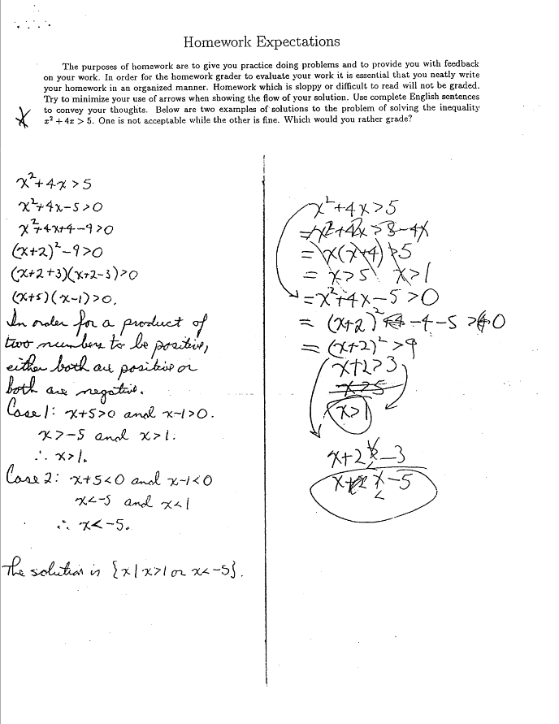

**UNT MISSION - COMMITMENT TO DIVERSITY AND INCLUSION**

As members of the UNT community, we have all made a commitment to be part of an institution that respects and values the identities of the students and employees with whom we interact. UNT does not tolerate identity-based discrimination, harassment, and retaliation. UNT’s full Non-Discrimination Policy can be found in the UNT Policies section of the syllabus.

**For more information please visit:**<https://ied.unt.edu/diversity-inclusion>

**COURSE POLICIES**

#### **Acceptable Student Behavior**

Student behavior that interferes with an instructor’s ability to conduct a class or other students' opportunity to learn is unacceptable and disruptive and will not be tolerated in any instructional forum at UNT. Students engaging in unacceptable behavior will be directed to leave the classroom and the instructor may refer the student to the Dean of Students to consider whether the student's conduct violated the Code of Student Conduct. The University's expectations for student conduct apply to all instructional forums, including University and electronic classroom, labs, discussion groups, field trips, etc. Visit UNT’s [Code of Student Conduct](https://deanofstudents.unt.edu/conduct) (https://deanofstudents.unt.edu/conduct) to learn more.

**Attendance**

* Each student is expected to attend every class session and stay the entire duration. If you (must) miss a class or activity, check Canvas to access all handouts and homework assigned during the missed class. You are responsible for completing all classroom activities you missed, getting the notes from a classmate, and turning in all work on the day it is due.

*For more information about UNT’s attendance policy visit* <https://policy.unt.edu/policy/06-039>

**Exams**

* There will be 3 in-class exams and a final exam. All exams will count toward the final grade.
* There are no make-up exams; if you miss an in-class exam, then you will receive a 0. However, your final exam may replace your lowest in-class exam if it is higher.
* Final Exam will be administered during the regular class meeting time. It is comprehensive and required.
* Unless announced otherwise, calculators will **not** be permitted for use on exams.
* Exam questions may be based on generalizations of material covered in the class and/or in the text. It will **not** include questions from certification exam preparation or your presentations.

**Help Sessions**

* The UNT learning center offers tutoring in a variety of formats at no additional cost to students. Students can choose from one-on-one tutoring, online tutoring, drop-in tutoring, or group tutoring. Students can request a tutor online through the Learning Center website: <http://learningcenter.unt.edu/tutoring>
* UNT Math Lab is located in SAGE HALL. More information about tutoring services is available at <https://math.unt.edu/mathlab>

**Make up Final Exam**

If unavoidable circumstances keep you from attending the final exam on the scheduled date and time, please contact me promptly via email and we can discuss how to address this situation.

**Rules of Engagement.** Rules of engagement refer to the way students are expected to interact with each other and with their instructors. Here are some general guidelines:

* While the freedom to express yourself is a fundamental human right, any communication that utilizes cruel and derogatory language based on race, color, national origin, religion, sex, sexual orientation, gender identity, gender expression, age, disability, genetic information, veteran status, or any other characteristic protected under applicable federal, or state law will not be tolerated.
* Treat your instructor and classmates with respect in any communication online or face-to-face, even when their opinion differs from your own.
* Ask for and use the correct name and pronouns for your instructor and classmates.
* Speak from personal experiences. Use “I” statements to share thoughts and feelings. Try not to speak on behalf of groups or other individual’s experiences.
* Use your critical thinking skills to challenge other people’s ideas, instead of attacking individuals.
* Avoid using all caps while communicating digitally. This may be interpreted as “YELLING!”
* Be cautious when using humor or sarcasm in emails or discussion posts as tone can be difficult to interpret digitally.
* Avoid using “text-talk” unless explicitly permitted by your instructor.
* Proofread and fact-check your sources.
* Keep in mind that online posts can be permanent, so think first before you type. See these [Engagement Guidelines](https://clear.unt.edu/online-communication-tips) (https://clear.unt.edu/online-communication-tips) for more information.

**Succeed at UNT**

This is a campaign to provide students with consistent student success messages, and user-friendly, accessible links to student support services. The six focused messages are: SHOW UP, FIND SUPPORT, TAKE CONTROL, BE PREPARED, GET INVOLVED, and BE PERSISTENT. You can access multiple student resource links, as well as short videos with student messages by going to <https://success.unt.edu>

**Syllabus Changes**

Should a need arise, I will amend, append, or otherwise make changes to this syllabus. Any such change will first be discussed with the students and then announced in class.

#### **Additional Student Support Services**

* [Registrar](https://registrar.unt.edu/registration) (https://registrar.unt.edu/registration)
* [Financial Aid](https://financialaid.unt.edu/) (https://financialaid.unt.edu)
* [Student Legal Services](https://studentaffairs.unt.edu/student-legal-services) (https://studentaffairs.unt.edu/student-legal-services)
* [Career Center](https://careercenter.unt.edu/) (https://careercenter.unt.edu)
* [Multicultural Center](https://idea.unt.edu/multicultural-center) (https://idea.unt.edu/multicultural-center)
* [Counseling and Testing Services](https://studentaffairs.unt.edu/counseling-and-testing-services) (https://studentaffairs.unt.edu/counseling-and-testing-services)
* [Pride Alliance](https://idea.unt.edu/pridealliance) (https://idea.unt.edu/pridealliance)
* [UNT Food Pantry](https://studentaffairs.unt.edu/food-pantry) (https://studentaffairs.unt.edu/food-pantry)

### **Academic Support Services**

* [Academic Resource Center](https://clear.unt.edu/canvas/student-resources) (https://clear.unt.edu/canvas/student-resources)
* [Academic Success Center](https://success.unt.edu/asc) (https://success.unt.edu/asc)
* [UNT Libraries](https://library.unt.edu/) (https://library.unt.edu)
* [Writing Center](https://writingcenter.unt.edu/) (https://writingcenter.unt.edu)
* [Math Lab](https://learningcenter.unt.edu/math-lab) (https://learningcenter.unt.edu/math-lab)

**Table1: Important Deadlines**

Please review deadlines at <https://registrar.unt.edu/registration/fall-registration-guide>