Fall 2025
World War II: European Theater, 4070
Syllabus

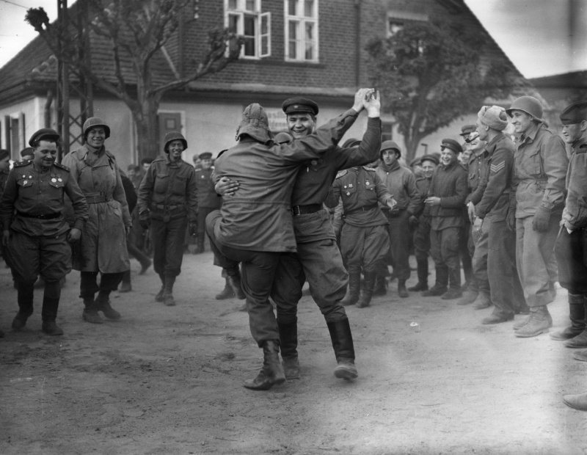
American and Soviet soldiers dance in the German village of Cobbelsdorf in April 1945, as their fellow fighters look on. This was one of the first Soviet-American encounters in the closing stages of World War II. Getty Images.

Course Information:
World War II: European Theatre, 4070
Instructor: Dr. Vojin Majstorovic
Email: vojin.majstorovic@unt.edu
Lectures: Wooten Hall 115, Mondays and Wednesdays 3.30 – 4.50 PM
Office: Wooten Hall 247
Office Hours: Wednesdays 10.00 – 11:30 AM or by appointment (in my office or on ZOOM,
https://unt.zoom.us/j/85885610038). Students should notify the instructor if they plan to come to the office during regular hours by 20.00 on Tuesday before office hours.

Course Description:
A survey of the European experience of World War II, the defining conflict in modern history that continues to cast its long shadow even into the 21st century. How did Germany, defeated in World War I, vanquish much of Europe only twenty years later? How did the Soviet Union, after losing millions of troops and its most important territories, manage to come back from the brink and completely reverse the German gains? Did the Axis have any chance of winning after the USA entered the war, with its vast industrial and human resources? How did the Americans and British plan and execute the largest sea-born invasion in history? How did millions of European civilians experience the war – including the Holocaust, bombings, combat, and various military occupations? What was the legacy of the war for postwar European society and international relations?

In this course, we will answer these questions by looking at the military, diplomatic, political, and social history of the war.

Course Requirements:
Participation: 15%
Midterm: 25%
Term Paper: 30%
Final Exam: 30%

The midterm, on October 13 (Class 16), will be based on lectures and readings. It will consist of identifications (requiring paragraph-long answers) and short answers (multiple-choice and matching). The midterm will take place in class.

Term papers, 5 pages long, are due on November 19. You will write a comparative analysis and review of 3 works on an aspect of World War II that interests you. One of your sources must be a scholarly monograph (a single-author book published by academic press). The remaining two sources can be a combination of academic monographs, memoirs, primary document collection (including interviews), films, or novels. You may use more than one academic monograph, but you should use only one of each type of source (one memoir, one film, etc.) There will be a 30% deduction if you do not use the correct sources. Speak to me if you are not sure about your sources. You cannot use any of the required readings as your sources. The term paper will not be accepted after November 30 at 23.59.

The final exam is accumulative, and it will be based on lectures and readings from the beginning of the course. It will consist of identifications, short answers, and possibly, an essay question. The final exam will take place in classroom on Wednesday, December 10, 1.30 – 3.30 PM.

All written work must be in Times New Roman Font, 12pt., double-spaced. You must use the Chicago-style citation format (here is the citation guide for Chicago style: https://www.chicagomanualofstyle.org/tools_citationguide/citation-guide-1.html). The penalty for all late work is 10% per calendar day.

Required reading:
Beevor, Antony. The Second World War. New York: Little, Brown, and Company, 2012.
The book is available in the UNT bookstore. All other readings are available on Canvas or online, through the UNT library website.

Attendance
Attendance and participation are worth 15% of the final grade. Students are allowed to miss three classes without the instructor’s approval or a medical note. After three unexcused absences, students will begin to lose marks. It should be noted that attendance is not enough to get full 15%, engagement and participation in discussions is expected.

The instructor will try to record all lectures, but sometimes he may forget to do so or there may be technical difficulties. The instructor is not obliged to record lectures, but will try to do so to make lives easier for students.

Class Recordings
Class recordings – when and if I make them – are the intellectual property of the instructor and are reserved for use only by students in this class and only for educational purposes. Students may not post or otherwise share the recordings outside the class, or outside the Canvas Learning Management System, in any form. Failing to follow this restriction is a violation of the UNT Code of Student Conduct and could lead to disciplinary action.

Equipment that Students Need
To successfully participate in this course, students will need to have access to a reliable Internet connection.

Laptops and Cell Phones:
Laptops must only be used for taking notes, but the connection to the Internet must be turned off. Anyone observed using their computer for purposes other than note-taking (messaging, surfing the Internet even if related to the course) will not be permitted to use their laptop for the duration of the course. Also, please ensure that cell phones are turned off and put away before you enter the classroom. Smartphones cannot be used in class for any purpose and must be kept off the tables. Students are not allowed to record lectures without the instructor’s permission.

Academic Integrity:
According to UNT Policy 06.003, Student Academic Integrity, academic dishonesty occurs when students engage in behaviors including, but not limited to cheating, fabrication, facilitating academic dishonesty, forgery, and plagiarism. A finding of academic dishonesty may result in a range of academic penalties or sanctions ranging from admonition to expulsion from the University.

The use of Artificial Intelligence (AI) to generate texts or rephrase existing texts is considered cheating. Similarly, the use of use AI tools, such as Grammarly, which correct grammar, punctuation, and can rephrase texts is not permitted. Students who use AI will receive a 0 on the assignment for the first offense and the instructor will file Academic Integrity Violation Report. The penalty for a second violation is to receive an “F” in the class, while another Academic Integrity Violation Report will be filed.

Accommodation Statement:
UNT makes reasonable academic accommodation for students with disabilities. Students seeking accommodation must first register with the Office of Disability Accommodation (ODA) to verify
their eligibility. If a disability is verified, the ODA will provide a student with an accommodation letter to be delivered to faculty to begin a private discussion regarding one’s specific course needs. Students may request accommodations at any time, however, ODA notices of accommodation should be provided as early as possible in the semester to avoid any delay in implementation. Note that students must obtain a new letter of accommodation for every semester and must meet with each faculty member prior to implementation in each class. For additional information see the ODA website at disability.unt.edu.
Emergency Notification & Procedures:
UNT uses a system called Eagle Alert to quickly notify students with critical information in the event of an emergency (i.e., severe weather, campus closing, and health and public safety emergencies like chemical spills, fires, or violence). In the event of a university closure, please refer to Canvas for contingency plans for covering course materials.

Class Schedule/Syllabus
I reserve the right to make changes to the course schedule and syllabus with appropriate advance notice. Readings noted for each topic should be read before the class meeting time

Class 1, August 18: Introduction

Class 2, August 20: The Legacy of World War I and the Versailles Treaty
- “Meet the Freikorps: Vanguard of Terror 1918-1923” (available on Canvas)

Class 3, August 25: The Nazis in Power
- Frank McDonough, Chapter 4 “The Ideology of Hitler and the Nazi Party,” pp. 50-65 in Hitler and the Rise of the Nazi Party (Abingdon: Routledge, 2017) (available on Canvas)

Class 4, August 27: German Aggression and Appeasement throughout the 1930s
- Beevor, “Introduction,” 1-10
- P. E. Caquet, “The Balance of Forces on the Eve of Munich,” The International History Review 40:1 (2018): 20-40 (available on Canvas)

Class 5, September 3: Poland Falls
- Beevor, pp. 11-39 (Chapters 1 and 2)

Class 6, September 8: The Soviet-Finnish War, Fall of Scandinavia, France, and Low Countries
- Beevor, pp. 79-121 (Chapters 6-7)

Class 7, September 10: The Battle of Britain
- Beevor, pp. 122-39 (Chapter 8)

Class 8, September 15: The Italian Expansionism in the Balkans and North Africa
- Beevor, pp. 140-85 (Chapters 9-11)

Class 9, September 17: Operation Barbarossa
- Beevor, pp. 186-18 (Chapter 12-13)

Class 10, September 22: The Battle of Moscow
- Beevor, pp. 219-67 (Chapters 14-16)

Class 11, September 24: From Moscow to Stalingrad
- Beevor, pp. 277-99 (Chapters 18 and 19); 327-73 (Chapters 22 and 24); 387-91 and 395-400 (part of Chapter 26)

Class 12, September 29: The Axis Defeat in Africa
- Beevor, pp. 312-26 (Chapter 21); 374-86 (Chapter 25); 391-95 (part of Chapter 26); 401-04 and 410-16 (parts of Chapter 27)

Class 13, October 1: The Battle of Atlantic and Allied Bombings of the Axis
- Beevor, pp. 436-58

Class 14, October 6: Home Front; Europe under the Nazis I: France, Low Countries, and Scandinavia
- Excerpts from Coetzee and Shevin-Coetzee, The World in Flames: A World War II Sourcebook, pp. 102-134; 139-140; 188-190; 296-297; 303-307 (available on Canvas)
- Beevor, pp. 425-35 (part of Chapter 28); 516-27 (Chapter 34)

Class 15, October 8: Making up missed materials from previous lectures

Class 16, October 13: Midterm Test

Class 17, October 15: Resistance and Genocide in Poland, Yugoslavia, and Greece
- Beevor, pp. 421-25 (part of Chapter 28)
- Jelena Batinić, Women and Yugoslav Partisans: A History of World War II Resistance (Cambridge: Cambridge University Press, 2015), pp. 1-26 Introduction, and pp. 124-67 (available on Canvas).

Class 18, October 20: Life and Death in the Axis-occupied Soviet Union
- Beevor, pp. 417-19
- Alexander Dallin, German Rule in Russia, 1941-1945: A Study of Occupation Policies (Boulder: Westview Press, 1981), pp. 276-98 (available on Canvas)

Class 19, October 22: The Axis lose initiative: The Kursk and the Fall of Italy
- Beevor, pp. 404-410 (part of Chapter 27); 469-88 (Chapter 31); 506-15 (Chapter 33); 545-50 (Chapter 36);
- Beevor, pp. 487-505 (Chapter 32); 528-44 (Chapter 35); 568-71; 567-85 (Chapter 38)*;
* Parts of Chapter 38 deal with Operations Bagration and Overlord)

Class 20, October 27: Multinational and Multiracial Armies
- Watch interview with Lawrence Young, Sr., WWII African American veteran, part of Central Connecticut State University Veterans History Project, https://www.youtube.com/watch?v=gmwxp45M6dc; transcripts of the interview can be found here, https://memory.loc.gov/diglib/vhp/story/loc.natlib.afc2001001.76177/transcript?ID=mv0001.

Class 21, October 29: Operation Bagration and the Red Army Summer & Autumn Offensives of 1944
- Beevor, pp. 586-594 (parts of Chapter 39); 607-12; 615-16 (parts of Chapter 40); 643-47 (parts of Chapter 42)

Class 22, November 3: D-Day
- Beevor, pp. 594-601 (parts of Chapter 39)

Class 23, November 5: From Normandy to Ardennes
- Beevor, pp. 606-07; 612-15; 633-43; 647-53 (parts of Chapter 42); 654-73 (Chapter 43)

Class 24, November 10: Allied Armies Come Face to Face with Genocide
- Dan Stone, The Liberation of the Camps: The End of the Holocaust and Its Aftermath (New Haven: Yale University Press, 2015), pp. 1-104 Introduction and Chapters 1-2 (available through UNT library catalog)

Class 25: November 12: German Collapse and Capitulation
- Beevor, pp. 602-606 (part of Chapter 40); pp. 674-691 (Chapter 44); pp. 709-769 (Chapters 46-49); pp.781-783 (part of Chapter 50)

Class 26: November 17, Wartime Sexual Violence
- Gergely Kunt, “Wartime Sexual Economy as Seen through a Hungarian Woman's World War II Diary,” Feminist Studies 43.1. (2017): 108-133.

Class 27, November 19: Collaborators and Perpetrators after the War
- Tony Judt, “Retribution” (Chapter 2), pp. 41-62 taken from Postwar: a History of Europe since 1945 (available on Canvas)
- Term Paper is Due

Class 28, December 1: Memory and Relevance of the War Today
- Lebow, Richard Ned, “The Memory of Politics in Postwar Europe” in The Politics of Memory in Postwar Europe (Durham: Duke University Press, 2006), pp. 1-39 (available on Canvas)

Class 29, December 3: Prep for the exam in the form of a Q&A session

