Winter 2025-2026
The Holocaust, 1933-1945, HIST4390
Syllabus
Dr. Vojin Majstorovic

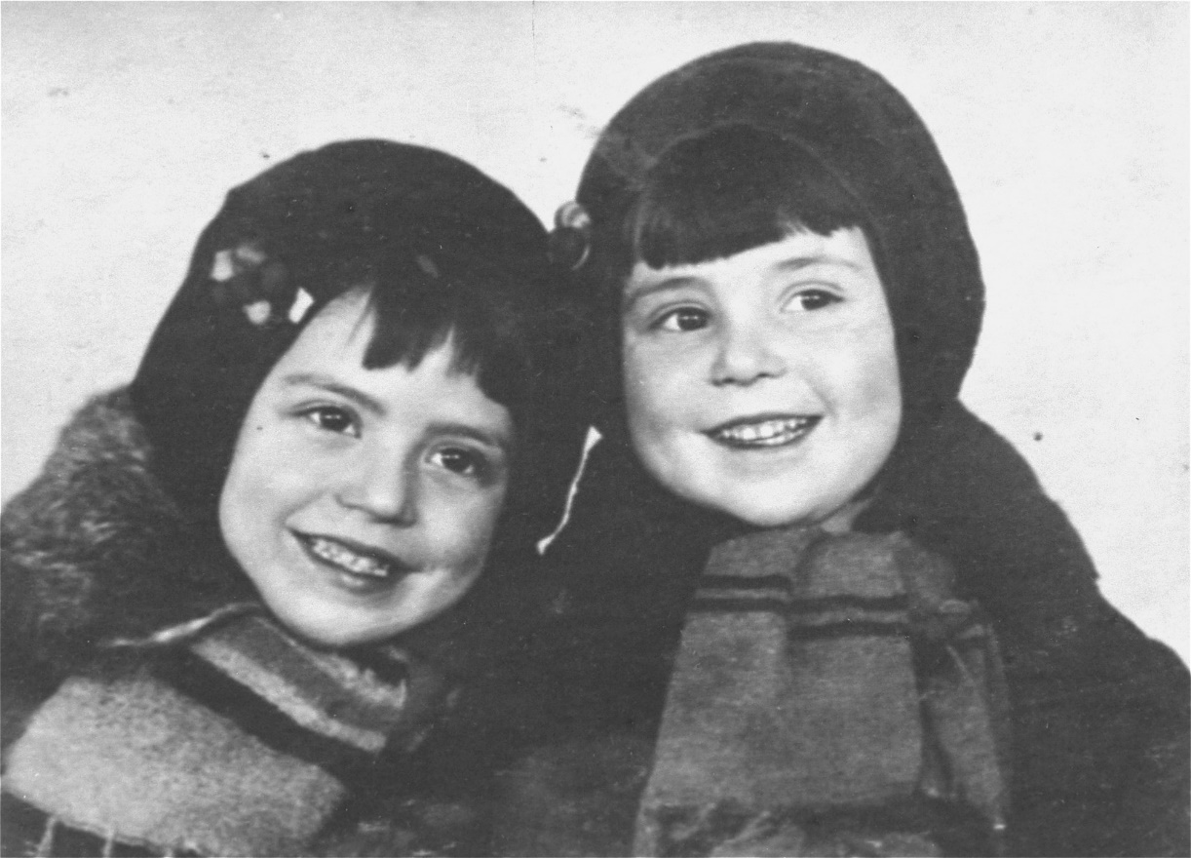
Image Credit: Portrait of four-year-old Malvina Babat and three-year-old Polina Babat, who were killed at Babi Yar; United States Holocaust Memorial Museum, Photograph 19096, courtesy of Babi Yar Society, Circa 1940- September 1941”

Course Information:
The Holocaust, 1933-1945, HIST 4390
Instructor: Dr. Vojin Majstorovic, vojin.majstorovic@unt.edu
- Office Hours: By appointment. Invite Link: https://unt.zoom.us/j/84258736499.
Teaching Assistant (TA): Stephen Bell, StephenBell@my.unt.edu.
- Office hours by appointment.

Course Description:
Holocaust refers to mass murder perpetrated by the Nazis and their allies against their perceived racial and ideological enemies. The Nazis pursued the murder of all Jews with the most consistency, but they also targeted people with disabilities, Roma, gays, Polish intelligentsia, and Soviet prisoners of war. This course will examine the history of the Holocaust from the perspective of the victims and perpetrators. In so doing, students will investigate the horrendous experiences of the persecuted, the role of the collaborators, and the killers’ ideology and mechanisms of mass murder.

Course Goals
- To deepen your knowledge of the events known as the Holocaust;
- To stimulate a reflection on the actions and experiences of ordinary people in the context of genocidal violence;
- To develop your reading, writing, and analytical skills.

Course Structure:
Module 1, December 15 – December 20: The Holocaust - Overview
Reading: Doris Bergen, War and Genocide: A Concise History of the Holocaust
- Due December 20
*Not accepted after January 3.

Module 2, December 15 – December 23: Nazis in Power & Social Death
- Viktor Klemperer, I Will Bear Witness: A Diary of the Nazi Years, 1933-1941
Volume 1, pp.3-27, I WILL BEAR WITNESS 1933-1941: A DIARY OF THE NAZI YEARS (link to ebook)..
- Watch the United States Holocaust Memorial Museum video, “The Path to Nazi Genocide: From Citizens to Outcasts, 1933–1938,” https://www.youtube.com/watch?v=5ubZv0YqrnE
- Due December 23
*Not Accepted after January 3.
** Only three students can access Klemperer's Diary through Course Reserves at any one time. If you need to obtain the reading, please log into course reserves, download the reading and log off.

Module 3, December 15 – December 27: War in the East
- Jan Grabowski, Hunt for the Jews: betrayal and murder in German-occupied Poland (link to eBook). pp.1-8
- Ilya Altman and Joshua Rubenstein eds., The Unknown Blackbook: The Holocaust in the German-occupied Soviet Territories, “The Recollections of the Teacher Emilia Borisovna Kotlova,” pp. 67-89, Print or View: The Unknown Black Book: The Holocaust in the German - Occupied Soviet Territories (link to PDF)
- The Manstein Order (link to article).
- Due December 27
*Not accepted after January 3

Module 4, December 15 – December 31: Jews and Non-Jews as Targets - Convergence and Divergence
Reading: Pierre Seel, I, Pierre Seel, Deported Homosexual A Memoir of Nazi Terror
- Due December 31
*Not accepted after January 3

Module 5, December 15 – January 3: Death Camps
Tadeusz Borowski, This Way for the Gas, Ladies and Gentlemen
- Due January 3
*Not accepted after January 4

All modules open at 8.00 AM on December 15, but they have different deadlines and dates after which they will not be accepted. The time for all deadlines and dates after which modules will not be accepted is 11.59 PM on the date stipulated. The late penalty is 1% per day. Please note that each module has a date (marked with an *) after which late work for it will not be accepted and you will get a ‘0’ on it.

The final exam will be posted on Canvas on December 15, and it will be due at 5 PM on January 4. (No extensions or late penalties are permitted for the final exam. Any late exams will receive a ‘0’).

All written work must be in Times New Roman Font, 12pt., and double-spaced. The penalty for late work is 1% per calendar day, until the day after which late work will not be accepted.

Required readings:
Doris Bergen, War and Genocide: A Concise History of the Holocaust (3rd edition)
Pierre Seel, I, Pierre Seel, Deported Homosexual A Memoir of Nazi Terror
Tadeusz Borowski, This Way for the Gas, Ladies and Gentlemen
- The three books are available in the bookstore or online

All additional readings can be found at the course reserves at Course Reserves for HIST 4390 (Majstorovic). Please note the password needed is VMHIST4390-2024.

Grading system:
The course is divided into five modules. Each module consists of a lecture and power-point presentation that I will post online, along with selected reading. Every module will have a multiple-choice quiz and a two-page written assignment based on the lecture and reading. Each module is 15% (quiz being 5%, and the written assignment 10%) for a total of 75% of your final grade. The Final Exam is worth 25%.

Students are required to watch or listen to lectures, which will be posted on Canvas. Lectures contain critical information that contextualizes readings and prepares students for module assignments and the final exam.

Your written assignment grade will be based on your analysis of materials, organization, and selection of evidence. Students with questions about their performance on an assignment should speak with the TA. If an issue cannot be resolved by the TA, then it can be taken up to the instructor.

90-99 = A; 80-89 = B; 70-79 = C; 60-69 = D; 59 and less = F

Academic Integrity:
According to UNT Policy 06.003, Student Academic Integrity, academic dishonesty occurs when students engage in behaviors including, but not limited, to cheating, fabrication, facilitating academic dishonesty, forgery, and plagiarism. A finding of academic dishonesty may result in a range of academic penalties or sanctions ranging from admonition to expulsion from the University.

The use of Artificial Intelligence (AI) to generate texts or rephrase existing texts is considered cheating. Similarly, the use of use AI tools, such as Grammarly, which correct grammar, punctuation, and can rephrase texts is not permitted. Students who use AI (including Grammarly) will receive a 0 on the assignment for the first offense and the instructor will file Academic Integrity Violation Report. The penalty for a second violation is to receive an “F” in the class, while another Academic Integrity Violation Report will be filed.

Accommodation Statement:
UNT makes reasonable academic accommodation for students with disabilities. Students seeking accommodation must first register with the Office of Disability Accommodation (ODA) to verify
their eligibility. If a disability is verified, the ODA will provide a student with an accommodation letter to be delivered to the faculty to begin a private discussion regarding one’s specific course needs. Students may request accommodations at any time, however, ODA notices of accommodation should be provided as early as possible in the semester to avoid any delay in implementation. Note that students must obtain a new letter of accommodation for every semester and must meet with each faculty member before implementation in each class. For additional information see the ODA website at disability.unt.edu.
Additional Resources:
The University of North Texas provides for students several resources to enable them to succeed in their studies. The Department of History also provides the History Help Center and History Department Library that are staffed by graduate students who can assist students with tutoring and essay writing advice. Below is contact information for helpful student resources: History Help Center, Wooten 220, (940) 565-4772. History Dept. Library, Wooten 267, (940) 369-7681

Student Success at UNT:
If you find that you have any trouble keeping up with assignments or other aspects of the course, make sure you let your professor or teaching assistant know as early as possible. As you will find, building rapport and effective relationships are key to becoming an effective professional. Make sure that you are proactive in informing your instructor or teaching assistant(s) when difficulties arise during the semester so that we can help you find a solution. As a UNT student, you have a lot on your plate. But you also have a lot of resources and plenty of people at UNT who want you to succeed. “Succeed at UNT” provides students with consistent student success messages, and user-friendly, accessible links to student support services. Please take advantage of such resources as you need.

Emergency Notification & Procedures:
UNT uses a system called Eagle Alert to quickly notify students with critical information in the event of an emergency (i.e., severe weather, campus closing, and health and public safety emergencies like chemical spills, fires, or violence). In the event of a university closure, please refer to Canvas for contingency plans for covering course materials.

Syllabus Change:
The instructor reserves the right to make any changes in order to meet the learning outcomes of the course. Any changes will be announced in a timely manner in Canvas.

