Spring 2026
WW2: Soviet-German War, 4073.001
Syllabus

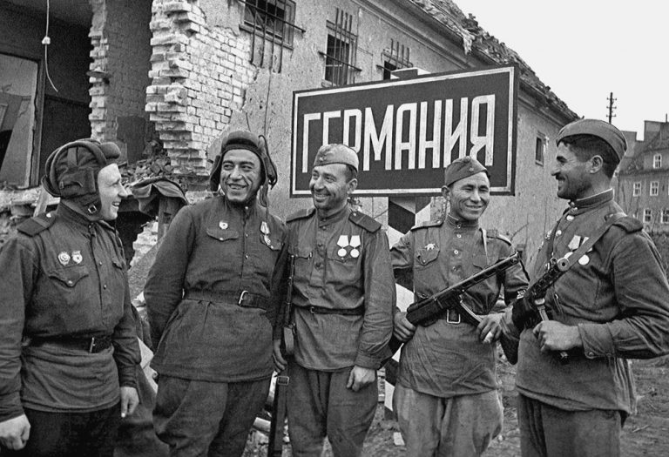
Red Army tank crew members and infantry enter Germany

Course Information:
WW2: Soviet-German War, 4073.01
Instructor: Dr. Vojin Majstorovic
Email: vojin.majstorovic@unt.edu
Lectures: Mondays and Wednesdays: 2.00 – 3.20 PM, Wooten Hall 121
Office Hours: Mondays 11.00 AM (Wooten Hall 247) or by appointment (in my office or on ZOOM, https://unt.zoom.us/j/85164873608). Students should notify the instructor if they plan to come to the office by 20.00 on Friday before office hours.
Course Description:
The Soviet German War, also known as the Eastern Front or the Great Patriotic War, was the most brutal conflict in European history and the decisive theater of World War II. The Soviet Union lost an estimated 26,6 million people in the war, of which around 14,5 million were military losses. The Germans and their allies suffered 8,5 million deaths in the East. The course explores the military, ideological, and social history of the war.

Course Requirements:
Participation: 15%
Midterm: 25%
Term Paper: 30%
Final Exam: 30%

The midterm, on March 4, will be based on lectures and readings in class. The test consists of identifications (requiring paragraph-long answers) and multiple-choice questions.

Term papers, 5 double-spaced pages, are due on April 27. You will write a comparative analysis and a review of 3 works on an aspect of World War II on the Eastern Front that interests you. One of your sources must be a scholarly monograph (a single-author academic book published by an academic press). The remaining two sources could be a combination of academic monographs, memoirs, primary document collections (including interviews), films, or novels. You may use more than one academic monograph, but you should use only one of each type of source (one memoir, one film, etc.) There will be a 30% deduction if you do not use the correct sources. Speak to me if you are not sure about your sources. You cannot use any of the required readings as your scholarly monography. The term paper will not be accepted after May 2.

The final exam is accumulative, and it will be based on lectures and readings from the beginning of the course. It will consist of identifications and short answers. The final exam will be taken place in class on May 4, 12:30 p.m. to 2:30 p.m.

All written work must be in Times New Roman Font, 12pt., double-spaced. You must use Chicago-style citation format (here is the citation guide for Chicago style: https://www.chicagomanualofstyle.org/tools_citationguide/citation-guide-1.html). The penalty for all late work is 5% per calendar day.

Grading scale:
90-99 = A; 80-89 = B; 70-79 = C; 60-69 = D; 59 and less = F

Required readings:
Svetlana Alexievich, The Unwomanly Face of War: An Oral History of Women in World War II (Random House, 2018).
Mark Edele, Stalinism at War: The Soviet Union in World War II (Bloomsbury Academic, 2021).

Attendance
Attendance and participation are 15% of the final grade. Students are allowed to miss three classes. After three unexcused absences, students will begin to lose marks. It should be noted that attendance is not enough to get a full 15%; engagement and participation in discussions are expected, especially of the books.

Laptops and Cell Phones:
Laptops must only be used for taking notes, and connection to the Internet must be turned off. Anyone observed using a computer for purposes other than note-taking (messaging, surfing the Internet, even if related to the course) will not be permitted to use their laptop for the duration of the course. Also, please ensure that cell phones are turned off and put away before you enter the classroom. Phones cannot be used in class for any purpose and must be kept off the tables. Students are not allowed to record lectures without the instructor’s permission.

Academic Integrity:
According to UNT Policy 06.003, Student Academic Integrity, academic dishonesty occurs when students engage in behaviors including, but not limited to cheating, fabrication, facilitating academic dishonesty, forgery, and plagiarism. A finding of academic dishonesty may result in a range of academic penalties or sanctions ranging from admonition to expulsion from the University.

The use of Artificial Intelligence (AI) to generate texts or rephrase existing texts is considered cheating. Similarly, the use of AI tools, such as Grammarly, which correct grammar and punctuation, and can rephrase texts, is not permitted.

Penalties for violations of academic integrity range from “0” on the particular assignment to “F” as the final grade.

Accommodation Statement:
UNT makes reasonable academic accommodation for students with disabilities. Students seeking accommodation must first register with the Office of Disability Accommodation (ODA) to verify
their eligibility. If a disability is verified, the ODA will provide a student with an accommodation letter to be delivered to the faculty to begin a private discussion regarding one’s specific course needs. Students may request accommodations at any time, however, ODA notices of accommodation should be provided as early as possible in the semester to avoid any delay in implementation. Note that students must obtain a new letter of accommodation for every semester and must meet with each faculty member prior to implementation in each class. For additional information see the ODA website at disability.unt.edu.

Emergency Notification & Procedures:
UNT uses a system called Eagle Alert to quickly notify students with critical information in the event of an emergency (i.e., severe weather, campus closing, and health and public safety emergencies like chemical spills, fires, or violence). In the event of a university closure, please refer to Canvas for contingency plans for covering course materials.

I reserve the right to make changes to the course schedule and syllabus with appropriate advance notice.

Class Schedule/Syllabus

Class 1, January 12: Introduction

Class 2, January 14: Rise of Stalin: Collectivization, Industrialization, and
Preparations for War
- Edele, 1-27

Class 3, January 21: Rise of Hitler: Nazism, German Imperialism and Rearmament

Class 4, January 26: The Prelude: The Spanish Civil War and the Soviet-Japanese War
- Edele, 29-46

Class 5, January 28: Molotov-Ribbentrop Pact and the fall of Poland
- Edele, 47-71

Class 6, February 2: The German Expansion in the Balkans and the Soviet Expansion into
Poland, the Baltics, Romania, and Finland
- Edele, 73-87

Class 7, February 4: Operation Barbarossa I – Border Battles and the fall of Kiev
- Edele, 73-92

Class 8, February 9: Operation Barbarossa II – The Battle of Moscow

Class 9, February 11: Siege of Leningrad

Class 10, February 16: Genocide of Soviet Prisoners of War

Class 11, February 18: Between Moscow and Operation Blue
- Edele, 93-107

Class 12, February 23: Operation Blue
- Edele, 107-113

Class 13, February 25: The Battle of Stalingrad, and Operations Uranus and Mars
- Edele, 107-113; 130-133

Class 14, March 2: Soviet and German War Economies
- Edele, 115-130

Class 15, March 4: The Midterm

Class 16, March 16: German Occupation of the Soviet Union

Class 17, March 18: Holocaust in the Soviet Union
- Edele, 135-149

Class 18, March 23: Soviet Partisan Warfare
- Edele, 151-173

Class 19, March 25: The Battle of Kursk and the Liberation of Ukraine

Class 20, March 30: Operation Bagration and the Liberation of Belarus and the Baltics.

Class 21, April 1: Liberation of the Holocaust Sites

Class 22, April 6: Women in the Red Army
- Svetlana Alexievich, The Unwomanly Face of War (discussion in class)

Class 23, April 8: Soviet Internationalism in Action: Non-Slavs in the Red Army

Class 24, April 13: The Endgame: the Fall of Romania, Hungary, Austria, and Germany

Class 25, April 15: Soviet Occupation of Policies in Eastern Europe and Germany

Class 26, April 20: Expulsion of Germans from Eastern Europe

Class 27, April 22: The Soviet-perpetrated Sexual Violence in Germany & Eastern Europe

Class 28, April 27: Memory of the War and its Significance Today
- Edele, 175-192

Class 29, April 29: Exam Review

