| **EDEE 3340: Teaching Social Studies** | |
| --- | --- |
| Instructor | Pronouns |
| Office location | Office hours |
| Contact info | Final Exam date/time/place |

# 

**DEPARTMENT OF TEACHER EDUCATION AND ADMINISTRATION: PREPARING TOMORROW’S EDUCATORS AND SCHOLARS**

**COURSE PREREQUISITES**

Admission to Teacher Education program; Concurrent enrollment in EDEE 3330 and EDRE 3350; Enrollment in Block A

# **CATALOG DESCRIPTION**

Principles of teaching social studies in primary and elementary school. Students observe social studies instruction and materials in real settings, apply principles of social studies instruction in classroom settings and experience first-hand the scope and sequence of the curriculum in a school setting. Course contains a field experience requirement.

**COURSE GOALS**

* Identify the five main disciplines of social studies;
* Articulate purposes for teaching elementary social studies;
* Identify conceptual frameworks for how to teach social studies;
* Plan for interdisciplinary social studies inquiry that engages young learners from diverse backgrounds and integrates technology;
* Identify and evaluate resources for a multicultural social justice social studies curriculum; and
* Commit to integrating social studies instruction into your future practice.

**REQUIRED FIELD HOURS**

N/A

**REQUIRED TEXTBOOKS AND/OR MATERIALS**

Dunbar, E.A. & Van Cleve, K. (2019). *Never Caught, the story of Ona Judge: George and Martha Washington’s Courageous Slave who dared to run away*. Aladdin books.

Rodriguez, N.N. & Swalwell, K. (2022). *Social Studies for a Better World: An Anti-Oppressive Approach for Elementary Educators.* W.W. Norton & Company.

**ATTENDANCE EXPECTATIONS**

This course is highly collaborative and interactive. Therefore, your attendance and participation are essential to the learning of everyone in our course. [University policy 06.039](https://policy.unt.edu/sites/default/files/06.039%20Student%20Attendance%20and%20Authorized%20Absences.pdf) will be followed for attendance problems. If necessary, students may miss one class with a valid excuse (see [university policy for excused absences](https://policy.unt.edu/sites/default/files/06.039%20Student%20Attendance%20and%20Authorized%20Absences.pdf)) and not face penalties related to their grade. Students must let the instructor know as soon as possible if they will be missing class. It is the students’ responsibility to obtain all notes and handouts missed during their absence. All assignments are due on dates indicated on the syllabus regardless of student absences. A second absence will result in a loss of points from the total grade. In the event that a student misses four or more classes, they will receive a failing grade. Students who miss more than one hour of class will be considered absent from that class meeting. Chronic tardiness or early departure will result in the lowering of a final grade at the instructor’s discretion (arriving more than 15 minutes late or leaving more than 15 minutes early). It is the student’s responsibility to drop this course, if necessary.

***For courses offered ONCE a week***

| **# of Absences** | **Total participation points for the class**  *(out of 20 points)* |
| --- | --- |
| 0 – 1 | 20 |
| 2 | 15 |
| 3 | 7 |
| 4 or more | You will automatically receive an F for your final grade |

**GRADING AND COURSE ASSIGNMENTS**

Students earn points for various assignments and activities throughout the semester. Points translate into the following grading scale: A (180-200), B (160-179), C (140-159), D (120-139). An overview of the major assignments is in the below chart.

| Reading Reflections | 70 | 35% |
| --- | --- | --- |
| Journey Box | 35 | 18% |
| One Pager | 25 | 13% |
| Inquiry Design Model Unit Plan | 45 | 23% |
| Participation and Professionalism | 25 | 13% |
| **Total** | **100** | **100%** |

**CLASS SCHEDULE** at a glance

| **CLASS DATE** | **CLASS TOPIC** | **ASSIGNMENTS DUE THIS WEEK** |
| --- | --- | --- |
| ***Unit 1: Why and How Should We Teach Social Studies?*** | | |
| **WEEK 1:** | What is social studies? |  |
| **WEEK 2:** | What is the purpose of social studies? | Reflection |
| **WEEK 3:** | Understanding and pushing against *normalization* | Reflection |
| ***Unit 2: How Do We Teach the Different Disciplines of Social Studies?*** | | |
| **WEEK 4:** | History education: Historical thinking | Reflection |
| **WEEK 5:** | History education: Humanizing historical figures | Reflection |
| **WEEK 6:** | Hard topics, dramatization, and gamification | Reflection  Draft of Journey Box |
| **WEEK 7:** | History education: Teaching history through literature | Reflection |
| **WEEK 8:** | History education: Teaching history through literature | Reflection  Journey Box |
| **SPRING BREAK** | | |
| **WEEK 10:** | Civics education: Community helpers and civic action | Reflection  One Pager |
| **WEEK 11:** | Civics education: Citizenship and government | Reflection |
| **WEEK 12:** | Economics education: Teaching (in)equity | Reflection |
| **WEEK 13:** | Geography education: Maps as stories and students as placemakers | Reflection |
| ***Unit 3: Pulling It All Together Through Integration and Inquiry*** | | |
| **WEEK 14:** | Teaching through inquiry | Reflection |
| **WEEK 15:** | Teaching through integration | Reflection  Inquiry Revision |
| **WEEK 16:** | Rethinking social studies | Reflection  Inquiry Draft |
| ***FINAL IDM DUE MAY 5, 2024*** | | |

**UNT TEACHER EDUCATION PROGRAM COMMITMENTS**

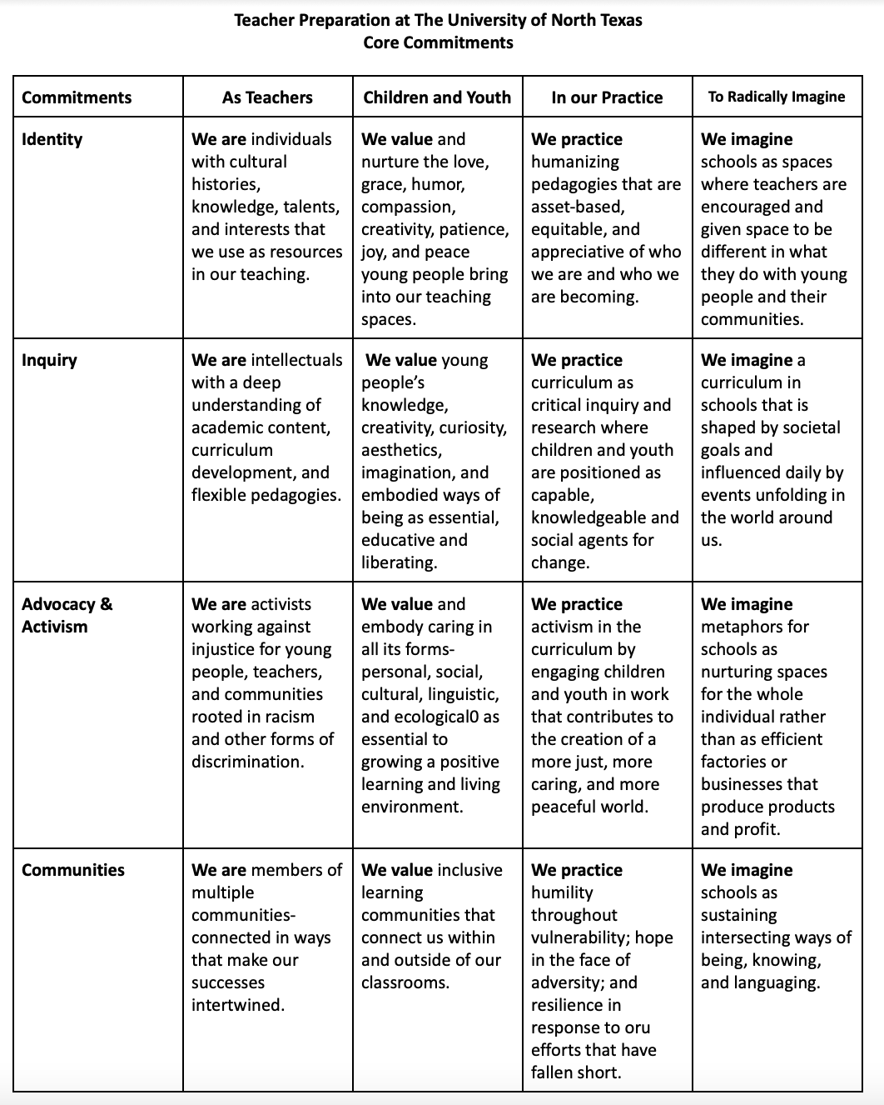

**Teacher Education & Administration Departmental Policy Statements**

**Gender Pronouns.** All people have the right to be addressed and referred to in accordance with their personal identity. In this class, we will share the name we prefer to be called and, if we choose, share the pronouns with which we would like to be addressed. As instructors, we will do our best to address and refer to all students accordingly and support classmates in doing so as well.

**Land Acknowledgment.** The University of North Texas occupies the ancestral, traditional and contemporary lands of the Wichita and Caddo people. We recognize Texas’ federally recognized Native Nations, historic Indigenous communities in Texas, Indigenous individuals and communities who live here now, and those who were forcibly removed from their homelands. In offering this land acknowledgment, we affirm Indigenous sovereignty, history, and experiences.

**Survivor Advocacy.** UNT is committed to providing a safe learning environment free of all forms of sexual misconduct, including sexual harassment sexual assault, domestic violence, dating violence, and stalking. Federal laws (Title IX and the Violence Against Women Act) and UNT policies prohibit discrimination on the basis of sex, and therefore prohibit sexual misconduct. If you or someone you know is experiencing sexual harassment, relationship violence, stalking, and/or sexual assault, there are campus resources available to provide support and assistance. UNT’s Survivor Advocates can assist a student who has been impacted by violence by filing protective orders, completing crime victim’s compensation applications, contacting professors for absences related to an assault, working with housing to facilitate a room change where appropriate, and connecting students to other resources available both on and off campus. The Survivor Advocates can be reached at SurvivorAdvocate@unt.edu or by calling the Dean of Students Office at 940-565-2648. Additionally, alleged sexual misconduct can be non-confidentially reported to the Title IX Coordinator at oeo@unt.edu or at (940) 565 2759.

**ADA Accommodations.** UNT makes reasonable academic accommodation for students with disabilities. Students seeking accommodation must first register with the Office of Disability Accommodation (ODA) to verify their eligibility. If a disability is verified, the ODA will provide a student with an accommodation letter to be delivered to faculty to begin a private discussion regarding one’s specific course needs. Students may request accommodations at any time, however, ODA notices of accommodation should be provided as early as possible in the semester to avoid any delay in implementation. Note that students must obtain a new letter of accommodation for every semester and must meet with each faculty member prior to implementation in each class. For additional information see the ODA website at disability.unt.edu.

**Food/Housing Insecurity.**​ ​Any student who has difficulty affording groceries or accessing sufficient food to eat every day, or who lacks a safe and stable place to live, and believes this may affect their performance in the course, is urged to contact the Dean of Students, Suite 409 at the University Union (or by calling 940-565-2648). The UNT Food Pantry is a useful resource for students who may need it. Please visit the website for more details, or feel free to come see me about this:​ ​<https://deanofstudents.unt.edu/resources/food-pantry>

**Title IX Services.**​ Sexual discrimination, harassment, & assault: UNT is committed to providing an environment free of all forms of discrimination and sexual harassment, including sexual assault, domestic violence, dating violence, stalking, etc. The federal Title IX law makes it clear that violence and harassment based on sex and gender are civil rights violations.

UNT’s Dean of Students’ website offers a range of resources to help support survivors, based on their needs:http://deanofstudents.unt.edu/resources​. Renee LeClaire McNamara is UNT’s Student Advocate and she can be reached via email at SurvivorAdvocate@unt.edu or by calling the Dean of Students’ office at 940-565-2648.

**University Mental Health Services.** ​I recognize that it is not easy to be a student. The demands for economic, intellectual, social, and emotional stability are often in competition, and it can grow weary. School is one aspect of your busy life, and while it’s important to stay the course, it’s also important to acknowledge when you may need more support. UNT’s Counseling Center, as well as the Student Health and Wellness Center, offer support through counseling, care for your well-being and psychiatric health, workshops for socio-emotional challenges, etc. These services are confidential, and most of these services are covered by your tuition. Feel free to see me for more support on this, call 940-565-2333 and/or refer to the following website:​ h​ ttps://speakout.unt.edu/content/mental-health-resources

**UNT Career Connect**​: All undergraduate students are expected to participate in “UNT Career Connect.” Each student needs to set up a UNT e-portfolio for this purpose. As a UNT student engages in real-life, career-related experiences in curricular and/or co-curricular settings, s/he should upload documentation of these experiences into his/her UNT e-portfolio. Course instructors will help students identify appropriate experiences and accompanying documentation/artifacts for inclusion in the e-portfolio. Through their respective e-portfolios, students are able to make connections across their student experiences and reflect upon their learning and skills in order to prepare them with marketable skills for careers and graduate degrees. The e-portfolio also serves as a useful device for future job interviews. Career Connect places emphasis on important job skills such as communication, teamwork, and critical thinking. For students seeking teacher certification, these on-the-job skills will be evaluated during student teaching using the North Texas Appraisal of Classroom Teaching (NTACT) or its successor instrument. Follow this link to learn more and to set up your personal e-portfolio: http://careerconnect.unt.edu/default .

**Disabilities Accommodation**​: “The University of North Texas complies with Section 504 of the 1973 Rehabilitation Act and with the Americans with Disabilities Act of 1990. The University of North Texas provides academic adjustments and auxiliary aids to individuals with disabilities, as defined under the law. Among other things, this legislation requires that all students with disabilities be guaranteed a learning environment that provides for reasonable accommodation of their disabilities. If you believe you have a disability requiring accommodation, please see the instructor and/or contact the Office of Disability Accommodation at 940-565-4323 during the first week of class.” Dr. Barbara Pazey is the compliance officer and contact person for the Department of Teacher Education & Administration.

**Observation of Religious Holidays**​: If you plan to observe a religious holy day that coincides with a class day, please notify your instructor as soon as possible.

**Academic Integrity**​: Students are encouraged to become familiar with UNT’s policy on Student Standards of Academic Integrity: http://policy.unt.edu/sites/default/files/untpolicy/pdf/7-Student_Affairs-Academic_Integrity.pdf. Academic dishonesty, in the form of plagiarism, cheating, or fabrication, will not be tolerated in this class. Any act of academic dishonesty will be reported, and a penalty determined, which may be probation, suspension, or expulsion from the university.

**Acceptable Student Behavior**​: Student behavior that interferes with an instructor’s ability to conduct a class or other students' opportunity to learn is unacceptable and disruptive and will not be tolerated in any instructional forum at UNT. Students engaging in unacceptable behavior will be directed to leave the classroom and the instructor may refer the student to the Dean of Students to consider whether the student's conduct violated the Code of Student Conduct. The university's expectations for student conduct apply to all instructional forums, including university and electronic classroom, labs, discussion groups, field trips, etc. The Code of Student Conduct can be found at <https://deanofstudents.unt.edu/conduct>.

**Attendance**​: See the instructor’s attendance policy.

**Eagle Connect**​: All official correspondence between UNT and students is conducted via Eagle Connect and it is the student's responsibility to read their Eagle Connect Email regularly.

**Cell Phones and Laptops**​: Students should turn off cell phones when they are in class unless the phones are being used for learning activities associated with the course. Similarly, laptops should be turned off, unless they are being used to take class notes and/or participate in class activities.

**SPOT**​: The Student Perceptions of Teaching (SPOT) is expected for all organized classes at UNT. This brief online survey will be made available to you at the end of the semester, providing you a chance to comment on how this class is taught. I am very interested in the feedback I get from students, as I work to continually improve my teaching. I consider the SPOT to be an important part of your participation in this class.

**Comprehensive Arts Program Policy**​. The Elementary Education program area supports a comprehensive arts program to assist preservice and inservice teachers to design and implement curricular and instructional activities which infuse all areas of the arts (visual, music, theater, and movement) throughout the elementary and middle school curriculum.

**Technology Integration Policy**​. The Elementary, Secondary, and Curriculum & Instruction program areas support technology integration to assist preservice and inservice teachers to design and implement curricular and instruction activities which infuse technology throughout the K-12 curriculum.

**EDUCATOR STANDARDS**

The UNT Educator Preparation Program curriculum includes alignment to standards identified by the Texas State Board of Educator Certification (SBEC) for beginning educators. These standards are addressed throughout your preparation and assessed through the TExES Certification exams required for your teaching certificate. Additionally, the Commissioner of TEA has adopted these rules pertaining to Texas teaching standards:

**Texas Teaching Standards:**

Standards required for all Texas beginning teachers fall into the following 6 broad categories:

Standard 1--Instructional Planning and Delivery. Standard 1Ai,ii,iv; 1Bi,ii (Lesson design)

Standard 2--Knowledge of Students and Student Learning

Standard 3--Content Knowledge and Expertise

Standard 4--Learning Environment

Standard 5--Data-Driven Practice

Standard 6--Professional Practices and Responsibilities

**EC-12 Professional Pedagogy and Responsibilities (PPR) Standards**

The beginning EC-12 teacher knows and understands:

* **Competency 001:** human developmental processes and applies this knowledge to plan instruction and ongoing assessment that motivate students and are responsive to their developmental characteristics and needs
* **Competency 002:** student diversity and knows how to plan learning experiences and design assessments that are responsive to differences among students and that promote all students' learning
* **Competency 005:** how to establish a classroom climate that fosters learning, equity and excellence and USES this knowledge to create a physical and emotional environment that is safe and productive
* **Competence 007:** principles and strategies for communicating effectively in varied teaching and learning contexts.

**EC-12 Tech Apps Standards**

The beginning EC-12 teacher knows and understands how to:

* **Standard I.** use and promote creative thinking and innovative processes to construct knowledge, generate new ideas, and create products
* **Standard II.** collaborate and communicate both locally and globally using digital tools and resources to reinforce and promote learning.
* **Standard III.** make informed decisions by applying critical-thinking and problem solving skills.

**TEXAS ESSENTIAL KNOWLEDGE AND SKILLS**

The following TEKS are addressed in this course. The Texas Essential Knowledge and Skills can be accessed on the Texas Education Agency Web site using the A-Z index at the following URL: <https://tea.texas.gov/academics/curriculum-standards>

# **ENGLISH LANGUAGE PROFICIENCY STANDARDS (ELPS)**

This course incorporates the ELPS in lesson planning and instructional delivery in order to improve language acquisition and content area knowledge of students who are English learners. The ELPs will be implemented by teacher candidates during instruction of the subject area for students who are English learners. The ELPs can be accessed via the Texas Education Agency using the following link: <http://ritter.tea.state.tx.us/rules/tac/chapter074/ch074a.html#74.4>.

# **TEXAS COLLEGE AND CAREER READINESS STANDARDS**

The Texas College and Career Readiness Standards can be accessed at the Texas Higher Education Coordinating Board Web site using the following link: <http://www.thecb.state.tx.us/index.cfm?objectid=EADF962E-0E3E-DA80-BAAD2496062F3CD8>

# **TECHNOLOGY APPLICATIONS**

[Technology Applications (All Beginning Teachers, PDF)](https://tea.texas.gov/WorkArea/linkit.aspx?LinkIdentifier=id&ItemID=51539612985) The first seven standards of the Technology Applications EC-12 Standards are expected of **all** beginning teachers and are incorporated in to the Texas Examination of Educator Standards (TExES) Pedagogy and Professional Responsibilities (PPR) test.