MGMT 3660: Contemporary Business Writing and Presentation Skills

University of North Texas
G. Brint Ryan College of Business
Fall 2026
Professor: Professor Tammy van der Leest
Department: Management ~ BLB 304F
Office Hours: Thursday, 10:00–11:00 am via Zoom
(https://unt.zoom.us/j/87575275064)
Email: tammy.vanderleest@unt.edu
TA: Shane Gray, ShaneGray@my.unt.edu

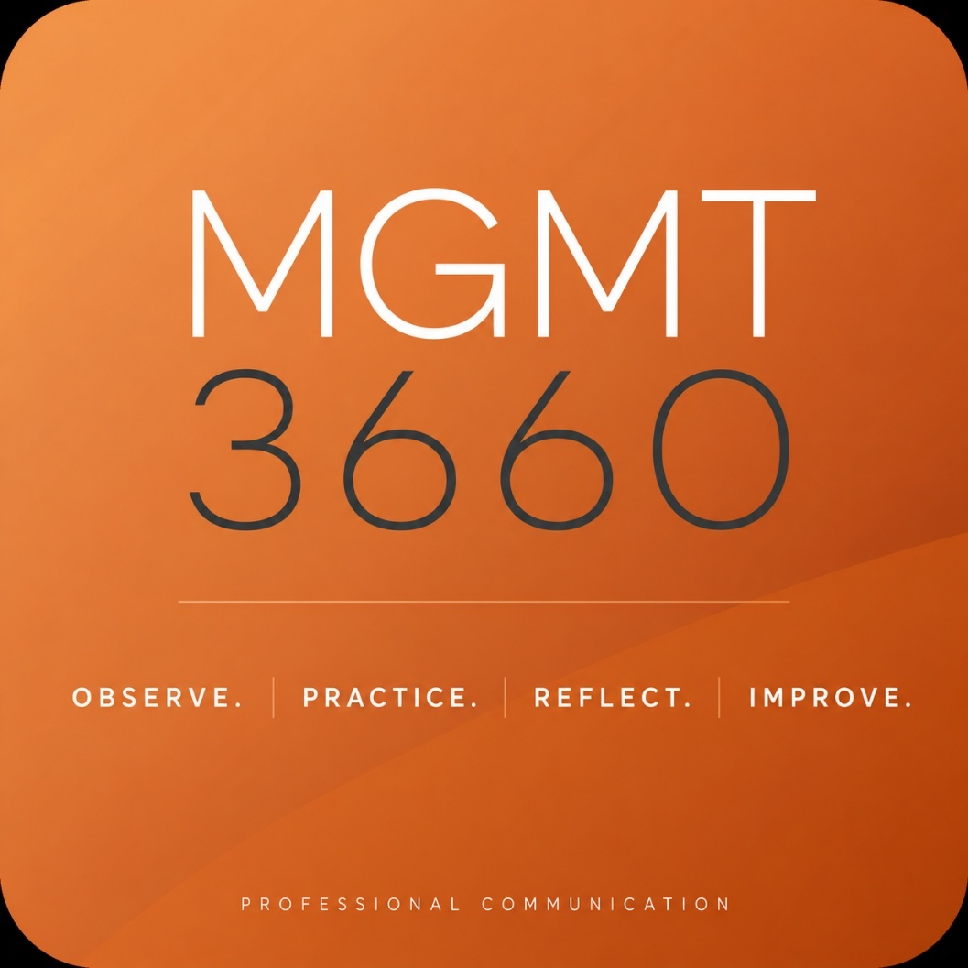

Course Introduction
Welcome to MGMT 3660, Contemporary Business Writing and Presentation Skills. This course focuses on developing the communication skills necessary to succeed in today’s professional environment. Throughout the semester, you will strengthen your ability to communicate clearly, confidently, and professionally across written, verbal, and interpersonal settings.
Effective business communication requires more than knowing what to say. It requires understanding your audience, adapting your message to the situation, and communicating with intention. Throughout this course, you will practice these skills through professional writing, presentations, workplace scenarios, collaborative activities, and real-world communication challenges.
The course is built around a simple philosophy: Observe. Practice. Reflect. Improve. Communication is a skill developed through experience and repetition. You will be expected to participate actively, apply feedback, and become increasingly comfortable communicating in situations that may require you to think and respond in the moment.
MGMT 3660 is delivered in a hybrid format, combining independent online preparation with required in-person class meetings. Our time together will emphasize application and practice rather than simply reviewing material that can be completed independently.
Required textbook: None.

Course Description
3 hours (3;0;1)
Provides students with the knowledge and skills necessary for effective oral and written communication in domestic and international professional settings. Communicate professionally by mastering how to write effective documents, deliver structured presentations, increase intercultural competencies, and develop employment communication skills.
Prerequisite(s): Open to business majors only.

Course Objectives
This course will focus on the following:

Professional Communication

This course is designed to elevate students’ professional presence by strengthening their abilities in written, oral, and visual communication. Students will:
• Examine and select appropriate communication channels by understanding the purposes, functions, and characteristics of digital and non-digital options, and by choosing the channel that best aligns with audience needs and communication goals.
• Produce effective professional written documents by applying the writing process, applying writing principles, and evaluating clarity, conciseness, correctness, organization, tone, and overall professionalism, while demonstrating an understanding of audience expectations and needs.
• Deliver effective professional presentations by applying the writing process and writing principles to develop content, demonstrating strong verbal and nonverbal communication skills, designing purposeful visual aids, and evaluating both content and delivery for clarity and impact.
• Collaborate with team members on virtual platforms to produce cohesive and professional group presentations.

Intercultural Communication

Students will examine how cultural dimensions and perceptual tendencies influence communication in global business environments. This includes:
• Identifying how cultural frameworks and perceptual tendencies affect written and oral communication across cultures.
• Describing intercultural verbal and nonverbal business etiquette and customs in key international markets.
• Determining effective techniques for improving verbal and nonverbal communication when interacting with diverse cultural audiences.
• Formulating written and oral messages that are appropriate for global and multicultural audiences.

Employment Communication

Students will evaluate the effectiveness of their current job application materials in relation to the expectations of the industries they intend to pursue. This includes:
• Applying knowledge of the writing process to assess and refine both the written and oral components of their professional documents.
• Applying writing principles to strengthen clarity, organization, tone, and professionalism in application materials.
• Analyzing the needs and expectations of potential employers, and considering how their qualifications, experiences, and professional goals align with those needs.
• Producing improved, audience-focused documents that demonstrate readiness for the job application process.

Professional Expectations
This course is designed to reflect the expectations of a professional business environment. As such, students are expected to demonstrate:
- Accountability through adherence to deadlines and course requirements
- Preparation through completion of assigned materials prior to engagement
- Professional communication that is clear, concise, and well-structured
- Active and meaningful engagement in all course activities
- Ownership of work that reflects individual effort, critical thinking, and a consistent author’s voice
Students who approach this course with professionalism, discipline, and attention to detail will find that these skills translate directly to success beyond the classroom. (Please refer to the UNT Academic Integrity Policy 06.003)

Communication
Clear and professional communication is an important part of this course. If you have a question or need clarification, please contact our TA or me through your UNT email, Canvas Inbox, or during office hours. I am happy to assist when course materials do not provide the information you need.
I balance teaching with departmental, university, service, and professional responsibilities. As a result, I am not continuously available by email. I generally respond within 24–48 hours during the business week. During especially busy periods, responses may take slightly longer. If you have not received a response within two business days, a courteous follow-up is always appropriate. Office hours are held weekly via Zoom and are available without an appointment. You are also welcome to contact me to arrange another meeting time when needed.
Before contacting me about course requirements, deadlines, or assignments, please review the syllabus, Canvas announcements, and the appropriate course module. Many questions can be answered quickly through these resources. If you still need clarification, please do not hesitate to contact our TA or me.
Communication Reminders
- Check Canvas announcements every 24–48 hours.
- Use your UNT email or Canvas Inbox for course communication.
- Include MGMT 3660 and your section number in the subject line.
- Do not use assignment comments for questions or course communication.
- Allow 24–48 hours during the business week for a response.
- If you have not received a response within two business days, a courteous follow-up is appropriate.
- Plan ahead when seeking assistance. Questions submitted shortly before an assignment deadline may not receive a response before the assignment is due.

Canvas & Technology
The hybrid structure of MGMT 3660 provides students with a significant degree of flexibility. Rather than attending class on campus multiple times each week, students complete portions of the course independently through Canvas and attend one required in-person meeting each week. Students are also permitted to complete the final online rather than returning to campus for a traditional in-person final.
This flexibility is a benefit of the hybrid course format, but it also requires greater individual responsibility. Students are responsible for maintaining reliable access to Canvas, monitoring course announcements and deadlines, and ensuring that assignments are successfully submitted on time.
All assignments must be submitted through Canvas prior to the stated deadline. Canvas is a digital system, and submission times are recorded precisely. If an assignment is submitted at 11:59 p.m. when the deadline is 11:59 p.m., it is late and is subject to the established late penalty. Students should plan to submit work in advance rather than waiting until the final minutes before a deadline.
Technology occasionally fails. Internet outages, computer problems, software issues, and other technical difficulties can occur unexpectedly. However, statements such as “there was a computer glitch” or “I experienced technical difficulties” do not automatically excuse a late submission. Waiting until shortly before a deadline increases the risk that an unexpected technical problem will affect your ability to submit work on time.
If you experience a legitimate technical problem that prevents you from accessing Canvas or submitting an assignment, contact the UNT Help Desk promptly and obtain a support ticket. When contacting the TA or me regarding the issue, provide the ticket number and any available documentation, such as a screenshot, so the situation can be appropriately evaluated.
Technology Reminders
- Maintain reliable access to Canvas and your UNT email.
- Monitor Canvas announcements and assignment deadlines regularly.
- 11:59 p.m. is the deadline, not the recommended submission time.
- Submit work early enough to allow for unexpected technical problems.
- A reported “glitch” does not automatically excuse a late submission.
- Contact the UNT Help Desk promptly when a legitimate technical problem occurs.
- Retain your support ticket number and screenshots or other documentation.

Course Structure & Attendance
MGMT 3660 is delivered in a hybrid format, combining independent online preparation with required in-person class meetings. Unlike a traditional course that may meet on campus multiple times each week, this course concentrates in-person instruction into one class meeting per week, with additional coursework and preparation completed independently.
Our limited classroom time is intentionally designed around application, discussion, professional communication, presentations, and collaborative activities that cannot be fully replicated through independent coursework. In addition, several weeks during the semester are designated for university holidays, collaboration activities, and other course requirements that do not follow the regular in-person meeting format. As a result, the number of traditional classroom meetings is already limited.
For this reason, regular attendance is an essential component of the course. Missing three or four additional class meetings in a once-per-week hybrid course represents a significant loss of in-person instructional time and may substantially limit a student's ability to participate successfully in course activities, presentations, collaborative work, and communication practice.
Students are responsible for all material covered, activities completed, and announcements made during class, regardless of attendance.
Attendance Policy
Students are permitted up to two unexcused absences without a course-grade penalty. Beginning with the third unexcused absence, the following consequences apply:
- Three unexcused absences: The final course grade will be reduced by one full letter grade. For example, a student who earns an A in the course will receive a B.
- Four or more unexcused absences: The student will receive an F for the course.
In accordance with UNT Policy 06.039, university-excused absences include religious holy days, participation in official university functions, required military service, pregnancy and parenting under Title IX, and official university closures. Students are responsible for following university procedures and providing appropriate notice or documentation when required.
Illness or another personal circumstance does not automatically constitute an excused absence. Notifying me that you will be absent is appreciated and demonstrates professional courtesy, but notification alone does not change an unexcused absence to an excused absence. Illnesses and extenuating circumstances that do not fall within a university-excused category will be considered in accordance with UNT Policy 06.039.
Students experiencing an extended illness or significant extenuating circumstance should contact me as soon as possible. Documentation or assistance through the Dean of Students may be appropriate depending upon the circumstances.
Tardiness: Arriving 10 or more minutes late to class is considered a tardy. Three tardies will be recorded as one unexcused absence for purposes of this attendance policy.

Late Work Policy
This course does not impose automatic zeros if you miss a deadline. Instead of a no-exception, automatic zero, you have automatic permission to submit work late, subject to a daily penalty of 15% per day for up to seven days. After seven days, late work will no longer be accepted since the point value will equate to zero. You do not need to tell me something came up, or ask for permission to submit after the deadline. As you already have permission, simply submit your work as early as you can to minimize the penalty.
Ideally, you will work ahead and not wait until the last minute to submit your work. That way, if something comes up at the last minute, such as an unexpected work obligation, a personal situation or emergency, loss of internet access, or another unforeseen circumstance, you will not have to worry about receiving a zero because you were unable to submit your work by the deadline.
If you do choose to wait and something comes up, please do not ask for an extension or waiver of the late penalty unless you have a verifiable excuse in accordance with university policy that is an extenuating circumstance. In that case, appropriate documentation should be provided when requesting an extension or waiver. Why should you not ask for an extension or waiver otherwise? Because I cannot provide special treatment that was not extended to others.
Awarding an individual extension or waiving the late penalty is not fair to students who structured their lives, often in very inconvenient ways, to ensure that they completed their work on time. It is also unfair to those who earned lower grades because they rushed to finish by the deadline. I am sure, and I mean this sincerely, that you may have very understandable reasons for waiting until close to a deadline and may simply be unlucky when something unexpected occurs.
Sometimes, that is how life works. Still, you chose to wait, something came up, and I cannot provide an exception when other students submitted on time or incurred the established late penalty when they did not. Please simply accept the consequences with grace, knowing that there is no judgment on my part.

Assignments and Grading
Grades in this course are based on total points earned. Grades are not rounded, and no assignments or scores will be dropped. The grade you receive at the conclusion of the course reflects the work you have completed and the points you have earned.
All assignments must be submitted via Canvas. Emailed assignments will not be accepted.
Any extra credit opportunities will be communicated through Canvas. These opportunities are designed to support engagement and provide limited flexibility; however, students should not rely on extra credit to improve their overall grade.
Consistent engagement and quality work are the most effective strategies for success in this course.

Expectations for Success
Students enter this course with a variety of academic, professional, and personal responsibilities. I recognize that balancing these commitments can be challenging. At the same time, success in MGMT 3660 requires a meaningful investment of time, preparation, and consistent engagement throughout the semester.
This course is designed to develop communication skills that extend beyond completing coursework and have direct application in professional environments. The time and effort you invest in this course are ultimately an investment in yourself and in the professional skills you will carry forward beyond the classroom. Assignments and activities provide opportunities to:
practice → feedback → refine → build greater confidence
The goal is not simply to complete assignments, but to strengthen your ability to communicate effectively and professionally in situations you are likely to encounter throughout your career.
Because this is a hybrid course, success requires consistent engagement both in and outside of the classroom. Our weekly in-person meetings focus on application, discussion, professional communication, collaborative activities, and presentation practice that cannot be replicated simply by completing work independently. Outside of class, students should allow adequate time to prepare, complete assignments, review course materials, and apply feedback.
Earning a high grade requires more than completing assignments. Strong performance reflects preparation, thoughtful engagement with course material, attention to detail, and the consistent production of quality work. If earning an A or B is an important personal goal, you should plan to devote the time and effort necessary to achieve that goal.
The most effective strategies for success are straightforward: manage your time carefully, remain current with assignments and course materials, prepare for in-person class meetings, apply feedback to future work, and communicate with me when you have questions or need clarification.

Assessing your work

Grades are based on mastery of the content. As a general rule, I do not grade on a “curve” because that is a comparison of your outcomes to others. I do, however, encourage you to maximize your learning with our coaching staff at the Learning Center. Also, please feel free to contact me if you ever feel like you are struggling, and remember that UNT offers a suite of Academic Support Services to help you:

• Academic Resource Center (https://clear.unt.edu/canvas/student-resources)
• Academic Success Center (https://success.unt.edu/asc)
• UNT Libraries (https://library.unt.edu/)
• Writing Lab (http://writingcenter.unt.edu/)

Please remember our Honor Code: “I commit myself to honor, integrity, and responsibility as a student representing the University of North Texas community. I understand and pledge to uphold academic integrity as set forth by UNT Student Academic Integrity Policy, 06.003 (https://policy.unt.edu/policy/06-003). I affirm that the work I submit will always be my own, and the support I provide and receive will always be honorable.”

Your final grade is based on the total points earned across Professional Communication & Presentations, Signature Assignments, and the Final Communication Challenge. The table below provides an overview of how the 1,000 course points are distributed.

Deliverables | Points
Professional Communication & Presentations (9) | 155
Signature Assignments (5) | 545
Final: Communication Challenge | 300
Total Points | 1000

Grading Scale
A | 900-1,000 points
B | 800-899 points
C | 700-799 points
D | 600-699 points
F | 0-599 points

Professional Communication & Presentation Exercises

Professional Communication & Presentations provide regular opportunities to practice and strengthen workplace communication skills. Activities may include in-class speaking, professional writing, presentations, outlines, briefs, and other applied communication exercises completed individually or collaboratively.

Signature Assignments

Signature Assignments require students to apply course concepts to more complex professional communication situations. These assignments may include multiple components and assess students’ ability to analyze an audience or situation, develop an appropriate communication strategy, and communicate effectively in written, verbal, and/or visual formats.

Final Communication Challenge

The Final Communication Challenge serves as the culminating assessment for the course and requires students to integrate and apply the communication skills developed throughout the semester. The assignment includes a professional interview and a comprehensive written report addressing a contemporary workplace communication challenge.

Artificial Intelligence (AI) Use: Course Policy
Intellectual honesty is a foundational expectation in this course. All submitted work must reflect your own thinking, analysis, professional judgment, and identifiable author’s voice.
AI tools may be used only when an assignment is specifically identified as AI-Friendly. When authorized, AI may support brainstorming, clarification, refinement, or other purposes specified in the assignment instructions. Students must remain the primary author of all submitted work.
Prohibited Use
Submitting AI-generated work as your own, using AI to complete work that you are expected to complete independently, or submitting work that does not reflect your own thinking and voice is not permitted. Work that appears overly generic or inconsistent with a student’s established work may be subject to review.
Guiding Principle
If AI is doing the thinking for you, it is not acceptable.
If AI is supporting your thinking, it may be appropriate.

MGMT 3660 Course Schedule

Unless otherwise noted, all graded exercises and assignments are due before 11:59 pm in Canvas.

 | Date | Topics | Special Instructions | Assignments, Quizzes, and Exercises
Week 1 | 8/18 | Lecture: Course Introduction,  Syllabus, Canvas, Developing your Professional Presence, Business Etiquette, & the Professional Introduction | Begin creating your Professional Introduction | - Quiz: Professional Etiquette
Week 2 | 8/25 | Lecture: Writing Fundamentals | In Class: Email Makeover | - Exercise: Professional Introduction
Week 3 | 9/1 | Lecture: Professional Interview Skills  Communication Debrief | In Class: Favorite Song | - Exercise: Favorite Song + Memo
Week 4 | 9/8 | Lecture: Professional Verbiage  Communication Debrief | In Class: Think on Your Feet Challenge | - Signature Assignment: Social Media Response
Week 5 | 9/15 | Lecture: Quantified Statements | In Class: Visit | - Exercise: Visit + 3-Point Recommendation
Week 6 | 9/22 | Lecture: Business Verbiage | In Class: Biz Trend | - Exercise: Biz Trend + Executive Brief

Week 7 | 9/29 | Communication Debrief | In Class: Resume Revision  In Class: Say This, Not That! | - Exercise: Resume Revision  - Exercise: Say This, Not That!
Week 8 | 10/6 | Collaboration Week | . | - Signature Assignment: Outline due + prepare to present team Hot Topic
Week 9 | 10/13 | Presentations: See team schedule |  | - Signature Assignment: Hot Topic Team Presentation  - Exercise: Unwrapped
Week 10 | 10/20 | Presentations: See team schedule  Communication Debrief |  | - Signature Assignment: Hot Topic Team Presentation  - Exercise: Unwrapped Due
Week 11 | 10/27 | Collaboration Week |  | - Signature Assignment: PowerPoint Due + Prepare to deliver Crisis Communication Challenge  - Interview: Begin project
Week 12 | 11/3 | Presentations: See team schedule  Communication Debrief | Begin Working On Interview | - Signature Assignment: Crisis Communication Team Challenge
Week 13 | 11/10 | Presentations: See team schedule  Lecture: Working Across Cultures | In Class: Corporate Rewrite Challenge | - Signature Assignment: Crisis Communication Team Challenge  - Signature Assignment: Executive Brief Video Due
Week 14 | 11/17 | Guest Panel | Attendance is mandatory | - Interview Due
Week 15 | 11/24 | Fall Semester Break
Week 16 | 12/1 | Capstone Studio |  | - Final: Begin working on your final
Week 17 | 12/8 | Final |  | - Final: Communication Challenge Due
Syllabus Modifications
The instructor reserves the right to modify the syllabus, schedule, and course content as needed. All updates will be communicated through Canvas announcements and course modules.

University & Course Policies

UNT Course Policies

RCOB Syllabus Statement on Academic Honesty
The G. Brint Ryan College of Business takes academic honesty seriously. Ethics and integrity are important business values that are essential to building trust. The adherence to both professional and legal standards is of the utmost importance. Academic dishonesty destroys trust, damages the university’s reputation, and the value of the degree.

According to UNT Policy 06.003, Student Academic Integrity, academic dishonesty occurs when students engage in behaviors including, but not limited to cheating, fabrication, facilitating academic dishonesty, forgery, plagiarism, and sabotage. A finding of academic dishonesty may result in a range of academic penalties or sanctions from admonition (a warning) to expulsion from the University.

Some of the most common examples of academic integrity violations include plagiarism, cheating (to include the use of chat rooms, sharing of answers, answers written on laptops, unauthorized assistance on examinations, homework, research papers or case analyses), and use of ChatGPT or other AI systems. Your work must be entirely your own. When working on assignments, you should not discuss your work with others unless approved by the course instructor. Group assignments should only be discussed with members assigned to your group, and all group members may be held accountable in some way for known academic integrity violations in a group assignment.

Another example of academic dishonesty relates to improper attribution. When preparing your assignments, you must cite all outside sources in the manner requested by your instructor. Copying or using material from any source prepared by or previously submitted by others, at UNT or other institutions, or downloaded from the Internet, is plagiarism. Unless directed otherwise in an assignment, large scale “cutting and pasting” from other sources, even if properly footnoted, is not appropriate. You should synthesize this material in your own words and provide proper citations and references.
Your instructor will specify what materials, if any, may be used on the tests and exams.
Using materials other than those permitted, talking with other individuals during the exam, individuals exchanging information about an exam when one has taken the exam and the other has not, or copying or using material from another individual’s exam is academic dishonesty and will result in a meeting to discuss academic integrity violations and potentially issue sanctions mentioned above, and may result in ineligibility for academic scholarships. The use of online assistance, such as sites commonly used for finding homework solutions, group chat, cell phones, smart watches, and similar tools during exams is not allowed for any reason unless specifically stated. No portion of an exam may be copied or photographed without permission.

Students are expected to conduct themselves in a manner consistent with the university's status as an institution of higher education and a Tier 1 research institution. A student is responsible for responding to a request to discuss suspected academic dishonesty when issued by an instructor or other university official. If a student fails to respond after a proper attempt at notification has been made, the university may take appropriate academic actions in the absence of the student’s participation.

ADA Policy Statement
The University of North Texas makes reasonable academic accommodation for students with disabilities. Students seeking reasonable accommodation must first register with the Office of Disability Access (ODA) to verify their eligibility. If a disability is verified, the ODA will provide you with a reasonable accommodation letter to be delivered to faculty to begin a private discussion regarding your specific needs in a course. You may request reasonable accommodations at any time; however, ODA notices of reasonable accommodation should be provided as early as possible in the semester to avoid any delay in implementation. Note that students must obtain a new letter of reasonable accommodation for every semester and must meet with each faculty member prior to implementation in each class. Students are strongly encouraged to deliver letters of reasonable accommodation during faculty office hours or by appointment. Faculty members have the authority to ask students to discuss such letters during their designated office hours to protect the privacy of the student. For additional information, refer to the Office of Disability Access website (https://studentaffairs.unt.edu/office-disability-access). You may also contact ODA by phone at (940) 565-4323

Emergency Notification & Procedures
UNT utilizes the Eagle Alert system to quickly notify students with critical information in the event of an emergency (i.e., severe weather, campus closing, and health and public safety emergencies like chemical spills, fires, or violence). In the event of a university closure, please refer to Canvas for contingency plans for covering course materials.

Acceptable Student Behavior
Student behavior that interferes with an instructor’s ability to conduct a class or other students' opportunity to learn is unacceptable and disruptive and will not be tolerated in any instructional forum at UNT. Students engaging in unacceptable behavior will be directed to leave the classroom, and the instructor may refer the student to the Dean of Students to consider whether the student's conduct violated the Code of Student Conduct. The university's expectations for student conduct apply to all instructional forums, including university and electronic classroom, labs, discussion groups, field trips, etc. Visit UNT’s Code of Student Conduct to learn more.

Rules of Engagement
Rules of engagement refer to the way students are expected to interact with each other and with their instructors. While the freedom to express yourself is a fundamental human right, any communication that uses cruel and derogatory language on the basis of race, color, national origin, religion, sex, sexual orientation, gender, age, disability, genetic information, veteran status, or any other characteristic protected under applicable federal or state law will not be tolerated.

Every student in this class should have the right to learn and engage within an environment of respect and courtesy from others. It is critical that each student hold themselves accountable for their own success. If you have read this far, you deserve a reward. Email me with the words easter egg in the subject line no later than end of day on seventeen august and you will receive ten extra credit points. We will discuss our classroom’s habits of engagement and I also encourage you to review UNT’s student code of conduct so that we can all start with the same baseline civility understanding (Code of Student Conduct) (https://policy.unt.edu/policy/07-012).

╔════════════════════════════════════════════╗
Remember, the focus of this class is professionalism.
╚════════════════════════════════════════════╝
Revised 8/10/2026

