MKTG 4770.001 SALES FORCE DESIGN AND MANAGEMENT
Tuesday/Thursday 11:00 am-12:20 pm: Room (BLB) 065 Fall 2025
Instructor Phone:  Email: | Terrence Suber  940-565-3091  Terrence.Suber@unt.edu | Office:  Office  Hours: | BLB 281  Tues/Thu 11 am to  12 pm, 2-3 pm
Or by appointment.

Introduction
This class, as part of the UNT B2B Professional Selling Program, offers you the student a unique set of opportunities. Each of you has made an academic/career decision to become part of the B2B Professional Selling Program at UNT – either as a major or minor area of study. Presumably, you have done this because you see yourself in a professional selling related career after graduating with your bachelor’s degree from UNT.
As you know, three of the goals of the B2B Professional Selling Program at UNT are (1) to secure an appropriate professional selling internship for each student in the Program and (2) to help ensure that each student in the Program receives one or more quality professional selling job offers prior to graduation.3) to provide you skills that will help you to succeed in the professional career that you secure
What this means is that we, your Professional Selling Program faculty, must strongly endorse your candidacy for both internship and employment opportunities. We can’t do this alone. It is up to each student to demonstrate the motivation, diligence, and learned skills throughout your time with us so that we can recommend you as a very high-quality applicant to potential employer firms.
How can you, the student, do this?

The same way you would do this in a professional employment situation
- You must arrive to all scheduled class meeting on time and prepared for that day’s scheduled activities; just as you would in a career employment situation.
- You must take an active, participatory role in class-related activities and discussions; demonstrating motivation and dedication to the Program.
- You must conduct yourself in a professional manner and stay focused, without distraction, on the particular objectives and activities of that day’s class meeting.
- You must allocate sufficient preparation time outside of class so as to perform at your best level on all exams, assignments, and activities. This doesn’t mean you have to be a perfect student. It does mean, however, that we must believe you are trying your best to realize your full potential.
The above are among the same criteria that future employers will use to evaluate you for retention, compensation, and promotion considerations. So think of your Professional Selling Faculty as your Sales Managers and impress us on a regular basis so that we can recommend you highly for that next promotion into a quality internship or career position.

Course Objective
This course will provide students with a broad overview of what sales organizations and sales managers consider when designing, organizing, modifying, and managing their salesforce and salespeople.
A few of this course’s topics will overlap with topics covered in other courses. These include, for example, sales force compensation plans, sales forecasting, and even the sales process. It is important for students to keep in mind that the purpose of this course and the required course textbook is to provide a general overview of what will be found in some sales organizations, but not necessarily in all sales organizations. Each organization is different, with its own unique approach to designing and managing its sales efforts.
The fact that some of the material included in this course’s required textbook is contrary to what you will learn in other classes within the UNT B2B Professional Selling Program should be expected, as the other classes are more carefully focused on current issues and practices in complex B2B Professional Selling environments; whereas this course’s textbook is more general purpose in nature. If you are unsure about varying viewpoints, ask for clarification.

Text and Other Needed Material
Required Textbook: “Sales Management: Analysis and Decision Making” 10th Edition 2020. Ingram, LaForge, Avila, Schwepker, Williams. ISBN: 978-0-367-25274-8
Any additional course materials will be made available to students via the course Canvas Platform site. Since this course is continually updated, the course Learn Web site will be under continual development and modification throughout the semester. Please be both patient and diligent in regularly checking the course Learn site for updates.

Course Format
The method of instructional delivery for this course may change as the semester progresses. The ordering of the topics and book chapters for the course is found on the final page of this syllabus. This ordering is subject to change, sometimes frequent change, in order to respond to emerging circumstances throughout the semester.
Any changes will be announced, in advance, in class, sent via broadcast email, or posted as a message on the class Canvas Platform site. It is each student’s responsibility to become aware of such modifications.

Exams
There are three exams in this class (subject to change as needed). Each exam will be in objective format (combination true/false and multiple-choice questions). The material covered in these exams will come primarily from the required course textbook. Additional exam material will include material covered during scheduled class meetings. Each of the exams in this class will carry an equal weight toward students’ final course grade.
The University has very clear schedules and policies regarding final exams. These schedules and policies are published at the beginning of each academic semester. As a faculty member, I am expected to adhere to these posted policies. Because of this, the administration of the final exam in this class will be according to the University’s scheduled day and time. Exceptions only will be made in extraordinary situations (personal travel arrangements do not fall within the extraordinary situation category).

Business Cases
There will be business case assignments that will help you in developing your critical thinking and problem-solving skills. These cases will prepare you for “real world” business scenarios and assignments that Sales Leaders face on a daily basis. In addition, to your written analysis, you will be asked to verbally discuss and support your analysis in a classroom setting to further enhance group learning and development.

Participation
During the semester there will be participation opportunities and assignments used to provide additional learning and to evaluate your course comprehension. You will be evaluated on your proactive engagement and positive contributions in class discussions, projects and guest speaker presentations and events. The timing of these participation opportunities is at the instructor’s discretion with the details disclosed solely during class time. Participation scoring opportunities encourage student engagement and positive attendance behavior. This component of providing opportunities for additional development and rewards is consistent with the professional business environment where career advancement is impacted by employee discipline, dependability, and an eagerness to learn. Only those students in class at the time of the activity are eligible for each specific participation opportunity.

Attendance and On-Time Arrival
Both class lecture and guest speaker class attendance are a requirement of this course. In addition to normal/traditional class meetings, we anticipate hosting a series of guest speakers during normally scheduled class-time throughout the semester. These guest speakers primarily represent companies interested in hiring both interns and full-time employees from among our Professional Selling Students
Every student is expected to attend all regularly scheduled class meeting regardless of type. This is consistent with industry expectations. Each student will be permitted two non-penalty absences. Beginning with the third absence a penalty reduction of 50 points will accrue for each subsequent absence. These penalties apply to both regular class sessions and to guest speaker class session presentations. So, for example, if a student misses three class meetings that student will have a penalty reduction of 50 points, missing four class meetings will accrue a penalty reduction of 100 points (50 + 50), five class meeting 150 penalty points, and so on.
Regular on-time arrival to each class meeting is a requirement of this course. This also is consistent with career expectations. Therefore, similar to attendance, each student will be permitted two non-penalty late arrivals. Beginning with the third late arrival a penalty reduction of 25 points will accrue for each subsequent late arrival. Students arriving more than 10 minutes after the start of class will be considered absent and receive the 50 point penalty associated with an absence rather than the 25 point penalty associated with a late arrival.
There is an axiom among professional organizations as follows, “If you arrive on time you are late, if you arrive 10 minutes early you are on-time.” Keeping within this axiom, there will be a zero tolerance range for late arrivals.

Grading
3 Exams | 600 points
5 Business Cases | 300 points
6 Written Participation Assignments | 300 points
In Class Assignments and Discussions_ | 100 points
Total | 1300 points
This class uses the following grading schema when no curve is applied:
1200 – 1300 = A = Excellent
1100 – 1199 = B = Good
1000 -- 1099 = C = Average (UNT Catalog = Fair)
900 -- 999 = D = Below Average (UNT Catalog = Passing) Below 900 = F = Failure
To provide an additional amount of flexibility final course grades will be rounded up at the XX5 breakpoint. So, for example, if a student’s final cumulative total points equal 1,095 that student’s course grade will be rounded up to = “B”. However, if a student’s final cumulative total points equal between 1,000 – 1,094, for example, that student’s course grade will = “C”. No exceptions to this rule will be considered.
When needed, final semester grades MAY BE curved to achieve a standard bell-shaped grade distribution of, for example, 10% As, 20% Bs, 40% Cs, 20% Ds, and 10% Fs. This potential curve will be based only on the scores of all students actively participating in all aspects of the course. Grades will not be curved throughout the semester for each Exam and for each Assignment. Note: when a final semester grade curve is used the customary grading schema of 1200 – 1300 Excellent, 1100 -1199 Good, etc. - as shown above - will not apply to student semester grades.
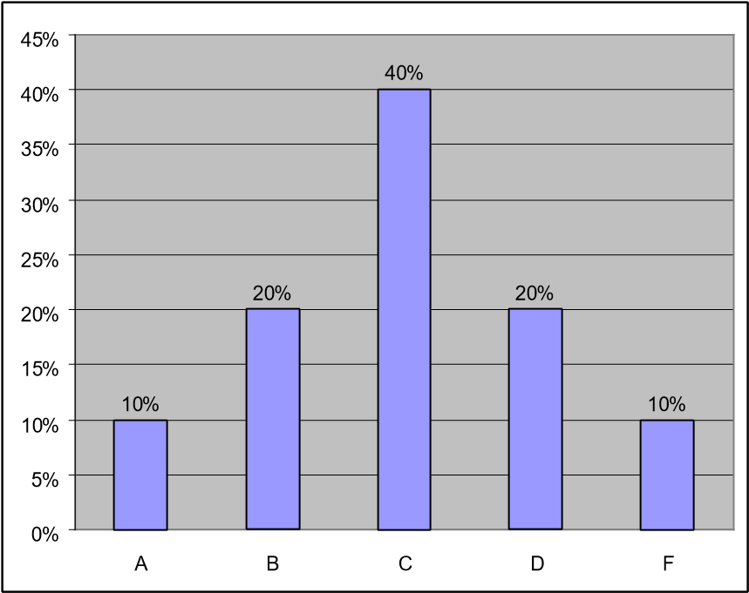

Requests for any type of special consideration
When any student requests special consideration for missing an exam, missing an assignment due date, or any other reason, written documentation, fully acceptable to the Professor, must be provided in support of such a special request. This will be required of all students. Without such documentation the request will be denied. Providing special consideration to a student without such documentation discriminates to the favor of the requesting student and to the detriment of all other students who, for example, took the exam at the scheduled time or turned in the assignment on the due date/time.

Electronic Devices
In the great majority of group business environments, the use of electronic devices is not considered acceptable behavior. This is especially true when you are participating in an important meeting or in front of an important customer. The only exception is if you are using an electronic device as an aid in demonstrating a product or service you are promoting. In all other cases, the use of paper and pen is the most acceptable method of taking notes on the topics being discussed.
Therefore, in this class the use of all forms of electronic devices is prohibited, and these devices should not be easily visible or accessible. This includes laptops, notepads, cell phones, MP3 players, earphones, cameras, etc. Any student observed using an electronic device for any reason whatsoever in this class will receive a penalty of 25 points subtracted from that student’s total point accumulation for the semester. The reduction of 25 points will apply to each observed occurrence and will be cumulative – just like absences and late arrivals.
If you receive an emergency message that you must respond to, then please get up and leave the classroom before using your cell phone or other electronic device. Also, it is expected that these departures will be short in duration (5 minutes or less) and occur a minimal number of times during the semester.

Academic Integrity
The G. Brint Ryan College of Business takes academic honesty seriously. Ethics and integrity are important business values, essential to building trust and adhering to both professional and legal standards. Academic dishonesty destroys trust, damages the reputation and the value of the degree and is unacceptable.
According to UNT Policy 06.003, Student Academic Integrity, academic dishonesty occurs when students engage in behaviors including, but not limited to cheating, fabrication, facilitating academic dishonesty, forgery, plagiarism, and sabotage. A finding of academic dishonesty may result in a range of academic penalties or sanctions from admonition (a warning) to expulsion from the University.
Some of the most common examples of academic integrity violations include plagiarism or cheating, such as unauthorized assistance on examinations, homework, research papers or case analyses. Your work must be entirely your own. When working on assignments, you should not discuss your work with others unless approved by the course instructor. Group assignments should only be discussed with members assigned to your group, and all group members may be held accountable in some way for known academic integrity violations in a group assignment.
Another example of academic dishonesty relates to improper attribution. When preparing your assignments, you must cite all outside sources in the manner requested by your instructor. Copying or using material from any source prepared by or previously submitted by others, at UNT or other institutions, or downloaded from the Internet, is plagiarism. Unless directed otherwise in an assignment, large scale “cutting and pasting” from other sources, even if properly footnoted, is not appropriate. You should synthesize this material in your own words and provide a footnote.
Your instructor will specify what materials, if any, may be used on the tests and exams.
Using materials other than those permitted, talking with other individuals during the exam, individuals exchanging information about an exam when one has taken the exam and the other has not, or copying or using material from another individual’s exam is academic dishonesty and will result in a meeting to discuss academic integrity violations and potentially issue sanctions mentioned above, and may result in ineligibility for academic scholarships. The use of online assistance, such as sites commonly used for finding homework solutions, group chat, cell phones, smart watches, and similar tools during exams is not allowed for any reason unless specifically permitted. No portion of an exam may be copied or photographed without permission.
Students are expected to conduct themselves in a manner consistent with the University's status as an institution of higher education. A student is responsible for responding to a request to discuss suspected academic dishonesty when issued by an instructor or other University official. If a student fails to respond after a proper attempt at notification has been made, the University may take appropriate academic actions in the absence of the student’s participation.
The G. Brint Ryan College of Business takes academic honesty seriously. Ethics and integrity are important business values, essential to building trust and adhering to both professional and legal standards. Academic dishonesty destroys trust, damages the reputation and the value of the degree and is unacceptable.
See the following UNT Web address for more detail: http://vpaa.unt.edu/academic-integrity.htm

American Disabilities Act Compliance
This course is in full compliance with the guidelines and recommendations of the American Disabilities Act. If you are registered with the University ODA office and would like accommodation on the examinations it is your responsibility to contact Dr. Lewin and make a request. Burden of proof is the responsibility of the student.

Final Grade Appeals, Changes, and the Awarding and Removal of an ‘Incomplete’
This Instructor strictly follows the guidelines set forth in the current Undergraduate Catalog for grade appeals, changes, and the awarding and removal of an ‘Incomplete’.

Acceptable Student Behavior
Student behavior that interferes with an instructor’s ability to conduct a class or other students' opportunity to learn is unacceptable and disruptive and will not be tolerated in any instructional forum at UNT. Students engaging in unacceptable behavior will be directed to leave the classroom and the instructor may refer the student to the Center for Student Rights and Responsibilities to consider whether the student's conduct violated the Code of Student Conduct. The University's expectations for student conduct apply to all instructional forums, including university and electronic classroom, labs, discussion groups, field trips, etc.
The Code of Student Conduct can be found at www.unt.edu/csrr

Student Perception of Teaching
Student Perception of Teaching (SPOT) is a requirement for all organized classes at UNT. This short survey is available to you at the end of the semester, providing you a chance to comment on how this class is taught. Feedback from students helps to improve this course. I consider SPOT to be an important part of your participation in this class.
ORDERING OF TOPICS, BUSINESS CASES AND EXAMS FOR THE SEMESTER
(DATES SUBJECT TO REVISION)
DATES | CHAPTER | SALES MANAGEMENT TEXTBOOK
8/19, 8/21 | 1 | Changing World of Sales Management
8/26 ,8/28 | 2 | Overview of Personal Selling  Business Case #1
9/2, 9/4 | 3 | Organizational Strategies and Sales Function
9/9 ,9/11, 9/16 | 4 | Sales Organization Structure and Salesforce Deployment  Business Case #2
9/18 |  | Exam #1
9/23, 9/25, 9/30 | 5 | Acquiring Sales Talent: Recruitment and Selection
10/2, 10/7, 10/9 | 6 | Continual Development of the Salesforce: Sales Training  Business Case #3
10/14, 10/16,10/21 | 7 | Sales Leadership, Management and Supervision  Guest Speaker: Phil Sorgen
10/23, 10/28,10/30 | 8 | Motivation and Reward System Management  Business Case #4
11/4 |  | Exam
11/6, 11/11, 11/13, 11/18, 11/20 | 9 | Evaluating the Effectiveness of the Organization
11/25, 11/27 |  | Thanks Giving Holiday
12/2 , 12/4 | 10 | Evaluating the Performance of Salespeople  Business Case #5
12/9 |  | Exam #3 (Final Exam)
Attendance Syllabus Statement:
Students are expected to attend class and to abide by the attendance policy established for the course. It is important that you communicate with the professor and the instructional team prior to being absent, so you, the professor, and the instructional team can discuss and mitigate the impact of the absence on your attainment of course learning goals. Please inform the professor and instructional team if you are unable to attend class meetings because you are ill, in mindfulness of the health and safety of everyone in our community.

