
DEPARTMENT OF MARKETING & LOGISTICS

COURSE SYLLABUS

Term: Spring 2021

Course TITLE: LSCM 4900, Special Topics in Logistics and Supply Chain Management

Catalog Topic chosen by the student and developed through meetings Description: and activities under the direction of the instructor.
Prerequisite(s): LSCM 3960.

INSTRUCTOR: Terrance L. Pohlen, PhD, CTL
BLB Bldg, Rm 290M
940-565-4660
E-mail: pohlen@unt.edu

OFFICE HOURS: Monday/Wednesday: 10:00 – 11:30 and 1:30 – 3:00.
Tues/Thurs: 10:00 – 11:30; and Friday: 10:00 – 11:30.
Other times by appointment. Appointments are preferred. Please indicate the purpose when scheduling the meeting. Many times, I often can resolve inquiries through an email response.
COMMUNICATION All communication relating to the course should occur through
CONTACT INFO: Canvas messages. Discussion topics have been created for posting questions related to specific chapters or assignments. Grade challenges and other communications related to the course should be accomplished through Canvas messages. Communication unrelated to the course (advising, internships, etc.) may be submitted to pohlen@unt.edu. All assignments will be turned-in using Canvas. Please see the assignments module in Canvas for instructions on posting assignments.

CANVAS USE: | Students are expected to check Canvas, unt.instructure.com, for any course updates on a daily basis. Announcements, updates, and revised materials will periodically be posted. Students are responsible for any updates posted in Canvas—on the course header, Canvas messages, or announcements.  Technical problems or system outages may affect Canvas. Students are expected to plan ahead and download required materials in advance of due dates. System outages or problems encountered with Canvas will not be accepted as an excuse for failing to complete an assignment. Canvas typically goes down for maintenance at 11:30PM on Saturday evenings.

Course To provide an understanding of the key logistics, transportation,

Objectives: and supply chain management concepts and the issues affecting the movement of goods and people through the supply chain. Particular emphasis will be placed on emerging trends and issues affecting logistics and supply chain management.

The course objectives are dependent on the topics selected by the student team. However, students should accomplish the following the objectives within this course:

Achieve an in-depth level of knowledge in an area relevant to logistics and supply chain knowledge

Engage with industry executives to gain a perspective regarding how the topic is applied in the business environment

Identify the key issues regarding the topic selected and how businesses are addressing

Determine future directions regarding the topic

Analyze and assess the available literature

Evaluate various methods for addressing the topic to include commercially available software packages

Synthesize the findings during the independent study effort into a comprehensive report

COURSE The course will be conducted in a blended format, combination of

FORMAT: in-class and distance. Narrated Powerpoint files may be used and contain the material that typically would have been covered in a traditional classroom environment for any class sessions employed distance education. These lectures supplement the course text. As a result, you must view the lectures and read the assigned material in the course text. The lecture material will be saved in two formats. The narrated version can be viewed with Adobe Reader version 9 or higher. The narrated version includes the Powerpoint slide, voice narration, and closed captioning (click on CC at the bottom of the screen to view the text while listening).

Course Overview: | The following is an approximate breakdown of the coverage of the topics covered in this course:

Topic | Portion of the course
Course introduction | 5%
Identification of key trends | 15%
Research of key trends | 20%
Summary of the relevant literature | 20%
Interviews with logistics and supply chain professionals | 10%
Research paper | 25%
Review of drafts and final paper | 5%
Total | 100%

GRADING: You should not view the graded elements, or assessments, as separate from learning course content. These assessments are an integral part of learning about logistics and supply chain management. Each graded element provides an opportunity for you to interact with the different problems frequently encountered by logistics professionals and to receive immediate feedback on how you have performed. The purpose of these assessments is to further your understanding of logistics.

The graded elements within the course include a major research paper, written abstracts of key journal articles or research reports required for this course, and attendance at the logistics executive lecturer series.

Graded Element | Percentage
Research paper | 60%
Abstracts | 35%
Professional Development (1) | 2.5%
Professional Development (2) | 2.5%
Total | 100.%
Note: Failure to meet deadlines or attend scheduled meetings with the faculty member may result in up to a one letter grade (10 percent of total points for the course) deduction from the final course grade.
Assignments You are expected to approach each assignment with the
and Due Dates: professionalism required in the “real” world by fulfilling completed staff work. Each assignment is due at 5:00PM on the Friday of the week assigned. A 50% penalty will be assessed for submissions within 24 hours after the assignment is due (one day late). A 100% penalty will be assessed for submissions more than 24 hours after the assignment is due. Correct spelling, grammar, and punctuation are expected and will be considered in the grading of all assignments. The overall appearance and professionalism of the submission will also be considered in the grade. All submissions will be typed (25% penalty if not).

Grading The following grading scale is guaranteed. You will receive no less

Scale: than the grade listed within the appropriate interval. I reserve the right to adjust the grading scale in favor of the class if warranted.
Numeric grades are not rounded up to the next higher letter grade. I frequently curve the grades for many of the assessments in the course. Rounding would result in an additional curve for a limited number of students near grade “breaks.”

Grade | Numeric Range | Grade Points
A | 90 to 100 | 4.0
B | 80 to 90 | 3.0
C | 70 to 80 | 2.0
D | 60 to 70 | 1.0
F | Below 60 | 0.0

CLASS SCHEDULE

LSCM 4900

Date | Topic
Week 1 | Course Introduction & Syllabus  Define problem scope, method, and deliverables
Week 2-holiday  Week 3 | Identification of research topic, key issues, and relevance to logistics and supply chain discipline  Meeting with faculty member
Week 4 | Key literature identified  Initial bibliography completed  Meeting with faculty member
Week 5 | Meeting to discuss observations and conclusions drawn from initial literature—future directions identified in meeting with faculty member  Initial Abstracts Due
Week 6 | Outline of research paper due  Feedback on abstracts during meeting with faculty member
Week 7 | Updated bibliography due  Meetings with faculty member
Week 8 | Companies and executives identified for targeted interviews  Meeting with faculty member
Week 9 | Spring Break
Week 10 | Initial draft of introduction and literature review due  Meetings with companies and executives  Meeting with faculty member
Week 11 | Feedback on initial draft of introduction and literature review  Meetings with companies and executives  Meeting with faculty member
Week 12 | Second set of Abstracts Due  Meetings with companies and executives  Meeting with faculty member
Week 13 | Feedback on abstracts  Complete bibliography due of relevant literature  Synopsis of meetings with companies and executives due  Meeting with faculty member
Week 14 and  Week 15-Holiday | Draft of finding section due  Outline of conclusions due  Meeting with faculty member
Week 16 | Final draft of introduction, literature review, and findings section due  Review and discussion of conclusions  Meeting with faculty member
Finals Week | Final paper due

ATTACHMENT 1

ABSTRACT GUIDELINES

You are required to prepare several one-page abstracts of refereed journal articles pertaining to transportation management.

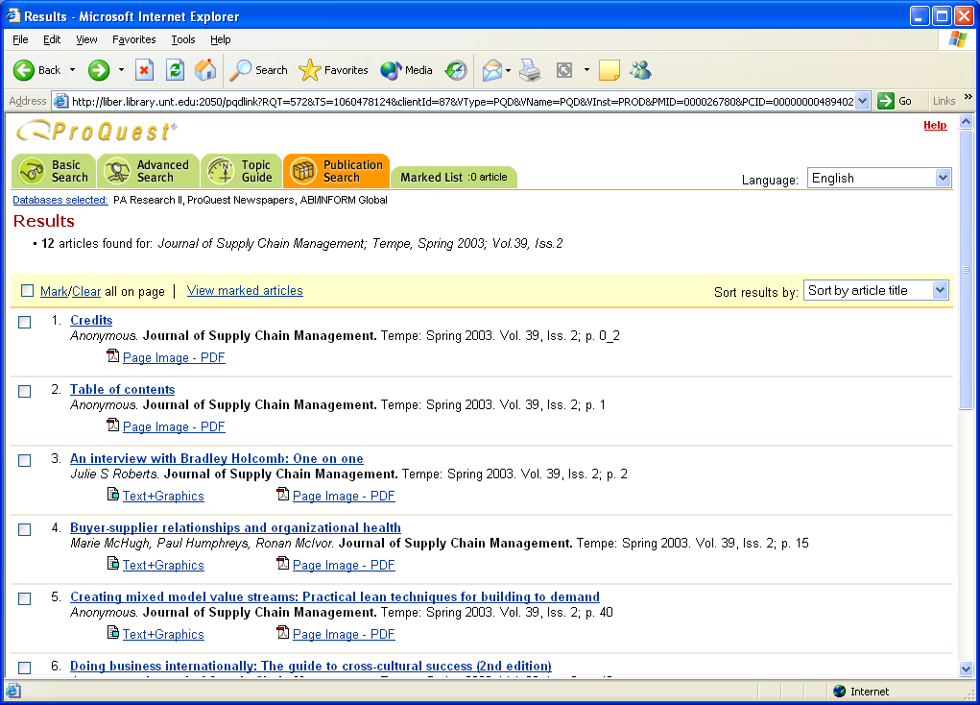

You can download and save a .pdf version of the file if you have Adobe Acrobat on your PC and by clicking on the camera icon.

You must use the following format when preparing your abstract. Place your name, the title of the article, and the course number on a cover page. At the top of the next page, in bold print, you should have the bibliographical entry for the article you are abstracting, in the following format:

La Londe, Bernard J. and Terrance L. Pohlen (1996), “Issues in Supply Chain Costing,” International Journal of Logistics Management, Vol. 7, No. 1, pp. 1-12.

Following this, skip one line, and begin your abstract. It should summarize the problem being addressed, outline the topic or method discussed, and review results/benefits/problems encountered. The following rules and criteria will be used to grade your abstract (these are in no particular order; they all are important).

Style:
- The text should be one-page only (and not shorter than one entire page), single-spaced, with one-inch margins and a 12 point Times New Roman or Arial font.
- The reference should be bold faced.
- Do not quote directly, and do not use any headings.
- Do not skip lines between paragraphs; simply indent the next paragraph and proceed.
- Do not refer to “the author(s)” or “the article.” You should write the abstract as if you are the author. This approach makes the abstract clearer and more readable.
- Do not abstract a research “note,” unless it is of considerable length (i.e., more than 5 pages or so).
- Do not abstract an article in a “magazine” instead of an academic journal.
- You must not have any obvious grammatical errors or misspelled words.
- Any sentence fragment results in an automatic one-letter grade reduction for that abstract.
- Failure to reserve your article in advance in Blackboard results in an automatic one-letter grade deduction for that abstract.
- Abstracting an article that has been reserved by another student results in an automatic one-letter grade deduction for that abstract.
- Do not use headings or lists.

Content:

- Do not select an article that is laden with mathematical notation, theorems, proofs, etc. that you do not understand.
- Very briefly tell me why you picked that particular article (why it is relevant or of interest to you.) Do not write more than two sentences regarding why.
- Indicate precisely which topic or method from class was discussed, and how that article made a contribution over and above previous work in the literature.
- Could you picture yourself standing up in front of the class and presenting this as a natural extension of the in-class lectures?
- Could your classmates read your abstract and have it make sense to them (not just to me)?
- Did you describe the problem environment well?
- Did you communicate well: did you haphazardly skip from one point to the next, or was your presentation logically sequenced?
- Did you indicate problems and benefits encountered, and/or experimental results?
- Did it appear that you simply copied segments from the text, without really understanding what you were writing?
- Did it appear that you simply abstracted the first article you picked up?
- Did you appear to be “filling?”
- Did you pick a “good” article; that is, one that has a very interesting or unusual discussion, and one that you could easily understand?
- Did you pique interest?
- Is the article relatively recent (within last 10 years)?
- Did you use terms in your abstract that you simply lifted out of the text, of which you probably have no idea of their meaning?
Sources for articles:

The following academic journals represent great starting places for selecting your articles. This list is by no means exhaustive. I strongly encourage you to start with The Transportation Journal, Journal of Business Logistics or The Journal of Transportation Management. These journals are application oriented, not filled with mathematical notation, and very readable. The same is true of The International Journal of Logistics Management, and International Journal of Physical Distribution and Logistics Management. You will find that many of the other journals in the list are heavily mathematical and very difficult to follow. I would suggest that you explore articles that discuss a linkage between transportation management and your particular field of interest first (i.e., if you’re an accounting major, look for an article discussing the linkages between, say, cost accounting and an operations topic).

Recommended Journals:

Production and Inventory Management Journal, International Journal of Purchasing and Materials Management, Decision Sciences, Management Science, Journal of Operations Management,, International Journal of Production Research, Journal of Business Logistics, Computers and Industrial Engineering, Industrial Management, Institute of Industrial Engineers (IIE) Transactions, International Journal of Forecasting, International Journal of Logistics Management, International Journal of Operations and Production Management, International Journal of Operations and Quantitative Management, International Journal of Production Economics, International Journal of Quality and Reliability Management, Journal of Business Forecasting, Journal of Forecasting, Journal of Industrial Engineering, Journal of Physical Distribution, Journal of Quality Management, Journal of Manufacturing and Operations Management, Naval Research Logistics Quarterly, Production and Operations Management, Production Planning and Control, Quality, Quality Progress, Supply Chain Management, Journal of Supply Chain Management

LSCM 4900 Abstract Evaluation Form
Page 1

Student name: ___________________________________

LSCM 4900 Abstract Evaluation Form
Page 2

Other comments:

ATTACHMENT 2

RESEARCH PAPER

GRADING TEMPLATE

Name:

LSCM4900
Paper Evaluations
Evaluation Element | Percent of Grade | Student  Grade
Relevance to logistics management—relationship of topic as well as student’s ability to relate paper and research to logistics management topics and techniques. | 5
Neatness and overall appearance of paper—margins, headings, use of graphics or tables. | 5
Length requirement—did student satisfy the minimum length requirement (minimum of 20 pages) (12 pitch, 1 inch margins). | 5
Organization—does the article follow a logical progression? Did the student integrate the researched material or is it just a sequence of discussions? Is the paper constructed to develop a well-developed conclusion? Are conclusions, issues, future directions, other positions clearly defended? | 15
Readability—how well is the paper written? Did the student make appropriate use of transitions, paragraphs, and sentence structure? Does the writing style flow well or is it choppy? Do paragraphs have a clearly stated topic sentence with two to three supporting sentences? Use of two sentence paragraphs will result in a grade deduction. | 10
Comprehensive discussion of topic—complete and thoroughness. Has the student thoroughly researched the topic and discussed it in the paper? Are key sources used? Does the student include professional as well as academic literature into the discussion? | 15
Analysis of topic—Does the student “analyze” the material, or is the paper simply a “report?” Are key issues identified and discussed? How current are the sources? How difficult was the material addressed? | 15
Future directions and Conclusions— Does the student draw meaningful conclusions? Quality of the discussion and integration of sources. How well did the student develop logical conclusions based on the analysis? Do the suggested future directions/issues make sense based on the research? How well did the student integrate the research into the case application analysis? | 15
Bibliography and footnotes—did student identify key and relevant sources—use of academic and research sources--go beyond simply an Internet or cursory search process? Are footnotes appropriately used? Are footnotes and bibliography entries complete? | 10
Spelling and grammar | 5
Total: | 100
Grade deductions:
Not typed | 20
Less than 10 refereed journal articles used in writing paper | 20
No table of contents | 15
No major or minor headings used in the paper | 10

