ADVANCED POETRY
SPRING 2026
MONDAYS / 6-9p
CLASSROOM: AUDB 212

OFFICE HOURS: MONDAYS / 4:30-6p + by appt
EMAIL: tarfia.faizullah@unt.edu

INTENTION: To progress in the path of becoming a writer. Progress does not mean perfection--far from it. Progress in this context means developing comfort with the discomfort of growing as a thinker and creator. Progress means accepting the inevitability of pitfalls encountered as a result of consistent and devoted passion to the art of writing.

FINAL PROJECT / OUTCOME:

1. A final portfolio consisting of 10-12 pages of polished & original poetry, accompanied by an artist's statement which will include a discussion of a form of your choice (see below), as well as a deeper and greater sense of one's personal passions & creative concerns.

2. A deeper understanding of a poetic form of your choice: this will entail selecting a form and study it privately all semester by writing in it, studying its characteristics, and learning its history. 3-5 poems in your portfolio should be in this form. The list of options include:

-sonnet
-prose poem
-cinquain
-sestina
-villanelle
-haiku
-triolet
-pantoum
-limerick
-cento
-rondel
-ghazal
-golden shovel
-palindrome
-ode
-elegy
-ekphrasis
-pastoral
-acrostic
-duplex
-concrete poem

HOW WE'LL GET THERE:

- weekly in-class writing + other relevant thought exercises
- weekly discussion of assigned reading
- weekly submission of your own original poems
- weekly peer review of your own original poems (workshop)

TEXT:

The Poetry Reader: An Anthology, ed. by Mark Yakich

SUPPLEMENTAL MATERIALS:

- pen & notebook / a pair of scissors / art supplies (colored pencils, markers, paints) / glue-stick
WORKSHOP: Every other week, one of your original compositions will be peer-reviewed (workshopped). Each poem will receive 10 minutes of discussion. In these discussions, the author is discouraged from speaking, though you will be given 1 minute (precisely!) before & after discussions to comment. On weeks you aren't being workshopped, you're expected to participate in the discussion of your peers' poems. You'll email your poem to us the Thursday before your designated workshop Monday.

ATTENDANCE: It's your time and money; what you put into it is what you'll get out of it. Please do me the courtesy of letting me know when you won't be in class / that you weren't in class so that I can keep some kind of track for grading purposes, and especially so I don't worry. Please don't feel the need to make excuses--you are allowed to not explain yourself.

GRADING: You will be assessed for consistency of attendance, level of in-class participation, quality of creative output, growth as a writer/thinker over the course of the semester, and polished quality of your final portfolio. You can ask me about your grade at any point in the semester, and I encourage you to.

CLASSROOM ETIQUETTE: Please do engage with each other with sincerity, respect, and compassion. Disagreeing with each other respectfully / practicing the articulation of your own perspective is encouraged. Interrupting, talking over someone else, rudeness, aggressiveness, and the like, will not be accommodated. In short, basic humanity is expected from all.

ACADEMIC FREEDOM: UNT has a robust policy regarding academic freedom and academic responsibility. Crucially, this policy encompasses not only the rights of faculty members but also the rights “of the student to freedom in learning.” As a student in this classroom, therefore, you have the right to encounter and debate new ideas, diverse forms of knowledge, and unfamiliar or contrary points of view. According to UNT policy, “it is not the proper role of the University to attempt to shield individuals from ideas and opinions they find unwelcome, disagreeable, or even deeply offensive.” At the same time, to encourage the free exchange of ideas, and to ensure that your right to learn is protected, the tone for such discussion must always be civil and respectful; hateful or discriminatory speech will not be tolerated. For more information, please consult the full UNT policy at https://policy.unt.edu/policy/06-035.

AUDIO/VIDEO RECORDING: Although UNT is a publicly supported institution, our classroom is not a public space. Therefore, in order to protect the intellectual property and privacy rights of both faculty and students, video and audio recordings are prohibited during class. The exception is for students who have been granted explicit approval as an ODA accommodation. For more information, please consult the full UNT policy at https://studentaffairs.unt.edu/office-disability-access/faculty/faculty-guide/accommodations-explained/Audio-Recording-Faculty.html

ODA ACCOMMODATION: Federal law requires that instructors make reasonable adjustments to provide educational access to students with disabilities, provided the accommodations do not fundamentally alter the essential elements of the course. Specifically, program accessibility is mandated under Section 504 of the Rehabilitation Act of 1973, the Americans with Disabilities Act (ADA) Amendments Act of 2008, and UNT Policy 16.001. In short, I'm always happy to discuss and engage in relevant strategies to enhance your classroom experience.

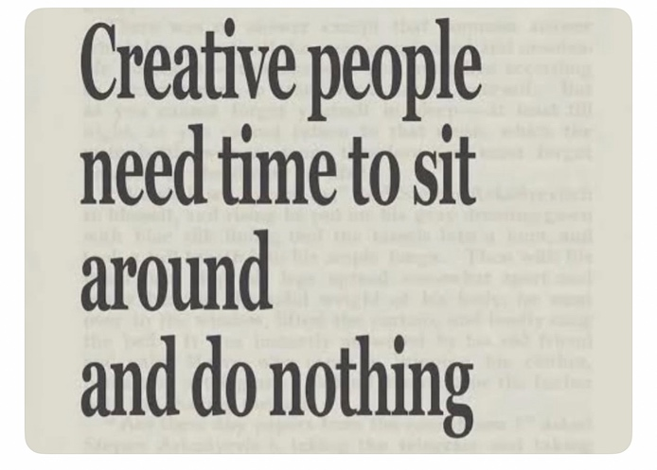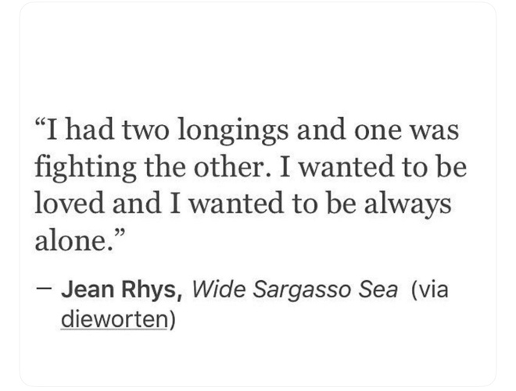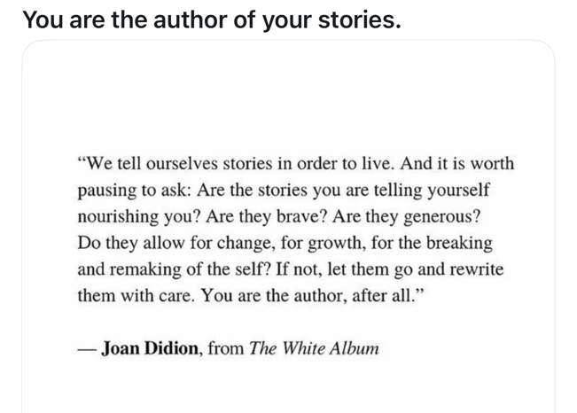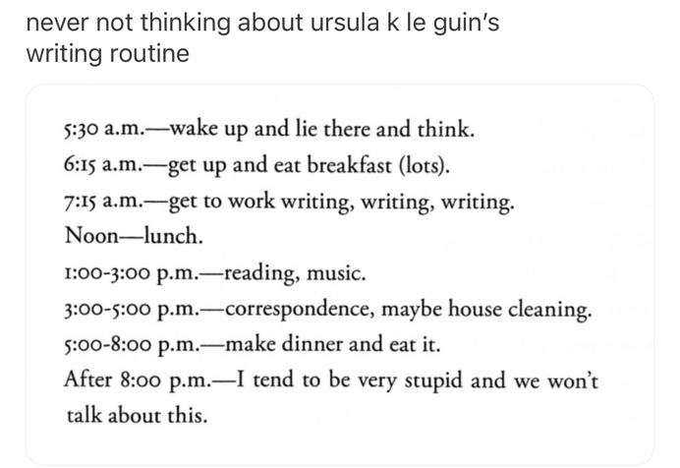

CALENDAR (Reading Assignments are due the day they are listed)

1/12/26: Intros & Icebreakers

1/19/26: MLK Day (No Class)

1/26/26: Haunting Poems

2/2/26: Haunting Poems (Cont.)

2/9/26: (TPR) "Ars Poetica" by Jose Olivarez
"Viewpoint" by Mahmud Darwish
"Someone I'm Afraid Of" by Zaki Ovais
"Diving Into the Wreck" by Adrienne Rich
"Bird-Understander" by Craig Arnold
"from the Book of Questions" by Pablo Neruda

Workshop Group 1

2/16/26: (TPR) "Altruism" by Molly Peacock
"Any Lit" by Haryette Mullen
"Ode to the Flute" by Ross Gay
"The Boy Calls Twilight" by Shane McRae
"from the Book of Questions" by Pablo Neruda
"This Room and Everything In It" by Li Young Lee

Workshop Group 2

2/23/26: (TPR) "Punctum / Metaphor" by Carolina Ebeid
"Apocatastasis" by G.C. Waldrep
"Paradoxes and Oxymorons" by John Ashberry
"We Were All Odysseus in Those Days" by Amorak Huey
"Ganymede" by Jericho Brown
"Creation Myth" by Mathias Svalina

Workshop Group 1

3/2/26: (TPR) "Lying in a Hammock" by James Wright
"Wild Geese" by Mary Oliver
"Part of Eve's Discussion" by Marie Howe
"Hive Minds" by Jennifer L. Knox
"Borges and I" by Jorge Luis Borges
"38" by Layli Longsoldier

Workshop Group 2

3/9/26: Spring Break (No Class)

3/16/26: (TPR) "The War Works Hard" by Dunya Mikhail
"Napoleon" by Miroslav Holub
"Poetry Reading" by Anna Swir
"Preface to a Twenty Volume Suicide Note" by Amiri Baraka
"Your Animal" by Gerald Stern
"no more grandma poems" by Yolanda Wisher

Workshop Group 1

3/23/26: "what's not to liken?" by Evie Shockley
"Poppies in October" by Sylvia Plath
"The Red Poppy" by Louise Gluck
"You Should Write a Poem About That" by Emilia Phillips
"Theories of Time and Space" by Natasha Trethewey
"Having a Coke with You" by Frank O'Hara

Workshop Group 2

3/30/26: (TPR) "One Art" by Elizabeth Bishop
"Variations on a Theme" by John Murillo
"Revision" by Maya Abu Al-Hayyat
"Pencil" by Marianne Boruch
"Dedication" by Czeslaw Milosz
"You Fixed It" by Zeina Hashem Beck

Workshop Group 1

4/6/26: (TPR) "from Please Bury Me in This" by Allison Benis White
"Self-Portrait with Profanity" by Safia Elhillo
"A Brief for the Defense" by Jack Gilbert
"Happiness" by Jane Kenyon
"Meditation at Lagunitas" by Robert Hass
"The Unwritten" by W.S. Merwin

Workshop Group 2

4/13/26: (TPR) "Things No One Knows" by Wanda Coleman
"from Obit" by Victoria Cang
"My Life" by Lyn Hejinian
"On Living" by Nazim Hikmet
"Under a Certain Little Star" by Wislawa Szymborska

Workshop Group 1

4/20/26: TBD / Workshop Group 2

4/27/26: TBD / Last Day of Class

5/4/26: Final Portfolios Due

