
Spring 2026 Syllabus
Location: CHEM 106
Tu, 4:00 PM – 5:20 PM
Th, 4:00 PM – 5:20 PM

CHEM 3451.001: Quantitative Analysis
Dr. Thomas Kiselak
University of North Texas

Welcome to Quantitative Analysis

Introduction
Table of Contents
Required Material 2
Schedule 3
How to Succeed 4
Format of Class 5
Grades & Assessment 6
Bio & Contact 9
University Policies 10

Contact Information
Dr. Thomas Kiselak
Thomas.kiselak@unt.edu
Office: CHEM 163

Drop-in Hours:
Thursday – 5:20PM – 6:00PM
Other times by request

Welcome to Quantitative Analysis (Chem 3451). This course is a core component of the chemistry curriculum and focuses on the theory and practice of determining how much of a chemical species is present in a sample. Building on your prior coursework in general and organic chemistry, this class emphasizes measurement, data quality, and chemical problem-solving.
The course closely follows the framework presented in Quantitative Chemical Analysis by Daniel C. Harris, which emphasizes the connection between chemical principles, experimental design, statistical analysis, and real-world applications. You will learn how chemical measurements are made, how uncertainty is quantified and minimized, and how analytical data are interpreted to support scientific conclusions.
A significant portion of this course is devoted to quantitative reasoning, including error analysis, statistics, calibration, and equilibrium calculations. You will be expected to apply algebra, logarithms, and basic statistics regularly. More importantly, you will be challenged to think critically about data quality, method selection, and the limitations of analytical results.
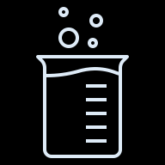

My goal is not only for you to master analytical techniques, but also to develop the mindset of a practicing scientist, one who can evaluate data skeptically, communicate results clearly, and make defensible conclusions based on evidence. This course can be demanding, but with consistent effort, strong study habits, and effective use of available resources (office hours, tutoring, and peer support), you will gain skills that are essential for careers in chemistry, medicine, engineering, and related fields.

Student Learning Objectives
By the end of the semester, you should be able to:
- Apply quantitative principles to evaluate analytical data quality
- Design and interpret chemical analyses using equilibrium and instrumental methods
- Communicate defensible conclusions while accounting for measurement uncertainty and error


Required Material

HOMEWORK System:
Doing homework on a continual basis is extremely important for checking your understanding and keeping up-to-date.
Homework will be assigned through Canvas, and due every Sunday night. Make sure that you are working on it a little bit every day, or every other day!

TEXT:
Quantitative Chemical Analysis, 11th edition
By: Daniel C. Harris and Charles A. Lucy
*Achieve Platform Required

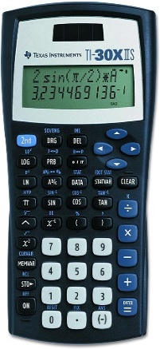
CALCULATOR:
Preferred: Texas Instruments TI-30XII Scientific Calculator
- Cost - less than $20
- Bring calculator to every class.
- Practice using your calculator
- Any scientific calculator is fine



OTHER Apps For Class
- Canvas Learning Management System (LMS)
- Achieve



Tentative Course Calendar
Chapter | Title | Approx. Start Date
0/1 | The Analytical Process – Chemical Measurements | 1/13
2 | Tools of the Trade | 1/20
3 | Experimental Error and Uncertainty | 1/27
 | Exam 1 – 2/3
5 | Quality Assurance and Calibration Methods | 2/5
6 | Chemical Equilibrium | 2/12
7 | Let the Titrations Begin | 2/19
11 | Acid-base Titrations | 2/26
 | Exam 2 – 3/5
 | Spring Break | 3/9 – 3/15
14 | Fundamentals of Electrochemistry | 3/17
15 | Electrodes and Potentiometry | 3/24
18 | Fundamentals of Spectrophotometry | 3/31
 | Exam 3 – 4/7
22 | Mass Spectrometry | 4/9
23 | Introduction to Chromatography | 4/16
24 | Gas Chromatography | 4/23
25 | High Performance Liquid Chromatography | 4/30

January 19th – Martin Luther King Jr. Day – university closed
March 9th – 15th – Spring Break, university closed
April 30th – Last day of class
Check https://registrar.unt.edu/sites/default/files/spring-2026-academic-calendar.pdf for other important dates!

I reserve the right to change or modify the syllabus at any time. If changes are made, students will be notified during scheduled class times and the revised syllabus will be made available on Canvas.

Teaching Assistants (TAs)

Snigdha Dutta
Office: CHEM 337
Drop-in hours: Tuesdays, 3:00 – 4:00pm
Email:snigdhadutta@my.unt.edu
The TAs are here to help with the logistics of the class, as well as provide help to you outside of the lecture and recitation. You can attend their drop-in hours as well to ask questions about the material, of what it’s like to be a graduate student in chemistry!

How To Succeed
- Follow the study cycle. It has been proven to work!

- Do lots of practice problems. They will show what you do and don’t know.

- Schedule tutoring sessions as early as possible.

Tips to succeed
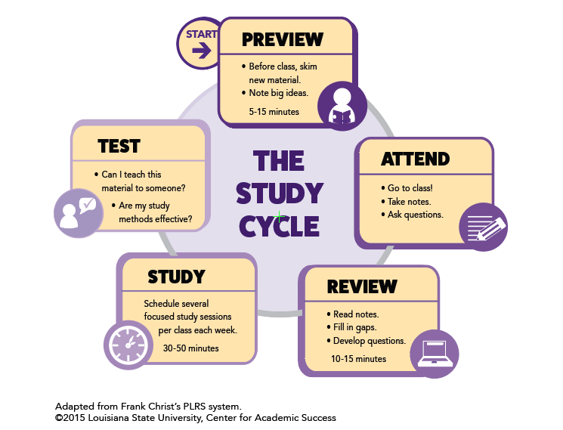

Tutoring Center
We have a tutoring center in the Chemistry building, the Chemistry Resource Center (CRC), room 231. It is staffed by Chemistry graduate students and they are available for drop-in tutoring. The Learning Center in Sage Hall also has a tutoring center, with drop-in, appointments, or even online tutoring available. See this link for schedules: https://chemistry.unt.edu/undergraduate-program/instructional-resources

Don’t wait to get help. Tutoring is most effective when it is started early.

Format of Class
Because learning can be challenging, we will be using a more active and student-centered approach to learning. Although we have more traditional stadium seating, I still expect that you will be engaged with the material by answering questions, working problems, taking notes, and discussing topics. We will use simulations, and group discussions. Your peers around you will be the first place you can turn to ask questions or verify your knowledge of the topics we are discussing! I ask questions during class and will wait for responses. Even wrong answers are okay! It helps me know where you are at in the discussion.
Before Class
- Review Last Class material
- Take Adaptive Quiz
- Write Down Questions
- Review upcoming topics (5-10 minutes)
- Download (or print) PPT
During Class
- Stay AWAKE!
- Follow along with notes
- Ask Questions
- Work through problems
- DON’T RE- WRITE NOTES
After Class
- Review Notes
- Ask questions in office hours
- Work through Homework

Grades and Assessment

Measuring Success in This Course

100.0% - 90.0% possible points – A
89.9% - 80.0% possible points – B
79.9% - 70.0% possible points – C
69.9% - 60.0% possible points – D
59.9% - 0.0% possible points – F

There may be extra credit offered throughout the semester, at the discretion of the instructor. Extra credit will not be offered after April 30th, so do not ask!
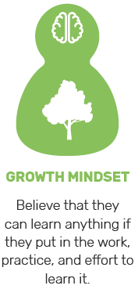
Homework: Doing problems on a continual basis is extremely important for checking your understanding and keeping up-to-date.
Homework will be assigned through Canvas/Achieve. The nature of many chemistry problems requires that solutions be written out in detail. It is important to show complete solutions, including set-up, units, and correct use of significant figures, not just final answers.


Quizzes: There will be a weekly adaptive quiz, available on Canvas. The nature of the quizzes is to prepare you for the material that will be presented. Accordingly, I strongly recommend you perform the quizzes before starting the chapter in class to identify strengths and weaknesses of the material before class.
Quizzes will prepare you for the material that is going to be presented and generally reflect the effort put forth in the mastery assessment. Quizzes are cumulative in that you achieve full credit once you have completed a sufficient amount of correct answers. It is likely that you will do poorly on the exams if you do not complete these.


Exams: There will be THREE exams. Each exam will have 100 points possible. If a student receives a “0” because of cheating, that grade cannot be used as the dropped grade.
All exams must be taken as scheduled. All exams must be taken at the regularly scheduled times. Exams cannot be taken outside the scheduled time. There will not be any makeup exams (unless there is a well-documented serious illness, requiring hospitalization).

Exam 1 (10% of Final Grade) – February 3rd
Exam 2 (10% of Final Grade) – March 5th
Exam 3 (10% of Final Grade) – April 7th
Final Exam (30% of Final Grade) – Tuesday, May 5th, 12:30 PM to 2:30 PM

PLAN ACCORDINGLY FOR THE TEST DATES!

You are expected to bring the following items to each exam: a pencil with a good eraser and a scientific calculator. Cell phones, tablets, laptop computers, or other electronic devices will NOT be allowed! Scratch paper will be provided.


WITHDRAWAL DATE: The last date to withdraw from a course this term (with a “W” grade) is Friday, April 10th. In accordance with University policy, no exceptions will be made to the deadline. If you are failing the class at this point in the semester, you should strongly consider withdrawing.

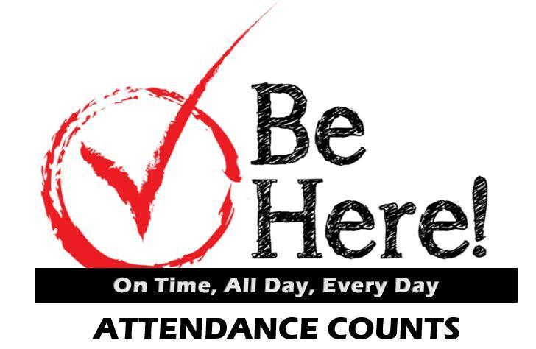
ATTENDANCE: Because class discussion and problem solving is at the heart of this course, you are required to be in class. Of course, I understand that sometimes emergencies or other unexpected circumstances arise that make attendance that day impossible. If this is the case, please talk with other students in the class to see what you missed, get copies of notes, etc. If you will be absent from a class for a university-sponsored activity, please make arrangements with me — beforehand — regarding any work you might miss.
Disruptive behavior such as talking, giggling, snoring, talking on a cell phone, playing on the Internet or texting, etc, will not be tolerated. Cell phones need to be muted during class. A student engaged in disruptive behavior can be asked to leave class immediately and can be suspended from class for a period of up to a week for the first offense, and longer if the behavior persists.
Taking photographs, video or audio recording of me or presentation materials without my explicit permission. In addition, earbuds or headphones are not allowed to be used during class time, unless you have a specific documented need for them. If this is the case, please see the Office of Disability Access (ODA) to ensure that the appropriate paperwork has been filed. https://studentaffairs.unt.edu/office-disability-access

Other Notes

By university regulations, a grade of “I” (Incomplete) cannot be given as a substitute for a failing grade in a course.

CHEM 3452 is the laboratory course and a separate course from CHEM 3451. Students will receive separate grades for the two courses. Dropping either course does NOT automatically drop you from the other course.

Regarding dissemination of information, I exclusively use Canvas to email the entire class with reminders of deadlines, changes to classroom policies, etc. In addition, I post the lecture notes and grades on Canvas. Please make it a habit to check Canvas (and your email) at least twice a week.

I will not respond to email received from non-UNT email addresses, especially concerning grade information. With a personal email address, I cannot be certain that it is you on the other end. As such, please use your official UNT email address to email me. But I welcome emails at any time!

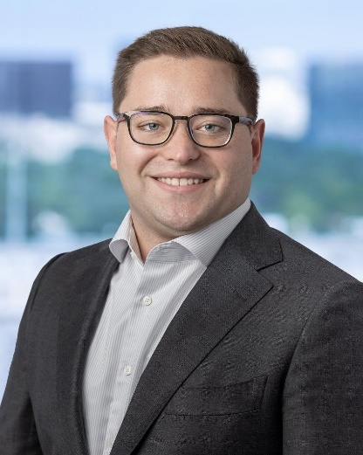
Biography and Contact
Hello and welcome to Quantitative Analysis! I'm Dr. Thomas Dieter Kiselak, and I'm excited to be your instructor this semester at the University of North Texas.
About me: I earned my Ph.D. in Chemistry with a focus in analytical chemistry, where I specialized in developing innovative drug delivery systems and advanced mass spectrometry techniques. That strong foundation in science led me into the field of intellectual property law. Today, I work as a patent attorney, protecting the types of inventions I once created in the lab.
My professional experience combines science, innovation, and law. I am especially interested in how chemistry forms the basis for what can be protected through patents, the common barriers students encounter when learning chemical concepts, and how to help students at both undergraduate and graduate levels overcome those obstacles. By linking legal principles with a deep understanding of chemistry, I have come to value how important it is to communicate science clearly and accurately.
- Why are you teaching? I am teaching because I love chemistry! I find great fulfillment in breaking down complex topics in a way that others can understand. It brings me joy to see students grasp new ideas and grow in confidence and ability.
- How do you define successful learning? I believe success looks different for every student. You define what success means to you, and my role is to help you reach that goal. If you leave this course with a stronger appreciation for chemistry, then that is also a success in my eyes!
- What can students expect from you? A supportive and practical approach to learning chemistry. I will connect atomic and molecular concepts to real-world challenges in medicine, technology, and industry. I will share examples drawn from my own experience. My teaching will focus on helping you overcome misconceptions and build confidence, so by the end of the course you can see yourself as someone who understands and enjoys chemistry.
- Outside the Classroom! I have a strong passion for mentorship and education, both in the sciences and in broader areas such as policy, innovation, and entrepreneurship. I volunteer my time to support educational and professional development programs, and I am committed to helping others reach their full potential. My journey has shown me how powerful a chemistry background can be, and I am excited to help you begin yours!
Drop-in Hours: Thursday 5:20 PM – 6:00 PM; or by appointment (preferred)
Drop-in hours are a time that I am in my office, door open and ready to talk to you! Come ask me any chemistry-related question you can think of. If you are coming during my normal hours, posted above, you do not have to make an appointment or otherwise let me know that you are coming. If you can’t make those hours, for whatever reason, send me an email and we can make an appointment.

Other University Policies

ACADEMIC DISHONESTY Students caught cheating or plagiarizing will receive a "0" for that particular assignment or exam. Additionally, the incident will be reported to the Dean of Students, who may impose further penalty. According to the UNT catalog, the term "cheating" includes, but is not limited to: a. use of any unauthorized assistance in taking quizzes, tests, or examinations; b. dependence upon the aid of sources beyond those authorized by the instructor in writing papers, preparing reports, solving problems, or carrying out other assignments; c. the acquisition, without permission, of tests or other academic material belonging to a faculty or staff member of the university; d. dual submission of a paper or project, or resubmission of a paper or project to a different class without express permission from the instructor(s); or e. any other act designed to give a student an unfair advantage. The term "plagiarism" includes, but is not limited to: a. the knowing or negligent use by paraphrase or direct quotation of the published or unpublished work of another person without full and clear acknowledgment; and b. the knowing or negligent unacknowledged use of materials prepared by another person or agency engaged in the selling of term papers or other academic materials.
ACCEPTABLE STUDENT BEHAVIOR Student behavior that interferes with an instructor’s ability to conduct a class or other students' opportunity to learn is unacceptable and disruptive and will not be tolerated in any instructional forum at UNT. Students engaging in unacceptable behavior will be directed to leave the classroom and the instructor may refer the student to the Dean of Students to consider whether the student's conduct violated the Code of Student Conduct. The university's expectations for student conduct apply to all instructional forums, including university and electronic classroom, labs, discussion groups, field trips, etc. The Code of Student Conduct can be found at http://deanofstudents.unt.edu.
ADA STATEMENT The University of North Texas makes reasonable academic accommodation for students with disabilities. Students seeking accommodation must first register with the Office of Disability Accommodation (ODA) to verify their eligibility. If a disability is verified, the ODA will provide you with an accommodation letter to be delivered to faculty to begin a private discussion regarding your specific needs in a course. You may request accommodations at any time, however, ODA notices of accommodation should be provided as early as possible in the semester to avoid any delay in implementation. Note that students must obtain a new letter of accommodation for every semester and must meet with each faculty member prior to implementation in each class. For additional information see the Office of Disability Accommodation website at http://disability.unt.edu. You may also contact them by phone at (940) 565-4323.
EMERGENCY NOTIFICATION & PROCEDURES UNT uses a system called Eagle Alert to quickly notify you with critical information in the event of an emergency (i.e., severe weather, campus closing, and health and public safety emergencies like chemical spills, fires, or violence). The system sends voice messages (and text messages upon permission) to the phones of all active faculty staff, and students. Please make certain to update your phone numbers at http://www.my.unt.edu. Some helpful emergency preparedness actions include: 1) know the evacuation routes and severe weather shelter areas in the buildings where your classes are held, 2) determine how you will contact family and friends if phones are temporarily unavailable, and 3) identify where you will go if you need to evacuate the Denton area suddenly. In the event of a university closure, please refer to Canvas for contingency plans for covering course materials.

RETENTION OF STUDENT RECORDS Student records pertaining to this course are maintained in a secure location by the instructor of record. All records such as exams, answer sheets (with keys), and written papers submitted during the duration of the course are kept for at least one calendar year after course completion. Course work completed via the Canvas online system, including grading information and comments, is also stored in a safe electronic environment for one year. You have a right to view your individual record; however, information about your records will not be divulged to other individuals without the proper written consent. You are encouraged to review the Public Information Policy and the Family Educational Rights and Privacy Act (FERPA) laws and the university’s policy in accordance with those mandates at the following link: http://essc.unt.edu/registrar/ferpa.html

STUDENT PERCEPTION OF TEACHING (SPOT) Student feedback is important and an essential part of participation in this course. The Student Perception of Teaching (SPOT) is a requirement for all organized classes at UNT. This short survey will be made available at the end of the semester to provide you with an opportunity to evaluate how this course is taught.

SUCCEED AT UNT UNT endeavors to offer you a high-quality education and to provide a supportive environment to help you learn and grown. And, as a faculty member, I am committed to helping you be successful as a student. Here’s how to succeed at UNT: Show up. Find Support. Get advised. Be prepared. Get involved. Stay focused. To learn more about campus resources and information on how you can achieve success, go to http://success.unt.edu/

HEALTH AND WELLNESS SUPPORT: UNT and the Chemistry Department care about your health and wellness. Below you will find some of our campus-based, local, and national resources for health and mental health support. These services can be used for you or to help you support a friend. As this list is not exhaustive, please visit https://studentaffairs.unt.edu/push/unt-resources for more information and additional resources on health and wellness.

Counseling and Testing Services  https://studentaffairs.unt.edu/counseling-and-testing-services | Health and Wellness Center  https://studentaffairs.unt.edu/student-health-and-wellness-center
UNT Police  https://police.unt.edu/ | Substance Abuse Center  https://studentaffairs.unt.edu/rise/programs/sure-program
UNT Food Pantry
https://studentaffairs.unt.edu/food-pantry
National Suicide Prevention Lifeline (includes Veteran support services)  1-800-273-TALK | Trevor Project/LGBTQ Support  866-488-7386

Commitment to Respect for All:
As members of the UNT community, we have all made a commitment to be part of an institution that respects and values the identities of the students and employees with whom we interact. UNT does not tolerate identity-based discrimination, harassment, and retaliation so we will work as a class to collaborate in ways that encourage inclusivity. We view diversity as encompassing the intersecting identities that make us unique individuals, including (but not limited to) ethnic/racial identity, nationality, sexual and LGBTQ+ identity, gender identity and expression, age, religious/spiritual beliefs, socioeconomic status, body shape/size, physical ability status, and varying points of view.

