
DEPARTMENT OF ECONOMICS
Course: ECONOMICS 1110.465 - PRINCIPLES OF MACROECONOMICS
This class is fully online, with no set meeting times.
Instructor: Ms. Matthys (or Ms. M)
Email: taylor.crews@unt.edu
Office: Wooten Hall 329
Office Hours: Monday and Wednesday 2:00pm – 3:00pm
Tuesday and Thursday 12:30pm - 1:30pm
Zoom office hours available by appointment

Welcome to Economics at UNT!

As members of the UNT community, we have all made a commitment to be part of an institution that respects and values the identities of the students and employees with whom we interact. UNT does not tolerate identity-based discrimination, harassment, and retaliation. UNT’s full non-discrimination policy can be found in the UNT Policies sections of this syllabus.

Principles of Economics Help Center

To assist you with this course, our department is happy to make a Help Center available for your use during the regular semester. The Principles of Economics Help Center is located in Wooten Hall, room 310 and will be open for student use starting Tuesday, January 21. Hours of operation are on the Help Center Information Sheet posted on Canvas. The help Center also offers online hours over Zoom.

Course Textbook

Required Text: Introduction to Macroeconomic Methods and Models (2024 edition)
Publisher: Top Hat; Authors: Kari L. Battaglia/Susan L. Dadres
This course requires the interactive digital textbook Introduction to Macroeconomic Methods and Models. The digital text and related assessments are accessed using the Top Hat platform (www.tophat.com).
To purchase the book for this course, go to Econ 1110.465 in Canvas and click on the TopHat LTI 1.3 link on the course page. If you do not click the launch link, then you will be removed from the course roster every night when the sync happens. In this case, you simply need to access Top Hat using an LTI 1.3 link. If you completed any assignments using a Top Hat account with the same email address as the email address you use to log into the LMS, then your answers and grades will be restored.

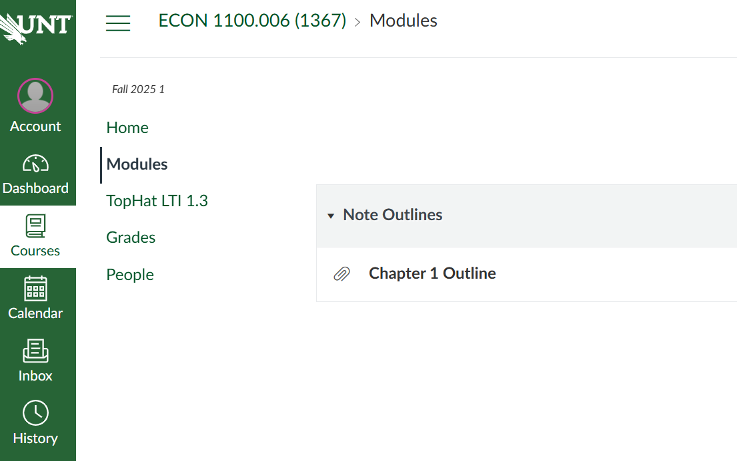

If you already have a Top Hat account, the textbook for this course will be added to your course lobby after the text is purchased. If you are new to Top Hat, you will be prompted to create an account once you click on any launch or deep link for Top Hat.

Make sure you purchase the digital text for Econ 1110.465, Spring 2026. Do NOT use a copy of the text that was purchased by another student because this would prevent you from getting homework credit.

You may purchase an access code for the textbook from the UNT bookstore OR you may go to the Top Hat website (https://tophat.com) and purchase access online.

For instructions on how to download the Top Hat app, please refer to the Top Hat's Getting Started Guide (https://bit.ly/31TGMlw). Please note you cannot create an account through mobile applications.
Should you require technical assistance with Top Hat at any time, please contact their Support Team directly by way of email (support@tophat.com), the in-app support button, or by calling 1-888-663-5491. Specific user information may be required by their technical support team when troubleshooting issues.
You can visit the Top Hat Overview (https://success.tophat.com/s/article/Student-Top-Hat-Overview-and-Getting-Started-Guide) within the Top Hat Success Center which provides a
brief overview on working with this platform.

Course Summary and Objectives

The purpose of this course is to develop and use economic theory to understand the relationships between macroeconomic variables, how they change over time, and what policy instruments can be used to influence them. National output, income, employment, the general level of prices, and interest rates are some of the primary variables of interest. The topics covered in macroeconomics are those which appear in the newspaper and affect our daily lives. A basic understanding of how the economy works is essential not only to further scholarship but also to personal decision-making and so is relevant to all students.
Course Objectives (CO):
CO 1. Describe how market forces result in an efficient allocation of scarce resources.

CO 2. Explain how product markets achieve equilibrium and identify factors that cause equilibrium price and quantity to change.

CO 3. Describe macroeconomic goals and the measurements used to evaluate the economy's performance.

CO 4. Illustrate how recessionary and inflationary gaps develop and compare the options of allowing the economy to self-correct versus using policy tools to achieve economic goals.

CO 5. Contrast the Classical approach of laissez-faire with the Keynesian approach of active policy management and identify the strengths and weaknesses of both approaches.

CO 6. Describe how the tools of fiscal policy are managed by the federal government and the impact of these tools on the economy as well as the government's national debt.

CO 7. Describe how the tools of monetary policy are managed by the Federal Reserve and the impact of these tools on the economy as well as financial markets.

CO 8. Predict the impact of different policy options on the economy's behavior in both the short run and the long run.

Grading Policy

Your final grade in this course will be determined from your scores on homework, a writing assignment, 6 midterm exams, and a comprehensive final exam.

Homework (Top Hat) 10%
Writing Assignments 5%
Exam 1 15%
Exam 2 15%
Lowest 2 of the 6 midterm exam grades will be dropped.
Exam 3 15%
Exam 4 15%
Exam 5 15%
Exam 6 15%
Comprehensive Final Exam 25%

Total 100%

Course grades are assigned according to the following scale:

A = ≥ 90% B = 80 – 89.99% C = 65 – 79.99% D = 50 – 64.99% F = ≤ 50%

You can monitor your performance (grade) in the course by logging into Canvas on a regular basis. You can also see me during my office hours or email for an appointment if you have concerns about your progress during the semester.

See https://registrar.unt.edu/registration/spring-academic-calendar.html for the Spring 2026 academic calendar and important University dates. Links to information about dropping this course or withdrawing from all classes can be found at https://registrar.unt.edu/registration-guide. If you decide to drop this course, you do so in your MyUNT portal. Instructors are not able to drop students from their class.

A grade of incomplete will be assigned according to UNT policy on incompletes. Before requesting a grade of incomplete, read this policy at http://registrar.unt.edu/grades/incompletes.

Exams

Exam dates and times, as well as the chapters to be covered are listed below as well as on the Course Calendar. Exams require the use of Lockdown Browser with the webcam.

MAKE-UP EXAM: Our department realizes that students may miss an exam due to unforeseen circumstances. If you miss an exam for any reason, you will receive a zero on the exam.

I understand unexpected things happen. To accommodate these situations, I will drop everyone’s lowest two (2) midterm exam grades at the end of the semester. The Final Exam will not be dropped.

Examination Dates

Exam 1 (Ch. 1, 2, 4) . . . . . . . . . . . . . . . . . . . . . Sunday, March 22nd

Exam 2 (Ch. 6 and 7) . . . . . . . . . . . . . . . . . . . . Sunday, March 29th

Exam 3 (Ch. 5) . . . . . . . . . . . . . . . . . . . . . Sunday, April 5th

Exam 4 (Ch. 8 and 9) . . . . . . . . . . . . . . . . . . . . Sunday, April 12th

Exam 5 (Ch. 10 and 11) . . . . . . . . . . . . . . . . . . . . Sunday, April 19th

Exam 6 (Ch. 12 and 13) . . . . . . . . . . . . . . . . . . . . Sunday, April 26th

Final Exam (Comprehensive through Ch. 13) . . . . . May 4th – May 5th

Go to https://registrar.unt.edu/exams/final-exam-schedule/spring.html for the UNT schedule of final exams.

Classroom and Exam Accommodations

If you are eligible for course accommodations under the ADA, be sure you have registered with the Office of Disability Assessment (ODA). Please schedule to meet with me if you would like to discuss your accommodations in person. For exam accommodations, you must schedule to take your exams at ODA according to the deadline set by ODA. Extended test time and other test accommodations are not provided otherwise.

Homework

Homework assignments come from the book on the Top Hat platform. Graded work in Top Hat counts for 10% of the semester course grade.

Writing Assignment

The writing assignment will be an essay format, written assessment given about halfway through class. The date and time of the Writing Assignment will be posted on the calendar below.

COURSE CALENDAR

Week | Chapters Covered | Assignments Due
March 16th - March 22nd | 1, 2, and 4 | Chapters 1-4 assessments, Exam 1
March 23rd - March 29th | 6 and 7 | Chapters 6-7 assessments, Exam 2
March 30th - April 5th | 5 | Chapter 5 assessments  Exam 3
April 6th - April 12th | 8 and 9 | Chapters 8-9 assessments  Exam 4
April 13th - April 19th | 10 and 11 | Chapters 10-11 assessments  Exam 5
April 20th - April 26th | 12 and 13 | Chapters 12-13 assessments  Exam 6
April 27th – May 3rd | Final Exam Review | Writing Assignment
May 4th – May 5th | Comprehensive Final | Final Exam

Go to https://registrar.unt.edu/exams/final-exam-schedule/spring.html for the UNT schedule of final exams.

Contacting Me

In person: I welcome you to drop by during the office hours listed on the first page of this syllabus. You do not need an appointment to see me during my in-person office hours. If you are unable to meet during my office hours, please email me to set up a mutually convenient time.

Via Email: All email must be sent through your UNT student email address (my.unt.edu) specifically to me at taylor.crews@unt.edu. Email from any other source or to any other email address is unlikely to make it through UNT filters and will not be answered.

If you contact me via email, the subject line of your email must have your course and section number to be opened. I will do my best to respond to email within 24 hours, Monday through Friday when UNT is open. If you do not get a response, please resend making sure to follow the above instructions.

You can also email me through Canvas using the Inbox icon on the left of the course home page.

Email correspondence should be appropriate and should not contain requests for me to provide you with missed assignments, handouts, notes, grades, etc. and should never be a request to treat your coursework and grade differently than what is outlined on this syllabus. Inappropriate emails and student requests will be forwarded to the appropriate campus office and/or official.

Outside of office hours, you can receive assistance at the Econ Help Center in Wooten Hall Room 310. See the Help Center Information Sheet on Canvas for Help Center hours of operation. Read through the information sheet in its entirety prior to your first visit to the Help Center.
Technical Help

Contact the Help Desk if you have any problems using Canvas.
Email: helpdesk@unt.edu Phone: 940-565-2324
Visit the website for additional information and hours of operation: https://it.unt.edu/helpdesk
For Top Hat technical assistance, see the second page of this syllabus.
Please read the following UNT policies that apply to all courses at UNT.

Copyrights

Class lectures are protected by state common law and federal copyrights. They are the original expression of the Instructor and may be recorded at the same time as delivered in order to secure protection. Whereas, you are authorized to take notes in class thereby creating a derivative of the lecture, the authorization extends only to making one set of notes for your PERSONAL USE. You are not authorized to record lectures or to make commercial use of them without the Instructor’s prior express written permission.
Disability Accommodation
The University of North Texas makes reasonable academic accommodation for students with disabilities. Students seeking reasonable accommodation must first register with the Office of Disability Access (ODA) to verify their eligibility. If a disability is verified, the ODA will provide you with a reasonable accommodation letter to be delivered to faculty to begin a private discussion regarding your specific needs in a course. You may request reasonable accommodations at any time; however, ODA notices of reasonable accommodation should be provided as early as possible in the semester to avoid any delay in implementation. Note that students must obtain a new letter of reasonable accommodation for every semester and must meet with each faculty member prior to implementation in each class. Students are strongly encouraged to deliver letters of reasonable accommodation during faculty office hours or by appointment. Faculty members have the authority to ask students to discuss such letters during their designated office hours to protect the privacy of the student. For additional information, refer to the ODA website at https://studentaffairs.unt.edu/office-disability-access/index.html. You may also contact ODA by phone at (940) 565-4323.
The Economics Department cooperates with the Office of Disability Access (ODA) to make reasonable accommodations for qualified students with disabilities. If you have not registered with ODA, we encourage you to do so. Please present your written accommodation request during the first two weeks of the semester if possible.
Academic Integrity Policy
Academic Integrity Standards and Consequences. According to UNT Policy 06.003, Student Academic Integrity, academic dishonesty occurs when students engage in behaviors including, but not limited to cheating, fabrication, facilitating academic dishonesty, forgery, plagiarism, and sabotage. A finding of academic dishonesty may result in a range of academic penalties or sanctions ranging from admonition to expulsion from the University. The UNT Department of Economics adheres to the University's Policy on Cheating and Plagiarism. To view the complete Student Academic Integrity policy, go to https://policy.unt.edu/policy/06-003.
Individuals engaging in activities that may be construed as cheating or plagiarizing should be prepared for the consequences; one consequence is to receive an “F” for the course. Please see below for further information on and explanation of cheating and plagiarism.
Cheating: The use of unauthorized assistance in an academic exercise, including but not limited to:
- use of any unauthorized assistance to take exams, tests, quizzes or other assessments;
- dependence upon the aid of sources beyond those authorized by the instructor in writing papers, preparing reports, solving problems or carrying out other assignments;
- acquisition, without permission, of tests, notes or other academic materials belonging to a faculty or staff member of the University;
- dual submission of a paper or project, or re-submission of a paper or project to a different class without express permission from the instructor;
- any other act designed to give a student an unfair advantage on an academic assignment.
Plagiarism: Use of another's thoughts or words without proper attribution in any academic exercise, regardless of the student's intent, including but not limited to:
- the knowing or negligent use by paraphrase or direct quotation of the published or unpublished work of another person without full and clear acknowledgement or citation.
- the knowing or negligent unacknowledged use of materials prepared by another person or by an agency engaged in selling term papers or other academic materials.
Important note: if you are retaking this class, all assigned work must be completed as instructed. Submitting work or answers from a previous semester constitutes cheating and will be treated as such.
Prohibition of Discrimination, Harassment, and Retaliation
The University of North Texas (UNT) prohibits discrimination and harassment because of race, color, national origin, religion, sex, sexual orientation, gender identity, gender expression, age, disability, genetic information, veteran status, or any other characteristic protected under applicable federal or state law in its application and admission processes; educational programs and activities; employment policies, procedures, and processes; and university facilities. The University takes active measures to prevent such conduct and investigates and takes remedial action when appropriate.
Classroom Conduct: Acceptable Student Behavior

Student behavior that interferes with the Instructor’s ability to conduct a class or other students' opportunity to learn is unacceptable and disruptive and will not be tolerated in any instructional forum at UNT. Students engaging in unacceptable behavior will be directed to leave the classroom and the Instructor may refer the student to the appropriate University office. The university's expectations for student conduct apply to all instructional forums, including university and electronic classrooms, labs, discussion groups, field trips, etc. The Code of Student Conduct can be found at https://policy.unt.edu/policy/07-012. See section IX for a list of the Categories of Misconduct and section X for a list of the Sanctions for Misconduct.

Sexual Assault Prevention
UNT is committed to providing a safe learning environment free of all forms of sexual misconduct, including sexual harassment, sexual assault, domestic violence, dating violence, and stalking. Federal laws (Title IX and the Violence Against Women Act) and UNT policies prohibit discrimination on the basis of sex, and therefore prohibit sexual misconduct. If you or someone you know is experiencing sexual harassment, relationship violence, stalking, and/or sexual assault, there are campus resources available to provide support and assistance. UNT’s Survivor Advocates can assist a student who has been impacted by violence by filing protective orders, completing crime victim’s compensation applications, contacting professors for absences related to an assault, working with housing to facilitate a room change where appropriate, and connecting students to other resources available both on and off campus. The Survivor Advocates can be reached at SurvivorAdvocate@unt.edu or by calling the Dean of Students Office at 940-565- 2648. Additionally, alleged sexual misconduct can be non-confidentially reported to the Title IX Coordinator at oeo@unt.edu or
Student Affairs and Dean of Students Office
For a comprehensive list of all of the services available to UNT students, please visit the Division of Students Affairs website at https://studentaffairs.unt.edu/departments/. Access to student-related policies, information, and services can be found at https://studentaffairs.unt.edu/dean-of-students/index.html. The Dean of Students is part of the Division of Student Affairs. The Dean of Students office provides a wide range of services and information for students such as Academic Rights, Gowns for Grads, and Student Legal Services.

