HIST 4173- Latin American Food History | Spring 2026
Tuesdays and Thursdays from 11am to 12:20pm
Wooten Hall 215
Dr. Sandra Mendiola
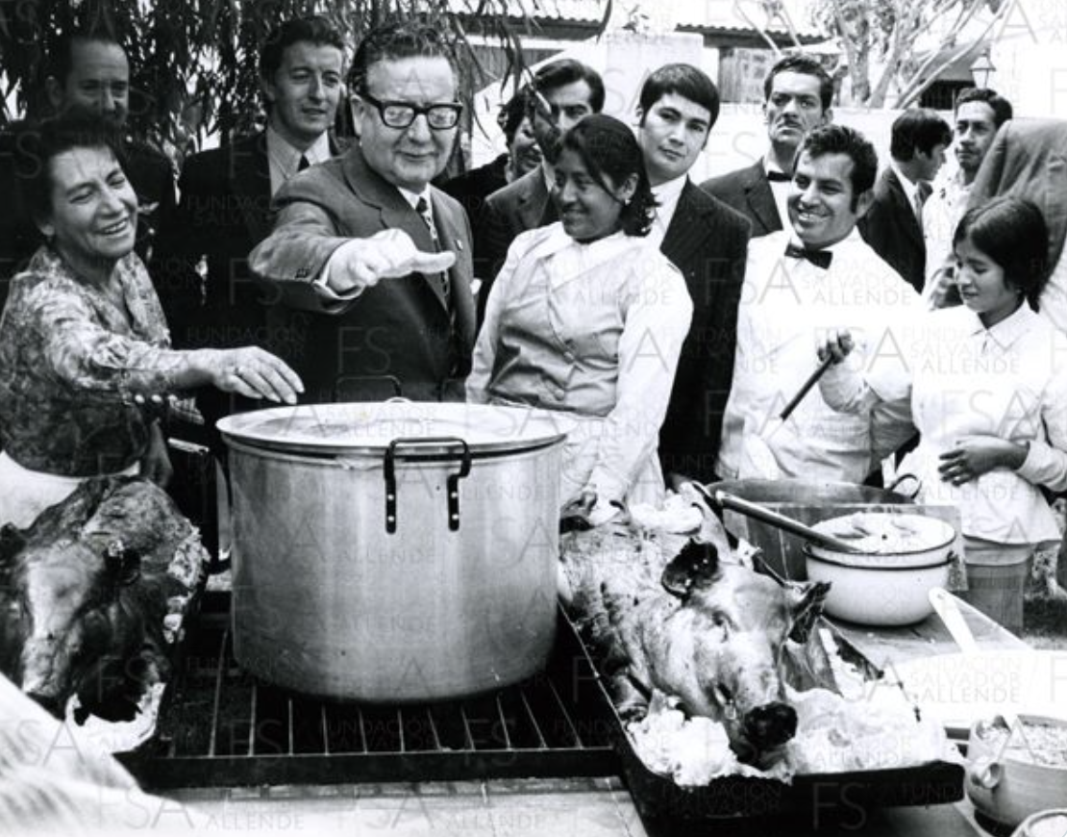

Best way to contact me: Sandra.Mendiolagarcia@unt.edu If you have questions or concerns, email me any time.

Communication is essential.
It is your responsibility to check your UNT email several times a week as well as logging in to Canvas to check announcements & assignments. I also expect that you answer to my emails
if I write or reply to you individually.

Student Hours (also known as Office Hours) in Wooten Hall 263 on:
Thursdays from 1:30 to 3:30pm.
Alternatively, email me to set up an online appointment that works for our schedules. Once you have the appointment, use this link: https://unt.zoom.us/j/9270366247

Course Description
Foods, foodways, and cuisines are as diverse as the people who inhabit over the two dozen countries of Latin America. This course provides a sample (“a probadita”) of this diversity. We will trace certain agricultural products, foods, dishes, cuisines, cooks, laborers, and cooking artifacts. In the process, we will connect food to Latin American history and, by extension, the food produced and consumed in the United States. As you will discover, food is connected to agriculture, emotions, identities, labor, and politics. In fact, in this course, you will have another taste of what scholars have contributed to the exciting fields of food history and food studies.

In part of this course, the hands-on section, you will develop the skills to conduct an oral history interview. You will interview a person involved in any aspect of food production (broadly defined) in our area. These interviews will be housed in our Oral History Center Program Collection. I will post instructions and important documents in Canvas under “Oral History Materials.”

Required Readings
This is an upper-level course, which requires you to read the materials assigned for each class and/or week. Your informed participation is extremely important. Be prepared to discuss by taking notes while you read and by preparing answers for questions that I will pose during our discussion. It is imperative that you keep up with your readings because you must also use that material for your assignments. If you have any questions about the content, do not hesitate to contact me. I am here to help!

Three required books and other readings: You may to buy or rent from our bookstore or from your favorite vendor.

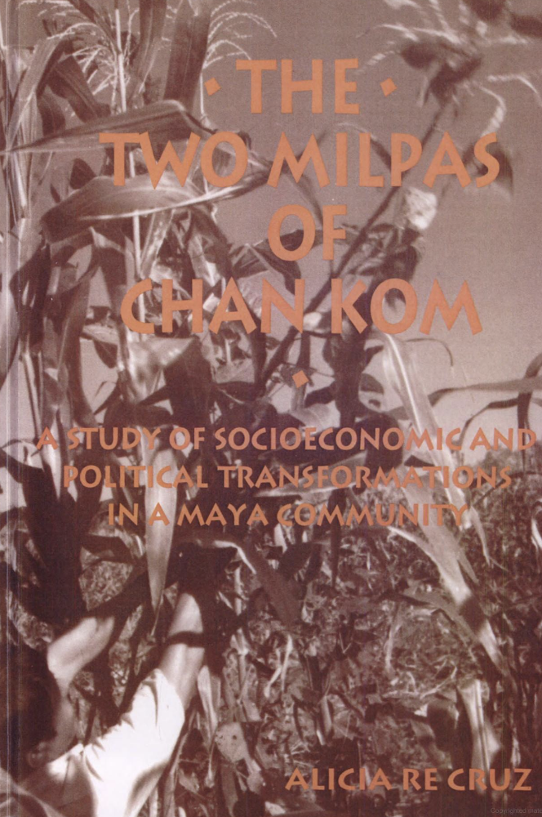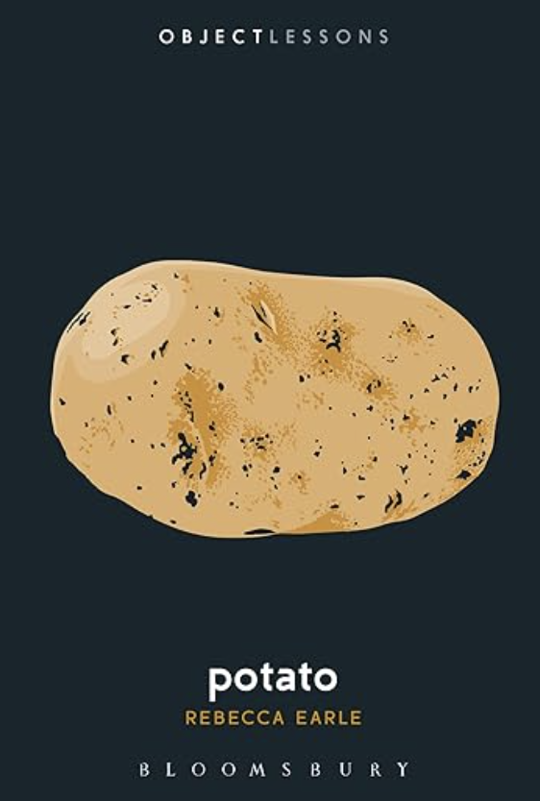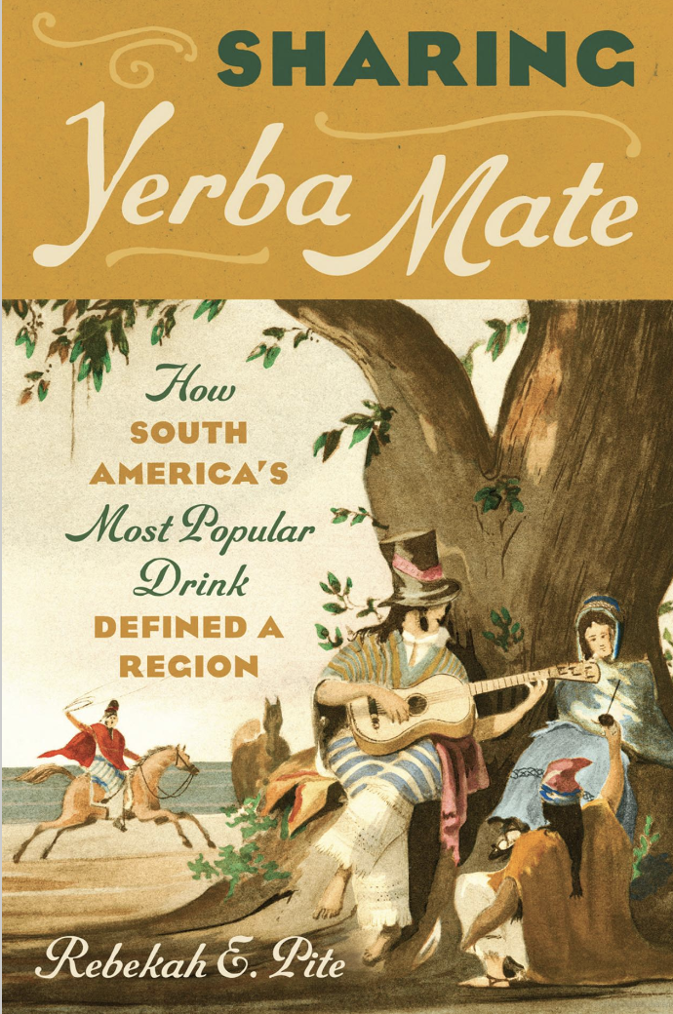

- Earle, Rebecca, Potato, New York: Bloomsbury Publishing, 2019. This book is available online through “unlimited user access” at the UNT Library:
https://discover.library.unt.edu/catalog/b6511798

- Re Cruz, Alicia, The Two Milpas of Chan Kom: Scenarios of a Maya Village Life, Albany: State University of New York Press, 1996. This book is available online through “multiple user access” at the UNT Library: https://discover.library.unt.edu/catalog/b6741428

- Pite, Rebekah E., Sharing Yerba Mate: How South America's Most Popular Drink Defined a Region, Chapel Hill: University of North Carolina Press, 2023.
This book is available online through “unlimited user access” at the UNT Library
https://discover.library.unt.edu/catalog/b7808912

*You will find additional required readings in Canvas.

Course Assignments
Assignment | Points Possible | Percentage of Final Grade
Mid-term Project | 200 points | 20%
Final Project | 250 points | 25%
Introducing yourself  Book Quizzes (3 @ 80)  Prep for Oral History Interview (2@ 25)  Participation | 10 points  240 points  50 points  150 points | 1%  24%  5%  15%
Student Leader | 100 points | 10%
Total Points Possible | 1000 points | 100%

HONORS STUDENTS: In addition to the regular assignments, you will write a 10-page research paper mainly based on primary sources about the topic of your choice that is related to any of the topics that we cover in class.

Explanation of assignments:

Student Leader (100 points): Every time we discuss our readings, two or three students will become “student leaders.” These students will become “experts” on their particular assigned readings by preparing two to three different complex questions (each) that they will ask to the larger group.

Participation (150 points): I will evaluate participation through class discussions and, if necessary, through pop quizzes. Your informed participation in every session is extremely important.

Mid-term Project (200 points): You will write a research paper about your favorite food using at least three academic sources and two primary sources. Specific instructions in Canvas.

Book Quizzes (240 points): You will write three book quizzes. See class schedule for specific dates.

Final Project (250 points). You will conduct an oral history interview OR a research paper based on interviews students have completed for the MAPP project (aka the Milpa project). Then, you will transcribe the interview, which you will also edit. Specific instructions in Canvas,

Grading
A = 900-1000
B = 800-899
C = 700-799
D = 600-699
F = 500-599

Late Work:
If you face any problems (i.e. sickness, outage, weak internet connection, caring for others) that prevent you from completing and/or uploading your work by the deadlines, contact me as soon as possible. You must provide evidence of your situation. Your grade for a tardy assignment will vary depending on how late you submit it. I will not provide any feedback for any late work.

Attendance Policy: Students are expected to attend all class meetings. Communicate with me prior to being absent, so we can discuss and mitigate the impact of your absences. I will deduct 5% from the final grade course for each absence over three absences. Three tardies or leaving early will be treated as one absence unless you have talked to me in advance.

UNT Academic Integrity Policy
According to UNT Policy 06.003, academic dishonesty occurs when students engage in behaviors including, but not limited to cheating, fabrication, facilitating academic dishonesty, forgery, plagiarism, and sabotage. A finding of academic dishonesty may result in a range of academic penalties or sanctions ranging from admonition to expulsion from the University.

How to avoid plagiarism? Use quotation marks when you use an author’s exact words. Cite your sources (Author, page number) or use footnotes even when you are paraphrasing. If you have any questions, please let me know before submitting an assignment. If Turnitin or your professor find plagiarized work or if you use artificial intelligence, you will receive F in that assignment.

Artificial Intelligence? Based on the Student Academic Integrity Policy (UNT Policy 6.003), any form of "unauthorized assistance" constitutes cheating. If the use of artificial intelligence is not authorized for the assignment in question, the violation is "cheating" and you may get a horrible F. In my course, I do not authorize the use of AI to write your assignments except for the transcription of your interview.

ADA Policy
UNT makes reasonable academic accommodation for students with disabilities. Students seeking accommodation must first register with the Office of Disability Accommodation (ODA) to verify their eligibility. If a disability is verified, the ODA will provide a student with an accommodation letter to be delivered to faculty to begin a private discussion regarding one’s specific course needs. Students may request accommodations at any time, however, ODA notices of accommodation should be provided as early as possible in the semester to avoid any delay in implementation. Note that students must obtain a new letter of accommodation for every semester and must meet with each faculty member prior to implementation in each class. For additional information see the ODA website (https://disability.unt.edu/)
Class Schedule
The professor reserves the right to change or modify the schedule below. I will notify you if any changes occur ahead of time.

Week 1
Jan 13: Introducing ourselves, the course and the Milpa Agricultural Place Making Project (aka Milpa Project.
Jan 15: Basic Concepts

Week 2
Jan 20: Mesoamerican Food
Read this primary source: “Cortes describes Tenochtitlan” in Hernán Cortes’s Second Letter
Jan 22: Read Pilcher’s excerpt of Que Vivan Los Tamales.

Week 3
Jan 27: The Milpa
Read: Alicia Re Cruz, The Two Milpas of Chan Kom (Chapters 1 through 4)
Jan 29: Read: Alicia Re Cruz, The Two Milpas of Chan Kom (Chapters 5 through 8)
Reading Quiz #1 due on Feb 1 in Canvas by 11:59 pm

Week 4
Feb 3: The Columbian Exchange
Feb 5: Read: Nathan Nunn and Nancy Qian, “The Columbian Exchange: A History of Disease, Food, and Ideas.” The Journal of Economic Perspectives 24, no. 2 (2010): 163-88 (in Canvas).

Week 5
Feb 10: The Columbian Exchange Revisited.
Read Rebecca Earle, Potato
Feb 12: Discussion of Potato (entire book)
Reading Quiz #2 due on Feb 15 in Canvas by 11:59 pm

Week 6
Feb 17: Immigrants and their Foods
Submit to Canvas the name, contact information, and a short bio of your potential interviewee by Feb 17 by 11:59 pm.

Feb 19: Read Elizabeth Zanoni “Manly Markets in le due Americhe, 1880-1914” in Migrant Marketplaces: Food and Italians in North and South America, Urbana: University of Illinois Press, 2018 (in Canvas).

Week 7
Feb 24: Food Mobilities
Feb 26: Read Mendiola “From Cornish Pastes to Mexican Pastes” in Food Mobilities: Making World Cuisines, Daniel Bender and Simone Cinotto, eds. Toronto: University of Toronto Press, 2023.

Week 8
Mar 3: Oral History Training
Mar 5: Possible fieldtrip
Submit ten questions for your interviewee to Canvas by 11:59pm on 3/5

Week 9 – Spring Break- No classes

Week 10
Mar 17: Food and Religion
Mar 19: Mid-term project due in Canvas

Week 11
Mar 24: Food and Revolution in Cuba
Mar 26: Hannah Garth, “La Lucha” in Food in Cuba: The Pursuit of a Decent Meal (Stanford: Stanford University Press, 2020 (in Canvas).

Week 12
Mar 31: Drinks in Latin America. Read first half of Rebekah Pite’s book Sharing Yerba Mate
Apr 2: Read second half of Pite’s Sharing Yerba Mate

Week 13
Apr 7: Food and Revolution in Chile
Apr 9: Read Joshua Frens-String, “Communists, Commissars, and Consumers: The Politics of Food on the Chilean Road to Socialism,” The Hispanic American Historical Review, 2018-08, Volume 98, Issue 3, pp. 471 – 501 (in Canvas)

Week 14
Apr 14: Reading Quiz #3 (Sharing Yerba Mate) due on April 14 in Canvas by 11:59 pm
Apr 16: Documentary

Week 15
Apr 21: Possible Zoom with Dr. Pite
Apr 23: Food Gentrification (Reading to be decided)

Week 16
Apr 28: Conclusions
April 30: Final Project Due (Oral history interview, three forms, and edited transcript)

