BEHV 5815.713
Practicum
Course Syllabus


Associate Professor and MS Graduate Advisor:
Samantha (Sam) Bergmann, Ph.D., BCBA-D, LBA (TX)
Pronouns: she/her
Office location: Chilton 361B
Office hours:
Tuesdays 2:00-3:00 PM and by appointment
Email: sam.bergmann@unt.edu

Welcome to UNT!

Course Description
This course is designed to help first year students successfully complete the initial semester of grad school and meet their professional goals in the Master of Science in Behavior Analysis graduate program. Experience and data tell us that engaging and responding increase the chances of success in every sphere of human activity. For that reason, we have chosen several activities that are likely to give students an initial boost and to set up a system that will flag conditions that a student may need extra support. If there are “flags” (in your monthly uploads, you tell us, or faculty see challenges) that you are struggling in classes and/or in connecting with others in the department, we will develop a plan to change the action steps and/or seek other options.

This syllabus explains the course structure, the activities and the evaluation process.

Course Structure
This course is designed to help you come into contact with activities that will increase your success in graduate school, help you form connections with members of the department, communicate issues that you encounter, and provide information to help you determine your professional goals. We will meet on the 2nd and 4th Fridays of each month from 3:00-4:00 PM in a seminar with your cohort and the MS graduate advisor. We will meet on the 2nd and 4th Fridays from 4:00-5:00/5:30 with the department for our bi-monthly Behavior Analysis Resource Colloquium. In addition, you will be responsible for engaging in a series of activities (see below). You will communicate your progress, so we can encourage you and provide you with feedback. Part of this will happen through a self-monitoring and shared GEM card, via personal connections in the activities themselves, and the monthly progress uploads.

Course Prerequisites
Admission to the MS Behavior Analysis degree program and Basic Behavior Principles undergraduate or leveling course.

Course Objectives & Activities
- Students will learn to talk about the process of success & mentoring; learning to reflect and evaluate their own progress and support the progress of others in their community
- Attend bi-weekly seminars with the MS Grad Advisor on 2nd and 4th Fridays 3:00-4:00 PM in BLB 050
- Students will participate in a formal community of practice around research and practice in behavior analysis. Active participation during the Behavior Analysis Research Colloquia is expected. In these meetings, we learn about the research that is currently being proposed, conducted, or defended in our faculty-directed research labs. An emphasis is placed on graduate students presenting their work for questions and feedback. All attendees are encouraged to ask questions throughout the presentation(s).
- Attend all Behavior Analysis Research Colloquia (BARC)
- 2nd & 4th Fridays from 4:00-5:00/5:30 (ending time depends on the presenter’s needs/preferences) in BLB 005
- Students will learn to visit a lab, learn about different areas of research and practice, understand the conditionality of scientific practices in behavior analysis, and find a thesis home. You will sample at least three of the labs that the department offers for students. After sampling some of the labs, you should identify at least one lab “home” to increase your participation and begin to learn research skills. At the end of the semester, you will write a plan to commit to a lab “home,” and you will identify a research project to assist on with the faculty advisor and/or senior graduate students. This component of the program is very important as labs are the heart of the Master of Science degree, important for expanding your support network in the program, and crucial to conducting the thesis for the degree.
- Attend at least 3 different lab meetings – these need to be different labs (e.g., TRAIL, ORCA, EEG) and not three different meetings with the same lab
- After you have sampled labs, identify at least one lab “home”
- Commit to attending meetings regularly for the following semester
- Commit to contributing to the lab by participating in lab research
- Complete CITI training so you can be added to IRBs with your “home” lab
  - You will complete CITI training for “Social & Behavioral Research Investigators” (human subjects research) that is offered online and submit proof of completion to assignment in Canvas.
  - Instructions: https://research.unt.edu/research-services/research-integrity-and-compliance/human-subjects-irb/training-and-education
- Students will learn to initiate and connect with other students, especially 2nd and 3rd year students who can help guide and give advice
- At least 4 times invite another student to a meal together, take a walk, talk after BARC, etc.
- You can each get 2 FREE meal cards from Dr. Bergmann to support this goal
- Students will learn to connect with faculty in order to learn, seek support, and develop mentoring relationships
- At least 2 non-class contacts with different faculty members
- Talk after classes, chat in hallways, talk after BARCs, visit office hours
- Students will learn to initiate study sessions with classmates, talk about, and delve into subject matter and form strong professional relationships.
- Attend at least 3 study sessions
  - In person or on zoom, can include group projects
- Students will refine their research and writing skills.
- Visit the UNT writing center at least 1 time
- Visit the Willis Library at least 1 time
- Students will learn to pay attention and communicate about what interests them, what is meaningful to them, and what they are learning.
- Make notes to yourself as the semester progresses, talk to faculty, peers, family and friends
- Create an infographic about the five most interesting things you learned this semester. Upload before the end of the semester.
- Students will learn to develop working goals to organize time, attention and activities in ways that best optimize success.
- Post a 1-page description of your working goals for the year. This should include identifying your lab “home,” committing to the lab meetings, and identifying a research project/activity to assist with to deepen your participation and understanding.
- Upload before the end of the semester.

Materials
The GEM card. If you don’t want a paper card, you can use an electronic version. In any case, it has to show your cumulative progress. After every five activities completed, you can come by Sam’s office or ask at the 5815 meetings to get a sticker or pin. These are symbolic tokens and a chance to check in with the advisor. Token exchanges are not required . What is required is that you take a picture of your GEM card and upload progress to the Canvas page each month. You can also use that opportunity to ask questions, rejoice, or comment, and I will respond. An example of how to fill out the GEM Card:

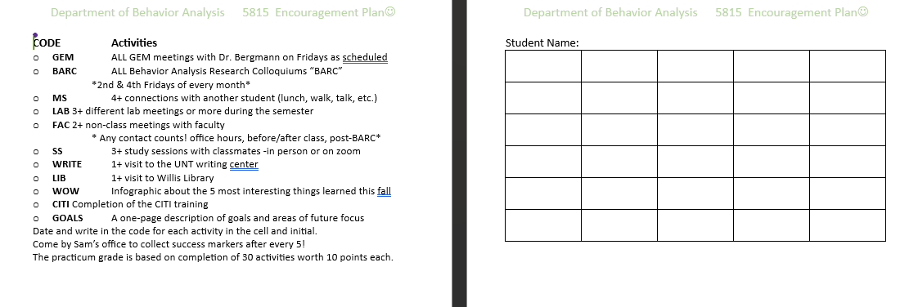
SS 5100z
10/12 SB
LAB Gonzalez
10/3 SB
CITI
9/22 SB
BARC
9/13 SB
Gem 9/6 SB
Sam Bergmann

Upload dates (take a picture, upload and comment, if you like)

Check in uploads: 9/30, 10/31, 11/30, 12/12

Completion uploads: Gem card, WOW infographic, and goal sheet uploaded by 12/12

Student Evaluation

Your grade in the course will be based on completion of the minimum GEM activities. These activities are meant to help you be successful and are the minimum. If you are able to engage at this level, it is highly likely that you will be successful as a full-time student. You will earn 10 points for each completed activity. There are 30 required activities, and the total points for the course equal 300. The grade percentages are as follows:

A = 90-100%
- B = 80-89.9%
- C = 70-79.9%
- F = below 70%

Course Evaluation

Student Perceptions of Teaching (SPOT) is the student evaluation system for UNT and allows students the ability to confidentially provide constructive feedback to their instructor and department to improve the quality of student experiences in the course

Lab Schedule and Information

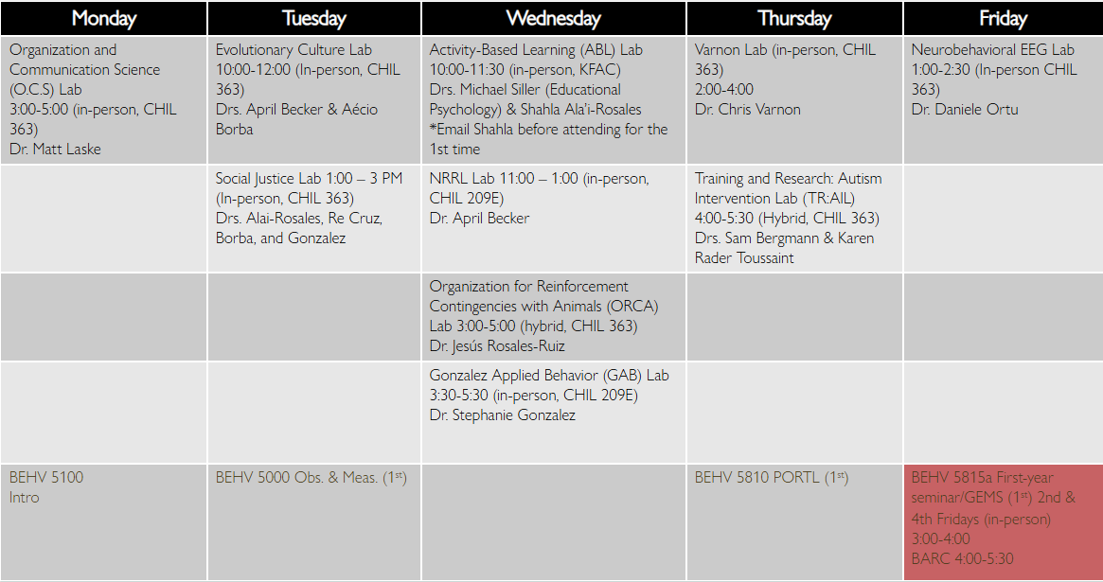
.
Course Policies

Attendance
Students are expected to attend all of the GEM meetings, all of the BARC meetings, and complete the activities. If for some reason you are unable, please talk to me as soon as possible, and we will develop a reasonable alternative plan.

Syllabus Change Policy
The professor reserves the right to make changes and updates to the syllabus as needed. Any updates to the syllabus will be posted on Canvas and an announcement will be made regarding relevant changes.

Basic Needs Policy
Your basic safety and well-being are more important than anything in this class. If you are experiencing any food or housing insecurity or personal adversity, please contact the Dean of Students https://deanofstudents.unt.edu. If you want to talk or need help with making contacts, please feel free to reach out. I will help as best as I can.
Acceptable and Unacceptable Use of AI
(Adapted from Temple University & Dr. Kenda Morrison)
Artificial Intelligence is defined as any text-generating software (e.g., ChatGPT, iA Writer, Marmot or Botowski). There is significant value of such technology and yo will likely use it during your careers. At the same time, for those you serve, there is value in being able to produce independent work demonstrating skills such as integration, reflection, analysis, and application of the content being taught.

Acceptable use. It is acceptable to use AI as an additional support when studying course content (e.g., seeking clarification about a concept). However, please keep in mind that AI has limitations of which to be aware:
- AI may generate content that is inaccurate or incomplete.
- AI models have built-in biases and unjust frameworks since they may be based upon limited, unreliable, or problematic sources.
- AI may have limitations such as evaluating information and thinking critically.

The use of generative AI tools (e.g. ChatGPT, Dall-e, etc.) is permitted in this course for the following activities:
- Brainstorming and refining your ideas; Finding information on your topic; Drafting an outline to organize your thoughts; and Checking grammar and style.

The use of generative AI tools is NOT permitted in this course for the following activities:
- Writing a draft of WOW infographic or Goal assignment.
- Writing entire sentences, paragraphs to complete WOW infographic or Goal assignment.
- You are responsible for the information you submit based on an AI query (for instance, that it does not violate intellectual property laws, or contain misinformation or unethical content use). Your use of AI tools must be properly documented and cited. Any assignment that is found to have used generative AI tools in unauthorized ways through “Turn it in” originality or AI detection will receive a “0”.
- When in doubt about permitted usage, please ask for clarification. This is new and exciting, but complicated territory. We will learn together

UNT Policies

Academic Integrity Policy
Academic Integrity Standards and Consequences. According to UNT Policy 06.003, Student Academic Integrity, academic dishonesty occurs when students engage in behaviors including, but not limited to cheating, fabrication, facilitating academic dishonesty, forgery, plagiarism, and sabotage. A finding of academic dishonesty may result in a range of academic penalties or sanctions ranging from admonition to expulsion from the University. In this course, engaging in academic dishonesty will result in a 0 on the assignment where academic dishonesty occurred.

ADA Policy
UNT makes reasonable academic accommodation for students with disabilities. Students seeking accommodation must first register with the Office of Disability Accommodation (ODA) to verify their eligibility. If a disability is verified, the ODA will provide a student with an accommodation letter to be delivered to faculty to begin a private discussion regarding one’s specific course needs. Students may request accommodations at any time; however, ODA notices of accommodation should be provided as early as possible in the semester to avoid any delay in implementation. Note that students must obtain a new letter of accommodation for every semester and must meet with each faculty member prior to implementation in each class. For additional information see the ODA website (https://studentaffairs.unt.edu/office-disability-access).

Emergency Notification & Procedures
UNT uses a system called Eagle Alert to quickly notify students with critical information in the event of an emergency (i.e., severe weather, campus closing, and health and public safety emergencies like chemical spills, fires, or violence). In the event of a university closure, please refer to Blackboard for contingency plans for covering course materials.

Retention of Student Records
Student records pertaining to this course are maintained in a secure location by the instructor of record. All records such as exams, answer sheets (with keys), and written papers submitted during the duration of the course are kept for at least one calendar year after course completion. Course work completed via the Canvas online system, including grading information and comments, is also stored in a safe electronic environment for one year. Students have the right to view their individual record; however, information about student’s records will not be divulged to other individuals without proper written consent. Students are encouraged to review the Public Information Policy and the Family Educational Rights and Privacy Act (FERPA) laws and the University’s policy. See UNT Policy 10.10, Records Management and Retention for additional information.

Acceptable Student Behavior
Student behavior that interferes with an instructor’s ability to conduct a class or other students' opportunity to learn is unacceptable and disruptive and will not be tolerated in any instructional forum at UNT. Students engaging in unacceptable behavior will be directed to leave the classroom and the instructor may refer the student to the Dean of Students to consider whether the student's conduct violated the Code of Student Conduct. The University's expectations for student conduct apply to all instructional forums, including University and electronic classroom, labs, discussion groups, field trips, etc. Visit UNT’s Code of Student Conduct to learn more.

Access to Information - Eagle Connect
Students’ access point for business and academic services at UNT is located at: my.unt.edu. All official communication from the University will be delivered to a student’s Eagle Connect account. For more information, please visit the website that explains Eagle Connect and how to forward e-mail Eagle Connect (https://it.unt.edu/eagleconnect).

Survivor Advocacy
UNT is committed to providing a safe learning environment free of all forms of sexual misconduct. Federal laws and UNT policies prohibit discrimination on the basis of sex as well as sexual misconduct. If you or someone you know is experiencing sexual harassment, relationship violence, stalking and/or sexual assault, there are campus resources available to provide support and assistance. The Survivor Advocates can be reached at SurvivorAdvocate@unt.edu or by calling the Dean of Students Office at 940.565.2648.

Academic Support & Student Services

Mental Health
UNT provides mental health resources to students to help ensure there are numerous outlets to turn to that wholeheartedly care for and are there for students in need, regardless of the nature of an issue or its severity. Listed below are several resources on campus that can support your academic success and mental well-being:
- Student Health and Wellness Center
- Counseling and Testing Services
- UNT Care Team
- UNT Psychiatric Services
- Individual Counseling

Chosen Names
A chosen name is a name that a person goes by that may or may not match their legal name. If you have a chosen name that is different from your legal name and would like that to be used in class, please let the instructor know. Below is a list of resources for updating your chosen name at UNT.
- UNT Records
- UNT ID Card
- UNT Email Address
- Legal Name
*UNT EUIDs cannot be changed at this time. The collaborating offices are working on a process to make this option accessible to UNT community members.

Pronouns
Pronouns (she/her, they/them, he/him, etc.) are a public way for people to address you, much like your name, and can be shared with a name when making an introduction, both virtually and in-person. Just as we ask and don’t assume someone’s name, we should also ask and not assume someone’s pronouns.
You can add your pronouns to your Canvas account so that they follow your name when posting to discussion boards, submitting assignments, etc.
Below is a list of additional resources regarding pronouns and their usage:
- What are pronouns and why are they important?
- How do I use pronouns?
- How do I share my pronouns?
- How do I ask for another person’s pronouns?
- How do I correct myself or others when the wrong pronoun is used?

Additional Student Support Services
- Registrar
- Financial Aid
- Student Legal Services
- Career Center
- Multicultural Center
- Counseling and Testing Services
- Pride Alliance
- UNT Food Pantry

Academic Support Services
- Academic Resource Center
- Academic Success Center
- UNT Libraries
- Writing Lab

