MKTG 3651.402: Foundations of Marketing for Non-Business Majors
Online Spring 2026 ( January 12, 2026- May 8, 2026)
Instructor:
Sarah Geisler
Email:
Sarah.Geisler@unt.edu
Phone:
940.565.3348
Office:
Business Leadership Building (BLB) 205B
Office Hours: Contact the instructor ahead of time to schedule and receive a link for a virtual Meeting at Sarah.Geisler@unt.edu
Instructor Availability: Monday- Friday 9:00 am-4:30 pm and Saturday 10:00 am-1:00 pm via pre-scheduled Zoom (or in-person) Appointment

Course Description:
3651: Foundations of Marketing Practice for Non-Business Majors. 3 Credit Hours (CH).
An introductory survey of marketing terminology, concepts, and practices from an applied perspective. Emphasis is on the activities performed by marketing managers to address real-world marketing problems. The primary emphasis is on identifying marketing opportunities and planning and executing marketing mix activities to target these opportunities. Marketing mix topics include development and management of products/services, price setting and management, supply chain and distribution channel management, and management of integrated marketing communications. Special emphasis is given to ethical, socially responsible and sustainable decision making and business practices. The course is designated for non-business majors.
Prerequisite(s): For non-business majors only.

LEARNİNG OBJECTİVES:
To understand the scope of marketing and its role within a firm and society.
To understand the scope of a marketing manager’s job in today’s complex and highly competitive global business environment.
To learn the basic marketing terminology and concepts. Exams are geared to ensuring that you know the ‘language of marketing’ and have a basic understanding of the major concepts.
Understand market segmentation and when it is used. Recognize factors used to segment and target consumer markets.
Explain how marketers position their products in the marketplace.
Identify how marketers manage a product's life cycle and recognize the importance of branding and alternative branding strategies.

Textbook & Cengage MindTap:
Foundations of Marketing 10th Edition
Author: William M. Pride and O.C. Ferrell
Publisher: Cengage
ISBN: 9798214510033
Purchase Link for Students: https://www.cengage.com/s/?q=9798214510033
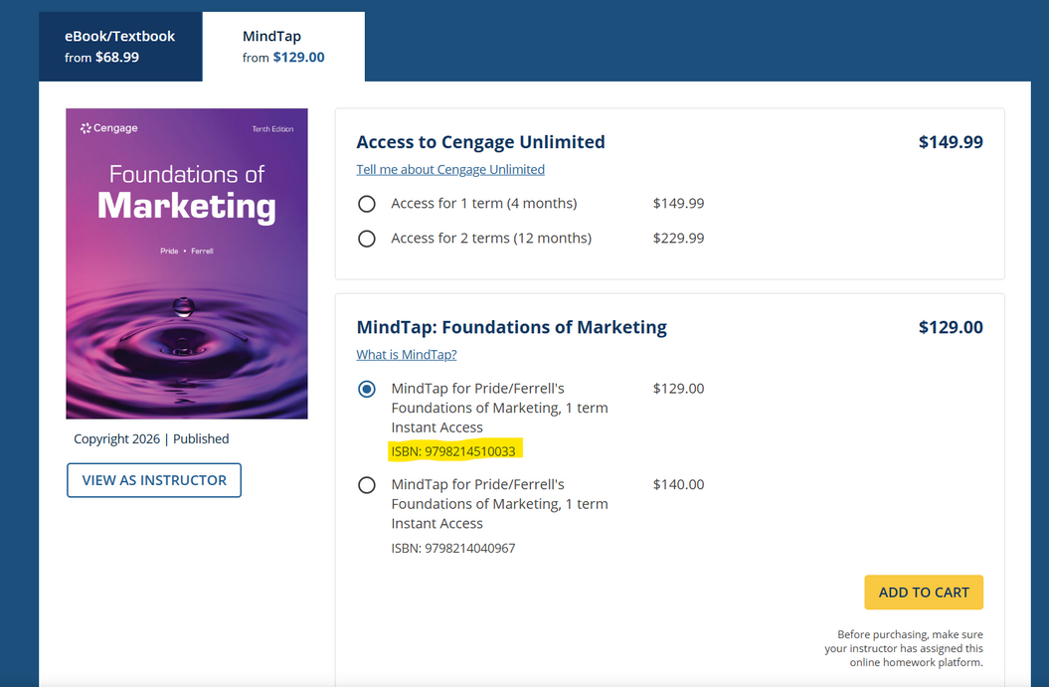
Online Access is Required for MindTap

To purchase a textbook WITH MindTap (Online Learning Platform) please visit https://www.cengage.com/student/

Message from Cengage:
https://course-pages.prod.eks.cengage.io/coursepages/UNT_MINDTAP
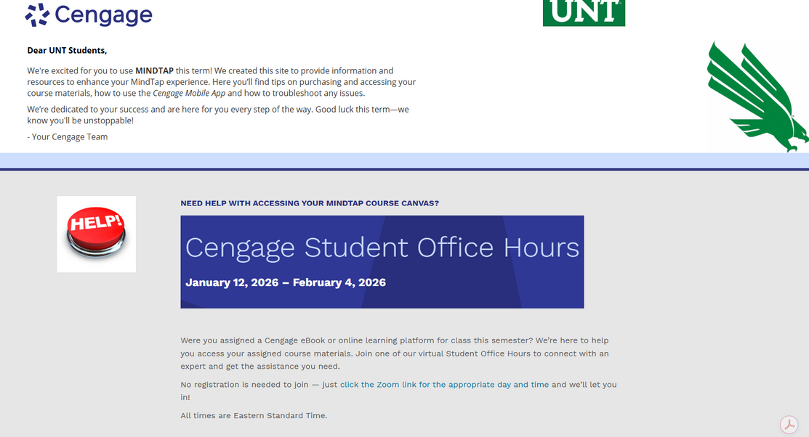
Linking your Cengage and Canvas Accounts:
https://startstrong.cengage.com/mindtap-canvas-ia-no/

Technology Requirements:
This is an online course built on digital competence to complete the coursework. Information on how to be successful in a digital learning environment can be found at (https://online.unt.edu/learn)
APPS required:
Respondus – Lockdown Browser using MONITOR with Webcam- this is located on the left side in the COURSE menu
To maximize the value and learning of this class, students will need:
- Computer with a reliable internet connection
- Canvas Learning Management System
- UNT Email
- Cengage MindTap: https://www.cengage.com/student/
- Microsoft Office 365: https://outlook.office.com/
- Google Docs: https://docs.google.com/
- Zoom App: https://zoom.us/
- Adobe Reader: https://get.adobe.com/reader/
- Web-camera and/or ability to videoconference and record videos
Technical Assistance
Here at UNT, we have a Student Help Desk that you can contact for help with Canvas or other tech issues.
UIT Help Desk: UIT Student Help Desk site (http://www.unt.edu/helpdesk/index.htm)
Email: helpdesk@unt.edu
Phone: 940-565-2324
In Person: Sage Hall, Room 130
For additional support, visit the Online Student Resources at https://studentaffairs.unt.edu/online-student-experience/online-student-resources/index.html.

Communication Expectations:
You may contact me at any time via UNT email, but remember to treat all email communications as professional correspondence. I will respond to your emails within 24 hours. Please note that I will not respond to emails sent after 12:00 p.m. on Sundays.
Please use email whenever you wish to message me. Do not use CANVAS. Why?
Because your use of email almost always makes it easier for me to answer your question(s) or otherwise help you more efficiently.
Email also makes it easier to convey attached information or evidence back and forth. Email likewise provides an easily accessible record, i.e., electronic footprint, documenting issues and items that were “said” and “agreed-upon.”
** Tips for Professional Communication**
- Use an appropriate salutation for the recipient, e.g., “Hello Professor Geisler” or “Mrs. Geisler.”
- Make the tone of your email professional. Ask yourself how you would interpret the tone and content of the email had you received it from someone else. Your email should not read like a text.
- Avoid slang and do not use email or text abbreviations.
- Remember that good grammar, spelling, and punctuation can make the difference between comprehension and confusion.
- Carefully proofread your email before hitting the ‘send’ button.
How to Succeed in this Course:
Helping you succeed in this course is my top priority! I hope you will take advantage of this. Here are a few things you could do to ensure you achieve the best results:
1. | Keep an open “learner’s” mindset!  You will learn new concepts that could only be retained if you apply them in class discussions, MindTap exercises, and other class assignments.
2. | Challenge yourself to do better and ask questions!  If you’re struggling with any material, please don't hesitate to talk to me. My office/students’ hours are dedicated to you and your professional development.
3. | Keep track of deadlines and stay on schedule! All assignment deadlines are listed below. If there are any alterations to the deadlines, they will be posted ahead of time on Canvas.  Keep yourself accountable and be prepared for the course activities, just as you would in a career employment situation!
4. | Take control of learning! Do not be afraid to ask for help or guidance in locating resources.  Take advantage of the FREE resources provided to you by UNT, such as Coursera and LinkedIn Learning, as well as other professional development opportunities available to students.

Teaching Philosophy:
Education is a collaborative journey, not a one-way transmission of information.

Fostering an Inclusive Environment
I am committed to cultivating a classroom atmosphere where learning is both engaging and meaningful. I believe that students perform best in a friendly, inclusive, and judgment-free space where they feel safe to express thoughts and take creative risks.
The Power of Inquiry
At the center of my approach is the "Socratic" method—the practice of asking questions to spark curiosity. I am passionate about prompting learners to ask "why," encouraging them to peel back the layers of complex marketing and communication principles; by shifting the focus from rote memorization to critical thinking, I aim to empower students to take ownership of their educational journeys and develop a deeper, more resilient understanding of the material.
Adaptability and Diverse Learning Styles
Recognizing that every student brings a unique perspective and a different learning style, I prioritize adaptability. Whether through hands-on creative workshops using the Adobe Suite, data-driven group discussions, or personalized one-on-one support, I strive to provide a variety of modalities that resonate with each participant.
A Commitment to Mentorship
Ultimately, I view teaching as a calling to inspire and nurture the next generation of professionals. My goal is to bridge the gap between academic theory and real-world application, fostering not just a temporary understanding of a subject, but a lifelong love of learning and a commitment to professional excellence.
Policies
Academic Integrity Policy
The G. Brint Ryan College of Business takes academic honesty seriously. Ethics and integrity are important business values, essential to building trust and adhering to both professional and legal standards. Academic dishonesty undermines trust, tarnishes the reputation and value of the degree, and is unacceptable.
According to UNT Policy 06.003, Student Academic Integrity, academic dishonesty occurs when students engage in behaviors, including but not limited to cheating, fabrication, facilitating academic dishonesty, forgery, plagiarism, and sabotage. A finding of academic dishonesty may result in a range of academic penalties or sanctions from admonition (a warning) to expulsion from the University.
Some of the most common examples of academic integrity violations include plagiarism or cheating, such as unauthorized assistance on examinations, homework, research papers, or case analyses. Your work must be entirely your own. When working on assignments, you should not discuss your work with others unless approved by the course instructor. Group assignments should only be discussed with members assigned to your group, and all group members may be held accountable in some way for known academic integrity violations in a group assignment.
Another example of academic dishonesty relates to improper attribution. When preparing your assignments, you must cite all outside sources in the manner requested by your instructor. Copying or using material from any source prepared by or previously submitted by others, at UNT or other institutions, or downloaded from the Internet, is plagiarism. Unless directed otherwise in an assignment, large-scale “cutting and pasting” from different sources, even if properly footnoted, is not appropriate. You should synthesize this material in your own words and provide a footnote.
Your instructor will specify what materials, if any, may be used on the tests and exams. Using materials other than those permitted, discussing the exam with other individuals, exchanging information about an exam when one has taken it and the other has not, or copying or using material from another individual’s exam constitutes academic dishonesty. It will result in a meeting to discuss academic integrity violations and potentially issue the aforementioned sanctions, and may also result in ineligibility for educational scholarships. The use of online assistance, such as sites commonly used for finding homework solutions, group chats, cell phones, smartwatches, and similar tools during exams, is not allowed for any reason unless specifically permitted. No portion of an exam may be copied or photographed without permission.
Students are expected to conduct themselves in a manner consistent with the University's status as an institution of higher education. A student is responsible for responding to a request to discuss suspected academic dishonesty when issued by an instructor or other University official. If a student fails to respond after a proper attempt at notification has been made, the University may take appropriate academic actions in the absence of the student’s participation.
Attendance & Participation
Class attendance is required for this course.
There will be regular discussion and/or MindTap activities each week, which will be graded and cannot be made up if students DO NOT submit their work during the established timeline. Timeline information for when attendance activities are due is provided in the detailed course schedule included in this syllabus. Finally, please respect your fellow students.
Requests for Special Consideration
When a student requests special consideration for missing a quiz, an assignment due date, or any other reason, they must provide written documentation to support the request. Providing special consideration to a student without documentation discriminates in favor of the requesting student and to the detriment of all other students.
Grading Challenge Policy
This Instructor strictly follows the guidelines outlined in the current Undergraduate Catalog for grade appeals, changes, and the awarding and removal of an ‘Incomplete’. Should you believe there is a grading error for a particular activity, you may make a grade “challenge”. This grade challenge must be made in writing to your instructor no more than 48 hours (two days) after the grade is posted and should specify why you believe the grade is incorrect. Challenges made after this time will not be accepted, and your grade will stand as recorded.
Late Submissions
You are expected to turn in assignments on time. Late assignments will not be accepted without an approved university excuse. Please pay attention to the deadlines!
Syllabus Change Policy
I reserve the right to change the syllabus, policies, and/or due dates, provided that:
(1) The change does not cause harm to any student.
and
(2) An announcement about the change is posted three days before any change occurs. One thing students can rest assured of: Changes to the syllabus are made with the students' interests in mind.
Americans with Disabilities Act
UNT makes reasonable academic accommodations for students with disabilities. Students seeking accommodation must first register with the Office of Disability Access (ODA) to verify their eligibility. If a disability is verified, the ODA will provide a student with an accommodation letter to be delivered to faculty, initiating a private discussion regarding the student’s specific course needs. Students may request accommodations at any time; however, ODA notices of accommodation should be provided as early as possible in the semester to avoid any delay in implementation. Note that students must obtain a new letter of accommodation for every semester and must meet with each faculty member before implementation in each class. For additional information, see the ODA website at disability.unt.edu.
Prohibition of Discrimination, Harassment, and Retaliation (Policy 16.004)
The University of North Texas (UNT) prohibits discrimination and harassment because of race, color, national origin, religion, sex, sexual orientation, gender identity, gender expression, age, disability, genetic information, veteran status, or any other characteristic protected under applicable federal or state law in its application and admission processes; educational programs and activities; employment policies, procedures, and processes; and university facilities. The University takes active measures to prevent such conduct and investigates and takes remedial action when appropriate.
Student Perception of Teaching
Student Perception of Teaching (SPOT) is a requirement for all organized classes at UNT. This short survey will be available to you at the end of the semester, providing an opportunity for you to comment on how this class is taught. Feedback from students helps to improve this course. I consider SPOT to be an essential part of your participation in this class.
Students will receive an email from "UNT SPOT Course Evaluations via IASystem Notification" (no-reply@iasystem.org) with the survey link. Students should look for the email in their UNT email inbox. Click on the link and complete the survey. Once students complete the survey, they will receive a confirmation email indicating that their submission has been received. For additional information, please visit the SPOT website (http://spot.unt.edu/) or email spot@unt.edu.
Emergency Notification and Procedures
UNT uses a system called Eagle Alert to quickly notify students with critical information in the event of an emergency (i.e., severe weather, campus closing, and health and public safety emergencies like chemical spills, fires, or violence). In the event of a university closure, please refer to Canvas for contingency plans for covering course materials.
Retention of Student Records
Student records pertaining to this course are maintained in a secure location by the instructor of record. All documents, including exams, answer sheets (with keys), and written papers, submitted during the course are retained for at least one calendar year after course completion. Coursework completed via the Canvas system, including grading information and comments, is also stored in a safe electronic environment for one year. Students have the right to view their individual records; however, information about students’ records will not be divulged to other individuals without proper written consent. Students are encouraged to review the Public Information Policy, the Family Educational Rights and Privacy Act (FERPA) laws, and the University’s policy. Refer to UNT Policy 10.10, Records Management and Retention, for further details.
Acceptable Student Behavior
Student behavior that interferes with an instructor’s ability to conduct a class or other students' opportunity to learn is unacceptable and disruptive and will not be tolerated in any instructional forum at UNT. Students engaging in inappropriate behavior will be directed to leave the classroom, and the instructor may refer the student to the Dean of Students for consideration of whether the student's conduct has violated the Code of Student Conduct. The University's expectations for student conduct apply to all instructional forums, including University and electronic classrooms, labs, discussion groups, field trips, and other similar settings. Visit UNT’s Code of Student Conduct (https://deanofstudents.unt.edu/conduct) to learn more.
Access to Information - Eagle Connect
Students’ access point for business and academic services at UNT is located at: my.unt.edu. All official communication from the University will be delivered to a student’s Eagle Connect account. For more information, please visit the website that explains Eagle Connect and how to forward e-mail Eagle Connect (https://it.unt.edu/eagleconnect).
Student Evaluation Administration Dates
Student feedback is a crucial component of participation in this course. The student evaluation of instruction is a requirement for all organized classes at UNT. Students will receive an email from "UNT SPOT Course Evaluations via IASystem Notification" (no-reply@iasystem.org) with the survey link. Students should check their UNT email inbox for the email. Click on the link and complete the survey. Once students complete the survey, they will receive a confirmation email indicating that their submission has been received. For additional information, please visit the SPOT website (http://spot.unt.edu/) or email spot@unt.edu.
Sexual Assault Prevention
UNT is committed to providing a safe learning environment free of all forms of sexual misconduct, including sexual harassment, sexual assault, domestic violence, dating violence, and stalking. Federal laws (Title IX and the Violence Against Women Act) and UNT policies prohibit discrimination based on sex, and therefore prohibit sexual misconduct. If students or someone they know is experiencing sexual harassment, relationship violence, stalking, and/or sexual assault, there are campus resources available to provide support and assistance. UNT’s Survivor Advocates can assist students who have been impacted by violence by filing protective orders, completing crime victim’s compensation applications, contacting professors for absences related to an assault, working with housing to facilitate a room change where appropriate, and connecting students to other available resources both on and off campus. The Survivor Advocates can be reached at SurvivorAdvocate@unt.edu or by calling the Dean of Students' Office at 940-565-2648. Additionally, alleged sexual misconduct can be reported confidentially to the Title IX Coordinator at oeo@unt.edu or (940) 565-2759.

Rules of Engagement
Rules of engagement refer to the manner in which students are expected to interact with one another and with instructors. Here are some general guidelines:
While the freedom to express yourself is a fundamental human right, any communication that utilizes cruel and derogatory language based on race, color, national origin, religion, sex, sexual orientation, gender identity, gender expression, age, disability, genetic information, veteran status, or any other characteristic protected under applicable federal or state law will not be tolerated.
Treat your instructor and classmates with respect in any communication online or face-to-face, even when their opinions may differ from your own.
Ask for and use the correct name and pronouns for your instructor and classmates.
Speak from personal experiences. Use “I” statements to share thoughts and feelings. Try not to speak on behalf of groups or other individuals’ experiences.
Use your critical thinking skills to challenge other people’s ideas, instead of attacking individuals.
Avoid using all caps while communicating digitally. This may be interpreted as “YELLING!”
Be cautious when using humor or sarcasm in emails or discussion posts, as tone can be challenging to interpret digitally.
Avoid using “text-talk” unless explicitly permitted by your instructor.
Proofread and fact-check your sources.
Remember that online posts are permanent. Think before you type.
Refer to the Engagement Guidelines (https://clear.unt.edu/online-communication-tips) for more information.

Grading and Assignments
Required Activity | Maximum Points Possible
3 Exams  - Exam 1:  - Chapters 1-5  - Exam 2:  - Chapters 6-9  - Exam 3:  - Chapters 10-13  - Exam 4  - Chapters 14- 17 | 800 (200 points each)  Complete an Adobe Professional Certificate with UNT COURSERA to replace your lowest test score!  EXAMS Require Responds Lockdown Browser + Webcam
Quizzes (Practice It!) | 130 (13 Quizzes @10 points each)  Requires Responds Lockdown Browser
Marketing Planning Project | 200 (2 parts @100 points each)
MindTap:  Learn It & Apply It Assignments | 143- Learn It!  247- Apply It! (Assignments & Case Activities)  MindTap total = 390
Attendance/Participation- Discussion Posts | 50 (5 posts @10 points each)
Extra Credit- LinkedIn Learning Certifications | 50 Points Possible
Total | 1,570
Grading
Final Grade A = 90% and above or 1,413 to 1,570+ points.
Final Grade B = 80% to 89.99% or 1,256 to 1,412 points.
Final Grade C = 70% to 79.99% or 1,099 to 1,255 points.
Final Grade D = 60% to 69.99 or 942 to 1,098 Points
Final Grade F = below 60% or below 941 Points.
Grade Breakdown
Exams (x 4 @ 200 points each)
You will have four exams, each worth 13% of your grade. Exams are overall 51% of your final grade. Some exams will be taken on Canvas and will be timed, with availability for at least 24 hours. If you lose internet, etc., you may be able to regain access, but the timer will not stop. Therefore, it is essential to use a reliable computer with a stable internet connection when taking your test.
Exams will be available in Canvas starting the Friday before they are due, and will be accessible until the following Sunday. Students will receive 180 minutes (3 hours) for each exam.
Example:
Exam 1- Chapters 1-4 will open on Friday, February 6, 2026, and will close on Sunday, February 8, 2026, at 11:59 pm
COMPLETE AN ADOBE PROFESSIONAL CERTIFICATION for a chance to replace your lowest exam score! Adobe Professional Certifications for (Low Exam Score Replacement):
UNT- Coursera: https://online.unt.edu/coursera-for-unt/index.html
Adobe Marketing Specialist Professional Certificate: (RECOMMENDED)
- Design Fundamentals with AI
- Generative AI Content Creation
- Digital Marketing
- Social Media Content and Strategy
- Multichannel Content Marketing
Adobe Content Creator Professional Certificate:
- Design Fundamentals with AI
- Social Media Content and Strategy
- Multimedia Content Creation
- Generative AI Content Creation
Adobe Graphic Designer Professional Certificate:
- Design Fundamentals with AI
- Generative AI Content Creation
- Image Editing
- Graphic design
- Document Design
Why get an Adobe Professional Certification with UNT Coursera? https://edex.adobe.com/credentials
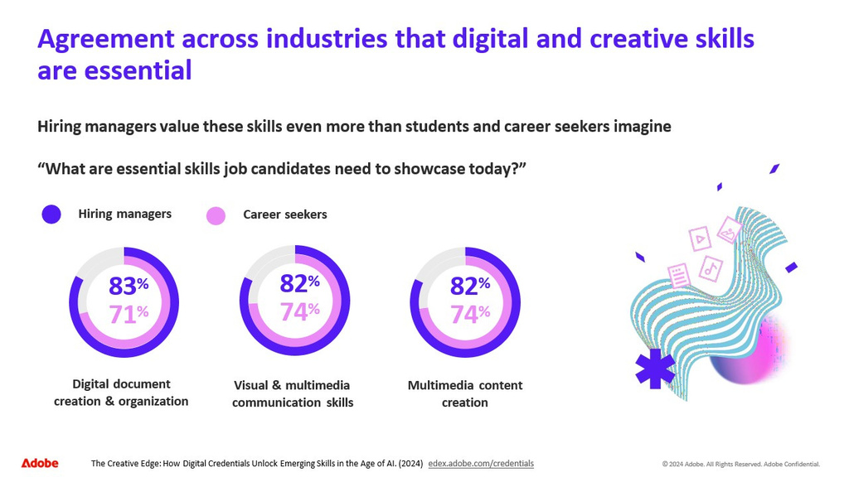
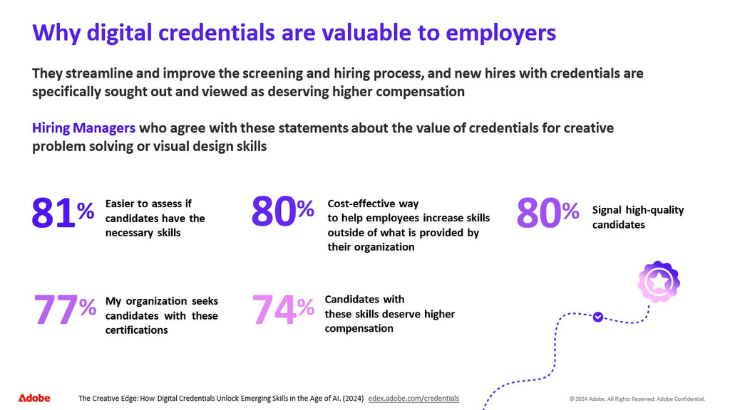
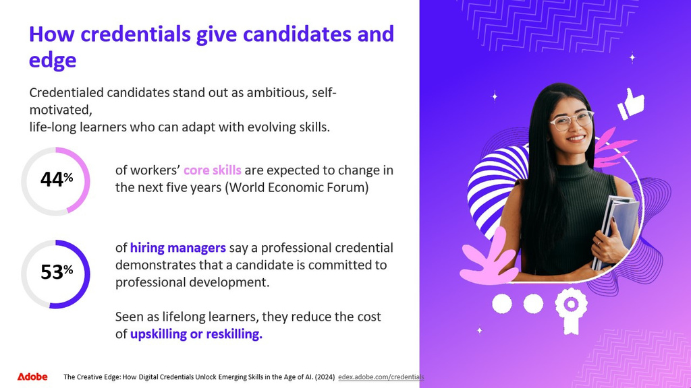
Weekly/Chapter Reading Quizzes (x13 @ 10 points each)
Each chapter will have a corresponding reading quiz. The quizzes will be worth 10 points each. You will be allowed 60 minutes to complete the quiz and will be given two attempts; your highest score will count toward your grade.
MindTap Assignments (points per individual assignment are listed in Cengage MindTap)
Each chapter has an online assignment that can be accessed through Canvas once your Cengage MindTap account is linked. The assignments for each week’s chapters will be due by Sunday at 11:59 pm. 20 Learn It assignments will be graded; however, I would STRONGLY recommend you complete all Learn It assignments (whether points are earned or not) in each assigned Chapter to help develop your knowledge.
Attendance/Participation (x5 @ 10 points each)
You will have a total of 5 Discussion posts to respond to over the semester. The discussion post will be due by Sunday at 11:59 pm of the corresponding week detailed in the semester schedule below. Discussions must be at LEAST 200 words that reflect critical thinking and analysis of assignments and assigned readings.
Marketing Planning Project (x2 @ 100 points each)
This course uses APA in-text and reference section citation style. Please note that the only acceptable file types for written assignments, again if or when asked to upload to Canvas, that are submitted for grading are single and ½ spaced (1.5) spaced and 12-point Times New Roman font, please: MS Word (.doc or .docx), PDF, MS PowerPoint
The Marketing Planning Projects are designed to help you think more strategically about your personal product and brand. Details about the assignments are as follows:
Part 1: Personal Marketing: Objectives / SWOT (100 Points)
Instructions: Develop a Narrated/Audio Voice memo & PowerPoint Presentation (This is a Marketing Class) 5 to 8 slides:
Include the following:
- List the Career/ Position you are pursuing
- List 3 industries you are interested in working in.
  - Example: Technology, Construction, Game Development, Pharmaceutical, Health Care, Food & Beverage, etc.
- List at least two companies that you want to target as a potential employer in each of the three industries you have chosen.
  - Example: You want to work in the Technology Industry, you may seek employment with Google, Apple, Samsung, LG, etc.
- Include your 3, 5, and 10-year Career goals- BE DETAILED
  - Example:
    - In 3 years, you plan to graduate and apply for your first job in your field of study.
    - In 5 years, you plan to be promoted at your organization and/or open your own company.
    - In 10 years, you aim to be one of the top professionals in your field and plan your next career adventure
- Develop and include your personal SWOT Analysis, review assignments, and assigned readings from the textbook.
  - What are your Strengths ( core competencies, skills, or work experience you possess that will help you reach your goals)?
  - What are your Weaknesses ( that you must overcome /strengthen to reach your goals)?
  - What are the Opportunities ( that you must take advantage of to help you accomplish your goal)?
  - What are the Threats ( you must prepare for that could prevent you from reaching your goals?)
*Key point to remember: Strengths and Weaknesses are internal, and Opportunities and Threats are external.*
Please do not exceed eight slides.
This assignment is worth 100 points.
Part 2: Product/Service/Idea Innovation and Branding (100 Points)
Instructions: Develop a Narrated/Audio Voice memo & PowerPoint Presentation, 5 to 10 slides covering a particular product, service, or idea, as if you were on that company's marketing team.
- Include the product/service/idea name and the industry it is associated with.
  - For example:
    - The University of North Texas Coursera Professional Certification Program in the field of education and professional development
- Verify the name and official branding guidelines for the corresponding company/organization.
  - Points will be taken off if you do not submit a PDF copy AND an active internet link to the company's official branding guidelines with your final assignment.
  - For example:
    - The UNT Official Brand Guide can be found at https://brandstrategy.unt.edu/identity-guide.html (PDF version will be available on Canvas)
- What problem(s) or need(s) does this product/service/idea solve?
  - Example:
    - The UNT Coursera program provides students with additional learning and professional development opportunities.
    - UNT Coursera provides UNT faculty, staff, and students with work at your own pace certification programs.
- Define the target market and why this product is a good fit for that market.
  - Example”
    - UNT COURSERA is targeted for UNT-affiliated individuals among faculty, staff, students, and alums.
How would you market this product?
  - Summarize the marketing plan –
    - How would you promote the product?
    - How would you reach your target market, what messaging or ideas would you use to promote the product, etc. (think 4 P’s – product, price, place (or distribution), and promotion - but don’t limit yourself to just that)
Please do not exceed 10 slides.
This assignment is worth 100 points.
Extra Credit Opportunities! (Total of 50 Points Possible)
ALL EXTRA CREDIT AND CERTIFICATION ASSIGNMENTS MUST BE SUBMITTED WITH COMPLETION CERTIFICATION/DOCUMENTATION by the Sunday before finals week, no later than 11:59 pm. Points for each extra credit opportunity are listed below. Please note you are encouraged to take advantage of all these opportunities, but only a max of 50 points will be applied to your score.
*TAKE CONTROL OF YOUR LEARNING! Please note this is for your personal/professional development, and other certifications can be proposed to replace these recommended certificates for extra credit opportunities. For Certificates completed that are not on this recommendation list, prior instructor approval will be required.
LinkedIn Learning- Certificates for 10 Points Extra Credit ( a combination of 50 max points) https://aits.unt.edu/support/linkedinlearning/index.html
Recommended (Non-recommended certifications will need to be approved by the instructor):
Product Marketing Foundations by Richard King | https://www.linkedin.com/learning/product-marketing-foundations-18780685/what-is-product-marketing?u=74650474
Social Media Marketing Foundations by Brian Honigman | https://www.linkedin.com/learning/social-media-marketing-foundations-22309474/community-based-social-networks?u=74650474
Marketing Analytics Foundations by Christina Inge | https://www.linkedin.com/learning/marketing-analytics-foundations/setting-the-stage-for-makering-analytics-foundations?contextUrn=urn%3Ali%3AlyndaLearningPath%3A56d7a3f83dd559b764b88a8f&u=74650474
Marketing Foundations: Customer Decision Journey by Dina Shapiro | https://www.linkedin.com/learning/marketing-foundations-customer-decision-journey/taking-the-customer-s-perspective?contextUrn=urn%3Ali%3AlyndaLearningPath%3A56d7a3f83dd559b764b88a8f&u=74650474
Content Marketing for Social Media by Madecraft and Colleen Jones | https://www.linkedin.com/learning/content-marketing-for-social-media/accelerate-your-content-marketing-on-social-media?contextUrn=urn%3Ali%3Ala_learningPlanV2%3AAEQAAE0Abl4BQaXi8W0ZJFKiNDbyNP6e4Msa8LM&u=74650474
Content Creation by Joanna Yung | https://www.linkedin.com/learning/content-creation-strategy-and-tools-24297120/learning-content-creation-strategy-and-tools?contextUrn=urn%3Ali%3Ala_learningPlanV2%3AAEQAAE0Abl4BQaXi8W0ZJFKiNDbyNP6e4Msa8LM&u=74650474
Business Law Basics for Influencer Marketing Campaigns by Madecraft and Ken Sterling | https://www.linkedin.com/learning/business-law-basics-for-influencer-marketing-campaigns/uncover-legal-secrets-for-influencers?u=74650474

Spring 2026  (Week & Dates) | Topic(s) & Chapter(s) | Assignment Details
Week 1  January 12- January 18 | Chapter 1: Customer-Driven Strategic Marketing | Due January 18, 2026 @ 11:59 pm  Canvas:  Discussion Post: Introductions and Pre-reading Question (5 points)  QUIZ- Chapter 1 (10points)  MindTap Assignment(s):  Learn It 1-1 Define Marketing (3 points)  Learn It 1-2 Marketing Deals with Products, Price, Distribution, and Promotion. (4 Points)  Learn It 1-3 Marketing Created Value (1 point)  Learn It 1-4: Marketing Occurs in a Dynamic Environment (2 points)  Apply It!- Case Activity: Chapter 1 Customer-Driven Strategic Marketing (12 points)
Week 2  January 19- January 25 | Chapter 2 Planning, Implementing, and Evaluating Marketing Strategies | Due January 25, 2026 @ 11:59 pm  Canvas:  QUIZ- Chapter 2 (10points)  MindTap Assignment(s):  Learn It 2-1: The Strategic Planning Process (3 points)  Learn It 2-2: Establishing Organizational Mission, Goals, and Strategies (2 Points)  Learn It 2-7: Creating the Marketing Plan (3 points)  Apply It!- Case Activity: Chapter 2 Planning, Implementing, and Evaluating Marketing Strategies (12 points)
Week 3  January 26- February 1 | Chapter 3: The Marketing Environment, Social Responsibility, and Ethics  &  Topic(s): Introduction to Marketing Plan Project- Part 1: Personal Marketing: Objectives / SWOT | Due February 1, 2026 @ 11:59 pm  Canvas:  QUIZ- Chapter 3 (10points)  MindTap Assignment(s):  Learn It 3-1: The Marketing Environment (3 points)  Learn It 3-7: Social Responsibility and Ethics in Marketing (3 points)  Learn It 3-8: Incorporating Social Responsibility and Ethics into Strategic Planning ( 2 points)  Case Activity: Chapter 3 The Marketing Environment, Social Responsibility, and Ethics (15 points)
Week 4  February 2 - February 8 | Chapter 4 Marketing Research and Information Systems  &  Topic(s): Ethics in Marketing Research | Due February 8, 2026 @ 11:59 pm  Canvas:  Discussion Post: Ethics in Marketing (5 points)  QUIZ- Chapter 4 (10 points)  Exam 1: Chapters 1-4 (200 points)  MindTap Assignment(s):  Learn It 4-1: The Importance of Marketing Research (2 points)  Learn It 4-2: Types of Research (4 points)  Learn it 4-5: Issues in Marketing Research (4 points)  Case Activity: Chapter 4 Marketing Research and Analytics (12 Points)
Week 5  February 9- February 15 | Chapter 5 Target Markets: Segmentation and Evaluation  &  Chapter 6 Consumer Buying Behavior | Due February 15, 2026 @ 11:59 pm  Canvas:  QUIZ- Chapters 5 & 6 (10 points)  MindTap Assignment(s):  Learn It 5-1: What are Markets? (5 Points)  Case Activity: Chapter 5 Target Markets: Segmentation and Evaluation (12 points)  Learn It Part 1: 6-1: Consumer Buying Decision Process (3 points)  Learn It Part 2: 6-1: Consumer Buying Decision Process (3 points)  Learn It 6-2: Types of Consumer Decision Making and Level of Involvement (3 points)  Learn It 6-6: Consumer Misbehavior (2 points)  Case Activity: Chapter 6 Consumer Buying Behavior (12 points)
Week 6  February 16 - February 22 | Chapter 7 Business Markets and Buying Behavior | Due February 22, 2026 @ 11:59 pm  Canvas:  QUIZ- Chapter 7 (10 points)  MindTap Assignment(s):  Learn It 7-3: Six Dimensions of Marketing to Business Customers (2 points)  Learn It 7-4: Business Buying Decisions (3 Points)  Case Activity: Chapter 7 Business Markets and Buying Behavior(12 points)
Week 7  February 23 - March 1 | Chapter 8 Reaching Global Markets | Due March 1, 2026 @ 11:59 pm  Canvas:  QUIZ- Chapter 8 (10 points)  MindTap Assignment(s):  Learn It 8-1: The Nature of Global Marketing Strategy ( 2 points)  Learn It 8-2: Environmental Forces in Global Markets (3 points)  Learn It 8-4: Methods of Entry into International Markets (3 points)  Case Activity: Chapter 8 Reaching Global Markets (12 points)
Week 8  March 2- March 8 | Chapter 9 Digital Marketing and Social Networking  &  Topics:  Introduction to Marketing Plan Assignment- Part 2: Product/Service/Idea Innovation and Branding  &  EXAM 2 | Due March 8, 2026 @ 11:59 pm  Canvas:  NO QUIZ THIS WEEK  Exam 2: Chapters 5-9 (200 Points)  Submit: Part 1: Personal Marketing Plan- Objectives / SWOT  MindTap Assignment(s):  Learn It Part 1: 9-2: Types of Digital Media (3 points)  Learn It Part 2: 9-2: Types of Digital Media (2 points)  Learn It 09-5: Ethical and Legal Issues (3 points)  Case Activity: Chapter 9 Digital Marketing and Social Networking (15 Points)  You Make the Decision: Part 3 Buying Behavior, Global Marketing, and Digital Marketing ( 25 points)
Week 9  March 9 - March 15 | SPRING BREAK | ALMOST THERE!
Week 10  March 16 - March 22 | Chapter 10 Product, Branding, and Packaging Concepts  &  Chapter 11 Developing and Managing Goods and Services | Due March 22, 2026 @ 11:59 pm  Canvas:  QUIZ- Chapters 10 and 11 (10 points)  Discussion Post: Product, Branding, and Packaging  MindTap Assignment(s):  Learn It 10-1: What Is a Product? (2 points)  Learn It 10-4: Product Life Cycles and Marketing Strategies (3 points)  Learn It Part 1: 10-6: Branding (3 points)  Learn It Part 2: 10-6: Branding (3 points)  Case Activity: Chapter 10 Product, Branding, and Packaging Concepts (15 points)  Learn It 11-3: Product Differentiation Through Quality, Design, and Support Services (3 points)  Learn It 11-4: Product Positioning and Repositioning (4 points)  Learn It 11-7: Organizing to Develop and Manage Products (2 points)  Case Activity: Chapter 11 Developing and Managing Goods and Services (12 points)
Week 11  March 23 - March 29 | Chapter 12 Pricing Concepts and Management  &  Chapter 13 Marketing Channels and Supply Chain Management | Due March 29, 2026 @ 11:59 pm  Canvas:  QUIZ- Chapters 12 and 13 (10 points)  EXAM 3- Chapters 10 - 13  MindTap Assignment(s):  Learn It 12-1: Price and Nonprice Competition (2 points)  Learn It 12-9: Pricing for Business Markets (4 points)  Case Activity: Chapter 12 Pricing Concepts and Management (15 points)  Learn It 13-1: Foundations of the Supply Chain (3 points)  Learn It 13-2: The Role of Marketing Channels in Supply Chains (4 points)  Learn It Part 1: 13-3: Types of Marketing Channels (4 points)  Learn It 13-5: Strategic Issues in Marketing Channels (2 points)  Learn It 13-7: Legal Issues in Channel Management (2 points)  Case Activity: Chapter 13 Marketing Channels and Supply Chain Management (15 points)
Week 12  March 30 - April 5 | Chapter 14 Retailing, Direct-to-Consumer Marketing, and Wholesaling | Due April 5, 2026 @ 11:59 pm  Canvas:  QUIZ- Chapter 14 (10 points)  MindTap Assignment(s):  Learn It Part 1:14-4: Strategic Issues in Retailing (4 points)  Learn It Part 2:14-4: Strategic Issues in Retailing (3 points)  Learn It 14-5: Direct to Consumer Marketing (2 points)  Case Activity: Chapter 14 Retailing, Direct-to-Consumer Marketing, and Wholesaling (12 Points)
Week 13  April 6 - April 12 | Chapter 15 Integrated Marketing and Communications | Due April 12, 2026 @ 11:59 pm  Canvas:  QUIZ- Chapter 15 (10 points)  MindTap Assignment(s):  Learn It 15-2: Promotion and the Communication Process (3 points)  Learn It 15-4: The Promotion Mix (3 points)  Learn It 15-7 and 15-8: Product Placement as Promotion and Criticisms and Defenses of Promotion (3 points)  Case Activity: Chapter 15 Integrated Marketing and Communications (12 points)
Week 14  April 13 - April 19 | Chapter 16 Advertising and Public Relations | Due April 19, 2026 @ 11:59 pm  Canvas:  QUIZ- Chapter 16 (10 points)  Discussion Post:  Public Relationships (PR) Campaigns  MindTap Assignment(s):  Learn It Part 1: 16-2: Developing an Advertising Campaign (3 points)  Learn It 16-4 and 16-5: Public Relations and Public Relations Tools (3 points)  Learn It 16-6: Evaluating Public Relations Effectiveness (2 points)  Case Activity: Chapter 16 Advertising and Public Relations (12 points)
Week 15  April 20- April 26 | Chapter 17 Personal Selling and Sales Promotion | Due April 26, 2026 @ 11:59 pm  Canvas:  QUIZ- Chapter 17 (10 points)  MindTap Assignment(s):  Learn It 17-1: The Nature and Goals of Personal Selling (2 points)  Learn It 17-2: Steps of the Personal Selling Process (4 points)  Case Activity: Chapter 17 Personal Selling and Sales Promotion (15 points)
Week 16  April 27 - May 3 | FINAL EXAM PREP | Due May 3, 2026 @ 11:59 pm  Canvas:  Submit: Part 2: Product/Service/Idea Innovation and Branding (100 points)  ADOBE CERTIFICATION FOR EXAM GRADE REPLACEMENT  EXTRA CREDIT CERTIFICATS
Week 17  May 4 -May 10 | FINALS WEEK | Due May 8, 2026 @ 11:59 pm  Canvas:  Discussion: End of Semester Wrap-up  EXAM 4: Chapters 14-17  YOU DID IT!

