MKTG 3651.401: Foundations of Marketing for Non-Business Majors
Online Summer 2026 ( May 18, 2026- June 19, 2026)
Instructor: Sarah Geisler
Email: Sarah.Geisler@unt.edu
Phone: 940.565.3348
Office: Business Leadership Building (BLB) 205B
Office Hours: Contact the instructor ahead of time to schedule and receive a link for a virtual Meeting at Sarah.Geisler@unt.edu
Instructor Availability: Monday- Friday 9:00 am-4:30 pm and Saturday 10:00 am-1:00 pm via pre-scheduled Zoom (or in-person) Appointment

Course Description:
3651: Foundations of Marketing Practice for Non-Business Majors. 3 Credit Hours (CH).
An introductory survey of marketing terminology, concepts, and practices from an applied perspective. Emphasis is on the activities performed by marketing managers to address real-world marketing problems. The primary emphasis is on identifying marketing opportunities and planning and executing marketing mix activities to target these opportunities. Marketing mix topics include development and management of products/services, price setting and management, supply chain and distribution channel management, and management of integrated marketing communications. Special emphasis is given to ethical, socially responsible and sustainable decision making and business practices. The course is designated for non-business majors.
Prerequisite(s): For non-business majors only.

LEARNİNG OBJECTİVES:
To understand the scope of marketing and its role within a firm and society.
To understand the scope of a marketing manager’s job in today’s complex and highly competitive global business environment.
To learn the basic marketing terminology and concepts. Exams are geared to ensuring that you know the ‘language of marketing’ and have a basic understanding of the major concepts.
Understand market segmentation and when it is used. Recognize factors used to segment and target consumer markets.
Explain how marketers position their products in the marketplace.
Identify how marketers manage a product's life cycle and recognize the importance of branding and alternative branding strategies.

Textbook & Cengage MindTap: Please note that the Cengage link is active on Canvas.
Foundations of Marketing 10th Edition
Author: William M. Pride and O.C. Ferrell
Publisher: Cengage
ISBN: 9798214510033
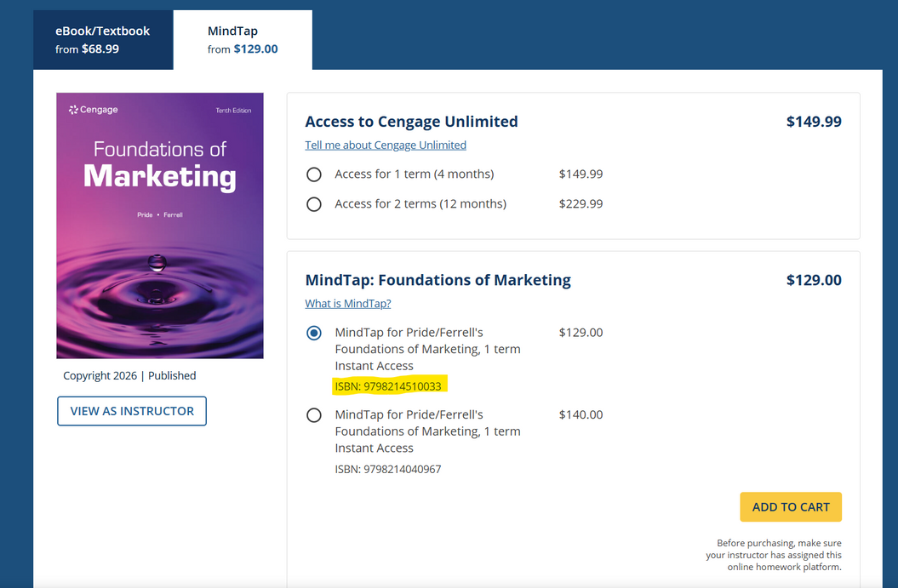
Online Access is Required for MindTap

To purchase a textbook WITH MindTap (Online Learning Platform) please visit https://www.cengage.com/student/

Please note you will need to linking your Cengage and Canvas Accounts:
https://startstrong.cengage.com/mindtap-canvas-ia-no/

Technology Requirements:
This is an online course built on digital competence to complete the coursework. Information on how to be successful in a digital learning environment can be found at (https://online.unt.edu/learn)
APPS required:
Respondus – Lockdown Browser using MONITOR with Webcam- this is located on the left side in the COURSE menu
For instructions on how to download the Lockdown Browser or to contact the UNT IT HelpDesk for assistance, please visit LockDown Browser | University of North Texas
To maximize the value and learning of this class, students will need:
- Computer with a reliable internet connection
- Canvas Learning Management System
- UNT Email
- Cengage MindTap: https://www.cengage.com/student/
- Microsoft Office 365: https://outlook.office.com/
- Google Docs: https://docs.google.com/
- Zoom App: https://zoom.us/
- Adobe Reader: https://get.adobe.com/reader/
- Web-camera and the ability to video conference and record presentation videos
- A quite testing area to complete exams and quizzes.
  - Please note that per the LockDown Browser requirements:
    - Students must be in view of the camera during the entire exam and cannot have any viewing obstructions.
    - Must have a strong internet connection.
    - Must not have other faces (people) in view of the camera. Please note that if you are completing your exam in a public space such as a library or student center, you should state this at the start of your exam and prior to answering any examination questions.
    - May not have any other device on, in use, or present during the examination.
  - Please note that all exams are closed-book and closed-notes.
Technical Assistance
Here at UNT, we have a Student Help Desk that you can contact for help with Canvas or other tech issues.
UIT Help Desk: UIT Student Help Desk site (http://www.unt.edu/helpdesk/index.htm)
Email: helpdesk@unt.edu
Phone: 940-565-2324
In Person: Sage Hall, Room 130
For additional support, visit the Online Student Resources at https://studentaffairs.unt.edu/online-student-experience/online-student-resources/index.html.

Communication Expectations:
You may contact me at any time via UNT email. As a friendly reminder, treat all email communications as professional correspondence. I will respond to your emails within 24 hours. Please note that I will not respond to emails sent after 12:00 p.m. on Sundays.
Please use email whenever you wish to message me. Do not use CANVAS. Why?
Because emailing me directly will almost always make it easier for me to answer your question(s) or otherwise help you more efficiently. Email also makes it easier to convey attached information or evidence back and forth. Email likewise provides an easily accessible record, i.e., electronic footprint, documenting issues and items that were “said” and “agreed-upon.”
** Tips for Professional Communication**
- Use an appropriate salutation for the recipient, e.g., “Hello Professor Geisler” or “Mrs. Geisler.”
- Make the tone of your email professional. Ask yourself how you would interpret the tone and content of the email had you received it from someone else. Your email should not read like a text
- Avoid slang and do not use abbreviations.
- Remember that good grammar, spelling, and punctuation can make the difference between comprehension and confusion.
- Carefully proofread your email before hitting the ‘send’ button.
How to Succeed in this Course:
Helping you succeed in this course is my top priority! I hope you will take advantage of this. Here are a few things you could do to ensure you achieve the best results:
1. | Keep an open “learner’s” mindset!  You will learn new concepts that could only be retained if you apply them in class discussions, MindTap exercises, and other class assignments.
2. | Challenge yourself to do better and ask questions!  If you’re struggling with any material, please don't hesitate to talk to me. My office/students’ hours are dedicated to you and your professional development.
3. | Keep track of deadlines and stay on schedule!  All assignment deadlines are listed below, in Canvas, and also in Cengage. If there are any changes to the deadlines, they will be posted on Canvas, via announcements, in advance.  Keep yourself accountable and be prepared for the course activities, just as you would in a career employment situation!  Please note: Late Submissions  You are expected to turn in assignments on time. Late assignments will not be accepted without an approved university excuse. Please pay attention to the deadlines!
4. | Take control of learning!  Do not be afraid to ask for help or guidance in locating resources.  Take advantage of the FREE resources provided to you by UNT, such as Coursera and LinkedIn Learning, as well as other professional development opportunities available to UNT students.

Teaching Philosophy:
Education is a collaborative journey, not a one-way transmission of information.
Fostering an Inclusive Environment
I am committed to cultivating a classroom atmosphere where learning is both engaging and meaningful. I believe that students perform best in a friendly, inclusive, and judgment-free space where they feel safe to express thoughts and take creative risks.
The Power of Inquiry
At the center of my approach is the "Socratic" method—the practice of asking questions to spark curiosity. I am passionate about prompting learners to ask "why," encouraging them to peel back the layers of complex marketing and communication principles; by shifting the focus from rote memorization to critical thinking, I aim to empower students to take ownership of their educational journeys and develop a deeper, more resilient understanding of the material.
Adaptability and Diverse Learning Styles
Recognizing that every student brings a unique perspective and a different learning style, I prioritize adaptability. Whether through hands-on creative workshops using the Adobe Suite, data-driven group discussions, or personalized one-on-one support, I strive to provide a variety of modalities that resonate with each participant.
A Commitment to Mentorship
Ultimately, I view teaching as a calling to inspire and nurture the next generation of professionals. My goal is to bridge the gap between academic theory and real-world application, fostering not just a temporary understanding of a subject but a lifelong love of learning and a commitment to professional excellence.

Policies
Academic Integrity Policy
The G. Brint Ryan College of Business takes academic honesty seriously. Ethics and integrity are important business values, essential to building trust and adhering to both professional and legal standards. Academic dishonesty undermines trust, tarnishes the reputation and value of the degree, and is unacceptable.
According to UNT Policy 06.003, Student Academic Integrity, academic dishonesty occurs when students engage in behaviors, including but not limited to cheating, fabrication, facilitating academic dishonesty, forgery, plagiarism, and sabotage. A finding of academic dishonesty may result in a range of academic penalties or sanctions from admonition (a warning) to expulsion from the University.
Some of the most common examples of academic integrity violations include plagiarism or cheating, such as unauthorized assistance on examinations, homework, research papers, or case analyses. Your work must be entirely your own. When working on assignments, you should not discuss your work with others unless approved by the course instructor. Group assignments should only be discussed with members assigned to your group, and all group members may be held accountable in some way for known academic integrity violations in a group assignment.
Another example of academic dishonesty relates to improper attribution. When preparing your assignments, you must cite all outside sources in the manner requested by your instructor. Copying or using material from any source prepared by or previously submitted by others, at UNT or other institutions, or downloaded from the Internet, is plagiarism. Unless directed otherwise in an assignment, large-scale “cutting and pasting” from different sources, even if properly footnoted, is not appropriate. You should synthesize this material in your own words and provide a footnote.
Your instructor will specify what materials, if any, may be used on the tests and exams. Using materials other than those permitted, discussing the exam with other individuals, exchanging information about an exam when one has taken it and the other has not, or copying or using material from another individual’s exam constitutes academic dishonesty. It will result in a meeting to discuss academic integrity violations and potentially issue the aforementioned sanctions, and may also result in ineligibility for educational scholarships. The use of online assistance, such as sites commonly used for finding homework solutions, group chats, cell phones, smartwatches, and similar tools during exams, is not allowed for any reason unless specifically permitted. No portion of an exam may be copied or photographed without permission.
Students are expected to conduct themselves in a manner consistent with the University's status as an institution of higher education. A student is responsible for responding to a request to discuss suspected academic dishonesty when issued by an instructor or other University official. If a student fails to respond after a proper attempt at notification has been made, the University may take appropriate academic actions in the absence of the student’s participation.
Attendance & Participation
For information on which absences are considered University Excused or if you have any questions on what an excused absence is, please refer to UNT Policy 06.039- Student Attendance and Authorized Absences | University Policy Office
Class attendance is required for this course.
There will be regular discussion and/or MindTap activities each week, which will be graded and cannot be made up if students DO NOT submit their work during the established timeline. Timeline information for when attendance activities are due is provided in the detailed course schedule included in this syllabus. Finally, please respect your fellow students.
Requests for Special Consideration
When a student requests special consideration for missing a quiz, an assignment due date, or any other reason, they must provide written documentation to support the request. Providing special consideration to a student without documentation discriminates in favor of the requesting student and to the detriment of all other students. For additional assistance, please refer to Student Attendance and Authorized Absences | University Policy Office.
Grading Challenge Policy
This Instructor strictly follows the guidelines outlined in the current Undergraduate Catalog for grade appeals, changes, and the awarding and removal of an ‘Incomplete’. Should you believe there is a grading error for a particular activity, you may make a grade “challenge”. This grade challenge must be made in writing to your instructor no more than 48 hours (two days) after the grade is posted and should specify why you believe the grade is incorrect. Challenges made after this time will not be accepted, and your grade will stand as recorded.
Late Submissions
You are expected to turn in assignments on time. Late assignments will not be accepted without an approved university excuse. Please pay attention to the deadlines!
Syllabus Change Policy
I reserve the right to change the syllabus, policies, and/or due dates, provided that:
(1) The change does not cause harm to any student.
and
(2) An announcement about the change is posted a minimum of three days before any change occurs. One thing students can rest assured of: Changes to the syllabus are made with the students' interests in mind.
Americans with Disabilities Act
UNT makes reasonable academic accommodations for students with disabilities. Students seeking accommodation must first register with the Office of Disability Access (ODA) to verify their eligibility. If a disability is verified, the ODA will provide a student with an accommodation letter to be delivered to faculty, initiating a private discussion regarding the student’s specific course needs. Students may request accommodations at any time; however, ODA notices of accommodation should be provided as early as possible in the semester to avoid any delay in implementation. Note that students must obtain a new letter of accommodation for every semester and must meet with each faculty member before implementation in each class. For additional information, see the ODA website at disability.unt.edu.
Prohibition of Discrimination, Harassment, and Retaliation (Policy 16.004)
The University of North Texas (UNT) prohibits discrimination and harassment because of race, color, national origin, religion, sex, sexual orientation, gender identity, gender expression, age, disability, genetic information, veteran status, or any other characteristic protected under applicable federal or state law in its application and admission processes; educational programs and activities; employment policies, procedures, and processes; and university facilities. The University takes active measures to prevent such conduct and investigates and takes remedial action when appropriate.
Student Perception of Teaching
Student Perception of Teaching (SPOT) is a requirement for all organized classes at UNT. This short survey will be available to you at the end of the semester, giving you the opportunity to comment on how this class is taught. Student feedback helps improve this course. I consider SPOT to be an essential part of your participation in this class, and I greatly appreciate your insight.
Students will receive an email from "UNT SPOT Course Evaluations via IASystem Notification" (no-reply@iasystem.org) with the survey link. Students should check their UNT email inbox for the email. Click on the link and complete the survey. Once students complete the survey, they will receive a confirmation email indicating that their submission has been received. For additional information, please visit the SPOT website (http://spot.unt.edu/) or email spot@unt.edu.
Emergency Notification and Procedures
UNT uses a system called Eagle Alert to quickly notify students with critical information in the event of an emergency (i.e., severe weather, campus closing, and health and public safety emergencies like chemical spills, fires, or violence). In the event of a university closure, please refer to Canvas for contingency plans for covering course materials.
Retention of Student Records
Student records pertaining to this course are maintained in a secure location by the instructor of record. All documents, including exams, answer sheets (with keys), and written papers, submitted during the course are retained for at least one calendar year after course completion. Coursework completed via the Canvas system, including grading information and comments, is also stored in a safe electronic environment for one year. Students have the right to view their individual records; however, information about students’ records will not be divulged to other individuals without proper written consent. Students are encouraged to review the Public Information Policy, the Family Educational Rights and Privacy Act (FERPA) laws, and the University’s policy. Refer to UNT Policy 10.10, Records Management and Retention, for further details.
Acceptable Student Behavior
Student behavior that interferes with an instructor’s ability to conduct a class or other students' opportunity to learn is unacceptable and disruptive and will not be tolerated in any instructional forum at UNT. Students engaging in inappropriate behavior will be directed to leave the classroom, and the instructor may refer the student to the Dean of Students for consideration of whether the student's conduct has violated the Code of Student Conduct. The University's expectations for student conduct apply to all instructional forums, including University and electronic classrooms, labs, discussion groups, field trips, and other similar settings. Visit UNT’s Code of Student Conduct (https://deanofstudents.unt.edu/conduct) to learn more.
Access to Information - Eagle Connect
Students’ access point for business and academic services at UNT is located at: my.unt.edu. All official communication from the University will be delivered to a student’s Eagle Connect account. For more information, please visit the website that explains Eagle Connect and how to forward e-mail Eagle Connect (https://it.unt.edu/eagleconnect).
Student Evaluation Administration Dates
Student feedback is a crucial component of participation in this course. The student evaluation of instruction is a requirement for all organized classes at UNT. Students will receive an email from "UNT SPOT Course Evaluations via IASystem Notification" (no-reply@iasystem.org) with the survey link. Students should check their UNT email inbox for the email. Click on the link and complete the survey. Once students complete the survey, they will receive a confirmation email indicating that their submission has been received. For additional information, please visit the SPOT website (http://spot.unt.edu/) or email spot@unt.edu.
Sexual Assault Prevention
UNT is committed to providing a safe learning environment free of all forms of sexual misconduct, including sexual harassment, sexual assault, domestic violence, dating violence, and stalking. Federal laws (Title IX and the Violence Against Women Act) and UNT policies prohibit discrimination based on sex, and therefore prohibit sexual misconduct. If students or someone they know is experiencing sexual harassment, relationship violence, stalking, and/or sexual assault, there are campus resources available to provide support and assistance. UNT’s Survivor Advocates can assist students who have been impacted by violence by filing protective orders, completing crime victim’s compensation applications, contacting professors for absences related to an assault, working with housing to facilitate a room change where appropriate, and connecting students to other available resources both on and off campus. The Survivor Advocates can be reached at SurvivorAdvocate@unt.edu or by calling the Dean of Students' Office at 940-565-2648. Additionally, alleged sexual misconduct can be reported confidentially to the Title IX Coordinator at oeo@unt.edu or (940) 565-2759.

Rules of Engagement
Rules of engagement refer to the manner in which students are expected to interact with one another and with instructors. Here are some general guidelines:
- While the freedom to express yourself is a fundamental human right, any communication that utilizes cruel and derogatory language based on race, color, national origin, religion, sex, sexual orientation, gender identity, gender expression, age, disability, genetic information, veteran status, or any other characteristic protected under applicable federal or state law will not be tolerated.
- Treat your instructor and classmates with respect in any communication online or face-to-face, even when their opinions may differ from your own.
- Speak from personal experiences. Use “I” statements to share thoughts and feelings. Try not to speak on behalf of groups or other individuals’ experiences.
- Use your critical thinking skills to challenge other people’s ideas, instead of attacking individuals.
- Avoid using all caps while communicating digitally. This may be interpreted as “YELLING!”
- Be cautious when using humor or sarcasm in emails or discussion posts, as tone can be challenging to interpret digitally.
- Avoid using “text-talk” unless explicitly permitted by your instructor.
- Proofread and fact-check your sources.
- Remember that online posts are permanent. Think before you type.
Refer to the Engagement Guidelines (https://clear.unt.edu/online-communication-tips) for more information.

Grading and Assignments
Required Activity | Maximum Points Possible
4 Exams  - Exam 1:  - Part 1- Chapters 1, 2, & 3  - Part 2- Chapters 4 & 5  - Exam 2:  - Part 3- Chapters 6, 7, 8, & 9  - Exam 3:  - Part 4- Chapters 10, 11, & 12  - Part 5- Chapters 13 & 14  - Exam 4  - Part 6- Chapters 15, 16, & 17 | 600 (150 points each)  Complete an Adobe Professional Certificate with UNT COURSERA to replace your lowest test score!  - EXAMS Require Responds Lockdown Browser + Webcam: A quite testing area to complete exams and quizzes.  - Please note that per the LockDown Browser requirements:  - Students must be in view of the camera during the entire exam and cannot have any viewing obstructions.  - Must have a strong internet connection.  - Must not have other faces (people) in view of the camera. Please note that if you are completing your exam in a public space such as a library or student center, you should state this at the start of your exam and prior to answering any examination questions.  - May not have any other device on, in use, or present during the examination.  - Please note that all exams are closed-book and closed-notes.
Attendance/Participation- Discussion Posts | 50 (5 posts @10 points each)
Your Marketing Campaign | 200 Points
MindTap:  “Learn It” & “You Make the Decision” Assignments | Total: 311 Points  Please note that “Learn It Assignments” vary from 1 to 5 points each.  All “You Make the Decision” Assignments are worth 25 points each.
Extra Credit- LinkedIn Learning Certifications | 50 Points Possible
Extra Credit- Adobe Professional Certification | Replaces your lowest exam score with a full 100%
Total | 1,161
Grading
Final Grade A = 90% and above or 1,045 to 1,161+ points.
Final Grade B = 80% to 89.99% or 929 to 1,044 points.
Final Grade C = 70% to 79.99% or 813 to 928 points.
Final Grade D = 60% to 69.99 or 697 to 812 Points
Final Grade F = below 59% or below 696 Points.
Grade Breakdown
Exams (x 4 @ 150 points each)
You will have four exams, each worth 13% of your grade. Exams are overall 52% of your final grade. Some exams will be taken on Canvas and will be timed, with availability for at least 24 hours. If you lose internet, etc., you may be able to regain access, but the timer will not stop. Therefore, it is essential to use a reliable computer with a stable internet connection when taking your test.
Exams will be available in Canvas starting the Friday before they are due, and will be accessible until the following Sunday at 11: 59 pm. Students will receive 180 minutes (3 hours) for each exam.
Example:
Exam 1 will open on Friday, February 6, 2026, and will close on Sunday, February 8, 2026, at 11:59 pm
MindTap Assignments ( 311 Total Points for MindTap Assignments)
Each chapter has an online assignment that can be accessed through Canvas once your Cengage MindTap account is linked. The assignments for each week will be due by Sunday at 11:59 pm. Cengage has many cool features and opportunities to apply your learning. While only some “Lean It” assignments are applied to your final grade, I STRONGLY recommend that you complete all " Lean It” assignments (whether points are earned or not) for each assigned Chapter to help develop your knowledge.
Attendance/Participation (x5 @ 10 points each)
You will have a total of 5 Discussion posts to respond to over the semester. The discussion post will be due by Sunday at 11:59 pm of the corresponding week detailed in the semester schedule below.
Please note that your initial discussion post MUST meet a minimum word count of 200 words. Additionally, note that commenting and discussing with other students in the discussion boards is highly encouraged, and to receive full points for your discussion participation, you must comment on at least one of your peers' posts. Please note that your comment MUST be at least 100 words.
Your Marketing Campaign (200 points)
Chapters to review for this assignment:
Chapter 9: Digital Marketing and Social Networking
Chapter 15: Integrated Marketing and Communications
Chapter 16: Advertising and Public Relations
For this assignment, you will take the knowledge and skills you have learned from your text, mainly chapters 9, 15, and 16, to create a digital marketing tool to promote the service, product, or event of your choice. For additional clarification, you can create any type of marketing communication tool as outlined in the text. This includes flyers, social media posts, graphics, digital advertisements, etc.
For example, you can create a flyer for your church's bake sale next month or maybe a social media post showcasing a career fair your degree program is holding. The main point of this assignment is to create a coherent, eye-catching, and consumer-friendly call to action for your selected service, product, or event.
This assignment will focus on the key features of digital marketing, including Addressability (The ability of the marketer to identify customers before they make a purchase), Interactivity (The ability of customers to express their needs and wants directly to the firm in response to its marketing communications), Accessibility (The ability for marketers/consumers to obtain digital information), Connectivity (The ability for consumers to be connected with marketers along with other consumers), and Control (The customers’ ability to regulate the information they view as well as the rate and exposure to that information).
Regardless of which media format you choose, think about how social media and the digital world impact the service, product, or event you selected. Then, in detail, explain why you selected the marketing media method you did and how this method fits with the marketing mix associated with your service, product, or event. Additionally, be sure to explain why you selected this marketing format and how it positively or negatively impacts your long-term marketing plan/goal.
For example, I decided to create a social media post for my younger sister’s babysitting gig. I would explain in detail why I decided to market this service flyer to the local Facebook Groups (churches, elementary schools, community centers, etc.), rather than posting my sister’s babysitting gig on LinkedIn or Google Ads. For more details or guidance, please review chapters 15 and 16.
To summarize this assignment, you will need to submit two parts.
Part 1: Your originally designed marketing media tool, flyer, graphic, social media post, etc.
Please submit the final product in addition to part 2
Part 2:
Option 1:
Create a Word or PDF document for your explanation and marketing mix impact statement. This portion should be around 2-3 pages; not to exceed 5 pages with APA in-text and reference section citation style. Please note this paper is to be single and ½ spaced (1.5) spaced and 12-point Times New Roman font.
Option 2:
Create a short video and/or presentation to clearly explain the marketing mix and how it was impacted by your selected marketing media tool. Please note this video should be between 5 and 8 minutes; please do not exceed 10 minutes/ 10 slides.
Extra Credit Opportunities! (Total of 50 Points Possible)
ALL EXTRA CREDIT AND CERTIFICATION ASSIGNMENTS MUST BE SUBMITTED WITH COMPLETION CERTIFICATION/DOCUMENTATION by the Sunday before finals week, no later than 11:59 pm. Points for each extra credit opportunity are listed below. Please note you are encouraged to take advantage of all these opportunities, but only a max of 50 points will be applied to your score.
*TAKE CONTROL OF YOUR LEARNING! Please note this is for your personal/professional development, and other certifications can be proposed to replace these recommended certificates for extra credit opportunities. For Certificates completed that are not on this recommendation list, prior instructor approval will be required.
LinkedIn Learning- Certificates for 10 Points Extra Credit ( a combination of 50 max points) https://aits.unt.edu/support/linkedinlearning/index.html
Recommended (Non-recommended certifications will need to be approved by the instructor):
Product Marketing Foundations by Richard King | https://www.linkedin.com/learning/product-marketing-foundations-18780685/what-is-product-marketing?u=74650474
Social Media Marketing Foundations by Brian Honigman | https://www.linkedin.com/learning/social-media-marketing-foundations-22309474/community-based-social-networks?u=74650474
Marketing Analytics Foundations by Christina Inge | https://www.linkedin.com/learning/marketing-analytics-foundations/setting-the-stage-for-makering-analytics-foundations?contextUrn=urn%3Ali%3AlyndaLearningPath%3A56d7a3f83dd559b764b88a8f&u=74650474
Marketing Foundations: Customer Decision Journey by Dina Shapiro | https://www.linkedin.com/learning/marketing-foundations-customer-decision-journey/taking-the-customer-s-perspective?contextUrn=urn%3Ali%3AlyndaLearningPath%3A56d7a3f83dd559b764b88a8f&u=74650474
Content Marketing for Social Media by Madecraft and Colleen Jones | https://www.linkedin.com/learning/content-marketing-for-social-media/accelerate-your-content-marketing-on-social-media?contextUrn=urn%3Ali%3Ala_learningPlanV2%3AAEQAAE0Abl4BQaXi8W0ZJFKiNDbyNP6e4Msa8LM&u=74650474
Content Creation by Joanna Yung | https://www.linkedin.com/learning/content-creation-strategy-and-tools-24297120/learning-content-creation-strategy-and-tools?contextUrn=urn%3Ali%3Ala_learningPlanV2%3AAEQAAE0Abl4BQaXi8W0ZJFKiNDbyNP6e4Msa8LM&u=74650474
Business Law Basics for Influencer Marketing Campaigns by Madecraft and Ken Sterling | https://www.linkedin.com/learning/business-law-basics-for-influencer-marketing-campaigns/uncover-legal-secrets-for-influencers?u=74650474
COMPLETE AN ADOBE PROFESSIONAL CERTIFICATION for a chance to replace your lowest exam score! Adobe Professional Certifications for (Low Exam Score Replacement):
UNT- Coursera: https://online.unt.edu/coursera-for-unt/index.html
Adobe Marketing Specialist Professional Certificate: (RECOMMENDED)
- Design Fundamentals with AI
- Generative AI Content Creation
- Digital Marketing
- Social Media Content and Strategy
- Multichannel Content Marketing
Adobe Content Creator Professional Certificate:
- Design Fundamentals with AI
- Social Media Content and Strategy
- Multimedia Content Creation
- Generative AI Content Creation
Adobe Graphic Designer Professional Certificate:
- Design Fundamentals with AI
- Generative AI Content Creation
- Image Editing
- Graphic design
- Document Design
Why get an Adobe Professional Certification with UNT Coursera? https://edex.adobe.com/credentials
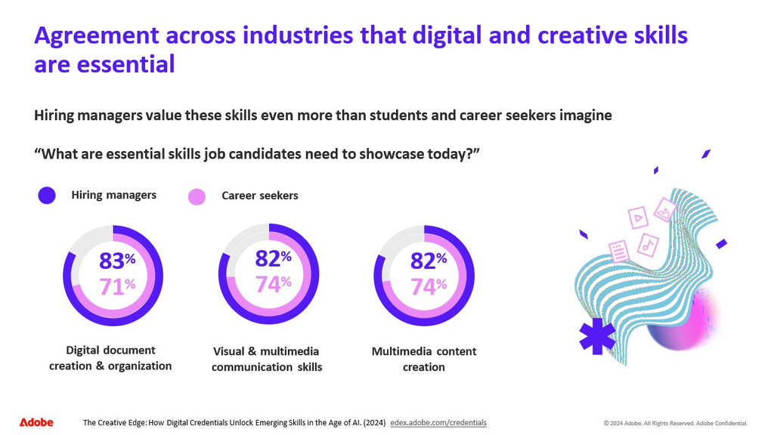
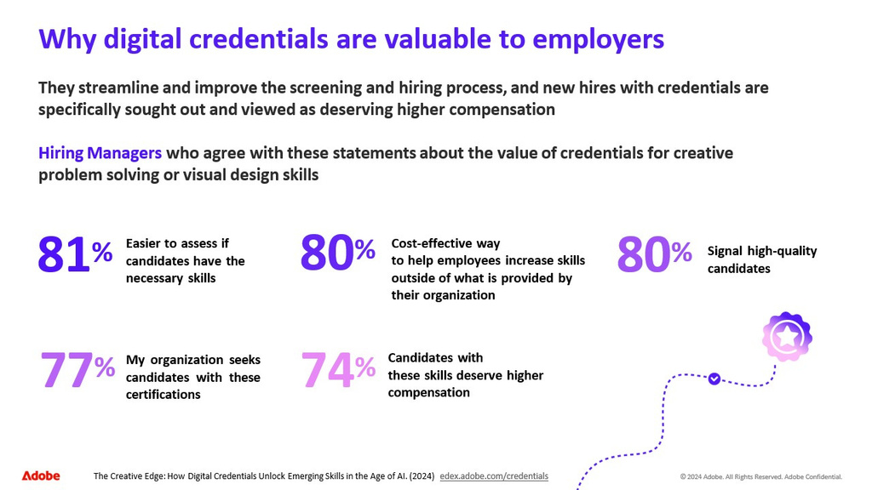
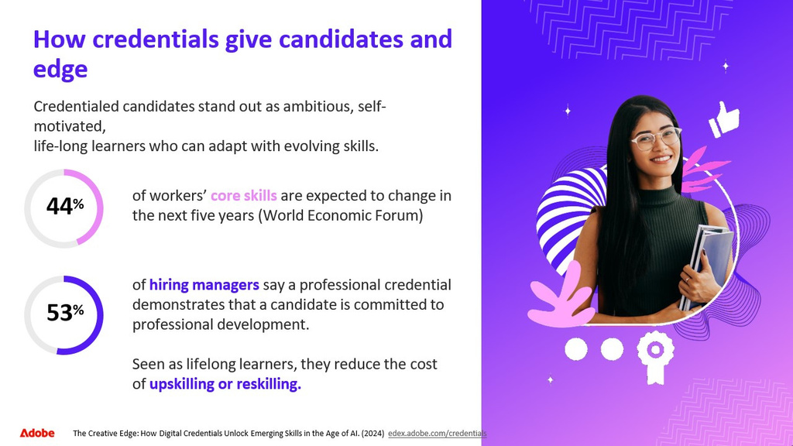

Summer 2026  (Week & Dates) | Topic(s) & Chapter(s) | Assignment Details
Week 1  May 18, 2026 – May 24, 2026 | Part 1- Chapters 1, 2, and 3  &  Part 2- Chapters 4 and 5 | Due May 18, 2026 @ 11:59 pm  Canvas:  Discussion Post: Introductions and Careers in Marketing (10 points)  Please read Appendix C: Careers in Marketing before you introduce yourself  Syllabus Acknowledgement  Due May 24, 2026 @ 11:59 pm  MindTap Assignment(s):  Read: Chapter 01 Customer-Driven Strategic Marketing  - Learn It 1-1: Defining Marketing (3 points)  - Learn It 1-2: Marketing Deals with Products, Price, Distribution, and Promotion (4 points)  Read: Chapter 02 Planning, Implementing, and Evaluating Marketing Strategies  - Learn It 2-1: The Strategic Planning Process (3 points)  - Learn It 2-7: Creating the Marketing Plan (3 points)  Read: Chapter 03 The Marketing Environment, Social Responsibility, and Ethics  - Learn It 3-1: The Marketing Environment (3 points)  - Learn It 3-7: Social Responsibility and Ethics in Marketing (3 points)  - Learn It 3-8: Incorporating Social Responsibility and Ethics into Strategic Planning (2 points)  You Make the Decision: Part 01 Marketing Strategy and Customer Relationships (25 points)  Read: Chapter 04 Marketing Research and Analytics  - Learn It 4-1: The Importance of Marketing Research (2 points)  - Learn It 4-2: Types of Research (4 points)  Read: Chapter 05 Target Markets: Segmentation and Evaluation  - Learn It Part 1: 5-2: Step 1: Identify the Appropriate Targeting Strategy (4 points)  - Learn It Part 1: 5-3: Step 2: Determine Which Segmentation Variables to Use (4 points)  - Learn It 5-4: Step 3: Develop Market Segment Profiles and 5-5: Step 4: Evaluate Relevant Market Segments (4 points)  - Learn It 5-6: Step 5: Select Specific Target Markets (2 points)  You Make the Decision: Part 02 Marketing Research and Target Market Analysis
Week 2:  May 25- May 31 | Part 3 -Chapters 6, 7, 8, and 9 | Due May 31, 2026 @ 11:59 pm  Canvas:  Discussion Post: Ethics in Marketing Research  Exam 1:  - Part 1- Chapters 1, 2, & 3  - Part 2- Chapters 4 & 5  MindTap Assignment(s):  Read: Chapter 06 Consumer Buying Behavior  - Learn It 6-2: Types of Consumer Decision Making and Level of Involvement (3 points)  - Learn it 6-6: Consumer Misbehavior (2 points)  Read: Chapter 07 Business Markets and Buying Behavior  - Learn It 7-1: Business Markets (3 points)  - Learn It 7-2: Using the North American Industry Classification System to Identify and Analyze Business Customers (3 points)  - Learn It 7-3: Six Dimensions of Marketing to Business Customers (2 points)  Read: Chapter 08 Reaching Global Markets  - Learn It 8-2: Environmental Forces in Global Markets (3 points)  - Learn It 8-3: Regional Trade Alliances, Markets, and Agreements (3 points)  - Learn It 8-4: Methods of Entry into International Markets (3 points)  Read: Chapter 09 Digital Marketing and Social Networking  - Learn It Part 1: 09-2: Types of Digital Media (3 points)  - Learn It Part 2: 09-2: Types of Digital Media (2 points)  - Learn It 09-4: Digital Marketing Strategy (2 points)  You Make the Decision: Part 03 Buying Behavior, Global Marketing, and Digital Marketing
Week 3:  June 1- June 7 | Part 4- Chapters 10, 11, and 12  &  Part 5- Chapters 13 and 14 | Due June 7, 2026 @ 11:59 pm  Canvas:  Discussion Post: Product, Branding, and Packaging (10 points)  Exam 2:  - Part 3- Chapters 6, 7, 8, & 9  MindTap Assignment(s):  Read: Chapter 10 Product, Branding, and Packaging Concepts  - Learn It Part 1: 10-2: Classifying Products (3 points)  - Learn It 10-3: Product Line and Product Mix (2 points)  - Learn It Part 1: 10-6: Branding (3 points)  - Learn It 10-4: Product Life Cycles and Marketing Strategies (3 points)  Read: Chapter 11 Developing and Managing Goods and Services  - Learn It 10-7 and 10-8: Packaging and Labeling (3 points)  - Learn It 11-3: Product Differentiation Through Quality, Design, and Support Services (3 points)  - Learn It 11-4: Product Positioning and Repositioning (4 points)  - Learn It 11-7: Organizing to Develop and Manage Products (2 points)  - Learn It Part 1: 11-6: Managing Services (3 points)  Read: Chapter 12 Pricing Concepts and Management  - Learn it 12-2: Development of Pricing Objectives (3 points)  - Learn It 12-3: Assessment of the Target Market's Evaluation of Price (3 points)  - Learn it Part 1: 12-8: Selection of a Pricing Strategy (3 points)  - Learn it Part 2: 12-8: Selection of a Pricing Strategy (3 points)  - Learn It 12-09: Pricing for Business Markets ( 4 points)  You Make the Decision: Part 04 Pricing Decisions ( 25 points)  Read: Chapter 13 Marketing Channels and Supply Chain Management  - Learn It 13-2: The Role of Marketing Channels in Supply Chains (4 points)  - Learn It Part 1: 13-3: Types of Marketing Channels (4 points)  - Learn It Part 2: 13-3: Types of Marketing Channels (2 points)  - Learn It 13-7: Legal Issues in Channel Management (2 points)  Read: Chapter 14 Retailing, Direct-to-Consumer Marketing, and Wholesaling  - Learn It Part 1:14-4: Strategic Issues in Retailing (4 points)  - Learn It Part 2:14-4: Strategic Issues in Retailing (3 points)  You Make the Decision: Part 05 Distribution Decisions (25 points)
Week 4: June 8 - June 14 | Part 6- Chapters 15, 16, and 17 | Due June 14, 2026 @ 11:59 pm  Canvas:  Participation Assignment:  Public Relations (PR) Assignment/Discussion Edward Bernays & the “Bacon and Eggs” Campaign (10 points)  Exam 3:  - Part 4- Chapters 10, 11, & 12  - Part 5- Chapters 13 & 14  MindTap Assignment(s):  Read: Chapter 15 Integrated Marketing and Communications  - Learn It 15-2: Promotion and the Communication Process (3 points)  - Learn It 15-4: The Promotion Mix (3 points)  - Learn It 15-5: Selecting Promotion Mix Factors (4 points)  Read: Chapter 16 Advertising and Public Relations  - Learn It 16-1: The Nature and Types of Advertising (4 points)  - Learn It 16-4 and 16-5: Public Relations and Public Relations Tools (3 points)  - Learn It 16-6: Evaluating Public Relations Effectiveness (2 points)  Read: Chapter 17 Personal Selling and Sales Promotion  - Learn It 17-1: The Nature and Goals of Personal Selling (2 points)  - Learn It 17-2: Steps of the Personal Selling Process (4 points)  - Learn It 17-6 and 17-7: Sales Promotion and Consumer Sales Promotion Methods (5 points)  You Make the Decision: Part 06 Promotion Decisions
Week 5:  June 15 - June 19 | Last Week &Final Exam Prep | Due June 19, 2026 @ 11:59 pm  Canvas:  Discussion: End of Semester Wrap-up  EXAM 4: Part 6- Chapters 15, 16, and 17  Optional Extra Credit Due:  LinkedIn Learning Extra Credit 1 of 5 (10 points)  LinkedIn Learning Extra Credit 2 of 5 (10 points)  LinkedIn Learning Extra Credit 3 of 5 (10 points)  LinkedIn Learning Extra Credit 4 of 5 (10 points)  LinkedIn Learning Extra Credit 5 of 5 (10 points)  ADOBE CERTIFICATION FOR LOW EXAM GRADE REPLACEMENT  YOU DID IT!

