ENGL 1325.007: Writing About Literature II

Professor: Robert Tate Morrison
Office Hours: TTh 12:30pm-1:30pm and Online Over Zoom (Or by Appointment)
Contact Info: Office: GAB 515
E-mail: Robert.Morrison@unt.edu (must use your UNT e-mail account)

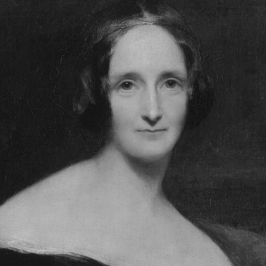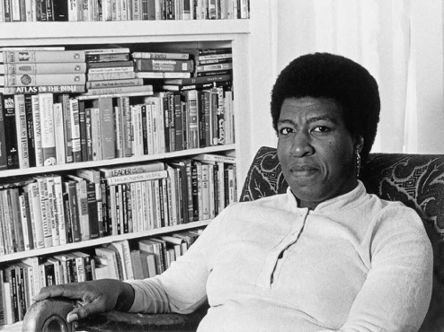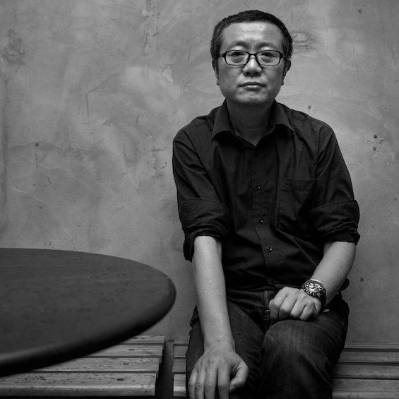

Course Description

This class will cover longform writing. We will read three novels, several short stories and a variety of academic essays. Students will attempt to deconstruct and interrogate these works in order to explain their relevance to today’s culture. Students will also read and analyze academic essays to see how practiced scholars plan, draft, and publish complex, substantive arguments about creative works. Students will use their knowledge of genre conventions, figurative devices, and rhetorical techniques to help explain how authors of such works have designed them to appeal to a wide audience with a wide array of concerns and interests. In doing so, students will learn to engage with a writing process of their own that is deliberate and recursive.

Texts*

- Mary Shelley’s Frankenstein, or the Modern Prometheus (e-book link)
- Octavia Butler’s Kindred (e-book link)
- Cixin Liu’s Three Body Problem
- Diana Hacker’s A Writer’s Reference (recommended)

*I will provide all other reading selections via Canvas. I recommend printing them out to make annotating easier. Downloading them and annotating them on a tablet also works.

Supplies

A good one subject notebook, something to write with, and one or two different colored pens or highlighters (for making annotations) is all you’ll need to take part in most day-to-day activities. You are free to pull up any of the previously mentioned texts on an e-reader, tablet, or laptop to follow along with class discussions. I will remind you to bring additional supplies and materials in the announcements on Canvas, if you need any.

Participation

I reserve the right to deduct up to ten points from a student’s final, end-of-semester average if they have not demonstrated a willingness to participate in class. In-class participation means regularly (read: not just once) demonstrating active listening and learning skills consistently, which includes both asking and answering questions when prompted, taking part in group activities, and maintaining focus during scheduled workdays and class discussions. If you’re having a bad day, I can be gracious, so long as it is not a consistent pattern of ignoring me or your classmates.

Evaluation

15% —— Writing Activities and Quizzes
15% —— Pre-Discussion Exercises
10% —— Research Proposal
25% —— Annotated Bibliography
35% —— Research Essay

Writing Activities and Quizzes

I assign daily work in addition to the major assignments listed on the syllabus. Daily work nearly always consists of tasks to be completed and (sometimes) submitted in class. I will also, on occasion, issue pop quizzes over readings and ask you to submit rough drafts and planning notes during scheduled workdays to make sure you’re up to speed and on task. Quizzes will be graded traditionally, but all other writing activities will be graded Pass/Fail with no written feedback.
Note: These assignments give each student the opportunity to attend to texts and the focus of the course, but do not replace in-class participation. If you miss a day, these assignments are still available on canvas and it is your responsibility to complete them.

Pre-Discussion Exercises

Pre-Discussion Exercises (or PDEs) help guide our reading, allow us to practice our writing and the way we frame oral responses, and—perhaps most importantly—prepare us to participate in other forms of constructive and meaningful classroom interactions. Thus, your answers to PDEs should be original AND well-developed to ensure the type of high-quality discourse that students should be engaging with at this level of instruction. Each exercise should be 200-400 words and will help you develop critical and thematic engagement.

Any student who (1) consistently fails to complete assigned PDEs with adequately developed answers on time or (2) is suspected of plagiarizing work from their peers or other sources may not make an A in the course regardless of their other grades.

PDEs are due at the beginning of class (unless instructed otherwise) and are graded on a two-point scale. Responses that are elaborate and insightful may score a max of two points; responses that are minimal, illogical, or otherwise incorrect may score a one or zero. Please see me if you have any doubts regarding the quality of your responses.

Essential Competencies

To be successful in this class, you must be able to:
- Read and carefully analyze literary texts
- Write clear, concise, and appropriate prose
- Recognize and employ academic writing conventions (MLA)
- Discuss literary texts and personal writing strategies
- Use word processing software, e-mail, and Canvas
- Manage your time wisely
- Ask questions
- Be open-minded

Disability Accommodation

In accordance with the terms and spirit of the Americans with Disabilities Act and Section 504, Rehabilitation Act, I’ll cooperate with the Office of Disability Accommodation to make reasonable accommodations for qualified students with disabilities. If you have disabilities and have not yet registered with ODA, I encourage you to register. Please present your request for accommodation to me no later than the fourth class day (by e-mail is best, if just to keep our conversation documented).

Course Workload

Attending university is different from attending high school in that you are expected to do more work outside of class and to take responsibility for making sure you are prepared to do well and participate in your courses. On average, you should expect to spend 2-3 hours outside of class for every hour you spend in class; however, if you begin to feel overwhelmed and underprepared, you may need to figure out how to better adapt. Come to office hours, stay after class, visit the UNT Writing Lab, and see your academic counselor. We are all here to help. That being said, an inability to adapt to an increased workload and challenging tasks is not an excuse to engage in academic dishonesty when such resources are available.

Plagiarism and Academic Dishonesty

While scholarly cooperation is an important part of academic life, learning to 1) do your own work accurately and completely and 2) attribute the work of others when you use and build on it is paramount to the trust integral to an academic community.

In English 1325, students are expected to complete all coursework on their own, except when their instructor clearly assigns them to work with a partner or group. Therefore, students should avoid the following:
- discussing their responses to assignments with one another outside of class
- asking other students for “peer reviews” not assigned as part of class
Moreover, English 1325 students should avoid inadvertently sharing their work by keeping printed work secure, printing all of their work themselves, and password-protecting all electronic access (computers, clouds, Google docs, emails etc.) to files related to their coursework.

Additionally, students should understand the UNT and TAMS policies covering violations of academic integrity standards. UNT Policy 06.003: Student Academic Integrity defines “cheating” as the following: “the use of unauthorized assistance in an academic exercise, including but not limited to:
- use of any unauthorized assistance to take exams, tests, quizzes, or other assessments;
- use of sources beyond those authorized by the instructor in writing papers, preparing reports, solving problems, or carrying out other assignments;
- use, without permission [from the instructor], of tests, notes, or other academic materials belonging to instructors, staff members, or other students of the University [Note: this item includes the use of materials from former students of the university, such as students who have previously attended TAMS];
- dual submission of a paper or project, or resubmission of a paper or project to a different class without express permission from the instructor;
- any other act designed to give a student an unfair advantage on an academic assignment” (UNT Policy 06.003, p. 2).

Further, the policy defines fabrication, plagiarism, and facilitating academic dishonesty in the following ways:

Fabrication: “falsifying or inventing any information, data, or research outside of a defined academic exercise.” (UNT Policy 06.003, p. 2).
Plagiarism: “use of another’s thoughts or words without proper attribution in any academic exercise, regardless of the student’s intent, including but not limited to:
- the knowing or negligent use by paraphrase or direct quotation of the published or unpublished work of another person without full and clear acknowledgement or citation.
- the knowing or negligent unacknowledged use of materials prepared by another person or by an agency engaged in selling term papers or other academic materials.” (UNT Policy 06.003, p. 3). Facilitating Academic Dishonesty: “helping or assisting another in the commission of academic dishonesty.” (UNT Policy 06.003, p. 2).

ANY use of ChatGPT or other generative AI writing tools (GrammarlyGO, GPT-3, GPT-4, BERT, or others) to produce assignment responses—including, but not limited to, “editing” essays or responses OR generating essays or responses for this course—is prohibited and constitutes cheating.

Any student in English 1325 found cheating, fabricating, plagiarizing, facilitating fabrication/cheating/plagiarizing, OR engaging in any other type of academic dishonesty addressed in UNT Policy 06.003 or the TAMS Handbook will fail the course. For the use of AI, any assignment flagged as more than 25% AI will result in a 0 without the possibility of redoing the assignment, and on the second offense, the student will automatically fail the course. Further, the instructor will report academic dishonesty to the UNT Office of Academic Integrity; these reports will become part of the student’s permanent academic record.

Class Policies

Grading Philosophy
- For our research paper in this class I will be giving letter grades only. That means your paper will receive one of the following letters:
  - A – 100%
  - B – <90%
  - C – <80%
  - D – <70%
  - F – <60%
- I will not provide any grade-deciding-rubrics or point-based system by which you can figure out how to calculate the type of work you must perform; however, I will be delivering feedback on this essay to explain suggestions for improving your writing, issues I took with your argument, and any other noteworthy responses that should communicate why you received the grade you did. I do not count off for spelling or grammatical mistakes, though I must be able to understand what you are saying in your writings. Please visit the UNT Writing Center for help with spelling and grammar.
- Canvas will automatically translate these letters into their grading system and you will be able to see your final grade throughout the semester without having to do any math on your own.
- Note: Canvas has a “what if?” feature that I believe allows you to speculate what your final grade might look like with a range of different possibilities for your assignments, but I would warn you to be careful with this feature because you may think you only need to shoot for a B on an assignment and end up turning in C or D level work. You should always turn in work to the best of your ability.

Attendance
- You can’t perform well unless you attend class. You are responsible for any material covered and any assignments scheduled in your absence, so please contact me as soon as you know you will not make it. After two (2) absences, your final grade will drop by one letter. If you exceed four (4) absences, you will receive an automatic F in the course.
- NOTE: Arriving late and leaving early without my express permission can be logged as absences. Sleeping during class, going off task, distracting others, and showing up unprepared may also be logged as absences.

Devices
- I will provide most readings and some activities via Canvas, so technology use in class will sometimes be mandatory. Make sure that your devices are charged, and/or that you bring necessary charging cords. That being said, I still encourage you to employ hard copies and physical notebooks for personal use whenever possible. You’ll likely be tempted to see what more you can do from your laptop or tablet, but resist the urge—stay on task.

Assignments
- All assignments should be submitted on time. Late assignments are deducted one letter grade for each day, and automatically receive a 0 after three days.
- Read all assignment prompts carefully. I do my best to explain everything you need to do and will sometimes offer advice on how to get it done. I would love to clarify my expectations for you and your work, so feel free to ask a lot of questions.
- Prepare all outside class assignments using appropriate word-processing software.
- Print out rough and final drafts for use during in-class peer review and to show me when you have a question about your writing.
- Be a stickler for detail and practice a style (MLA9).
- Save and store copies of ALL assignments, big or small.

E-mail
- Use your UNT e-mail account for this class and check your e-mail diligently for course announcements and emergency updates. When you send me an e-mail, please use a clear subject line—for example, “question about Tuesday’s DQs”—and tell me what class section you are in (ex. 1325.000). Proofread your messages and sign your e-mail appropriately.

Taking Notes
- I expect you to take notes during lectures and discussions; I prefer you to do so in a physical notebook (for ease of access and accountability), but you are free to use whatever means you need to, so long as they do not present a distraction to you and others. You should also take notes outside of class as you read stories and articles to ensure you are prepared to discuss them with me and with others.
Canvas
- I will ask you to upload your notes, daily work, and other assignments directly to Canvas at the end of some class days. Further, we will use Canvas extensively should UNT close for severe weather or any other reason. You can access Canvas at unt.instructure.com using your EUID and password.
- I will ask you to provide a link to a GoogleDoc (or some other file with visible version history) for all written assignments. Be prepared to add me as an editor to that file when requested.

Public Writing
- You should consider that all of your submitted writing for this course, including prewriting, drafts, in-class assignments, and final projects, is public writing. The writing that you submit in this course may be viewed by me and possibly your classmates as well. Please do not submit any information about yourself that you do not want to be public.

Content Warning
- Some of the texts for this course may contain content that is hard for you. We will only ever address these issues through a sensitive but academic lens, but please be aware that some of our reading may be emotionally intense

Participation and Civility
- We are all members of an academic community where it is our shared responsibility to cultivate a climate where all students/individuals are valued and where both they and their ideas are treated with respect. Therefore, I expect you to conduct yourself in a professional and respectful manner during all class-related activities. I expect you to listen to and respect the viewpoints of others, even if you strongly disagree with them. When you do voice disagreement, do so in a civil manner. Remember that you are accountable for all of your actions in this course, including your submitted work, your grades, and your interactions with other students and me.
- Everyone will have multiple opportunities to participate in class. Participation can be many things, including all of the following:
  - Participating actively in small group work, class meetings, and discussions
  - Completing all assignments on time
  - Coming prepared to online conferences/office hours
- Here are some of the “Rules of Engagement” UNT recommends as guidelines for our class:
  - While the freedom to express yourself is a fundamental human right, any communication that utilizes cruel and derogatory language on the basis of race, color, national origin, religion, sex, sexual orientation, gender identity, gender expression, age, disability, genetic information, veteran status, or any other characteristic protected under applicable federal or state law will not be tolerated.
  - Treat your instructor and classmates with respect in any communication online or face-to-face, even when their opinion differs from your own.
  - Ask for and use the correct name and pronouns for your instructor and classmates.
  - Speak from personal experiences. Use “I” statements to share thoughts and feelings. Try not to speak on behalf of groups or other individual’s experiences.
  - Use your critical thinking skills to challenge other people’s ideas, instead of attacking individuals.
  - Be cautious when using humor or sarcasm in emails or discussion posts as tone can be difficult to interpret digitally.
  - Avoid using “text-talk” unless explicitly permitted by your instructor.
  - Proofread and fact-check your sources.
  - Keep in mind that online posts can be permanent, so think first before you type.
- You also can visit the Engagement Guidelines page at https://clear.unt.edu/online-communication-tips for more information.

Student Support Services

UNT provides mental health resources to students to help ensure there are numerous outlets to turn to that wholeheartedly care for and are there for students in need, regardless of the nature of an issue or its severity. Listed below are several resources on campus that can support your academic success and mental well-being:
- Student Health and Wellness Center (https://studentaffairs.unt.edu/student-health-and-wellness-center)
- Counseling and Testing Services (https://studentaffairs.unt.edu/counseling-and-testing-services)
- UNT Care Team (https://studentaffairs.unt.edu/care)
- UNT Psychiatric Services (https://studentaffairs.unt.edu/student-health-and-wellness-center/services/psychiatry)
- Individual Counseling (https://studentaffairs.unt.edu/counseling-and-testing-services/services/individual-counseling)
Other student support services offered by UNT include
- Registrar (https://registrar.unt.edu/registration)
- Financial Aid (https://financialaid.unt.edu/)
- Student Legal Services (https://studentaffairs.unt.edu/student-legal-services)
- Career Center (https://studentaffairs.unt.edu/career-center)
- Multicultural Center (https://edo.unt.edu/multicultural-center)
- Counseling and Testing Services (https://studentaffairs.unt.edu/counseling-and-testing-services)
- Pride Alliance (https://edo.unt.edu/pridealliance)
- UNT Food Pantry (https://deanofstudents.unt.edu/resources/food-pantry )
Academic Support Services
- Academic Resource Center (https://clear.unt.edu/canvas/student-resources)
- Academic Success Center (https://success.unt.edu/asc)
- UNT Libraries (https://library.unt.edu/)

Class Calendar
(subject to change)

Week 1
January 13 – Review syllabus; lecture: defining terms and objectives
January 15 – Talk about “What a Thought,” “The Veldt,” and “The Enormous Radio” in class; work on summary and critical analysis skills, spotting and understanding genre conventions

Week 2
January 20 – Talk about “The Vampyre”; learn abt academic writing, concepts and “lenses” by working through “Kristeva, Femininity, Abjection” together in class
January 22 – Finish “Kristeva,” talk about “The Birthmark” and discuss Gothic horror and early sci-fi, the role of Frankenstein; discuss (briefly) challenges and expectations for In-Class Prose Explication

Week 3
January 27 – Frankenstein, Vol 1, “Letters” to Ch. 2
January 29 – Frankenstein, Vol 1, Chs. 3-7
Week 4
February 3 – Frankenstein, Vol 2, Chs. 1-5; learn how to further analyze and respond to rhetoric using critique from Knight’s Quarterly Review (1824)
February 5 – Frankenstein, Vol 2, Chs. 6-9; practice rhetorical analysis on modern academic text: “Female Gothic: The Monster’s Mother”; craft reverse outline, finding important claims and quotes

Week 5
February 10 – Frankenstein, Vol 3, Chs. 1-4; finish analysis of “Female Gothic: The Monster's Mother,” present findings and discuss as a class, probe further questions or connections
February 12 – Finish Frankenstein, Vol 3, Chs. 5-8 (+ “Walton, in continuation”); read and discuss “Mary Shelley’s Monstrous Eve”? “The Gothic Image at Diodati”?

Week 6
February 17 – Read and compare “The Howling Man” and “Eyes of Dust” w/ prev. stories in search of interesting trends and topics; discuss Annotated Bibliography and how they work
February 19 – Analyze and compare “The Story We Used to Tell” and “The New You”; begin considering interesting ideas and opinions for your capstone research paper. They can stem from anything we have read or discussed, or even from your own favorite sci-fi or horror media. Make a list of 3-4 to show me next class.

Week 7
February 24 – The Three Body Problem, Chs. 1-3; find articles in the UNT database that correspond with your ideas and interests; practice citing and evaluating sources of info
February 26 – Three Body Problem, Chs. 4-9; choose one article and begin to craft your very first AB entry (complete citation + annotation)! Submit for review before you leave
Week 8
March 3 – Three Body Problem, Chs. 10-14; Exploratory AB Workday – find more sources
March 5 – Three Body Problem, Chs. 15-20; submit Exploratory AB (three complete entries); continue finding articles over break . . .

Week 9
March 10 – SPRING BREAK (continue reading: Three Body Problem, Chs. 21-25)
March 12 – SPRING BREAK (continue reading: Three Body Problem, Chs. 26-30)

Week 10
March 17 – Finish Three Body Problem, Chs. 31-35?; review Exploratory AB feedback; talk about AB Final Draft and refining topics for the Research Essay
March 19 – Considering the readings, your interests and research, write a Formal Research Proposal for your Research Essay. Submit before you leave

Week 11
March 24 – Talk about “The Nine Billion Names of God” and “Day of the Builders”; AB Workday: find, read, and begin writing up two more articles
March 26 – Talk about “Perchance to Dream”; talk abt Research Paper, view rubric, and plan to write intro w/ clear thesis or research question; look at some pro/student examples. submit AB Final Draft

Week 12
March 31 – Kindred, “Prologue,” “The River,” and “The Fire”; Research Paper Workday – See and evaluate more student examples? Learn how to integrate outside sources!
April 2 – Kindred, “The Fall”; Research Paper Workday

Week 13
April 7 – Kindred, “The Fight” (first half); paper conferences
April 9 – Kindred, “The Fight” (second half); paper conferences

Week 14
April 14 – Kindred, “The Storm”; Research Paper Workday – Bring a draft. Peer review
April 16 – Kindred, “The Rope,” Epilogue; Research Paper Workday – Respond to feedback

Week 15
April 21 –Research Paper Workday – Craft the Works Cited page
April 23 – Research Paper Workday – Bring a good, revised draft for peer review #2

Week 16
April 28 – Reflect on the semester
April 30 – Submit Research Essay Final Draft; send me all notes, files, and drafts, including final draft on Canvas.

Finals Week
May 2nd – 8th – No Final Exam

