

American Sign Language 3

SGNL 2040

Section 004: MWF 12:00PM – 12:50PM in LANG 315

Section 006: MWF 1:00PM – 1:50PM in LANG 315

Instructor: Peter M. Quint, M.Ed. (He/Him) Office: LANG 401B Hours: By appointment: MWF 10:00AM-10:30AM
E-Mail: peter.quint@unt.edu
*Connect with me through email or Canvas. During busy times, my inbox becomes full, so if you contact me and do not receive a response within 2 business days, please send a follow up email.
Text & Other Materials/Supplies:
- Interactive Online Student Materials for Signing Naturally Units 7-12 ($69.95)

- Canvas - To fully participate in this class, students will need internet access to reference content on the Canvas Learning Management System and a recording device for expressive assignments. If circumstances change, you will be informed of other technical needs to access course content.
Course Description: The Signing Naturally Units 7–12 and videos are designed to build upon skills you learned
previously in Units 1–6. These materials, along with class instruction, give you opportunities to:
- Review and expand practice of the key grammar from Units 1–6, expand vocabulary and range of topics, increase narrative and conversational fluency, compare aspects of ASL and English through translation exercises, compare aspects of the Deaf culture, American culture, and your own culture and understand your role as an ASL student in the Deaf community.
Upon completion of Unit 7, the student will effectively use ASL receptively and expressively in the following
domains:
- Identifying present people
- Describing personal items
- Describing lost items
Upon completion of Unit 8, the student will effectively use ASL receptively and expressively in the following
domains:
- Making requests
- Agreeing with conditions
- Asking for advice
Upon completion of Unit 9, the student will effectively use ASL receptively and expressively in the following
domains:
- Discussing neighborhoods
- Describing your own neighborhood
- Describing a restaurant
- Suggesting a place to eat
Helpful web resources: www.lifeprint.com, www.aslpro.com, www.aslbrowser.com

How to Succeed in this Course
No Talking Policy: We insist on maintaining a signing environment in the classroom for two reasons:
- It is imperative that you develop the habit of signing when Deaf people are present because it is considered rude and insulting to talk in front of a Deaf person. This class is taught by a Deaf instructor. Information should be accessible for everyone present.
- This is an immersion class; only the target language is used. Using ASL only will help develop both comprehension skills and expressive skills quickly and effectively. Talking disrupts this process and delays language development. If a fellow student asks for help, feel free to use signs you have learned, gesture or if needed by writing back and forth.
ADA accommodation statement: The University of North Texas makes reasonable academic accommodation for students with disabilities. Students seeking reasonable accommodation must first register with the Office of Disability Access (ODA) to verify their eligibility. If a disability is verified, the ODA will provide you with a reasonable accommodation letter to be delivered to faculty to hold a private discussion regarding your specific needs in a course. You may request reasonable accommodations at any time; however, ODA notices of reasonable accommodation should be provided as early as possible in the semester to avoid any delay in implementation. Note that students must obtain a new letter of reasonable accommodation for every semester and must meet with each faculty member prior to implementation in each class. Students are strongly encouraged to deliver letters of reasonable accommodation during faculty office hours or by appointment. Faculty members have the authority to ask students to discuss such letters during their designated office hours to protect the privacy of the student. For additional information, refer to the Office of Disability Access. You may also contact ODA at (940) 565-4323.
Participation: Students are expected to attend ALL class meetings and participate during class. It is important to communicate with the professor PRIOR to being absent, so you and the professor, can discuss the impact of the absence on your attainment of course learning goals. Because participation happens in the classroom with the instructor and peers, points cannot be made up. This instructor takes attendance at all class meetings.
Attendance/participation grade policy: Because of the interactive practice requirements and importance of instructor-student exposure to concepts and skills, attendance and daily participation is counted as 20% of the total course grade. There are 100 point attendance/participation grades at 4 intervals of the course: weeks 4, 8, 12 and 16. Ten points are deducted for each unexcused absenc(5 attendance points plus 5 participation points). Accumulated absences can have a negative effect on overall grade (i.e. In a 4 week period, there are 12 class meeting sessions. If one class a week is unexcused, that is 4 class sessions, which is a total of 40 points. So the student will earn 60%(D-) for that 4 week period in the Attendance/participation grade.) The 20% attendance/participation overall grade is averaged between the 4 attendance/participation grade period assignments.
Research has shown that students who attend class are more likely to be successful. Being punctual indicates our respect for others. Please arrive before class begins to find a seat and connect with your peers. The beginning of class is especially critical however, being late to class is sometimes inevitable. If you are late, know you are welcome to join, but please do so without distracting others.

Supporting Your Success and Creating an Inclusive Learning Environment
I value the perspectives students bring to our campus. Work with me to create a classroom culture of open communication, mutual respect, and inclusion. All discussions should be respectful and civil. Although disagreements and debates are encouraged, personal attacks are unacceptable. I want to ensure a safe and welcoming classroom for all. If you ever feel this is not the case, let me know. We are all learning together.
Every student has the right to learn and engage within an environment of respect and courtesy from others. We will discuss our classroom’s habits of engagement and I encourage you to review UNT’s student code of conduct so that we can all start with the same baseline civility understanding: Code of Student Conduct

Assessing Your Work: Grades are based on mastery of the content. As a rule, I do not grade on a “curve” because that is a comparison of your outcomes to others. I encourage you to find opportunities to learn with and through others. Explore Navigate’s Study Buddy tool to join study groups. Maximize your learning with our student tutors. Focus on areas you are struggling with by attending scheduled study group sessions or with the tutor before each exam.
Course Evaluation
Receptive Exams 30%
Expressive Exams 30%
Participation 20%
Signing Naturally Homework 10%
Deaf Culture/Deaf Events 10%
A = 90-100% B = 80-89.99% C = 70-79.99% D = 60-69.99% F = 59.99% or less
Course Policies
Classroom: Appropriate behavior is expected of all students taking this course. At the beginning of each class, we will establish the Deaf-space/visual learning environment needed for success. This means to turn off all electronic devices and have them out of view as not to be a distraction and engage with others using visual/non-verbal means of communication and learning. Violation of this policy will result in the loss of individual participation points for the class(5 points each occurrence)
The average college student is expected to spend three (3) hours per week for each one (1) hour of class working on the course to learn the content. If you are an “average” college-level learner, you should spend about nine (9) hours per week to studying for this course. Adjust hours to accommodate your learning level.
Help maintain a positive learning environment by arriving on time, turning off phones before arriving to class, and avoiding distracting behaviors. Any student whose behavior disturbs our learning environment may be asked to leave, and participation points will not be awarded for the day.
Exams: There will be two receptive and two expressive exams this semester. The instructor has a policy of NO MAKE-UP EXAMS unless there is an extreme emergency and SUBSTANTIAL documentation provided the following class attended. No late documentation will be accepted. Documentation must be provided by a qualified practitioner and will be verified. Students must abide by the UNT Academic Integrity Policy. Students committing academic dishonesty will receive a grade of Zero (0) and will be referred to the Dean of Students office (see Student Code of Conduct).
Assignments: Forty percent of your grade will be calculated using your participation, homework assignments and Deaf Culture Events/Assignments. Students will receive regular feedback on their performance from the instructor. This is a college course: NO EXTRA CREDIT opportunities will be available.

Late Work: A grade of zero (0) will be assigned to any homework assignment that is not completed and turned in on the date and time it is due. NO EXCEPTIONS. Do not send homework to the instructor via email.
Academic Honesty: Academic integrity is taking responsibility for one’s own work, being individually accountable, and demonstrating intellectual honesty and ethical behavior. Ethical behavior and independent thought are essential for the highest level of academic achievement. It is the aim of the faculty the University to foster a spirit of complete honesty and a high standard of integrity. The attempt of students presenting any work that they have not honestly performed is regarded by the faculty and administration as a serious offense and renders the offenders liable to serious consequences, possibly suspension. “Scholastic dishonesty” includes, but is not limited to cheating, plagiarism, collusion, falsifying academic records, misrepresenting facts, and any act designed to give unfair academic advantage to the student (such as, but not limited to, submission of essentially the same written assignment for two courses without the prior permission of the instructor) or the attempt to commit such an act. Students who plagiarize will receive a grade of zero for the assignment and the case will be submitted to the Office of Student Conduct.

Deaf Culture Experience: To gain an in-depth understanding of Deaf culture, students are given two options by which they can satisfy this requirement.
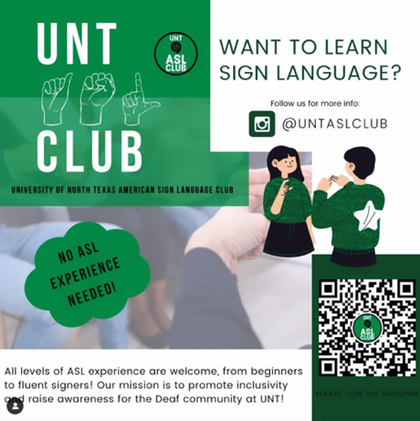
Deaf Culture Experience Option 1: Deaf event attendance: Attend two (2) Deaf Culture Events during the semester. Pick any 2 from the following:
ASL Club Meetings – dates and times listed in schedule. A full, 1 page, 12-point font reflection paper will be due at the end of event. Contact information: officialuntaslclub@gmail.com
Deaf Coffee Chat – Zera Coffee House in Denton. 1st and 3rd Saturdays of the month. 7:00 to 11:00 PM. 420 E. McKinney St, Denton.
Other local/regional Deaf events announced by your instructor. I.e. the Deaf Night Out (DNO) events which occur monthly in the DFW area.
Virtual workshops listed below and also shared by your instructor.
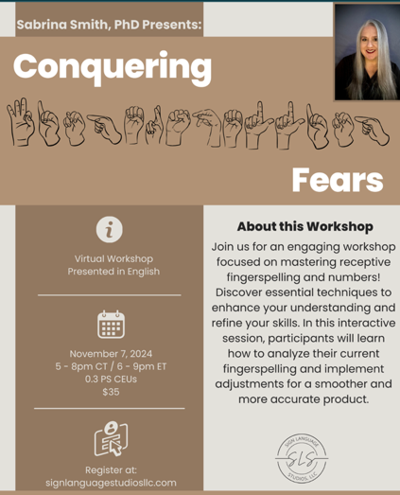
Conquering Fears Virtual Fingerspelling Workshop
Presented in English: November 7, 2024, 5-8pm CT
Workshop Description: Join us for an engaging workshop focused on mastering receptive fingerspelling and numbers! Discover essential techniques to enhance your understanding and refine your skills. In this interactive session, participants will learn how to analyze their current fingerspelling and implement adjustments for a smoother and more accurate product.
Certificate of completion is required to earn credit. Certificate must have name and date of completion to earn credit.

National Deaf Center OnDemand Learning
Certificate of completion is required to earn credit. Certificate must have name and date of completion to earn credit.
Click to register: Deaf 101; Attitudes and Biases as Barriers for Deaf People
Click to register: Building Relationships with Deaf Communities:
Click to register: Introduction to Interpreting Services
Events must be submitted by the due date or credit will not be given. See schedule for details.
Deaf Culture experience option 2: Self-Paced book study: Choose one (1) book study from the options provided by Sign Language Studios, LLC (SLS).
- Sign up and purchase the book study guide/questions. $75 fee
- Order/purchase the book. Prices vary.
- Submit SLS study guide purchase confirmation by the Deaf Culture Experience 1 assignment due date prior to midterms. 100 points for this assignment
- Read the book
- Answer the study guide questions
- Submit the study guide to SLS at least two weeks prior to the Deaf culture experience 2 assignment near the end of the semester.
- Get a certificate of completion from SLS prior to the Deaf Culture Experience 2 and submit it as an attachment to the assignment by the assignment due date. 100 points for this assignment.
SELF-PACED BOOK STUDIES ***If you choose the book study, no additional Deaf events are required.
!!!Certificate of completion must be submitted by Deaf Culture Experience 2 assignment due date. See Schedule for details!!!
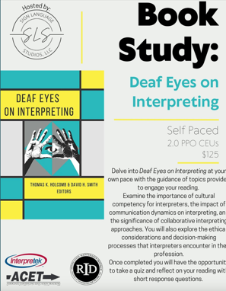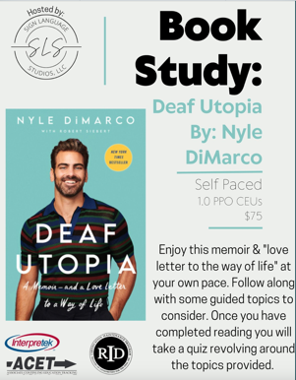

Course Schedule: Calendar is subject to change depending on what is covered in class.

Week# | Class dates | SN units/lessons/skills | Assignments due
1 | Mon 8/18  Wed 8/20  Fri 8/22 | ASL I review : SN units 1-3  ASL II review : SN units 4 and 5  Deaf Culture pre-lesson : DPN! Documentary and discussion around audism. | Fri 8/22  -Have Signing Naturally Online Student Materials purchased by now.  HW: DPN! Questions answered on Canvas.
2 | Mon 8/25  Wed 8/27  Fri 8/29 | Unit 7 Lesson 1 : Classifiers and identifying present people  Unit 7 lesson 4: Describing personal items  Unit 7 lesson 5: Translating sentences with “have”  Unit 7 lesson 7: Numbers: asking HOW-MANY? | Fri 8/29  HW: SN 7.1, 7.4, 7.5 and 7.7
3 | Mon 9/1  Wed 9/3  Fri 9/5 | 9/1: Labor day holiday  Unit 7 Lesson 6: Translating sentences with DRIVE-TO, TAKE, PICK-UP.  Unit 7 lesson 8: Describing lost items  Deaf Culture: Art Kruger-Deaf sports and the AAAD. | Fri 9/5  HW: SN 7.6, 7.8, 7.13  -Inform instructor of Deaf Culture requirement choice. 2 events or 1 book study.
4 | Mon 9/8  Wed 9/10  Fri 9/12 | Unit 7 Lesson 9: Numbers: Telling the year  Unit 7 lesson 10: Translating sentences with “have” 2  Unit 7 lesson 11: Culture: Greetings and leave-takings  Unit 7 lesson 13: Comprehension: The Family Portrait | Fri 9/12  Attendance/participation grade 1 submitted by instructor(weeks 1-4)  HW: SN 7.10, 7.11
5 | Mon 9/15  Wed 9/17  Fri 9/19 | Unit 7 receptive exam: Describing people and things.  Unit 8 lesson 1: Making requests  Unit 8 lesson 2: Fingerspelling: months  Unit 8 lesson 6: Numbers: phone numbers  Culture: Minimizing interruptions:Unit 8 lesson 13 | Mon 9/15  Unit 7 receptive exam in class.  Fri 9/19  HW: SN 8.1, 8.2, 8.6
6 | Mon 9/22  Wed 9/24  Fri 9/26 | Unit 8 lesson 3: Agreement verbs  Unit 8 lesson 4: Agreeing with conditions  Unit 8 lesson 5: Negations 1  Culture: Nathie Marbury | Fri 9/26  HW: SN 8.4, 8.5
7 | Mon 9/29  Wed 10/1  Fri 10/3 | Unit 8 lesson 7: Asking for Advice 1  Unit 8 lesson 11: Negations 2  Culture: Name Signs in the Deaf-World: Unit 8 lesson 14 | Fri 10/3  HW: SN 8.7, 8.11, 8.14
8 | Mon 10/6  Wed 10/8  Fri 10/10 | Unit 8 lesson 8: Asking for a sign  Unit 8 review: Making requests and asking for advice.  ASL III miderm expressive exam (skills learned in units 7 and 8)  Culture: Deaf Culture 1 requirement | Fri 10/10  Mid point of term  ASL III midterm expressive exam due on Canvas today  HW: SN 8.8  -Deaf Culture1 requirement due:  *Deaf event 1 report  Or  *Book Study registration evidence.  -Attendance/participation 2 scores submitted by instructor(Weeks 5-8)
9 | Mon 10/13  Wed 10/15  Fri 10/17 | Unit 8 lesson 9: Agreement verbs 2  Unit 8 lesson 10: Asking for Advice 2  Unit 8 lesson 12: Comprehension: The Candy Bar  Deaf Culture: | Fri 10/17  HW: SN 8.9, 8.10, 8.12
10 | Mon 10/20  Wed 10/22  Fri 10/24 | Unit 8 review  Unit 8 receptive exam in class.  Unit 9 Lesson 1 :Discussing neighborhoods | Wednesday 10/22  Unit 8 receptive exam in class.  Fri 10/24  HW: Unit 8 self-assessment, SN 9.1,
11 | Mon 10/27  Wed 10/29  Fri 10/31 | Unit 9 Lesson 2 : Places in the neighborhood  Unit 9 Lesson 3 :Numbers: Giving the time 1  Unit 9 lesson 4: Describing your neighborhood  Unit 9 Lesson 5 : Giving directions: Next to, across from. | Fri 10/31  HW: SN 9.3, 9.4, 9.5,
12 | Mon 11/3  Wed 11/5  Fri 11/7 | Unit 9 Lesson 6 : Yes/no Questions 1  Unit 9 lesson 8: Giving directions: Where to turn  Unit 9 Lesson 7 : Describing a restaurant  Unit 9 Lesson 10 : Suggesting a place to eat  Deaf Culture: ASL number stories | Fri 11/7  HW: SN 9.6, 9.10, 9.7  -Attendance/participation 3 scores submitted by instructor(Weeks 9-12)
13 | Mon 11/10  Wed 11/12  Fri 11/14 | Unit 9 Lesson 9 : Numbers: Giving the time 2  Unit 9 lesson 12: Yes/no questions 2  Unit 9 Lesson 11 : Giving directions: perspective shift  Unit 9 Lesson 14 : Comprehension: Stop the Traffic  Unit 9 review and self-assessment  Deaf Culture: Eric Malzkuhn  Unit 9 Lesson 13: Keeping others informed | Fri 11/14  HW: SN 9.9, 9.11
14 | Mon 11/17  Wed 11/19  Fri 11/21 | Unit 9 comprehension: Partner assessment activity in-class  Deaf Culture: Sound and Fury | Mon 11/17  Unit 9 comprehension: Partner assessment activity in-class (Canvas scored assignment)  Fri 11/21 HW: Sound and Fury DCMP workshop certificate of completion due.
Vac | 11/24-11/28 | Thanksgiving break
15 | Mon 12/1  Wed 12/3  Fri 12/5 No class | Final Expressive project preparation and peer critique. | Fri 12/5  -Deaf Culture 2 requirement due:  *Deaf event 2 report  Or  *Book Study certificate of completion.  -Attendance/participation 4 scores submitted by instructor(Weeks 13-15)
Finals | Mon 12/8 | Final expressive project/exam | Mon 12/8:  Final expressive project/exam due on Canvas

