
CHEM 1410.003: General Chemistry 1
Chemistry For Science Majors
Dr. Peter VanNatta
Spring 2026 Syllabus
Location: CHEM 109
M/W/F, 11:00 – 11:50am

Recitation:
Location: GAB 104
W, 2:00 – 2:50pm
University of North Texas

Welcome to General Chemistry 1

Introduction
Table of Contents
Required Material 2
Schedule 3
How to Succeed 4
Format of Class 5
Grades & Assessment 6
Bio & Contact 9
University Policies 10

Contact Information
Dr. Peter VanNatta
peter.vannatta@unt.edu
Office: CHEM 112a (NMR Lab)

Drop-in Hours:
M/W/F, 12 pm – 1 pm
Other times by request

This is the first of a two-semester sequence of general chemistry for science majors, intended to introduce you to the foundations of chemistry. The material is presented in what’s referred to as an atoms first approach, which means that we begin by talking about the parts of the atom, then how they join together to create molecules, then what kind of reactions the molecules can go through. It is a gradual building up of the information that you need to understand the next topic, hopefully told in a coherent story. We approach problems in both a qualitative and quantitative manner, so math skills (basic arithmetic, algebra, and calculator skills) are a must!

Student Learning Objectives
By the end of the semester, you should be able to:
- Explain atomic structure and behavior on both the microscale and macroscale levels.
- Use particulate-level behavior to predict and explain macroscopic behavior.
- Use molecular structure to predict and explain reactions.
- Apply tools and skills in solving chemical problems.
- Critically assess chemical problems.
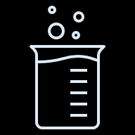

The goal for this semester is for every student to develop an intuition for the complexity of chemistry, as well as improve ther understanding of how to think like a scientist, specifically as it applies to critically thinking about the information that you are given and problem-solving skills. This can be frustrating at times, but we will have a lot of resources available to help you do so.
Good study habits will be essential to success. Logic and critical thinking will be necessary to solve various problems presented in line with the ACS curriculum guidelines. Many resources are available to assist students, including help-centers, departmental tutors, and Instructor/TA weekly office hours.

Required Material

TEXT:
Chemistry, Atoms First, 2nd Ed.

OpenStax book, so freely available! Can also download a PDF for offline-access

HOMEWORK System:
Doing homework on a continual basis is extremely important for checking your understanding and keeping up-to-date.
Homework will be assigned through Canvas, and due every Sunday night. Make sure that you are working on it a little bit every day, or every other day!

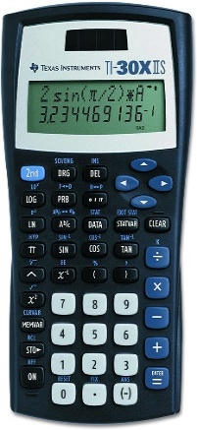
CALCULATOR:
Preferred: Texas Instruments TI-30XII Scientific Calculator
- Cost - less than $20
- Bring calculator to every class.
- Practice using your calculator
- Any scientific calculator is fine

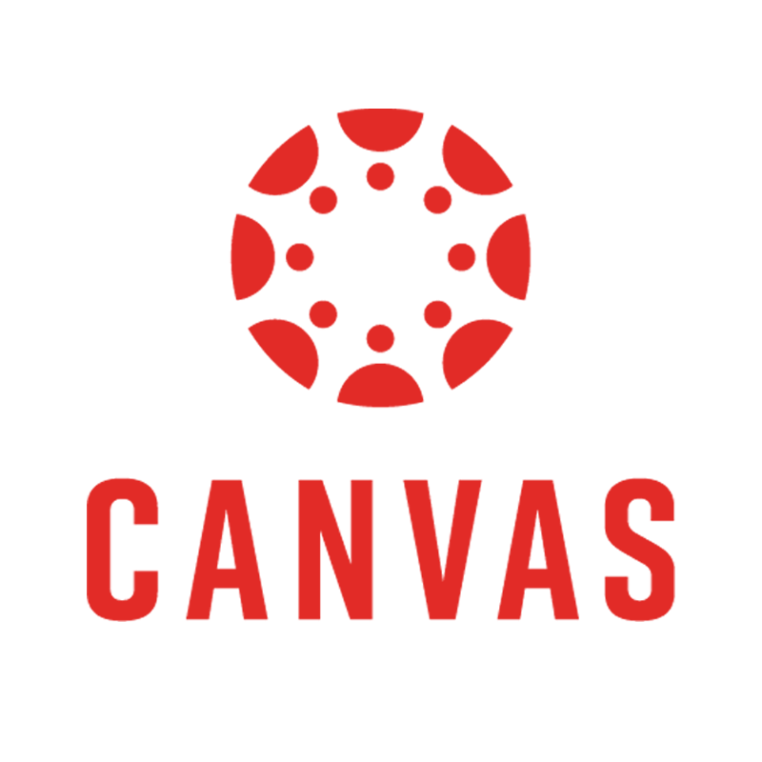

OTHER Apps For Class
- Canvas Learning Management System (LMS)
- iClicker (bring an internet-capable device)


Tentative Course Calendar
Chapter | Title | Approx. Start Date
1 | Chemistry: The Science of Change | 1/12
 | Welcome, Syllabus, Course Expectations | 1/12
 | Phases and Classification of Matter  Physical and Chemical Properties | 1/14
 | Measurements  Uncertainty, Accuracy, Precision  Mathematical Treatment of Measurement Results | 1/16
2 | Atoms and the Periodic Table | 1/21
 | Evolution of Atomic Theory | 1/21
 | Atomic Structure and Symbolism | 1/23
 | Chemical Formulas | 1/26
3 | Quantum Theory and the Electronic Structure of Atoms | 1/28
 | Electromagnetic Energy, Bohr Model | 1/28
 | Development of Quantum Theory | 1/30
 | Electronic Structure of Atoms | 2/2
 | Periodic Variations in Element Properties | 2/4
 | Ionic and Molecular Compounds | 2/6
 | Exam 1 – 2/9 | 2/9
4 | Chemical Bonding and Molecular Geometry | 2/11
 | Ionic Bonding, Covalent Bonding and Electronegativity | 2/11
 | Chemical Nomenclature | 2/13
 | Lewis Symbols and Structures | 2/16
 | Formal Charges and Resonance | 2/18
 | Molecular Structure and Polarity | 2/20
5 | Advanced Theories of Bonding | 2/23
 | Atomic Orbitals and Valence Bond Theory | 2/23
 | Hybridization and Multiple Bonds | 2/25
 | Molecular Orbital Theory | 2/27
6 | Composition of Substances and Solutions | 3/2
 | Formula Mass, Empirical and Molecular Formulas | 3/2
 | Molarity and other Concentration Units | 3/4
 | Exam 2 – 3/6 | 3/6
7 | Chemical Reactions | 3/15
 | Writing and Balancing Chemical Reactions | 3/17
 | Classifying Chemical Reactions and Reaction Stoichiometry | 3/21
 | Reaction Yields and Quantitative Analysis | 3/24
8 | Gases | 3/26
 | Gas Pressure and Gas Laws | 3/26
 | The Ideal Gas Law | 3/28
 | Stoichiometry of Gas-Phase Reactions | 3/31
 | Effusion and Diffusion of Gases | 4
 | Kinetic Molecular Theory | 3/27
 | Deviation from the Ideal | 3/30
 | Exam 3 – 4/1 | 4/1
9 | Thermochemistry | 4/3
 | Energy Basics and Calorimetry | 4/3
 | Enthalpy | 4/6
 | Strengths of Ionic and Covalent Bonds | 4/8
10 | Liquids and Solids | 4/8
 | Intermolecular Forces and Properties of Liquids | 4/10
 | Phase Transitions and Phase Diagrams | 4/13
 | Solid State and Crystals | 4/15
11 | Solutions and Colloids | 4/17
 | Dissolution Process and Electrolytes | 4/20
 | Electrolytes | 4/22
 | Solubility and Colligative Properties | 4/24
 | Exam 4 – 4/27 | 4/27
12 | Review for final exam | 4/29
 | Final Exam – 5/4 | 5/4

January 16th – MLK Jr. Day, university closed
March 9th – 13th – Spring Break, university closed
April 29th – Last day of class
Check http://calendar.unt.edu/event-calendar/Academics for other important dates!

I reserve the right to change or modify the syllabus at any time. If changes are made, students will be notified during scheduled class times and the revised syllabus will be made available on Canvas.

Teaching Assistants (TAs)

Matthew Breuer
Office: CHEM 115
Drop-in hours: 2:00 – 3:00 pm Tuesdays and 11:00 am – 12:00 pm Thursdays
Email: MatthewBreuer@my.unt.edu

The TAs are here to help with the logistics of the class, as well as provide help to you outside of the lecture and recitation. You can attend their drop-in hours as well to ask questions about the material, of what it’s like to be a graduate student in chemistry!

How To Succeed in General Chemistry
- Follow the study cycle. It has been proven to work!

- Attend PLTL – they have tips to tackling my tricky questions.

- Do lots of practice problems. They will show what you do and don’t know.

- Schedule tutoring sessions as early as possible.

Tips to succeed
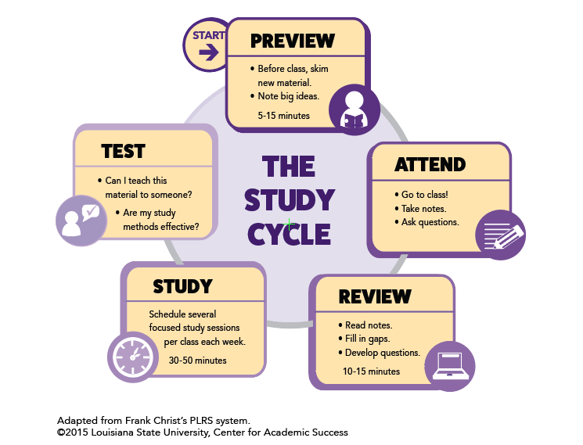

Peer-Led Team Learning (PLTL)
We have a program called PLTL (Peer-Led Team Learning) that is available for this section. You sign up and agree to attend weekly meetings with a group from your class, led by a PLTL leader. This meeting is 90 minutes, once a week. More information about this program will be given in class and can be found on Canvas. This session is NOT intended to be a tutoring session.

Tutoring Center
We have a tutoring center in the Chemistry building, the Chemistry Resource Center (CRC), room 231. It is staffed by Chemistry graduate students and they are available for drop-in tutoring. The Learning Center in Sage Hall also has a tutoring center, with drop-in, appointments, or even online tutoring available. See this link for schedules: https://chemistry.unt.edu/undergraduate-program/instructional-resources
Don’t wait to get help. Tutoring is most effective when it is started early.

Format of the Class
Because learning can be challenging, we will be using a more active and student-centered approach to learning. Although we have more traditional stadium seating, I still expect that you will be engaged with the material by answering questions, working problems, taking notes, and discussing topics. We will use simulations, iClicker response questions, and group discussions. Your peers around you and in your recitation group will be the first place you can turn to ask questions or verify your knowledge of the topics we are discussing! I ask questions during class and will wait for responses. Even wrong answers are okay! It helps me know where you are at in the discussion.

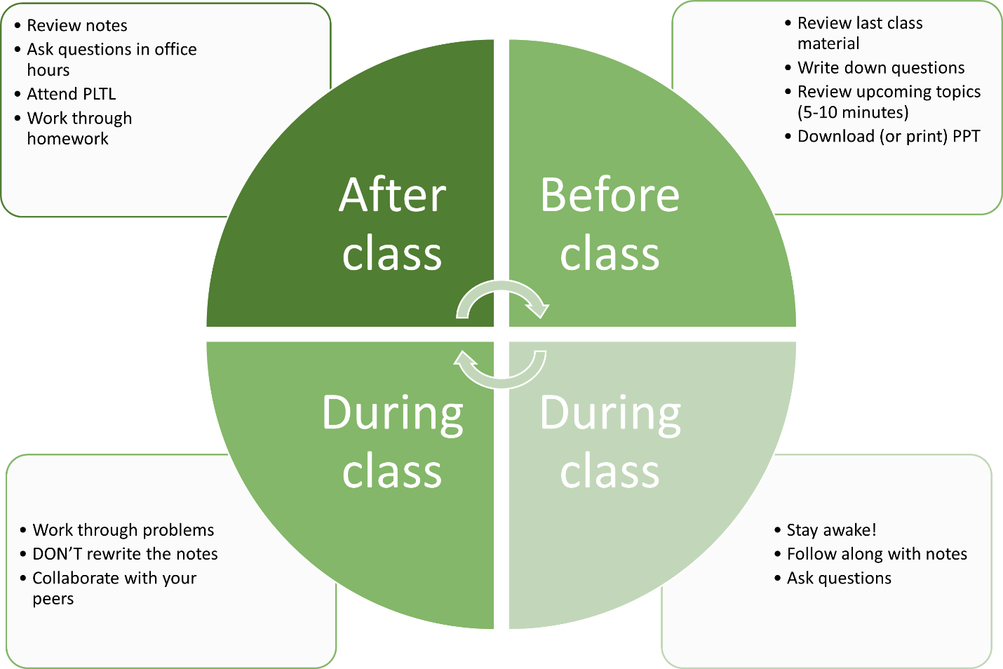

Recitation
Attendance at the recitation hour is required! There will be a group assignment, to be turned in at the end of the recitation period (or as otherwise instructed). This is a time for you to work on problems, as chemistry is a quantitative science. This is not the time for working on homework, material for other classes, or a social hour.

Grades and Assessment

Measuring Success in This Course
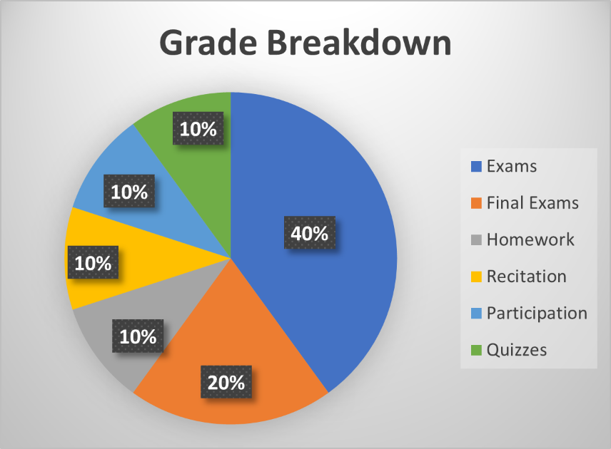

100.0% - 90.0% possible points – A
89.9% - 80.0% possible points – B
79.9% - 70.0% possible points – C
69.9% - 60.0% possible points – D
59.9% - 0.0% possible points – F

There may be extra credit offered throughout the semester, at the discretion of the instructor. Extra credit will not be offered after May 4th, so do not ask!
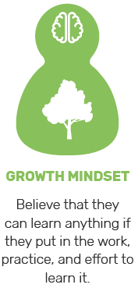
Homework: Doing problems on a continual basis is extremely important for checking your understanding and keeping up-to-date.
Homework will be assigned through Canvas. Other sources, including recitation worksheets, will be used for additional practice. The nature of many chemistry problems requires that solutions be written out in detail. It is important to show complete solutions, including set-up, units, and correct use of significant figures, not just final answers.


Quizzes: There will be a weekly quiz, given at the end of recitation every Wednesday. If the university is closed that Wednesday for whatever reason, there will be no quiz that week.
Quizzes will check your mastery of concepts and skills and generally reflect attendance and the effort put forth in the mastery assessment. If you are doing poorly on quizzes, it is likely that you will do poorly on the exams unless something changes quickly. Use low quiz grades as a warning. Try working some extra problems from the text – and ask for help.


Exams: There will be FOUR 50-minute exams that are comprised of 20 multiple choice questions. Each exam will have 100 points possible. Your average will be calculated after dropping the lowest hourly exam grade. If a student receives a “0” because of cheating, that grade cannot be used as the dropped grade.
All quizzes and exams must be taken as scheduled. All exams must be taken at the regularly scheduled times. Exams cannot be taken outside the scheduled time. There will not be any makeup exams. A missed exam will count as your dropped test (unless there is a well-documented serious illness, requiring hospitalization).

Exam 1 (100 points) – February 9th
Exam 2 (100 points) – March 6th
Exam 3 (100 points) – April 1st
Exam 4 (100 points) – April 27th
Final Exam (200 points) – Thursday, May 4th, 10:00 am to 12:00 pm

PLAN ACCORDINGLY FOR THE TEST DATES!

Midterm exams will be administered in-class, during the regularly scheduled lecture periods. You will get plenty of notice of how the testing will be completed. Answers will be recorded on scantron ‘bubble sheets’. You are expected to bring the following items to each exam: a writing utensil (preferably a #2 pencil with a good eraser) and a scientific calculator. Cell phones, tablets, laptop computers, programmable calculators, or other electronic devices will NOT be allowed! Scratch paper will be provided.

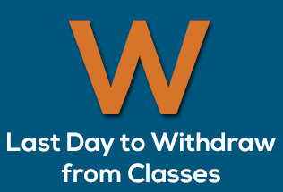
WITHDRAWAL DATE: The last date to withdraw from a course this term (with a “W” grade) is Friday, April 7th. In accordance with University policy, no exceptions will be made to the deadline. If you are failing the class at this point in the semester, you should strongly consider withdrawing.
You must earn a grade of at least C in CHEM 1410 in order to take CHEM 1420, and you must earn a C or better in CHEM 1420 in order to continue taking courses in chemistry.

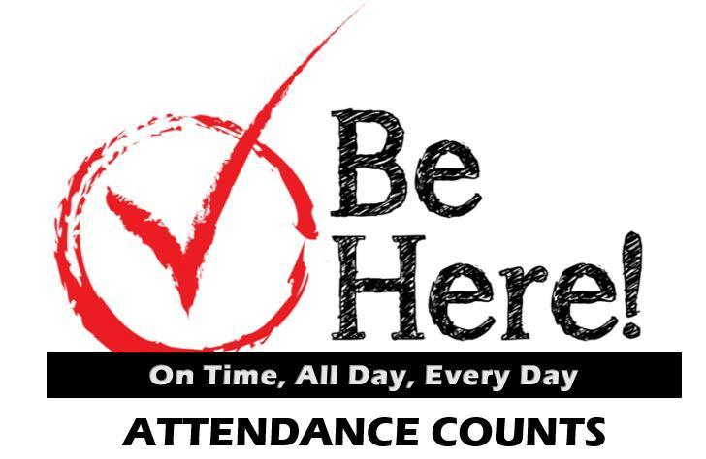
ATTENDANCE: Because class discussion and problem solving is at the heart of this course, you are required to be in class. You will check in either through Canvas or iClicker, so make sure that you bring a phone, laptop, tablet, or other WiFi-enabled device to class. In addition, participation in the course will be measured through the number of iClicker questions (presented throughout the class period) you have answered. Of course, I understand that sometimes emergencies or other unexpected circumstances arise that make attendance that day impossible. If this is the case, please talk with other students in the class to see what you missed, get copies of notes, etc. If you will be absent from a class for a university-sponsored activity, please make arrangements with me — beforehand — regarding any work you might miss.
Disruptive behavior such as talking, giggling, snoring, talking on a cell phone, playing on the Internet or texting, etc, will not be tolerated. Cell phones need to be muted during class. A student engaged in disruptive behavior can be asked to leave class immediately and can be suspended from class for a period of up to a week for the first offense, and longer if the behavior persists.
Taking photographs, video or audio recording of me or presentation materials without my explicit permission. In addition, earbuds or headphones are not allowed to be used during class time, unless you have a specific documented need for them. If this is the case, please see the Office of Disability Access (ODA) to ensure that the appropriate paperwork has been filed. https://studentaffairs.unt.edu/office-disability-access

Other Notes

By university regulations, a grade of “I” (Incomplete) cannot be given as a substitute for a failing grade in a course.

CHEM 1430 is the laboratory course and a separate course from CHEM 1410. Students will receive separate grades for the two courses. Dropping either course does NOT automatically drop you from the other course.

Regarding dissemination of information, I exclusively use Canvas to email the entire class with reminders of deadlines, changes to classroom policies, etc. In addition, I post the lecture notes and grades on Canvas. Please make it a habit to check Canvas (and your email) at least twice a week.

I will not respond to email received from non-UNT email addresses, especially concerning grade information. With a personal email address, I cannot be certain that it is you on the other end. As such, please use your official UNT email address to email me. But I welcome emails at any time!

Other University Policies

ACADEMIC DISHONESTY Students caught cheating or plagiarizing will receive a "0" for that particular assignment or exam. Additionally, the incident will be reported to the Dean of Students, who may impose further penalty. According to the UNT catalog, the term "cheating" includes, but is not limited to: a. use of any unauthorized assistance in taking quizzes, tests, or examinations; b. dependence upon the aid of sources beyond those authorized by the instructor in writing papers, preparing reports, solving problems, or carrying out other assignments; c. the acquisition, without permission, of tests or other academic material belonging to a faculty or staff member of the university; d. dual submission of a paper or project, or resubmission of a paper or project to a different class without express permission from the instructor(s); or e. any other act designed to give a student an unfair advantage. The term "plagiarism" includes, but is not limited to: a. the knowing or negligent use by paraphrase or direct quotation of the published or unpublished work of another person without full and clear acknowledgment; and b. the knowing or negligent unacknowledged use of materials prepared by another person or agency engaged in the selling of term papers or other academic materials.
ACCEPTABLE STUDENT BEHAVIOR Student behavior that interferes with an instructor’s ability to conduct a class or other students' opportunity to learn is unacceptable and disruptive and will not be tolerated in any instructional forum at UNT. Students engaging in unacceptable behavior will be directed to leave the classroom and the instructor may refer the student to the Dean of Students to consider whether the student's conduct violated the Code of Student Conduct. The university's expectations for student conduct apply to all instructional forums, including university and electronic classroom, labs, discussion groups, field trips, etc. The Code of Student Conduct can be found at http://deanofstudents.unt.edu.
ADA STATEMENT The University of North Texas makes reasonable academic accommodation for students with disabilities. Students seeking accommodation must first register with the Office of Disability Accommodation (ODA) to verify their eligibility. If a disability is verified, the ODA will provide you with an accommodation letter to be delivered to faculty to begin a private discussion regarding your specific needs in a course. You may request accommodations at any time, however, ODA notices of accommodation should be provided as early as possible in the semester to avoid any delay in implementation. Note that students must obtain a new letter of accommodation for every semester and must meet with each faculty member prior to implementation in each class. For additional information see the Office of Disability Accommodation website at http://disability.unt.edu. You may also contact them by phone at (940) 565-4323.
EMERGENCY NOTIFICATION & PROCEDURES UNT uses a system called Eagle Alert to quickly notify you with critical information in the event of an emergency (i.e., severe weather, campus closing, and health and public safety emergencies like chemical spills, fires, or violence). The system sends voice messages (and text messages upon permission) to the phones of all active faculty staff, and students. Please make certain to update your phone numbers at http://www.my.unt.edu. Some helpful emergency preparedness actions include: 1) know the evacuation routes and severe weather shelter areas in the buildings where your classes are held, 2) determine how you will contact family and friends if phones are temporarily unavailable, and 3) identify where you will go if you need to evacuate the Denton area suddenly. In the event of a university closure, please refer to Canvas for contingency plans for covering course materials.

RETENTION OF STUDENT RECORDS Student records pertaining to this course are maintained in a secure location by the instructor of record. All records such as exams, answer sheets (with keys), and written papers submitted during the duration of the course are kept for at least one calendar year after course completion. Course work completed via the Canvas online system, including grading information and comments, is also stored in a safe electronic environment for one year. You have a right to view your individual record; however, information about your records will not be divulged to other individuals without the proper written consent. You are encouraged to review the Public Information Policy and the Family Educational Rights and Privacy Act (FERPA) laws and the university’s policy in accordance with those mandates at the following link: http://essc.unt.edu/registrar/ferpa.html

STUDENT PERCEPTION OF TEACHING (SPOT) Student feedback is important and an essential part of participation in this course. The Student Perception of Teaching (SPOT) is a requirement for all organized classes at UNT. This short survey will be made available at the end of the semester to provide you with an opportunity to evaluate how this course is taught.

SUCCEED AT UNT UNT endeavors to offer you a high-quality education and to provide a supportive environment to help you learn and grown. And, as a faculty member, I am committed to helping you be successful as a student. Here’s how to succeed at UNT: Show up. Find Support. Get advised. Be prepared. Get involved. Stay focused. To learn more about campus resources and information on how you can achieve success, go to http://success.unt.edu/

HEALTH AND WELLNESS SUPPORT: UNT and the Chemistry Department care about your health and wellness. Below you will find some of our campus-based, local, and national resources for health and mental health support. These services can be used for you or to help you support a friend. As this list is not exhaustive, please visit https://studentaffairs.unt.edu/push/unt-resources for more information and additional resources on health and wellness.

Counseling and Testing Services  https://studentaffairs.unt.edu/counseling-and-testing-services | Health and Wellness Center  https://studentaffairs.unt.edu/student-health-and-wellness-center
UNT Police  https://police.unt.edu/ | Substance Abuse Center  https://studentaffairs.unt.edu/rise/programs/sure-program
UNT Food Pantry
https://studentaffairs.unt.edu/food-pantry
National Suicide Prevention Lifeline (includes Veteran support services)  1-800-273-TALK | Trevor Project/LGBTQ Support  866-488-7386

Commitment to Respect for All:
As members of the UNT community, we have all made a commitment to be part of an institution that respects and values the identities of the students and employees with whom we interact. UNT does not tolerate identity-based discrimination, harassment, and retaliation so we will work as a class to collaborate in ways that encourage inclusivity. We view diversity as encompassing the intersecting identities that make us unique individuals, including (but not limited to) ethnic/racial identity, nationality, sexual and LGBTQ+ identity, gender identity and expression, age, religious/spiritual beliefs, socioeconomic status, body shape/size, physical ability status, and varying points of view.

