University of North Texas
History Department

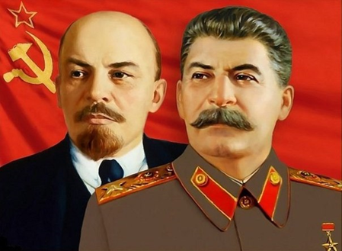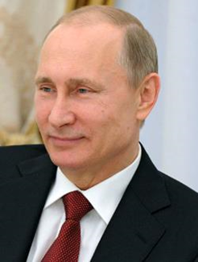

HIST 4060-001 Russia in the 20th and 21st centuries

Office Hours: Wednesday 4.50 – 5.50 pm, or by appointment at WH 237.
Prof. Olga Velikanova E-mail: Velikanova@unt.edu

This lecture face-to-face course surveys the social, political and cultural history of the Soviet and modern Russia presented by a professor who lived half of her life under socialism. Socialist experiment will be presented as an alternative way to modernity. The course will emphasize the developments of Stalinism, based on the modern approaches of Western and Russian historiography and new revelations from the Russian archives. We‘ll critically analyze various sources of information – political documents, propaganda texts and images, and intelligence reports. In this class, we’ll discuss the interrelations of government, individual personality and social forces in defining the historical process. The course is multi-media based: we will draw not only on the text, books and documents but on fiction literature, paintings and movies. Besides in-class Lectures you find studying materials - PowerPoint presentations, links to the movies, articles, and instructions - on the Canvas.
Learning Objectives of the course are: to develop students’ ability of historical thinking, i.e. to understand the meaning of the events, their causes and effects, in variety of contexts. Students will be able to read historical and political texts critically, convey their ideas in written and oral form, and articulate coherent argumentation well-supported with historical evidence.
The experience of other countries does offer some important lessons. At the end of this course, students should be able 1. Identify the origins, influences, and limits of one’s own cultural heritage. 2. Demonstrate the ability to learn from and empathize with perspectives and experiences different from one’s own. 3. Describe the impacts of complex, worldwide systems. By studying a civilization different from their own, students will learn the language of global mutual understanding and enhance the ability to engage effectively in regional, national, and global communities crucial in our modern world. In addition to learning Russian history, this course will significantly improve students’ intercultural competence and creative, analytical skills that will benefit all of their endeavors throughout their life, especially critical thinking.

Required Textbook and reading:

P. Kenez, A History of the Soviet Union from the Beginning to its Legacy, 3 ed.

M. Bulgakov: Heart of a Dog (a satire on a New Soviet Person)(bookstore or online)
http://www.lib.ru/BULGAKOW/dogheart_engl.txt
A. Solzhenitsyn: One Day in the Life of Ivan Denisovich (Bookstore or in the library)

Storey, Writing history. Guide for students (Service desk in library, on reserve)

Further reading(optional): L.Chukovskaya: Sofia Petrovna(a novel about everyday life during the Great Terror of the 1930s); David Benioff: City of Thieves (adventures of two boys during the siege of Leningrad 1941-1944)

Requirements:
You must read the required readings in advance. Students are expected to attend class meetings regularly and to abide by the attendance policy established for the course. It is important that you communicate with the professor before being absent, or if you cannot attend class meetings because you are ill, so you and the professor can discuss and mitigate the impact of the absence on your attainment of course learning goals. Non-reporting to the instructor about the reasons of your absence may impact your grade.
Cell phones must be switched off during the session. Respecting the learning environment, do not text; use your computer only to take notes related to the class. When you have short questions, do not hesitate to come to me after the lecture; for consultations, you are welcome to come to office hours at 4.50 on Wednesday or by appointment to WH 237.
Evaluation. See dates on Canvas (in the Modules) :
Mid-term exam (27%) online
Final Exam (28%), TBA, online
Bibliography for essay (4-5 sources), Title and thesis - 3 %. See Bibliography in our textbook, and the List of topics handout on Canvas
Discussions* (two) 4+4 =8 %
Film screening mini-essay 3 % and Board game Queue playing: 3 %.
Attendance and participation 8%
Research Essay 20%: 5 double space pages plus bibliography. The essay should consist of an introduction, body and conclusion, presenting an argument and supporting evidence. Read the Writing Guide on library reserve! See Topics and Rubrics on Canvas. Students will be given further instructions in advance.
You can get bonus points by participating in the UNT guest lectures and special events announced in the class. A special assignment option on “Why did the USSR win in World War II” (oral presentation in class with outline instead of essay) is possible (discuss with instructor ASAP).
UNT’s grading system uses the letters A (>90), B(>80), C(>70), D(>60), F(<60)%.
*Group discussions in class: Students select and discuss one question (See questions on Canvas), join the respective group on the People tab on Canvas, write a half-page draft with students’ names and quotations (template/handout on Canvas, hard copy is given in the class) and elect two-three presenters who make a 5-minute presentation in class. Other groups/students respond with questions and comments(evaluated) and evaluate the presentation. Bring all necessary materials to answer - like notes, quotations and text of the story.

Exams (online) will cover the class lectures, all reading materials, and videos. Make-ups will be given only in the case of a true emergency, with all necessary documentation and the instructor being contacted as soon as possible. The exams will have various types of questions, including multiple choice, identifications, definitions, short answers, and chronology questions. The mid-semester exam will cover the class lectures and reading materials for the first half of the course and the end-semester exam will cover the second half of the course. Students will be given more information in advance.

Course Outline: Required reading for every week see on Canvas.
Week 1. Introduction. Historical geography. Russian Empire in the beginning of the 20th century. Crisis of Autocracy. Political parties. World War I.

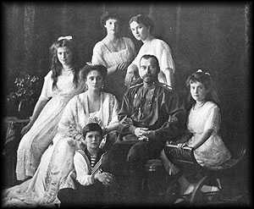The Romanov Family c.1915

Week 2. Revolutions of 1917.
Film screening. After reading the textbook, and reading the “Lecture on the Film “October” on Canvas, you watch VIDEO online
Oktiabr’(1928), by Eisenstein:
https://www.youtube.com/watch?v=YVuf3T3k-W0
Submit your analysis (1 page) to Canvas(3% value). See questions on Canvas.

Week 3. The Civil War. War Communism. Utopian Visions. What was the Russian model of socialism?

Week 4. Economy, Politics and Society in the 1920s. Economy of shortages. National policies. Start reading Bulgakov, Heart of a Dog (1926)

Week 5. Culture and Society in the 1920s. Art of Avant-Garde. The church and Bolshevik’s religious politics. Concept of a New Man.
Reading: Bulgakov, Heart of a Dog.(Discussion)
Document: Lenin’s order on shooting clergy and bourgeoisie. https://www.loc.gov/exhibits/archives/trans-ae2bkhun.html

Week 6. Stalin’s Rise to Power. Socialist offensive: Industrialization.
Collectivization.
Video in class: Documentary The Hand of Stalin. Or
The Stalin Years - Joseph Stalin Documentary 2019, up to min 1.38.(online) optional

Week 7. Socialist offensive: Cultural Revolution. Official Culture. Socialist Realism in Painting, Literature, Cinema.

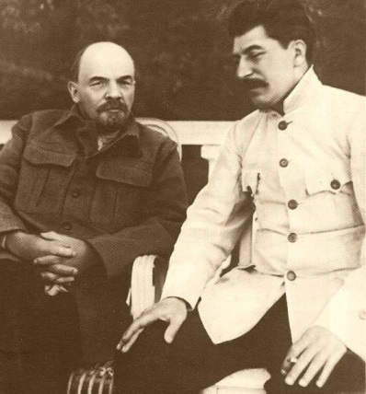 Lenin & Stalin in 1922 (fake picture – a montage)

Week 8. Beliefs and Fears. Great Terror. Video in class. Mid-term Exam

Week 9. Everyday Life in Stalin’s Russia. Conceptualizing Stalinism. Models of socialism.
- Board Game “Queue” 3 %(Food lines: Strategies of survival in economy of shortages). You play in groups of 2-5 in the Media library during this week. Write a Feedback paragraph – what did you learn? Submit to Canvas.
- Start reading A.Solzhenitsyn One Day in the Life of Ivan Denisovich

Week 10. USSR in World War II.
Special assignment option (one student) on “Why did the USSR win in World War II” (oral presentation in class with outline instead of essay) is possible (discuss with instructor ASAP). Essay bibliography due.

Week 11. WWII and Its Impact. De-Stalinization. “Thaw” Culture. Solzhenitsyn.
- A.Solzhenitsyn: One Day in the Life of Ivan Denisovich (Discussion)

Week 12. The Soviet Way of Life – the 1970-1980s. Economy, Foreign policy.
Society. Gorbachev and the End of Soviet Socialism.

Week 13. Post-Communism. Conversion to Capitalism.

Week 14. Russia in the XXI century. Putin.
Essay due

Final exam: TBA Online
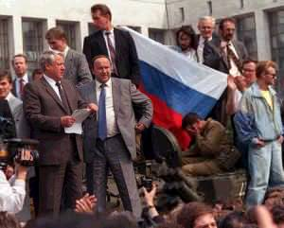B.Yeltsin on the tank in the August 1991 Coup.

UNT makes reasonable academic accommodations for students with disabilities. Students seeking accommodation must first register with the Office of Disability Access (ODA) to verify their eligibility. If a disability is verified, the ODA will provide a student with an accommodation letter to be delivered to faculty to begin a private discussion regarding one’s specific course needs. Students may request accommodations at any time, however, ODA notices of accommodation should be provided as early as possible in the semester to avoid any delay in implementation. Note that students must obtain a new letter of accommodation for every semester and must meet with each faculty member prior to implementation in each class. For additional information see the ODA website at disability.unt.edu. Tel: 940-565-4323

Emergency: UNT uses a system called Eagle Alert to quickly notify students with critical information in the event of an emergency (i.e., severe weather, campus closing, and health and public safety emergencies like chemical spills, fires, or violence). In the event of a university closure, please refer to Canvas for contingency plans for covering course materials.

Student Academic Integrity. Students are reminded that university regulations on plagiarism and cheating will be strictly enforced. These regulations are found in the University Calendar.

SPOT: The Student Evaluation of Teaching Effectiveness is a requirement for all organized classes at UNT. I consider the SPOT to be an important part of your participation in this class.

I value the many perspectives students bring to our campus. Please work with me to create a classroom culture of open communication, mutual respect, and inclusion. Disagreements and debates are encouraged and all discussions should be respectful and civil. Together, we can ensure a safe and welcoming classroom for all.

Students who attend class regularly are more likely to be successful. You should attend every class unless you have a university excused absence or you are sick. The attendance policy requires you to be actively engaged in discussions and group work (no substitution for such activities). If you must miss class, please let me know prior to your absence. A number of absences without informing me about the reasons can decrease your grade.

