Course Development Syllabus for

SOCI 1510 400 (Section) / Introduction to Sociology Online

Fall 2025

This course is 100% online. There are no class meetings and no expectations to meet online at the same time.

Instructor Information
Natalia Heringer Mendonca, PhD Candidate.
Email: natalia.heringermendonca@unt.edu (Please put "SOCI 1510.400" in the subject line); don't hesitate to contact me. Please reach out to me via UNT email or Canvas inbox.
Office Hours are Tuesdays from 10:00 am to 12:00 pm and by appointment (both in Person or via Zoom). Office location is SYMR 288M Sycamore.

TA Information: Phyllis Tiffin-White (PhyllisTiffin-White@my.unt.edu)

Communication Expectations
I will respond within 24-48 hours, except on weekends and public holidays. I am the instructor for this course, which was designed by Dr. Gregg. If you need help or have questions about the course, please email me or use the Inbox in Canvas to message me (not Dr. Gregg). When communicating in Canvas or via UNT email, please follow UNT CLEAR's Guidelines and Online Communication Tips (https://clear.unt.edu/online-communication-tips).

Required Course Materials

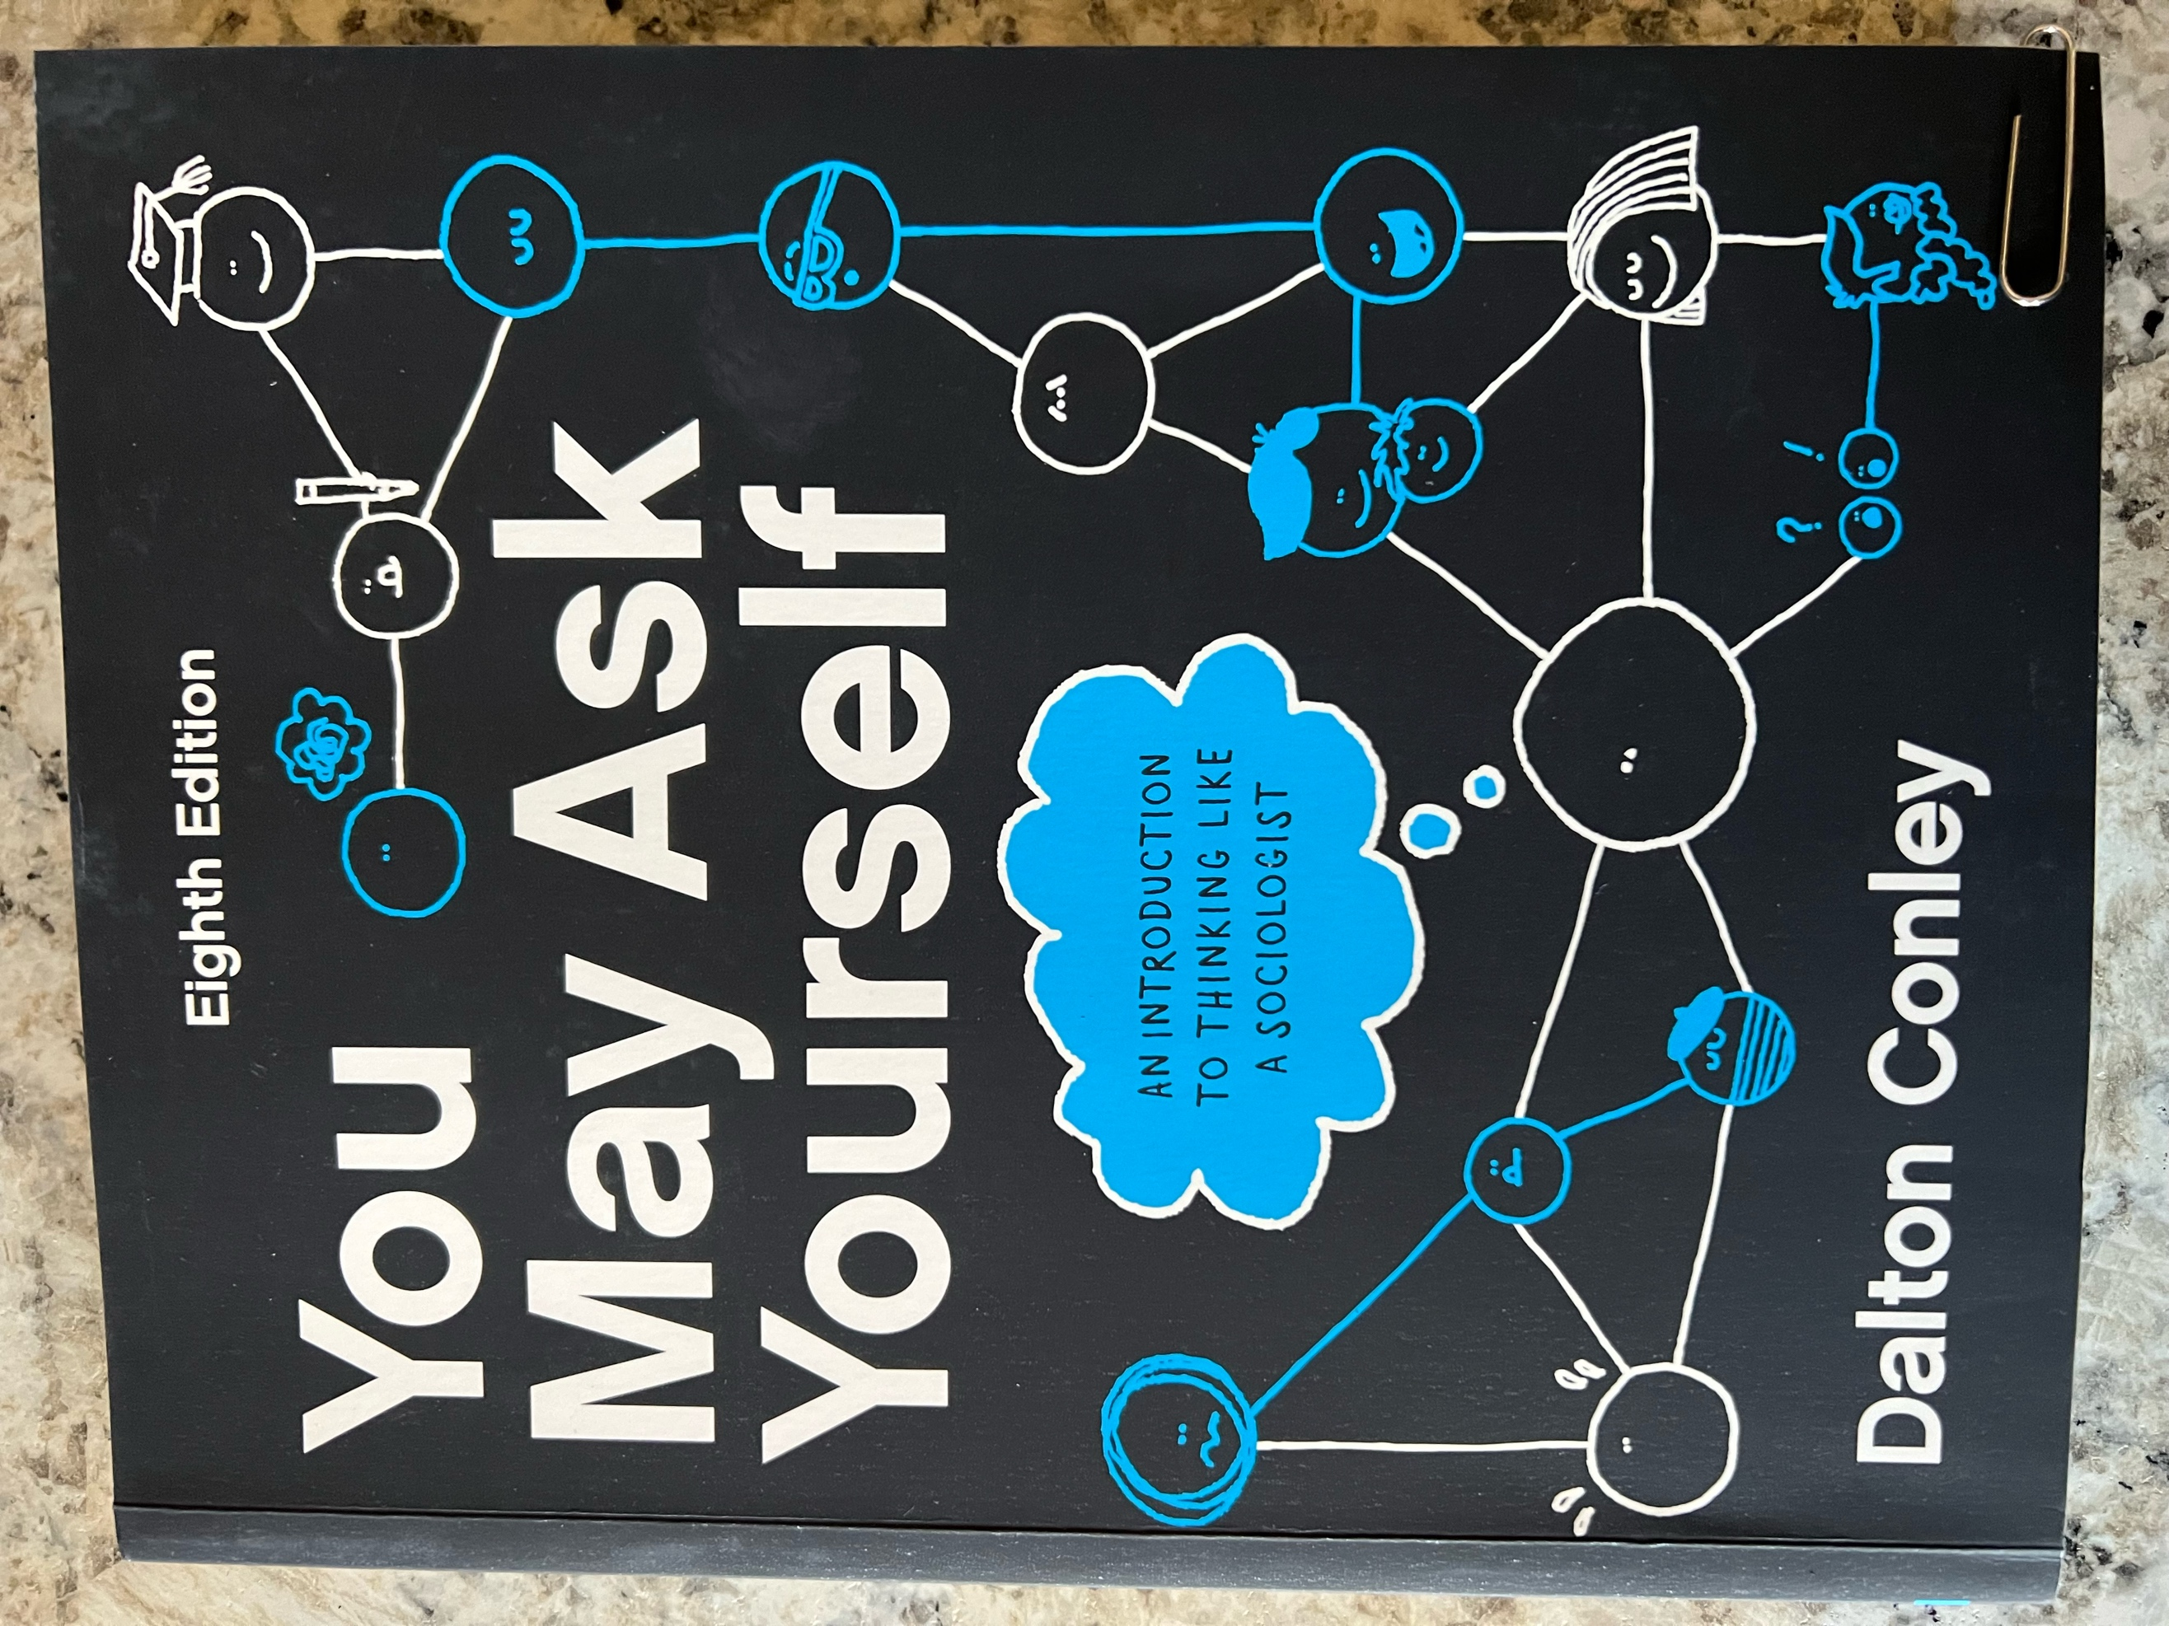

The UNT bookstore on campus should be able to help you with the required material for this course. This semester, we will be using Dalton Conley’s You May Ask Yourself, 8th Ed. (the full version) as the main text. If your book does not look like the picture above, you do not have the right book for the course. Do not use any of the earlier versions of this text for the course. ISBN for the paperback version of the 8th Ed. of this book is: 978-1-324-04425-3.

- If you choose to purchase the hard copy of this book, it comes with a registration code at the front of the book that provides access to WW Norton’s digital home page. The digital home page has resources that will enhance your learning, such as videos and animation films introducing you to each chapter.
- If you choose to purchase the online version of the book, access to the digital home page is included online.
- Here is a link to WW Norton’s digital home page for the 8th Ed. of Conley’s book: https://digital.wwnorton.com/youmayask8
- Note that WW Norton allows 21-days of free access to the online version of the book. This may be useful to students who are delayed receiving financial aid. Please know that after 21-days you will be kicked out of the online version. The expectation is that you will properly purchase the required version of this book for the semester at some point.

ODA Student Book Access Information
- Here is where you can find additional information regarding different formats WW Norton can help with: https://wwnorton.com/accessibility/alternative-formats
- The ebook for the Conley text can be very helpful for students with accessibility needs. Students can access that here on the digital landing page: https://digital.wwnorton.com/youmayask8
- Or the bookstore can order an access card that students can purchase with this ISBN for the 8th Ed. of Conley’s book: 978-1-324-06242-4

Department of Sociology
Our department features innovative research, work opportunities, and award-winning faculty widely recognized for their publications. The department’s signature strengths are in gender, race and ethnicity, medical sociology, and sociological theory.

Course Description
Social and cultural basis for human behavior; impact of societal groups and organizations on personal identity, feelings, and actions; influence on the self in relation to the family, peer groups, social classes, religion, and social institutions. Satisfies liberal arts and social sciences core social science requirements. This course is required of all sociology majors and minors.

Course Structure
This course is 100% online. There are no class meetings and there are no expectations to meet online at the same time. Students are expected to follow the expectations in the syllabus and work each week from Sunday 12:00 a.m. to Saturday 11:59 p.m. to accomplish the course objectives. Most assignments in this course are due before midnight on Saturdays. Assignments include chapter quizzes, Tests, and the following additional assignment.
- In Part 2 of the course (when we cover Chs 7-10 of Conley’s text), you will learn about different forms of inequality in society. In relation to this, students are asked to write a short paper for the purpose of UNT assessment. This short paper is called the Inequality Assignment. When the time comes, students will turn this paper in twice: 1) Once for UNT assessment; and 2) Once as an assignment to be graded in this course.

Course Objectives (Using Bloom’s Taxonomy)
By completing this course, students should be able to:
- Recall and identify terms, concepts, ideas related to studies, and sociological theories learned from the readings each week that are related to the study of society. (Quizzes – REMEMBERING)
- Recall and identify terms, concepts, ideas related to studies, and sociological theories learned in each part of the course that are related to the study of society. (Tests – REMEMBERING)
- Synthesize numerical data and apply sociological theory in order to demonstrate an understanding of social Inequality. (Inequality Assignment – ANALYZING)

Course Timeline
Deadlines are mostly due on Saturdays (11:59 pm), except for Test 2, due on Wednesday, 12/10.
Event | Date / Details
Classes Begin | Monday 8/18 – All students should check into the course!
Labor Day | Monday 9/1 (No Classes)
Syllabus Quiz | Due before midnight (11:59 p.m.) on Saturday of Week One 8/23
Chapter Quizzes | Due before midnight (11:59 p.m.) on most Saturdays
Online Tests | Test 1 (due at the end of Part 1 of the Course) on Saturday 9/27  Test 2 (due at the end of Part 3 of the Course) on Saturday 12/10
Inequality Assignment | Due at the end of Part 2 of the Course (before midnight on Saturday 11/1)
Fall Break | 11/24-11/30 (No Classes)
Pre-Finals Days | 12/3-12/4
Last Class Meeting | 12/4
Reading Day | No Classes 12/5
Semester Ends | 12/12 at midnight (11:59 p.m.)

How to Succeed in this Course
To succeed in this online course, students should log into Canvas frequently each week and pay attention to the announcements. The instructor (and TA) will provide helpful information pertaining to the course via announcements. Students should keep up with the assigned readings as listed under the heading Course Timeline and should plan to take the quizzes and complete the assignments before the due dates.

It is recommended that students NOT WAIT until Saturday to begin completing the work in this course. Although the due date for most assignments is Saturday before midnight, it is best to turn in your work during the week sometime. That way, if there is a problem with Canvas, employees of UNT are available to help you. Additionally, although the films made for this course are optional, they will enhance your learning of the chapter materials. So, to succeed in this course, please plan to watch the films in Canvas.

Late Work and Missing Work
All assignments should be submitted by the indicated dates and times embedded in the syllabus/Canvas. There will be no extensions except in cases of documented emergencies.
- In the event of a legitimate emergency, students should contact the instructor via the Inbox in Canvas to discuss their situation prior to missing an assignment.
- Each student is allowed only one documented emergency per semester.
- As stated above, in the event your emergency is very serious, the instructor will prompt you to contact the Dean of Students so that you receive a blanket excuse from the University for your work in all classes. Here is the link: https://studentaffairs.unt.edu/dean-of-students/index.html
Caitlin Edgar, MS, Student Services Coordinator, Dean of Students Office, Caitlin.edgar@unt.edu, 940-565-2648.

ADA Accommodation Statement
The University of North Texas makes reasonable academic accommodation for students with disabilities. Students seeking reasonable accommodation must first register with the Office of Disability Access (ODA) to verify their eligibility. If a disability is verified, the ODA will provide you with a reasonable accommodation letter to be delivered to faculty to begin a private discussion regarding your specific needs in a course. You may request reasonable accommodations at any time; however, ODA notices of reasonable accommodation should be provided as early as possible in the semester to avoid any delay in implementation. Note that students must obtain a new letter of reasonable accommodation for every semester and must meet with each faculty member prior to implementation in each class. Students are strongly encouraged to deliver letters of reasonable accommodation during faculty office hours or by appointment. Faculty members have the authority to ask students to discuss such letters during their designated office hours to protect the privacy of the student. For additional information, refer to the Office of Disability Access website (https://studentaffairs.unt.edu/office-disability-access). You may also contact ODA by phone at (940) 565-4323.

Supporting Your Success
UNT strives to offer you a high-quality education and a supportive environment, so you learn and grow. As a faculty member, your instructor is committed to helping you be successful as a student. To learn more about campus resources and information on how you can be successful at UNT, go to unt.edu/success and explore unt.edu/wellness. To get all your enrollment and student financial-related questions answered, go to scrappysays.unt.edu.

Statement of Inclusiveness
Every student in our class should have the right to learn and engage within an environment of respect and courtesy from others. I encourage you to review UNT’s student code of conduct so that we can all start with the same baseline civility understanding (Code of Student Conduct) (https://policy.unt.edu/policy/07-012).

Attendance and Participation
Since this is 100% an online course, students should plan to check into the course frequently during the week. Assignments are due every single week in the semester. The only week when there are no assignments planned is over the Fall or Spring Break.

Your participation online will be closely monitored and your instructor (and TA) will communicate with you frequently using the grading comments in Canvas. Please read the grading comments and alter your work based on the suggestions you see there. Note that students who are not fully engaged in the course will be reported to UNT’s CARE Team. Someone from the Dean of Students will be in contact.

Teaching Philosophy
My personal approach to teaching this course involves creating an open and engaging online atmosphere where students can broaden their perspective on the changing structure of social life and learn to develop a sociological imagination by making the familiar seem strange. This means closely examining things in society that have been previously taken for granted as “normal”.

Technical Requirements and Skills
Here is a list of the minimum technology requirements for students for this course:
- A working computer and reliable internet access are REQUIRED.
  - If your Internet fails or if your personal computer has an issue, you are expected to use the computer clusters on campus to complete your work. Students’ technology fees pay for access to working computers with reliable internet access and should be utilized when need be.
  - If it is not possible to go to campus (e.g., during the time of COVID), please find some other working computer with reliable Internet access to complete your work.
- Microsoft Office Suite
- Uploads to Canvas have been set to only accept .pdf .doc .docx files.
  - If the professor or TA cannot open your document, you will be awarded a zero and you have one week to contact them to discuss. If after one week, you have not contacted the professor or TA, the zero will stand.
- Note that Canvas does not interface well with Pages or Google Docs. Do not upload your files using these word processing systems.

Rules of Engagement
Here are some general guidelines for the way students are expected to interact with each other and with their instructor and TA in class sessions and online:
- While the freedom to express yourself is a fundamental human right, any communication that utilizes cruel and derogatory language on the basis of race, color, national origin, religion, sex, sexual orientation, gender identity, gender expression, age, disability, genetic information, veteran status, or any other characteristic protected under applicable federal or state law will not be tolerated.
- Treat your instructor and classmates with respect in any communication online or face-to-face, even when their opinion differs from your own.
- Ask for and use the correct name and pronouns for your instructor and classmates.
- Speak from personal experiences. Use “I” statements to share thoughts and feelings. Try not to speak on behalf of groups or other individual’s experiences.
- Use your critical thinking skills to challenge other people’s ideas, instead of attacking individuals.
- Avoid using all caps while communicating digitally. This may be interpreted as “YELLING!”
- Be cautious when using humor or sarcasm in emails as tone can be difficult to interpret digitally.
- Avoid using “text-talk”. This is not permitted by your instructor.
- Proofread and fact-check your sources.
- Keep in mind that online posts can be permanent, so think first before you type.
See these Engagement Guidelines (https://clear.unt.edu/online-communication-tips) for more information.

Assignments and Technical Issues

Students are responsible for knowing the Canvas environment. This means that students are responsible for their own training in Canvas. Technical problems with Canvas software are to be directed to the Help Desk 940-565-2324 / Sage Hall 330 / helpdesk@unt.edu.

Course Requirements
Below are listed the required assignments and point values for the course.
Description of Assignment | Point Value/%
Syllabus Quiz  - Due before the end of Week One | 80 /4%
Chapter Quizzes  - All 12 quizzes are Required.  - Students should not miss any of the quizzes.  - Worth up to 100 points each (12 X 100 = 1200 points) | 1200 / 60%
2 Tests  - Test 1 (Chs 1-4)  - Test 2 (Chs 12, 14, 15, 18)  - Each test is worth up to 200 points. | 400 / 20%
Part 2 Inequality Assignment  - Required of all students taking SOCI 1510 at UNT. Assignment is used for UNT assessment purposes.  - Students should upload this assignment twice in Canvas.  - Once for UNT assessment (not graded)  - Once more for this course (graded and worth up to 320 points) | 320 / 16%
TOTAL | 2000 / 100%

The Grading Scale
At the end of the semester, your grade is based on the Grading Scale.
Percent | Letter Grade
90-100% of 2000 Points | A
80-89% of 2000 Points | B
70-79% of 2000 Points | C
60-69% of 2000 Points | D
59% or less of 2000 Points | F

Course Policies
Below is a list of items that you can expect from your professor (and TA if there is one), as well as a list of items that, if you choose to stay in this course and not drop it, you are agreeing to abide by in this course. Please consider these expectations our course policies.

What you can expect from your professor and TA:
- Respect and active listening.
- Consistent grading with return time within two weeks.
- Willingness to teach, learn and answer questions.
- To be prepared each week for our class.
- To allow ample opportunity for you to do well in this course.
- To be available by appointment for additional help.
- To treat everyone equally and fairly.

What the professor and TA expect from you:
- Patience with the professor, TA, and with all others who participate in this class.
- To read the syllabus carefully each week and know what is supposed to happen. This is our contract. The professor and TA will do all that they can to abide by the syllabus, so they expect you to do the same.
- Active participation in the Canvas environment as required by the syllabus.
  - If it appears you are not actively engaged in this course, the professor and/or TA will use the UNT Care Team reporting system to make recommendations.
- To complete all assignments as they are scheduled in the Course Timeline.
- To act with academic integrity during any quizzes or tests, and in all writing. Your work should be your own. Cheating will not be tolerated! See UNT policy on academic dishonesty.
  - Do not use any form of AI to generate your assignments in this course. If you do this, your instructor will submit an academic integrity violation and report you to UNT for cheating.
- To read the grading comments that the professor and/or TA provide on all your assignments. They will incorporate tips for how to do better on future assignments.
- To use the Writing Center on campus (in Sage Hall) if you need help with writing assignments.
- To put assignments in the correct spot in Canvas. If you put things in the wrong spot, you will receive a zero (0) and your work will not be graded. If this happens, you have one week to rectify the situation with your instructor and/or TA. After that, the zero (0) will stand.
- To follow all directions in the syllabus and in Canvas for any and all course assignments. If you do not follow the directions, your grade will be substantially reduced and you may be awarded zero (0) points.
- To buy and use the correct version of the required book for the course. Right now, that is the 8th Edition of Dalton Conley’s You May Ask Yourself (full edition with 18 chapters). Do not use any other earlier version of the book for this course.
  - If you analyze something other than what everyone else is analyzing in your assignments, or if you misquote something from the book, you will receive a zero (0). This is especially important when completing the writing assignment for Part 2 of the course.
  - If the professor and/or TA happen look up something you quote from the book and it is not on the page cited, you will automatically fail the assignment and receive a zero (0) with no chance to redo the assignment.
- To buy and use the correct version of the book by Week One of the course and appropriately cite all your work when you quote. This means use quotation marks and cite the page number for your quotes.
- To be responsible for your work and prepare for and handle situations of computer and Internet difficulties. If your Internet is out, go somewhere where it is working (like the computer clusters on campus) so that you do not miss assignments. Everyone is expected to have a working computer with reliable Internet access for this course.
- To complete your work on time in the course. Everyone in the course has 7 days each week to complete the work items expected.
- To not wait until the last minute to begin your work. This means do not wait until late Saturday night to start your assignments for this course. If you aim for completing your work by Thursday of each week, if you have some technical difficulty, you’ll have time to correct it.
- To request an “Incomplete” in writing at least one week before the Final Exam Week. This request must be accompanied by documentation of the reason that the course cannot be completed before the end of the semester and will only be considered if at least 50% of course tests and assignments have been completed with a passing grade.
- To contact the professor or the TA if you find that you need additional help in this course. Visits to office hours or online meetings using a teleconferencing usually help students get on track.
- To contact the Dean of Students, Seeking Options and Solutions (S.O.S) Office, in the event of a personal emergency in your life. This includes extended illness or hospitalization, death in family, or other personal issue that hinders your possibility of success in the course. Here is the URL and the contact information for that office.
  - https://deanofstudents.unt.edu/resources/seeking-options-and-solutions



More Details about Course Assignments

Syllabus Quiz (80 Points)
In week one of the course, students are required to take an online quiz in Canvas over the Syllabus and course expectations (SylQ). The intention of this quiz is for you to demonstrate your understanding of the course requirements and expectations. If you have read the syllabus, watched the video introducing you to the course, and read the directions for all assignments, you should do very well on this quiz. This quiz is worth up to 100 points. Students are allowed 20 minutes to take the quiz and are permitted to take this quiz twice. If you do not do well the first time, revisit the information in the syllabus and try again.

Chapter Quizzes (1200 Points)
As we move through the course, we will be examining material discussed in Dalton Conley’s 8th Ed. text. Before the end of each week, students are asked to take one or more quizzes over the material assigned to read. Quizzes open on Sundays at 12:00 a.m. and close on Saturdays at 11:59 p.m. (midnight). Students have 7 days during the week to take the quiz. For this reason, no one should miss a quiz in this course. Here are more details on the quizzes.

- There are 18 chapters in Conley’s 8th Ed. text. We will only use 12 of the 18 chapters.
  - Note that we skip chapters 5, 6, 11, 13, 16, and 17.
- There are 12 quizzes over the 12 chapters we use from Conley’s text.
- Students should plan to take all 12 of the quizzes. No one should miss a quiz.
  - None of your quiz scores are dropped.
  - If you miss a quiz, the grade book will populate with a zero.
  - If you miss a quiz, you have missed the opportunity for these points in the course.
- To prepare for quizzes, students should read the chapter assigned and watch the optional video lecture(s) where the instructor explains some (but not all) of the major ideas of the chapter.
- Quizzes are open book and open notes.
- Each quiz consists of 10 multiple choice or true or false questions with only one best answer. Each question is worth 10 points.
- Each quiz is worth up to 100 points.
- Students are permitted 20 minutes and only 1 attempt at each quiz.
- Answers to the quiz questions will be released one week after the quiz falls due.
- If you think you might miss a deadline for a quiz, contact your instructor in advance of the due date and time. If you do this, extensions are routinely granted.
- Quizzes are automatically scored in Canvas.

2 Tests (200 each: 400 Points)
This course is divided up into three parts that correspond with Conley’s 8th Ed. text. At the end of Parts 1 and 3, there is a Test over the chapters covered. If you have read the chapters, watched the films, and taken the quizzes, you should do very well on the Tests.

- Test 1 -- Part 1 Chs. 1-4
- Test 2 – Part 3 Ch12, Ch14, Ch15, Ch18

Students should take all 2 tests in Canvas.

Each test is worth up to 200 points.
- As you take each Test, you will be presented with a combination of 50 true/false and/or multiple-choice questions.
- There is only one best answer for each question.
- You are permitted 1 hour (60 minutes) to take the Test. After that, your Test will automatically submit in Canvas and your grade will be recorded in the grade book.
- Any unanswered questions will be marked as incorrect.
- You are only permitted one attempt at each Test.
- Tests are open book and students can use their own notes while taking them.
- Students should not work with others when taking the Tests.
- If you need to arrange for a different date or time for one of the Tests, you must request this from your instructor at least one week in advance of the due date. If you do this, your instructor will work with you to arrange a different time.
- Helpful reminders will be sent to you in Canvas to remind you to take the Tests.
- If you miss a Test, you have missed your opportunity to earn these points in the course.
- The course is considered over after the time for Test 2 ends.

Inequality Assignment - Part 2 (320 Points)

General Explanation of Assignment
All students at UNT who take this course are required to complete the Inequality Assignment. This assignment is used for assessment purposes, but we will also use it as a graded assignment for this course. The Inequality assignment goes well with Part 2 of our course, which is all about Fault Lines…Social Divisions and Inequality. In this part of the course, we learn about stratification, gender inequality, race inequality, and poverty. This assignment culminates into a short, properly formatted paper that is 2-4 pages in length.

Students will turn this assignment in twice in Canvas:
- Once for UNT assessment purposes (ungraded, but you will earn a Complete or Incomplete grade for this submission); and again
- For this course as a graded assignment (worth 320 points).

Instructions for what and how to write are in Canvas in the Module called Part 2 Inequality Assignment. Students will find two documents with instructions for this assignment in Canvas. Please follow the instructions called Dr. Gregg’s Instructions_Inequality Assignment. By following these instructions, students will be able to upload the paper in both spots necessary.

Note that a separate document with instructions for UNT Assessment must be included in the course. These instructions are there for reading purposes only. They are much more complicated and have far less help than Dr. Gregg’s Instructions. It is okay to ignore this document.

More Details About the Assignment
Below are a thorough explanation of the different parts of this paper and an outline that will guide you in the development of your writing. Below that are details about how you will be graded for points in this course.

Purpose: The purpose of this paper is for students to demonstrate an ability to synthesize and explain numerical data and incorporate sociological theoretical perspectives into explanations for the patterns found in the data.

Theory: Throughout the semester (and especially in Part 2 of the course), we have developed an understanding of various sociological theories including conflict theories, functionalism, symbolic interactionism, and other theories related to race, class, and gender (such as intersectionality) from reading and studying Dalton Conley’s book. Students will need to select and apply at least two theories to an explanation for the patterns found in the numerical data provided.

The Data: In this exercise, you will use the data provided in the 4 Figures embedded in this syllabus (and in Canvas) that come from the Kaiser Family Foundation State Health Data to identify numerical patterns and then explain the patterns you see by applying any two sociological theoretical perspectives we have learned about in from Dalton Conley’s book.

The Course Material: This means that you are REQUIRED to use Dalton Conley’s 8th Ed. of You May Ask Yourself: An Introduction to Thinking Like a Sociologist in your writing to explain the patterns you see in the data. Since we have not used any other source for the course, no other source is necessary for this paper. In fact, DO NOT USE ANY OTHER SOURCE in your writing.

Guidance: To help you get started, below is the outline that should be used to guide the development of the paper as you write.

Outline for Paper
Paragraph 1 | Introduction | To Do:  To open the paper, state the issue and concept of what you will be presenting in the paper.  Introduce Conley and the source of the data you will be using to discuss inequality.  Then, develop a clear thesis statement.
Paragraph 2 | Data | To Do:  Review the four figures provided looking for patterns you see pertaining to race and/or gender. Jot down some notes.  In your writing, state patterns in the data and extrapolate possible social connections focusing on inequality. In other words, do you see evidence of any inequality in the patterns you observe?
Paragraphs 3-6 | Theory/Data | To Do:  Review Conley’s book for possible theoretical explanations for the patterns you see in the data. Focus on Chs 7 – 10 (which we used to study inequality for the course), but you can also use Ch11 which is specifically about Health and Society (which we do not use for the course).  In at least 2 paragraphs (1 for each theory), give a brief review of the theories you use to make sense of the observed patterns in the data.  Apply each theory as it relates to the data.  Quote Conley and cite appropriately in these paragraphs.
Paragraph 7 | Conclusion | To Do:  To wrap up your paper, think BIG PICTURE. Explain what the connections you made between theory and data mean for society.  Try to focus on the social implications present in the data. In other words, WHAT DOES THIS ALL MEAN FOR SOCIETY?  Strive to explain how these patterns relate to inequality in society.

Note: You do not need to discuss all data visualizations provided below. You may focus on one or multiple, depending on the social theories you choose to use in your writing. You can choose to focus on patterns you see pertaining to just race, or just gender, or you can focus on both. What is most important is that you use two sociological theories learned from Conley’s book to make sense of the data, as well as using the data to support, build on, or challenge existing theories related to inequality.

Formatting Requirements
The assignment must adhere to the following formatting requirements:
- The paper must be at least 2 pages (but no more than 4 pages).
- The paper must be written in 12-point Times New Roman font.
- The paper must be double spaced.
- All page margins must be 1-inch.
- Any text or other sources that paraphrased, quoted, or used for general guidance must be cited appropriately, using any conventional citation method you are familiar with (e.g., APA, MLA, ASA, etc.). If you are not familiar with a citation method, seek assistance from the instructor or the free University writing lab.
- The Purdue Owl is a valuable resource for formatting. You are encouraged to use this source if you have any formatting questions.
ACCOMMODATIONS NOTE: The figures from the Kaiser Family Foundation below are not accessible and do not meet ADA guidelines. In Canvas there is an Excel spreadsheet where the data is accessible for all. Please reach out if you need help accessing the documents available for this writing assignment.

Figures to Be Used

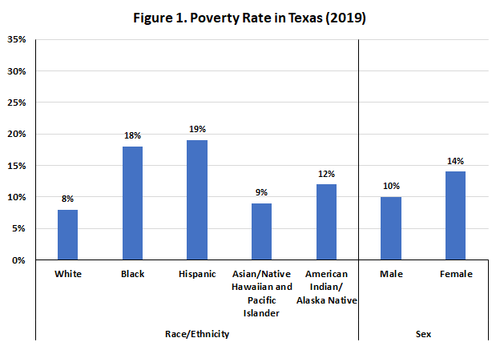
Notes: Persons of Hispanic origin may be of any race; all other racial/ethnic groups are non-Hispanic. The U.S. Census Bureau's poverty threshold for a family with two adults and one child was $20,578 in 2019.
Source: Kaiser Family Foundation estimates based on the 2008-2019 American Community Survey, 1-Year Estimates. https://www.kff.org/statedata/

Source: Kaiser Family Foundation. Licensed under CC BY-NC-ND 4

ACCOMMODATIONS NOTE: The figures from the Kaiser Family Foundation below are not accessible and do not meet ADA guidelines. In Canvas is an Excel spreadsheet where the data is accessible for all.

Figures to Be Used

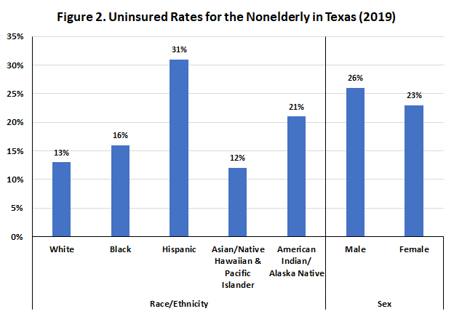
Notes: Persons of Hispanic origin may be of any race; all other racial/ethnic groups are non-Hispanic. “Uninsured” includes those without health insurance and those who have coverage under the Indian Health Service only. “Rate” refers to the percentage of the population or subpopulation with no insurance.
Source: Kaiser Family Foundation estimates based on the 2008-2019 American Community Survey, 1-Year Estimates. https://www.kff.org/statedata/

Source: Kaiser Family Foundation. Licensed under CC BY-NC-ND 4

ACCOMMODATIONS NOTE: The figures from the Kaiser Family Foundation below are not accessible and do not meet ADA guidelines. In Canvas is an Excel spreadsheet where the data is accessible for all.

Figures to Be Used

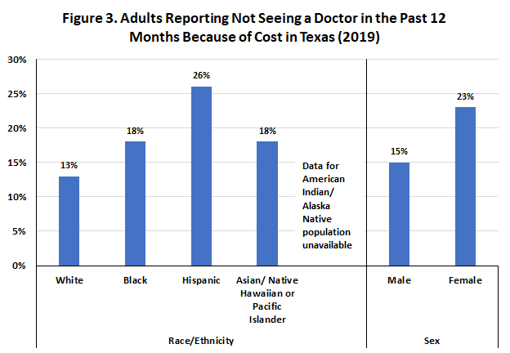
Notes: Persons of Hispanic origin may be of any race; all other racial/ethnic groups are non-Hispanic. Data represent adults who reported that there was a time in the past 12 months when they needed to see a doctor but could not because of cost.
Source: Kaiser Family Foundation analysis of the Centers for Disease Control and Prevention (CDC)'s 2013-2019 Behavioral Risk Factor Surveillance System (BRFSS). https://www.kff.org/statedata/

Source: Kaiser Family Foundation. Licensed under CC BY-NC-ND 4

ACCOMMODATIONS NOTE: The figures from the Kaiser Family Foundation below are not accessible and do not meet ADA guidelines. In Canvas is an Excel spreadsheet where the data is accessible for all.

Figures to Be Used

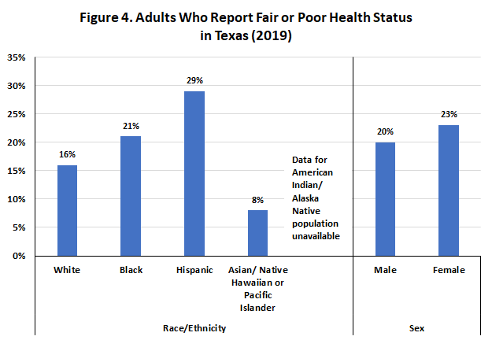
Notes: Persons of Hispanic origin may be of any race; all other racial/ethnic groups are non-Hispanic. The remaining categories of self-reported health are “good,” “very good,” and “excellent.”
Source: Kaiser Family Foundation analysis of the Centers for Disease Control and Prevention (CDC)'s 2013-2019 Behavioral Risk Factor Surveillance System (BRFSS). https://www.kff.org/statedata/

Source: Kaiser Family Foundation. Licensed under CC BY-NC-ND 4

ACCOMMODATIONS NOTE: The figures from the Kaiser Family Foundation below are not accessible and do not meet ADA guidelines. In Canvas is an Excel spreadsheet where the data is accessible for all.

