

FUNDAMENTALS OF CONDUCTING MUAG 3800-004
Curriculum Syllabus
Fall 2026

Instructor: Nathan Howard
Email: nathanhoward2@my.unt.edu
Office: MPAC 136 (Orchestral Library) / MPAC 132 (IRR) [for in-person appointments]
Office Hours: MWF 10:00 – 10:55pm [by appointment through email]
TTh [Zoom, by appointment through email]

Course Content:
The Fundamentals of Conducting course is designed for the development of a professional conducting approach. The course will cover beginning and intermediate conducting techniques, score analysis and preparation, development of visual and aural skills, and transposition skills.

Required materials:
- Fundamentals of Conducting workbook. (Provided by instructor)
- Baton (shorter and light)
- Primary instrument.
- Video recording device

Course Purpose:
This course partially fulfills requirements for undergraduate music majors.

Expected Outcomes:
Students will have made significant improvements in knowledge and ability in the following areas:
- Physical technique of conducting.
- Score study and analysis.
- Orchestral transpositions.
- Aural skills.

Course Requirements and expectations:
This is a skills-based course, so regular attendance is essential. (See specifics regarding class attendance on page 2.) Regular and thorough preparation for class is also required; this means bringing all the required materials to class every single day, thorough preparation of class conducting materials before each class session as well as practice of individual parts before each class session.

Course Times and Location:
MWF 9:05 – 9:55AM
MPAC 132 - IRR

GRADING:
Conducting work in class (cumulative) 50%
Exams (other than final, cumulative) 20%
Final (written) exam 10%
Final (conducting exam / jury) exam 10%
Rehearsal and concert reports 10%
100%
PREREQUISITES
Junior (or higher) in good standing.
Successful completion of MUTH 2500/2510

COURSE REQUIREMENTS
Attendance Attendance is expected for all scheduled classes. The nature of the course always requires active participation and interaction among all class members.
Absences will result in a lowering of the final grade as follows:

  - no affect
  - reduction of 1 letter grade
  - reduction of 2 letter grades
  - reduction of 3 letter grades
6(+) grade of WF if withdrawal is requested, or final grade of F

*Each tardy will be counted as ½ an absence

ATTENDANCE
Students are expected to attend class meetings regularly and to abide by the attendance policy established for the course. It is important that you communicate with the professor and the instructional team prior to being absent, so you, the professor, and the instructional team can discuss and mitigate the impact of the absence on your attainment of the course learning goals.

Please inform the professor and instructional team if you are unable to attend class meetings because you are ill, in mindfulness of the health and safety of the community.

CONDUCTING ASSIGNMENTS
Weekly conducting assignments will be given and graded. Each student will be expected to conduct the assigned musical excerpts in class with the class members as the ensemble. Absence from class on a pre-assigned conducting assignment will result in the student being passed over for that conducting sequence, with a grade of zero or no credit. The instructor, in advance of the absence, may approve exceptions. The opportunity to make up a missed conducting assignment will be at the discretion of the instructor and will be rare. Part of your preparation for conducting assignments, is being able to play your part—right notes, right rhythms, right dynamics. We cannot learn how to conduct if the group does not know their notes.
REHEARSAL OBSERVATIONS (2)
Each student is required to submit two orchestra rehearsal observations. Submissions are made through Canvas.

All reports must be typed – double spaced, 12-point Times New Roman font, and all margins 1 inch. The length must be a minimum of one page and a maximum of two pages (300–500 words maximum). Use formal writing guidelines. Failure to complete this requirement will result in the reduction of the final grade by one letter grade. For full credit, the assignments must be submitted on the dates found on page 5, by the beginning of class at 9:05am.
Submit online through Canvas. Correct spelling and the use of the English language is expected. In your observation, consider the following:

- Name of ensemble and conductor. Date of rehearsal observed.
- Baton (or hand) technique
Is it clear/understandable? Is it effective musically? Is it visible?
- Verbalizations
Does the conductor talk too much?
Do the performers respond well to the conductor’s instructions? Was the conductor professional in his/her comments?
- Rehearsal technique
Is there a plan for the rehearsal?
Is the ensemble’s interest focused on the music? Is there an opportunity to relax in rehearsal?
What was accomplished during the rehearsal?
- Musicality
Does the conductor insist upon dynamics, accents, phrasing, and rhythmic exactitude? Were the balances correct, solo lines brought out, and/or supporting lines appropriate? Were intonation discrepancies addressed?
Did the conductor insist on the correct style of each work?

CONCERT OBSERVATIONS (2)
Each student is required to submit two concert observations of conducted performances. A live symphonic concert from a UNT orchestra or a DFW professional orchestra is mandatory for this assignment. Submissions are made through Canvas.
All reports must be typed – double spaced, 12-point Times New Roman font, and all margins 1 inch. The length must be a minimum of one page and a maximum of two pages. Use formal writing guidelines. Failure to complete this requirement will result in the reduction of the final grade by one letter grade. For full credit, the assignments must be submitted on the dates found on page 5, by the beginning of class at 9:05am.

Submit online through Canvas as a Word File. Correct spelling and the use of the English language is expected. In your observation, consider the following:

- Name of ensemble and conductor, date of concert.
- Stage Presence
How does the conductor enter the stage?
How does the conductor acknowledge the audience and the performers?
What does the conductor do between movements of a multi-movement work?
How does the conductor acknowledge soloists or featured sections?
How does the conductor acknowledge the entire ensemble?
How does the conductor exit the stage?
- Baton (or hand) technique
Is it clear/understandable?
Is it effective musically?
Is it visible?
- Musicality
In what ways does the conductor enable the musical performance? (mechanics, musicianship, etc.)
How does the conductor visibly communicate style and musicianship to the ensemble?
Other general observations.

*If a student is absent on the submission date of a Rehearsal/Concert Observation, they must turn in the assignment during the next class meeting.

Weekly distribution of material to be covered, assignments, excerpts, exams, and quizzes, etc.:
WEEK 1 [8/17]
Orientation; course and syllabus overview; anatomy of the beat; basic concepts of use of gravity (AID); conducting planes.
Discussion of the “four hinges”; conducting in 2, 3, & 4; introduction to transposition.
WEEK 2 [8/24]
Continue work on patterns in 2, 3, & 4; preparatory gestures and cut-offs; score study concepts; SoH 1–5. Introduction to conducting in 1.
Bring instrument Friday for read-through.
Prep for the following week: continue SoH 1–5; score study 1, 2.
WEEK 3 [8/31]
Excerpts 1 & 2; conducting in 1; preparatory gestures; passive vs. active gestures. Score study 9–11 (SS 9–11).
*Rehearsal observation #1 due Friday, September 4 at 9:50 AM.
Prep: prepare excerpt 5 (Group A) or excerpt 6 (Group B); continue SoH 9–11 on your own.
WEEK 4 [9/7]
*No class 9/7 (Labor Day)
Excerpt 5 (Group A); excerpt 6 (Group B); score study 7/10.
Prep: continue SoH 9–11; prepare excerpt 7.
WEEK 5 [9/14]
Excerpt 7; subdivided 4/4 and 9/8, 12/8, 6/8.
**Exam #1 [Friday, September 18]
Basic conducting concepts; transpositions; terms; conducting in 4, 2, 3, & 1; passive, active, and preparatory gestures; cutoffs and cues.
*Rehearsal observation #2 due Friday, September 18 at 9:50 AM.
Prep: prepare excerpts 8 (Group A) & 13 (Group B).
WEEK 6 [9/21]
Excerpt 8 (Group A); excerpt 13 (Group B). Fermatas (three ways).
Prep: score study excerpt 14 (Group A), excerpt 15 (Group B).
WEEK 7 [9/28]
Excerpt 14 (Group A); excerpt 15 (Group B).
Prep: score study excerpt 17; SoH 10–11.
WEEK 8 [10/5]
Finish excerpt 15 (Group B); excerpt 17.
Score study excerpts 18 & 19.
Prep: prepare conducting on excerpts 18 & 19.
WEEK 9 [10/12]
Excerpt 18 (Group A); excerpt 18 (Group A) + 19 (Group B), with score study 20; excerpt 19 (Group B).
*Concert observation #1 due Friday, October 16 at 9:50 AM.
Prep for the following week: score study 19 / 20.5; SoH 12, 13.
WEEK 10 [10/19]
Excerpt 20.5; gestures of syncopation; SoH 14; texture and stylistic changes; cueing; score study excerpt 24 (Egmont – Beethoven).
Prep: prepare for Exam #2; score study excerpt 24; SoH on your own.
WEEK 11 [10/26]
**Exam #2 [Monday, October 26]:
Basic conducting concepts; review of transpositions; terms (part 2); conducting in 4, 2, 3, & 1; passive and active gestures; preparatory gesture/cutoff; cues; fermata; conducting in divided patterns (4, 2, 3); irregular time signatures; more sophisticated gestures (legato/tenuto/sostenuto, staccato, breathing/cueing gesture, etc.); plus all material from Exam #1.
Excerpt 24.
Prep for the following week: continue preparing excerpt 24; SoH on your own.
WEEK 12 [11/2]
Continued work on excerpt 24.
*Concert observation #2 due Friday, November 6 at 9:50 AM.
Prep: rest; conducting juries preparation and consultations.
WEEK 13 [11/9]
Conducting portion of the final exam this week. Review for written finals.
WEEK 14 [11/16]
Finals / consultations / make-up.
Written finals, Wednesday, 11/18.
THANKSGIVING BREAK 11/23–11/29
No class (11/30 and 12/2); consultations only.
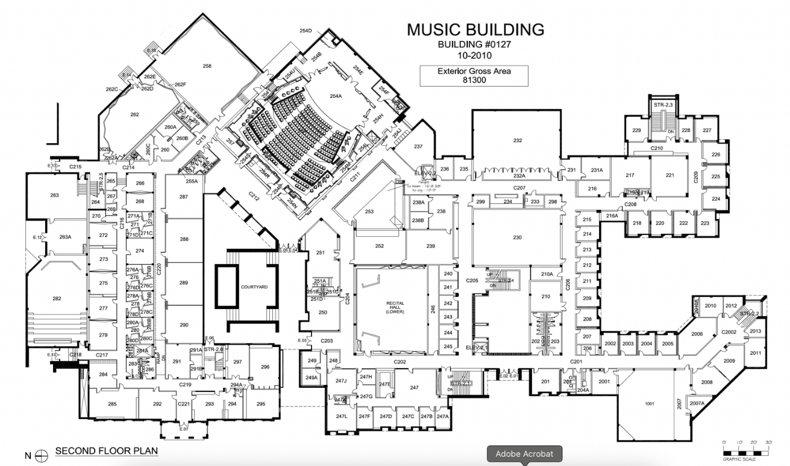

DEFIBRILLATORS IN THE COLLEGE OF MUSIC
- Music Building: Across from the west side of the Music Commons, directly across from the elevator
- Music Building: Third floor hallway, across from the staircase that comes up from the Copy Room. Next to Room 322
- Music Building: Across from the Copy Room next to Room 293
- Music Building: Voertman Lobby by the big double set of doors that lead out to the courtyard
- Music Building: Main Office (247) under the student worker’s desk
- Music Annex: Next to room MA117, near the triple set of doors on the east side of the building
- Music Practice Building North: First floor on the Avenue C side
- Music Practice Building South: First floor on the Avenue C side
- Bain Hall: First floor by the restrooms
- Murchison Performing Arts Center: Located off the main lobby, beyond the grand staircase, across from the single occupancy restroom (next to the public water fountains)

ACADEMIC INTEGRITY
Students caught cheating or plagiarizing will receive a "0" for that particular assignment or exam [or specify alternative sanction, such as course failure]. Additionally, the incident will be reported to the Dean of Students (Office of Academic Integrity), who may impose further penalty. According to the UNT catalog, the term “cheating" includes, but is not limited to: a. use of any unauthorized assistance in taking quizzes, tests, or examinations; b. dependence upon the aid of sources beyond those authorized by the instructor in writing papers, preparing reports, solving problems, or carrying out other assignments; c. the acquisition, without permission, of tests or other academic material belonging to a faculty or staff member of the university; d. dual submission of a paper or project, or resubmission of a paper or project to a different class without express permission from the instructor(s); or e. any other act designed to give a student an unfair advantage. The term “plagiarism” includes, but is not limited to: a. the knowing or negligent use by paraphrase or direct quotation of the published or unpublished work of another person without full and clear acknowledgment; and b. the knowing or negligent unacknowledged use of materials prepared by another person or agency engaged in the selling of term papers or other academic materials.
See: Academic Integrity
LINK: https://policy.unt.edu/policy/06-003

STUDENT BEHAVIOR
Student behavior that interferes with an instructor’s ability to conduct a class or other students' opportunity to learn is unacceptable and disruptive and will not be tolerated in any instructional forum at UNT. Students engaging in unacceptable behavior will be directed to leave the classroom and the instructor may refer the student to the Dean of Students to consider whether the student's conduct violated the Code of Student Conduct. The university's expectations for student conduct apply to all instructional forums, including university and electronic classrooms, labs, discussion groups, field trips, etc.
See: Student Code of Conduct
Link: https://deanofstudents.unt.edu/conduct

ACCESS TO INFORMATION – EAGLE CONNECT
Your access point for business and academic services at UNT occurs at my.unt.edu. All official communication from the university will be delivered to your Eagle Connect account. For more information, please visit the website that explains Eagle Connect.
See: Eagle Connect
LINK: eagleconnect.unt.edu/

ODA STATEMENT
The University of North Texas makes reasonable academic accommodation for students with disabilities. Students seeking accommodation must first register with the Office of Disability Access (ODA) to verify their eligibility. If a disability is verified, the ODA will provide you with an accommodation letter. You can now request your Letters of Accommodation ONLINE and ODA will mail your Letters of Accommodation to your instructors. You may wish to begin a private discussion with your professors regarding your specific needs in a course. Note that students must obtain a new letter of accommodation for every semester. For additional information see the Office of Disability Access.
See: ODA
LINK: disability.unt.edu. (Phone: (940) 565-4323)

Health and Safety Information
Students can access information about health and safety at: https://music.unt.edu/student-health-and-wellness

Registration Information for Students
See: Spring Academic Calendar Information
Link: https://registrar.unt.edu/registration/spring-academic-calendar.html

Semester Calendar, Spring 2026
See: Spring Semester Calendar
Link: https://registrar.unt.edu/sites/default/files/spring-2026-academic-calendar.pdf

Financial Aid and Satisfactory Academic Progress

Undergraduates
A student must maintain Satisfactory Academic Progress (SAP) to continue to receive financial aid. Students must maintain a minimum 2.0 cumulative GPA in addition to successfully completing a required number of credit hours based on total hours registered. Students cannot exceed attempted credit hours above 150% of their required degree plan. If a student does not maintain the required standards, the student may lose their financial aid eligibility.

Students holding music scholarships must maintain a minimum 2.5 overall cumulative GPA and 3.0 cumulative GPA in music courses.

If at any point you consider dropping this or any other course, please be advised that the decision to do so may have the potential to affect your current and future financial aid eligibility. It is recommended that you to schedule a meeting with an academic advisor in your college or visit the Student Financial Aid and Scholarships office to discuss dropping a course before doing so.
See: Financial Aid
LINK: http://financialaid.unt.edu/sap

Graduates
A student must maintain Satisfactory Academic Progress (SAP) to continue to receive financial aid. Students must maintain a minimum 3.0 cumulative GPA in addition to successfully completing a required number of credit hours based on total registered hours per term. Music scholarships require a 3.5 cumulative GPA. Students cannot exceed maximum timeframes established based on the published length of the graduate program. If a student does not maintain the required standards, the student may lose their financial aid eligibility.

If at any point you consider dropping this or any other course, please be advised that the decision to do so may have the potential to affect your current and future financial aid eligibility. It is recommended you schedule a meeting with an academic advisor in your college, an advisor in UNT-International or visit the Student Financial Aid and Scholarships office to discuss dropping a course.
See: Financial Aid
LINK: http://financialaid.unt.edu/sap

RETENTION OF STUDENT RECORDS
Student records pertaining to this course are maintained in a secure location by the instructor of record. All records such as exams, answer sheets (with keys), and written papers submitted during the duration of the course are kept for at least one calendar year after course completion. Course work completed via the Canvas online system, including grading information and comments, is also stored in a safe electronic environment for one year. You have a right to view your individual record; however, information about your records will not be divulged to other individuals without the proper written consent. You are encouraged to review the Public Information Policy and the Family Educational Rights and Privacy Act (FERPA) laws and the university’s policy in accordance with those mandates.
See: FERPA
Link: http://ferpa.unt.edu/

COUNSELING AND TESTING
UNT’s Center for Counseling and Testing has an available counselor for students in need. Please visit the Center’s website for further information:
See: Counseling and Testing
Link: http://studentaffairs.unt.edu/counseling-and-testing-services.

For more information on mental health resources, please visit:
See: Mental Health Resources
Link: https://disparities.unt.edu/mental-health-resources

ADD/DROP POLICY
Please be reminded that dropping classes or failing to complete and pass registered hours may make you ineligible for financial aid. In addition, if you drop below half-time enrollment you may be required to begin paying back your student loans. See Academic Calendar (listed above) for additional add/drop Information.

Drop Information: https://registrar.unt.edu/registration/spring-academic-calendar.html

STUDENT RESOURCES
The University of North Texas has many resources available to students. For a complete list, go to:
See: Student Resources
Link: https://success.unt.edu/aa-sa-resources

CARE TEAM
The Care Team is a collaborative interdisciplinary committee of university officials that meets regularly to provide a response to student, staff, and faculty whose behavior could be harmful to themselves or others.
See: Care Team
Link: https://studentaffairs.unt.edu/care-team

