Course Development Syllabus for

SOCI 1510 400 (Section) / Introduction to Sociology Online

Spring 2026

Instructor Information

Momna Rani, PhD Candidate
Email: Momna.rani@unt.edu (Please include ‘SOCI 1510.400’ in the subject line. Do not hesitate to contact me. Please reach out to me via UNT email or Canvas inbox.
Office Hours are Wednesdays from 01:00 - 5:00 p.m. and by appointment. Office location is SYMR 288T Sycamore.

Teaching Assistant

Peng Zhang
Office location: 288D Sycamore Hall.
peng.zhang@unt.edu

Communication Expectations
I will respond within 24-48 hours, except on weekends and public holidays. I am the instructor for this course, which was designed by Dr. Gregg. If you need help or have questions about the course, please email me or use the Inbox in Canvas to message me (not Dr. Gregg). When communicating in Canvas or via UNT email, please follow UNT CLEAR's Guidelines and Online Communication Tips (https://clear.unt.edu/online-communication-tips).

Department of Sociology
Our department features innovative research, work opportunities, and award-winning faculty widely recognized for their publications. The department’s signature strengths are in gender, race and ethnicity, medical sociology, and sociological theory.

Course Description
Social and cultural basis for human behavior; impact of societal groups and organizations on personal identity, feelings, and actions; influence on the self in relation to the family, peer groups, social classes, religion, and social institutions. Satisfies liberal arts and social sciences core social science requirements. This course is required of all sociology majors and minors.

Important Dates and Times
Classes Begin Monday 01/12 – All students should check into the course!
MLK Holiday Monday 01/19 (No Classes)
Syllabus Quiz Due before midnight (11:59 p.m.) on Sunday of Week One (01/18)
Chapter Quizzes Due before midnight (11:59 p.m.) on most Sundays
Discussions Two Discussions:
- Introductions due before midnight (11:59 p.m.) on Sundays of Week One
- Midway Discussion due before midnight (11:59 p.m.) on Sundays 03/01
Other Assignment Inequality Assignment (due at the end of Part 2 of course) Due before midnight on Sunday 04/05
Online Tests Test 1 (due at the end of Part 1 of the course) before midnight on Sunday 2/22
Test 2 (due at the end of Part 2 of the course) before midnight on Sunday 03/29
Spring Break Week 9, 03/09-03/15 (No Classes)
Pre-Finals Days Wednesday 04/29- Thursday 04/30
Last Class Meeting Thursday 04/30
Reading Day No Classes 05/01
Final Exam There is no Final Exam. Instead, students will take Test 3 (pertaining to Part 3 of the course) and is due during Final Exams week. Test 3 opens in Canvas on Monday 05/04 at 12:00 a.m. and closes on Friday 05/08 at midnight (11:59 p.m.).
Semester Ends Friday, 05/08 at midnight (11:59 p.m.)

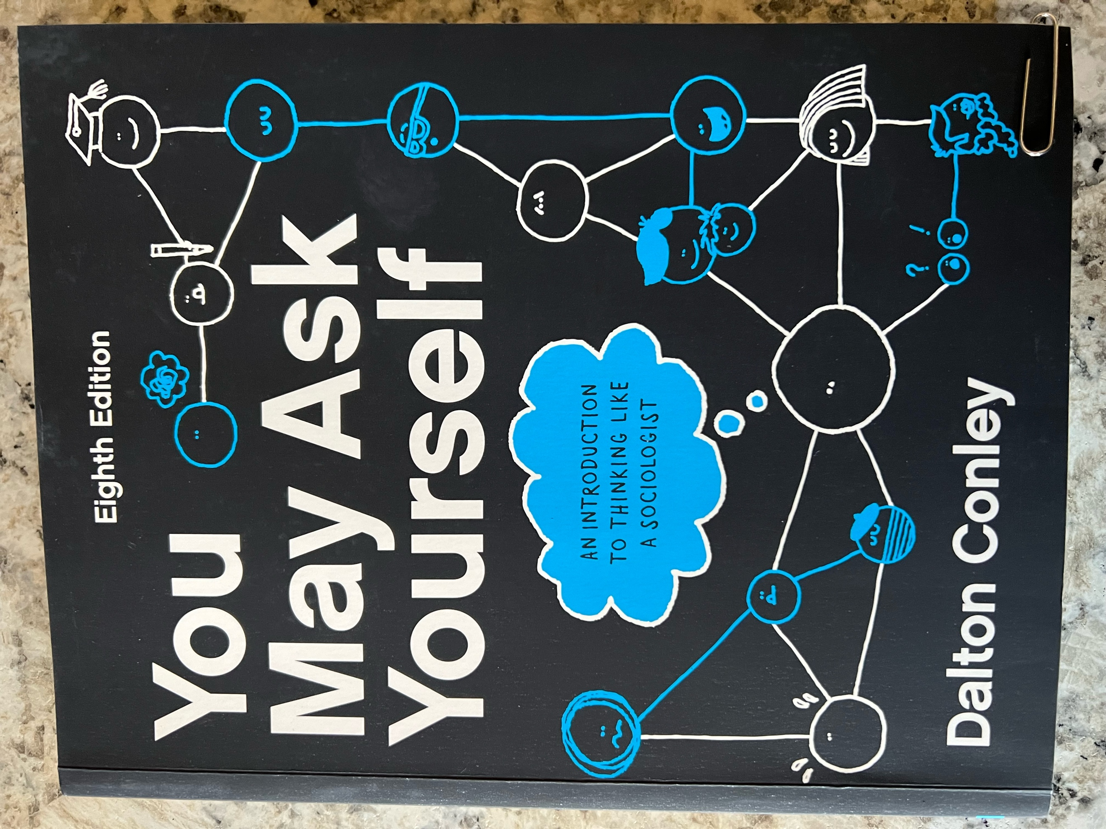

Required Course Materials
The UNT bookstore on campus should be able to help you with the required material for this course. This semester we will be using Dalton Conley’s You May Ask Yourself, 8th Ed. (the full version) as the main text. If your book does not look like the picture above, you do not have the right book for the course. Do not use any of the earlier versions of this text for the course. ISBN for the paperback version of the 8th Ed. of this book is: 978-1-324-04425-3.

- If you choose to purchase the hard copy of this book, it comes with a registration code at the front of the book that provides access to WW Norton’s digital home page. The digital home page has resources that will enhance your learning, such as videos and animation films introducing you to each chapter.
- If you choose to purchase the online version of the book, access to the digital home page is included online.
- Here is a link to WW Norton’s digital home page for the 8th Ed. of Conley’s book: https://digital.wwnorton.com/youmayask8
- Note that WW Norton allows 21 days of free access to the online version of the book. This may be useful to students who are delayed receiving financial aid. Please know that after 21 days you will be kicked out of the online version. The expectation is that you will properly purchase the required version of this book for the semester at some point.

ODA Student Book Access Information
- Here is where you can find additional information regarding different formats WW Norton can help with: https://wwnorton.com/accessibility/alternative-formats
- The eBook for the Conley text can be very helpful for students with accessibility needs. Students can access that here on the digital landing page: https://digital.wwnorton.com/youmayask8
- Or the bookstore can order an access card that students can purchase with this ISBN for the 8th Ed. of Conley’s book: 978-1-324-06242-4

Course Structure
This course is 100% online. There are no class meetings and there are no expectations to meet online at the same time. Students are expected to follow the expectations in the syllabus and work each week from Monday 12:00 a.m. to Sunday 11:59 p.m. to accomplish the course objectives. Most assignments in this course are due before midnight on Sundays. Assignments include discussions, chapter quizzes, tests, and the following additional assignment.
- In Part 2 of the course (when we cover Chs 7-10 of Conley’s text), you will learn about different forms of inequality in society. In relation to this, students are asked to write a short paper for the purpose of UNT assessment. This short paper is called the Inequality Assignment. When the time comes, students will turn this paper in twice: 1) Once for UNT assessment; and 2) Once as an assignment to be graded in this course.

Course Objectives (Using Bloom’s Taxonomy)
By completing this course, students should be able to:
- Recall and identify terms, concepts, ideas related to studies, and sociological theories learned from the readings each week that are related to the study of society. (Quizzes – REMEMBERING)
- Connect to others in the course by periodically sharing how they are doing. (Discussions – UNDERSTANDING)
- Recall and identify terms, concepts, ideas related to studies, and sociological theories learned in each part of the course that are related to the study of society. (Tests – REMEMBERING)
- Synthesize numerical data and apply sociological theory to demonstrate an understanding of social Inequality. (Inequality Assignment – ANALYZING)

How to Succeed in this Course
To succeed in this online course, students should log into Canvas frequently each week and pay attention to the announcements. The instructor (and TA) will provide helpful information pertaining to the course via announcements. Students should keep up with the assigned readings as listed under the heading Tentative Course Schedule and should plan to take the quizzes and complete the assignments each week before the due dates. Everyone has seven days to complete the work in the course.

It is recommended that students NOT WAIT until Sunday to begin completing the work in this course. Although the due date for most assignments is Sunday before midnight, it is best to turn in your work during the week sometime. That way, if there is a problem with Canvas, employees of UNT are available to help you. Additionally, although the films made for this course are optional, they will enhance your learning of the chapter materials. So, to succeed in this course, please plan to watch the films in Canvas.

If for some reason you need to miss a due date in this course, it is best to send your instructor a message using the Inbox in Canvas to ask for an extension. If you do this BEFORE, rather than AFTER, missing an assignment, extensions are routinely granted. It is always best to keep communications open between students and professors. Please do your best to communicate. Because communication is key, I encourage students to reach out to me using the Inbox in Canvas at least one time over the course of the semester.

ADA Accommodation Statement
The University of North Texas makes reasonable academic accommodation for students with disabilities. Students seeking reasonable accommodation must first register with the Office of Disability Access (ODA) to verify their eligibility. If a disability is verified, the ODA will provide you with a reasonable accommodation letter to be delivered to faculty to begin a private discussion regarding your specific needs in a course. You may request reasonable accommodations at any time; however, ODA notices of reasonable accommodation should be provided as early as possible in the semester to avoid any delay in implementation. Note that students must obtain a new letter of reasonable accommodation for every semester and must meet with each faculty member prior to implementation in each class. Students are strongly encouraged to deliver letters of reasonable accommodation during faculty office hours or by appointment. Faculty members have the authority to ask students to discuss such letters during their designated office hours to protect the privacy of the student. For additional information, refer to the Office of Disability Access website (https://studentaffairs.unt.edu/office-disability-access). You may also contact ODA by phone at (940) 565-4323.

Supporting Your Success
UNT strives to offer you a high-quality education and a supportive environment, so you learn and grow. As a faculty member, your instructor is committed to helping you be successful as a student. To learn more about campus resources and information on how you can be successful at UNT, go to unt.edu/success and explore unt.edu/wellness. To get all your enrollment and student financial-related questions answered, go to scrappysays.unt.edu.

Statement of Inclusiveness
Every student in our class should have the right to learn and engage within an environment of respect and courtesy from others. I encourage you to review UNT’s student code of conduct so that we can all start with the same baseline civility understanding (Code of Student Conduct) (https://policy.unt.edu/policy/07-012).

Attendance and Participation
Since this is 100% an online course, students should plan to check into the course frequently during the week. Assignments are due every single week in the semester. The only week when there are no assignments planned is over the Spring Break.

Your participation online will be closely monitored, and your instructor (and TA) will communicate with you frequently using the grading comments in Canvas. Please read the grading comments and alter your work based on the suggestions you see there. Note that students who are not fully engaged in the course will be reported to UNT’s CARE Team. Someone from the Dean of Students will be in contact.

Teaching Philosophy
My personal approach to teaching this course involves creating an open and engaging online atmosphere where students can broaden their perspective on the changing structure of social life in the United States and learn to develop a sociological imagination by making the familiar seem strange. This means closely examining things in society that have been previously taken for granted as “normal”.

Technical Requirements and Skills
Here is a list of the minimum technology requirements for students for this course:
- A working computer and reliable internet access are REQUIRED.
  - If your Internet fails or if your personal computer has an issue, you are expected to use the computer clusters on campus to complete your work. Students’ technology fees pay for access to working on computers with reliable internet access and should be utilized when need be.
  - If it is not possible to go to campus (e.g., during the time of COVID), please find some other working computer with reliable Internet access to complete your work.
- Microsoft Office Suite
- Uploads to Canvas have been set to only accept .pdf .doc .docx files.
  - If the professor or TA cannot open your document, you will be awarded a zero and you have one week to contact them to discuss. If after one week, you have not contacted the professor or TA, the zero will stand.
- Note that Canvas does not interface well with Pages or Google Docs. Do not upload your files using these word processing systems.

Rules of Engagement
Here are some general guidelines for the way students are expected to interact with each other and with their instructor and TA in class sessions and online:
- While the freedom to express yourself is a fundamental human right, any communication that utilizes cruel and derogatory language on the basis of race, color, national origin, religion, sex, sexual orientation, gender identity, gender expression, age, disability, genetic information, veteran status, or any other characteristic protected under applicable federal, or state law will not be tolerated.
- Treat your instructor and classmates with respect in any communication online or face-to-face, even when their opinion differs from your own.
- Ask for and use the correct name and pronouns for your instructor and classmates.
- Speak from personal experiences. Use “I” statements to share thoughts and feelings. Try not to speak on behalf of groups or other individual’s experiences.
- Use your critical thinking skills to challenge other people’s ideas, instead of attacking individuals.
- Avoid using all caps while communicating digitally. This may be interpreted as “YELLING!”
- Be cautious when using humor or sarcasm in emails or discussion posts as tone can be difficult to interpret digitally.
- Avoid using “text-talk”. This is not permitted by your instructor.
- Proofread and fact-check your sources.
- Keep in mind that online posts can be permanent, so think first before you type.
See these Engagement Guidelines (https://clear.unt.edu/online-communication-tips) for more information.

Assignments and Technical Issues
All assignments should be submitted by the indicated dates and times embedded in the syllabus. There will be no extensions, except in cases of documented emergencies.
- In the event of a legitimate emergency, students should contact their instructor via the Inbox in Canvas to discuss their situation PRIOR TO missing an assignment. When students do this, instructors routinely grant extensions.
- Each student is allowed only one documented emergency per semester.
- As stated above, in the event your emergency is very serious, your instructor will prompt you to contact the Dean of Students so that you receive a blanket excuse from the University for your work in all classes. Here is a link to the contacts in the Dean of Students office.
  - Contacts at the Dean of Students Office
  - Telephone number: 940-565-4909

Students are responsible for knowing the Canvas environment. This means that students are responsible for their own training in Canvas. Technical problems with Canvas software are to be directed to the Help Desk 940-565-2324 / Sage Hall 330 / helpdesk@unt.edu.

Course Requirements
Below are listed the required assignments and point values for the course.
Description of Assignment | Point Value/%
Syllabus Quiz  - Due before the end of Week One | 100 /5%
Chapter Quizzes  - All 12 are Required.  - Students should not miss any of the quizzes.  - Worth up to 100 points each (12 X 100 = 1200 points) | 1200 / 60%
2 Discussions and Responses  - At the start of the semester introducing yourself; and  - Midway through the semester to check in about this course.  - Each discussion is worth up to 50 points. | 100 / 5%
3 Tests (Only 2 Count)  - Test 1 over Part 1 (Chs 1-4)  - Test 2 over Part 2 (Chs 7-10)  - Test 3 over Part 3 (Chs 12, 14, 15, 18)  - Each test is worth up to 200 points.  - Students should take all 3 Tests.  - The lowest of your 3 Test scores will be dropped at the end of the semester. | 400 / 20%
Part 2 Inequality Assignment  - Required of all students taking SOCI 1510 at UNT. Assignment is used for UNT assessment purposes.  - Students should upload this assignment twice in Canvas.  - Once for UNT assessment (not graded)  - Once more for this course (graded and worth up to 200 points) | 200 / 10%
TOTAL | 2000 / 100%

The Grading Scale
At the end of the semester, your grade is based on the Grading Scale.
Percent | Letter Grade
90-100% of 2000 Points | A
80-89% of 2000 Points | B
70-79% of 2000 Points | C
60-69% of 2000 Points | D
59% or less of 2000 Points | F

Course Policies
Below is a list of items that you can expect from your professor (and TA if there is one), as well as a list of items that, if you choose to stay in this course and not drop it, you are agreeing to abide by in this course. Please consider these expectations our course policies.

What you can expect from your professor and TA:
- Respect and active listening.
- Consistent grading with return time within one to two weeks.
- Willingness to teach, learn and answer questions.
- To be prepared each week for our class.
- To allow ample opportunity for you to do well in this course.
- To be available by appointment for additional help.
- To treat everyone equally and fairly.

What the professor and TA expect from you:
- Patience with the professor, TA, and with all others who participate in this class.
- To read the syllabus carefully each week and know what is supposed to happen. This is our contract. The professor and TA will do all that they can to abide by the syllabus, so they expect you to do the same.
- Active participation in the Canvas environment as required by the syllabus.
  - If it appears you are not actively engaged in this course, the professor and/or TA will use the UNT Care Team reporting system to make recommendations.
- To complete all assignments as they are scheduled in the Tentative Course Schedule below in the syllabus.
- To act with academic integrity during any quizzes or tests, and in all writing. Your work should be your own. Cheating will not be tolerated! See UNT policy on academic dishonesty.
  - Discussions are set up to require you to post your own original thoughts before seeing other students’ posts. If you enter a period “.” Or some other gibberish to get into the discussion before posting your own original ideas, this will be considered an academic integrity violation, and the instructor will report you to UNT for cheating.
  - Do not use any form of AI to generate your assignments in this course. If you do this, your instructor will submit an academic integrity violation and report you to UNT for cheating.
- To read the grading comments that the professor and/or TA provide on all your assignments. They will incorporate tips for how to do better on future assignments.
- To use the Writing Center on campus (in Sage Hall) if you need help with writing assignments.
- To put assignments in the correct spot in Canvas. If you put things in the wrong spot, you will receive a zero (0) and your work will not be graded. If this happens, you have one week to rectify the situation with your instructor and/or TA. After that, the zero (0) will stand.
- To follow all directions in the syllabus and in Canvas for all course assignments. If you do not follow the directions, your grade will be substantially reduced, and you may be awarded zero (0) points.
- To buy and use the correct version of the required book for the course. Right now, that is the 8th Edition of Dalton Conley’s You May Ask Yourself (full edition with 18 chapters). Do not use any other earlier version of the book for this course.
  - If you analyze something other than what everyone else is analyzing in your assignments, or if you misquote something from the book, you will receive a zero (0). This is especially important when completing the writing assignment for Part 2 of the course.
  - If the professor and/or TA happen look up something you quote from the book and it is not on the page cited, you will automatically fail the assignment and receive a zero (0) with no chance to redo the assignment.
- To buy and use the correct version of the book by Week One of the course and appropriately cite all your work when you quote. This means use quotation marks and cite the page number for your quotes.
- To be responsible for your work and prepare for and handle situations of computer and Internet difficulties. If your Internet is out, go somewhere where it is working (like the computer clusters on campus) so that you do not miss assignments. Everyone is expected to have a working computer with reliable Internet access for this course.
- To complete your work on time in the course. Everyone in the course has 7 days each week to complete the work items expected.
- To not wait until the last minute to begin your work. This means do not wait until late Sunday night to start your assignments for this course. If you aim for completing your work by Thursday of each week, if you have some technical difficulty, you’ll have time to correct it.
- To request an “Incomplete” in writing at least one week before the Final Exam Week. This request must be accompanied by documentation of the reason that the course cannot be completed before the end of the semester and will only be considered if at least 50% of course tests and assignments have been completed with a passing grade.
- To contact the professor or the TA if you find that you need additional help in this course. Visits to office hours or online meetings using a teleconferencing usually help students get on track.
- To contact the Dean of Students, Seeking Options and Solutions (S.O.S) Office, in the event of a personal emergency in your life. This includes extended illness or hospitalization, death in family, or other personal issue that hinders your possibility of success in the course. Here is the URL and the contact information for that office.
  - https://deanofstudents.unt.edu/resources/seeking-options-and-solutions

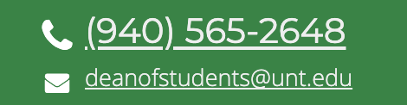

Tentative Course Schedule

Getting Started in the Course
Week 1 is meant for us to get to know each other and get started in the course. You should acquire the materials you need to be successful in Part 1 of the course and then do the following. Check things off as you go so that you do not miss a thing.

Week 1 (01/12-01/18)
✓ | Description of work to be completed | Other Details
TO DO: | - Obtain the required book.  - Work through the pages in Canvas for Week 1 Module  - Read the Syllabus  - Watch film introducing you to the course  - Take Syllabus Quiz  - Participate in the discussion for introductions and respond to others  - Ask your instructor any questions you may have about the course using the Inbox in Canvas | UNT Book Store  All the information you need to get started in the course is found in the Module called Introduction in Canvas.  The Syllabus Quiz and the Discussion are due before midnight on Sunday, 01/18.

Part 1 Summary -- Using Your Sociological Imagination
Part 1 of the course consists of 5 weeks. Each week has slightly different learning objective(s) that correspond with the material in the text. Notice that we will not be using all the chapters in Part 1 of the book. We only cover Chs 1- 4, and we skip Ch5 and Ch6. For each chapter we use there is a quiz due sometime before the end of the week on Sunday at midnight. After completing Chs 1-4, Test 1 covers the information found in all four chapters.

Week 2 Learning Objectives
By the end of this week, students should be able to:
- Recall and identify terms, concepts, ideas related to studies, and sociological theories learned about from reading Ch1, The Sociological Imagination: An Introduction. (Ch1 Quiz)

Week 2 (01/19-01/25)
✓ | Description of work to be completed | Other Details
TO DO: | - Read Ch1 the Sociological Imagination: An Introduction.  - Optional: Watch the films associated with this chapter.  - Study the terms in the margins of the chapter.  - Take the chapter quiz sometime before the end of the week. | Ch1 Quiz is due before midnight on Sunday 01/25.

Week 3 Learning Objectives
By the end of this week, students should be able to:
- Recall and identify terms, concepts, ideas related to studies, and sociological theories learned about from reading Ch2, Methods. (Ch2 Quiz)

Week 3 (01/26-02/01)
✓ | Description of work to be completed | Other Details
TO DO: | - Read Ch2 Methods.  - Optional: Watch the films associated with this chapter.  - Study the terms in the margins of the chapter.  - Take the chapter quiz sometime before the end of the week. | Ch2 Quiz is due before midnight on Sunday 02/01.

Week 4 Learning Objectives
By the end of this week, students should be able to:
- Recall and identify terms, concepts, ideas related to studies, and sociological theories learned about from reading Ch3, Culture and Media. (Ch3 Quiz)

Week 4 (02/02-02/08)
✓ | Description of work to be completed | Other Details
TO DO: | - Read Ch3 Culture and Media.  - Optional: Watch the films associated with this chapter.  - Study the terms in the margins of the chapter.  - Take the chapter quiz sometime before the end of the week. | Ch3 Quiz is due before midnight on Sunday 02/08.

Week 5 Learning Objectives
By the end of this week, students should be able to:
- Recall and identify terms, concepts, ideas related to studies, and sociological theories learned about from reading Ch4, Socialization and the Construction of Reality. (Ch4 Quiz)

Week 5 (02/09-02/15)
✓ | Description of work to be completed | Other Details
TO DO: | - Read Ch4 Socialization and the Construction of Reality.  - Optional: Watch the films associated with this chapter.  - Study the terms in the margins of the chapter.  - Take the chapter quiz sometime before the end of the week. | Ch4 Quiz is due before midnight on Sunday 02/15.

Week 6 Learning Objectives
By the end of this week, students should be able to:
- Recall and identify terms, concepts, ideas related to studies, and sociological theories learned in Part 1 of the course that are related to the study of society. (Test 1)

Week 6 (02/16-02/22)
✓ | Description of work to be completed | Other Details
TO DO:  DUE | - Review Chs 1-4 to prepare for Test 1.  - Students can review by:  - Rewatching all the optional films associated with Chs 1-4.  - Reviewing any notes taken about the chapters.  - Studying the terms in the margins of the chapters.  - When ready, take Test 1 sometime before the end of the week. | Test 1 is online in Canvas and is due before midnight on Sunday 02/22.

Part 2 Summary -- Fault Lines…Social Divisions and Inequality
To begin Part 2 of the course, please participate in the Midway discussion and respond kindly to others. Part 2 of our course consists of 5 more weeks. Each week has slightly different learning objective(s) that correspond with the material in the text. Notice that we will not be using all the chapters in Part 2 of the book. We only cover Chs 7-10, and we skip Ch11. For each chapter we use there is a quiz due sometime before the end of the week on Sunday at midnight. After completing Chs 7-10, Test 2 covers the information found in all four chapters.

Inequality Assignment
While completing the work for Chs 7-10, students should also be working on the Part 2 Inequality Assignment which requires you to synthesize numerical data and apply sociological theory to demonstrate an understanding of social Inequality. Details for this assignment can be found toward the end of the Syllabus under the heading Part 2 Inequality Assignment. This assignment falls due the same week as Test 2. Note that students should upload this assignment two times in Canvas: 1) Once for UNT assessment; and 2) Once more for this course for a grade.

Week 7 Learning Objectives
By the end of this week, students should be able to:
- Recall and identify terms, concepts, ideas related to studies, and sociological theories learned about from reading Ch7, Stratification. (Ch7 Quiz)

Week 7 (02/23-03/01)
✓ | Description of work to be completed | Other Details
TO DO:  DUE | - Read Ch7 Stratification.  - Optional: Watch the films associated with this chapter.  - Study the terms in the margins of the chapter.  - Take the chapter quiz sometime before the end of the week.  - Participate in the Midway Discussion to check in about the course. | Ch7 Quiz and the Midway discussion are both due before midnight on Sunday 03/01.
 | Part 2 Inequality Assignment  - Read the directions for the Part 2 Inequality Assignment.  - Directions for this assignment can be found toward the end of the syllabus and in Canvas.  - Review Conley’s book for any discussion of theory. The Index will be useful for this.  - Begin crafting an analysis of the data embedded in the assignment.  - Your analysis should be at least 2 pages in length and should use a conventional citation method such as APA, MLA, etc.… | Part 2 Inequality Assignment due before midnight on 04/05.

Week 8 Learning Objectives
By the end of this week, students should be able to:
- Recall and identify terms, concepts, ideas related to studies, and sociological theories learned about from reading Ch8, Gender. (Ch8 Quiz)

Week 8 (03/02-03/08)
✓ | Description of work to be completed | Other Details
TO DO: | - Read Ch8 Gender.  - Optional: Watch the films associated with this chapter.  - Study the terms in the margins of the chapter.  - Take the chapter quiz sometime before the end of the week. | The Ch8 Quiz is due before midnight on Sunday 03/08.
 | Part 2 Inequality Assignment  - Read the directions for the Part 2 Inequality Assignment.  - Directions for this assignment can be found toward the end of the syllabus and in Canvas.  - Review Conley’s book for any discussion of theory. The Index will be useful for this.  - Continue crafting an analysis of the data embedded in the assignment.  - Your analysis should be at least 2 pages in length and should use a conventional citation method such as APA, MLA, etc.… | Part 2 Inequality Assignment due before midnight on 04/05.

Week 09 Spring Break (03/09-03/15) – No Classes – Be with family, friends, and neighbors! Enjoy yourself! Come back ready to finish out the semester strong!

Week 10 Learning Objectives
By the end of this week, students should be able to:
- Recall and identify terms, concepts, ideas related to studies, and sociological theories learned about from reading Ch9, Race. (Ch9 Quiz)

Week 10 (03/16-03/22)
✓ | Description of work to be completed | Other Details
TO DO: | - Read Ch9 Race.  - Optional: Watch the films associated with this chapter.  - Study the terms in the margins of the chapter.  - Take the chapter quiz sometime before the end of the week. | The Ch9 Quiz is due before midnight on Sunday 03/22.
 | Part 2 Inequality Assignment  - Read the directions for the Part 2 Inequality Assignment.  - Directions for this assignment can be found toward the end of the syllabus and in Canvas.  - Review Conley’s book for any discussion of theory. The Index will be useful for this.  - Continue crafting an analysis of the data embedded in the assignment.  - Your analysis should be at least 2 pages in length and should use a conventional citation method such as APA, MLA, etc.… | Part 2 Inequality Assignment due before midnight on 04/05.

Week 11 Learning Objectives
By the end of this week, students should be able to:
- Recall and identify terms, concepts, ideas related to studies, and sociological theories learned about from reading Ch10, Poverty. (Ch10 Quiz)

Week 11 (03/23-03/29)
✓ | Description of work to be completed | Other Details
TO DO: | - Read Ch10 Poverty.  - Optional: Watch the films associated with this chapter.  - Study the terms in the margins of the chapter.  - Take the chapter quiz sometime before the end of the week. | The Ch10 Quiz is due before midnight on Sunday 03/29.
 | Part 2 Inequality Assignment  - Read the directions for the Part 2 Inequality Assignment.  - Directions for this assignment can be found toward the end of the syllabus and in Canvas.  - Review Conley’s book for any discussion of theory. The Index will be useful for this.  - Continue crafting an analysis of the data embedded in the assignment.  - Your analysis should be at least 2 pages in length and should use a conventional citation method such as APA, MLA, etc.… | Part 2 Inequality Assignment due before midnight on 04/05.

Week 12 Learning Objectives
By the end of this week, students should be able to:
- Recall and identify terms, concepts, ideas related to studies, and sociological theories learned in Part 2 of the course that are related to the study of society. (Test 2)
- Synthesize numerical data and apply sociological theory to demonstrate an understanding of social Inequality. (Part 2 Inequality Assignment)

Week 12 (03/30-04/05)
✓ | Description of work to be completed | Other Details
TO DO:  DUE | - Review Chs 7-10 to prepare for Test 2.  - Students can review by:  - Rewatching all the optional films associated with Chs 7-10.  - Reviewing any notes taken about the chapters.  - Studying the terms in the margins of the chapters.  - When ready, take Test 2 sometime before the end of the week. | Test 2 is online in Canvas and is due before midnight on Sunday 04/05.
DUE | Part 2 Inequality Assignment due  - Double check to make sure you’ve followed all directions for this assignment before uploading it to Canvas.  - Be sure to upload the assignment twice: 1) Once for UNT Assessment; and 2) Once more for a grade in this course. | Part 2 Inequality Assignment due before midnight on 04/05.

Part 3 Summary -- Building Blocks…Institutions of Society
Part 3 of our course consists of 5 more weeks. Each week has slightly different learning objective(s) that correspond with the material in the text. Notice that we will not be using all the chapters in Part 3 of the book. We only cover Chs 12, 14, 15 and 18 and we skip Chs 13, 16, and 17. For each chapter we use there is a quiz due sometime before the end of the week on Sunday at midnight. After completing these chapters, Test 3 covers the information found in all four chapters. There is no additional assignment in Part 3 of the course.

Week 13 Learning Objectives
By the end of this week, students should be able to:
- Recall and identify terms, concepts, ideas related to studies, and sociological theories learned about from reading Ch12, Family. (Ch12 Quiz)

Week 13 (04/06-04/12)
✓ | Description of work to be completed | Other Details
TO DO: | - Read Ch12 Family.  - Optional: Watch the films associated with this chapter.  - Study the terms in the margins of the chapter.  - Take the chapter quiz sometime before the end of the week. | The Ch12 Quiz is due before midnight on Sunday 04/12.

Week 14 Learning Objectives
By the end of this week, students should be able to:
- Recall and identify terms, concepts, ideas related to studies, and sociological theories learned about from reading Ch14, Capitalism and the Economy. (Ch14 Quiz)

Week 14 (04/13-04/19)
✓ | Description of work to be completed | Other Details
TO DO: | - Read Ch14 Capitalism and the Economy.  - Optional: Watch the films associated with this chapter.  - Study the terms in the margins of the chapter.  - Take the chapter quiz sometime before the end of the week. | The Ch14 Quiz is due before midnight on Sunday 04/19.

Week 15 Learning Objectives
By the end of this week, students should be able to:
- Recall and identify terms, concepts, ideas related to studies, and sociological theories learned about from reading Ch15, Authority and the State. (Ch15 Quiz)

Week 15 (04/20-04/26)
✓ | Description of work to be completed | Other Details
TO DO: | - Read Ch15 Authority and the State.  - Optional: Watch the films associated with this chapter.  - Study the terms in the margins of the chapter.  - Take the chapter quiz sometime before the end of the week. | The Ch15 Quiz is due before midnight on Sunday 04/26.

Week 16 Learning Objectives
By the end of this week, students should be able to:
- Recall and identify terms, concepts, ideas related to studies, and sociological theories learned about from reading Ch18, Collective Action, Social Movements, and Social Change. (Ch18 Quiz)

Week 16 (04/27-05/03)
✓ | Description of work to be completed | Other Details
TO DO: | - Read Ch18 Collective Action, Social Movements, and Social Change.  - Optional: Watch the films associated with this chapter.  - Study the terms in the margins of the chapter.  - Take the chapter quiz sometime before the end of the week. | NOTE: If you need to take the quiz before Wednesday, please do so. Ch18 quiz has been left open all week to allow more flexibility for you and for consistency with the course structure.  The Ch18 Quiz is due before midnight on Sunday 05/03.
04/29-04/30 | Pre-Finals Days | REVIEW
05/01 | Reading Day | REVIEW

Week 17 Learning Objectives
By the end of this week, students should be able to:
- Recall and identify terms, concepts, ideas related to studies, and sociological theories learned in Part 3 of the course that are related to the study of society. (Test 3)

FINAL EXAMS (05/04-05/08)
✓ | Description of work to be completed | Other Details
TO DO:  DUE | - Review Chs 12, 14, 15, and 18 to prepare for Test 3.  - Students can review by:  - Rewatching all the optional films associated with the chapters in Part 3.  - Reviewing any notes taken about the chapters.  - Studying the terms in the margins of the chapters.  - Test 3 opens at 12:00 a.m. on Monday 05/04 and closes at 11:59 p.m. on Friday 05/08. | Test 3 is online in Canvas and is due before midnight on Friday 05/08.

More Details about Course Assignments

Syllabus Quiz (100 Points)
In week one of the course, students are required to take an online quiz in Canvas over the Syllabus and course expectations (SylQ). The intention of this quiz is for you to demonstrate your understanding of the course requirements and expectations. If you have read the syllabus, watched the video introducing you to the course, and read the directions for all assignments, you should do very well on this quiz. This quiz is worth up to 100 points. Students are allowed 20 minutes to take the quiz and are permitted to take this quiz twice. If you do not do well the first time, revisit the information in the syllabus and try again.

Chapter Quizzes (1200 Points)
As we move through the course, we will be examining material discussed in Dalton Conley’s 8th Ed. text. Before the end of each week, students are asked to take one or more quizzes over the material assigned to read. Chapter quizzes open Monday at 12:00 a.m. and close Sunday at 11:59 p.m. You have the full week to complete each quiz. For this reason, no one should miss a quiz in this course. Here are more details on the quizzes.

- There are 18 chapters in Conley’s 8th Ed. text. We will only use 12 of the 18 chapters.
  - Note that we skip chapters 5, 6, 11, 13, 16, and 17.
- There are 12 quizzes over the 12 chapters we use from Conley’s text.
- Students should plan to take all 12 of the quizzes. No one should miss a quiz.
  - None of your quiz scores are dropped.
  - If you miss a quiz, the grade book will populate with a zero.
  - If you miss a quiz, you have missed the opportunity for these points in the course.
- To prepare for quizzes, students should read the chapter assigned and watch the optional video lecture(s) where the instructor explains some (but not all) of the major ideas of the chapter.
- Quizzes are open book and open notes.
- Each quiz consists of 10 multiple choice or true or false questions with only one best answer. Each question is worth 10 points.
- Each quiz is worth up to 100 points.
- Students are permitted 20 minutes and only 1 attempt at each quiz.
- Answers to the quiz questions will be released one week after the quiz falls due.
- If you think you might miss a deadline for a quiz, contact your instructor in advance of the due date and time. If you do this, extensions are routinely granted.
- Quizzes are automatically scored in Canvas.

Discussions (100 Points)
There are two discussions in this course.
- The first discussion is due before the end of the first week. In this first discussion, students are asked to introduce themselves and respond in a meaningful way to at least one other person in the class. For full points, students should use their best college writing to answer the specific questions asked in the discussion prompt.
- The second discussion is midway through the course and is meant for students to check in with each other about how the course is going for them. Students should respond to at least one other person in a meaningful way. For full points, students should use their best college writing to answer the specific questions asked in the discussion prompt.
- Students should follow the directions in Canvas for what to write in the discussions. Each discussion is worth up to 50 points.

How You Will Be Graded
- Follows directions and writes well. (10)
- Answers all questions asked/Address all prompts. (30)
- Responds to at least one other person in a meaningful way. (10)

3 Tests 400 Points
This course is divided up into three parts that correspond with Conley’s 8th Ed. text. At the end of each Part is a test over the chapters covered. If you have read the chapters, watched the films, and taken the quizzes, you should do very well on the tests.

- Test 1 -- Part 1 Chs. 1-4
- Test 2 -- Part 2 Chs 7-10
- Test 3 -- Part 3 Ch12, Ch14, Ch15, Ch18

Students should take all 3 tests in Canvas.

Only 2 tests will count toward your final grade. This means your lowest test score will be dropped.

Each test is worth up to 200 points.
- As you take each test, you will be presented with a combination of 50 true/false and/or multiple-choice questions.
- There is only one best answer for each question.
- You are permitted 1 hour (60 minutes) to take the test. After that, your test will automatically submit in Canvas and your grade will be recorded in the grade book.
- Any unanswered questions will be marked as incorrect.
- You are only permitted one attempt at each test.
- Tests are open book and students can use their own notes while taking them.
- Students should not work with others when taking the tests.
- The exact due date and time for the tests vary by semester. Please refer to page 1 of this syllabus and follow the Tentative Course Schedule for when each test falls due.
- If you need to arrange for a different date or time for one of the tests, you must request this from your instructor at least one week in advance of the due date. If you do this, your instructor will work with you to arrange a different time.
- Helpful reminders will be sent to you in Canvas to remind you to take the tests.
- If you miss a test, you have missed your opportunity to earn these points in the course.
- The course is considered over after the time for test 3 ends.

Part 2 Inequality Assignment 200 Points

General Explanation of Assignment
All students at UNT who take this course are required to complete the Inequality Assignment. This assignment is used for assessment purposes, but we will also use it as a graded assignment for this course. The Inequality assignment goes well with Part 2 of our course which is all about Fault Lines…Social Divisions and Inequality. In this part of the course, we learn about stratification, gender inequality, race inequality, and poverty. This assignment culminates into a short, properly formatted paper that is 2-5 pages in length.

Students will turn this assignment in twice in Canvas:
- Once for UNT assessment purposes (ungraded, but you will earn a Complete or Incomplete grade for this submission); and again
- For this course as a graded assignment (worth 200 points).

Instructions for what and how to write are in Canvas in the Module called Part 2 Inequality Assignment. Students will find two documents with instructions for this assignment in Canvas, but only need to follow the instructions called Dr. Gregg’s Instructions for the Inequality Assignment. By following these instructions, students will be able to upload the paper in both spots necessary.

Note that a separate document with instructions for UNT Assessment must be included in the course. These instructions are there for reading purposes only. They are much more complicated and have far less help than Dr. Gregg’s Instructions. It is okay to ignore this document.

More Details About the Assignment
Below is a thorough explanation of the different parts of this paper and an outline that will guide you in the development of your writing. Below that are details about how you will be graded for points in this course.

Purpose: The purpose of this paper is for students to demonstrate an ability to synthesize and explain numerical data and incorporate sociological theoretical perspectives into explanations for the patterns found in the data.

Theory: Throughout the semester (and especially in Part 2 of the course), we have developed an understanding of various sociological theories including conflict theories, functionalism, symbolic interactionism, and other theories related to race, class, and gender (such as intersectionality) from reading and studying Dalton Conley’s book. Students will need to select and apply at least two theories to an explanation for the patterns found in the numerical data provided.

The Data: In this exercise, you will use the data provided in the 4 Figures embedded in this syllabus (and in Canvas) that come from the Kaiser Family Foundation State Health Data to identify numerical patterns and then explain the patterns you see by applying any two sociological theoretical perspectives we have learned about in from Dalton Conley’s book.

The Course Material: This means that you are REQUIRED to use Dalton Conley’s 8th Ed. of You May Ask Yourself: An Introduction to Thinking Like a Sociologist in your writing to explain the patterns you see in the data. Since we have not used any other source for the course, no other source is necessary for this paper. In fact, DO NOT USE ANY OTHER SOURCE in your writing.

Guidance: To help you get started, below is the outline that should be used to guide the development of the paper as you write.

Outline for Paper
Paragraph 1 | Introduction | To Do:  To open the paper, state the issue and concept of what you will be presenting in the paper.  Introduce Conley and the source of the data you will be using to discuss inequality.  Then, develop a clear thesis statement.
Paragraph 2 | Data | To Do:  Review the four figures provided looking for patterns you see pertaining to race and/or gender. Jot down some notes.  In your writing, state patterns in the data and extrapolate possible social connections focusing on inequality. In other words, do you see evidence of any inequality in the patterns you observe?
Paragraphs 3-6 | Theory/Data | To Do:  Review Conley’s book for possible theoretical explanations for the patterns you see in the data. Focus on Chs 7 – 10 (which we used to study inequality for the course), but you can also use Ch11 which is specifically about Health and Society (which we do not use for the course).  In at least 2 paragraphs (1 for each theory), give a brief review of the theories you use to make sense of the observed patterns in the data.  Apply each theory as it relates to the data.  Quote Conley and cite appropriately in these paragraphs.
Paragraph 7 | Conclusion | To Do:  To wrap up your paper, think BIG PICTURE. Explain what the connections you made between theory and data mean for society.  Try to focus on the social implications present in the data. In other words, WHAT DOES THIS ALL MEAN FOR SOCIETY?  Strive to explain how these patterns relate to inequality in society.

Note: You do not need to discuss all data visualizations provided below. You may focus on one or multiple, depending on the social theories you choose to use in your writing. You can choose to focus on patterns you see pertaining to just race, or just gender, or you can focus on both. What is most important is that you use two sociological theories learned from Conley’s book to make sense of the data, as well as using the data to support, build on, or challenge existing theories related to inequality.

Formatting Requirements
The assignment must adhere to the following formatting requirements:
- The paper must be at least 2 pages (but no more than 5 pages).
- The paper must be submitted in PDF format.
- The paper must be written in 12-point Times New Roman font.
- The paper must be double spaced.
- All page margins must be 1-inch.
- Any text or other sources that paraphrased, quoted, or used for general guidance must be cited appropriately, using any conventional citation method you are familiar with (e.g., APA, MLA, ASA, etc.). If you are not familiar with a citation method, seek assistance from the instructor or the free University writing lab.
- The Purdue Owl is a valuable resource for formatting. You are encouraged to use this source if you have any formatting questions.
ACCOMMODATIONS NOTE: The figures from the Kaiser Family Foundation below are not accessible and do not meet ADA guidelines. In Canvas there is an Excel spreadsheet where the data is accessible for all. Please reach out if you need help accessing the documents available for this writing assignment.

How You Will Be Graded (for this course)
- Directions/Writing/Format (20 points)
- Coherent Introduction (first paragraph) (30 points)
- Analysis of Data (next paragraph) (30points)
- Use of 2 theories (paragraphs 2-6) (100 points)
- Conclusion (last paragraph) (20 points)

Figures to Be Used

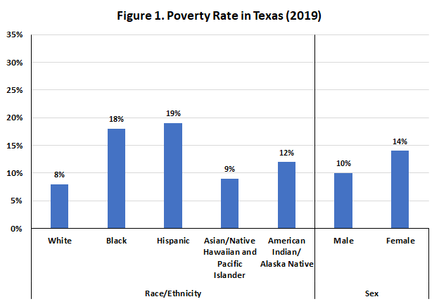
Notes: Persons of Hispanic origin may be of any race; all other racial/ethnic groups are non-Hispanic. The U.S. Census Bureau's poverty threshold for a family with two adults and one child was $20,578 in 2019.
Source: Kaiser Family Foundation estimates based on the 2008-2019 American Community Survey, 1-Year Estimates. https://www.kff.org/statedata/

Source: Kaiser Family Foundation. Licensed under CC BY-NC-ND 4

ACCOMMODATIONS NOTE: The figures from the Kaiser Family Foundation below are not accessible and do not meet ADA guidelines. In Canvas is an Excel spreadsheet where the data is accessible for all.

Figures to Be Used

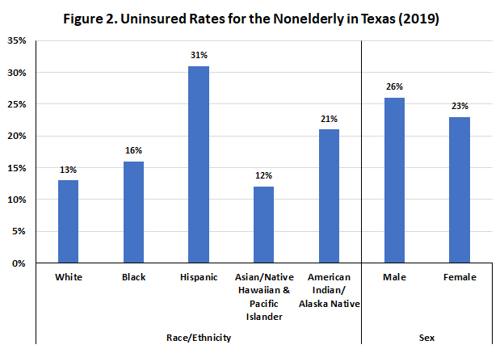
Notes: Persons of Hispanic origin may be of any race; all other racial/ethnic groups are non-Hispanic. “Uninsured” includes those without health insurance and those who have coverage under the Indian Health Service only. “Rate” refers to the percentage of the population or subpopulation with no insurance.
Source: Kaiser Family Foundation estimates based on the 2008-2019 American Community Survey, 1-Year Estimates. https://www.kff.org/statedata/

Source: Kaiser Family Foundation. Licensed under CC BY-NC-ND 4

ACCOMMODATIONS NOTE: The figures from the Kaiser Family Foundation below are not accessible and do not meet ADA guidelines. In Canvas is an Excel spreadsheet where the data is accessible for all.

Figures to Be Used

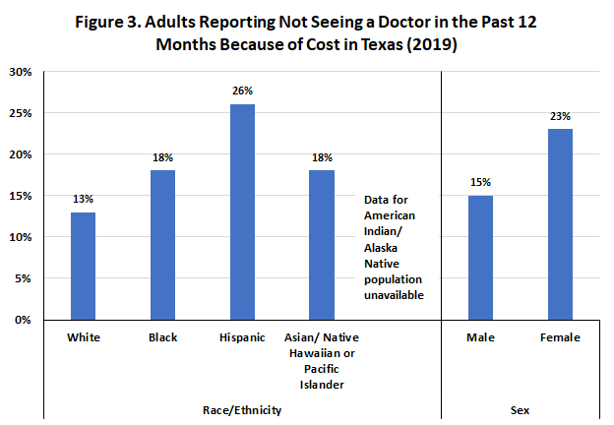
Notes: Persons of Hispanic origin may be of any race; all other racial/ethnic groups are non-Hispanic. Data represent adults who reported that there was a time in the past 12 months when they needed to see a doctor but could not because of cost.
Source: Kaiser Family Foundation analysis of the Centers for Disease Control and Prevention (CDC)'s 2013-2019 Behavioral Risk Factor Surveillance System (BRFSS). https://www.kff.org/statedata/

Source: Kaiser Family Foundation. Licensed under CC BY-NC-ND 4

ACCOMMODATIONS NOTE: The figures from the Kaiser Family Foundation below are not accessible and do not meet ADA guidelines. In Canvas is an Excel spreadsheet where the data is accessible for all.

Figures to Be Used

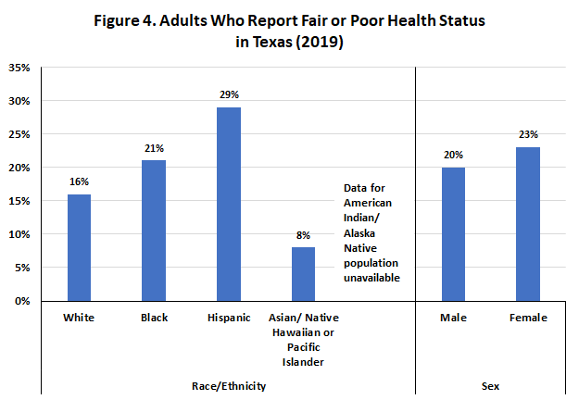
Notes: Persons of Hispanic origin may be of any race; all other racial/ethnic groups are non-Hispanic. The remaining categories of self-reported health are “good,” “very good,” and “excellent.”
Source: Kaiser Family Foundation analysis of the Centers for Disease Control and Prevention (CDC)'s 2013-2019 Behavioral Risk Factor Surveillance System (BRFSS). https://www.kff.org/statedata/

Source: Kaiser Family Foundation. Licensed under CC BY-NC-ND 4

ACCOMMODATIONS NOTE: The figures from the Kaiser Family Foundation below are not accessible and do not meet ADA guidelines. In Canvas is an Excel spreadsheet where the data is accessible for all.

