Syllabus: MGMT 3660/400 & 401
Contemporary Business Writing and Presentation Skills (5-week course)
Instructor | Email & Zoom | Office Location & Hours
Mara Singer | Mara.Singer@UNT.edu  https://unt.zoom.us/my/  marasinger | Via Zoom  Thursdays from 11-12:30 pm  or by appointment
Teaching Assistant | Email
My Nguyen | NgocDiemMy.Nguyen@unt.edu
  - Summer 2026 Online May 18 – June 19

WELCOME!
Welcome to MGMT 3660! In today's interconnected business world, effective communication across cultures and platforms is a crucial professional skill. This course will equip you with the knowledge and practical experience to communicate confidently and effectively in diverse professional settings, whether by writing compelling business documents, delivering impactful presentations, or navigating cross-cultural business interactions.

Course Description
This course provides you with the knowledge and skills necessary for effective oral and written communication in domestic and international professional settings. You'll learn to communicate professionally by mastering how to:
- Write effective business documents
- Deliver structured presentations
- Increase intercultural competencies
- Apply emotional intelligence to professional communication
- Compose effective business emails and reports

Expectations and Goals
By the end of our five-week course, you will be able to:

Professional Communication
- Select effective communication channels
- Choose the right medium for different audiences and purposes
- Understand strengths and limitations of digital and non-digital communication

- Create professional written documents
- Apply effective writing processes
- Produce clear, concise, and correct business documents

- Deliver professional presentations
- Design effective visuals and content
- Demonstrate strong verbal and nonverbal skills
- Adapt presentations for synchronous and asynchronous formats
- Collaborate effectively with team members on virtual platforms

Intercultural Communication
- Communicate effectively across cultures
- Identify how cultural dimensions impact business communication
- Navigate international business etiquette and customs
- Create messages for global audiences

Course Materials
I will be providing you with several readings on Canvas.
Any such readings will be listed in the course schedule (in your Course Materials module) or by an announcement. Be sure to check the Course Materials module for those files.

Free, open-source textbooks:
Business Communication for Success
https://pressbooks.gvsu.edu/businesscommunication/
Chapters 9, 14, 17, 20

Technical and Professional Communication
https://open.library.okstate.edu/technicalandprofessionalwriting/
Chapters 1, 2, 4, 5, 6, 9

Effective Professional Communication
https://openpress.usask.ca/rcm200/
Chapters 2, 5, 25, 26, 27, 28, 30, 31, 32, 33 and Appendices C, F, H

Suggested Textbook
Talk Like Ted: The 9 public speaking secrets of the world’s top minds (2022) by Carmine Gallo (Amazon)
Smart Brevity: The Power of Saying More with Less (2022) by J. Vandehei, M. Allen, & R. Schwartz (Amazon)

Additional Information and Resources
https://emilypost.com/advice/downloadable-business-etiquette-resources

Additional readings will be posted in Canvas under the modules.

What’s this course about….
MGMT 3660 – Summer 2026
Success in an Online Course
While the online classroom shares many similarities with the face-to-face classroom, success in online education requires specific skills and expectations that any dedicated student can learn. Check How to Succeed as an Online Student for tips and resources for successful online learning.

Keys to Success
Stay on Schedule
- Be sure you know due dates and test dates
- Turn in work on time (preferably before it is due in case there are any problems)
- Check Canvas regularly for announcements and updates
- Be aware that each module requires about 8-10 hours of work per week
Get Help Early
- Attend office hours via Zoom
- Email me with questions (I respond within 24 hours on weekdays)
- Use UNT support services
Engage Actively
- Seek feedback and apply feedback to improve your work
- Participate meaningfully in discussions
- Complete all practice exercises
- Check grades weekly and inquire within 4 days if you have questions
Technical Support
- UIT Help Desk: http://www.unt.edu/helpdesk/index.htm
- Email: helpdesk@unt.edu
- Phone: 940-565-2324
- Location: Sage Hall, Room 330
- Hours: Mon-Thu (8am-midnight), Fri (8am-8pm), Sat (9am-5pm), Sun (noon-midnight)

Getting Help
The University is committed to providing a reliable online course system to all users. However, in the event of any unexpected server outage or any unusual technical difficulty which prevents students from completing a time sensitive assessment activity, the instructor will extend the time windows and provide an appropriate accommodation based on the situation. Students should immediately report any problems to the instructor and contact the UNT Student Help Desk and obtain a ticket number. The instructor and the UNT Student Help Desk will work with the student to resolve any issues at the earliest possible time.

UNT Help Desk: Sage Hall 330 | (940) 565-2324 | http://it.unt.edu/helpdesk | helpdesk@unt.edu
In Person: Sage Hall, Room 330 Walk-In Availability: 8am-9pm
Telephone Availability:
• Sunday: noon-midnight
• Monday-Thursday: 8am-midnight
• Friday: 8am-8pm
• Saturday: 9am-5pm
Laptop Checkout: 8am-7pm

For additional support, visit Canvas Technical Help.

UNT provides mental health resources to students to help
ensure they have numerous outlets to turn to regardless of
the nature of an issue or its severity. Listed below are several
resources on campus that can support students’ academic
success and mental well-being:
• Student Health and Wellness Center (https://studentaffairs.
unt.edu/student-health-and- wellness-center)
• Counseling and Testing Services (https://studentaffairs.unt.edu/counseling-and-testing-services)
• UNT Care Team (https://studentaffairs.unt.edu/care)
• UNT Psychiatric Services (https://studentaffairs.unt.edu/student-health-and-wellness-center/services/psychiatry)
• Individual Counseling (https://studentaffairs.unt.edu/counseling-and-testing-services/services/individual-counseling)

Other student support services offered by UNT include the
following:
• Registrar (https://registrar.unt.edu/registration)
• Financial Aid (https://financialaid.unt.edu/)
• Student Legal Services (https://studentaffairs.unt.edu/student-legal-services)
• Career Center (https://studentaffairs.unt.edu/career-center)
• Multicultural Center (https://edo.unt.edu/multicultural-center)
• Counseling and Testing Services (https://studentaffairs.unt.
edu/counseling-and-testing-services)
• Pride Alliance (https://edo.unt.edu/pridealliance)
• UNT Food Pantry (https://deanofstudents.unt.edu/resources/food-pantry)

UNT offers the following academic support services:
• Academic Resource Center (https://clear.unt.edu/canvas/student-resources)
• Academic Success Center (https://success.unt.edu/asc)

Be an active learner.
You will retain more information and perform better in the course if you learn
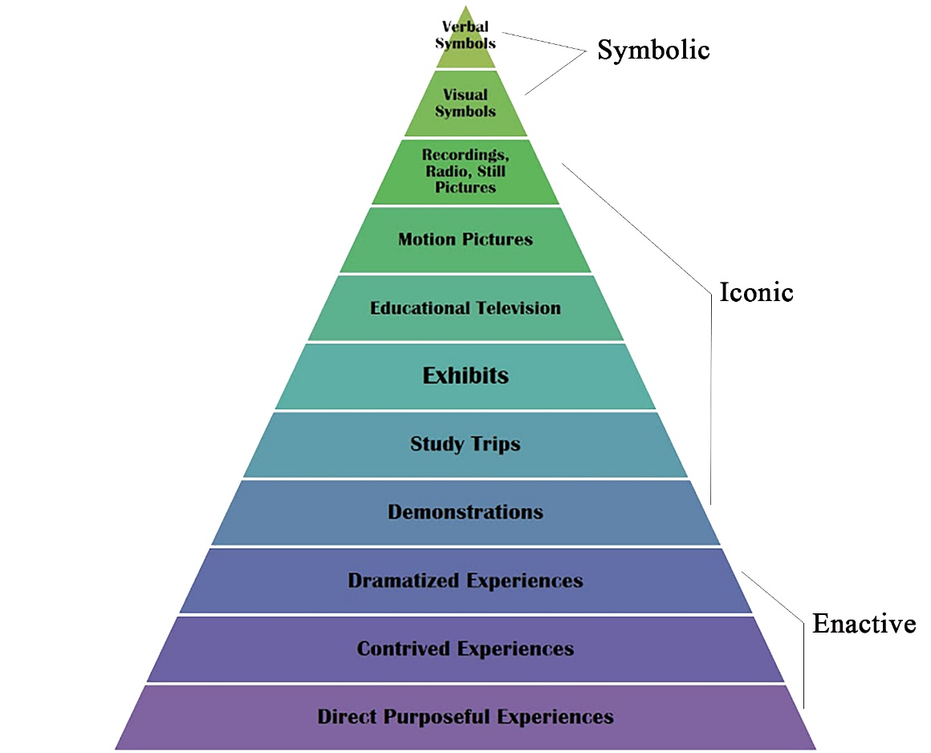
actively rather than passively. The Cone of Experience illustrates the differences between active and passive learning. The top half of the triangle represents passive learning, which includes reading, hearing words, and watching videos. The bottom half of the triangle illustrates active learning, which includes conducting a presentation, simulating a real experience, and participating in hands-on workshops. Note that learners remember “10 percent of what they read” but “70 percent of what they say and write” and “90 percent of what they do.” In other words, you will be more successful in the course if you read, take notes, participate, and complete all assignments.
Source: https://www.researchgate.net/figure/Edgar-Dales-Cone-of-Experience-shows-that-after-two-weeks-we-mainly-remember-information_fig1_336935595

Seek Feedback
First and foremost, I am here to help you! Office hours offer you the opportunity to ask for clarification or find support with understanding the class materials. Come visit me! I am here to help you and always welcome students’ questions. I hold in-person and virtual office hours. Students who visit me during office hours typically do better than they would have if they had neglected to seek help. If you are unable to connect during office hours, please email me with two times / days you may be available for an appointment. Remember to be proactive in your learning and seek clarification.

Use my UNT email address when you want to contact me. Students should only email me from their UNT student email address so that I know the message is from a student and it does not get filed as junk by the system. I will try to respond to email inquiries received Mondays through Fridays within 24 hours. You should not expect an answer on weekends or after 5 pm on weekdays. Include your class section in all correspondence. You may also contact me via Canvas Inbox. Students should not expect to contact me via the comments section on a Canvas assignment page. I will leave feedback about the assignment in this section. However, this should not be used if students are looking for a response to their questions.

Check Announcements in Canvas
Plan to check announcements in Canvas regularly. I will use this section in Canvas to share updates, resources to complete assignments, and assignment feedback with the class.

Meet all deadlines
No late assignments will be accepted. You will be able to make up assignments or quizzes only if you have a UNT-approved excused absence that is due to extenuating circumstances. “I had a technical problem,” “my Internet was down,” “my niece was sick,” “my dog was sick,” “I didn’t feel well,” “I could not find a parking place” etc., are not UNT-approved excuses or extenuating circumstances. If you submit an assignment after the due date without proper documentation, you will receive a grade of zero. Refer to UNT’s Policy 06-039 (revised in February 2019) for information about excused absences.

All assignments must be submitted via Canvas. Emailed assignments will not be accepted.

Check Your Grades Every Week

Because this is a condensed course, you have 4 days to inquire about your grade on an assignment, exercise, quiz, or final after I post it on Canvas. Please wait 24 hours before contacting me to dispute a grade. During that time, you should review the assignment details, the grading rubric, the feedback you have received, and reflect on the quality of the work you turned in. If you would still like to meet, send me an email to set up a meeting in person or on Zoom since I am not permitted to discuss grades over email. In your email, explain why I should reconsider your grade and submit any supporting documentation. You should come to our scheduled meeting with specific examples that demonstrate that you earned a higher grade than you received. If you miss your scheduled meeting, you forfeit your right to a grade dispute. If you contact me to schedule a meeting after 5 days of receiving your grade, you also forfeit your right to a grade dispute.

The instructor reserves the right to make changes to the syllabus and course schedule. Changes to the syllabus, course information, and due dates will be available in Canvas.

Assessing Your Work
Written and oral assignments, graded exercises, quizzes, and the departmental final will allow you to earn your desired grade in this course. I will calculate your final grade by adding the points you earned during the semester.
Remember, the grade you receive is the grade you EARNED!

Course Evaluation
Your final grade for this course will consist of the following evaluations:
CATEGORY | COMPONENTS | POINTS
Business Communication | Professional Email Series & EI Reflection | 100
 | Proposal Presentation Full-Sentence Outline | 50
 | Proposal Presentation | 100
 | Negative News Email | 50
 | Final Business Report | 200
Cross-Cultural Communication | International Business Presentation | 100
Assessments | Exercises (10 @ 30 points each) | 300
 | Discussion boards (1per week @ 20 points each) | 100
 | Syllabus quiz | 10
TOTAL |  | 1,010

Grading Scale
A | 90-100%
B | 80-89%
C | 70-79%
D | 60-69%
F | 0-59%
Instructors will assess students’ performance with the following methods of evaluation:
- Written Assignments
- Oral Assignments
- Exercises and Quizzes
- Discussion Board

These percentages will change if new practical exercises are added.
Departmental quizzes and practical exercises are predominantly writing based.
* Students must dress professionally for the major oral assignment (group project and presentation).
The associate dean for assessment and academic reporting will receive a copy of the final exam results and report them to the AACSB and SACS accrediting agencies.
Any Extra Credit options are posted on Canvas.
Grades are based on mastery of content. As a rule, I do not round grades, nor do I offer additional exercises at the end of the semester to improve grades.

Graded Activities
The course components described below will make up your total grade. More information about the assignments and grading rubrics will be available on Canvas. Please review the Canvas assignments for descriptions and guidelines for each assignment.
Turnaround Time: You will receive feedback on written assignments and presentations between 5-10 business days after submission.

Application Exercises
Practical Exercises will help you improve your writing competency. They will also help you prepare for the major assignments. Each graded practical exercise will be worth 30 points. You have two total attempts at each exercise. You will be unable to obtain a good grade if you don’t study the module learning materials and the relevant textbook chapters.

Extra Credit
You will have the following opportunities to earn extra credit:
https://www.linkedin.com/learning/tips-for-writing-business-emails
Tips for Writing Emails: You will receive 5 bonus points if you complete this LinkedIn Learning course and submit proof that you completed the course successfully. You must complete this course and turn in your certificate by June 17.

SPOT Evaluations
Student Perceptions of Teaching (SPOT) is the student evaluation system for UNT. SPOT allows students the ability to provide confidential constructive feedback to their instructor and department to improve the quality of student experiences in the course. SPOT is a requirement for all organized classes at UNT. The survey will be available during the last week of the semester to provide students with an opportunity to evaluate how this course is taught. Students will receive an email from “UNT SPOT Course Evaluations via IASystem Notification” with the survey link. Students should look for the email in their UNT email inbox. They should simply click on the link and complete the survey. Once students complete the survey, they will receive a confirmation email that they have submitted the survey. For additional information, please visit the SPOT website or email spot@unt.edu.

UNT POLICIES
Academic Integrity Policy
Academic Integrity Standards and Consequences. According to UNT Policy 06.003, Student Academic Integrity,
academic dishonesty occurs when students engage in behaviors including, but not limited to cheating, fabrication,
facilitating academic dishonesty, forgery, plagiarism, and sabotage. A finding of academic dishonesty may result in
a range of academic penalties or sanctions ranging from admonition to expulsion from the University.

Students with Accommodations
The College of Business complies with the Americans with Disabilities Act in making reasonable accommodations for qualified students with disabilities. University policy requires that students notify their instructors within the first week of classes that accommodations will be needed. If you have an established disability as defined in the Americans with Disabilities Act and would like to request accommodations, please contact Dr. Singer as soon as possible.

ADA Policy Statement
The University of North Texas makes reasonable academic accommodation for students with disabilities. Students seeking reasonable accommodation must first register with the Office of Disability Access (ODA) to verify their eligibility. If a disability is verified, the ODA will provide you with a reasonable accommodation letter to be delivered to faculty to begin a private discussion regarding your specific needs in a course. You may request reasonable accommodations at any time; however, ODA notices of reasonable accommodation should be provided as early as possible in the semester to avoid any delay in implementation. Note that students must obtain a new letter of reasonable accommodation for every semester and must meet with each faculty member prior to implementation in each class. Students are strongly encouraged to deliver letters of reasonable accommodation during faculty office hours or by appointment. Faculty members have the authority to ask students to discuss such letters during their designated office hours to protect the privacy of the student. For additional information, refer to the Office of Disability Access website (https://studentaffairs.unt.edu/office-disability-access). You may also contact ODA by phone at (940) 565-4323.

Important Notice for F-1 Students taking Distance Education Courses
To read detailed Immigration and Customs Enforcement regulations for F-1 students taking online courses, please
go to the Electronic Code of Federal Regulations website. The specific portion concerning distance education courses is located at Title 8 CFR 214.2 Paragraph (f)(6)(i)(G).
The paragraph reads:
(G) For F-1 students enrolled in classes for credit or classroom hours, no more than the equivalent of one class or
three credits per session, term, semester, trimester, or quarter may be counted toward the full course of study requirement if the class is taken on-line or through distance education and does not require the student’s physical
attendance for classes, examination or other purposes integral to completion of the class. An on-line or distance
education course is a course that is offered principally through the use of television, audio, or computer transmission including open broadcast, closed circuit, cable, microwave, or satellite, audio conferencing, or computer conferencing. If the F-1 student’s course of study is in a language study program, no on-line or distance education classes may be considered to count toward a student’s full course of study requirement.

University of North Texas Compliance
To comply with immigration regulations, an F-1 visa holder within the United States may need to engage in an
on-campus experiential component for this course. This component (which must be approved in advance by the instructor) can include activities such as taking an on-campus exam, participating in an on-campus lecture or lab activity, or other on-campus experience integral to the completion of this course. If such an on-campus activity is required, it is the student’s responsibility to do the following:
1. Submit a written request to the instructor for an on-campus experiential component within one week of the
start of the course.
2. Ensure that the activity on campus takes place and the instructor documents it in writing with a notice sent to
the International Student and Scholar Services Office. ISSS has a form available that you may use for this purpose.
Because the decision may have serious immigration consequences, if an F-1 student is unsure about his or her need to participate in an on-campus experiential component for this course, s/he should contact the UNT International Student and Scholar Services Office at 940-565-2195 or by email to get clarification before the one-week deadline.

Student Verification
UNT takes measures to protect the integrity of educational credentials awarded to students enrolled in distance education courses by verifying student identity, protecting student privacy, and notifying students of any special meeting times/locations or additional charges associated with student identity verification in distance education courses. See UNT Policy 07-002 Student Identity Verification, Privacy, and Notification and Distance Education Courses for more information.

Use of Student Work
A student owns the copyright for all work (e.g. software, photographs, reports, presentations, and email postings) he or she creates within a class, and UNT is not entitled to use any student work without the student’s permission unless all of the following criteria are met:
• The work is used only once.
• The work is not used in its entirety.
• Use of the work does not affect any potential profits from the work.
• The student is not identified.
• The work is identified as student work.
If the use of the work does not meet all of the above criteria, then the university office or department using the work must obtain the student’s written permission.
Transmission and Recording of Student Images in Electronically-Delivered Courses
1. No permission is needed from a student for his or her image or voice to be transmitted live via videoconference
or streaming media, but all students should be informed when courses are to be conducted using either method
of delivery.
2. In the event an instructor records student presentations, he or she must obtain permission from the student
using a signed release in order to use the recording for future classes in accordance with the Use of Student-Created Work guidelines above.
3. Instructors who video-record their class lectures with the intention of re-using some or all of recordings for
future class offerings must notify students on the course syllabus if students’ images may appear on video. Instructors are also advised to provide accommodation for students who do not wish to appear in class recordings.

G. Brint Ryan College of Business Statement of Academic Honesty
The G. Brint Ryan College of Business takes academic honesty seriously. Ethics and integrity are important business values, essential to building trust and adhering to both professional and legal standards. Academic dishonesty destroys trust, damages the reputation and value of degrees and is unacceptable.

Some of the most common examples of academic integrity violations include plagiarism or cheating, such as unauthorized assistance on examinations, homework, research papers, or case analyses. Your work must be entirely your own. When working on assignments, you should not discuss your work with others unless approved by the course instructor. When preparing your assignments, you must cite all outside sources in the manner requested by your instructor (APA style). Copying or using material from any source prepared by or previously submitted by others at UNT or other institutions or downloaded from the Internet is plagiarism.

Unless directed otherwise in an assignment, large scale cutting and pasting from other sources, even if properly footnoted, is not appropriate. You should synthesize this material in your own words and provide a footnote.

Your instructor will specify what materials, if any, may be used on tests and exams. Using materials other than those permitted, talking with other individuals during the exam, individuals exchanging information about an exam after one has taken the exam and the other has not, or copying or using material from another individual’s exam is academic dishonesty and will result in a meeting to discuss academic integrity violations and potentially issue sanctions mentioned above and may result in ineligibility for academic scholarships. The use of online assistance, such as sites commonly used for finding homework solutions, group chat, cell phones, smart watches, and similar tools during exams is not allowed for any reason unless specifically permitted. No portion of an exam may be copied or photographed without permission.

Students are expected to conduct themselves in a manner consistent with the University’s status as an institution of higher education. A student is responsible for responding to a request to discuss suspected academic dishonesty when issued by an instructor or other University official. If a student fails to respond after a proper attempt at notification has been made, the University may take appropriate actions in the absence of the student’s participation.

Acceptable Student Behavior
Students should conduct themselves in a manner that demonstrates respect for the rights and property of others and upholds the integrity of the university community. Student behaviors that interfere with the instructor’s ability to conduct a class or the students’ ability/opportunity to learn are unacceptable. Students engaging in unacceptable behaviors may be directed to leave the classroom and may also be referred to the Dean of Students. UNT’s expectations for student conduct apply to all instructional forums, including onsite and online classrooms, labs, discussion groups, and field trips. The Code of Student Conduct is available at: https://deanofstudents.unt.edu/conduct.

Artificial Intelligence (AI) Usage Rules Intellectual honesty is vital to an academic community. Thus, all work submitted in this course must be your own, completed in accordance with the university’s academic regulations. Do not use any type of AI to write your written assignments or any other work in this course. All content must be developed/written by you. Otherwise, the assignment will be scored zero points. (However, you can use grammar checker programs such as Grammarly to check your spelling and grammar.)

UNT Learning Center (Sage Hall, Room 315, Learning.Center@unt.edu, 940-369-7006)
The UNT Learning Center offers assistance to help students succeed in their classes. The Learning Center offers free tutoring, workshops, and the following programs: Supplemental Instruction (group study sessions for many core courses), Volunteer Tutors (individualized tutoring in over 100 courses), Connecting for Success (individualized academic counseling and resource referrals), SMARTHINKING.com (24/7 online tutoring), Learning Success Workshops (covering an array of academic topics), Academic Success Programs (series for students on Academic Alert/Probation), Study Skills Classes, and Speed Reading Classes.

Emergency Notification & Procedures - Eagle Alert
UNT uses a system called Eagle Alert to quickly notify students with critical information in the event of an emergency (e.g., severe or inclement weather, campus closing, health and public safety emergencies like chemical spills, fires, violence). Students are responsible for providing UNT with their phone numbers. The system can send voice messages and text messages. UNT also has a campus emergency Twitter account at @UNTEagleAlert and a “Mean Green Ready” mobile app. In the event of a university closure, students should refer to Canvas for the contingency plans prepared by their instructors.

Emergency Evacuation Procedures for the Business Leadership Building
Severe Weather: In the event of severe weather, all building occupants should immediately seek shelter in the designated shelter-in-place in the building. If unable to safely move to the designated shelter-in-place area, seek shelter in a windowless interior room or hallway on the lowest floor of the building. All building occupants should take shelter in rooms 055, 077, 090, and the restrooms on the first floor.

Bomb Threat/Fire: In the event of a bomb threat or fire in the building, all building occupants should immediately evacuate the building using the nearest exit. Once outside, proceed to the designated assembly area. If unable to safely move to the designated assembly area, contact one or more members of your department or unit to let them know you are safe and inform them of your whereabouts. Persons with mobility impairments who are unable to safely exit the building should move to a designated area of refuge and await assistance from emergency responders. All building occupants should immediately evacuate the building and proceed to the south side of Crumbly Hall in the grassy area west of parking lot 24.

Retention of Student Records
The Family Educational Rights and Privacy Act of 1974 (FERPA) protects the privacy of the students’ educational records. Individual instructors will maintain their students’ educational records, such as exams and assignments in a secure location for at least one calendar year after course completion. Students have the right to view their individual records.

