KINE 4000: Psychology of Sport
Department of Kinesiology, Health Promotion, and Recreation
University of North Texas, Fall Semester – 2026

Instructor Information
Megan Ware, M.S., PhD
Assistant Professor of Sport and Exercise Psychology
Department of Kinesiology, Health Promotion, and Recreation
Pronouns: she/her/hers
Office Location: Physical Education Building (PEB), room 205H
Office Hours: Monday 1:00-2:00 PM, Wednesday 12:00 noon- 2:00 PM
Email: Megan.ware@unt.edu
Class Day and Time: Monday and Wednesday, 2:20-3:40PM
Class Location: Business Leadership Building (BLB) 170

Teaching Assistant (TA) Information
Alan Alcala
AlanAlcala@my.unt.edu

Primary Undergraduate Textbook (optional)
Weinberg, R. S., & Gould, D. (2024). Foundations of sport and exercise psychology (8th ed.). Champaign, IL: Human Kinetics.

Additional Suggested Resources (not required)
Meltzoff, J. & Cooper, H. (2018). Critical thinking about research: Psychology and related fields (2nd ed.). Washington, DC: American Psychological Association.

American Psychological Association. (2020). Publication manual of the American Psychological Association (7th ed.). Washington, DC: American Psychological Association.

Leong, F. T., & Austin, J. T. (2024). The psychology research handbook: A guide for graduate students and research assistants (3rd ed.). Thousand Oaks, CA: SAGE Publications.

Strunk, W., & White, E. B. (1999). Elements of style (4th ed.). New York, NY: Macmillan.

Note. Additional readings may be posted on Canvas throughout the semester. You will be expected to read these materials for discussions, quizzes, and exams.

Primary Topics

Part I Introduction to Sport and Exercise Psychology

Part II Learning about Participants

Part III Understanding Sport and Exercise Environments

Part IV Focusing on Group Processes

Part V Improving Performance

Part VI Enhancing Health and Well-Being

Part VII Facilitating Psychological Growth and Development

Course Description

The purpose of this course is to provide an overview of the theories and principles that influence human behavior in sport and physical activity. The American Psychological Association (Division 47) defines sport and exercise psychology as the scientific study of the psychological factors associated with participation and performance in sport, exercise, and other types of physical activity. Sport and exercise psychology practitioners focus primarily on:

- Helping individuals use psychological principles and skills to achieve optimal mental health and to improve performance.

- Understanding how participation in sport, exercise, and physical activity affects their psychological development, health, and well-being.

Course Objectives
- To develop an understanding of sociological and psychological factors related to human movement and behavior in sport and physical activity.

- To read, synthesize, and critique existing scientific literature; and to discuss the status and ramifications for future research related to sport and physical activity.

- To become acquainted with contemporary theory, research design, methodology, and analytical techniques appropriate to sport and exercise psychology research.

- To demonstrate an ability to incorporate sport and exercise psychology theory covered in class by completing a research project in the field.

- To understand effective interventions and strategies for improving human performance and effectiveness in sport and physical activity.

Course Expectations
- This course offers you the flexibility to drop your lowest exam and quizzes; however, such a structure requires self-discipline and motivation to ensure you are trying to perform your best throughout the semester.

- If you have special learning needs, inform me immediately.

- If at any point during the semester you are unhappy with your performance in this class, contact me immediately.

- Academic dishonesty will not be tolerated (e.g., copying, plagiarism, cheating) and will result in a failing grade for the semester.

Course Structure
Both in-class and online (Canvas) platforms will be used to enhance the delivery of this course. Students must check the Canvas site regularly for course updates. Canvas will provide a description of each class, class projects, and reading assignments. Additionally, lecture notes, chapter self-tests, project information, exam review materials, and other chapter materials will be found on the Canvas site.

Course Prerequisites
PHED 1000, KINE 2030, KINE 2050, and KINE 3080 with a minimum average GPA of a 3.0 across the four courses are required prior to taking this course.

Course Competencies of Strength and Conditioning
The UNT Department of Kinesiology, Health Promotion, and Recreation is recognized by the NSCA Education Recognition Program (ERP) and maintains the standards for the Council on Accreditation of Strength and Conditioning Education (CASCE). This course is designed to equip students with the knowledge, skills, and abilities in strength and conditioning. In alignment with CASCE Professional Standards and Guidelines, this course curriculum includes competencies in psychology of sport and exercise (III.C.5.a-i).

Technical Support

For any technical issues that you may encounter during the duration of this class, contact the UNT Student Helpdesk at:

UIT Helpdesk

Location: Sage Hall, 130

Phone: 940-565-2324

Email: helpdesk@unt.edu

Technical Skill Requirements
Students will be required to understand how to download and upload files, send and receive emails, and navigate the Canvas online learning platform.

Use of Generative AI
You are encouraged, in a limited fashion, to use Generative AI (GenAI) tools such as Claude, ChatGPT, Gemini, etc. to support your learning and develop skills for a GenAI-oriented workforce. This use will help us stay technically proficient and ethically grounded. However, GenAI should complement, not replace, your critical thinking or our course materials. If something seems unclear, please seek clarification.

In accordance with the UNT Honor Code, unauthorized use of GenAI tools is
prohibited. Using GenAI content without proper credit or substituting your own work
with GenAI undermines the learning process and violates UNT academic integrity
policy. If you're unsure whether something is allowed, please seek clarification.

Classroom Etiquette
This course involves lectures and activities in and out of class. Student behavior that interferes with an instructor’s ability to conduct a class or other students' opportunity to learn is unacceptable, disruptive, and will not be tolerated in any instructional forum at UNT. Students are expected to be respectful to the instructor and other students.

As members of the UNT community, we have all made a commitment to be part of an institution that respects and values the identities of the students and employees with whom we interact. UNT does not tolerate identity-based discrimination, harassment, and retaliation. UNT’s full Non-Discrimination Policy can be found in the UNT Policies section of the syllabus.

Guidelines:
- Come to class prepared and ready to start on time.
- Turn cell phones off or to vibrate. If your phone rings during class, silence the call. If you must take a call, exit the classroom to talk.
- Only discuss topics related to course content during class time. Talking during a lecture or engaging in inappropriate discussions is distracting to others and me.
- Using a laptop to take notes is allowed, but not suggested. According to several recent studies, computers can hinder learning and is distracting to others (Sana, Weston, & Cepeda, 2013). Sit in the back row with the volume muted if you plan on using a computer during class.

Failure to follow these guidelines will result in you:
- Being asked to leave the classroom,
- Receiving a “zero” on the activity (quiz, test, etc.) of the day, and
- Possibly being referred to the Center for Student Rights and Responsibilities to consider whether conduct violated the Code of Student Conduct (Policy 07.012).

Out of Classroom Etiquette (emails and scheduled appointments/office hours)
Information about this class and updates to the assignments will be posted as announcements on Canvas and sent via email to your UNT account. If you do not use your UNT account on a regular basis, then forward your e-mail messages to an account that you check on a regular basis.

Send emails to Megan.ware@unt.edu and not only through Canvas. Students are expected to write professional emails carefully and thoughtfully. For example, use a meaningful and specific subject line (e.g., KINE 4000: Project 1 Question), a greeting (e.g., Hello Dr. Ware), and a signature with your name at the end (e.g., Best regards, John Doe). Note. Writing professional emails is an important skill for all students so proofread before sending and avoid using abbreviations and all lower/upper case lettering. Due to the large number of emails that I receive, you must include “KINE 4000” in your subject if you want me to receive the email sooner.

If you need to speak with me and have a conflict with a scheduled appointment/office hours, I will be happy to make a separate appointment at a time that is convenient for us both. Be punctual when we have a scheduled appointment/office hours. For example, showing up 20 minutes after a scheduled appointment/office hours may result in my door being closed, the remote session being deactivated, and cancellation of the meeting. Additionally, come to scheduled appointments/office hours focused and ready to talk about your ideas, questions, and/or concerns.

Rules of Engagement

Rules of engagement refer to the way students are expected to interact with each other and with their instructors. Here are some general guidelines:

- While the freedom to express yourself is a fundamental human right, any communication that utilizes cruel and derogatory language on the basis of race, color, national origin, religion, sex, sexual orientation, gender identity, gender expression, age, disability, genetic information, veteran status, or any other characteristic protected under applicable federal or state law will not be tolerated.

- Treat your instructor and classmates with respect in any communication online or face-to-face, even when their opinion differs from your own.

- Ask for and use the correct name and pronouns for your instructor and classmates.

- Speak from personal experiences. Use “I” statements to share thoughts and feelings. Try not to speak on behalf of groups or other individual’s experiences.

- Use your critical thinking skills to challenge other people’s ideas, instead of attacking individuals.

- Avoid using all caps while communicating digitally. This may be interpreted as “YELLING!”

- Be cautious when using humor or sarcasm in emails or discussion posts as tone can be difficult to interpret digitally.

- Avoid using “text-talk” unless explicitly permitted by your instructor.

- Proofread and fact-check your sources.

- Keep in mind that online posts can be permanent, so think first before you type.

See these Engagement Guidelines (https://clear.unt.edu/online-communication-tips) for more information.

Americans with Disabilities Compliance (Policy 04.015)

The University of North Texas makes reasonable academic accommodation for students with disabilities. Students seeking reasonable accommodation must first register with the Office of Disability Access (ODA) to verify their eligibility. If a disability is verified, the ODA will provide you with a reasonable accommodation letter to be delivered to faculty to begin a private discussion regarding your specific needs in a course. You may request reasonable accommodations at any time; however, ODA notices of reasonable accommodation should be provided as early as possible in the semester to avoid any delay in implementation. Note that students must obtain a new letter of reasonable accommodation for every semester and must meet with each faculty member prior to implementation in each class. Students are strongly encouraged to deliver letters of reasonable accommodation during faculty office hours or by appointment. Faculty members have the authority to ask students to discuss such letters during their designated office hours to protect the privacy of the student. For additional information, refer to the Office of Disability Access website (https://studentaffairs.unt.edu/office-disability-access/). You may also contact ODA by phone at 940-565-4323.

Prohibition of Discrimination, Harassment, and Retaliation (Policy 16.004)
The University of North Texas (UNT) prohibits discrimination and harassment because of race, color, national origin, religion, sex, sexual orientation, gender identity, gender expression, age, disability, genetic information, veteran status, or any other characteristic protected under applicable federal or state law in its application and admission processes; educational programs and activities; employment policies, procedures, and processes; and university facilities. The University takes active measures to prevent such conduct and investigates and takes remedial action when appropriate. This policy can be reviewed online at https://policy.unt.edu/policy/16-004.

Ethical Standards and Academic Dishonesty (Policy 06.003)
Students are expected to conduct themselves in a manner consistent with the University's status as an institution of higher education. In the class setting, students shall follow their instructors’ directions and observe all academic standards and requirements published in course syllabi and other course materials. A student is responsible for responding to an academic dishonesty report issued by an instructor or other University authority. If a student fails to respond after proper attempts at notification, the University may take appropriate academic actions in the absence of the student.

UNT policy will be followed in cases of academic dishonesty (e.g., cheating, plagiarizing, copying, etc.). Students caught cheating during an exam/quiz or plagiarizing a written assignment will be charged under the University's Code of Student Conduct. Among other punishments, students found guilty run the risk of having their score changed to a zero, receiving a grade of F for the course, and/or dismissal from the University. Students should be familiar with the Student Standards of Academic Integrity. Please review the student rights and responsibilities information online at https://policy.unt.edu/policy/06-003.

Family Educational Rights and Privacy Act (FERPA) Information (Policy 07.018)
Students have the right to expect their grades will be kept confidential. Every attempt will be made to keep your information confidential. Neither your course grades nor grades for any assignment will be posted in a way that could result in you being identified by other students or faculty members. The FERPA policy can be reviewed online at https://policy.unt.edu/policy/07-018.

Emergency Notification & Procedures
UNT uses a system called Eagle Alert to quickly notify students with critical information in the event of an emergency (i.e., severe weather, campus closing, and health and public safety emergencies like chemical spills, fires, or violence). In the event of a university closure, please refer to Canvas for contingency plans for covering course materials.

Retention of Student Records (Policy 04.008)
Student records pertaining to this course are maintained in a secure location by the instructor of record. All records such as exams, answer sheets (with keys), and written papers submitted during the duration of the course are kept for at least one calendar year after course completion. Course work completed via the Canvas online system, including grading information and comments, is also stored in a safe electronic environment for one year. Students have the right to view their individual record; however, information about student’s records will not be divulged to other individuals without proper written consent. Students are encouraged to review the Public Information Policy and the Family Educational Rights and Privacy Act (FERPA) laws and the University’s policy. See UNT Policy 04.008, Records Management and Retention (https://policy.unt.edu/policy/04-008) for additional information.

Acceptable Student Behavior
Student behavior that interferes with an instructor’s ability to conduct a class or other students' opportunity to learn is unacceptable and disruptive and will not be tolerated in any instructional forum at UNT. Students engaging in unacceptable behavior will be directed to leave the classroom and the instructor may refer the student to the Dean of Students to consider whether the student's conduct violated the Code of Student Conduct. The University's expectations for student conduct apply to all instructional forums, including University and electronic classroom, labs, discussion groups, field trips, etc. Visit UNT’s Code of Student Conduct (https://deanofstudents.unt.edu/conduct) to learn more.

Access to Information - Eagle Connect
Students’ access point for business and academic services at UNT is located at: my.unt.edu. All official communication from the University will be delivered to a student’s Eagle Connect account. For more information, please visit the website that explains Eagle Connect (https://it.unt.edu/eagleconnect).

Student Evaluation Administration Dates
Student feedback is important and an essential part of participation in this course. The student evaluation of instruction is a requirement for all organized classes at UNT. The survey will be made available during the end of the semester to provide students with an opportunity to evaluate how this course is taught. Students will receive an email from "UNT SPOT Course Evaluations via IASystem Notification" (no-reply@iasystem.org) with the survey link. Students should look for the email in their UNT email inbox. Simply click on the link and complete the survey. Once students complete the survey, they will receive a confirmation email that the survey has been submitted. For additional information, please visit the SPOT website (http://spot.unt.edu) or email spot@unt.edu.

Survivor Advocacy

UNT is committed to providing a safe learning environment free of all forms of sexual misconduct. Federal laws and UNT policies prohibit discrimination on the basis of sex as well as sexual misconduct. If you or someone you know is experiencing sexual harassment, relationship violence, stalking and/or sexual assault, there are campus resources available to provide support and assistance. The Survivor Advocates can be reached at SurvivorAdvocate@unt.edu or by calling the Dean of Students Office at 940-565-2648.

Attendance Standards
It is vital that students attend class in-person and online (i.e., check Canvas, download/review lecture slides, complete lecture quizzes) to improve understanding of course content and stay up to date with course requirements, as the course calendar is subject to change. In the event of illness, students are responsible for notifying the instructor in advance and for making up any missed work. All university excused absences must be accompanied by appropriate documentation. In the event that you are scheduled to take part in an official University function on the date of a quiz or an exam, contact me in order to schedule a make-up test session.

Course Evaluation
Final grades will be determined based on the total number of points that you accumulate during the semester. Final letter grades will be determined using the grading scale provided below:

ACTIVITY | PERCENT (%) | POINTS | YOUR POINTS
Exams (4 @ 25 points each) | 43 | 100
Quizzes (10 @ 5 points each) | 21 | 50
Project 1 (1 @ 25 points) | 11 | 25
Project 2 (1 @ 25 points) | 11 | 25
Attendance (daily @ 1 point) | 14 | 32
TOTALS | 100 | 232

Grading Scale
A: 89.5-100% (207.6-232 points)
B: 79.5-89.4% (184.4-207.5 points)
C: 69.5-79.4% (161.2-184.3 points)
D: 59.5-69.4% (138.0-161.1 points)
F: 0-59.4% (0-137.9 points)
Late Work
Late work will not be accepted. Adhere to all assignment due dates listed below.

Incompletes
Students will not be allowed to take an Incomplete in this course due to poor planning on their part. However, if you find you do have a legitimate reason for an Incomplete, talk with me as soon as possible to discuss the situation and to identify the documentation that will be required to support your request. Consult the UNT catalog or Office of the Registrar (https://registrar.unt.edu/grades/incompletes) to review conditions under which an Incomplete may be granted.

Exams
Five exams will be administered (25 points each) to assess your ability to synthesize the information dealt with in this course. Collectively, these exams will constitute 43% of your final grade. The exams will primarily consist of objective-type questions (e.g., multiple choice and matching) but may also contain applied questions. Four of 5 exams will count toward your final grade (100 total points). If you complete > 4 exams, your top 4 scores will be used to calculate a point total. If you complete < 4 exams, only those recorded will be used to calculate a point total and any missing exams will be scored as a 0. If you attempt to take an exam for another student who is absent, then both students will be receive a zero and points will be deducted from the final grade. All exams will cover content from class materials and discussions.

Sample Test Questions

- The lowest level of moral reasoning is characterized by internal control. True or False (circle one)?

- The positive “sandwich” approach to correcting errors involves:
  - Positive statement, corrective feedback, positive statement
  - Corrective feedback, positive statement, corrective feedback
  - Positive statement, negative statement, positive statement
  - Verbal feedback, nonverbal feedback, verbal feedback

- Vivid imagined events produce an innervation in muscles similar to that produced by physical movements. This is an illustration of the ______________________.
  - Symbolic learning theory
  - Psychoneuromuscular theory
  - Muscular contraction theory
  - Innervation theory

Learning Module Quizzes
Multiple quizzes will be administered and account for 21% of your final grade. As with exams, they will consist of multiple choice, matching, true/false, or short answer questions. It is your responsibility to read the materials (e.g., syllabus, chapters, lecture notes, and assignments) and prepare prior to each quiz. A total of 12-15 quizzes will be administered throughout the semester (5 points each). Ten of the 12-15 quizzes will count toward your final grade (50 total points). If you complete > 10 quizzes, your top 10 scores will be used to calculate your point total. If you complete < 10 quizzes, only those recorded will be used to calculate your point total and any missing quizzes will count as a 0. If you attempt to take a quiz for another student, then both students will receive a zero and points will be deducted from the final grade.

Projects
Two projects will be assigned and represent 22% of your final grade.

Project 1: Journal Article Evaluation and Journal Abstract Data Sheet
Project 1 ensures that you are able to read and correctly interpret sport and exercise psychology research. It involves two parts and is worth 25 points: (a) Journal Article Evaluation Form and Journal Abstract Data Sheet – worth 15 points (see Instruction 3), and (b) Quiz – worth 10 points (see Instruction 4).

Instructions
- Go to Canvas and navigate to the Project 1 module containing the two articles below (APA citations listed).

Fang, B. B., Lu, F. J., Gill, D. L., Chiu, Y. H., Cheng, Y. C., Hsieh, M. H., & Zhang, Z. (2023). Interactive effects of dispositional mindfulness and PETTLEP imagery training on basketball shooting performance: A randomized controlled trial. Psychology of Sport and Exercise, 65, 102366.

O'Sullivan, D., Gordon, B. R., Lyons, M., Meyer, J. D., & Herring, M. P. (2023). Effects of resistance exercise training on depressive symptoms among young adults: A randomized controlled trial. Psychiatry Research, 326, 115322.

- Choose one of the articles and print out the entire document. Read the journal article very carefully. You will have to read it several times to fully understand the information. Pay special attention to the introduction section, the rationale for the study, its purpose, the basic method used, results, the discussion of the results, and the implications. Unless you've had advanced statistical courses, the Results section may be difficult to understand, but try to understand as much as you can (e.g., read the text and look over the tables and figures). Also, remember that the article's Discussion section often emphasize the major findings. While reading your selected article, you will want to address the following in your Journal Abstract Data Sheet:

- Explain the purpose of the study.
- Indicate how the study was conducted (explain who the participants were and what they did).
- Discuss the primary results of the study (explain what was found).
- Discuss the implications of the study (explain how practitioners, coaches, or researchers can use the results).
- Discuss the conclusions of the study (explain what the results mean).
- Indicate the limitations of the study (indicate whether the authors acknowledge the limitations of the study and identify any additional limitations you may find).
- Provide information on possible future research directions (if you were conducting research in this area, what would be the next study you would conduct based on the outcome of this study?).

Note. Responding to these points will most likely help you complete the Journal Article
Evaluation Form and the Journal Abstract Data Sheet. This will also help you prepare for the quiz.

- Complete the Journal Article Evaluation Form AND type (no hand-written papers will be accepted) your Journal Abstract Data Sheet for one of the research articles available on Canvas (see the following pages). Be sure to include a title page. The purpose of this is to help you learn how to efficiently summarize research articles. Your final paper should be virtually free of grammatical and spelling errors.

- Complete the online quiz pertaining only to the article you read. To successfully answer the 10 questions on the quiz (worth 1 point each), you will need to have read (several times) and understood the article of choice.

- Submit your assignment using the Project 1 submission link found on Canvas. All files must be submitted in .docx format. Be sure to append the Journal Article Evaluation Form to the end of your Journal Abstract Data Sheet.

Evaluation Criteria
This project is worth 25 points (11% of your grade).

CRITERIA WEIGHT | POINTS | YOUR POINTS
Part 1. Journal Abstract Data Sheet Content (e.g., use of APA reference format, title page, purpose, methods, results, implications, limitations, and conclusion) | 5
Part 2. Organization, clarity and quality of writing, and format (12-point Times New Roman font, double-spaced lines, 1-inch by 1-inch margins, and ≤ 500 words total) | 5
Part 3. Your personal evaluation based on past experience (e.g., as an athlete, coach, fitness leader, spectator, or as research article reviewer) and the Journal Article Evaluation Form | 5
Part 4. Quiz on content from selected article | 10
TOTALS | 25
Project 1: Journal Abstract Data Sheet Format and Instructions

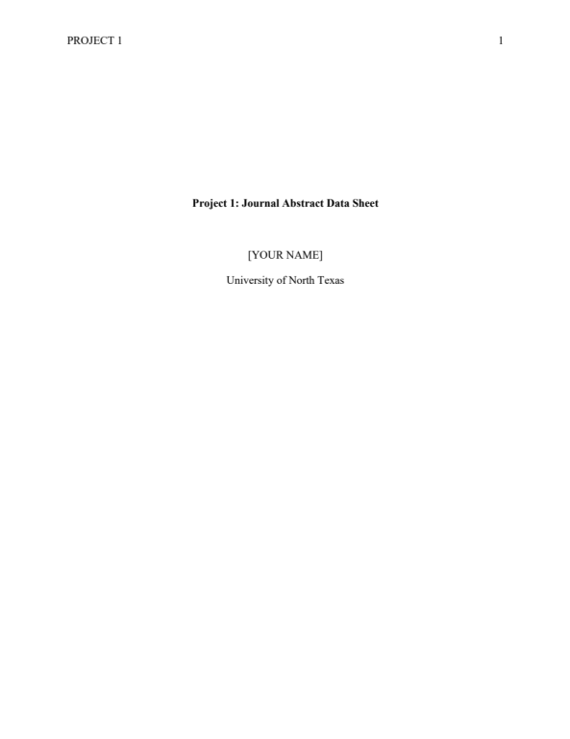

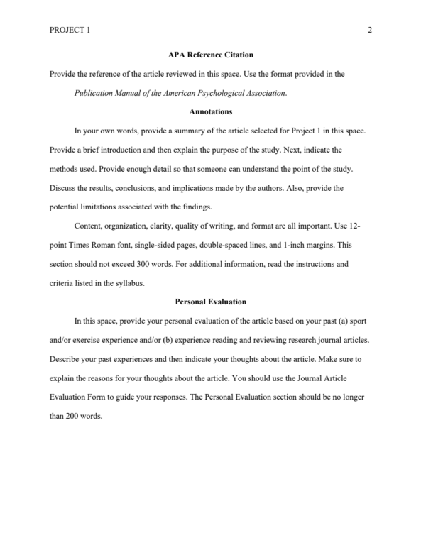
Project 1: Journal Article Evaluation Form

1 = Completely Incompetent, 2 = Poor, 3 = Mediocre, 4 = Good, 5 = Excellent

CHARACTERISTIC | 1 | 2 | 3 | 4 | 5
1. Problem is clearly stated
2. Hypotheses are clearly stated
3. Problem is significant
4. Assumptions are clearly stated
5. Limitations of the study are stated
6. Important terms are defined
7. Relationship of the problem to previous research is made clear
8. Research design is described fully
9. Research design is appropriate for the solution of the problem
10. Research design is free of specific weaknesses
11. Population and sample are described
12. Method of sampling is appropriate
13. Data-gathering methods or procedures are described
14. Methods or procedures are appropriate to the solution of the problem
15. Data-gathering methods or procedures are utilized correctly
16. Validity and reliability of the evidence gathered are established
17. Appropriate methods are selected to analyze the data
18. Methods used in analyzing the data are applied correctly
19. Results of the analysis are presented clearly
20. Conclusions are clearly stated
21 Conclusions are substantiated by the evidence presented
22. Generalizations are confined to the population from which the sample was drawn
23. Article is clearly written
24. Article is logically organized
25. Tone of the article displays an unbiased, impartial scientific attitude

Adapted from the Handbook in Research Evaluation (Isaac & Michael, 1983)

Project 2: Social Reinforcement Field Observation
For Project 2, you will observe instruction of group physical activity and code instructor behavior using the Coaching Behavior Assessment System (CBAS; Smith, Smoll, & Hunt, 1977). This project consists of three parts and is worth 25 points: (a) completed CBAS form based on your observation/coding session – worth 5 points (see Instructions 1-4), (b) detailed description and evaluation of instructor’s behaviors – worth 10 points (see Instruction 5), and (c) Quiz – worth 10 points (see Instruction 6).

Instructions
- Select a physical activity instructor (e.g., physical activity teacher, coach, fitness leader, or athletic trainer) to observe in-person or remotely. The instructor should be working with four or more individuals during your observation period. For example, you might consider watching a filmed exercise class (e.g., spin class, Zumba, yoga, etc.) or attend a sporting event (e.g., basketball, soccer, etc.). These do not have to be live sessions and could have occurred in the past. If comfortable, you can attend a live session. You will need to code coaching behaviors for at least 25 minutes.

- Become very familiar with the CBAS before completing your observation session (i.e., use the syllabus and online module to prepare). Review the categories before you attempt to code behavior during the session. Try to get a feel for the behaviors before you begin your coding. Ensure you can clearly see and hear the instructor.

- Use the CBAS coding sheet that is provided on Canvas (Project 2 module) to record the instructor's behavior toward the individuals with whom she or he is working. For each behavior, place a mark next to the appropriate category.

- After you have completed your observation session, tally the totals in each of the categories. Record each category total and the grand total. Use these totals to determine the percentages and ratios for each behavioral category. See the example posted on Canvas for additional guidance.

- Answer the 3 questions on the back of the CBAS form. All answers should be typed under each question on a single page (~85 words per question; ≤ 250 words total) in Times New Roman 12-point font (no hand-written forms will be accepted). Each response should summarize your observations by providing specific details (e.g., describe the population and activity, include specific behavior ratios/percentages and quotes, discuss thoughts on overall effectiveness of instruction).

- Complete the 10-point online quiz (10 questions worth 1 point each) pertaining to terms and concepts related to the CBAS.

- Submit your assignment using the Project 2 submission link found on Canvas. All files must be submitted in .docx format.

Explanation of the Behavioral Categories used on the CBAS
Become familiar with each category prior to initiating your observation. Be able to recognize the behavior and immediately code it correctly. If you deliberate too long, you may lose track of other behaviors. The twelve categories are broken up into two classes: (a) reactive behaviors (items 1-8) and (b) spontaneous behaviors (items 9-12). A reactive behavior is a response to a specific behavior while a spontaneous behavior is initiated by the coach and is not a response to a discernible preceding event.

Reactive Behaviors:
- Reinforcement – A rewarding reaction (verbal or nonverbal) to a good play or high-quality effort such as saying “good job” or “way to go”.

- Non-reinforcement – Failure to respond to a good performance.

- Mistake-contingent encouragement – Encouragement given to an athlete following a mistake.

- Mistake-contingent technical instruction – Instruction or demonstration to an athlete on how to correct a mistake he/she has made.

- Punishment – A negative reaction (verbal or nonverbal) following a mistake such as saying “what the … was that?”

- Punitive technical instruction – Technical instruction following a mistake given in a punitive or hostile manner.

- Ignoring mistakes – Failure to respond to an athlete’s mistake. Not responding to an athlete’s mistake can be just a harmful as punishment.

- Keeping control – Reactions intended to restore or maintain order among team members. Coaches should be able to keep control in a positive manner.

Spontaneous Behaviors:
- General technical instruction – Spontaneous instruction in the techniques and strategies of the sport (not following a mistake).

- General encouragement – Spontaneous encouragement that does not follow a mistake.

- Organization – Administrative behavior that sets the stage for play by assigning duties or responsibilities.

- General communication – Interactions with athletes unrelated to the game.

Evaluation Criteria
This project is worth 25 points (11% of your grade).

CRITERIA WEIGHT | POINTS | YOUR POINTS
Part 1. Social Reinforcement Field Observation Data Sheet (provide number of behaviors for each category, total number of  behaviors, percentages, and ratios) | 5
Part 2. Description and evaluation of coaching behaviors  (provide detailed responses to the questions on the back of the CBAS, follow format guidelines, and ≤ 250 words total) | 5
Part 3. Organization, clarity and quality of writing, and format | 5
Part 4. Quiz on terms and concepts related to the CBAS | 10
TOTALS | 25

Project 2: Social Reinforcement Field Observation Data Sheet
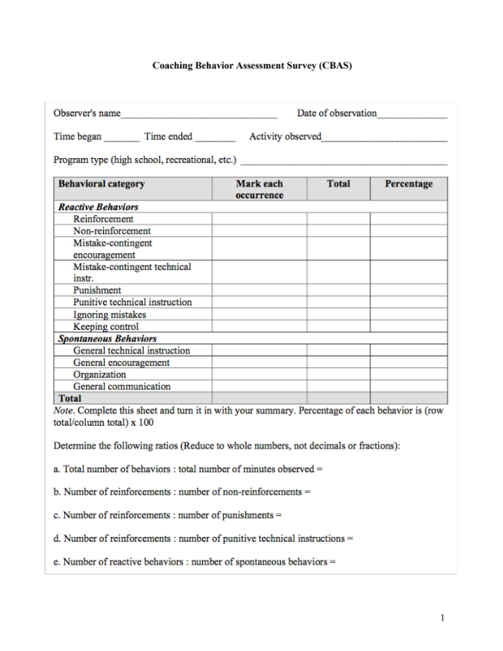
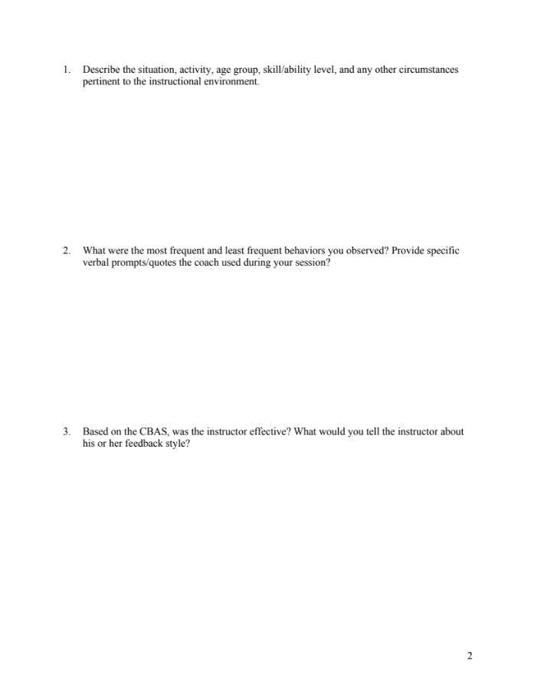

Adapted from the Coaching Behavior Assessment System (Smith, Smoll, & Hunt, 1977)

Academic Support & Student Services
Student Support Services

Mental Health
UNT provides mental health resources to students to help ensure there are numerous outlets to turn to that wholeheartedly care for and are there for students in need, regardless of the nature of an issue or its severity. Listed below are several resources on campus that can support your academic success and mental well-being:
- Student Health and Wellness Center (https://studentaffairs.unt.edu/student-health-and-wellness-center)
- Counseling and Testing Services (https://studentaffairs.unt.edu/counseling-and-testing-services)
- UNT Care Team (https://studentaffairs.unt.edu/care)
- UNT Psychiatric Services (https://studentaffairs.unt.edu/student-health-and-wellness-center/services/psychiatry)
- Individual Counseling (https://studentaffairs.unt.edu/counseling-and-testing-services/services/individual-counseling)

Chosen Names
A chosen name is a name that a person goes by that may or may not match their legal name. If you have a chosen name that is different from your legal name and would like that to be used in class, let the instructor know. Below is a list of resources for updating your chosen name at UNT.
- UNT Records
- UNT ID Card
- UNT Email Address
- Legal Name

*UNT euIDs cannot be changed at this time. The collaborating offices are working on a process to make this option accessible to UNT community members.

Pronouns
Pronouns (she/her, they/them, he/him, etc.) are a public way for people to address you, much like your name, and can be shared with a name when making an introduction, both virtually and in-person. Just as we ask and don’t assume someone’s name, we should also ask and not assume someone’s pronouns.

You can add your pronouns to your Canvas account so that they follow your name when posting to discussion boards, submitting assignments, etc.

Below is a list of additional resources regarding pronouns and their usage:
- What are pronouns and why are they important?
- How do I use pronouns?
- How do I share my pronouns?
- How do I ask for another person’s pronouns?
- How do I correct myself or others when the wrong pronoun is used?

Additional Student Support Services
- Registrar (https://registrar.unt.edu/registration)
- Financial Aid (https://financialaid.unt.edu/)
- Student Legal Services (https://studentaffairs.unt.edu/student-legal-services)
- Career Center (https://studentaffairs.unt.edu/career-center)
- Multicultural Center (https://edo.unt.edu/multicultural-center)
- Counseling and Testing Services (https://studentaffairs.unt.edu/counseling-and-testing-services)
- Pride Alliance (https://edo.unt.edu/pridealliance)
- UNT Food Pantry (https://deanofstudents.unt.edu/resources/food-pantry)

Academic Support Services
- Academic Resource Center (https://clear.unt.edu/canvas/student-resources)
- Academic Success Center (https://success.unt.edu/asc)
- UNT Libraries (https://library.unt.edu/)
- Writing Lab (http://writingcenter.unt.edu/)

Tentative Class Outline and Schedule*

WEEK | DATE | TOPIC
Week 1 | 17-Aug | Overview of Course & Syllabus  Discuss PROJECT 1: Article Evaluation/Abstract Data Sheet  CHAPTERS 1 & 2: Welcome to Sport and Exercise Psychology & Science and Professional Practice of Sport and Exercise Psychology
Week 1 | 19-Aug | CHAPTERS 1 & 2: Welcome to Sport and Exercise Psychology & Science and Professional Practice of Sport and Exercise Psychology  Syllabus quiz due
Week 2 | 24-Aug | CHAPTER 3: Personality and Sport
Week 2 | 26-Aug | CHAPTER 4: Motivation
Week 3 | 31-Aug | CHAPTER 4: Motivation
Week 3 | 2-Sept | Learning Module Quizzes 1-3 due  EXAM #1
Week 4 | 7-Sept | Labor Day Holiday
Week 4 | 9-Sept | CHAPTER 5: Arousal, Stress, and Anxiety
Week 5 | 14-Sept | PROJECT 1: Article Evaluation/Abstract Data Sheet & Quiz due  CHAPTER 5: Arousal, Stress, and Anxiety
Week 5 | 16-Sept | Discuss PROJECT 2: Social Reinforcement Field Observation  CHAPTER 7: Feedback, Reinforcement, and Intrinsic Motivation
Week 6 | 21-Sept | CHAPTER 7: Feedback, Reinforcement, and Intrinsic Motivation
Week 6 | 23-Sept | Learning Module Quizzes 4-5 due  EXAM #2
Week 7 | 28-Sept | CHAPTER 9: Team Dynamics and Cohesion
Week 7 | 30-Sept | CHAPTER 9: Team Dynamics and Cohesion
Week 8 | 5-Oct | CHAPTER 9: Team Dynamics and Cohesion
Week 8 | 7-Oct | CHAPTER 10: Leadership
Week 9 | 12-Oct | CHAPTER 10: Leadership
Week 9 | 14-Oct | Learning Module Quizzes 6-7 due  EXAM #3
Week 10 | 19-Oct | CHAPTER 11: Communication
Week 10 | 21-Oct | CHAPTER 12: Introduction to Psychological Skills Training
Week 11 | 26-Oct | PROJECT 2: Social Reinforcement Field Observation and Quiz due  CHAPTER 12: Introduction to Psychological Skills Training
Week 11 | 28-Oct | CHAPTER 13: Arousal Regulation
Week 12 | 2-Nov | CHAPTER 13: Arousal Regulation
Week 12 | 4-Nov | Learning Module Quizzes 8-10 due  EXAM #4
Week 13 | 9-Nov | CHAPTER 14: Imagery
Week 13 | 11-Nov | CHAPTER 14: Imagery
Week 14 | 16-Nov | CHAPTER 17: Concentration
Week 14 | 18-Nov | CHAPTER 17: Concentration
Week 15 | 23-Nov | Thanksgiving Break
Week 15 | 25-Nov | Thanksgiving Break
Week 16 | 30-Nov | Topic TBD
Week 16 | 2-Dec | Learning Module Quizzes 11-12 due  EXAM #5
*schedule subject to change

