THEATRE 4920

**CNC Programming**

**Tuesday/Thursday 11:00 –12:20**

**RTFP Design Studio Room 137**

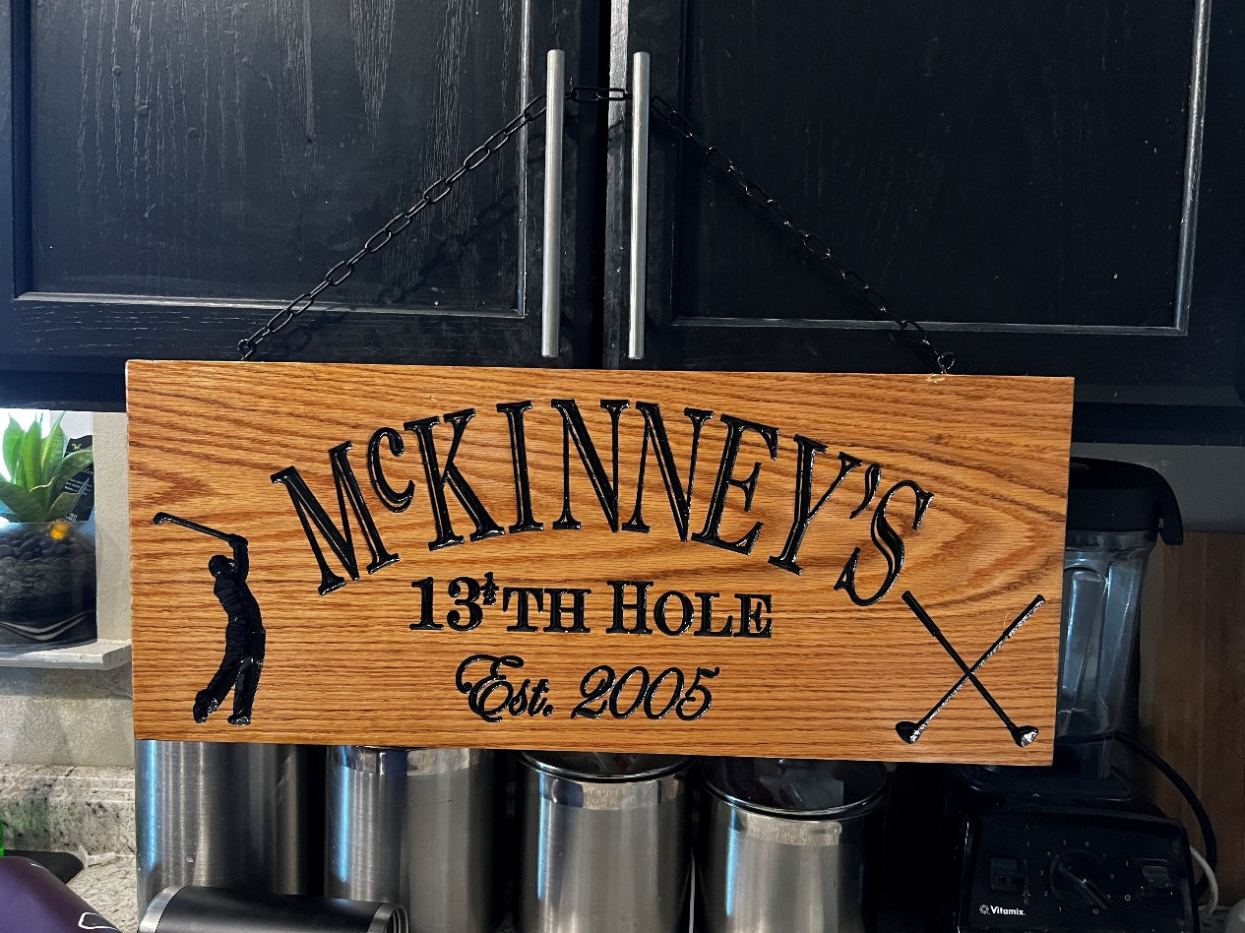**Instructor Contact**

**Name: Matthew McKinney**

**Pronouns: He/His**

**Office Location: 213**

**Office Hours: T/TH 9:30 – 10:30**

**Or by appointment**

**Email: Matthew.McKinney@unt.edu**

**Course Objectives**

This course will introduce you to the world of CNC programming. We will examine the technical issues and solutions that are found in many theater productions with specific regards to:

* Drafting techniques
* Tool pathing
* Bit selection
* Material selection
* Calculating federates
* CNC machine operation

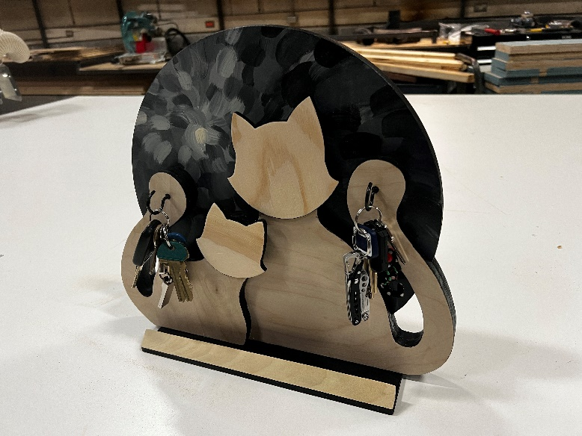At pertinent steps along the way, we will pick up the tools of the trade and perform the tasks required of the in realizing a design, including your own personal project which you will be responsible for from concept to completion.

**Materials**

**Programs:** This class centers around two programs listed below. You will need to install and them on your own laptop.

* Vectorworks – Student license is free to students
* V-Carve – Install the DEMO version

**Required Materials:**

* Personal laptop
* Safety Glasses

**Class Format**

* The class time will be divided between Lecture time and Lab time.
* **Lecture**: Student participation in lecture, when asked, is encourage. Attending the lecture is expected. However, things do come up that may take priority, see the class participation section.
* **Lab**: Lab is very participatory. You will be working with tools and other equipment on department productions. You will get dirty. Please dress appropriately and come prepared to learn (lockers can be checked out from me). Lab should be fun. Please keep a positive attitude and you will be surprised what you can learn. You may come into the lab when it is open to work on projects with prior approval.

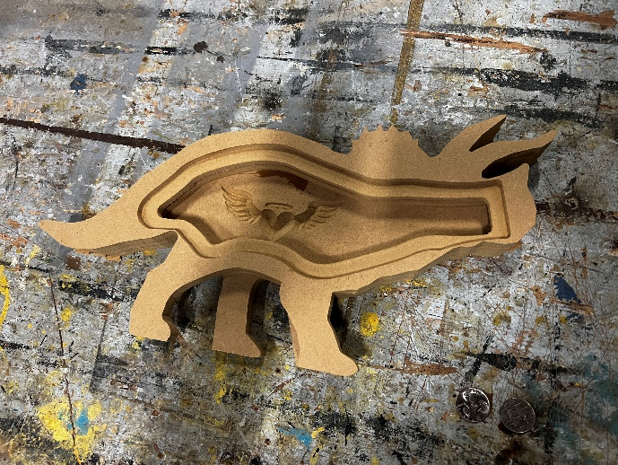

**Class Participation**

* Attendance and participation counts 150 Points towards your final grade
* After 2 unexcused absences 50 points will be removed for each subsequent absence
* 3 tardies (1-15 minutes late) will count as an absence
* If you are more than 15 minutes late you are considered absent

**Course Requirements**

* Attendance and Participation 150 Points
* Assignments:
  + Program operations 100 Points
  + Machine operation 100 Points
  + Sign Project 100 Points
  + Box Project 100 Points
  + Production Project 100 Points
  + Special Project 100 Points
* Final Project:
  + Drafting/Tool pathing 100 Points
  + Product 150 Points

________________________________________________

* TOTAL 1000 Points

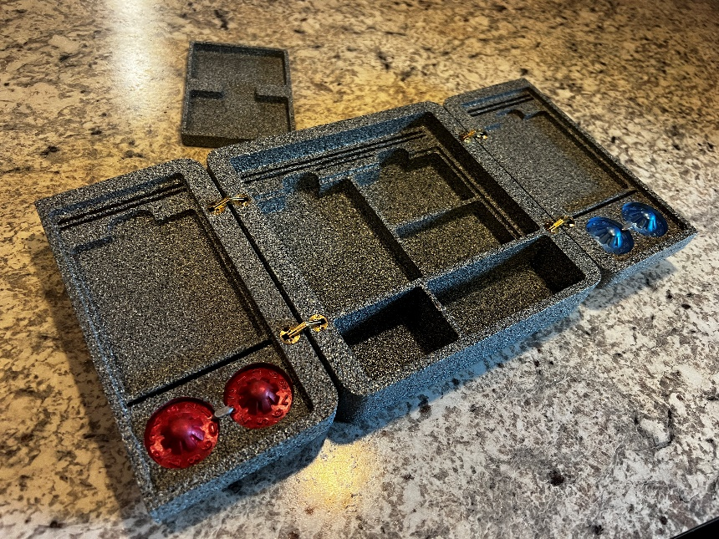**Grading**

* A = 900-1000
* B = 800-899
* C = 700-799
* D = 600-699
* F = 500-599

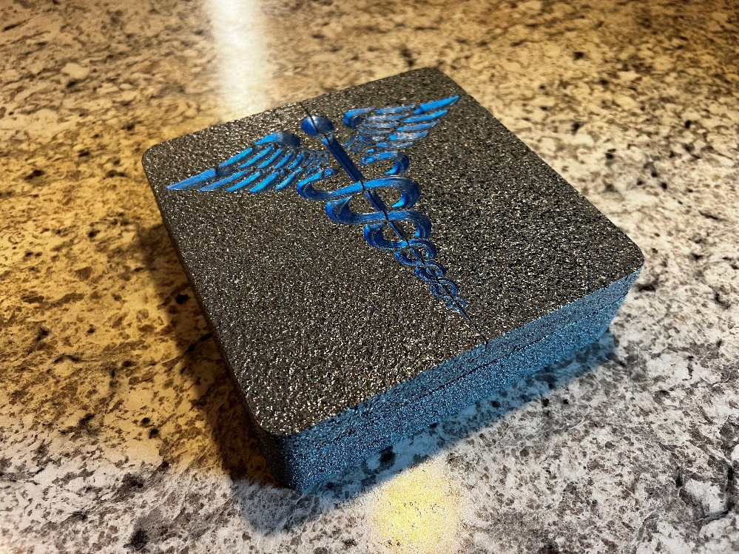Your assignments must be on time. If you are unable to have your work at the start of the class it is due, the grade will drop 50% if turned in within 24 hours. After 24 hours it will not be accepted. This of course will be amended for excused absences.

**Course Calendar**

|  |  |  |
| --- | --- | --- |
| Week #  DATE | TUESDAY | THURSDAY |
| 1  8/21 | **CLASS**: Meet & Greet, Syllabus, Expectations, Download programs | **CLASS**: Introduction to CNC programming |
| 2  8/28 | **CLASS:** CNC drafting with Vectorworks, CNC template files, CNC symbols. Sign Practice project in Vectorworks  **LAB:** Personal Sign Project design in Vectorworks | **CLASS**: Learning V-carve, Sign practice project in VCarve |
| 3  9/4 | **CLASS**: Exporting to a G-code file  **LAB:** Sign Project in V-Carve | **CLASS**: Machine Operation, How to use the CNC table, Startup, shutdown, loading a program, Changing bits, zeroing the table. |
| 4  9/11 | **CLASS**:  **LAB:** Sign Project on the CNC table | **CLASS**: CNC symbols: dog bones, dog tongue, mouse ears, splices, corner reliefs. |
| 5  9/18 | **CLASS**:  **LAB:** Box Project design in Vectorworks | **CLASS**: |
| 6  9/25 | **CLASS**: | **CLASS**: |
| 7  10/2 | **CLASS**: | **CLASS**: |
| 8  10/9 | **CLASS**: | **CLASS**: |
| 9  10/16 | **CLASS**: | **CLASS**: |
| 10  10/23 | **CLASS**: | **CLASS**: |
| 11  10/30 | **CLASS**: | **FINAL**: |
| 12  11/6 | **CLASS**: | **CLASS**: |
| 13  11/13 | **CLASS**: | **CLASS**: |
| 11/20 | **FALL BREAK** | **FALL BREAK** |
| 14  11/27 | **CLASS**: | **CLASS**: |
| 15  12/4 | **CLASS**: | **CLASS**: |
| 12/11 | FINAL: FINAL PROJECT PRESENTAIONS | |