THEATRE 1046 **Stagecraft I**

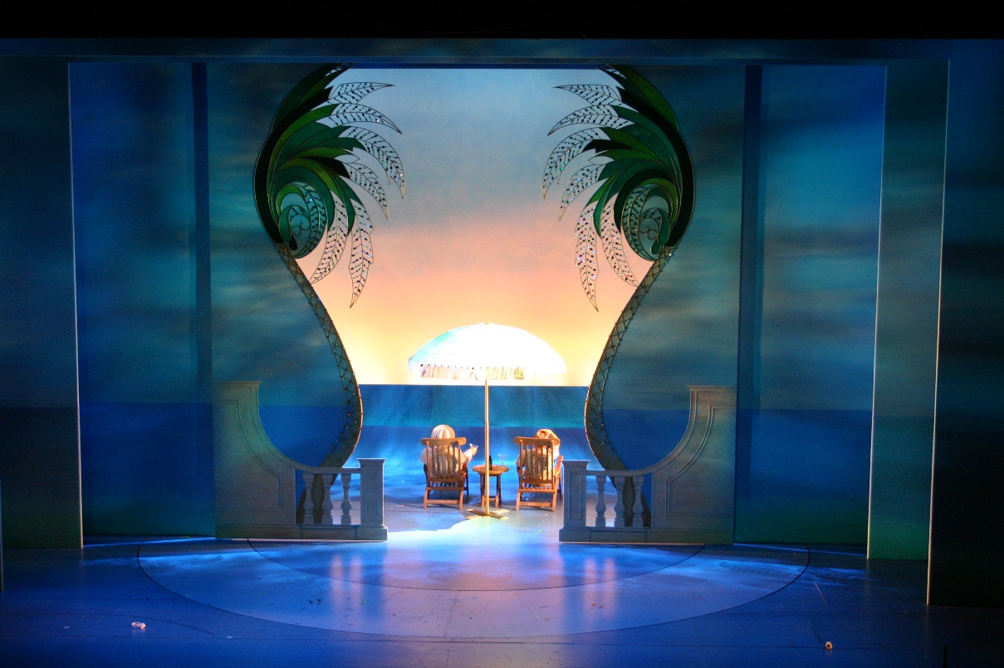**Tuesday/Thursday 12:30 –1:50**

**RTFP Design Studio Room 137**

**Instructor Contact**

**Name: Matthew McKinney**

**Pronouns: He/His**

**Office Location: 213**

**Office Hours: T/TH 9:30 – 10:30**

**Or by appointment**

**Email: Matthew.McKinney@unt.edu**

**Course Objectives**

This course will introduce the beginning theatre artist to the incredible variety of work that takes place “behind the scenes” of theatrical production. We will examine the process by which the physical production comes together. We will examine the technical issues and solutions that are found in many productions with specific regards to:

* 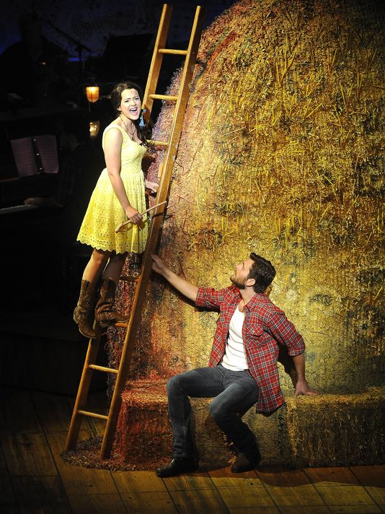Tools and materials
* Wood and metal working
* Basic scenery
* Stage terminology
* Knots and rigging
* Basic drafting
* Special Effects
* Advanced constructions techniques
* Technical rehearsal process

At pertinent steps along the way, we will pick up the tools of the trade and perform the tasks required of the technical director in realizing a design, including your own personal project which you will be responsible for from concept to completion.

**Materials**

**Text Books**

* *Illustrated Theatre Production Guide* (4th ed.)by John Holloway
* *Backstage Handbook* by Paul Carter

**Required Materials:**

* Safety Glasses (I will provide)
* Minimum 16 foot Tape Measure (I will provide)
* Architects Scale Rule
* Pencil and Notebook

**Class Format**

* **Lecture**: The Tuesday, Thursday class meetings are lecture format with some time

devoted to hands on training. Student participation in lecture, when asked, is encourage. Attending the lecture is expected. However, things do come up that may take priority, see the class participation section.

* **Lab**: Lab is very participatory. You will be working with tools and other equipment on

department productions. You will get dirty. Please dress appropriately and come prepared to

learn (lockers can be checked out from me). Lab should be fun. Please keep a positive attitude

and you will be surprised what you can learn.

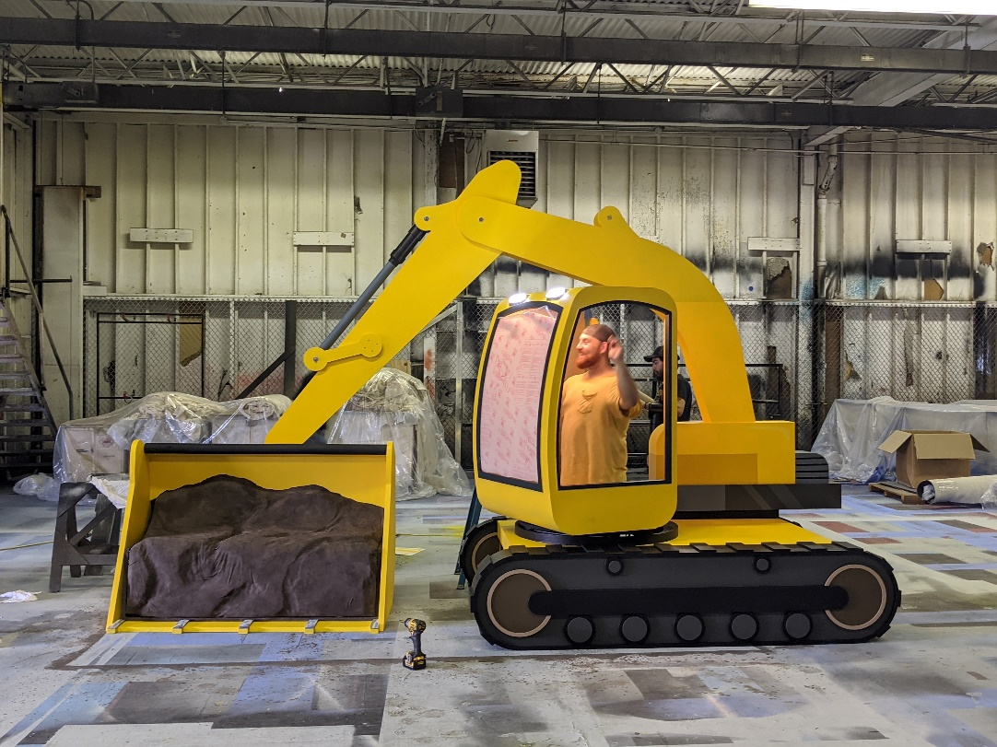You will determine your lab schedule for work in the Scene Shop during shop hours of:

* Mon-Fri 1:00 – 6:00
* Tue & Thu 10:00 – 12:00

You are responsible for 30 lab hours for the semester. you are required to complete a minimum of 2 hours session, 1 session per week for 15 weeks. You may also have longer sessions or do multiple sessions per week. You will commit to your own schedule for them semester in the first week of class.

There are limited time slots available for each workday (during shop hours). There will be a link in Canvas to a site where you may sign up for the hours you want to come in. You are responsible for tracking your lab hours throughout the semester.

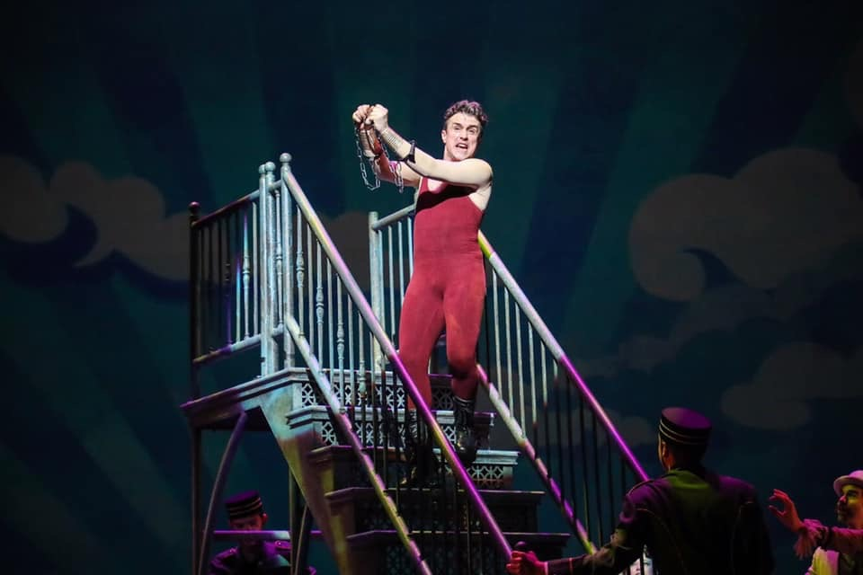**Class Participation**

* Attendance and participation counts 150 Points towards your final grade
* After 2 unexcused absences 50 points will be removed for each subsequent absence
* 3 tardies (1-15 minutes late) will count as an absence
* If you are more than 15 minutes late you are considered absent

**Course Requirements**

* 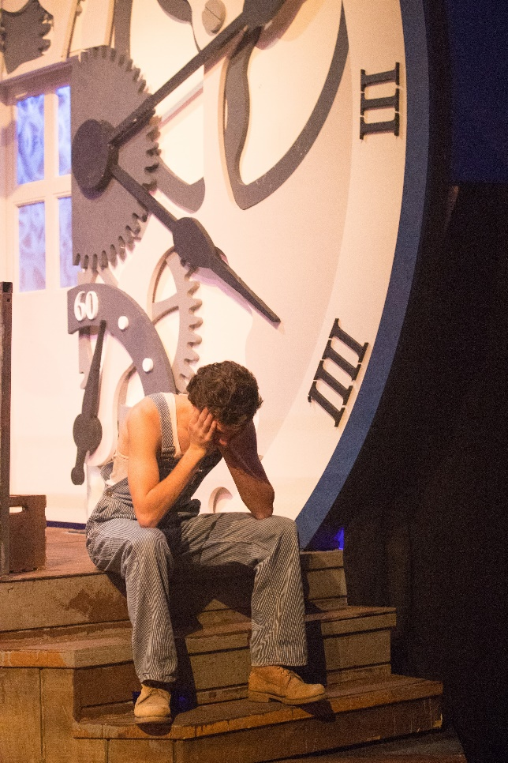Attendance and Participation 150 Points
* Lab Hours 150 Points
* Assignments:
  + Hand tool research 50 Points
  + Wine Bottle Stand 50 Points
  + Drafting Project 50 Points
* Quizzes:
  + Tool Safety Quiz50 Points

*(must pass with 85% for course credit)*

* + Materials and Scenery 50 Points
  + Organic Scenery 50 Points
  + Knots 50 Points
  + Rigging and Soft goods 50 Points
* Final Exam: 150 Points
* Final Project:
  + Drafting 50 Points
  + Product 100 Points

________________________________________________

* TOTAL 1000 Points

**Turned in**

**late work**

**Grading**

* A = 900-1000, B = 800-899, C = 700-799, D = 600-699, F = 500-599

Your assignments must be on time. If you are unable to have your work at the start of the class it is due, the grade will drop 50% if turned in within 24 hours. After 24 hours it will not be accepted. This of course will be amended for excused absences.

**Course Calendar**

|  |  |  |
| --- | --- | --- |
| Week #  DATE | TUESDAY | THURSDAY |
| 1  8/19 | **CLASS**: Meet & Greet, Syllabus, Tower Building | **CLASS**: Shop tour and PPE  Hand tool Assignment **READ**: Chapter 10 |
| 2  8/26 | **CLASS** Large tool tutorial 1 – MITER SAW  **READ**: Chapters 11 & 12 | **CLASS**: Large tool tutorial 2 – TABLE SAW **READ**: |
| 3  9/2 | **CLASS**: Large tool tutorial 3 – DRILL PRESS,BAND SAW, BELT SANDER  **DUE**: Hand tool Research paper (ONLINE SUBMISSION) | **CLASS**: Hand Tool Research Presentation **DUE**: Hand Tool Research presentations |
| 4  9/9 | **QUIZ**: Tool safety quiz **CLASS**: Wine Bottle Project lab 1 | **CLASS**: Wine Bottle Project lab 2 |
| 5  9/16 | **CLASS**: Wine Bottle Project lab 3  **DUE**: Wine Bottle Stand | **CLASS**: Drafting **READ**: Chapter 19 |
| 6  9/23 | **CLASS**: Drafting | **CLASS**: Materials of Scenery **READ**: Chapter 13 & 14 |
| 7  9/30 | **CLASS**: Flats: Construction, materials, cut lists **READ**: Chapter 15  **DUE**: Drafting Project | **CLASS**: Platforms & Stairs, Building flat demo **READ**: Chapter 16 & 17 |
| 8  10/7 | **QUIZ**: Materials & Scenery quiz **CLASS**: Knots **READ**: Chapter 7 | **CLASS**: Organic Scenery |
| 9  10/14 | **QUIZ**: Knots quiz  **CLASS**: Special Effects - Water | **CLASS**: Rigging: Components, running a line set **READ**: Chapter 8 |
| 10  10/21 | **QUIZ**: Organic Scenery quiz  **CLASS**: Jobs in technical Theatre **READ**: Chapter 1 | **QUIZ**: Rigging  **CLASS**: Technical Rehearsals **READ**: Chapter 2 |
| 11  10/28 | **CLASS**: FINAL JEAPORDY - STUDY SESSION | **FINAL**: Final exam in class |
| 12  11/4 | **CLASS**: Personal Projects Lab  **DUE:** Plan of action, material requests | **CLASS**: Personal Projects Lab |
| 13  11/11 | **CLASS**: Personal Projects Lab  **DUE**: Project drafting, cut list | **CLASS**: Personal Projects Lab |
| 14  11/18 | **CLASS**: Personal Projects Lab | **CLASS**: Personal Projects Lab |
| 11/25 | **FALL BREAK** | **FALL BREAK** |
| 15  12/2 | **CLASS**: Personal Projects Lab | **CLASS**: Personal Projects Lab |
| 12/11 | FINAL: FINAL PROJECT PRESENTAIONS | |