Organic Chemistry II

Fall 2025

Chem 2380, Section 003

Course: Tuesday, Thursday 9:30 am

Welcome!!
As members of the UNT community, we have all made a commitment to be part of an institution that respects and values the identities of the students and employees with whom we interact. UNT does not tolerate identity-based discrimination, harassment, and retaliation. UNT’s full Non-Discrimination Policy can be found in the UNT Policies section of the syllabus.
Every student in my classroom (physical or virtual) is welcome to be there. I ask that you treat one another with utmost respect. Inappropriate comments regarding a persons’ identity are not in line with the school’s code of conduct and will not be tolerated.
I set my course structure up so that every single student can succeed in this course, can learn organic chemistry, and can grow in critical thinking and problem solving. I WANT YOU TO SUCCEED! IF you are not happy with your grade, please please reach out to me:

Instructor Contact
Name: Dr. Melissa Collini
Email: Melissa.Collini@unt.edu
(in general emails after business hours/weekends will be responded to the next business day)
Pronouns: She/Her/Hers
To learn more about me go to linktr.ee/organicmelissa

Student drop-in hours (office hours):
Tuesday: 11:00 am- 12:00 pm (in person, CHEM 307D).
Wednesday: 10:00 am – 11:00 am (Online- https://unt.zoom.us/my/drcollini)
Thursday: 12:30 pm - 1:30 pm (in person, CHEM 307D).

If these times don’t work, you have options:
· If you have content-related questions reach out to your TA, ask in class, attend PLTL, or use the search function on my YouTube channel to see if the question has been answered already!
· If you have confidential (grades, accommodations, etc.) questions please email me! I will do my best to find an appointment time.

Student drop-in/office hours are a time that I am in my office (chemistry building room 307D – in a hallway just past the elevator on the 3rd floor), or online on my zoom link (listed above) with my door open and ready to talk to you! Come ask me questions about the material we are covering in class, or anything else that you have questions about. There is no question too small to be covered in office hours. If you are coming during my normal hours, posted above, you do not have to make an appointment or otherwise let me know that you are coming. Office hours are generally open for many students to come in and chat. If you need to chat about something confidential, just let me know and I will try to set some time aside.
Office Location: Chemistry Building, Room 307D

Communication Expectations:
I will primarily communicate with my students in the classroom, via GroupMe, and via announcements on canvas. Please make sure that you have notifications turned on or check in very regularly to ensure you receive important messages.
Class GroupMe: https://groupme.com/join_group/109227917/dmgue7uD
Rules for GroupMe: You must use the name that you go by in class (first name and at least the last initial). The code of conduct for UNT still applies in the GroupMe, as it would any other university space. If you violate the code of conduct I will remove you from the group. Please do not direct message me on GroupMe – I will not answer. Address your questions to the class group only.
Students can reach me most easily by email. If you have any personal concerns, questions, etc. please reach out at Melissa.Collini@unt.edu. I try to have strong work/life boundaries, so I am much less likely to answer emails on the weekend or evening when I am spending time with my friends and family. If it has been more than a week since you have emailed me and you have not received a response, please follow up. I do my best to get to every email, but things can easily get lost with so many emails coming in.
CLEAR has a webpage for students that provides Online Communication Tips (https://clear.unt.edu/online-communication-tips) if you need any help!

Teaching Philosophy
My full teaching philosophy can be found on my linktree (linktr.ee/OrganicMelissa)
I love teaching, and I have a background in chemistry education research and organic chemistry research. I use this expertise and evidence-based practices to help my students succeed in their goals. I’ll be doing my best to create a learning environment that achieves that, makes organic chemistry accessible and interesting. I will try to communicate expectations clearly, as well as the reasons behind each of my expectations, to help my students achieve their goals in this course. I also recognize that learning does not happen in a vacuum, and that we struggle to focus on learning when we have life situations going on.

Course Prerequisites or Other Restrictions
Organic chemistry 1 should only be taken after passing CHEM 1410, 1420 or an equivalent general chemistry sequence.

Course Objectives
At the end of this course students will be able to think critically about movement of electrons and predict the outcomes reactions in organic chemistry, and all other objectives as listed in the course description/handbook.

Materials

Course Technology & Skills

Minimum Technology Requirements & Computer Skills
Technology required is a web cam and a computer which is compatible with lockdown browser. You need to be able to access canvas and all the materials there, be able to take a picture and attach as upload as a pdf for homework, and any online homework videos or lectures.
Required materials:
· A webcam compatible with lockdown browser which will show your entire face and hands/notes
· A computer that enables you to access all materials
· Means of uploading a pdf (taking a picture or digitally).
Strongly Suggested Materials (but not required)

· OpenStax Organic Chemistry: A Tenth Edition, by John McMurray, link: https://openstax.org/details/books/organic-chemistry?Book%20details (this textbook and its many student resources are free!)
- Organic Chemistry as a Second Language (Klein)

Student Expectations and Responsibilities
I expect students to actively participate in class, and to complete their assignments in a timely fashion.

Instructor Expectations and Responsibilities

You can expect me post assignments, to hold student drop-in hours, answer emails in a timely fashion, provide feedback/grades, and do everything I can (within reason) to help you learn organic chemistry well.

Course Schedule

(See next two pages) This schedule is only an estimation of the course content and is subject to change. The quiz and exam dates won’t change – but the content of those assessments is subject to change. Homework may be given an extension but will not be due earlier.
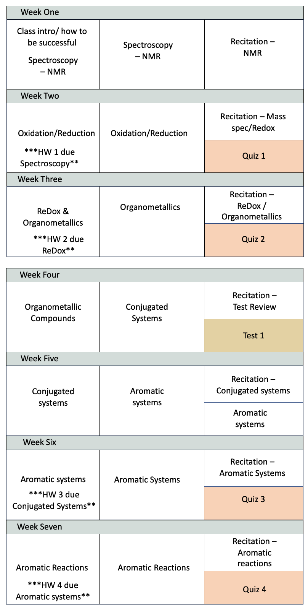
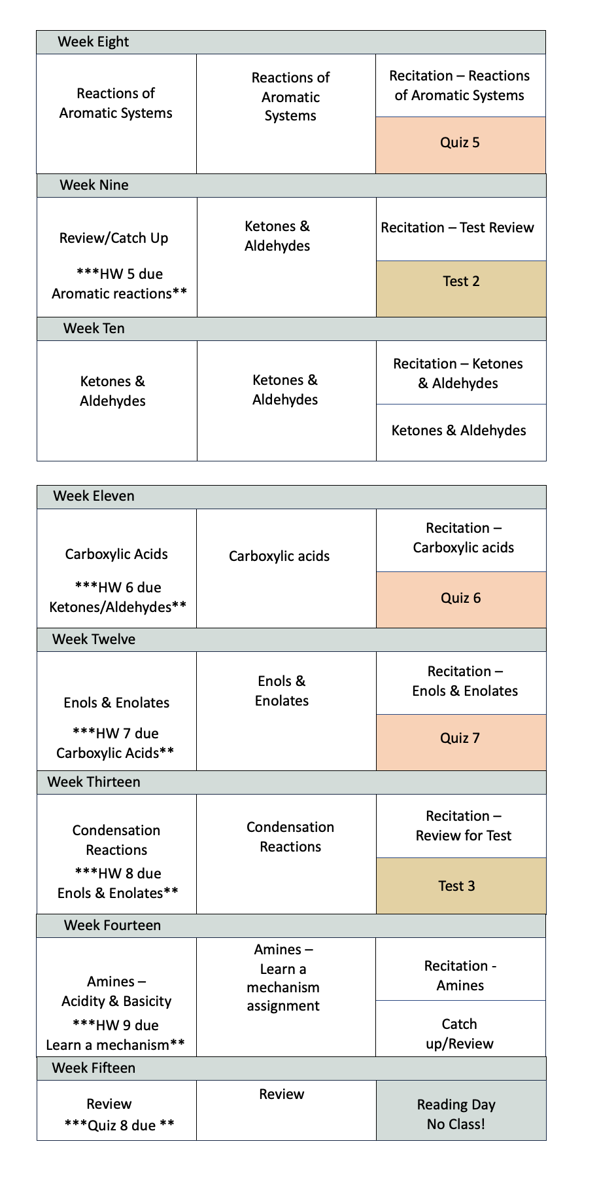

THE FINAL EXAM IS SET BY THE REGISTRAR AND WILL TAKE PLACE ON THUSRDAY DECEMBER 11th AT 8:00 AM IN OUR USUAL MEETING SPOT

Grading
Below is the grading scale (A-F) along with the point totals I will use to calculate the final grade. SOMETIMES CANVAS WILL ESTIMATE YOUR GRADE - BUT TYPICALLY IT DOES NOT ESTIMATE ACCURATELY, SO I ENCOURAGE YOU TO CALCULATE IT YOURSELF!
Your grade will be calculated by the following:
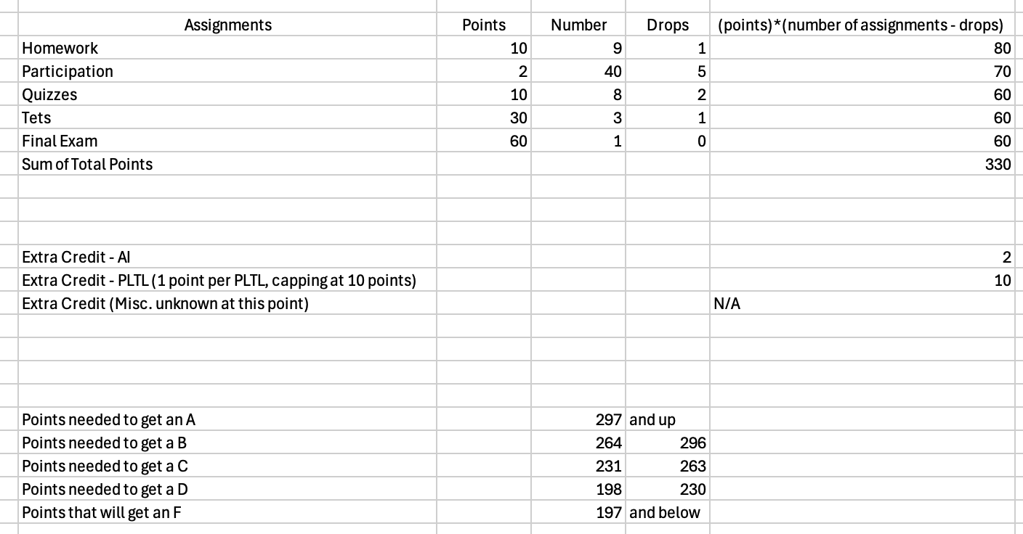
Participation –
What: These will consist of in-class activities and recitation activities where you will earn points. Note that you will get several drops for these grades, see attendance policy (below) for more info.
Why: I include this as a grade because organic chemistry is very difficult to learn if you are not coming to class, and so this is a way to pad your grade. Simply by showing up to class and actively participating, you can get ~20% of your grade.

Homework –
What: Homework will be a mix of free-response and multiple choice questions. You will be given the answers to the homework, because the goal of the homework is for you to practice. The best way to do the homework is to try to do the questions without looking at your notes or the answer, and then check yourself. As you gain more confidence, it is better to do several in a row before you check your answer, since that simulates the test. I will be spot grading based on the work shown – if you just give the answer that won’t be worth a grade (because the answers are provided). The lowest homework grade will be dropped, and the rest will be added to your overall grade
Why: Organic chemistry, like math, needs to be practiced. You may understand what I did when I show it on the board, but if you do not practice it will be difficult to reproduce. I don’t grade you on the correct answers, since I know that can be googled, but instead on your effort. This also gives accountability to begin studying before the quizzes/exams.
Quizzes –
What: Quizzes will be short (approx. 30 minutes), typically free-response. The lowest quiz will be dropped, and the rest will be added to your overall grade. Unless otherwise noted, quizzes will be taken with a webcam that shows your face and hands and a lockdown browser.
Why: Studies show that more low-stakes assignments like quizzes are more effective in long-term understanding than few, high-stakes assignments like tests. These will provide accountability in studying before the exam, and help you understand your strengths/weaknesses.
Exams –
What: Exams will be approx. 60 minutes, given in recitation, and will be a mix of multiple choice and free response. The lowest exam will be dropped, and the other two will be added to your overall grade. Unless otherwise noted, exams will be taken with a webcam that shows your face and hands and lockdown browser.
Why: Exams are another way to show your understanding, and to provide accountability in deeper comprehension of the material.
You are allowed to use a modeling kit (provided by you), periodic table (provided by me), and scratch paper (provided by you) during the quizzes and exams.

Academic Dishonesty Policy –
Quizzes and Exams are not collaborative. You may not ask for help from anyone other than the instructor, look up answers, use AI, or otherwise try to find an answer outside of your brain. Any attempt to find an exam answer from a source other than yourself is considered academic dishonesty. Any attempt to falsify participation grades are also considered academic dishonesty. These will be reported to the office of academic integrity, and you will receive a zero on this assignment (a zero which cannot be counted towards your dropped grades).

Extra Credit – Due by 11:59 the day before reading day (or on date noted in assignment)
I DO NOT BUMP GRADES BECAUSE I PROVIDE SO MUCH EXTRA CREDIT.
I also do not accept late work after the date/time listed above. If you email me asking for an extension on reading day, you will be ignored (Unless you have ODA accommodations explicitly for an extension, and you email me within the allowed time frame for your accommodations).
Artificial Intelligence in Chemistry –At any point during the semester, you may submit a free response question (+.5) from a quiz or a test to an AI chatbot (such as ChatGPT or Gemini) and then critique the answer that is given to you. You must determine if the answer is accurate or not (+.5) and write a short paragraph (in your own words) explaining why it is/is not an acceptable answer (+.5). You must include your prompt and the chatbot’s response (+.5). I will then grade this to determine if it is an accurate/acceptable answer. You must upload this on canvas in the appropriate assignment by 11:59 the day before the reading day.

PLTL Sessions – 10 points on overall grade Attending hours 10 hours of PLTL sessions will result in a 10 point bump to your final grade. This caps at 10 points. Attending less than 10 hours of PLTL sessions will scale accordingly (ex: 5 hours = 5 point bump). Attending more than 10 hours of PLTL sessions will not give more extra credit. However, data has shown that students who attend the PLTL sessions regularly do significantly better in the class! PLTL sessions do not replace the time that you should be spending on your own studying the material. You must sign in and out for every PLTL session you attend to receive this credit. For online classes, if you are not participating you will not receive credit for attending. Attending multiple PLTL sessions in one week is totally allowed, but your extra credit points will max out at 2 points per week.
Late Work
BETTER LATE THAN NEVER.
My general policy is to accept late work with some points docked for being late - this does not apply to quizzes or tests, and for online classes I will have some time-sensitive assignments to encourage you to keep on track throughout the semester (such as recitation and some extra credit). Those assignments will close after the due date). Typically 1 day late will get you a maximum of 90%. 2-7 days late will get you a maximum of 80%, 8 -28 late will get you a maximum of 70%, and more than 28 days late will get you a maximum of 50%. Late work is always better than a zero. See Exam and Quiz policy below for missed exams or quizzes. If you are struggling to complete your work on time, please reach out to me BEFORE THE ASSIGNMENT IS DUE so that we can come up with a game plan together. All work for the semester can be turned in no later than THE DAY BEFORE READING DAY at 11:59 PM. I cannot stress enough that at this point I will not accept any work at all, not even 5 minutes late.
University approved absences
While participation is a grade in this class, you have several dropped grades that are intended to cover a variety of absences for a variety of reasons. If you have a university approved absence that interferes with the set date of taking a quiz or exam, here is the university policy and my policy:
For absences or missed assignments related to any of the following, please reach out directly to the dean of students, have them verify your situation, and I will provide extensions on homework and notes, excuse you from quizzes, or provide a make-up test as needed.
- Temporary disability or injury
- Extended medical absence (roughly two weeks)
- Hospitalization
- Major illness or death of a loved one
- Car accident that removes transportation
- Housing Emergencies
- Significant mental health concerns.
For absences related to any of the following, email me WITH DOCUMENTATION and I will excuse you from quizzes or provide a make-up test as needed.
- Professional school/university interviews
- Conference attendance
- Receiving awards/scholarship
- School-sanctioned event (sports, field trip, etc).
- Religious holy day
For absences or missed assignments related to any of the following, please do not email me. These will be covered by your dropped grades and the extensive extra credit I have included in the syllabus:
- Personal travel
- Short-term illnesses (less than 10 days, strep, cold, flu, etc)
- Power outages/technical difficulties

Technical Assistance
Part of working in the online environment involves dealing with the inconveniences and frustration that can arise when technology breaks down or does not perform as expected. Here at UNT we have a Student Help Desk that you can contact for help with Canvas or other technology issues. For any technical assistance please see the UIT helpdesk (http://www.unt.edu/helpdesk/index.htm). If you do not have access to technology, you can checkout technology from the university.
For additional support, visit Canvas Technical Help (https://community.canvaslms.com/docs/DOC-10554-4212710328)

Rules of Engagement
Rules of engagement refer to the way students are expected to interact with each other and with their instructors. Here are some general guidelines:
· While the freedom to express yourself is a fundamental human right, any communication that utilizes cruel and derogatory language on the basis of race, color, national origin, religion, sex, sexual orientation, gender identity, gender expression, age, disability, genetic information, veteran status, or any other characteristic protected under applicable federal or state law will not be tolerated.
· Treat your instructor and classmates with respect in any communication online or face-to-face, even when their opinion differs from your own.
· Ask for and use the correct name and pronouns for your instructor and classmates.
· Speak from personal experiences. Use “I” statements to share thoughts and feelings. Try not to speak on behalf of groups or other individual’s experiences.
· Use your critical thinking skills to challenge other people’s ideas, instead of attacking individuals and their identities.
· Avoid using all caps while communicating digitally. This may be interpreted as “YELLING!”
· Be cautious when using humor or sarcasm in emails or discussion posts as tone can be difficult to interpret digitally.
· Proofread and fact-check your sources.
· Keep in mind that online posts can be permanent, so think first before you type.
See these Engagement Guidelines (https://clear.unt.edu/online-communication-tips) for more information.
Syllabus Change Policy
This syllabus is subject to change as the instructor sees fit. All syllabus updates will be posted on canvas in an announcement.

UNT Policies

Academic Integrity Policy
Academic Integrity Standards and Consequences. According to UNT Policy 06.003, Student Academic Integrity, academic dishonesty occurs when students engage in behaviors including, but not limited to cheating, fabrication, facilitating academic dishonesty, forgery, plagiarism, and sabotage. A finding of academic dishonesty may result in a range of academic penalties or sanctions ranging from admonition to expulsion from the University. [Insert specific sanction or academic penalty for specific academic integrity violation.]

ADA Policy
UNT makes reasonable academic accommodation for students with disabilities. Students seeking accommodation must first register with the Office of Disability Accommodation (ODA) to verify their eligibility. If a disability is verified, the ODA will provide a student with an accommodation letter to be delivered to faculty to begin a private discussion regarding one’s specific course needs. Students may request accommodations at any time, however, ODA notices of accommodation should be provided as early as possible in the semester to avoid any delay in implementation. Note that students must obtain a new letter of accommodation for every semester and must meet with each faculty member prior to implementation in each class. For additional information see the ODA website (https://disability.unt.edu/).

Prohibition of Discrimination, Harassment, and Retaliation (Policy 16.004)
The University of North Texas (UNT) prohibits discrimination and harassment because of race, color, national origin, religion, sex, sexual orientation, gender identity, gender expression, age, disability, genetic information, veteran status, or any other characteristic protected under applicable federal or state law in its application and admission processes; educational programs and activities; employment policies, procedures, and processes; and university facilities. The University takes active measures to prevent such conduct and investigates and takes remedial action when appropriate.

Emergency Notification & Procedures
UNT uses a system called Eagle Alert to quickly notify students with critical information in the event of an emergency (i.e., severe weather, campus closing, and health and public safety emergencies like chemical spills, fires, or violence). In the event of a university closure, please refer to Canvas for contingency plans for covering course materials.

Retention of Student Records
Student records pertaining to this course are maintained in a secure location by the instructor of record. All records such as exams, answer sheets (with keys), and written papers submitted during the duration of the course are kept for at least one calendar year after course completion. Course work completed via the Canvas online system, including grading information and comments, is also stored in a safe electronic environment for one year. Students have the right to view their individual record; however, information about student’s records will not be divulged to other individuals without proper written consent. Students are encouraged to review the Public Information Policy and the Family Educational Rights and Privacy Act (FERPA) laws and the University’s policy. See UNT Policy 10.10, Records Management and Retention for additional information.

Acceptable Student Behavior
Student behavior that interferes with an instructor’s ability to conduct a class or other students' opportunity to learn is unacceptable and disruptive and will not be tolerated in any instructional forum at UNT. Students engaging in unacceptable behavior will be directed to leave the classroom and the instructor may refer the student to the Dean of Students to consider whether the student's conduct violated the Code of Student Conduct. The University's expectations for student conduct apply to all instructional forums, including University and electronic classroom, labs, discussion groups, field trips, etc. Visit UNT’s Code of Student Conduct (https://deanofstudents.unt.edu/conduct) to learn more.

Access to Information - Eagle Connect
Students’ access point for business and academic services at UNT is located at: my.unt.edu. All official communication from the University will be delivered to a student’s Eagle Connect account. For more information, please visit the website that explains Eagle Connect and how to forward e-mail Eagle Connect (https://it.unt.edu/eagleconnect).

Survivor Advocacy
UNT is committed to providing a safe learning environment free of all forms of sexual misconduct. Federal laws and UNT policies prohibit discrimination on the basis of sex as well as sexual misconduct. If you or someone you know is experiencing sexual harassment, relationship violence, stalking and/or sexual assault, there are campus resources available to provide support and assistance. The Survivor Advocates can be reached at SurvivorAdvocate@unt.edu or by calling the Dean of Students Office at 940-5652648.
Transmission and Recording of Student Images in Electronically-Delivered Courses
- No permission is needed from a student for his or her image or voice to be transmitted live via videoconference or streaming media, but all students should be informed when courses are to be conducted using either method of delivery.
- In the event an instructor records student presentations, he or she must obtain permission from the student using a signed release in order to use the recording for future classes in accordance with the Use of Student-Created Work guidelines above.
- Instructors who video-record their class lectures with the intention of re-using some or all of recordings for future class offerings must notify students on the course syllabus if students' images may appear on video. Instructors are also advised to provide accommodation for students who do not wish to appear in class recordings.
Example: This course employs lecture capture technology to record class sessions. Students may occasionally appear on video. The lecture recordings will be available to you for study purposes and may also be reused in future course offerings.
No notification is needed if only audio and slide capture is used or if the video only records the instructor's image. However, the instructor is encouraged to let students know the recordings will be available to them for study purposes.

Class Recordings & Student Likenesses
Synchronous (live) sessions in this course will be recorded for students enrolled in this class section to refer to throughout the semester. Class recordings are the intellectual property of the university or instructor and are reserved for use only by students in this class and only for educational purposes. Students may not post or otherwise share the recordings outside the class, or outside the Canvas Learning Management System, in any form. Failing to follow this restriction is a violation of the UNT Code of Student Conduct and could lead to disciplinary action.

Academic Support & Student Services

Student Support Services

Mental Health
UNT provides mental health resources to students to help ensure there are numerous outlets to turn to that wholeheartedly care for and are there for students in need, regardless of the nature of an issue or its severity. Listed below are several resources on campus that can support your academic success and mental well-being:
· Student Health and Wellness Center (https://studentaffairs.unt.edu/student-health-and-wellness-center)
· Counseling and Testing Services (https://studentaffairs.unt.edu/counseling-and-testing-services)
· UNT Care Team (https://studentaffairs.unt.edu/care)
· UNT Psychiatric Services (https://studentaffairs.unt.edu/student-health-and-wellness-center/services/psychiatry)
· Individual Counseling (https://studentaffairs.unt.edu/counseling-and-testing-services/services/individual-counseling)

Chosen Names
A chosen name is a name that a person goes by that may or may not match their legal name. If you have a chosen name that is different from your legal name and would like that to be used in class, please let the instructor know. Below is a list of resources for updating your chosen name at UNT.
· UNT Records
· UNT ID Card
· UNT Email Address
· Legal Name
*UNT euIDs cannot be changed at this time. The collaborating offices are working on a process to make this option accessible to UNT community members.

Pronouns
Pronouns (she/her, they/them, he/him, etc.) are a public way for people to address you, much like your name, and can be shared with a name when making an introduction, both virtually and in-person. Just as we ask and don’t assume someone’s name, we should also ask and not assume someone’s pronouns.
You can add your pronouns to your Canvas account so that they follow your name when posting to discussion boards, submitting assignments, etc.
Below is a list of additional resources regarding pronouns and their usage:
o What are pronouns and why are they important?
o How do I use pronouns?
o How do I share my pronouns?
o How do I ask for another person’s pronouns?
o How do I correct myself or others when the wrong pronoun is used?

Additional Student Support Services
· Registrar (https://registrar.unt.edu/registration)
· Financial Aid (https://financialaid.unt.edu/)
· Student Legal Services (https://studentaffairs.unt.edu/student-legal-services)
· Career Center (https://studentaffairs.unt.edu/career-center)
· Multicultural Center (https://edo.unt.edu/multicultural-center)
· Counseling and Testing Services (https://studentaffairs.unt.edu/counseling-and-testing-services)
· Pride Alliance (https://edo.unt.edu/pridealliance)
· UNT Food Pantry (https://deanofstudents.unt.edu/resources/food-pantry)

Academic Support Services
· Academic Resource Center (https://clear.unt.edu/canvas/student-resources)
· Academic Success Center (https://success.unt.edu/asc)
· UNT Libraries (https://library.unt.edu/)
· Writing Lab (http://writingcenter.unt.edu/)

