CHEM 3452

QUANTITATIVE ANALYSIS LAB
(Summer, 2026)

CHEMISTRY 3452 Quantitative Analysis Lab
*Note, Lab starts on June 23th

Course Description: The CHEM 3452 lab course is to accompany the CHEM 3451 Quantitative Analysis. Various experiments are designed to utilize statistical treatment of data, sampling and transfer techniques, gravimetric and volumetric methods, titration analysis, electroanalytical and introductory instrumental analysis.

Course Objectives:
- To cultivate students' hand-on operation skills in field of quantitative analysis
- To introduce quantitative measurements in gravimetric, volumetric, electroanalytical and chromatographic separation.
- Understand factors that affect accuracy and precision of measurements and apply statistical analysis.

Lab Coordinator
- MK Altafi [mohammadkazemaltafi@my.unt.edu]

Lab Instructors

- Alondra [AlondraSilvaLeon@my.unt.edu] (Section: 301)
- Richard [RichardMcCrary@my.unt.edu] (Section: 302)

Lab Manual A Lab Manual will be provided. There will be a brief discussion of each lab at the beginning of the period. The student will be expected to have read the lab manual and prepared relevant lab operation notes in the lab notebook before coming to class since the pre-lab discussion will focus on why, not how the lab is done.

Materials: Besides this lab manual, you will also need a lab notebook for class. You must have a writing utensil (a pencil is not allowed) to record your data in ink. And eye protection, either safety glasses or safety goggles, is mandatory. Notebooks will be inspected at the end of the lab session, unannounced times during the semester, and graded according to completeness and organization.

Lab Reports: The last page of each lab handout is the lab report sheet, on which you will report your lab results. This information will come directly from your lab notebook. Once the notebook entry for a specific lab is complete, you should scan a PDF copy of the completed lab report and submit it on Canvas no later than one week after the lab has been done. If necessary, the lab may be typed up into Microsoft Word (however, it is still required you keep a notebook). This information will come directly from your lab notebook (see below, lab TA will verify this at the end of each lab), and any blanks on the report must be filled in or explained. The completed lab report that gives a concise summary of the results, correction, and discussion are due at the beginning of the next lab period. Pre-lab and post lab report submissions will only be taken up to 2 days after the initial due date with a 25% deduction. If more than 3 lab reports are turned in late, disciplinary action will be taken against that student.

Lab Notebook: All students will use a lab notebook to record all data obtained in this lab. The notebook must be one in which the pages are permanently attached -- loose-leaf notebooks are not acceptable. Recording data on scratch paper, paper towels, etc. before transfer to the notebook is expressly forbidden. Any student found using such scratch paper will have their lab grade for that lab lowered by 1 point, and the scratch paper will be discarded.

Missing Lab:
Arrive late over 15 minutes will be counted as an absence. The missing lab will receive a zero grade. No make-up lab unless permission is obtained in advance.
Medical absence requires a proper doctor’s statement. According to UNT’s Grade Appeal Policy (p. 3): “A student will not be penalized for a university-excused absence and will be allowed, when practicable, to take an examination or complete an assignment from which the student is excused within a reasonable period after the absence.” Please coordinate with the lab supervisor to schedule a makeup assignment ASAP.

Grading

Each lab report of CHEM 3452 will be calculated as follows

Prelab 30 pts
Result 45 pts
TA Evaluation 5 pts

A student is expected to keep a lab notebook in which all experiments are to be recorded. Lab reports are to be electronically submitted onto Canvas by scanning a PDF copy of the notebook entry (can be done via smartphone or scanners provided in the library) or by re-writing the notebook entry into Microsoft Word. Reports are to be turned in no later than one week after the completion of the experiment.
Notebooks will be inspected at the end of the lab session, and at unannounced times during the semester, and graded according to completeness and organization.
The "TA Evaluation" portion of your lab grade will reflect your attitude, preparedness, and safety consciousness during lab.

DO’s
- Wear safety goggles all the time inside the lab.
- Make sure that your working area and common working areas such as the scales are always clean after every experiment.
- Wear closed shoes and proper lab attire

DON’T’S
- Eat inside the lab
- Break glassware or destroy the equipment (Scales etc.)
- Spend too much time doing nothing especially when it’s a partner-based experiment

Laboratory Results:

The grade is determined solely on the accuracy of the reported numeric results for the values. The results are graded based on the scale below:

% Error | Points
0-19 | 20
20-39 | 18
40-59 | 16
60-79 | 14
80-99 | 12
≥100 | 10

Grading Scale

Final percent Average Letter Grade

90 - 100 % A
80 - 89 % B
70 - 79 % C
60 - 69 % D
Below 60 % F

The Chemistry Department believes in reasonably accommodating individuals with disabilities and complies with university policy established under Section 504 of the Rehabilitation Act of 1973 and the Americans with Disabilities Act (1990) to provide equal access and opportunity. Please communicate with your professor as to your specific needs and/or the Office of Disability Accommodation (ODA) (Room 321, Union, 565-4323).

Academic Ethics: A high level of ethical conduct will be maintained in this course. Any evidence of an act of academic dishonesty during the exams will result in an automatic F and expulsion from this course. Please adhere to University policies and the UNT Code of Conduct and Discipline with respect to academic ethics and honesty.
https://vpaa.unt.edu/ss/integrity

Course Policies

Attendance:
Students are expected to attend lab class meetings regularly per specified lab schedule. You must communicate with the professor and the instructional team before being absent, so you, the Lead Lab Coordinator, and the instructional team can discuss and mitigate the impact of the absence on your attainment of course learning goals. Refer to the “missing lab section”.
Academic Integrity Policy
Academic Integrity Standards and Consequences. According to UNT Policy 06.003, Student Academic Integrity, academic dishonesty occurs when students engage in behaviors including, but not limited to cheating, fabrication, facilitating academic dishonesty, forgery, plagiarism, and sabotage. A finding of academic dishonesty may result in a range of academic penalties or sanctions ranging from admonition to expulsion from the University.
This includes the use of any sort of AI-written/generated text detected in your lab report following review by Turnitin.com. Additionally, no self-plagiarism is permitted (i.e., copy and paste from a previous lab report/class assignment previously completed).

CHEM 3452
LABORATORY SCHEDULE
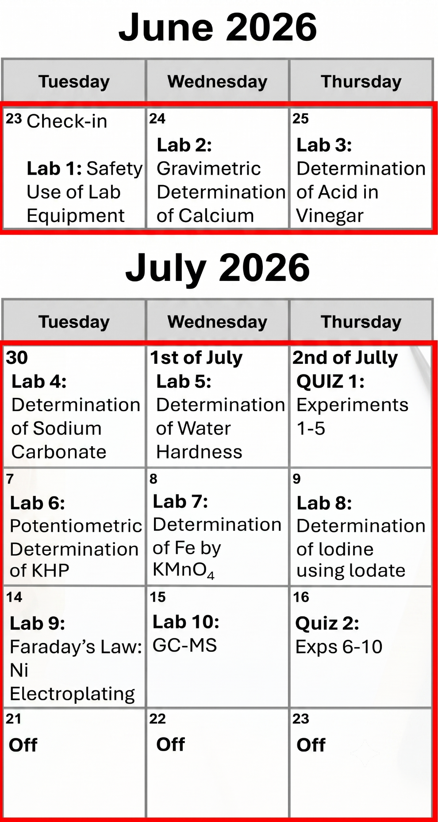

Lab Reports

The last page of each lab handout is the lab report sheet, on which you will report your lab results. This information will come directly from your lab notebook (see below), and any blanks on the report must be filled in or explained. The report sheets are due at the beginning of the lab period immediately following the completion of the lab. Late lab reports will be penalized by ten points, and no lab will be accepted more than two weeks after the date due.

Lab Notebook

All students will use a lab notebook to record all data obtained in this lab. The notebook must be one in which the pages are permanently attached -- loose leaf notebooks are not acceptable. Recording data on scratch paper, paper towels, etc. before transfer to the notebook is expressly forbidden. Any student found using such scratch paper will have their lab grade for that lab lowered by 10 points, and the scratch paper will be discarded.

Your lab notebook must always be up-to-date. Since you will not be recording data anywhere else, this should not be a problem.

The notebook will contain the following information in a clear, easy-to-read, understandable manner:

A) A brief description of experimental procedure, or a flow chart.
This should be written in advance of the lab period. It is for your own use an organizational aid as you perform the lab.

B) All raw data, preferably recorded in data tables for easy reference.

C) At least one example of every calculation.

D) All conclusions (such as composition of unknown), and any reasons why lab results are not up to expectations (such as: "neighbor's experiment blew up all over my reaction vessel"). Results should be in tabular form, well labelled, and easy to understand by someone not familiar with your notebook.

E) If your notebook is illegible, all conclusions will be assumed to be incorrect and graded accordingly.

Leave an empty page at the beginning of your notebook for a "Table of Contents". Fill it in as you complete each experiment.

Lab Reports

Once the notebook entry for a specific lab is complete, you should scan a PDF copy and submit it on Canvas no later than one week after the lab has been done. If necessary, the lab may be typed up into Microsoft Word (however, it is still required you keep a notebook).

CHEM 3452 -MANDATORY LABORATORY PRACTICES

Lab Clothing and Eye Protection

Eye protection is required by state law for everyone in a laboratory, regardless of whether they are actually doing anything or not. Goggles are strongly recommended since they provide more adequate splash protection. Any person who refuses to wear eye protection will leave the laboratory and take an automatic "0" for that lab exercise.

We will be using large quantities of acids and bases this semester. These chemicals tend to dissolve clothing (and flesh) with which they come into contact. It is advisable to consider any garment worn to the lab as potentially disposable -- dress accordingly. Also: since most liquids tend to follow gravity after a spill, long pants and closed shoes are recommended.

Exercise caution when touching anything. It is especially unwise to sit or lean on the lab benches. If an acid or base has been spilled and left to evaporate, it will have left a residue that could easily install air conditioning in any clothing it contacts.

  - Long pants that cover the whole leg are MANDATORY
  - Eye Protection (goggles or safety glasses)
  - Long hair pulled back and out of the way
  - Closed-toe shoes
  - If the above rules are not followed, you will be given 15 minutes to come back to the lab with the appropriate safety gear. Showings after 15-minute grace period, students are late and will be given a “0” for the lab
Glassware

  - Glassware needs to be cleaned at the beginning and end of every lab period
  - Rinse with distilled water before use during the experiment
  - When glassware breaks, alert the TA who will dispose of the broken glassware in the appropriate container
Reagents
  - NEVER put any reagent or chemical back into the source container once it is removed
  - Excess reagents should be discarded into the corresponding chemical waste container
  - Always use clean pipettes when collecting reagents

Chemical waste

  - Pay attention to the amount of chemical waste in the bottle before adding more
  - NEVER overfill and select the appropriate container
  - When close to being full, alert the TA so they can get a new container
Balance/Scales
- Brush off the chemical residue before and after weighing
- NEVER put solid chemicals directly onto the scale, use weighing paper or weighing pans
- Make sure the area is free of dust and chemicals once finished
- Keep containers closed when not in use
- Any powder left at that scale at the end of the lab period will lead to points deducted from the class
Acid/Base
- Safety when using concentrated acids and bases is the utmost importance. Consult instructions on how to handle concentrated strong acids or concentrated strong bases
- Alert the TA if any chemical spills might occur

Hot Plates and Countertops

- The countertop needs to be cleaned before students finish the lab
- Clean any spills on hotplates right away to avoid serious damage, and learn the precautions and guidelines on how to use hot plates correctly. Never overheat solutions more than needed or leave hot plates unattended

Graphing

Several experiments in this lab will require the use of graphical methods of data analysis. When graphing continuous data (including most experimental results), a smooth curve should be drawn through the data points so that there are an equal number of points above and below the line. This is essentially a method of determining the average value of a function along the curve. A few other points to remember when graphing:

A) Use as much of the graph paper as possible. Your graphs will be more readable and more accurate.

B) If more than one curve is shown on the same sheet of paper, use
different colored lines, different symbols for the data points (circles and ……………...stars, for example), or dotted versus continuous lines to differentiate the ……………...data sets. Make certain the difference is obvious, and provide a key to ……………...identify which is which.

C) The x- and y-axes need not start at zero. Use only the parts of the axes ……………..which contain the domain and range of your data.

The following graphs illustrate these points, with the graphs on the left showing good techniques and those on the right showing poor techniques. 1A and 1B show the benefit of graphing only that portion of the graph that is of interest. Graphs 2A and 2B illustrate the best way to draw a line through a series of data points (calculators can do this by a least square program).

Placeholder for Figures 1 to 3 A &B.
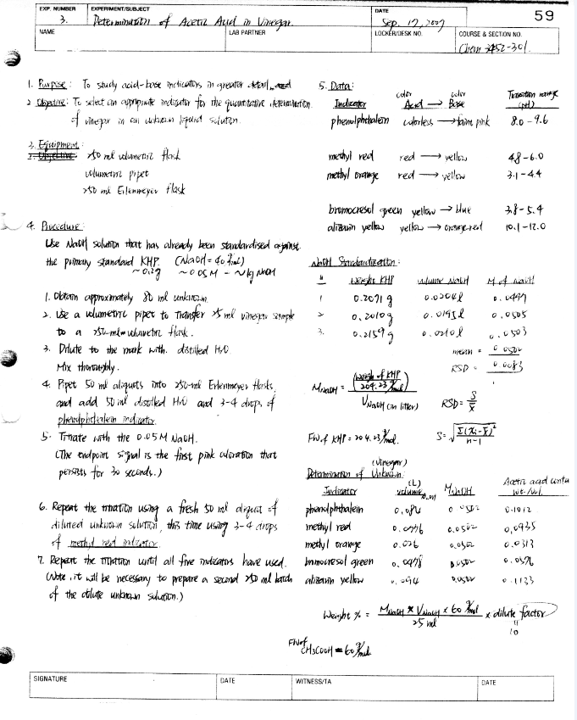
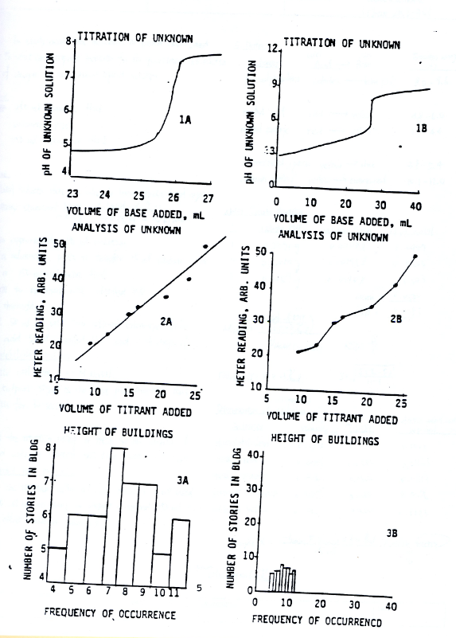
Lab report Example
