**“*Let’s eat, drink, and be merry for tomorrow we die.***

***Or who knows, perhaps even today!”*** *(66)*

**And Then There Were None**

By Agatha Christie

**Artistic Vision**

Lisa Devine, Director

UNT – Fall 2025

***My deep respect for Agatha Christie***

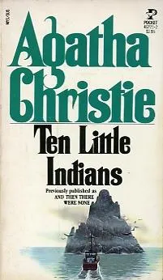and solve the crime presented. It is an invigorating form of escapism as the characters’ fate is in my hands. Agatha Christie is known as the ‘Queen of Crime’ as she helped to develop this genre. Noted by the Guiness Book of Worlds Records, she is the best-selling writer of books of all time with over 6 billion copies sold. (Only the Bible has sold more.) Her play, The Mousetrap, is the longest running play in the West End at 73 years and over 30,000 performances. She wrote in many forms including novels, novellas, and plays. She allowed an adaptation of one of her novels and was displeased with the outcome so she vowed that she would be the only adaptor of her stories. Our script is her adaptation of the novel. As a director trained in working with the playwright to bring a story to the stage, I want to bring her vision to our audiences by depicting the original 1939 ending, as described in the title.

***Writing the Novel***

When Agatha Christie sat down to write this mystery, her goal was to write a story in which all the characters die, and the reader would not know who was responsible for the crime. It was first published in 23 parts in the Daily Express over several weeks. Each installment added a new layer to the mystery. Readers could not figure out who was the killer. Agatha Christie was proud of this achievement. From her autobiography, she wrote *“the person who was really please with it was myself, for I knew better than any critic how difficult it had been.”* The outrage from the readers was so intense that she wrote an explanation of how and why the murders had been achieved from Judge Wargrave’s perspective entitled “*A Manuscript Document Sent to Scotland Yard*”.

***Location: Soldier Island***

According to biographer Janet Morgan, Soldier Island is “*modeled after Burgh Island off the coast at Kingsbridge.”* (Morgan, 220) It is located off the South coast of England near Devon. This is the area that Agatha Christie grew up in a small Southern coast town of Torquay. From the novel, the approach to the island from the south side shows itself to be a rock as it “shelved gently down to the sea.” (Christie, 29) A first impression of the island is described on Dr. Armstrong’s arrival in the novel as *“There was something magical about an island – the mere word suggested fantasy. You lost touch with the world – an island was a world of its own. A world, perhaps, from which you might never return.”* (Christie, 36) It is revealed that William Blore knows this island from before the house was built as the recalls, *“Remember this island when I was a kid. Never thought I’d be doing this sort of a job in a house here. Good thing, perhaps that one can’t foresee the future.”* (Chrisie, 39) William Blore, Phillip Lombard, and Dr. Armstrong search the island for a way to escape (after 2 guests have been murdered). *“On the northwest side, towards the coast, the cliffs fell sheer to the sea below, their surface unbroken. On the rest of the island there were no trees and very little cover.”* (Christie, 123)

**The Mansion**

On Burgh Island, a hotel was built in 1929 in the Art Deco styling that is described in the novel. Christie reportedly stayed at the hotel’s beach house to write the novel. The hotel may have been the inspiration for the home featured. In the novel and the play, there is a mystique surrounding who built the hotel AND who owns the hotel, currently. This mystery is exploited by the U.N. Owens to lure the “guests” to the island. In the newspapers it had been reported that the *“original purchase by an American millionaire who was crazy about yachting – and an account of the luxurious modern house he had built on this little island off the Devon coast. The unfortunate fact that the new third wife of the American millionaire was a bad sailor had led to the subsequent putting gup of the house and island for sale.*” (Christie, 1). When described in the newspapers, it was said the house was *“to be absolutely the last word in luxury.”* (Christie, 4)

**The Art Deco Style**

What a visitor could experience when staying at Burgh Island is to be transported back to the *“glamorous era of the 1930s.”* The Burgh Island website promises that this is “*a truly immersive experience, combining the classic elegance of the 20s and 30s with a truly masterful Art Deco theme throughout the entire hotel.”* (burghisland.com) Agatha Christie and other mystery writers are tied to this movement as it gained popularity in the 1920s and 1930s and was *“centered a commitment to decadence.”* Tara Dennis, director of interior design studio Archie Bolden states that *“Art Deco is generally summed up in three words: rich, bold, and decadent with abstract shapes, patterns, and motifs, usually layered in a way that evokes glamour and luxury.*” (Walter, Meg. Dwell.com) Recently, CBS Sunday Morning did a short history of Art Deco: <https://www.youtube.com/watch?v=-PcjhQhA86A>

***Playing with Perception***

5 Stages of Perception:

1. Stimulation
2. Organization
3. Interpretation-Evaluation
4. Memory
5. Recall

Definition of Perception – An active process by which you become aware of objects, events, and people through your five senses.

In the novel, Agatha Christie begins by writing from each character’s point of view about the adventure he/she has been invited to on Soldier Island. Each was enticed by a relationship or a moment from their past. In Chapter 1, we are given a glimpse into what is occurring in their lives and what has brought them to this event whether it is a needed vacation, work opportunity or a reunion. This structure of seeing the same event from 11 perspectives sets up a weapon we can use to build our show. Using the Stages of Perception to fool our audiences and keep them guessing as to who is puppeteering these murders.

***Perception and Optical Illusions***

*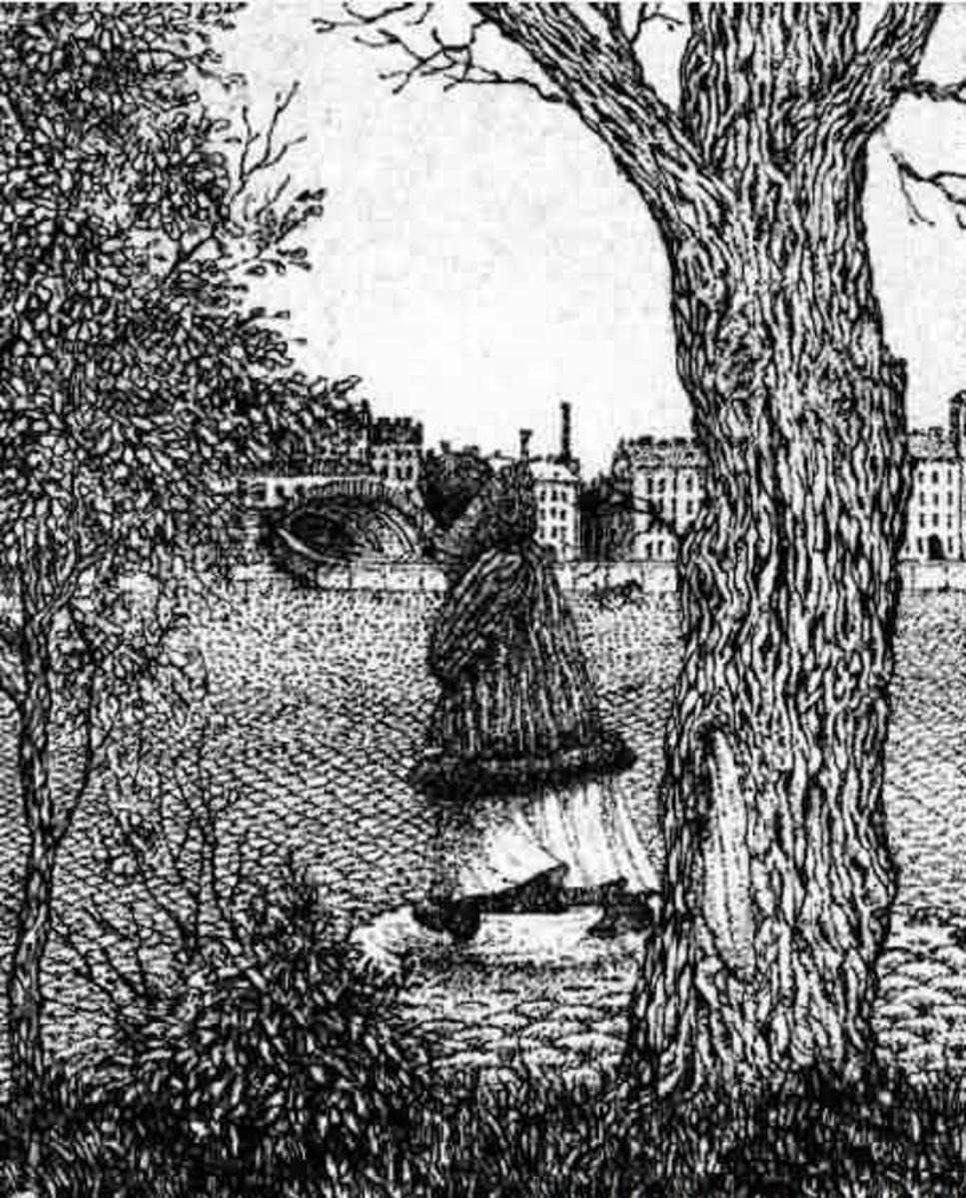“In the middle of life we are in death.”* (45) Each of our characters have been accused of being responsible – in some ways – to the death of another human being. Are they guilty? Were they in the wrong place at the wrong time? Did the victim get what was morally coming to them? The answers to these questions is a matter of perception. Keeping the audience guessing deepens the mystery. Each character has their own perception as to what happened to the victims that Mr. Owens has accused them of murdering. Knowing how humans perceive allows us to play making their stories clash into optical illusions that make the audience question everything - thus leaving them with nothing. This is my goal with our production.

***Creating YOUR character’s Moral Compass***

What Agatha Christie has written is a mosaic of perceptions from which characters burst forth. I started to place the characters on a spectrum from those who are less guilty to those who are despicable. I have my opinions BUT I realized that this is your jobs as actors. To understand their perspective so well that you can defend them – in a court of law. Who has the guilty conscience that plagues them? Does this make them more human? Who has no remorse? How does their moral compass guide them in their actions? Recognize there are no villains in this show. Be ready to defend their actions.

***Romantic Fantasy***

Each of the murders in our story has been well planned and tied perfectly to the “Ten Little Soldiers” nursery rhyme by Mr. Owens. Someone who knows each of the participants and the “crimes” they have committed. What our audience will witness is a fantasy born during childhood. *“I was born with other traits besides my romantic fancy. I have a definite sadistic delight in seeing or causing death. . . . From an early age I knew very strongly the lust to kill.”* (Christie, 285) The desire grew in adulthood to not just *“judge by act”.* (Christie, 287) Until the idea was hatched of “*how often murders must be committed which the law was unable to touch.”* (Christie, 288). This launched the fantasy into action steps.

***“I must – I must – I must- commit a murder!***

***And what is more, it must be no ordinary murder!***

***It must be a fantastical crime – something stupendous – out of common!***

***In that one respect, I have still, I think an adolescent’s imagination.***

***I wanted something theatrical, impossible!*** (Christie , 287)

This story is viewed through the romantic fantasy of:

**Sir Lawrence Wargrave**