FADM 3570 Decorative Accessories Merchandising Fall 2022
Lecture: Mondays and Wednesdays from 10:00AM to 11:20AM in Chilton 349
Contact Information:
Instructor: Ms. Lisa Choate
Office: 330E Chilton Hall
Email: Lisa.Choate@unt.edu
Telephone: 831-601-3675 or CMHT Main Office Chilton 331 at 940-565-2436
Student Office Hours: Monday, Wednesday 9:30 – 10:00; 11:20 – 12:00 or via Zoom by appointment
Communications: All emails must have a subject heading that begins with the following: FADM 3570: your subject here”.
You may expect a same-day response in most cases before 6pm except on weekends/holidays. Responses to emails without
this subject heading may be delayed. Most assignments will be graded within 5-10 business days; if there is an issue that
requires a longer period of time for grading, you will be notified.

Description: | Overview of decorative accessories in their historical context and in current industry applications. Production and merchandising of products including giftware, lighting, home accents, accent furniture, rugs, soft goods, tabletop, etc.
Required Texts & Resources: | - Elsasser, V. H. (2016). Know Your Home Furnishings, Fairchild Publications. 2nd Edition  - UNT Library LibGuides/HFMD Subject Guides  - Home Furnishings Industry Trade publications (HFN, HAT, others), trade websites, E-newsletters, and assigned for other readings/assignments.  - Use of UNT Library Print & Electronic Resources.  - Other materials for use in class: paper, pen or pencil, laptop or other device for researching the Internet, creating and submitting assignments on Canvas during class. |  | 
Building Your Resource Library | - The Substance of Style: How the Rise of Aesthetic Value Is Remaking Commerce, Culture, and Consciousness, Virginia Postrel, Harper Perennial  - Any publications by Judith Miller (i.e., The Illustrated Dictionary of Antiques & Collectibles. | 
In-class behavior: Do NOT take pictures/images of slides or other classroom materials with your tablet, cell phone or other devices, unless specified by me. You are not authorized to provide/post your notes to anyone/anyplace else outside of this class, or to make any commercial use of them without permission from Dr. Brandon.
Assignments, projects, and tests in courses vary from year to year so the same information or format or will be different from those other students have submitted in the past.

Course Objectives + Student Learning Outcomes

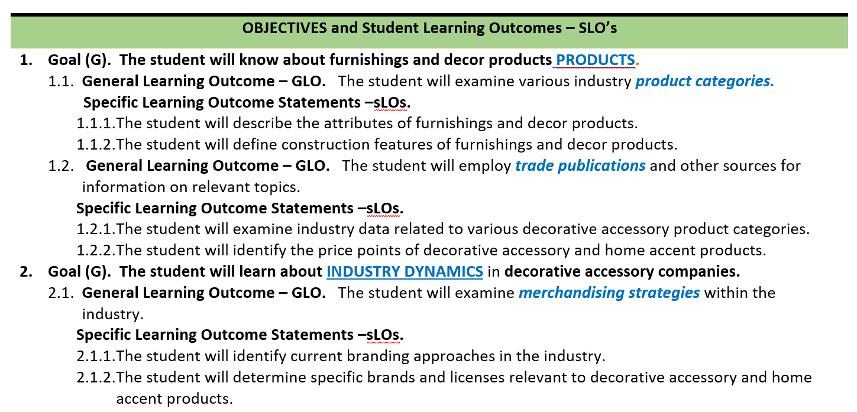
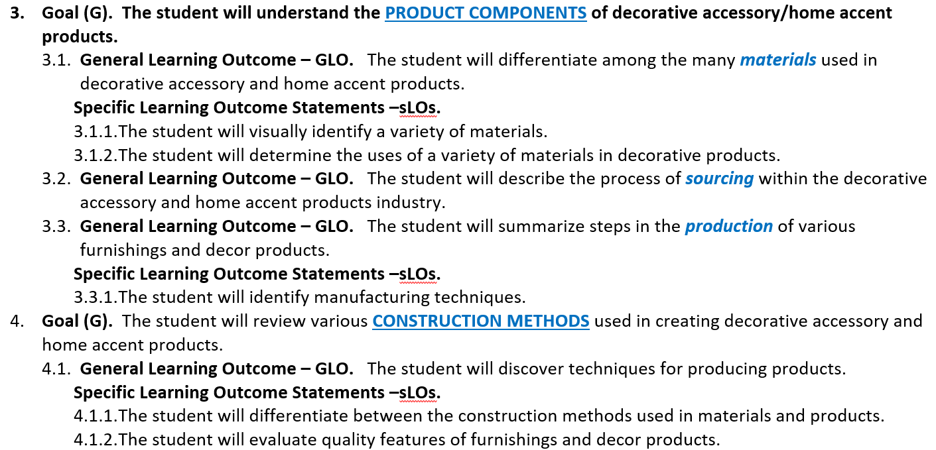
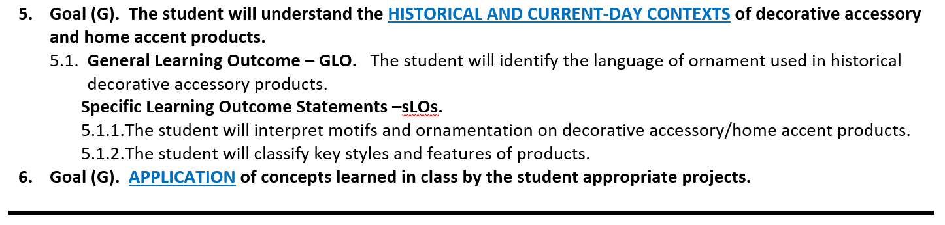

Best Practices for Success in FADM Courses
- I am committed to helping you succeed, but you must do your part:
  - Prepare for class by pre-reading topic information, finding relevant items and watching any assigned materials so the topics covered in class are not completely new information, you already have an introduction or overview.
  - Attend classes. Be on time or early and stay the entire class time or you will miss pertinent information you need to know. See more attendance items below.
  - Be creative, curious, and self-motivated. Find interesting items related to topics in class and share them via Canvas.
  - Review the rubric expectations for grading for individual assignments. Just because something is submitted is not a guarantee of it earning full point value. Points are earned based on the level of expectations met.
  - You will be required to problem-solve and be innovative.
- If you miss a class, message me ASAP or by the end of the next day to discuss. If you know you will miss an upcoming class (religious, medical, UNT sports, etc. absences), alert me as soon as possible (earlier is better) prior to the missed day.
- Be prepared to submit documentation for all absences. You will be referred to the Dean of Students Office which collects and verifies this documentation. I will work with you on an individual basis for suggestions regarding how to get caught up.
- Some course materials (those that I create and others) to assist you in learning the course topics will be posted in Canvas or distributed in class. However, class slides will not be posted. It is your responsibility to be prepared for class, be in class, take good notes and find follow-up information to enhance your knowledge.


Course Schedule
FADM 3570
Decorative Accessories Merchandising Fall 2022
Week | Date | Topics for Lecture & Learning | Reading Assignments (before class) | Due Dates & Reminders
1 | 8-29 | Course and Industry Introduction | Ch. 1 + Industry Periodicals (HFN, Furniture Today, Home Accents Today, etc.) + Module Content
1 | 8-31 | Overview, Trade Publications, etc.
2 | 9-5 | Holiday, no class
2 | 9-7 | Marketspace for HF
3 | 9-12 | Merchandising Foundations
3 | 9-14 | Glass | Ch. 4 + Module Content
4 | 9-19 | Glass | Ch. 4 + Module Content
4 | 9-21 | Glass (class will not meet so you may attend the Career Expo; lecture and a brief assignment will be online for an extended amount of time in place of this lecture) | Ch. 4 + Module Content | 9-21 CMHT Career Expo–Union Ballroom 10am-1pm
5 | 9-26 | Glass | Ch. 4 + Module Content
5 | 9-28 | Ceramics | Ch. 5 + Module Content | 9/28 Exam 1 (Intro-Glass)
6 | 10-3 | Ceramics
6 | 10-5 | Ceramics
7 | 10-10 | Carpets & Rugs | Ch. 12 (pp.283-295) + Module Content | 10/10 Exam 2 (Ceramics)
7 | 10-12 | Carpets & Rugs | Ch. 12 (pp.283-295) + Module Content
8 | 10-17 | Carpets & Rugs | Ch. 12 (pp.283-295) + Module Content
8 | 10-19 | Carpets & Rugs | Ch. 12 (pp.283-295) + Module Content
9 | 10-24 | Wood & Furniture | Ch. 3 & 9 + Module Content | 10/24 Exam 3 (Carpets & Rugs)
9 | 10-26 | Wood & Furniture | Ch. 3 & 9 + Module Content
10 | 10-31 | Wood & Furniture | Ch. 3 & 9 + Module Content
10 | 11-2 | Wood & Furniture | Ch. 3 & 9 + Module Content
11 | 11-7 | Metals | Ch. 7 + Module Content
11 | 11-9 | Metals | Ch. 7 + Module Content
12 | 11-14 | Metals | Ch. 7 + Module Content
12 | 11-16 | Metals | Ch. 7 + Module Content
13 | 11-21 | Tabletop | Ch. 13 + Module Content | 11-21 Exam 4 (Wood & Furniture-Metals)
13 | 11-23 | Holiday - no class | Ch. 13 + Module Content
14 | 11-28 | Tabletop | Ch. 13 + Module Content
14 | 11-30 | Plastics | Ch. 6 + Module Content
15 | 12-5 | Plastics; Lighting | Ch. 14 + Module Content
15 | 12-7 | Lighting; Course Wrap-Up/Review | Ch. 14 + Module Content
16 | Exam 5 (Tabletop, Plastics & Lighting)  12/18 Section 002 MW = Saturday December 10 8:00AM to 10:00PM in Chilton 349
* This schedule is a guide and may be subject to modifications; if changed, you will be notified in class and it will be updated online in Canvas.

Course Requirements | Points | Due Dates and Times
Applied Learning Activities (bonuses possible) | 0 | In lecture class only
Assignments (9) | 180 | TBD (will be revealed in class)
Exam 1 | 45 | 9/7
Exam 2 | 45 | 10/11
Exam 3 | 45 | 10/24
Exam 4 | 45 | 11/22
Exam 5 | 45 | 12/15
Professional Development (bonus of 10 points possible) | 0 | 11/21
Total | 405 | All assignments due at 11:59PM unless otherwise stated.

Course Requirements
- Applied Learning Activities (ALA) will be given during lectures in class. Application of course material is critical to understanding and your overall learning achievements. Since these activities will occur only during our regularly scheduled class sessions, your attendance and engagement is critical to your success. There are no makeups, but there will be plenty of opportunities to earn points during classes. These will be used for attendance, participation and will be graded as well. Although I don’t offer extra credit, I do offer bonus points for some of the ALAs. Some may be pop quizzes, application or product pages. These may be on Canvas, on your notebook paper or on a handout.
- Assignments: are by lecture topic and will be revealed in class with the due dates; points may vary from 10-25 points for a total of 180 points. They will be posted and turned in on Canvas. These may be on Canvas, on your notebook paper or on a handout. It may be a sheet you complete, a video watched with an essay, a tour with questions, a guest lecturer and your thoughts. It could be almost anything about history, notable names, what’s happening today and more.
- Exams are divided purposefully between subjects to assess experience with the reading material and familiarity with the materials presented in lecture. Exams may be paper + Scantron (provided) + #2 pencil or they may be offered on Canvas using Lockdown Browser. Either way, they will only be available to those who are in the classroom on the date specified on the Course Schedule. Exams are 30 questions for 30 minutes for 45 points. One Exam may be made up with approved excuse (date and time TBD will be determined between myself and the student but will most likely be on Reading Day 12/9 at 9am).
- Professional Development (10 points bonus): The objective is to attend an event with a speaker or the Career Expo which is extracurricular and then prove that you attended and learned something new. If you are not in the College of Merchandising, Hospitality or Tourism and these event(s) do not interest you, you may find your own event to attend. Please review the event with me first. There are many events and speakers and organizations on campus! Pick something you are interested in and which may help you in your career.
        - Career Expo 9/21 10:00AM– 1:00PM, See announcement in Canvas Announcements.
        - Panel Discussion: TBA
        - TBD or create your own (again, please review with me).

Grading

- Rubrics for each of the assignments will be posted in Canvas throughout the semester.
- Grades are not curved. They will be rounded to 1 decimal point (ex: 89.75% will be rounded to 89.8% which is below 90% minimum for A; a grade of B will be assigned).
- To calculate grade: Points Earned/Points Possible*100. It is best to calculate your Current Grade using this formula. The Total grade on Canvas may or may not be accurate depending on what is showing and not showing at any given moment in Grades on Canvas.
- If you believe a grade is incorrect, you have 5 business days from the time of posting to dispute the grade.
- If you are struggling in the course, meet with me early; do not wait. Take responsibility for your actions and your study habits!
- All discussion of grades will take place privately during office hours or in an appointment we set up. It will not be appropriate to ask to discuss grades before class, during class or after class in front of other students.
- The final semester grade will be determined as follows:
A = 90-100%
B = 80-89.9%
C = 70-79.9%
D = 60-69.9%
F = 59.9% or below
See the “Levels of Achievement for earning points”….included on each individual assignment rubric.
Levels of achievement for earning points on assignments and projects – individual point values are available on individual assignments.
A – level points
- Expectations and requirements met at an exceptional level.
- Items submitted are more than the listed minimal requirements.
- No mistakes, no edits needed (spelling, grammar, punctuation, etc.)
- Great ATD (attention to detail), precision, composition, graphic design, etc.
- Effort, professionalism, and creativity are highly evident.
B – level points
- Meets expectations at a very good level.
- Minor edits needed (spelling, grammar, punctuation, etc.)
- Some room for improvement.
C – level points
- Average Work. Effort and items are average work, but not more.
- More work/edits/improvement needed in substance, writing, visuals, etc.)
- ATD needs improvement
D – level points
- Insufficient Effort. Needs much more evidence of effort, work appears hurried or last minute.
- Incomplete items, many edits are needed
- ATD lacking
F – level points
- Severely Deficient Work.
- Incomplete items or sections.
- Many edits needed.
- Effort is not evident.
F – level points – 0 points
- No submission.
Absence Documentation

Any documentation (medical or other) for class absences will be referred to the Dean of Students who verifies those items.

- Student are expected to be respectful of other students, guests, and faculty. Behavior that interferes with an instructor’s ability to conduct a class or other students' opportunity to learn is unacceptable and disruptive and will not be tolerated in any instructional forum at UNT.
- Students engaging in unacceptable behavior will be directed to leave the classroom and may be referred to the Dean of Students for possible violation of the Code of Student Conduct.
- UNTs expectations for student conduct apply to all instructional forums, including university and electronic classroom, labs, discussion groups, field trips, etc. The Code of Student Conduct can be found at www.deanofstudents.unt.edu.

The College of Merchandising, Hospitality and Tourism requires that students respect and maintain all university property. Students are accountable through disciplinary action for any intentional damages they cause in classrooms. (e.g., writing on tables, destruction of items, etc.).

Refrain from disruptive behavior (e.g., arriving late, leaving early, sleeping, talking on the phone, texting or game playing, making inappropriate comments, ringing cell phones, dressing inappropriately).

Incomplete “I” grades are not automatic and must adhere to UNT Policy which includes “ An (I) is given only during the last one-fourth of a term/semester and only if a student (1) is passing the course and (2) has a justifiable and documented reason, beyond the control of the student (such as serious illness or military service), for not completing the work on schedule. The student must arrange with the instructor to finish the course at a later date by completing specific requirements. These requirements must be listed on a Request for Grade of Incomplete form signed by the instructor, student, and department chair; and also entered on the grade roster by the instructor”.

Attendance and Participation Expectations (UNT Policy 06.039)
The University of North Texas recognizes that student success is promoted by regular attendance and participation in class.
You are responsible for attending each class and securing your own lecture notes should you miss. During class….
- Engage in and stay engaged in class activities.
- Do not work on items other than those related to our immediate class topic.
- Refrain from texting or taking calls – scheduled class time is specified for our work.
- You may need to check out a CMHT laptop and bring to class for certain days – check it out and bring to class. If you have to leave class to secure a laptop, you will miss information you need. See the CMHT IT information in the CMHT Policies Part 1 – posted in Canvas.
- You may be required to use a headset or earphones on certain days. Secure one that works with either your own laptop or a CMHT laptop.
- Be respectful to all.
- Dress appropriately.
- Communication: The most important thing you can do is to let me know when you cannot attend and why (especially illness/quarantine/isolation). We can decide later if it’s an approved excuse or not. Be sure you understand what the stated approved excuses (see below). I recognize that life happens, but your classes are the #1 priority! If you experience any hardships such as illness, accident, family crisis please know that these policies may be amended and therefore you should communicate with me as soon as you feel comfortable doing so. If for any reason you do not feel comfortable discussing health issues with me, please contact the Student Health and Wellness Center or Dean of Students. If I can be flexible and still be fair to the class by applying the same policy, I will do so. But if I have to make special exceptions, I won’t. Just remember that if answers have already been released to the class, it may not be possible.
  - Missing 1-2 classes: please let me know what’s going on--especially anything from COVID@unt.edu--but I’m not worried about you catching up. Be sure to get notes from students in class.
  - Missing a longer period of time, then we need to talk in person. More than likely I will require that you notify the Dean of Students so they may verify your situation.
  - Why should you keep in touch? I don’t want anyone to fail; there’s always a way to deal with the stuff that life throws at you (provided it’s true!).

- I will take attendance using iClicker. You must have an account whether you have an electronic device or not. No seating chart. A sign-in sheet will be made available at the lectern in case your electronic device is not working.

- You cannot achieve the course objectives unless you attend class and actively engage. If you are not in class, you are absent regardless of whether ‘excused’ or ‘unexcused’ and you will miss the ALA if there is one for that day. You are responsible for attending each class meeting and securing your own lecture notes should you miss.

- Students are expected to be in class the entire meeting time. This means no getting up and leaving in the middle of class (bathroom breaks, answering the phone, etc.). Unless you have a medical reason, you are expected to sit in your seat for the entire class meeting without disruption. You should use the restroom prior to class or after class. I understand emergencies happen, but DO NOT MAKE THIS A HABIT! Each time you get up from your seat during class, you disrupt the learning of your classmates.

- You are expected to be courteous, professional and respectful when attending class.

- Students will not be penalized for missing class due to religious holy days or ROTC. Student athletes with proper documentation will not be penalized for attending athletic competitions. If you know you will miss a class due to one of these excused absences, please inform me by the end of the first two weeks of classes (first 2 days of classes in summer sessions) and I will attempt to reschedule assessments with regard to those days.
  - Per the UNT Student Attendance and Authorized Absences Policy, an absence may be excused for the following reasons:
    - a religious holy day, including travel for that purpose;
    - active military service, including travel for that purpose;
    - participation in an official university function;
    - illness or other extenuating circumstances;
    - pregnancy and parenting under Title IX; and (see the Policy for specifics);
    - when the University is officially closed by the President.
    - Dean of Student’s approved excuse (could be anything);
    - a medical excuse: a written statement by a doctor needs to be provided to me stating that you were too ill to be in class or to take the exam at the scheduled time—this would need to be verified by Dean of Students;
    - death in the immediate family; notification from Dean of Student’s office and Funeral program must be provided;
    - a university-excused absence: proof of participation must be provided. Arrangements must be made at least one week prior to the activity or absence.
    - Doctor’s appointments are not excused absences.

Exams/Quizzes and Makeup Exams
You are responsible for taking all exams at the scheduled times. Please email me prior to the exam if you believe you have an excused absence. All approved makeup exams are given on Reading Day at 9-11am or at another arranged time between myself and you. A student is allowed one make-up exam. Makeup exams are for students who missed an exam, not to improve an exam grade. If you lose internet connection during an exam, please contact me as soon as possible. I will watch the status of exams online.

Final exams will be administered at the designated time (no earlier and no later). Should you have more than two finals on one day, you may request to reschedule one of these exams on another day during the final exam period. Please check the course calendar early in the semester to avoid any schedule conflicts. I’m here to help!

Assignment Due Dates and Submission
Deadlines are firm. But if you know you have something coming up that will challenge your time management, please talk to me. If late submission is possible and allowed, assignments are considered late and are downgraded at the rate of 10% for each calendar day late up to 2 days late. If the Answer Key is already published, I will not accept late submissions. If you see that the assignment is available beyond the due date on Canvas, that means I will accept a late submission.
- Do not email assignments to me without prior permission! Emailed assignments will not be accepted without prior arrangement and extenuating circumstances. Missing the deadline is not an extenuating circumstance.
- When submitting an assignment to Canvas, always sign out and then sign in again to Canvas to ensure that what you submitted shows up properly. Also be sure you submitted the completed assignment and not the blank.
- If I can’t open the file, I can’t grade it. Do not submit Google docs; the assignment tells you what formats are accepted.
- Due Dates and Times: Unless otherwise stated on the Course Schedule below or on Canvas, all items are due at end of day 11:59pm.
- All assessments can be found in the “Assignment” module or in the relevant “Subject” module.
- The hours of 10pm to Midnight are extremely busy on Canvas and submissions may take a while to load. Plan ahead.
- I may require Turnitin for some special assignments. This checks to see whether anyone else has a similar assignment.
- Students should immediately report any problems to me and contact the UNT Student Help Desk: helpdesk@unt.edu or 940.565.2324 and obtain a ticket number. We will work with the student to resolve any issues at the earliest possible time.

Academic Dishonesty
A range of disciplinary actions may result from any finding of academic dishonesty (i.e., admonition, class failure, expulsion) depending upon the severity of the misconduct. At a minimum for this class, any finding of academic misconduct on exams, writing assignments, or any other graded assignment will result in a “0” for that graded activity or assignment. For additional information, please refer to UNT Policy 06.003 and the CMHT Syllabus Addendum.

Academic dishonesty includes, but is not limited to, the use of any unauthorized assistance in taking quizzes, tests, or exams; dependence upon the aid of sources beyond those authorized by the instructor, the acquisition of tests or other material belonging to a faculty member, dual submission of a paper or project, resubmission of a paper or project to a different class without express permission from the instructors, or any other act designed to give a student an unfair advantage. Plagiarism includes the paraphrase or direct quotation of published or unpublished works without full and clear acknowledgment of the author/source. Academic dishonesty will bring about disciplinary action which may include expulsion from the university. This is explained in the UNT Student Handbook.
See UNT policy: https://policy.unt.edu/sites/default/files/06.003_StudentStandardsOfAcademicIntegrity_8_2017.pdf
Policies and penalties for academic dishonesty:
- Cheating on an exam will result in automatic failure on that assessment (e.g.,). Examples of cheating include but are not limited to:
  - Any communication during an exam (ex: passing notes, texting each other during an exam, GroupMe chats and similar apps during an exam)
  - Use of unauthorized assistance to take the exam
  - Acquisition of the exam without permission
- Dual submission of a paper or project or resubmission of a paper or project to a different class without express permission from the instructor will result in “0” points for that assignment without the opportunity to complete.
- Dual submission of a paper or project or resubmission of a paper or project to the same class by different students without express permission from the instructor will result in “0” points for that assignment without the opportunity to complete. This is called plagiarism.
- Plagiarism (depending on the severity) will result no credit on an assessment.
- Fabrication or inventing any information, data or research as a part of an academic exercise will result in no credit on an assessment.
- Facilitating Academic Dishonesty or assisting another in the commission of academic dishonesty will result in failure for the assignment (for either or both individuals).
- Sabotage or acting to prevent others from completing their work or willfully disrupting the academic work will result in failure from the class.
- More than 1 (one) incident will result in failure of the course.
- All incidents will be reported to the Office of Academic Integrity.

Course Recordings
It is unlikely I will record lectures anymore; however, if I do, then:
Class recordings are the intellectual property of the university or instructor and are reserved for use only by students in this class and only for educational purposes. Students may not post or otherwise share the recordings outside the class, or outside the Canvas Learning Management System, in any form. Failing to follow this restriction is a violation of the UNT Code of Student Conduct and could lead to disciplinary action.

In the Classroom:
- Put belongings you won’t be using under the table.
- Bring your laptop to the classroom on-site, too. You may need to work in class.

Course Technology & Skills

Minimum Technology Requirements
Provide a list of the minimum technology requirements for students, such as:
- Computer
- Reliable internet access
- Speakers
- Microphone
- Plug-ins
- Microsoft Office Suite
- Canvas Technical Requirements (https://clear.unt.edu/supported-technologies/canvas/requirements)

Computer Skills & Digital Literacy
Provide a list of course-specific technical skills learners must have to succeed in the course, such as:
- Using Canvas
- Using email with attachments
- Downloading and installing software
- Using spreadsheet programs
- Using presentation and graphics programs

Rules of Engagement
Rules of engagement refer to the way students are expected to interact with each other and with their instructors. Here are some general guidelines:
- While the freedom to express yourself is a fundamental human right, any communication that utilizes cruel and derogatory language on the basis of race, color, national origin, religion, sex, sexual orientation, gender identity, gender expression, age, disability, genetic information, veteran status, or any other characteristic protected under applicable federal or state law will not be tolerated.
- Treat your instructor and classmates with respect in any communication online or face-to-face, even when their opinion differs from your own.
- Ask for and use the correct name and pronouns for your instructor and classmates.
- Speak from personal experiences. Use “I” statements to share thoughts and feelings. Try not to speak on behalf of groups or other individual’s experiences.
- Use your critical thinking skills to challenge other people’s ideas, instead of attacking individuals.
- Avoid using all caps while communicating digitally. This may be interpreted as “YELLING!”
- Be cautious when using humor or sarcasm in emails or discussion posts as tone can be difficult to interpret digitally.
- Avoid using “text-talk” unless explicitly permitted by your instructor.
- Proofread and fact-check your sources.
- Keep in mind that online posts can be permanent, so think first before you type.
See these Engagement Guidelines (https://clear.unt.edu/online-communication-tips) for more information.

Course Evaluation
Student Perceptions of Teaching (SPOT) is the student evaluation system for UNT and allows students the ability to confidentially provide constructive feedback to their instructor and department to improve the quality of student experiences in the course. [11/21-12/8.]

Emergency Notification
If there is an emergency, I will post instructions on Canvas.

Technical Assistance
Part of working in the online environment involves dealing with the inconveniences and frustration that can arise when technology breaks down or does not perform as expected. Here at UNT we have a Student Help Desk that you can contact for help with Canvas or other technology issues.
UIT Help Desk: UIT Student Help Desk site (http://www.unt.edu/helpdesk/index.htm)
Email: helpdesk@unt.edu
Phone: 940-565-2324
In Person: Sage Hall, Room 130
Walk-In Availability: 8am-9pm
Telephone Availability:
- Sunday: noon-midnight
- Monday-Thursday: 8am-midnight
- Friday: 8am-8pm
- Saturday: 9am-5pm
Laptop Checkout: 8am-7pm
For additional support, visit Canvas Technical Help (https://community.canvaslms.com/docs/DOC-10554-4212710328)

Rules of Engagement
Rules of engagement refer to the way students are expected to interact with each other and with their instructors. Here are some general guidelines:
- While the freedom to express yourself is a fundamental human right, any communication that utilizes cruel and derogatory language on the basis of race, color, national origin, religion, sex, sexual orientation, gender identity, gender expression, age, disability, genetic information, veteran status, or any other characteristic protected under applicable federal or state law will not be tolerated.
- Treat your instructor and classmates with respect in any communication online or face-to-face, even when their opinion differs from your own.
- Ask for and use the correct name and pronouns for your instructor and classmates.
- Speak from personal experiences. Use “I” statements to share thoughts and feelings. Try not to speak on behalf of groups or other individual’s experiences.
- Use your critical thinking skills to challenge other people’s ideas, instead of attacking individuals.
- Avoid using all caps while communicating digitally. This may be interpreted as “YELLING!”
- Be cautious when using humor or sarcasm in emails or discussion posts as tone can be difficult to interpret digitally.
- Avoid using “text-talk” unless explicitly permitted by your instructor.
- Proofread and fact-check your sources.
- Keep in mind that online posts can be permanent, so think first before you type.
See these Engagement Guidelines (https://clear.unt.edu/online-communication-tips) for more information.

