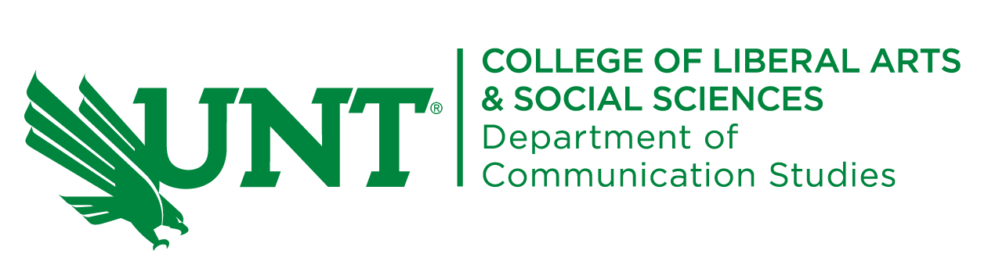

COMM 3120: Nonverbal Communication

Dr. Lori Byers
byers@unt.edu
Office: GAB 332/by appointment at Frisco Landing
Office hours: Directly after class and by appointment (online or in person)

Course description:

Applications of research and theory in understanding the impact of nonverbal communication in a variety of human contexts.

Course aspirations:

Upon completion of this course, students should be able to:
- Understand the importance and power of unspoken rules, messages, and cultures.
- Understand the role of nonverbal communication in expressing identity
- Explain and analyze the role of nonverbal communication in the creation, expression, and maintenance of identity, behavior and cultures across contexts (interpersonal, generational, intercultural, organizational, etc.).
- Practice emotional intelligence and rhetorical sensitivity regarding nonverbal communication across contexts.
- Practice increased awareness and self-monitoring of one’s own nonverbal cues.

Course assignments:

Attendance activities (300 points total)
Learning is a social activity. We learn from others in the class and we learn from spontaneous discussions that occur in class. We are all expected to attend classroom sessions. We will have daily activities in class (sometimes announced ahead of time and sometimes announced that day) that cannot be made up if you are absent (unless you have a university excused absence). On days that we complete class online, these activities could involve class discussions or reading summaries. These assignments should be a great way to raise your grade.

Short essays (3 X 100 points = 300 points total)
You will write four short essays to provide you the opportunity to apply and discuss course concepts. Your writing should be focused and thoroughly explain the concept(s) you choose. Your essays may consist of overviews of nonverbal concepts and research, applied analyses of nonverbal communication in different contexts (politics, social media, shows, relationships, etc.). Please incorporate a minimum of five credible outside sources to add depth and insight to each essay. Please discuss your topics and ideas with me ahead of time.

Nonverbal Communication Across Cultures Presentation and Guide (200 points total)
Each student will compare and contrast the nonverbal behaviors of two different cultures (excluding the U.S., although you are welcome to include U.S. behaviors in your analysis of the two other cultures). What are the spoken and nonspoken rules of nonverbal behavior in your chosen cultures? How do these differences in nonverbal behavior reveal themselves in different contexts such as family relationships, intimate relationships, public settings, professional settings, etc.? What makes the cultures you selected stand out from other cultures? You will both present to the class and create an applied guide for future professional travelers.

Applied nonverbal communication plan & strategy project (200 points)
You will submit a complete and thorough guide of one aspect of nonverbal communication for a locally owned business or nonprofit organization. Potential topics include nonverbal communication for organizational success, persuasive nonverbal communication for “friendraising” and fundraising, etc. I am completely open to more ideas – I want this assignment to be one that matters to you and that you enjoy. We will discuss different plans and strategies throughout the course.

Your communication plan should include, at a minimum:
- Your organization’s goals relevant to your project;
- Your target audience, including potential demographics and psychographics;
- An analysis of the organization’s existing needs with examples included;
- A detailed overview of ways nonverbal communication can help your organization succeed;
- Credible sources to justify all of your choices (minimum of 10).

Grade distribution:

1000 points total are possible in this course.
Canvas tracks your percentages for you as we go along.
Borderline grades will be determined based on attendance activities.

A: 900 – 1000
B: 800 – 899
C: 700 – 799
D: 600 – 699
F: Below 600

Policy statements:

This syllabus is subject to change and is not a contract.

Course Accessibility
The University of North Texas makes reasonable accommodation for students with disabilities. Students needing a reasonable academic accommodations must first register with the Office of Disability Access (ODA) to verify their eligibility. If a disability is verified, the student will request their letter of accommodation. ODA will provide faculty with a reasonable accommodation letter via email to begin a private discussion regarding a student’s specific needs in a course. Students may request reasonable accommodations at any time; however, ODA notices of reasonable accommodation should be provided as early as possible in the semester to avoid any delay in implementation. Note that students must obtain a new letter of reasonable accommodation for every semester and must meet with each faculty member prior to implementation in each class. Students are strongly encouraged to meet with faculty regarding their accommodations during office hours or by appointment. Faculty members have the authority to ask students to discuss such letters during their designated office hours to protect the privacy of the student. For additional information, refer to the Office of Disability Access website.

Academic Integrity Standards and Consequences
According to UNT Policy 06.003, Student Academic Integrity, academic dishonesty occurs when students engage in behaviors including, but not limited to cheating, fabrication, facilitating academic dishonesty, forgery, plagiarism, and sabotage. A finding of academic dishonesty may result in a range of academic penalties or sanctions ranging from admonition to expulsion from the University. Violations of this policy may result in failure of the assignment and even failure of the course.

Emergency Notification & Procedures
UNT uses a system called Eagle Alert to quickly notify students with critical information in the event of an emergency (i.e., severe weather, campus closing, and health and public safety emergencies like chemical spills, fires, or violence). In the event of a university closure, please refer to the UNT Learning Management System (LMS) for contingency plans for covering course materials.

Discussing issues related to Diversity, Equity, & Inclusion in Texas
Texas Senate Bill 17, the recent law that outlaws diversity, equity, and inclusion programs at public colleges and universities in Texas, does not in any way affect content, instruction or discussion in a course at public colleges and universities in Texas. Expectations and academic freedom for teaching and class discussion have not been altered post-SB 17, and students should not feel the need to censor their speech pertaining to topics including race and racism, structural inequality, LGBTQ+ issues, or diversity, equity, and inclusion.

Basic Needs Security
Any student who faces challenges securing their food or housing and believes this may affect their academic performance is urged to contact the Dean of Students for support (940-565-2648). UNT has both a Food Pantry and a “Seeking Options & Solutions” (SOS) team who work to help students navigate diverse concerns, including identifying resources for personal, academic, financial, and social issues.

Recording Class
Privacy is considered a basic classroom right in this course. This course will encourage open and robust discussions on issues and ideas without fear that any statements made will be used for inappropriate or retaliatory purposes. To ensure the comfort and protection of everyone in our classroom, recording of any kind is prohibited in this space (this includes audio recordings, live-streaming, photographs of course materials, etc.) unless a student has an approved accommodation from the Office of Disability Access (ODA). In such cases, all students in the course will be notified whenever recording will be taking place.

AI Clause (as part of larger Academic Integrity policy)
The goal of higher education is to become better thinkers and better writers. Both of these skills require development and practice. Intellectual honesty is vital to an academic community and for my fair evaluation of your work. All work submitted in this course must be your own. Contributions from anyone or anything else- including AI sources, must be properly quoted and cited every time they are used (including any AI generated material). Failure to do so constitutes an academic integrity violation, and I will follow UNT’s policy in those instances. AI tools such as ChatGPT, QuillBot, Grammarly Premium have their place in helping to make our lives easier; these tools can also hurt your capacity to engage in critical thinking. Please talk with me before using any of these tools for this class to ensure that we’re in agreement as to how they will affect your work to avoid failure of assignments or failure of the course.

Academic Support:
- I am here for you. I actively advocate for your success in this course. Make an appointment with me, e-mail me, visit during office hours, or make an appointment online or in person. I want to help resolve issues & questions.
- Take advantage of the writing lab – you’ve already paid for this service. This is great place to talk about ideas, improve the organization of your paper, or work on your writing skills. Check the Writing Center website for more information about hours, request an appointment, or find out how to receive feedback on your writing online. You can also contact them at 940-565-2563, e-mail: WritingLab@unt.edu, visit them in Sage Hall 150 to set up an appointment, or go during walk-In hours at Willis 250.
- Use our COMM Library in GAB 318; you can also see our holdings and hours online through the COMM website.
- UNT offers SO many resources for you to succeed. Please become familiar with the many services available to you (especially the Counseling Center and the Learning Center).

