Forensic Science Analysis Syllabus

**Course Number:** CHEM 3330.001, .301, .302

**Term:** Fall 2025

# Instructor Information

**Dr. Charlie Williams (she/her)**

* Office Location: CHEM 263
* Drop-In Hours: MWF 9:30 - 10:30 am
* Email: [Charlie.williams@unt.edu](mailto:Charlie.williams@unt.edu)
* Phone: 940-369-5775

# TA Information

**Alondra Silva Leon**Email: [alondrasilvaleon@my.unt.edu](mailto:alondrasilvaleon@my.unt.edu)

**Nicki Stewart**Email: [nicholettestewart@my.unt.edu](mailto:nicholettestewart@my.unt.edu)

# Course Information

**Lecture Meetings**

Dates: August 18 – December 3

Room: ENV 190

Section 001: MWF 8:00 – 8:50

**Lab Meetings**

Dates: August 27 – November 21

Room: CHEM 280

Section 301: W 12:00 – 2:50

Section 302: F 12:00 – 2:50

## Course Description

This course is a survey of select forensic science fields; the recognition, collection, preservation and analysis of physical evidence related to those fields; and the professional requirements needed to obtain and maintain employment in those fields. The lab component consists of hands-on activities designed to give an introductory understanding of the materials and methods used in the field for the topics discussed in lecture.

## Course Objectives

By the end of this course, students will be able to:

* Identify the responsibilities, professional requirements, and professional organizations associated with the forensic specializations covered in the course
* Discuss the nature and impact of major historical developments in forensic science
* Compare and contrast the evidentiary value of different types of physical evidence based on concepts of persistence, transfer, and class/individual characteristics
* Perform crime scene documentation and evidence collection tasks correctly and independently
* Perform introductory-level analysis and comparisons of fingerprints, blood/bloodstain patterns, impressions, toolmarks, firearm evidence, hairs, and fibers

# Materials & Technology Requirements

## Required Materials

* 1 bound lab notebook (not spiral-bound) and blue or black ink pen
* Lab safety glasses or goggles
* Scientific calculator (basic trig functions)

## Materials You May Use

* Camera or smartphone w/ camera
  + One per lab group will suffice
  + Lab cameras are also available

## Technology Requirements

This course has digital components. To fully participate in this class, students will need internet access to reference content on the Canvas Learning Management System and access to a device(s) on which you can use the following:

* Microsoft Office Suite (primarily Word and PowerPoint)
* Speakers/headphones
* Scanner/scanner app
* Diagram and infographic creation tools (any free site/software will be sufficient, and several options will be provided with related assignment instructions)

If circumstances change, you will be informed of other technical needs to access course content.  Information on how to be successful in a digital learning environment can be found at [Learn Anywhere](https://online.unt.edu/learn).

# Connect With Your Instructor!

### Written Communication

* I generally prefer that we communicate via email (with your UNT student email address) rather than within Canvas Conversations.
  + Please include ‘CHEM 3330’ in the subject line.
* You should typically receive a response within 24 business hours. (I do not guarantee responses on the weekend.)

### Drop-In Hours

* MWF 9:30 - 10:30 am in CHEM 263
* Come ask questions about class, provide or seek feedback, talk about career options or other professional topics, or just drop by for 5 minutes to tell me about your latest hobby or exciting life events.
* I am always willing to arrange another time for an in-person or Zoom meeting. Just shoot me an email with your availability for the next 2-3 days, and we’ll make it happen!

# Course Requirements

All due dates, assignment requirements, and grading criteria/rubrics will provided on Canvas.

## Lecture

### Learning Activities

You’ll have 2-4 varied activities per module, depending on the amount of material in that module.

**Homework Assignments (10-50 pts each)**

* May include summaries or reflections of reading assignments, brief case descriptions, small question sets, etc.

**In-Class Activities (10-50 pts each)**

* Guided discussions, group activities, handouts, demonstrations, etc. May be graded on participation or by handing in work at the end of that period.
* In addition to the activities in the schedule below, impromptu extra credit activities may occur at any time.

### Assessments

Each Unit will consist of a quiz per major topic and an exam at the end of the Unit.

**Quizzes** **(20 pts each)**

* Low stakes 15-minute assessment at the end of each topic to help you reflect on how well you’re retaining material.
* The last question will always be written by you and reviewed by a partner.

**Midterm Unit Exams (3x, 100 pts each)**

* Mixture of multiple choice (20%), matching/labeling (10-20%), short answer (20-40%), and essay questions (20-30%).

**Final Exam (200 pts)**

* ~60% Unit 4 material, ~40% Unit 1-3 material. Mixture of multiple choice, short answer, and essay questions.

## Lab

Each Unit will consist of 2-4 lab activities and 1 lab practical. Labs are planned to align with the topics currently being discussed in lecture.

**Lab Reports (50 pts each lab)**

* Detailed accountof each lab activity recorded contemporaneously; a typed report on each exercise that contains a brief description of methods and materials, written descriptions of results and observations with accompanying photos, responses to any supplementary questions provided, and scans/clear photos of your lab notebook pages for that exercise.

**Lab Practicals** **(3x, 100 pts each)**

* Brief exercises in which you’ll demonstrate retention of hands-on skills by being monitored while performing a task or delivering a physical product or report.

## Lecture Schedule

|  |  |  |  |
| --- | --- | --- | --- |
| **Week** | **Date** | **Topic** | **Planned Activities** |
| 1 | 8/18  8/20  8/22 | Introduction to course; overview of forensic science  The Crime Lab, brief history of forensic science  Crime scene investigation – arrival to documentation | Syllabus activity, Q&A, lecture  Lecture, discussion  **Quiz 1**, lecture |
| 2 | 8/25  8/27  8/29 | Crime scene investigation – documentation  Crime scene investigation wrap-up  **Quiz;** Nature of evidence –types of evidence | Lecture, scene doc. activity  Lecture, discussion  **Quiz 2,** Lecture |
| 3 | 9/1  9/3  9/5 | **Labor Day – Campus Closed**  Nature of evidence – evidence collection and packaging  Evidence **quiz** and discussion | **n/a**  Lecture  **Quiz 3**, discussion |
| 4 | 9/8  9/10  9/12 | Exam Review  **Exam (Unit 1)**  Fingerprints – history | Interactive Game  **Exam**  Lecture, Bertillon demo |
| 5 | 9/15  9/17  9/19 | Fingerprints – anatomical features, permanence  Fingerprints – patterns  Fingerprint in-class activity | Lecture  Lecture, ungraded activity  Fingerprint matching activity (graded) |
| 6 | 9/22  9/24  9/26 | Fingerprints – development  Fingerprint **quiz** and discussion  Blood – introduction, typing | Lecture  **Quiz 4**, discussion  Lecture |
| 7 | 9/29  10/1  10/3 | Blood – typing, testing  Blood – bloodstains  Blood – blood spatter | Lecture  Lecture  Lecture |
| 8 | 10/6  10/8  10/10 | Bloodstain in-class activity  Blood **quiz** and discussion  Exam Review | Bloodstain identification activity  **Quiz 5**, discussion  Interactive Game |
| 9 | 10/13  10/15  10/17 | **Exam (Unit 2)**  Firearms – introduction, types  Firearms – evidence analysis | **Exam**  Lecture  Lecture |
| 10 | 10/20  10/22  10/24 | Firearms – basics of shooting reconstruction  Toolmarks – types, collection and comparison methods  Toolmarks – Serial number recovery | Calculation activity  Lecture  Lecture |
| 11 | 10/27  10/29  10/31 | Firearms/Toolmarks **quiz** and discussion  Impressions – introduction  Impressions – collection and comparison methods | **Quiz 6**, discussion  Lecture  Lecture |
| 12 | 11/3  11/5  11/7 | Impressions **quiz** and discussion  No class meeting  Exam Review | **Quiz 7**, discussion  Peer review written assignment  Interactive Game |
| 13 | 11/10  11/12  11/14 | **Exam (Unit 3)**  Hair evidence  Fiber evidence | **Exam**  Lecture  Lecture |
| 14 | 11/17  11/19  11/21 | Hair/fiber **quiz** and discussion  Glass evidence  Soil evidence | **Quiz 8**, discussion  Lecture  Lecture |
| 15 | 11/24 | **THANKSGIVING BREAK** | n/a |
| 16 | 12/1  12/3  12/5 | Soil/glass **quiz** and discussion  Final exam review  **Reading day – no class** | **Quiz 9**, discussion  Quizizz Game |
| 17 | **12/8** | **Final Exam – 8:00-10:00 am** |  |

## Lab Schedule

|  |  |  |
| --- | --- | --- |
| **Week** | **DATES (W, F)** | **TOPIC** |
| 1 | 8/20 - 8/22 | **No Lab** |
| 2 | 8/27 - 8/29 | Documentation – taking crime scene notes, taking crime scene photographs and preparing sketches |
| 3 | 9/3 - 9/5 | Evidence Collection – identification of different types of evidence, proper collection, proper preservation and packaging of evidence; chain of custody |
| 4 | 9/10 - 9/12 | **Practical** **Lab Quiz 1** |
| 5 | 9/17 - 9/19 | Fingerprints: Tenprints and Powder Development – collection of tenprints, Henry classification, fingerprint powder methods |
| 6 | 9/24 - 9/26 | Fingerprints: Chemical Development and Comparison – chemical development methods (cyanoacrylate, ninhydrin, iodine, crystal violet), use Henry classification to find tenprint match for unknown tenprint; supplementary fingerprint powder work as needed |
| 7 | 10/1 - 10/3 | Blood Analysis – blood typing, collection of blood stains |
| 8 | 10/8 - 10/10 | Blood Analysis – presumptive testing, height of passive drop, surface textures, impact angles |
| 9 | 10/15 - 10/17 | **Practical** **Lab Quiz 2** |
| 10 | 10/22 - 10/24 | Bullet Analysis – use calipers to measure diameter, lands, and grooves, determine caliber, assess casings for extraction, ejection, breechface, and firing pin marks, identify possible firearm from pre-assembled list of possibilities |
| 11 | 10/29 – 10/31 | Toolmarks / Serial Number Reconstruction – compare toolmarks made by a variety of tools, use silicon casting material to make a cast of a toolmark, recover serial numbers that have been filed down on different types of steel |
| 12 | 11/5 - 11/7 | Impression Detection and Collection – photography, electrostatic lift, dental stone casting |
| 13 | 11/12 - 11/14 | **Practical** **Lab Quiz 3** |
| 14 | 11/19 - 11/21 | Hair/fiber lab (details TBA) |
| 15 | 11/26 – 11/28 | **No lab – Thanksgiving Break** |
| 16 | 12/3 | **No lab – last week of class** |

These are all subject to change as needed but should only vary by 1-2 days (if at all). I will communicate any changes as early as possible in class and on Canvas.

## Emergency Notification & Procedures

UNT uses a system called Eagle Alert to quickly notify students with critical information in the event of an emergency (i.e., severe weather, campus closing, and health and public safety emergencies like chemical spills, fires, or violence). **In the event of a university closure, please refer to Canvas for contingency plans for covering course materials.**

# Grading

## Category Weights

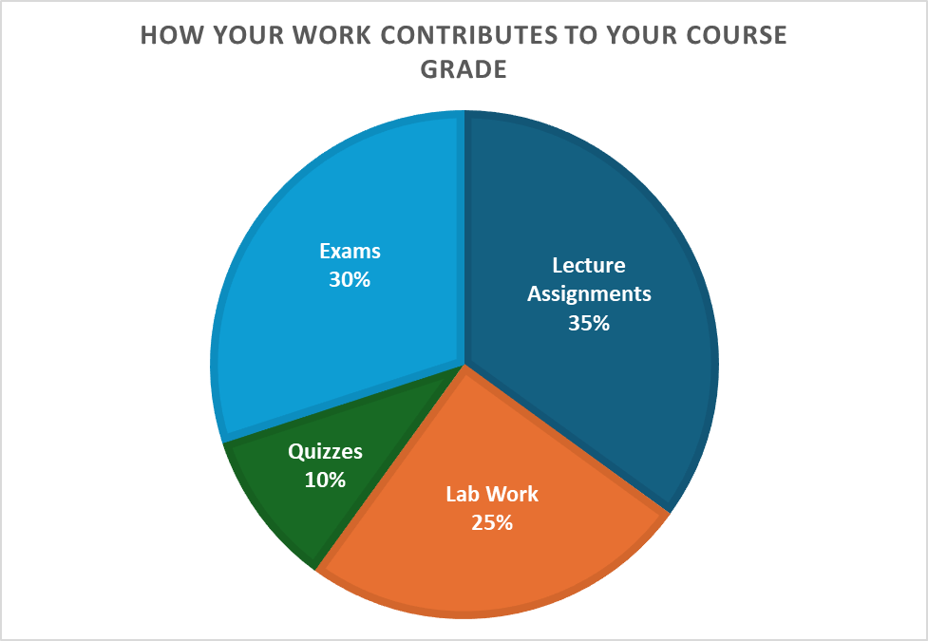

## Letter Grades

**A (90.0% and above)** – Fully meets or exceeds learning objectives with clear, accurate, and insightful work.

**B (80.0% - 89.9%)** – Meets learning objectives with mostly accurate and well-developed work.

**C (70.0% - 79.9%)** – Adequately meets learning objectives with understanding and execution that could be more thoroughly developed.

**D (60.0% - 69.9%)** – Partially meets learning objectives with limited understanding or incomplete work.

**F (59.9% and below)** – Does not meet learning objectives; work is missing, inaccurate, or off-topic.

## Late Work

Late work will be accepted until the date and time of the Unit Exam with increasing point penalties - 10% the first day, 20% the second day, up to a maximum of 50%. These penalties are designed to discourage you from procrastinating every assignment while being forgiving for times when life happens and you just can’t get it done in time.

Life happens! Everyone gets one extended deadline (not including delays due to approved absences) – just shoot me an email as far in advance as you can (but no later than 24 hours after the due date) and I’m happy to accommodate. Deadlines will not be extended past the exam date.

## Academic Integrity Policy

According to UNT Policy 06.003, Student Academic Integrity, academic dishonesty occurs when students engage in behaviors including, but not limited to cheating, fabrication, facilitating academic dishonesty, forgery, plagiarism, and sabotage. A finding of academic dishonesty may result in a range of academic penalties or sanctions ranging from admonition to expulsion from the University.

**As students in the forensic science program, ethical behavior is paramount. Therefore, I adopt a zero -tolerance policy with respect to any violations of academic integrity. A single minor violation will result in a minimum of a zero for the assignment and may include an extra educational assignment. Repeated minor violations or a single major violation (plagiarism, using a phone during a test, copying a neighbor, turning in an assignment for an absent classmate, etc.) will result in a course failure.**

Turnitin will be used for writing assignments. If your similarity score is above 50%, you may receive a zero for that assignment, so be sure to write everything in your own words and cite your sources.

## Generative AI

Throughout the semester, you may use specific Generative AI (GenAI) tools for assistance with outlining or proofreading certain assignments, with guidance on responsible use. You should never use GenAI to create your assignments for you, and citations it uses are often incorrect or not appropriate for academic work.

I use GenAI to enhance materials, create scenarios, etc. I will always disclose how I use GenAI, and I expect the same from you. In accordance with the UNT Honor Code, unauthorized use of GenAI tools is prohibited. Using GenAI content without proper credit or substituting your own work with GenAI undermines the learning process and violates academic integrity. If you're unsure whether something is allowed, please seek clarification.

# Lecture Policies

## Attendance

Attendance is expected but is not graded. Graded in-class activities and quizzes are a regular occurrence. I will waive one missed in-class activity and drop the lowest quiz grade.

## Class participation

Participation is a key part of this course and will enhance your retention of material and engagement with your peers. Participation will be monitored through checking notes after discussions, handing work, etc. If you miss half or more of a graded activity, you may receive half points.

## 

## University-Excused Absences

Communicate with me to schedule a make-up as soon as possible if you miss a graded activity or assessment.

* Preferably in advance but no later than 24 hours afterwards
* Make-up must be completed within 2 school days
* Extenuating circumstances will be considered as needed

## Unexcused Absences

A maximum of one (1) quiz or exam missed because of an unexcused absence may be made up at my sole discretion. Follow guidelines for university-excused absences for consideration

## Examination Policy

Exams will be administered in our classroom at our regularly scheduled class time. Any changes to exam dates will be announced in advance of the new date in class and via Canvas.

Latecomers will not be allowed to begin their exam after the first completed exam has been handed in.

# Lab Policies

## Attendance

Lab attendance is mandatory. If you are more than 15 minutes late, you may not be allowed to participate in lab that day. Labs and lab practicals take a lot of time, supervision, space, and supplies to set-up and run. Therefore, full make-ups are often not possible. I will excuse a maximum of ONE lab per student at my discretion if an approved make-up is not feasible.

There is ultimately no substitute for hands-on practice and collaboration. Excusing more than one lab per student would significantly alter the delivery of the material and impair my ability to assess your content mastery.

## University-Excused Absences

Communicate with me to schedule a make-up, alternate activity, or attendance of a different section

* Preferably in advance but no later than 24 hours afterwards
* Make-up must be completed within 5 school days
* Extenuating circumstances will be considered as needed
* I will work with you to arrange an abbreviated activity, alternate assignment, or have you attend the other section.
* Note - You may not switch labs without prior authorization from instructor or TA as this still requires coordination and planning for supplies and group assignments.

## Unexcused Absences

A maximum of one (1) lab because of an unexcused absence may be made up **at my sole discretion**. Follow guidelines for university-excused absences for consideration.

## Lab Notebook

Each lab entry will be kept in a notebook with blue or black ink. Procedures and preparatory notes may be written ahead of time, but all observations and experiment notes should be made in real time. Notes should never be written in a separate place and copied over unless you have explicit instructions to do so. Notebooks may be periodically checked, and violations may result in a 50-100% reduction in points for that day’s lab.

Your TA will cover specific requirements during your first lab for how labs are graded and a summary will be provided on Canvas.

## Safety

While working in laboratory sessions, students enrolled in CHEM 3330 are required to follow proper safety procedures and guidelines in all activities requiring lifting, climbing, walking on slippery surfaces, using equipment and tools, handling chemical solutions and hot and cold products. Students should be aware that UNT is not liable for injuries incurred while students are participating in class activities. All students are encouraged to secure adequate insurance coverage in the event of accidental injury. Students who do not have insurance coverage should consider obtaining Student Health Insurance. Brochures for student insurance are available in the UNT Student Health and Wellness Center. Students who are injured during class activities may seek medical attention at the Student Health and Wellness Center at rates that are reduced compared to other medical facilities. If students have an insurance plan other than Student Health Insurance at UNT, they should be sure that the plan covers treatment at this facility. If students choose not to go to the UNT Student Health and Wellness Center, they may be transported to an emergency room at a local hospital. Students are responsible for expenses incurred there.

# Instructor Responsibilities and Feedback

* It is my responsibility to help students grow and learn, provide clear instructions for projects and assessments, answer questions about assignments, identify additional resources as necessary, review and update course content, etc.
* I will typically reply to emails within 24 hours except on weekends as discussed in the Contact section
* Grades will typically be posted within 1 week
  + If you feel that there have been any errors in assignment grading, you are responsible for contacting myself or the TA within 1 week of receiving that grade.
* I will announce any syllabus changes as quickly as possible via Canvas and upload clear corrections accordingly.

# Supporting Your Success and Creating an Inclusive Learning Environment

I value the many perspectives students bring to our campus. Please work with me to create a classroom culture of open communication, mutual respect, and belonging. All discussions should be respectful and civil. Although disagreements and debates are encouraged, personal attacks are unacceptable. Together, we can ensure a safe and welcoming classroom for all. If you ever feel like this is not the case, please stop by my office and let me know. We are all learning together.

We will discuss our classroom’s habits of engagement and I also encourage you to review UNT’s student code of conduct so that we can all start with the same baseline civility understanding (Code of Student Conduct) (https://policy.unt.edu/policy/07-012).

## ADA Policy

The University of North Texas makes reasonable accommodations for students with disabilities. To request accommodations, you must first register with the Office of Disability Access (ODA) by completing an application for services and providing documentation to verify your eligibility each semester. Once your eligibility is confirmed, you may request your letter of accommodation. ODA will then email your faculty a letter of reasonable accommodation, initiating a private discussion about your specific needs in the course.

You can request accommodations at any time, but it’s important to provide ODA notice to your faculty as early as possible in the semester to avoid delays in implementation. Keep in mind that you must obtain a new letter of accommodation for each semester and meet with each faculty member before accommodations can be implemented in each class. You are strongly encouraged to meet with faculty regarding your accommodations during office hours or by appointment. Faculty have the authority to ask you to discuss your letter during their designated office hours to protect your privacy. For more information and to access resources that can support your needs, refer to the [Office of Disability Access](https://studentaffairs.unt.edu/office-disability-access) website (https://studentaffairs.unt.edu/office-disability-access)