Marriage & Family / SOCI 3000-001
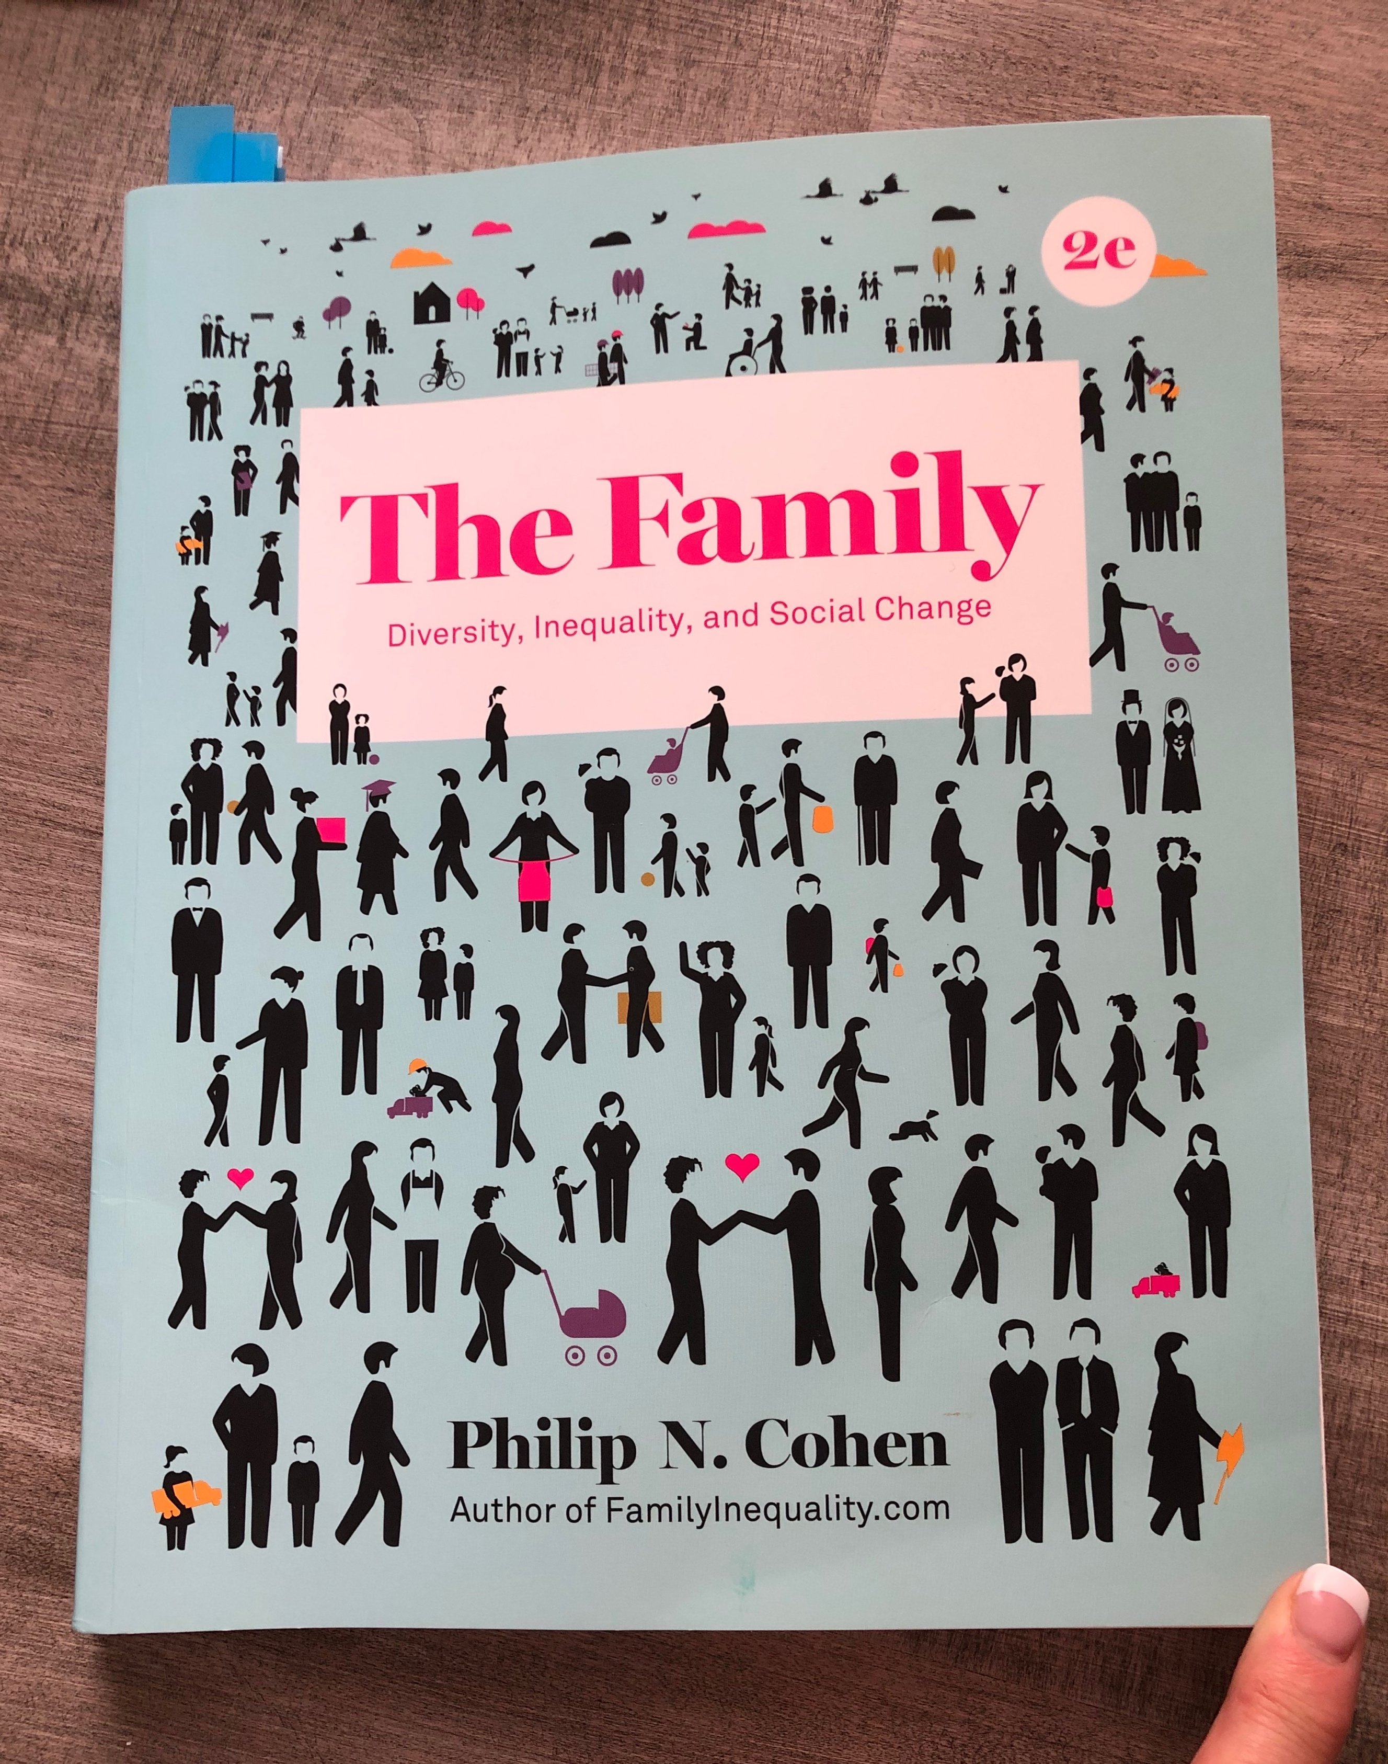
Fall 2019 / T/Th 11:00 – 12:20
Terrill Hall 121
Dr. Karen Monique Gregg
TA: Zoriliz Rivera

IMPORTANT UNT DATES
Classes begin: 1/13 Spring Break: 3/9-3/15
MLK Day (No Classes): 1/20 Last Day of Class: 4/28
Census Date: 1/27 Pre-Final Days: 4/29-30
Mid-Semester: 3/6 Final Exams: 5/2-5/7

IMPORTANT DATES IN THIS COURSE
- Discussion posts are due the first (Saturday, 1/18) and last week (Thursday, 4/30) of the course
- Quizzes are always due before midnight (11:59 p.m.) on Saturdays
- Two Exams:
  - The Midterm Exam is due online in Canvas before midnight on Saturday, 3/7
  - The Final Exam is due online in Canvas before 12:30 p.m. on Tuesday 5/5
- TedTalk film and discussion days are unannounced in the Syllabus. These are the equivalent of Pop Quizzes worth 100 points each. Students are expected to attend all class meetings so that they do not miss these assignments.

GENERAL INFORMATION

Contact with Professor: Please post any questions you may have in the Q&A Discussion. I will correspond with you frequently in grading comments.

Office Hours: Sycamore 288V, Tues & Thurs 1:00-3:00 p.m. & by appointment

Inbox Canvas: If you need to speak to me privately, the BEST way to do so is via the Inbox in Canvas. Please allow 24-hours for a response.

Unavailable: I do not respond to emails or messages in the evenings or on weekends. If you email me then, please expect a reply the next business day.

Dr. Gregg E-mail: Karen.Gregg@UNT.edu

TA E-mail: Zoriliz.Rivera@unt.edu

UNT INFORMATION
The University of North Texas (UNT) is a major public research university deeply committed to advancing educational excellence and preparing students to become thoughtful, engaged citizens of the world.

College of Liberal Arts and Sciences / Mission and Vision
The College of Liberal Arts and Social Sciences (formerly the College of Arts and Sciences) began in 1945 with a diverse set of 14 departments. Today, our family of 22 academic departments and programs remains eclectic. And so are the college's alumni, who number in the tens of thousands and live throughout the United States and in many countries around the world. Our alumni have distinguished themselves in areas ranging from scientific research to politics to business and finance.

Mission: Our mission is to kindle the thirst for truth, justice, and beauty; to foster cultural literacy and scientific investigation; and to cultivate thinking, speaking, and writing abilities characterized by clear expression and logically coherent, evidence-based arguments. We see these as the values, forms of knowledge, and skills most needed by citizens of a democracy and by productive members of the global workforce.

Vision: We seek a future in which the achievements of our faculty and students reach ever greater heights of excellence and public recognition; in which a spirit of inclusion and mutual respect is maintained and strengthened among faculty and students with differing viewpoints and from diverse backgrounds; and in which increasing interdisciplinary collaboration opens up new opportunities for intellectual, empirical, and creative discovery.

Department of Sociology
We are a dynamic community of faculty, staff and students who share a commitment to developing sociological imaginations in ourselves and others. Our mission as a department is to provide undergraduate and graduate students with conceptual and methodological tools to productively analyze social patterns. High-level sociological training prepares our students for careers in education, marketing, social services, government, data science, health care and many other fields.

COURSE INFORMATION

Course Catalog Description
Interpersonal dynamics of marriage and family life; role and influence of the family as both a powerful primary group and as a social institution in society; current status of families in the United States plus cross-national and historical patterns.

COURSE OBJECTIVES
- In this course students will:
  - Consider the themes of increasing inequality, increasing diversity, and social change as it relates to marriage and family over the last 150 years.
  - Take into account the changing characteristics of the modern family based on the theory of modernity.
  - Explore questions related to individual identity and institutional dynamics, personal freedom, and the need for self-definition in modern society.
  - Learn to use and interpret demographic data derived from the U.S. Census.
  - Develop an understanding of the overlapping nature of three institutional arenas: the family, the market, and the state.

Required Materials
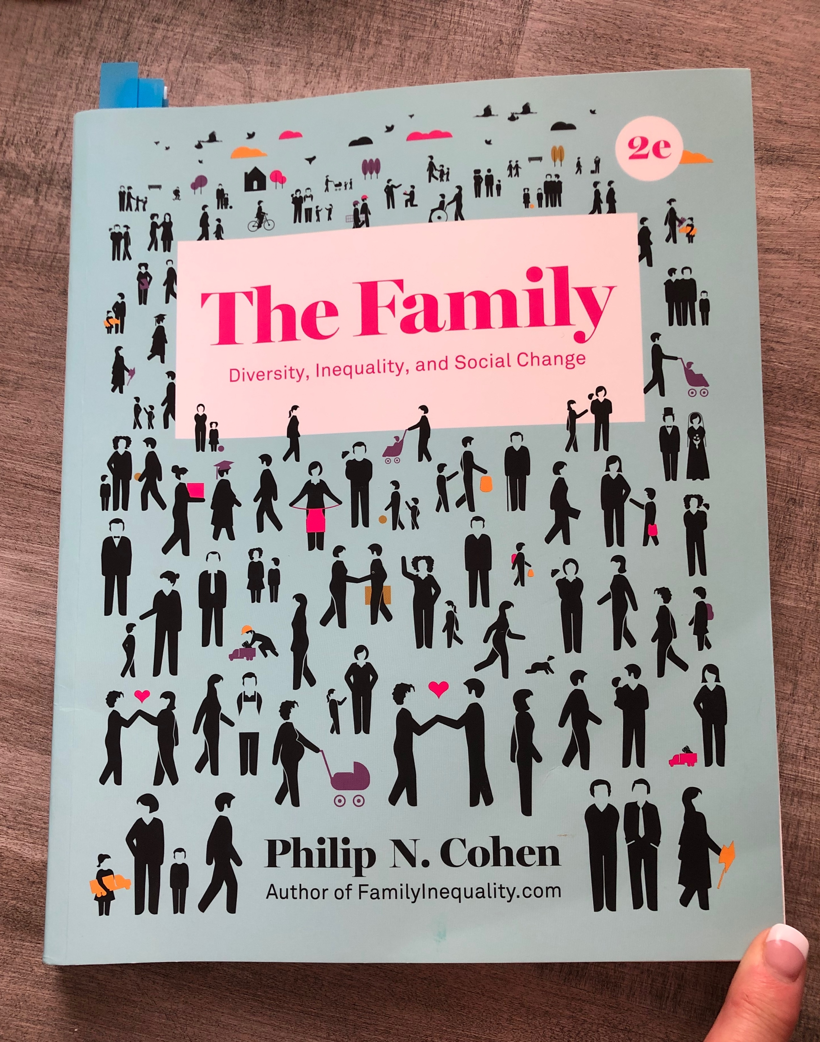
ISBN: 978-0-393-61457-2
Philip N. Cohen. 2018. The Family, W.W. Norton. Students must get 2nd edition! If the picture on the front of your book does not look like this, you have the wrong book.

The best way to obtain the required course materials is through the UNT book store on campus. Not having the required material for the course by week one of the course is not a sufficient excuse for missing class or the assignments.

Quizzes, exams, and papers are based on the 2nd edition of the book. Do not buy any other version! This means do not buy the online version, the condensed version, or the first edition. If you use any other version, you will most likely be doing the wrong assignments and you will receive a zero (0). You may also be citing the wrong page numbers in your assignments. If you do this, you will receive a zero (0).

Important: For the course to be fair, everyone must have the required materials for the course.

To function in this course, students must have access to a working computer with reliable Internet access. Computer failures or Internet outages are not acceptable excuses for missed work.

UNT ADMINISTRATIVE DETAILS

UNT Code of Student Conduct
Click here to see the expectations regarding your conduct as a student of UNT. https://policy.unt.edu/policy/07-012

UNT Academic Integrity
Academic integrity emanates from a culture that embraces the core values of trust and honesty necessary for full learning to occur. As a student-centered public research university, the University of North Texas promotes the integrity of the learning process by establishing and enforcing academic standards. Academic dishonesty breaches the mutual trust necessary in an academic environment and undermines all scholarship. For more information, see: https://vpaa.unt.edu/fs/resources/academic/integrity

UNT Participation/Attendance
The University of North Texas recognizes that student success is promoted by regular attendance and participation in class. It is the responsibility of the faculty member to notify students in writing of any special attendance requirements for the class. This policy applies to all modes of course delivery. For more information see: https://policy.unt.edu/policy/06-039

Prof Gregg’s Requirements
You are expected to log into the Canvas site often and to participate on a weekly basis in the course. You have work to complete every week in Canvas. If it appears that you are not participating in the course, I will use the Care Team reporting system to alert the university of your lack of participation. Someone will reach out to you.

Office of Disability Access
UNT is committed to providing equal access to higher education for academically qualified students with disabilities. The Office of Disability Access assists students with disabilities in achieving their academic potential by coordinating a variety of services. The office acts as a liaison between the student, instructors, and other university resources and community agencies.
To be eligible for services, you must register with the Office of Disability Access (ODA) and provide current documentation of the disability. ODA recommends that students contact the office at least eight weeks before enrolling at UNT to ensure sufficient time to plan for individualized academic modifications and services. While every effort is made to accommodate students with disabilities, it is the student’s responsibility to make needs known, provide proper documentation, and request services in a timely manner. See: https://disability.unt.edu

Prof Gregg’s Requirements
If a student is eligible for accommodations based on a documented disability with ODA, he or she is required to notify Dr. Gregg in the form of a letter from the ODA within one week of the start date for the course. At that time, Dr. Gregg will meet (or trade emails) with the student to discuss reasonable accommodations for him or her to be successful in this course. Once the course has started, no new accommodations will be made (unless the documented disability is new or Dr. Gregg is contacted by ODA).

UNT Writing Center
The Writing Center at the University of North Texas provides support for undergraduate and graduate writers across the disciplines. Their mission is to help students improve as writers at all levels, and they support a culture of teaching and learning at UNT through peer tutoring, interactive workshops, classroom support, and consultation with faculty and staff. For more information, see: https://writingcenter.unt.edu/our-mission

UNT TITLE IX Information
The University of North Texas is committed to providing a safe environment for all community members. Dating violence, domestic violence, sexual harassment, sexual coercion, sexual exploitation, sexual violence, and stalking are prohibited. Please see their page on reporting sexual violence for more information. UNT is here to help. Find more information about sexual violence, including campus and community resources at https://deanofstudents.unt.edu/sexual-misconduct?utm_medium=deanofstudents&utm_source=web&utm_campaign=dsa-home-page.

PROFESSOR GREGG’S COURSE EXPECTATIONS

What you can expect from your instructor:
- Respect and active listening.
- Consistent grading with return time within one-two weeks.
- Willingness to teach, learn and answer questions.
- To be prepared each week for our class.
- To allow ample opportunity for you to do well in this course.
- To be available by appointment for additional help.
- To treat everyone equally and fairly.

What I expect from you:
- Patience with me as the instructor and with all others who participate in this class.
- Active participation in our class in the Canvas environment as required by the syllabus.
- To complete all assignments as they are scheduled in the syllabus.
- Consistent participation in class and on-line. If it appears you are not actively engaged in this course, Prof. Gregg will use the UNT Care Team reporting system to make recommendations.
- To read the syllabus carefully each week and know what is supposed to happen. This is our contract. Prof. Gregg and the TA will do all that they can to abide by the syllabus, so they expect you to do the same.
- To act with academic integrity during any tests and in all writing. Your work should be your own. Cheating will not be tolerated! See above for the UNT policy on academic dishonesty.
- To read the grading comments that Prof. Gregg and the TA provide on all of your assignments. They will incorporate tips and you will learn important things about yourself as a student by reading these comments. If you need extra help with your writing, Dr. Gregg and the TA will suggest that you use the Writing Center on campus (found in Sage Hall).
- To put assignments in the correct space in Canvas. If you put things in the wrong spot, you will receive a zero (0) and your work will not be graded.
- To follow ALL directions in the syllabus, if you do not follow the directions, you will automatically receive a zero (0) on that assignment.
- To buy and use the correct version of the book. Right now, that is the 2nd Edition of Phillip N. Cohen’s The Family: Diversity, Inequality, and Social Change. If you analyze something other than what everyone else is analyzing, you will receive a zero (0). This is especially important when completing any writing assignments. Please buy and use the correct version of the book.
- IMPORTANT: If we happen look up something you quote in the book and it is not on the page cited, you will automatically fail the assignment and receive a zero (0) with no chance to redo the assignment.
- To be responsible for your work and prepare for and handle situations of computer and Internet difficulties. If your Internet is out, go somewhere where it is working so that you do not miss any of the assignments.
- You have 7 days each week to complete the work items for the week. Do not wait until the last minute to begin your work. Dr. Gregg recommends completing your work by Thursday or Friday each week. That way, if you do have some technical difficulty, you’ll have 24-48 hours to correct it.
- If you need additional help in this course, it is your responsibility to contact Dr. Gregg or the TA to make an appointment. Visits to office hours usually help students get on track.

ASSIGNMENTS and TECHNICAL ISSUES
All assignments should be submitted by the indicated dates and times embedded in the syllabus. There will be no extensions, except in cases of documented emergencies. In the event of a legitimate emergency, students are to contact the Dr. Gregg to arrange for an in-person meeting during office hours. When possible, students should contact Dr. Gregg PRIOR TO missing the assignment. Each student is allowed only one documented emergency per semester. If you contact Dr. Gregg PRIOR TO the missed assignment, you may or may not be granted leniency in missing the assignment.

Students are responsible for knowing the Canvas environment. This means that students are responsible for their own training in Canvas. Technical problems with Canvas software are to be directed to the Help Desk.

UNT Help Desk - 940-565-2324 / Sage Hall 330 / helpdesk@unt.edu
Monday - Thursday 8:00 am - midnight
Friday 8:00 am - 8:00 pm
Saturday 9:00 am - 5:00 pm
Sunday noon – midnight

Technical problems with computers or Canvas ARE NOT satisfactory excuses for missing assignment deadlines. I suggest that you DO NOT wait until the last minute to submit assignments. If you experience trouble with your computer or your home Internet access, you are expected to use the computer clusters on campus to complete your work on time.

At the end of the semester I will base your grade on the Grading Scale below.

Dr. Gregg’s Grading Scale
≥ 92% = A | 74-83% = C | Anything lower than 65% = F
84-91% = B | 65%-73% = D

SUMMARY of COURSE ASSIGNMENTS & VALUES

Attendance and Participation on Tuesdays and Thursdays:  - Attendance will be taken randomly and recorded in Canvas. | 100 Points / About 7% of grade
Weekly Quizzes:  - 13 Quizzes – 1 for each Ch. in Cohen  - Must take 10 X 50 Pts = 500 Points  - Can skip 3 Quizzes with no penalty  - Cannot take >10 Quizzes | 500 Points / About 33% of grade
Midterm Exam (end of Week 8):  - Online -- Chs. 1-7  - 50 Questions | 200 Points / About 13% of grade
TedTalk Films & In-Class Discussions  5 X 100 = 500 Points | 500 Points / About 33% of grade
Final Exam (scheduled by Registrar):  - Online – Chs. 8-13  - 50 Questions | 200 Points / About 13% of grade
TOTAL | 1500 Points

COURSE ASSIGNMENTS and VALUES
To prepare you for the work in this course, you are asked to read chapters from Cohen’s 2nd Ed. of The Family, attend class lectures on Tuesdays and Thursdays, watch the Story Behind the Numbers animation videos, and practice terms with flash cards before attempting the weekly quizzes and exams. Everything except the chapter reading (and lectures) can be found in Canvas in the module folders.

Attendance and Participation Tuesdays and Thursdays
- To do well in this course, students must attend class.
- Attendance will be taken randomly and recorded in the gradebook in Canvas.
- If you a student is late, it is their responsibility to check with the TA or Prof. Gregg to see if attendance was taken.
  - If you do not do this, and you are marked absent because you are late, we will not change the grade.

Weekly Quizzes:
- Quizzes are online in Canvas.
- Quizzes can be found in module folders for each chapter in Canvas.
- Quizzes are due before midnight on Saturdays (11:59 p.m.).
- There are 13 quizzes. You are required to take 10 quizzes.
  - This means you can skip 3 quizzes at some point in the semester. You get to decide when. When you skip one, the gradebook will be populated with “Excused”. If you miss more than 3, the gradebook will be populated with a zero (0).
  - If you fail to take the required 10 quizzes in this course, your grade will be lowered by 10% for failure to complete the requirements of the course.
- Each quiz is worth 50 points.
- Quizzes are made up of 10 randomly selected, Multiple Choice questions that have only one best answer.
- You are given 20 minutes to take each quiz. After that, your quiz will automatically submit and your quiz will be scored.
- If you are not pleased with your performance, you are permitted to retake the quiz a second time. After the second attempt, Canvas will show you the correct answers to the ones you missed.
  - Your highest score of the two attempts will be recorded in the grade book.
- Quizzes cannot be made up if missed. This is because everyone has 7 days each week to complete the quiz. Surely you can find 20 minutes in this 7-day period to complete the work in this course. Do not email me asking me to make up a quiz.
  - NOTE: Students are allowed to work ahead on quizzes. This means that all quizzes are open and ready for you to take starting the first day of the course.
- Do not email me to discuss Quiz questions. If you want to discuss a quiz question, see me in office hours. Come prepared.

Midterm and Final Exams:
- Exams are online in Canvas.
- Exams can be found in module folder for exams.
- Exams have specific due dates and times. Consult the Syllabus for when they are due.
  - If you fail to take the required Midterm or Final this course, your grade will be lowered by 10% for failure to complete the requirements of the course.
- Exams are worth 200 points.
- Exams are open book and open notes.
- Exams are made up of 50 randomly selected, True/False and/or Multiple Choice questions that have only one best answer. There are no essay questions on the exams.
- You are only given one attempt on each of the exams.
- You are given one and one-half hours (90 minutes) to take each exam. After that, your exam will automatically submit and your exam will be scored.
  - I do not release the correct answers to the exams. If you’d like to discuss your exam, see me in office hours within one week of taking the exam.
- Consult the Syllabus for when exams open and close.
- You are expected to work on your own during the exams.

TedTalks and Discussions:
At several points in the semester we will watch and discuss 5 TedTalks in class related to marriage and family. On these days, the TA will lead class showing you the TedTalk, lead a discussion about the film, and require you to write out something to turn in. These in-class assignments will vary.
- These are unannounced in the Syllabus. This is to encourage you to attend class lectures.
- Each time we do this is worth 100 points.
- You must be present to participate with others and to view the TedTalk, discuss it with your peers, and complete the assignment.
- Since these 5 assignments require you to do something with your peers, they cannot be made up for any reason.

TENTATIVE COURSE SCHEDULE

Week 1 Theme  Introduction to Marriage and Family |  | DATES: January 12 – January 18
 | Description |  | To Do/How To/Where
Tues 1/14 | Introductions  Attendance, Syllabus, Canvas  Homework for Fun Thursday:  Family of Origin: Type a one-page summary of your family (1-2 paragraphs). How many brothers and sisters do you have? Where do you fit in? What do your parents do? What is your home like? What is your neighborhood like? What do you do as a family?  Relationship status: Next, type one paragraph describing your current relationship status. (5-10 sentences) |  | Print Syllabus before coming to class.  Attend Class  Bring this 2-part typed assignment to class on Thursday.  You will not be admitted to class Thursday if you do not show up with a typed summary. You will be asked to use class time to complete the assignment.
Disc  Post | Assignment:  Post an introduction in the Discussion for Introductions. Tell the class:  - Your major.  - How far along are you in your studies at UNT.  - Why you took this course (i.e., what interests you about marriage and family).  - Respond to at least one other student after you post. |  | Graded as Complete/Incomplete  Due before midnight (11:59 p.m.) Saturday 1/18
Fun Thurs | Meet the TA  Group Work – Speed Dating |  | Attend Class/Participate in Group
 | Homework:  - Read Ch. 1 in Cohen for next week |  | TEXT

Week 2 Theme  Ch 1 A Sociology of the Family |  | DATES: January 19 – January 25
 | Description |  | To Do/How To/Where
Mon | MLK Jr. Day – No Class |  | DO NOT Attend Classes
Tues & Thurs | Dr. Gregg Lectures  Story Behind the Numbers Animation |  | Attend Class / Take Notes
 | Homework:  - Take Ch. 1 Quiz Online in Canvas  - Read Ch. 2 in Cohen for next week  - Come to class next week prepared to discuss Ch. 2 |  | Quiz in Canvas is due before midnight Saturday 1/25

Week 3 Theme  Ch 2 The Family in History |  | DATES: January 26 – February 1
 | Description |  | To Do/How To/Where
Tue & Thur | Dr. Gregg Lectures  Story Behind the Numbers Animation |  | Attend Class / Take Notes
 | Homework:  - Take Ch. 2 Quiz Online in Canvas  - Read Ch. 3 in Cohen for next week  - Come to class next week prepared to discuss Ch. 3 |  | Quiz in Canvas is due before midnight Saturday 2/1

Week 4 Theme  Ch 3 Race, Ethnicity, and Immigration |  | DATES: February 2 – February 8
 | Description |  | To Do/How To/Where
Tue & Thur | Dr. Gregg Lectures  Story Behind the Numbers Animation |  | Attend Class / Take Notes
 | Homework:  - Take Ch. 3 Quiz Online in Canvas  - Read Ch. 4 in Cohen for next week  - Come to class next week prepared to discuss Ch. 4 |  | Quiz in Canvas is due before midnight Saturday 2/8

Week 5 Theme  Ch 4 Families and Social Class |  | DATES: February 9 – February 15
 | Description |  | To Do/How To/Where
Tue & Thur | Dr. Gregg Lectures  Story Behind the Numbers Animation |  | Attend Class / Take Notes
 | Homework:  - Take Ch. 4 Quiz Online in Canvas  - Read Ch. 5 in Cohen for next week  - Come to class next week prepared to discuss Ch. 5 |  | Quiz in Canvas is due before midnight Saturday 2/15

Week 6 Theme  Ch 5 Gender |  | DATES: February 16 – February 22
 | Description |  | To Do/How To/Where
Tue & Thur | Dr. Gregg Lectures  Story Behind the Numbers Animation |  | Attend Class / Take Notes
 | Homework:  - Take Ch. 5 Quiz Online in Canvas  - Read Ch. 6 in Cohen for next week  - Come to class next week prepared to discuss Ch. 6 |  | Quiz in Canvas is due before midnight Saturday 2/22

Week 7 Theme  Ch 6 Sexuality |  | DATES: February 23 – February 29
 | Description |  | To Do/How To/Where
Tue & Thur | Dr. Gregg Lectures  Story Behind the Numbers Animation |  | Attend Class / Take Notes
 | Homework:  - Take Ch. 6 Quiz Online in Canvas  - Read Ch. 7 in Cohen for next week  - Come to class next week prepared to discuss Ch. 7 |  | Quiz in Canvas is due before midnight Saturday 2/29
REMINDER: In addition to your Quiz over Ch. 7, the Midterm Exam is due next week over Chs. 1-7 in Cohen and any and all things that took place in class. Midterm will open at 12:00 a.m. on Sunday 3/1.

Week 8 Theme  Ch 7 Love and Romantic Relationships |  | DATES: March 1 – March 7
 | Description |  | To Do/How To/Where
Tue & Thur | Dr. Gregg Lectures  Story Behind the Numbers Animation |  | Attend Class / Take Notes
 | Homework:  - Take Ch. 7 Quiz Online in Canvas  - Read Ch. 8 in Cohen for next week  - Come to class next week prepared to discuss Ch. 8 |  | Quiz in Canvas is due before midnight Saturday 3/7
DUE | The Midterm is online. The Midterm is over Chs. 1-7 in Cohen’s text. Any and all things that took place in class are open for examination. Good luck! |  | Midterm is due before midnight on Saturday 3/7

WEEK 9 SPRING BREAK (3/8-3/14)

Week 10 Theme  Ch 8 Marriage and Cohabitation |  | DATES: March 15 – March 21
 | Description |  | To Do/How To/Where
Tue & Thur | Dr. Gregg Lectures  Story Behind the Numbers Animation |  | Attend Class / Take Notes
 | Homework:  - Take Ch. 8 Quiz Online in Canvas  - Read Ch. 9 in Cohen for next week  - Come to class next week prepared to discuss Ch. 9 |  | Quiz in Canvas is due before midnight Saturday 3/21

Week 11 Theme  Ch 9 Families and Children |  | DATES: March 22 – March 28
 | Description |  | To Do/How To/Where
Tue & Thur | Dr. Gregg Lectures  Story Behind the Numbers Animation |  | Attend Class / Take Notes
 | Homework:  - Take Ch. 9 Quiz Online in Canvas  - Read Ch. 10 in Cohen for next week  - Come to class next week prepared to discuss Ch. 10 |  | Quiz in Canvas is due before midnight Saturday 3/28

Week 12 Theme  Ch 10 Divorce, Remarriage and Blended Families |  | DATES: March 29 – April 4
 | Description |  | To Do/How To/Where
Tue & Thur | Dr. Gregg Lectures  Story Behind the Numbers Animation |  | Attend Class / Take Notes
 | Homework:  - Take Ch. 10 Quiz Online in Canvas  - Read Ch. 11 in Cohen for next week  - Come to class next week prepared to discuss Ch. 11 |  | Quiz in Canvas is due before midnight Saturday 4/4

Week 13 Theme  Ch 11 Work and Families |  | DATES: April 5 – April 11
 | Description |  | To Do/How To/Where
Tue & Thur | Dr. Gregg Lectures  Story Behind the Numbers Animation |  | Attend Class / Take Notes
 | Homework:  - Take Ch. 11 Quiz Online in Canvas  - Read Ch. 12 in Cohen for next week  - Come to class next week prepared to discuss Ch. 12 |  | Quiz in Canvas is due before midnight Saturday 4/11

Week 14 Theme  Ch. 12 Family Violence and Abuse |  | DATES: April 12 – April 18
 | Description |  | To Do/How To/Where
Tue | Dr. Gregg Lectures  Story Behind the Numbers Animation |  | Attend Class / Take Notes
Thur  4/16 | Denton County Friends of Family Speaker |  | Attend Class / Take Notes
 | Homework:  - Take Ch. 12 Quiz Online in Canvas  - Read Ch. 13 in Cohen for next week  - Come to class next week prepared to discuss Ch. 13 |  | Quiz in Canvas is due before midnight Saturday 4/18

Week 15 Theme  Ch. 13 The Future of the Family |  | DATES: April 19 – April 25
 | Description |  | To Do/How To/Where
Tue & Thur | Dr. Gregg Lectures  Story Behind the Numbers Animation |  | Attend Class / Take Notes
 | Homework:  - Take Ch. 13 Quiz Online in Canvas  - No additional reading assigned. |  | Quiz in Canvas is due before midnight Saturday 4/25

Week 16 Theme  Wrapping it All Up |  | DATES: April 26 – April 28
 | Description |  | To Do/How To/Where
Tue | Dr. Gregg Lectures & Goodbyes  SPOT Evaluations |  | Attend Class / Take Notes
Disc  Post | Assignment:  Post a Goodbye Message to Dr. Gregg in the Discussion for Goodbyes. Tell the class:  - Something really important that you learned in this class (your general take-away).  - Did you enjoy the class? Yes? No? Why or why not?  - Do you have any recommendations for change? |  | Graded as Complete/Incomplete  Due before midnight (11:59 p.m.) Thursday 4/30  NOTE THURSDAY!!!!
Wed – Fri | University Reading / Study Days |  | No Classes held

Week 17FINAL EXAMS WEEK |  | DATES: May 2 – May 7
 | Description |  | To Do/How To/Where
Opens Friday 5/1  Closes Tuesday 5/5 | Final Exam is online. Final exam is over Chs. 8-13 in Cohen’s text. Any and all things that took place in class are open for examination. Good luck! |  | Do Not Attend Class  Take Final Exam before 12:30 p.m. on Tuesday 5/5.

Copied from the Registrar’s Website 12/23/2019
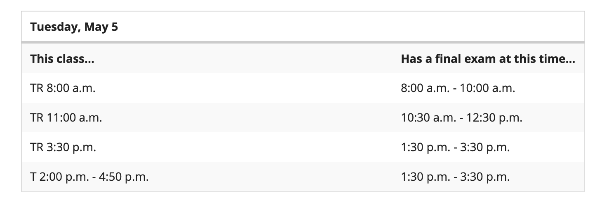

A copy of Cohen’s 2nd Edition of The Family has been put on reserve at the Willis Library and is available to check out for 2 hours at a time.
If you prefer to use the online version of this book, W.W. Norton allows students free access for the first 21 days. To obtain online access to this book, go to: https://digital.wwnorton.com/thefamily2 Click on Purchase Options. Click on Purchase or Register for Access. Establish an account by registering with your UNT email. Once registered, click on “I want to sign up for 21 days of trial access.
TA leads discussions and grades students. TedTalk days are random and students must be present to participate. If you miss a TedTalk day, it cannot be made up.
To proceed, I recommend that each week you read the syllabus and check off the expected work items as you go. If you do this, you won’t miss a thing.
I do not post the PowerPoints lectures in Canvas. To benefit from the PowerPoint lectures, you must attend class.

