Marriage & Family / SOCI 3000
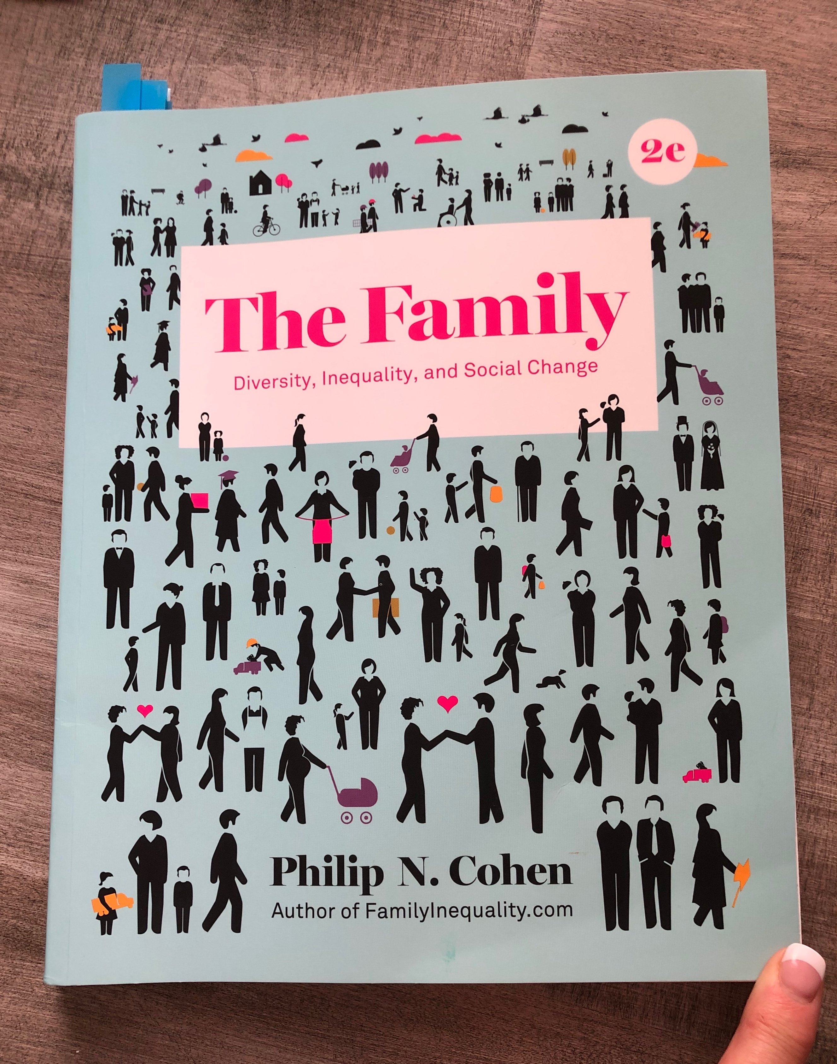
Fall 2019 / M/W/F 10:00-10:50
Wooten Hall 116
Dr. Karen Monique Gregg

TA Mehr Mumtaz

Important Dates and Times
- Classes Start 8/26/19
- Labor Day 9/2
- Quizzes are due before midnight (11:59 p.m.) on Saturdays, except the week of Thanksgiving
- Sociology in Practice due each week in class on Fridays
- No class 11/28 and 11/29
- Last official day of classes 12/6
- Final Exams begin Saturday 12/7 and End on Friday 12/13.
  - In person students will complete SIP13 at the Final Exam on Saturday 12/7 from 8:00 a.m. – 10:00 a.m. (assume the location in Wooten 116 unless otherwise changed)

General Information

Contact with Professor: Post any questions you may have in the Discussion for Q&A. I will usually correspond with you and grade for this course on Monday- Wednesday of each week.

Office Hours: 12:30-3:00 on Mondays and Wednesdays
Office: Sycamore Hall (SYMR) 288V

Inbox Canvas: If you need to speak to me privately, the BEST way to do so is via the Inbox in Canvas.

UNT E-mail: Karen.Gregg@UNT.edu
Please allow 24 hours for a response. I do not respond to emails or messages on weekends. If you email me then, please expect a reply on Monday.

UNT INFORMATION
The University of North Texas (UNT) is a major public research university deeply committed to advancing educational excellence and preparing students to become thoughtful, engaged citizens of the world.

College of Liberal Arts and Sciences / Mission and Vision
The College of Liberal Arts and Social Sciences (formerly the College of Arts and Sciences) began in 1945 with a diverse set of 14 departments. Today, our family of 22 academic departments and programs remains eclectic. And so are the college's alumni, who number in the tens of thousands and live throughout the United States and in many countries around the world. Our alumni have distinguished themselves in areas ranging from scientific research to politics to business and finance.

Mission: Our mission is to kindle the thirst for truth, justice, and beauty; to foster cultural literacy and scientific investigation; and to cultivate thinking, speaking, and writing abilities characterized by clear expression and logically coherent, evidence-based arguments. We see these as the values, forms of knowledge, and skills most needed by citizens of a democracy and by productive members of the global workforce.

Vision: We seek a future in which the achievements of our faculty and students reach ever greater heights of excellence and public recognition; in which a spirit of inclusion and mutual respect is maintained and strengthened among faculty and students with differing viewpoints and from diverse backgrounds; and in which increasing interdisciplinary collaboration opens up new opportunities for intellectual, empirical, and creative discovery.

Department of Sociology
We are a dynamic community of faculty, staff and students who share a commitment to developing sociological imaginations in ourselves and others. Our mission as a department is to provide undergraduate and graduate students with conceptual and methodological tools to productively analyze social patterns. High-level sociological training prepares our students for careers in education, marketing, social services, government, data science, health care and many other fields.

The University Core Curriculum
This course fulfills the campus wide University Core Curriculum Requirement: Social and Behavioral Sciences. The course objective is to help students in “Developing Critical Thinking, Communication Skills, Empirical and Quantitative Skills, and Social Responsibility.” For more information about the University Core Curriculum, go to: http://catalog.unt.edu/content.php?catoid=20&navoid=2148

COURSE INFORMATION
Course Catalog Description
Interpersonal dynamics of marriage and family life; role and influence of the family as both a powerful primary group and as a social institution in society; current status of families in the United States plus cross-national and historical patterns.

Required Materials
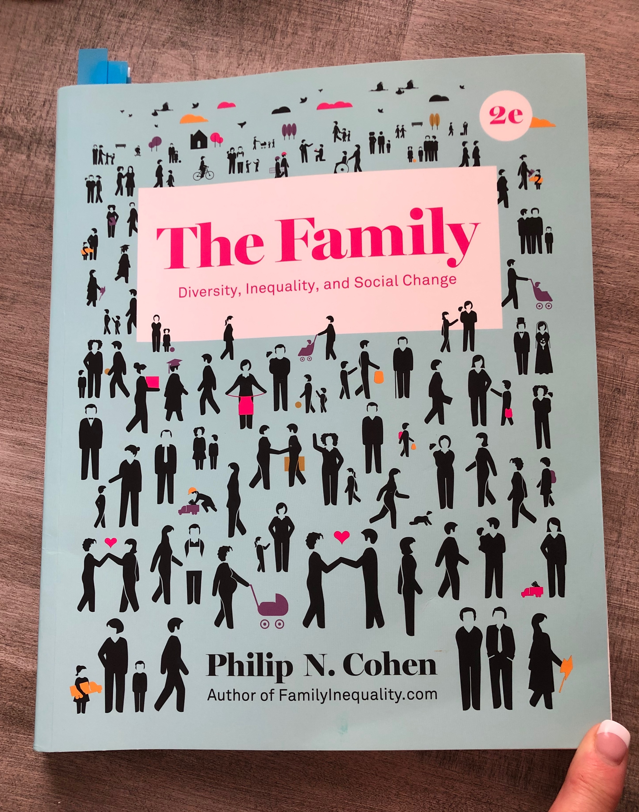
ISBN: 978-0-393-61457-2
Philip N. Cohen. 2018. The Family, W.W. Norton. Students must get 2nd edition! If the picture on the front of your book does not look like this, you have the wrong book.

The best way to obtain the required course materials is through the UNT book store on campus. Not having the required material for the course by week one of the course is not a sufficient excuse for missing class or the assignments.

All assignments, quizzes and papers are based on the 2nd edition of the book. Do not buy any other version! This means do not buy the online version, the condensed version, or the first edition. If you use any other version, you will most likely be doing the wrong assignments and you will receive a zero (0). You may also be citing the wrong page numbers in your assignments. If you do this, you will receive a zero (0).

Bottom Line: FOR THE COURSE TO BE FAIR, EVERYONE MUST HAVE THE REQUIRED MATERIALS FOR THE COURSE.

To function in this course, students must have access to a working computer with reliable Internet access. Computer failures or Internet outages are not acceptable excuses for missed work.

UNT ADMINISTRATIVE DETAILS
UNT Code of Student Conduct
Click here to see the expectations regarding your conduct as a student of UNT. https://policy.unt.edu/policy/07-012

UNT Academic Integrity
Academic integrity emanates from a culture that embraces the core values of trust and honesty necessary for full learning to occur. As a student-centered public research university, the University of North Texas promotes the integrity of the learning process by establishing and enforcing academic standards. Academic dishonesty breaches the mutual trust necessary in an academic environment and undermines all scholarship. For more information, see: https://vpaa.unt.edu/fs/resources/academic/integrity

UNT Participation/Attendance
The University of North Texas recognizes that student success is promoted by regular attendance and participation in class. It is the responsibility of the faculty member to notify students in writing of any special attendance requirements for the class. This policy applies to all modes of course delivery. For more information see: https://policy.unt.edu/policy/06-039

Prof Gregg’s Requirements
If you are enrolled in an in person course, you are expected to attend class every time the class meets. This is because attendance in the in person courses leads to student success. Please do not email me to tell me when will be absent. If you are obviously not attending class on a regular basis, I will reach out to you to discuss. If you fail to attend class on a regular basis, your final grade will be lowered by 10%. Attendance will periodically be taken (approximately 4 times).

If you are enrolled in an online course, you are expected to log into the Canvas site often and to participate on a weekly basis in the course. There is work to be completed every week in Canvas. If it appears that you are not participating in the course, I will use the Care Team reporting system to alert the university of your lack of participation. Someone will reach out to you.

Dr. Gregg’s Attendance
I will not miss class without notification via Canvas. If for some reason I am unable to make it to campus (due to a traffic accident or emergency, for example), I will do my best to communicate this to you. In face-to-face classes, if I am not in class 15 minutes after the start time, you are permitted to leave with no penalty.

Office of Disability Access
UNT is committed to providing equal access to higher education for academically qualified students with disabilities. The Office of Disability Access assists students with disabilities in achieving their academic potential by coordinating a variety of services. The office acts as a liaison between the student, instructors, and other university resources and community agencies.
To be eligible for services, you must register with the Office of Disability Access and provide current documentation of the disability. Contact the office at least eight weeks before enrolling at UNT to ensure sufficient time to plan for individualized academic modifications and services. While every effort is made to accommodate students with disabilities, it is the student’s responsibility to make needs known, provide proper documentation, and request services in a timely manner. See: https://disability.unt.edu
Prof Gregg’s Requirements
If you are eligible for accommodations based on a documented disability with the Office of Disability Access, you are required to notify me in the form of a letter from the Office of Disability Access within one week of the start date for the course. At that time, we will meet to discuss reasonable accommodations for you to be successful in this course.

UNT Writing Center
The Writing Center at the University of North Texas provides support for undergraduate and graduate writers across the disciplines. Our mission is to help students improve as writers at all levels, and we support a culture of teaching and learning at UNT through peer tutoring, interactive workshops, classroom support, and consultation with faculty and staff. For more information, see: https://writingcenter.unt.edu/our-mission

UNT TITLE IX Information
The University of North Texas is committed to providing a safe environment for all community members. Dating violence, domestic violence, sexual harassment, sexual coercion, sexual exploitation, sexual violence, and stalking are prohibited. Please see our page on reporting sexual violence for more information. We are here to help. Find more information about sexual violence, including campus and community resources at https://deanofstudents.unt.edu/sexual-misconduct?utm_medium=deanofstudents&utm_source=web&utm_campaign=dsa-home-page.

PROFESSOR GREGG’S COURSE EXPECTATIONS
What you can expect from your instructor:
1. Respect and active listening.
2. Consistent grading with return time within one-two weeks.
3. Willingness to teach, learn and answer questions.
4. To be prepared each week for our class.
5. To allow ample opportunity for you to do well in this course.
6. To be available by appointment for additional help.
7. To treat everyone equally and fairly.

What I expect from you:
1. Patience with me as the instructor and with all others who participate in this class.
2. Active participation in our class in the Canvas environment as required by the syllabus.
3. To take quizzes and to complete all assignments as they are scheduled in the syllabus.
4. Consistent participation in person and on-line. If it appears you are not actively engaged in this course, Prof. Gregg will use the UNT reporting system to make recommendations.
- If you must use your cell phone, it is okay to get up and exit to do so. Everyone has important things in their life going on. Please be polite.
- If you use your cell phone in class, first Dr. Gregg will ask you to put it away.
- If you continually use your cell phone in class, Dr. Gregg may ask you to leave.
5. To read the syllabus carefully each week and know what is supposed to happen. This is our contract. Prof. Gregg will do all that she can to abide by the syllabus, so she expects you to do the same.
6. To act with academic integrity during quizzes and in all writing. Your work should be your own. Cheating will not be tolerated! See above for the UNT policy on academic dishonesty.
7. To read the grading comments that Prof. Gregg provides on all of your writing assignments. She will incorporate tips and you will learn important things about yourself as a writer by reading these comments. If she thinks you need extra help with your writing, she will suggest that you use the Writing Center on campus.
8. To put assignments in the correct space in Canvas. If you put things in the wrong spot, you will receive a zero (0).
9. To follow ALL directions in the syllabus, if you do not follow the directions, you will automatically receive a zero (0) on that assignment.
10. To buy and use the correct version of the book. Right now, that is the 2nd Edition of Philip N. Cohen’s The Family. If you analyze something other than what everyone else is analyzing, you will receive a zero (0). This is especially important when completing any writing assignment. Please buy and use the correct version of the book.
- For example, if I happen look up something you quote in the book and it is not on the page cited, you will automatically fail the assignment and receive a zero (0) with no chance to redo the assignment.
11. To be responsible for your work and prepare for and handle situations of computer and Internet difficulties. If your Internet is out, go somewhere where it is working so that you do not miss quizzes or other assignments. You have 7 days each week to complete the work items for the week. Do not wait until the last minute to begin your work. I recommend completing your work by Thursday or Friday each week. That way, if you do have some technical difficulty, you’ll have 24-48 hours to correct it.

ASSIGNMENTS and TECHNICAL ISSUES
All assignments should be submitted by the indicated dates and times embedded in the syllabus. There will be no extensions, except in cases of documented emergencies. In the event of a legitimate emergency, students are to contact the professor to arrange for an alternative or make-up assignment, at the professor’s discretion and this must happen PRIOR TO missing the assignment. Each student is allowed only one documented emergency per semester.

Students are responsible for knowing the Canvas environment. This means that students are responsible for their own training in Canvas. Technical problems with Canvas software are to be directed to the Help Desk.

UNT Help Desk - 940-565-2324 / Sage Hall 330 / helpdesk@unt.edu
Monday - Thursday 8:00 am - midnight
Friday 8:00 am - 8:00 pm -- Saturday 9:00 am - 5:00 pm -- Sunday noon – midnight

Technical problems with computers or Canvas ARE NOT satisfactory excuses for missing assignment deadlines. I suggest that you DO NOT wait until the last minute to submit assignments. If you experience trouble with your computer or your home Internet access, you are expected to use the computer clusters on campus to complete your work on time.

A LONG NOTE ABOUT GRADES
This course is setup on a 1000-point grading scale. As you move forward in the course, you will be working your way up from zero (0) toward 1000 (a perfect score). In Canvas, there is a running total keeping track of your progress toward 1000. Each quiz or assignment builds your grade up to the grade you hope to achieve.

The simplest way to explain how you will earn your grade is that in this course you are trying to accumulate points. Just pay attention to the point accumulation and you’ll do fine. Sometimes students only pay attention to their average or percentage shown in Canvas and this is when confusion sets in. I want you to ignore this and only pay attention to the points. Let’s think about a few examples.

- Say we are nearing the end of the semester and you see that you have earned 930 points. On a 1000-point scale, these 930 points = 93 A.
- If you have earned 840 points, these 840 points = 84 B.
- If you have anything over 1000 points = >100% A+!
- So, however many points you have at the end will be used to calculate your final grade.

At the end of the semester I will base your grade on the Grading Scale below.

Dr. Gregg’s Grade Scale
>1000 = A+
≥ 930 = A 790 = C+
900-920 = A- 740-780 = C 640-680 = D
890 = B+ 700-730 = C- 600-630 = D- ≤ 590 = F
840-880 = B 690 = D+
800-830 = B-

COURSE ASSIGNMENTS and VALUES
Assignments:
To prepare you for the work in this course, you are asked to read chapters from Cohen’s 2nd Ed. of The Family, attend class lectures on Mondays and Wednesdays, watch the Story Behind the Numbers animation videos, watch Sociology in Practice films (and answer questions) on Fridays, and finally practice terms with flash cards before attempting quizzes. Everything except the chapter reading (and lectures) can be found in Canvas in the module folders.

To proceed, I recommend that each week you read the syllabus and check off the expected work items as you go. If you do this, you won’t miss a thing. Also, if you do all of the work items, you will be thoroughly prepared for the following graded assignments.

Weekly Quizzes (70% of Grade):
- Quizzes can be found in module folders for each chapter in Canvas.
- Quizzes are due before midnight on Saturdays (11:59 p.m.).
- There are 15 quizzes. Each quiz is worth 50 points.
  - You are required to take 14 quizzes.
  - If you fail to take the required 14 quizzes in this course, your grade will be lowered for failure to complete the requirements of the course.
- Everyone is required to take the syllabus quiz in week one of the semester as one of the required 14 quizzes.
- Of the remaining 14, you are only required to take 13 quizzes, but if you take all of the remaining 14, you can earn up to 50 extra credit points.
  - One of these 14 quizzes is based on a film that you MUST attend class to watch, otherwise you cannot take the quiz. (If you do not attend, but take the quiz, your grade will be reduced to zero for failure to comply with the requirement to attend class.)
  - The remaining 13 quizzes are based on Cohen’s text.
- Quizzes are made up of 10 randomly selected, Multiple Choice questions that have only one best answer.
- You are given 20 minutes to take each quiz. After that, your quiz will automatically submit and your quiz will be scored.
- If you are unhappy with your performance, you are permitted to retake the quiz a second time. After the second attempt, Canvas will show you the correct answers to the ones you missed.
  - Your highest score of the two attempts will be recorded in the grade book.
- Quizzes cannot be made up if missed. This is because there is one built in extra credit quiz for this reason. Do not email me asking me to make up a quiz.
- If you skip a quiz, the grade book for that quiz will populate with a zero. The zero is meaningless. To understand how your final grade is calculated refer to A LONG NOTE ABOUT GRADES (above).

I allow students to take one extra quiz for many reasons:
- Sometimes it takes students a while to obtain the book for the course. Allowing you to miss a quiz, gives these students ample time to obtain the course materials.
- Students rarely earn 100% on all of the quizzes and assignments in this course. Sometimes the material in the chapter just doesn’t grab you and you don’t do well and that’s okay. You can make up lost points by taking an extra quiz.
- Sometimes the quiz questions are tricky. I do not argue quiz questions with students so do not email me about this. Taking an extra quiz will make up for any tricky questions you may encounter.
- If you have some sort of an emergency situation during the course of the semester (a death in the family, a car accident, etc.) the extra quiz allows you to miss course work without having a penalty.

Required Syllabus Quiz 50 Points
13 more Required Quizzes 13 X 50 = 650 Points
TOTAL 700 Points* (70% of the course grade)
*Possible 750 if you take all 15 quizzes
Sociology in Practice Assignments (30% of Grade):
- For each chapter in Cohen (13) you are assigned to complete a sociology in practice assignment (SIP) in class on Fridays. This will consist of watching a short film in class and then working in groups to answer questions on a worksheet.
  - Your participation in this group activity is worth up to 25 points for each SIP.
  - You must attend class to earn these points. SIPs cannot be made up for any reason.
- There are 13 SIP assignments. You are required to complete 12 of them, but if you attend and participate for all 13, you can earn up to 25 extra credit points.
  - If you fail to complete the required 12 SIPs in this course, your grade will be lowered for failure to complete the requirements of the course.

12 Friday SIP Assignments 12 X 25 = 300 Points* (30% of the course grade)

*Possible 325 if you participate in all 13 SIP assignments

Summary of Assignments and Values
Description | Points / Percentage
15 Quizzes / 14 Required X 50 Points = | 700 / 70%
13 SIPs / 12 Required X 25 Points = | 300 / 30%
No Final Exam
TOTAL | 1000 / 100%
Possible 75 Points of Extra Credit

TENTATIVE COURSE SCHEDULE

Week 1 Theme  Introduction to Marriage and Family |  | DATES: August 25 – August 31
 | Description |  | To Do/How To/Where
Mon 8/26 | Introductions  Attendance, Syllabus, Canvas  Homework for Fun Wednesday:  Family of Origin: Type a one-page summary of your family (1-2 paragraphs). How many brothers and sisters do you have? Where do you fit in? What do your parents do? What is your home like? What is your neighborhood like? What do you do as a family?  Relationship status: Next, type one paragraph describing your current relationship status. (5-10 sentences) |  | Print Syllabus before coming to class.  Attend Class  Bring this 2-part typed assignment to class on Wednesday.  You will not be admitted to class Wednesday if you do not show up with a typed summary.
Fun Wed | Group Work – Speed Dating |  | Attend Class/Participate in Group
Fri | Meet the TA(s)  Discussion – Explain SIP Fridays |  | Attend Class/Participate
 | Homework:  - Take Syllabus Quiz Online in Canvas  - Read Ch. 1 in Cohen for next week |  | Quiz in Canvas is due before midnight Saturday 8/31

Week 2 Theme  Ch 1 A Sociology of the Family |  | DATES: September 1 – September 7
 | Description |  | To Do/How To/Where
Mon | Labor Day Holiday – No Class |  | DO NOT Attend Class
No Fun Wed | Dr. Gregg Lectures (Unusual Week)  Story Behind the Numbers Animation |  | Attend Class / Take Notes
SIP Fri | Watch SIP1  “Technology and Parenting: Sperm Donor X” (8:30)  Complete Worksheet in Group |  | Attend Class/Participate in group for a grade
 | Homework:  - Take Ch. 1 Quiz Online in Canvas  - Read Ch. 2 in Cohen for next week |  | Quiz in Canvas is due before midnight Saturday 9/7

Week 3 Theme  Ch 2 The Family in History |  | DATES: September 8 – September 14
 | Description |  | To Do/How To/Where
Mon & Wed | Dr. Gregg Lectures  Story Behind the Numbers Animation |  | Attend Class / Take Notes
SIP Fri | Watch SIP2  “Families in Global Context: Generation Boomerang” (5:30)  Complete Worksheet in Group |  | Attend Class/Participate in group for a grade
 | Homework:  - Take Ch. 2 Quiz Online in Canvas  - Read Ch. 3 in Cohen for next week |  | Quiz in Canvas is due before midnight Saturday 9/14

Week 4 Theme  Ch 3 Race, Ethnicity, and Immigration |  | DATES: September 15 – September 21
 | Description |  | To Do/How To/Where
Mon & Wed | Dr. Gregg Lectures  Story Behind the Numbers Animation |  | Attend Class / Take Notes
SIP Fri | Watch SIP3  “Families and Public Policy: Multiracial Ethnicity” (7:19)  Complete Worksheet in Group |  | Attend Class/Participate in group for a grade
 | Homework:  - Take Ch. 3 Quiz Online in Canvas  - Read Ch. 4 in Cohen for next week |  | Quiz in Canvas is due before midnight Saturday 9/21

Week 5 Theme  Ch 4 Families and Social Class |  | DATES: September 22 – September 28
 | Description |  | To Do/How To/Where
Mon & Wed | Dr. Gregg Lectures  Story Behind the Numbers Animation |  | Attend Class / Take Notes
SIP Fri | Watch SIP4  “Families in a Global Context: Chain of Love” (6:42)  Complete Worksheet in Group |  | Attend Class/Participate in group for a grade
 | Homework:  - Take Ch. 4 Quiz Online in Canvas  - Read Ch. 5 in Cohen for next week |  | Quiz in Canvas is due before midnight Saturday 9/28

Week 6 Theme  Ch 5 Gender |  | DATES: September 29 – October 5
 | Description |  | To Do/How To/Where
Mon & Wed | Dr. Gregg Lectures  Story Behind the Numbers Animation |  | Attend Class / Take Notes
SIP Fri | Watch SIP5  “Families and Health: Refrigerator Mothers” (7:19)  Complete Worksheet in Group |  | Attend Class/Participate in group for a grade
 | Homework:  - Take Ch. 5 Quiz Online in Canvas  - Read Ch. 6 in Cohen for next week |  | Quiz in Canvas is due before midnight Saturday 10/5

Week 7 Theme  Ch 6 Sexuality |  | DATES: October 6 – October 12
 | Description |  | To Do/How To/Where
Mon & Wed | Dr. Gregg Lectures  Story Behind the Numbers Animation |  | Attend Class / Take Notes
SIP Fri | Watch SIP6  “Families, Crime, and Deviance: A Sentence for Two” (10:48)  Complete Worksheet in Group |  | Attend Class/Participate in group for a grade
 | Homework:  - Take Ch. 6 Quiz Online in Canvas  - Read Ch. 7 in Cohen for next week |  | Quiz in Canvas is due before midnight Saturday 10/12

Week 8 Theme  Ch 7 Love and Romantic Relationships |  | DATES: October 13 – October 19
 | Description |  | To Do/How To/Where
Mon & Wed | Dr. Gregg Lectures  Story Behind the Numbers Animation |  | Attend Class / Take Notes
SIP Fri | Watch SIP7  “Religion and Families: Between Two” (3:44)  Complete Worksheet in Group |  | Attend Class/Participate in group for a grade
 | Homework:  - Take Ch. 7 Quiz Online in Canvas  - Read Ch. 8 in Cohen for next week |  | Quiz in Canvas is due before midnight Saturday 10/19

Week 9 Theme  Ch 8 Marriage and Cohabitation |  | DATES: October 20 – October 26
 | Description |  | To Do/How To/Where
Mon & Wed | Dr. Gregg Lectures  Story Behind the Numbers Animation |  | Attend Class / Take Notes
SIP Fri | Watch SIP8  “Single Parenthood: The Motherhood Manifesto” (5:01)  Complete Worksheet in Group |  | Attend Class/Participate in group for a grade
 | Homework:  - Take Ch. 8 Quiz Online in Canvas  - Read Ch. 9 in Cohen for next week |  | Quiz in Canvas is due before midnight Saturday 10/26

Week 10 Theme  Ch 9 Families and Children |  | DATES: October 27 – November 2
 | Description |  | To Do/How To/Where
Mon & Wed | Dr. Gregg Lectures  Story Behind the Numbers Animation |  | Attend Class / Take Notes
SIP Fri | Watch SIP9  “The Meanings of Marriage: Wedding Advice” (4:57)  Complete Worksheet in Group |  | Attend Class/Participate in group for a grade
 | Homework:  - Take Ch. 9 Quiz Online in Canvas  - Read Ch. 10 in Cohen for next week |  | Quiz in Canvas is due before midnight Saturday 11/2

Week 11 Theme  Ch 10 Divorce, Remarriage and Blended Families |  | DATES: November 3 – November 9
 | Description |  | To Do/How To/Where
Mon & Wed | Dr. Gregg Lectures  Story Behind the Numbers Animation |  | Attend Class / Take Notes
SIP Fri | Watch SIP10  “Diverse Family Forms: Grandparents Raising Grandchildren” (6:26)  Complete Worksheet in Group |  | Attend Class/Participate in group for a grade
 | Homework:  - Take Ch. 10 Quiz Online in Canvas  - Read Ch. 11 in Cohen for next week |  | Quiz in Canvas is due before midnight Saturday 11/9

Week 12 Theme  Ch 11 Work and Families |  | DATES: November 10 – November 16
 | Description |  | To Do/How To/Where
Mon & Wed | Dr. Gregg Lectures  Story Behind the Numbers Animation |  | Attend Class / Take Notes
SIP Fri | Watch SIP11  “Diverse Family Forms: The Evolution of Dad” (9:14)  Complete Worksheet in Group |  | Attend Class/Participate in group for a grade
 | Homework:  - Take Ch. 11 Quiz Online in Canvas  - Read Ch. 12 in Cohen for next week |  | Quiz in Canvas is due before midnight Saturday 11/16

Week 13 Theme  Ch. 12 Family Violence and Abuse |  | DATES: November 17 – November 23
 | Description |  | To Do/How To/Where
Mon & Wed | Dr. Gregg Lectures  Story Behind the Numbers Animation |  | Attend Class / Take Notes
SIP Fri | Watch SIP Ch. 12  “Families, Crime, and Deviance: A Mother Never Gives Up Hope” (8:46)  Complete Worksheet in Group |  | Attend Class/Participate in group for a grade
 | Homework:  - Take Ch. 12 Quiz Online in Canvas  - No reading assigned for next week. Must attend class next week to participate in class and be eligible to take the in-class quiz. This quiz cannot be made up for any reason. |  | Quiz in Canvas is due before midnight Saturday 11/23

T H A N K S G I V I N G W E E K
Week 14 Theme  Fun |  | DATES: November 24 – November 30
 | Description |  | To Do/How To/Where
Mon | FILM: TBD |  | Attend Class / Take Notes
Fun Wed | CLASS DISCUSSION  In Class Quiz over this week’s material  This is unusual |  | DUE IN CLASS ONLY WEDNESDAY 11/27
No Classes Thursday or Friday
Homework:
- Read Ch. 13 Cohen for next week

Week 15 Theme  Ch. 13 The Future of the Family |  | DATES: December 1 – December 7
 | Description |  | To Do/How To/Where
Mon & Wed | Dr. Gregg Lectures  Story Behind the Numbers Animation |  | Attend Class / Take Notes
Fri 12/6 | ALL CAMPUS – Reading Day |  | Do not attend Class
 | Homework:  - Take Ch. 13 Quiz Online in Canvas  - No additional reading assigned. |  | Quiz in Canvas is due before midnight Saturday 12/7

Week 16 FINAL EXAMS WEEK |  | DATES: December 7 – December 13
 | Description |  | To Do/How To/Where
Saturday 12/7  Time TBA | Watch SIP13  “The Meanings of Marriage: The Year of the Paper” (8:50)  Complete Worksheet in Group |  | Attend Class/Participate in group for a grade  Say goodbye to Dr. Gregg!

I do not post the PowerPoints in Canvas. To benefit from the PowerPoint lectures, you must attend class.

