Jazz Bass
Room 280A
_____________________________________________________________________________________

Instructor: Kai Wagner
Email: KaiWagner@my.unt.edu
Office: Music Building 280A
Office Hours: by appointment

Prerequisites:
Jazz bass lessons will be offered to jazz majors after successful completion (a grade of A, B, or C) in MUJS 1131 Jazz Perf Fund I (for bass) section 502, MUJS 1132 Jazz Perf Fund II (for bass) section 502, Jazz Improvisation I, Jazz Improvisation II, and passing the classical upper division exam (UDE).

Lessons:
The semester consists of thirteen sessions: eleven 50-minute private lessons, one final jury during dead week, and the jazz bass departmental.

Learning objectives:
- To develop playing technique on the bass.
- To expand understanding of the role of the bass player in an ensemble.
- To diversify melodic language when accompanying and when soloing.
- To develop a theoretical knowledge through study of theory and of aural skills through practical application in repertory.

Departmental Performances:
“All students who are enrolled in jazz bass lessons will be expected to perform in jazz bass departmental at least once per semester. Come and lead a rehearsed group of your choice. At least one tune should be a bass feature where you play the melody. Turn in the information sheet to the program office at least one week before your departmental. Plan on a 30-minute performance. You will need to bring all necessary equipment for your performance including extension cords, amps, drums, and a recording device. A piano will be provided. You will be expected to record your performance and write a 1-2 page analysis of the concert after you listen to the recording. Turn that analysis into Professor Seaton within a week. It is your responsibility to bring any type of recording device you choose. Please try to set up as quickly as possible so that the performance can begin. After the performance, there will be an open discussion about it. All attendees are encouraged to participate in this discussion. Comments may include suggestions for a better performance and praise. Be an observant listener. Look for many things including: technique, posture, musicality, tone, harmonic ideas, bass lines, soloing, group interaction, communication, and etcetera.”
– Professor Seaton

Departmental Attendance Policy:
“Attendance at weekly departmental recitals is mandatory for all jazz bass majors. Students who have a regular conflict at this hour may be excused for the semester. Please provide your class schedule or other explanation to me (Lynn Seaton) within the first week of classes. For those enrolled in jazz bass lessons, three or more unexcused absences will result in a lowering of a full letter grade. Excused absences are routinely granted for illness with an excuse coming from the Health Center or your doctor within 48 hours after missing class. Individual excused absences for other reasons must be cleared in advance. If you cannot attend one of the classes, let me (Lynn Seaton) know in advance. I am flexible and understanding, just communicate with me on a professional level.” – Professor Seaton

Attendance:
Students are expected to attend class meetings regularly and to abide by the attendance policy established for the course. It is important that you communicate with the professor and the instructional team prior to being absent, so you, the professor, and the instructional team can discuss and mitigate the impact of the absence on your attainment of the course learning goals. Please inform the professor and instructional team if you are unable to attend class meetings because you are ill, in mindfulness of the health and safety of everyone in our community.

Required Texts:
The Jazz Bass Book. John Goldsby.
*Note: This text will also be required for private lessons with Professor Lynn Seaton.

Recommended Texts:
A LEGAL collection of songs from the standard repertory (Writers deserve their royalties!) such as:
"The New Real Book". 3 Volumes
Any of the legal “Real Book” volumes
Dick Hyman’s two books - “Professional Chord Changes and Substitutions” Vol. 1
“All the Right Changes” Vol. 2
Frank Mantooth’s books- Best Chord Changes for the World’s Greatest Standards” Volumes 1-5

One or more of the following collections of solo transcriptions such as:
Any of the Paul Chambers Solo books by Jim Stinnett
"The Music of Oscar Pettiford" by Volkes Nahmann
"The Bass Tradition" by Todd Coolman
"The Charlie Parker Omnibook"
“Scott LaFaro 15 Solo Transcriptions” by Phil Palombi
"Jazz Solos for Bass” by Lynn Seaton

Join the International Society of Bassists at www.isbworldoffice.com
Professor Seaton also recommends that you join the ISB. Benefits include:
- A biannual conference featuring performances and seminars given by world class bassists
- A monthly publication with cutting edge information about what’s happening in the bass world
- A rich library of music and other resources
- Being entered into a directory of professional performing artists, luthiers, and educators
- Lower rates on instrument insurance.
Please feel free to ask me for more information on the ISB, as I would love to be an advocate for the organization.

Evaluation:
Grading is based on your performance in the following areas: weekly lesson attendance/preparation/participation, jury performance, and departmental performance.

Grade Scale:
A= 90-100%
B=80-89%
C=70-79%
D=60-69%
F=59% and below

Attendance policy:
“Attendance is mandatory. Two missed lessons without advance notice and permission of the instructor will result in the grade being lowered one degree. If the instructor must miss a lesson, a makeup will be scheduled. There will be no makeup lessons for unexcused student absences. See the Departmental attendance policy above.” – Professor Seaton

Course Schedule:

Week | Lesson Plan | Assigned
1 | Review Syllabus, Discuss goals and expectations | Tune 1 Prep  Original Tunes due Wks. 8 & 12. Hire combos and reserve a room.  Arpeggios in E & F
2 | Tune 1 Prep  Arpeggios in E & F | Tune 1 Routine, Tune 2 Prep  Arpeggios in Gb
3 | Tune 1 Routine, Tune 2 Prep  Arpeggios in Gb | Tune 2 Routine, Tune 3 Prep  Arpeggios in G
4 | Tune 2 Routine, Tune 3 Prep  Arpeggios in G | Transcription 1:  Every Note played by bassist from recording of choice  Arpeggios in Ab
5 | Transcription 1:  Every Note played by bassist from recording of choice  Arpeggios in Ab | Tune 3 Routine, Tune 4 Prep  Arpeggios in A
6 | Tune 3 Routine, Tune 4 Prep  Arpeggios in A | Tune 4 Routine, Tune 5 Prep  Arpeggios in Bb
7 | Tune 4 Routine, Tune 5 Prep  Arpeggios in Bb | Bring in a combo, play original tune/standards  Arpeggios in B
8 | Bring in a combo, play original tune/standards  Arpeggios in B | Tune 5 Routine, Tune 6 Prep  Arpeggios in C
9 | Tune 5 Routine, Tune 6 Prep  Arpeggios in C | Transcription 2:  Non-Bass solo of choice  Arpeggios in Db
10 | Transcription 2:  Non-Bass solo of choice  Arpeggios in Db | Tune 6 Routine  Arpeggios in D
11 | Tune 6 Routine  Arpeggios in D | Bring in a combo, play original tune/standards  Arpeggios in Eb
12 | Bring in a combo, play original tune/standards  Arpeggios in Eb | Prepare for jury, do SPOT
13 | Jury | --

Assignments:
There are four major assignments for the lessons: Tunes, Arpeggios, Transcriptions, and Combos.

Tunes
Tunes are designed to learn repertory thoroughly and as a opportunity to practice technique in a musical application. Each Tune will require two phases of learning: Prep and Routine. In the Prep stage that happens one week prior to the Routine stage, the student will bring a legal copy or create their own lead sheet for their tune of choice. This lead sheet should be in accordance with a recording of choice, probably the original recording or other significant recording unless there is a good reason not to). Make sure to know the title of the album, the year it was recorded, and the personnel on the track.
Often, lead sheets that are already created are incorrect; make sure to bring in an accurate lead sheet. Label the lead sheet already labeled on each chord change with the appropriate chord-scale (e.g. if chord is C13b9, label the chord “C H/W”, etc.).
The second stage is the Routine. This will be a performance-based etude that will force the student to know the tune thoroughly. The routine will involve ___ steps: first, you will play the entire melody and counterline rubato, making sure to express every change (this will be demonstrated for you in the first lesson), then, in time, you will play an intro if appropriate, two choruses of bassline, and two choruses of solo. There will be six Tunes for which you will complete the Prep and Routine sequence.

Arpeggios
Arpeggios are an inevitable part of your walking and soloing improvisation. Each week (except the first), you will prepare the same arpeggios in new keys such that by the jury week, you will have learned all of the arpeggios in all keys. For each key, play a two-octave arpeggio to the 9th (to the 8th for the diminished arpeggio) for the major 7th, dominant 7th, minor 7th, half-diminished 7th, and diminished 7th, consecutively without stopping, as fast as you can in time without sacrificing clarity or technique. For example, the arpeggio sequence in E would be played as follows:
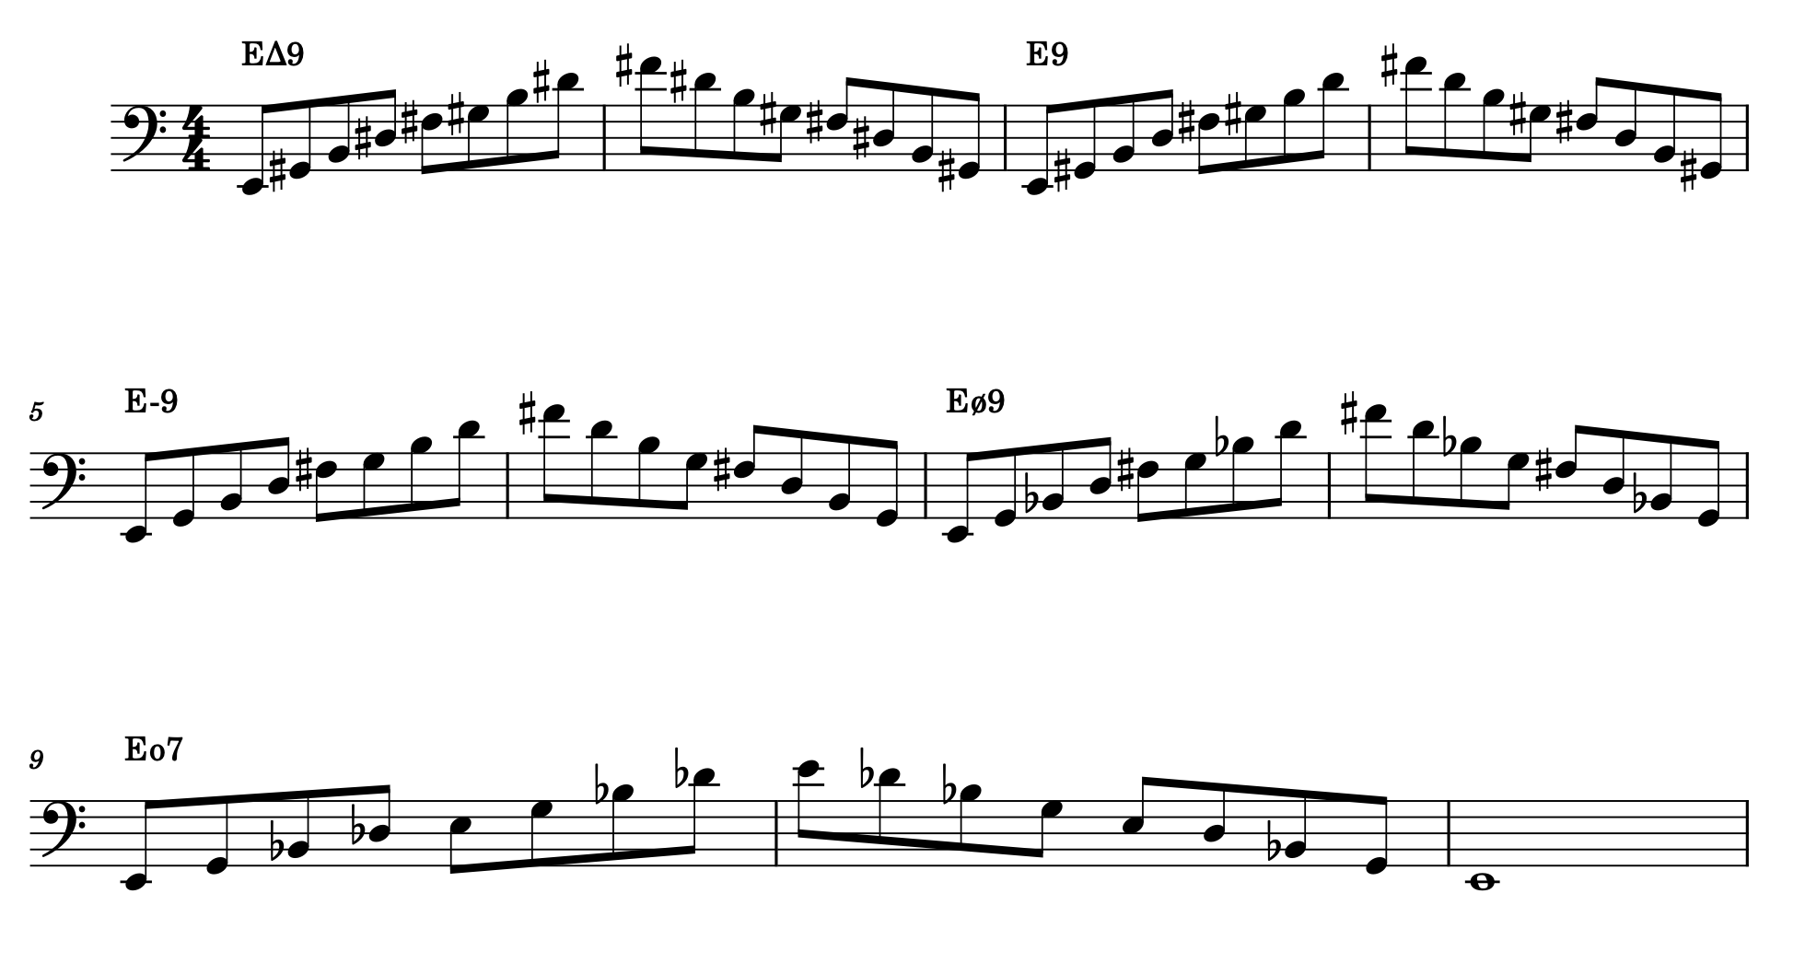

Transcriptions
Two transcriptions will be prepared, for weeks 5 and 10 respectively. The first will be a transcription of all notes played by a bass player from a recording of your choice. This may or may not include a solo, but including a solo is encouraged. The second transcription will be a solo transcription of an instrument other than bass. For both transcriptions, provide a written transcription, including chord changes, articulations on all quarter notes, and any other pertinent information, all on in digital notation. Students will play the entirety of the transcription along with the recording. Finding recordings of one of six Tunes learned throughout the semester could be helpful.

Combos
For weeks 8 and 12, the student will be responsible for reserving a room and finding a drummer and pianist (horns optional) to play with live. Rehearsal with the group beforehand is not necessary; feel free to prepare with the group as much as you would like. For both weeks, write at least one new original tune and bring in a lead sheet for the band and the instructor to read, and play it. The student and the band will also collectively call standards. This will be an opportunity for the instructor to assess the student’s playing in a live group setting. Calling one of six Tunes learned throughout the semester could be helpful. If no one is available during the regular lesson time, we can find a different time that week when people/rooms are available.

Jury:
Your jury evaluation will consist of three parts: One Routine from this semester of your choosing, one other Routine from this semester chosen randomly, and one key of Arpeggios from this semester chosen randomly.

Students with Disabilities:
Students with disabilities that affect their work in this class are invited to speak with the instructor privately about how to best accommodate any needs. Students must proactively speak with instructor for any accommodations to be considered legitimate and actionable.

SPOT Evaluations:
The standard UNT SPOT evaluation will be done at the end of the course. This class is relatively new, and any suggestions for teaching methods or content will be taken into consideration. If you have comments or suggestions for improving the course before then, please let the instructor know at any time.

