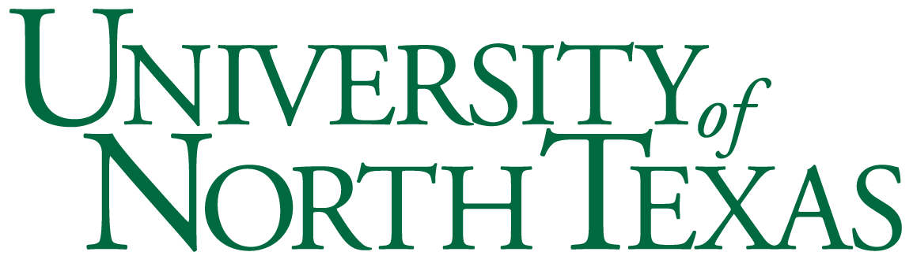

## Department of Sociology

SOCI 3700: Sociology of Religion

Tuesday/Thursday 3:30-4:50 pm

Wooten Hall 316

Instructor: Kevin McCaffree, PhD

**Office**: 288b Sycamore Hall

**Office Hours**: Thursday 2:00pm-3:15pm

**Teaching Assistant:** Ronaldo Monasterio

**Email**: ronaldo.monasterio@unt.edu

Contact the teaching assistant, initially, for all course inquiries

## Course Description

This course will describe and discuss the current issues, empirical findings, and theoretical controversies in the sociology of religion. Among other things, this course will focus on religious belief (e.g., in God), behavior (e.g., prayer) and belonging (e.g., affiliation with a church) as well as the widespread modern decline of religiosity. Issues of gender, class and race will also be discussed as each relates to religiosity and the loss of religiosity.

**Books**

We will be using three texts for this course:

1. Mirola, W., M.O Emerson and S.C. Monahan (eds.) 2019 (3rd edition). *Sociology of Religion: A Reader.* NY: Routledge
2. Smith, H. 2009. *The World’s Religions.* Harper Collins
3. Zuckerman, P., L.W. Galen and F.L. Pasquale. 2016. *The Nonreligious: Understanding Secular People and Societies.* NY: Oxford.

Assignments and Grading:

Your grade in this course will be determined by four exams. All testing will be done (and all grades will be posted) on the CANVAS site for this course: <https://unt.instructure.com>

Attendance:

Class attendance is not mandatory. However, a significant portion of exam questions will be drawn from lecture material. It is therefore in your interest to attend class regularly.

Participation in class (e.g., asking questions, sharing observations or experiences) is a valued component of this course. Frequent participation will make a student eligible for end-of-semester grade increases as determined by the instructor.

Exams:

There are four multiple-choice exams for this course that cover material from class lecture and assigned readings.

Exams will be administered online, via the CANVAS course site (visit [https://unt.instructure.com](https://unt.instructure.com/)), during the date and time we would normally meet for class (see course calendar below).

Each exam is worth 100 points for a total of 400 points possible.

No makeup exams will be administered without evidence of a documented—and verifiable—medical emergency.

Grading Scale:

A = 90 to 100% of 400 possible points

B = 80 to 89%

C = 70 to 79%

D = 60 to 69%

F = Below 60%

**Academic Integrity:**

It is the responsibility of each student to be familiar with UNT’s Policy on Academic Integrity. Plagiarism, copying, cheating, or giving assistance to other students during examinations is a violation of academic integrity. Cases of suspected cheating or plagiarism will be reported to the Dean of Students office. Note that any and all work submitted in order to meet the requirements of this course must be originally created for this course. In other words, you may not turn in anything submitted for another course and/or section of this course you have previously taken.

University Policy 06.003 states, “UNT promotes the integrity of learning processed and embraces the core values of trust and honesty. Academic integrity is based on educational principles and procedures that protect the rights of all participants in the educational process and validate the legitimacy of degrees awarded by the university. In the investigation and resolution of allegations of student academic dishonesty, the university’s actions are intended to be corrective, educationally sound, fundamentally fair, and based on reliable evidence.”

For more information on what constitutes plagiarism, as well as tips on citing your resources, visit [www.plagiarism.org](http://www.plagiarism.org/). If you require clarification on what counts as academic dishonesty, it is your responsibility to ask the instructor of the course.

**Academic Accommodations:**

The University of North Texas makes reasonable academic accommodation for students with disabilities. Students seeking accommodation must first register with the Office of Disability Accommodation (ODA) to verify their eligibility. If a disability is verified, the ODA will provide you with an accommodation letter to be delivered to faculty to begin a private discussion regarding your specific needs in a course. You may request accommodations at any time, however, ODA notices of accommodation should be provided as early as possible in the semester to avoid any delay in implementation. Note that students must obtain a new letter of accommodation for every semester and must meet with each faculty member prior to implementation in each class. For additional information see the Office of Disability Accommodation website at [http://disability.unt.edu](http://disability.unt.edu/). You may also contact them by phone at (940) 565-4323.

Course Schedule*:

**Week 1:** 1/14, 1/16 **Topic:** Introduction and Overview

* Introduction
* Overview of the course
* Mirola et al., Chapter 1

**Week 2:** 1/21, 1/23 **Topic:** Theorizing the Concept of“Religion”

* Mirola et al., Chapters 2, 3

**Week 3:** 1/28, 1/30 **Topic:** Theorizing the Concept of“Religion”

* Mirola et al., Chapter 13, 18

**Week 4:** 2/4, 2/6 **Topic:** Theorizing the Concept of“Religion”

* Mirola et al., Chapter 17

**Week 5:** 2/11, 2/13 **Topic:** Theorizing the Concept of“Religion”

* Take “Exam One” on CANVAS Thursday, 2/13, between 3:30-4:15 pm.

**Week 6:** 2/18, 2/20 **Topic:** Religion Around the World

* Smith, Chapters 6,7,8
* Mirola et al., Chapter 26

**Week 7:** 2/25, 2/27 **Topic:** Religion Around the World

* Smith, Chapters 3, 4, 5

**Week 8:** 3/3, 3/5 **Topic:** Religion Around the World

* Smith, Chapter 2
* Mirola et al., Chapters 6, 29
* Zuckerman et al., Chapter 2
* Take “Exam Two” on CANVAS Thursday, 3/5, between 3:30-4:15 pm.

**Week 9:** 3/10, 3/12 **Topic:** SPRING BREAK

**Week 10:** 3/17, 3/19 **Topic:** Race and Religion in the US

* Mirola et al., Chapters 22, 23, 30

**Week 11:** 3/24, 3/26 **Topic:** Gender, Sexuality and Religion in the US

* Mirola et al., Chapters 24, 27, 16

**Week 12:** 3/31, 4/2 **Topic:** Class, Education and Religion in the US

* Mirola et al., Chapters 19, 20, 21, 31
* Take “Exam Three” on CANVAS Thursday, 4/2, between 3:30-4:15 pm.

**Week 13:** 4/7, 4/9 **Topic:** The Secularization of Society

* Mirola et al., Chapters 4, 5, 7

**Week 14:** 4/14, 4/16 **Topic:** TheSecularization of Society

* Zuckerman et al., Chapters 1, 3, 4

**Week 15:** 4/21, 4/23 **Topic:** The Future--Secular/Civil, or New Age Religions?

* Zuckerman et al., Chapters 5, 6, 7

**Week 16:** 4/28, 4/30 **Topic:** The Future-- Secular/Civil, or “New Age” Religions?

* Zuckerman et al., 8, 9, 10
* Mirola et al., Chapter 34

**Week 17:** **FINALS**

* Take “Exam Four” on CANVAS on Tuesday 5/5, between 1:30-2:30 pm.

*This syllabus, with its course schedule, is based on the most recent information about the course content and schedule planned for this course. Its content is subject to revision as needed to adapt to new knowledge or unanticipated events. Updates will remain focused on achieving the course objectives and students will receive notification of such changes. Students are responsible for attending to such changes or modifications posted on the CANVAS site ([https://unt.instructure.com](https://unt.instructure.com/)) for this course.