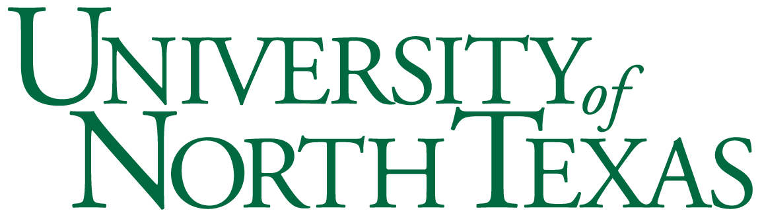

## Department of Sociology

SOCI 3630: Drugs, Crime and Society

Monday/Wednesday 2:00-3:20 pm

Gateway Center Room 131

Instructor: Kevin McCaffree, PhD

Email: kevin.mccaffree@unt.edu

**Office**: 288b Sycamore Hall

**Office Hours**: Wednesday, 1pm-2pm; 4pm-6pm

In this course you will learn about cutting edge and controversial issues within the field of criminology, with a special focus on the issues of drugs use, criminal behavior and drug-related crime. More specifically, the objectives of this course are to introduce you to:

* current national data trends around drug use
* the criminological theories most widely used by researchers
* controversies and debates about drug classification, drug use, drug-related crime and drug policy
* real-world application of theory to a criminal case

**Books for the course****? Nope.**

**Grading**

Attendance and Participation:

Attendance is not required.

However, all exam questions will be drawn from lecture material, so it is in your interest to attend classes regularly.

I’ll eventually learn who comes to class and who doesn’t, who participates and who doesn’t. Regular participation in class can positively influence the final grade you receive at the end of the semester.

Powerpoints will **not** be posted on Canvas (university copyright issues).

Exams:

There are three essay exams in this course.

The first two exams will be taken in class, using only a Blue Book, no laptops or phones. (Bring a blue book and pen to class on exam days! See course schedule below).

The final exam essay exam will be submitted online, via Canvas.

Each exam is worth 100 points, for a total of 300 points.

To be as fair as possible to everyone, **no makeup exams** will be available without verifiable evidence of a documented medical emergency.

Grading Scale:

A = 90 to 100% of 300 possible points (+ possible extra credit for attendance/participation)

B = 80 to 89%

C = 70 to 79%

D = 60 to 69%

F = Below 60%

Academic Integrity:

It is the responsibility of each student to be familiar with UNT’s Policy on Academic Integrity. Plagiarism, copying, cheating, or giving assistance to other students during examinations is a violation of academic integrity. Cases of suspected cheating or plagiarism will be reported to the Dean of Students office. Note that any and all work submitted in order to meet the requirements of this course must be originally created for this course. In other words, you may not turn in anything submitted for another course and/or section of this course you have previously taken.

University Policy 06.003 states, “UNT promotes the integrity of learning processed and embraces the core values of trust and honesty. Academic integrity is based on educational principles and procedures that protect the rights of all participants in the educational process and validate the legitimacy of degrees awarded by the university. In the investigation and resolution of allegations of student academic dishonesty, the university’s actions are intended to be corrective, educationally sound, fundamentally fair, and based on reliable evidence.”

For more information on what constitutes plagiarism, as well as tips on citing your resources, visit [www.plagiarism.org](http://www.plagiarism.org/). If you require clarification on what counts as academic dishonesty, it is your responsibility to ask the instructor of the course.

Academic Accommodations:

The University of North Texas makes reasonable academic accommodation for students with disabilities. Students seeking accommodation must first register with the Office of Disability Accommodation (ODA) to verify their eligibility. If a disability is verified, the ODA will provide you with an accommodation letter to be delivered to faculty to begin a private discussion regarding your specific needs in a course. You may request accommodations at any time, however, ODA notices of accommodation should be provided as early as possible in the semester to avoid any delay in implementation. Note that students must obtain a new letter of accommodation for every semester and must meet with each faculty member prior to implementation in each class. For additional information see the Office of Disability Accommodation website at [http://disability.unt.edu](http://disability.unt.edu/).

Course Schedule*:

**Week 1:** 8/19, 8/21 **Topic:** Introduction and Overview

* Introduction
* Overview of the course (Q & A)
* General Discussion: drug use, addiction, crime and incarceration

**Week 2:** 8/26, 8/28 **Topic:** Drug Use Rates and Trends

* Are people using drugs more often or less often? Which drugs? Why?

**Week 3:** 9/2, 9/4 **Topic:** Drug Use Rates and Trends

* Class Canceled Monday for Labor Day
* (Cont.) Are people using drugs more often or less often? Which drugs? Why?

**Week 4:** 9/9, 9/11 **Topic:** The “War” on Drugs

* Why are some drugs illegal? How has our approach to drug legality changed?

**Week 5:** 9/16, 9/18 **Topic:** The “War” on Drugs

* (Cont.) Why are some drugs illegal? How has our approach to drug legality changed?

**Week 6:** 9/23, 9/25 **Topic:** The Business of Selling Drugs Today

* What does the *illegal* drug market look like? What does the *legal* drug market look like?

**Week 7:** 9/30, 10/2 **Topic:** The Opioid Epidemic

* What is the “opioid epidemic?” How did it begin?

**Week 8:** 10/7, 10/9 **Topic:** The Opioid Epidemic

* (Cont.) What is the “opioid epidemic?” How did it begin?

**Week 9:** 10/14, 10/16 **Topic:** “Bonding/Control” Theories of Deviance

* **Exam One on Monday, 10/14**
* How is social connectedness related to drug use and addiction?

**Week 10:** 10/21, 10/23 **Topic:** “Strain” Theories of Deviance

* How is stress related to drug use and addiction?

**Week 11:** 10/28, 10/30 **Topic:** “Social Learning” Theories of Deviance

* How is learning and conformity related to drug use and addiction?

**Week 12:** 11/4, 11/6 **Topic:** The Social Psychology of Addiction

* Why is drug addiction so hard to treat? What works?

**Week 13:** 11/11, 11/13 **Topic:** Application to the Real World: Reopening a Cold Case

* **Exam Two on Monday, 11/11**
* News Coverage, Review of the Evidence

**Week 14:** 11/18, 11/20 **Topic:** Application to the Real World: Reopening a Cold Case

* Review of the evidence

**Week 15:** 11/25, 11/27 **Topic:** Thanksgiving Break—Classes Canceled

**Week 16:** 12/2, 12/4 **Topic:** Review and Final Exam

* Last Questions/Review of the case on 12/2
* No class meeting on 12/4
* **Final Essay uploaded to Canvas on 12/4 by 5 pm**

**Week 17 (Final Exam)**

**No Class Meeting**

*This syllabus, with its course schedule, is based on the most recent information about the course content and schedule planned for this course. Its content is subject to revision as needed to adapt to new knowledge or unanticipated events. Updates will remain focused on achieving the course objectives and students will receive notification of such changes. Students are responsible for attending to such changes or modifications posted on the CANVAS site ([https://unt.instructure.com](https://unt.instructure.com/)) for this course.