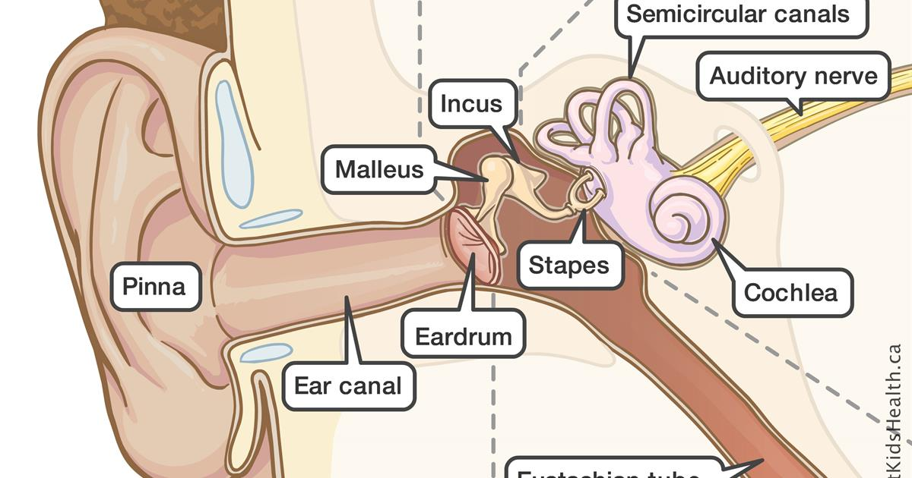

DEPARTMENT OF SPEECH AND HEARING SCIENCES UNIVERSITY OF NORTH TEXAS
ASLP 3040
INTRODUCTION TO AUDIOLOGY
Summer 2026

INSTRUCTOR: Katherine Alsop, Au.D. CCC-A, AIB-VRC
TEACHING ASSISTANT: Jillian Schneider
CLASS: Online
OFFICE HRS: Fridays, 12-3:30 pm or by appointment
EMAIL: katherine.alsop@unt.edu
jillianschneider@my.unt.edu

Course Objective:

This course is designed to provide undergraduate students with an introduction to the field of audiology. It will provide information on:
- What the field of Audiology encompasses
- What Audiologists do
- Why would anyone want to be an Audiologist
- Credentials needed to practice Audiology
- Introduction to normal and impaired auditory and vestibular systems
- Behavioral test measures used in the evaluation of auditory function
- Physiologic test measures used in the evaluation of auditory function
- Basic audiologic management issues

Learning Outcomes
At the end of the course the students should be able to:
- Describe and discuss the scope of Audiology
- Determine the normal structure and function of the auditory and vestibular systems
- Compare and contrast common etiologies of auditory disorders
- Assess basic diagnostic procedures in the identification of hearing loss
- Explain basic treatment options available

Required Text:
DeBonis, D. A., & Donohue , C. L. (2019). Survey of audiology: Fundamentals for audiologists and health professionals (3rd ed.). Thorofare: Slacks Incorporated.

Additional Reading:
Additional readings may be assigned, and students will be expected to know the material for the exams.

Course Requirement:
Before enrolling in ASLP 3040, students must have completed a human biology, statistics, and physics course with a grade of C or better, as well as ASLP 2015 and ASLP 2020. Students may attempt to earn a C in these courses only TWICE.

The students will take three examinations, five quizzes, and submit two assignments. Assignments will be uploaded to Canvas for grading, and physical or emailed copies will not be accepted. One opportunity for extra credit is potentially available, but it is only available after completing Quiz 3. Students are to work on assignments, quizzes, and tests independently, but all assignments, quizzes, and tests are open-book.

GRADING
Activities Percent
Exam 1 15
Exam 2 15
Exam 3 25
Assignments 30
Quizzes 15
------
TOTAL 100

Final percentages will be computed, and grades will be assigned according to the following criteria:

Percentage Final Grade

89.5-100 A
79.5-89.49 B
69.5-79.49 C
59.5-69.49 D
<60 F

The final exam is cumulative. No makeup exams will be provided, except in emergency cases (proof required), and no extra credit will be offered after 6/8/2026.

Academic Integrity
Any kind of academic dishonesty will not be tolerated and will result in formal disciplinary action. The University’s rules on academic integrity regarding cheating, plagiarism etc., will be enforced vigorously. Academic dishonesty is defined in the UNT Policy on Student Standards for Academic Integrity. Any suspected case of Academic Dishonesty will be handled in accordance with the University's policy and procedures. Possible academic penalties range from a verbal or written admonition to a grade of "F" in the course. Further sanctions may apply to incidents involving major violations. You will find the policy and procedures at http://vpaa.unt.edu/academic-integrity.htm.
ODA:
The University of North Texas makes reasonable academic accommodations for students with disabilities. Students seeking accommodation must first register with the Office of Disability Accommodation (ODA) to verify their eligibility. If a disability is verified, the ODA will provide you with an accommodation letter to be delivered to faculty to begin a private discussion regarding your specific needs in a course. You may request accommodations at any time, however, ODA notices of accommodation should be provided as early as possible in the semester to avoid any delay in implementation. Note that students must obtain a new letter of accommodation for every semester and must meet with each faculty member prior to implementation in each class. For additional information, see the Office of Disability Accommodation website at http://www.unt.edu/oda. You may also contact them by phone at 940.565.4323.

This statement and other ODA information is available on the ODA website http://www.unt.edu/oda

SPOT:
The Student Perceptions of Teaching (SPOT) is a requirement for all organized classes at UNT, including this class. A short survey will be made available to you at the end of the semester, providing you with a chance to comment on how this class is taught. We are very interested in student feedback as we work to continually improve our teaching. We consider SPOT to be an important part of your participation in this class.
Course Outline:
The course calendar below lists all lectures, assignments, quizzes, and exams. Note that the due date for all assignments and exams is June 19th, 2026. It is your responsibility to plan ahead and make sure that all modules, quizzes, exams, and assignments are completed before the end of the summer course. All modules are locked and can only be unlocked once you have completed the previous module.

Module/Exam | Readings | Module  Due Dates
Lecture 1: Profession of Audiology | DeBonis chapter 1 | 6/19 @ 11:59 PM
Lecture 2: Hearing Science Abbreviated | DeBonis chapter 2 | 6/19 @ 11:59 PM
Lecture 3: Anatomy and Physiology  Anatomy Labeling Available*** | DeBonis chapter 3 | 6/19 @ 11:59 PM
Lecture 4: Pathology of the Ear | DeBonis chapter 7 | 6/19 @ 11:59 PM
Exam 1
Due by 11:59pm 6-19-2025
Lecture 5: Types of Hearing Loss and Classifications | DeBonis chapter 2 | 6/19 @ 11:59 PM
Lecture 6: Evaluation: Case History and Otoscopy | DeBonis chapter 4 | 6/19 @ 11:59 PM
Lecture 7: Evaluation: Immittance and OAEs | DeBonis chapter 5  & 6 | 6/19 @ 11:59 PM
Lecture 8: Evaluation: Pure Tones and Speech Testing  Audiogram Interpretation Available*** | DeBonis chapter 6 | 6/19 @ 11:59 PM
Exam 2
Due by 11:59pm 6-19-2025
Lecture 9: Advanced Eval: Evoked Potentials and Medical Bias | DeBonis chapter 10 | 6/19 @ 11:59 PM
Exam 3
Due by 11:59pm 6-19-2025
All assignments due***

