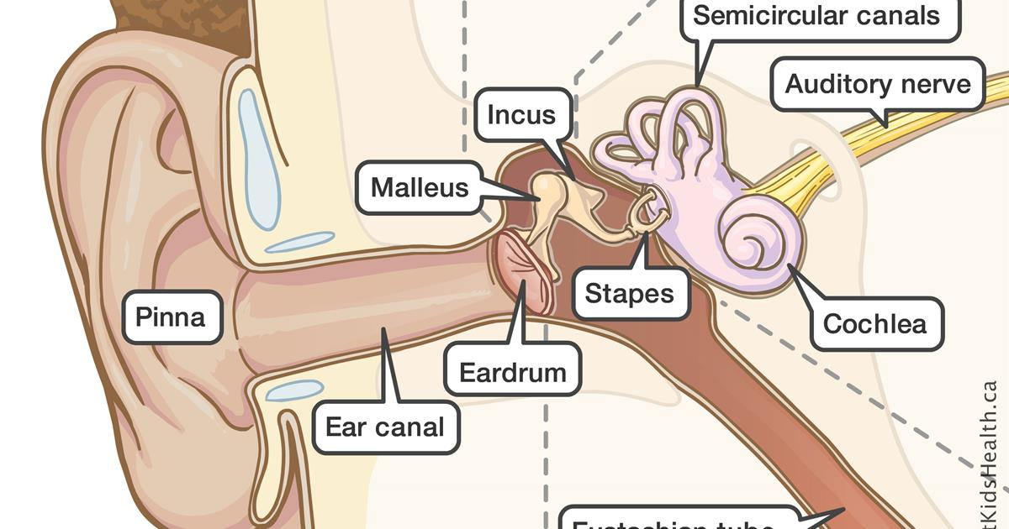

DEPARTMENT OF SPEECH AND HEARING SCIENCES UNIVERSITY OF NORTH TEXAS

ASLP 3040

INTRODUCTION TO AUDIOLOGY

Fall 2025

INSTRUCTOR: Katherine Alsop, Au.D. CCC-A, AIB-VRC

TEACHING ASSISTANT: Cassie Nedrud

CLASS: Tuesdays and Thursdays 4-5:20 pm at Wooten 317

OFFICE: UNT Speech and Hearing Center #152

MEETING HRS: By appointment

EMAIL: [katherine.alsop@unt.edu](mailto:katherine.alsop@unt.edu)

[cassandra.nedrud@my.unt.edu](mailto:cassandra.nedrud@my.unt.edu)

LECTURE SLIDES: Available on Canvas

Course Objective:

This course is designed to provide undergraduate students with an introduction to the field of audiology. It will provide information on:

* What the field of Audiology encompasses
* What Audiologists do
* Why would anyone want to be an Audiologist
* Credentials needed to practice Audiology
* Introduction to normal and impaired auditory and vestibular systems
* Behavioral test measures used in the evaluation of auditory function
* Physiologic test measures used in the evaluation of auditory function
* Basic audiologic management issues

Learning Outcomes

At the end of the course the students should be able to:

* Describe and discuss the scope of Audiology
* Determine the normal structure and function of the auditory and vestibular systems
* Compare and contrast common etiologies of auditory disorders
* Assess basic diagnostic procedures in the identification of hearing loss
* Explain basic treatment options available

Required Text:

DeBonis, D. A., & Donohue , C. L. (2019). *Survey of audiology: Fundamentals for audiologists and health professionals* (3rd ed.). Thorofare: Slacks Incorporated.

Additional Reading:

Additional readings may be assigned and students will be expected to know the material for the exams.

Course Requirement:

Before enrolling in ASLP 3040, students must complete with a grade of C or better in a human biology, statistics and physics course as well as ASLP 2015 and ASLP 2020. Students may attempt to earn a C in these courses only TWICE.

The students will take three examinations through Canvas, complete five quizzes, satisfactorily complete a clinic tour and write a report, and submit the completed audiogram interpretation assignment. Clinic tours will be done at pre-scheduled times convenient to the UNT Speech and Hearing Clinic personnel, the teaching assistant, and the students. Reports for the tour should be NO MORE than two pages (double-spaced with 12-point font) and must be submitted by 4:00 pm on the due date. The audiogram interpretation packet will be assigned in the latter half of the semester. Students are to work on it independently and turn in the answers within one week. Extra credit assignments may be available throughout the semester at the discretion of the instructor.

GRADING

Activities Percent

Exam 1 20

Exam 2 20

Exam 3 20

Tour Report 15

Quizzes 10

Audiogram interpretation 15

------

TOTAL 100

***There will be 5 pop quizzes throughout the semester. These quizzes will not be announced and there will be no opportunity to make them up if missed, except in emergency cases (proof required).***

Final percentages will be computed, and grades will be assigned according to the following criteria:

Percentage Final Grade

90-100 A

80-89 B

70-79 C

60-69 D

<60 F

If a grade is at the cusp and able to be rounded up to the next letter grade (__9.5% or above), then it will be rounded. Anything below that number will remain that letter grade.

The final exam is cumulative. No makeup exams will be provided, except in emergency cases (proof required). Failure to be present for a scheduled exam, an unscheduled pop quiz, a pre-scheduled clinic tour, or to turn in reports will result in a 0 on that activity.

**Course Outline:**

The course calendar below lists all lectures, assignments, and exams.

|  |  |  |  |
| --- | --- | --- | --- |
| **Days** | **Topics** | **Reading rec’d** | **Assignments** |
| 8/19 | Introduction, syllabus  History of Audiology | DB chapter 1 | **Clinic Tour Assigned** |
| 8/21 | Profession of Audiology |  |  |
| 8/26 | Hearing Science | DB chapter 2 |  |
| 8/28 | Hearing Science |  |  |
| 9/2 | Anatomy and Physiology: Outer and  Middle Ear | DB chapter 3 | **Clinic Tour Due** |
| 9/4 | Anatomy and Physiology: Inner Ear |  |  |
| 9/9 | Anatomy and Physiology: CNS | DB chapter 3 |  |
| 9/11 | Review for Exam 1 |  |  |
| **9/16** | **Exam 1** |  |  |
| 9/18 | Pathology of the Ear: Outer and Middle  Ear |  |  |
| 9/23 | Pathology of the Ear: Inner Ear and CNS | DB chapter 3  DB chapter 7 |  |
| 9/25 | Types of Hearing Loss | DB chapter 2 |  |
| 9/30 | Classification of Hearing Loss | DB chapter 2 |  |
| 10/2 | How to Read an Audiogram |  |  |
| 10/7 | Evaluation: Case History and Otoscopy | DB chapter 4 |  |
| 10/9 | **TAA CONFERENCE - NO CLASS** |  |  |
| 10/14 | Evaluation: Immittance and OAEs | DB chapter 5&6 |  |
| 10/16 | Immittance and OAEs Lab  Review for Exam 2 |  |  |
| **10/21** | **Exam 2** |  |  |
| 10/23 | Evaluation: Pure Tones | DB chapter 4 & 5 |  |
| 10/28 | Evaluation: Masking and Speech Testing | DB chapter 4 & 5 | **Audiogram**  **Interpretation**  **Assigned** |
| 10/30 | Pure Tone Testing Lab |  |  |
| 11/4 | Advanced Eval: Evoked Potentials | DB chapter 10 | **Audiogram**  **Interpretation Due** |
| 11/6 | Advanced Eval: Auditory Processing/  Tinnitus |  |  |
| 11/11 | Advanced Eval: Balance and Medical  Bias | DB chapter 9 |  |
| 11/13 | Advanced Eval: Pediatrics | DB chapter 8 |  |
| 11/18&20 | **ASHA CONFERENCE - NO CLASS** |  |  |
| 11/25&27 | **THANKSGIVING – NO CLASS** |  |  |
| 12/2 | Final Exam Review |  |  |
| 12/4 | Final Exam Review (case studies) |  |  |
| **12/9** | Exam 31:30-3:30 PM |  |  |

**UNT Policies**

Academic Integrity Standards and Consequences

According to UNT Policy 06.003, Student Academic Integrity, academic dishonesty occurs when students engage in behaviors including, but not limited to cheating, fabrication, facilitating academic dishonesty, forgery, plagiarism, and sabotage. A finding of academic dishonesty may result in a range of academic penalties or sanctions ranging from admonition to expulsion from the University. Any suspected case of Academic Dishonesty will be handled in accordance with the University policy and procedures. Possible academic penalties range from a verbal or written admonition to a grade of "F" in the course. Further sanctions may apply to incidents involving major violations. You will find the policy and procedures at http://vpaa.unt.edu/academic-integrity.htm.

ADA Accommodation Statement

UNT makes reasonable academic accommodation for students with disabilities. Students seeking accommodation must first register with the Office of Disability Accommodation (ODA) to verify their eligibility. If a disability is verified, the ODA will provide a student with an accommodation letter to be delivered to faculty to begin a private discussion regarding one’s specific course needs. Students may request accommodations at any time, however, ODA notices of accommodation should be provided as early as possible in the semester to avoid any delay in implementation. Note that students must obtain a new letter of accommodation for every semester and must meet with each faculty member prior to implementation in each class. For additional information see the ODA website at disability.unt.edu.

Attendance Policy

Students are expected to attend classes regularly and to abide by the attendance policy established for each class. If a student is unable to attend a class, a timely email or other notification of absence is expected to let the instructor know a student will not be in class. Any student wanting accommodation to observe a religious holiday must inform the instructor a minimum of three days prior to the observed religious holiday and make appropriate arrangements for the class activities that they will be missing.

Class Conduct:

I value the many perspectives students bring to our campus. Please work with me to create a classroom culture of open communication, mutual respect, and belonging. All discussions should be respectful and civil. Although disagreements and debates are encouraged, personal attacks are unacceptable. Together, we can ensure a safe and welcoming classroom for all. If you ever feel like this is not the case, please stop by my office and let me know.

Emergency Notification & Procedures

UNT uses a system called Eagle Alert to quickly notify students with critical information in the event of an emergency (i.e., severe weather, campus closing, and health and public safety emergencies like chemical spills, fires, or violence). In the event of a university closure, please refer to Blackboard for contingency plans for covering course materials.

ODA:

The University of North Texas makes reasonable academic accommodation for students with disabilities. Students seeking accommodation must first register with the Office of Disability Accommodation (ODA) to verify their eligibility. If a disability is verified, the ODA will provide you with an accommodation letter to be delivered to faculty to begin a private discussion regarding your specific needs in a course. You may request accommodations at any time, however, ODA notices of accommodation should be provided as early as possible in the semester to avoid any delay in implementation. Note that students must obtain a new letter of accommodation for every semester and must meet with each faculty member prior to implementation in each class. For additional information see the Office of Disability Accommodation website at <http://www.unt.edu/oda>. You may also contact them by phone at 940.565.4323.

This statement and other ODA information is available on the ODA website <http://www.unt.edu/oda>

SPOT:

The Student Perceptions of Teaching (SPOT) is a requirement for all organized classes at UNT, including this class. A short survey will be made available to you at the end of the semester, providing you with a chance to comment on how this class is taught. We are very interested in student feedback as we work to continually improve our teaching. We consider the SPOT to be an important part of your participation in this class.

Use of Artificial Intelligence for Assignments:

According to the UNT Academic Integrity Policy (UNT Policy 6.003), any form of "unauthorized assistance" constitutes cheating. As a result, the use of any artificial intelligence is not authorized for assignments in this course.

Syllabus Policy

The syllabus is not a contract, it is a guide for students regarding academic success and behavior. The Professor reserves the right to change the contents if required, and students will be notified of the changes