THEATRE 1046 Stagecraft I
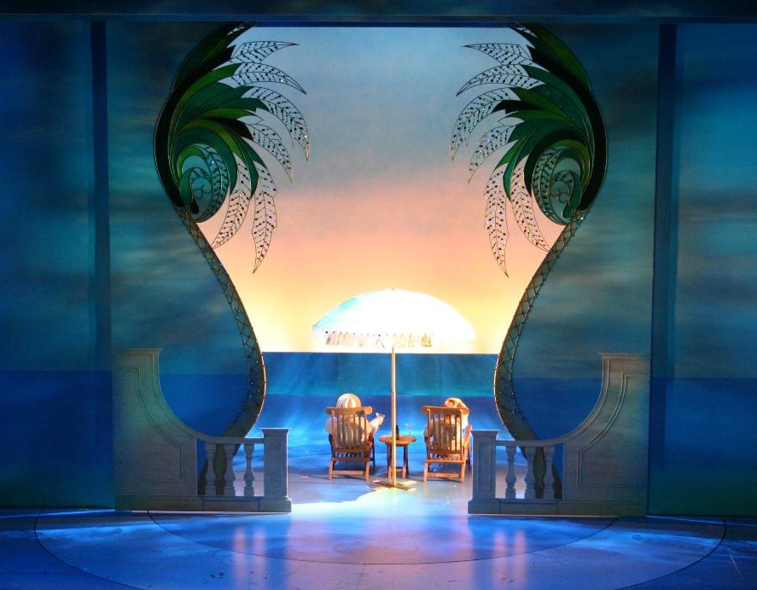
Tues/Thurs 1:00pm – 2:20pm
RTFP Design Studio Room 137

Instructor Contact
Name: Jake Blakeman
Pronouns: He/His
Office Location: DATH 103G
Office Hours: T/TH 9:30am-10:30am
(by appointment, I can find other times if you reach out to me)
Email: Jake.Blakeman@gmail.com

Email Policy: You may contact me via Canvas or my UNT email. I will respond within 24 hours (or by Monday if the message is sent after 3:00 PM on Friday).
When emailing, include your course and section number in the subject line. Please only use your UNT email or Canvas. Messages from other email accounts will not be answered.
Course Objectives
This course will introduce the beginning theatre artist to the incredible variety of work that takes place “behind the scenes” of theatrical production. We will examine the process by which the physical production comes together. We will examine the technical issues and solutions that are found in many productions with specific regards to:
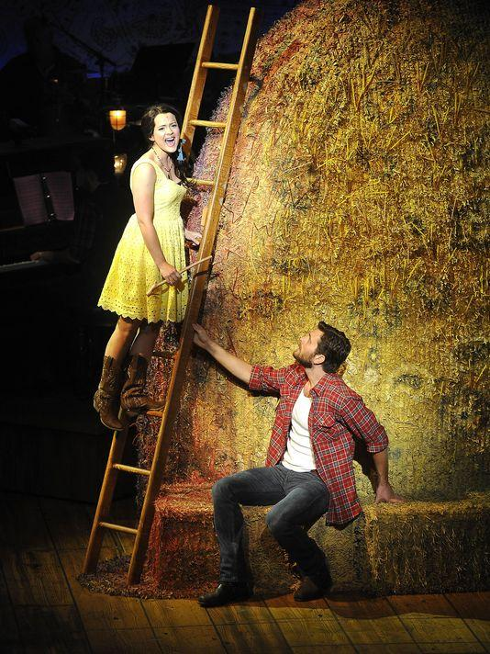
- Tools and materials
- Wood and metal working
- Basic scenery
- Stage terminology
- Knots and rigging
- Basic drafting
- Special Effects
- Advanced constructions techniques
- Technical rehearsal process

At pertinent steps along the way, we will pick up the tools of the trade and perform the tasks required of the technical director in realizing a design, including your own personal project which you will be responsible for from concept to completion.

Materials
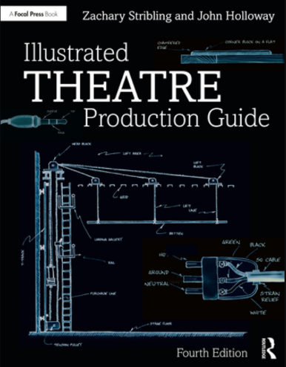
Text Books
- Illustrated Theatre Production Guide (4th ed.)by John Holloway
- Backstage Handbook by Paul Carter

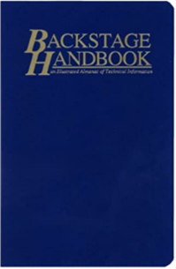
Required Materials:
- Safety Glasses (I will provide)
- Minimum 16 foot Tape Measure (I will provide)
- Architects Scale Rule
- Pencil and Notebook

Class Format
- Lecture: The Tuesday, Thursday class meetings are lecture format with some time
devoted to hands on training. Student participation in lecture, when asked, is encourage. Attending the lecture is expected. However, things do come up that may take priority, see the class participation section.

- Lab: Lab is very participatory. You will be working with tools and other equipment on
department productions. You will get dirty. Please dress appropriately and come prepared to
learn (lockers can be checked out). Lab should be fun. Please keep a positive attitude
and you will be surprised what you can learn.

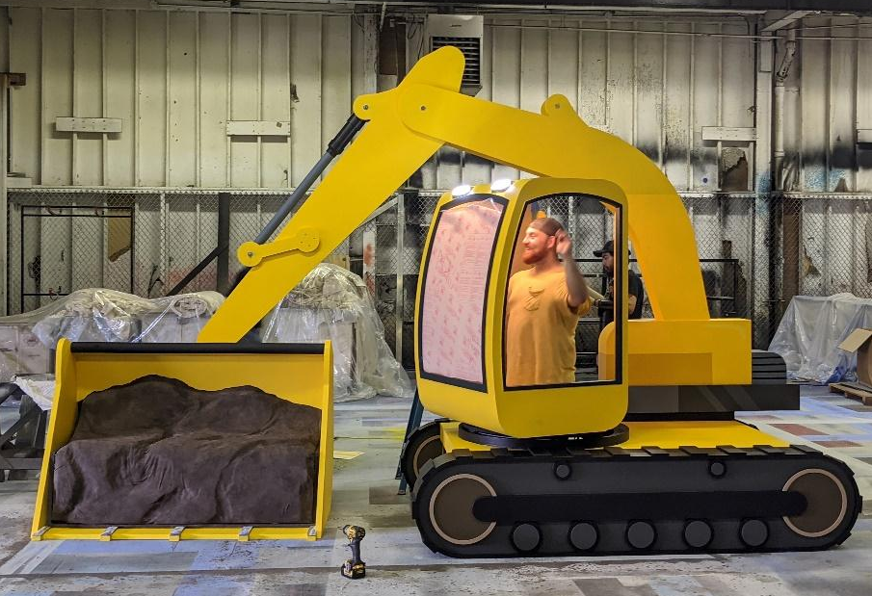
You will determine your lab schedule for work in the Scene Shop during shop hours of:

- Mon-Fri 1:00 – 6:00

You are responsible for 30 lab hours for the semester. you are required to complete a minimum of 2 hours session, 1 session per week for 15 weeks. You may also have longer sessions or do multiple sessions per week. You will commit to your own schedule for the semester in the first week of class.

There are limited time slots available for each workday (during shop hours). There will be a link in Canvas to a site where you may sign up for the hours you want to come in. You are responsible for tracking your lab hours throughout the semester.
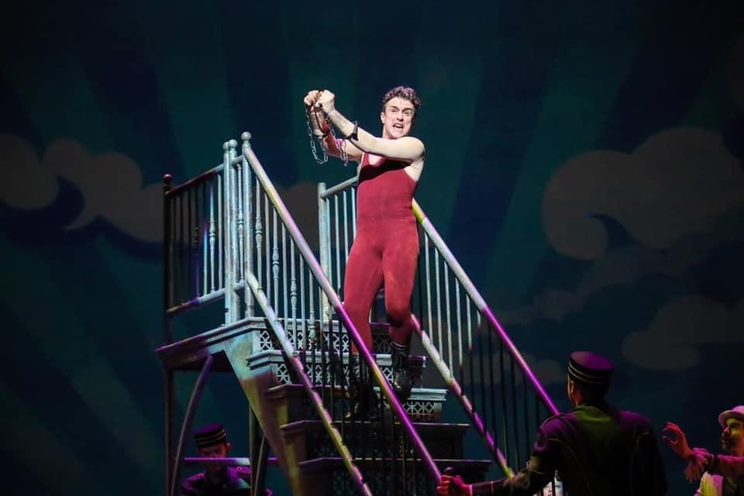
Class Participation
- Attendance and participation counts 150 Points towards your final grade
- After 2 unexcused absences 50 points will be removed for each subsequent absence
- 3 tardies (1-15 minutes late) will count as an absence
- If you are more than 15 minutes late you are considered absent

Course Requirements
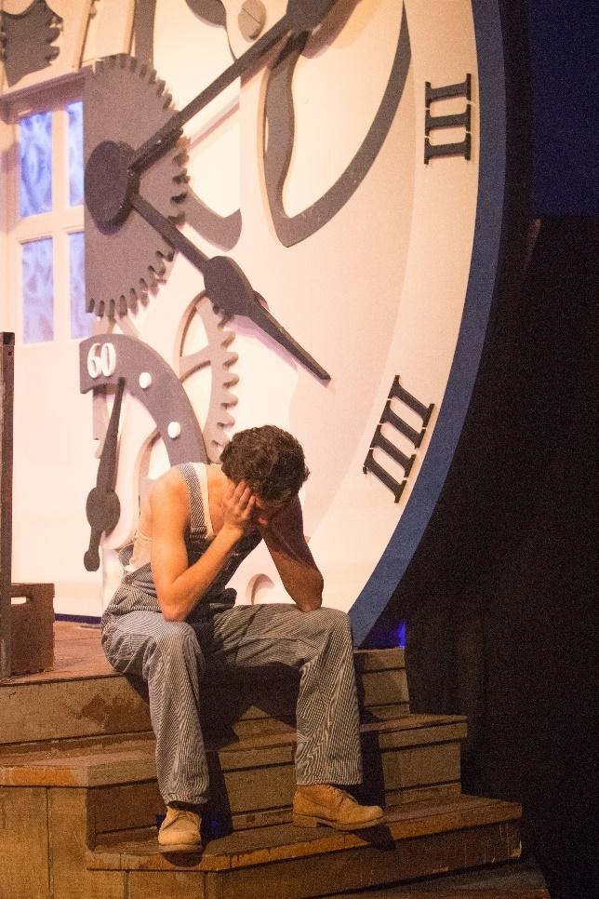
- Attendance and Participation 150 Points
- Lab Hours 150 Points
- Assignments:
  - Hand tool research 50 Points
  - Wine Bottle Stand 50 Points
  - Drafting Project 50 Points
- Quizzes:
  - Tool Safety Quiz 50 Points
(must pass with 85% for course credit)
  - Materials and Scenery 50 Points
  - Organic Scenery 50 Points
  - Knots 50 Points
  - Rigging and Soft goods 50 Points

- Final Exam: 150 Points

- Final Project:
  - Drafting 50 Points
  - Product 100 Points
________________________________________________
- TOTAL 1000 Points
Turned in
late work

Grading
- A = 900-1000, B = 800-899, C = 700-799, D = 600-699, F = 500-599
Your assignments must be on time. If you are unable to have your work at the start of the class it is due, the grade will drop 50% if turned in within 24 hours. After 24 hours it will not be accepted. This of course will be amended for excused absences.
Course Calendar
Week # | Tuesday |  | Thursday
 | 1/13 |  | 1/15
1 | Class: Meet & Greet, Sylabus, Tower Building |  | Class: Shop and theatre Tour Bingo  Read: Chapter 3,4,5
 | 1/20 |  | 1/22
2 | Class:Hand tool Assignment & Large tool toutorial 1  Read: Chapters 10 & 11 |  | Class: Large tool toutorial 2  Read: Chapter 12
 | 1/27 |  | 1/29
3 | Class: Hand Tool Research Presentaion  Due: Hand Tool Research |  | Class: Drafting  Read: Chapter 19
 | 2/3 |  | 2/5
4 | QUIZ: Tool safety quiz  Class: Wine Bottle Project 1 |  | Class: Wine Bottle Project 2  Due: Drafting Project
 | 2/10 |  | 2/12
5 | Class: Materials of Scenery  Read:Chapter 13 & 14 |  | Class: Flats: Construction, materials, cutlists  Read: Chapter 15
 | 2/17 |  | 2/19
6 | Class:PLATFORMS & STAIRS:legs vs Studwalls, attachment, triscuits vs 2x4 vs 1x  Read: Chapter 16 & 17 |  | QUIZ: Materials & Scenery quiz  Class: Knots  Read: Chapter 7
 | 2/24 |  | 2/26
7 | Class: Knots review, Organic Scenery |  | Class: Special Effects - Water
 | 3/3 |  | 3/5
8 | Class: Jeaporady |  | Class: Midterm
 | 3/10 |  | 3/12
9 | Class: SPRING BREAK - NO CLASSES |  | Class: SPRING BREAK - NO CLASSES
 | 3/17 |  | 3/19
10 | Class: What is Theatre |  | Class: Rigging: Components, running a lineset  Read: Chapter 8
 | 3/24 |  | 3/26
11 | Class: Softgoods: Types, materials, how to fold  Read: Chapter 6 |  | QUIZ: Rigging and softgoods  Class: Jobs in technical Theatre  Read: Chapter 1
 | 3/31 |  | 4/2
12 | Class: Techincal Rehearsals  Read: Chapter 2 |  | Class: Advanced Construction Techniques - CNC  Read: Chapter 20
 | 4/7 |  | 4/9
13 | Class: Automation  Read: Chapter 21 |  | Class: Metal Working  Personal Projects Assisgned  Read: Chapter 18
 | 4/14 |  | 4/16
14 | Class: Personal Projects Lab |  | Class: Personal Projects Lab
 | 4/21 |  | 4/23
15 | Class: Floating Lecture |  | Class: Final Jeaporady
 | Thursday 5/7 10:00-12:00
16 | FINAL

Syllabus Updates
This syllabus is a living document and may be updated at any time at the instructor’s discretion. Students will be notified of any changes through Canvas and/or class announcements.
Syllabus Acknowledgment
I, ____________________________________________ (print name),
have read and understand the requirements and policies of:
THEA 1046 – Stagecraft I
and have a thorough, clear understanding of the course requirements, standards, and policies. This includes class assignments, the attendance/lateness policy for UNT acting classes, grading criteria for the course, and classroom protocol.
Signature: _____________________________
Date: _____________________________

